Reported accuracy in geohazard susceptibility mapping is a function of the absence sampling design
A simulation-grounded correction, with an empirical test in the Western Himalaya
Chandra-Bhaga and Upper Beas basins, Himachal Pradesh and Jammu & Kashmir, India
Sanskar Gupta
School of Computer Science Engineering and Technology, Bennett University, Greater Noida, Uttar Pradesh, India
Correspondence: Sanskar.in127@gmail.com

Abstract
Machine-learning susceptibility maps for snow avalanches, landslides and related geohazards routinely report areas under the ROC curve above 0.90, and those values are used to compare models, select predictors and justify operational products. Because such data are presence-only, the absences are invented by the analyst, and we show that this choice, rather than the model, largely determines the reported score. In synthetic data where absences are displaced from presences along a direction carrying no information about the outcome, a model with NO predictive skill whatsoever reports AUC 0.739 at a displacement of one standard deviation, 0.910 at two and 1.000 at six. Reported AUC is therefore not comparable across studies that chose their absences differently, and above a displacement of about three standard deviations it cannot distinguish a model that works from one that does not. We measure the absence designs of a published avalanche susceptibility protocol and of two corrected alternatives on the same scale, using an independent Sentinel-1 inventory of 6,364 candidate release sites in the Chandra-Bhaga and Upper Beas basins of the Western Himalaya. Drawing absences from flat, vegetated, urban and cropland terrain, as this literature does, places them 7.06 standard deviations from the presences, where the simulation predicts that a null model scores 1.000 — and 1.000 is what the protocol returns on real data. We then show that the absolute skill of a presence-only model is not identifiable from the data it was fitted to. Two synthetic worlds were constructed whose observed presence and absence samples are nearly indistinguishable — their separations differ by 0.02 and their reported AUCs by 0.043 — while their ability to rank genuinely susceptible terrain differs by 0.281. A difference between the two samples enters an AUC identically whether it arises because presences are different terrain or because absences were drawn from elsewhere, so no statistic computed from those samples can attribute it. We report our own failed attempts at a correction for the same reason. What remains identifiable is the relative effect of the absence design, obtained by holding presences, predictors and model fixed and varying only the sampling: the published protocol returns 1.000, terrain-matched absences 0.954, and aspect-matched absences with corrected labels 0.866. Training on displaced absences and evaluating on a fixed honest test set shows the model itself is little harmed, falling only from 0.975 to 0.952; what the design corrupts is the figure a study reports about itself. Two further diagnostics agree: 1 km climate and 500 m snow-cover predictors are statistically interchangeable with raw spatial coordinates, and reported AUC rises with the background sampling ratio while precision-recall performance falls. We recommend that susceptibility studies hold out an evaluation set whose absences are drawn like the presences; code and data are released.
Keywords: susceptibility mapping, pseudo-absence selection, sampling bias, model evaluation, presence-only data, snow avalanches, Sentinel-1, Western Himalaya

1. Introduction
Snow avalanches threaten settlements, highways and glacial lakes across the Indian Himalayan Region (IHR). Because field survey is impractical over this terrain, avalanche susceptibility maps (ASM) are produced by training classifiers on past avalanche locations and a set of topographic, climatic and snowpack predictors. Reported performance is consistently high, with recent IHR studies citing AUC values of 0.87–0.95.
Such values are only meaningful if the negative class represents terrain where avalanches could occur but did not. In practice, published studies draw non-avalanche points from flat vegetated areas, urban settlements, water bodies and croplands. These locations differ from avalanche release zones in nearly every predictor simultaneously, so a classifier can achieve excellent scores by recognising land cover rather than avalanche conditions. The field has meanwhile concentrated its methodological attention on spatial cross-validation, which addresses a different problem — spatial autocorrelation between training and test folds.
This study asks which of these two design choices actually drives reported performance, and whether the resulting models encode avalanche physics or study-design artefacts. We address it with a controlled 2×2 experiment on an independently constructed inventory, followed by explainability and ablation diagnostics. We apply the same scrutiny to our own pipeline and report two artefacts we found there.

1.1 Scope and intent
What is under test here is a PROTOCOL, not a paper. The absence rule examined below recurs throughout avalanche susceptibility work in the region: the study we reproduce cites earlier applications reporting AUC values of 0.88 and 0.87 built the same way. Our results therefore speak to a convention the field has inherited, and they apply to our own models exactly as they apply to published ones — Section 4.1 reports what happens when we run the conventional protocol on our own data, and the answer is a perfect score.
We take Abhinav and Sattar (2025) as the reference implementation because it is recent, it covers these basins, and it documents its predictors, models and sampling clearly enough to be rebuilt independently. That is not true of every study in this area, and reproducing a result is only possible when the original is reported carefully. Where our figures differ from theirs, the difference reflects the experimental design we impose rather than an error on their part: a model trained against flat, vegetated absences is answering a different and easier question than one trained against terrain-matched background, and neither number is wrong for the question it answers.

2. Study area
The Chandra-Bhaga and Upper Beas basins lie in Himachal Pradesh and the Jammu & Kashmir union territory, in the Western Himalaya. The region receives heavy winter snowfall from westerly disturbances and has a documented history of avalanche impacts on the Leh–Manali highway and on settlements including Manali, Keylong and Udaipur.
All analysis is carried out over a rectangular extent covering both basins, 76.40–78.10° E and 31.90–33.20° N, rather than over hydrologically delineated basin outlines. The extent therefore includes some terrain beyond the two catchments, and spans 554–6,565 m against the 1,123–6,329 m usually quoted for the basins themselves. Potential release terrain — slope between 28 and 60°, after Bühler et al. (2018) — covers 11,705 km², roughly half the extent, and every areal statistic reported in Section 4 refers to that domain rather than to the full rectangle.
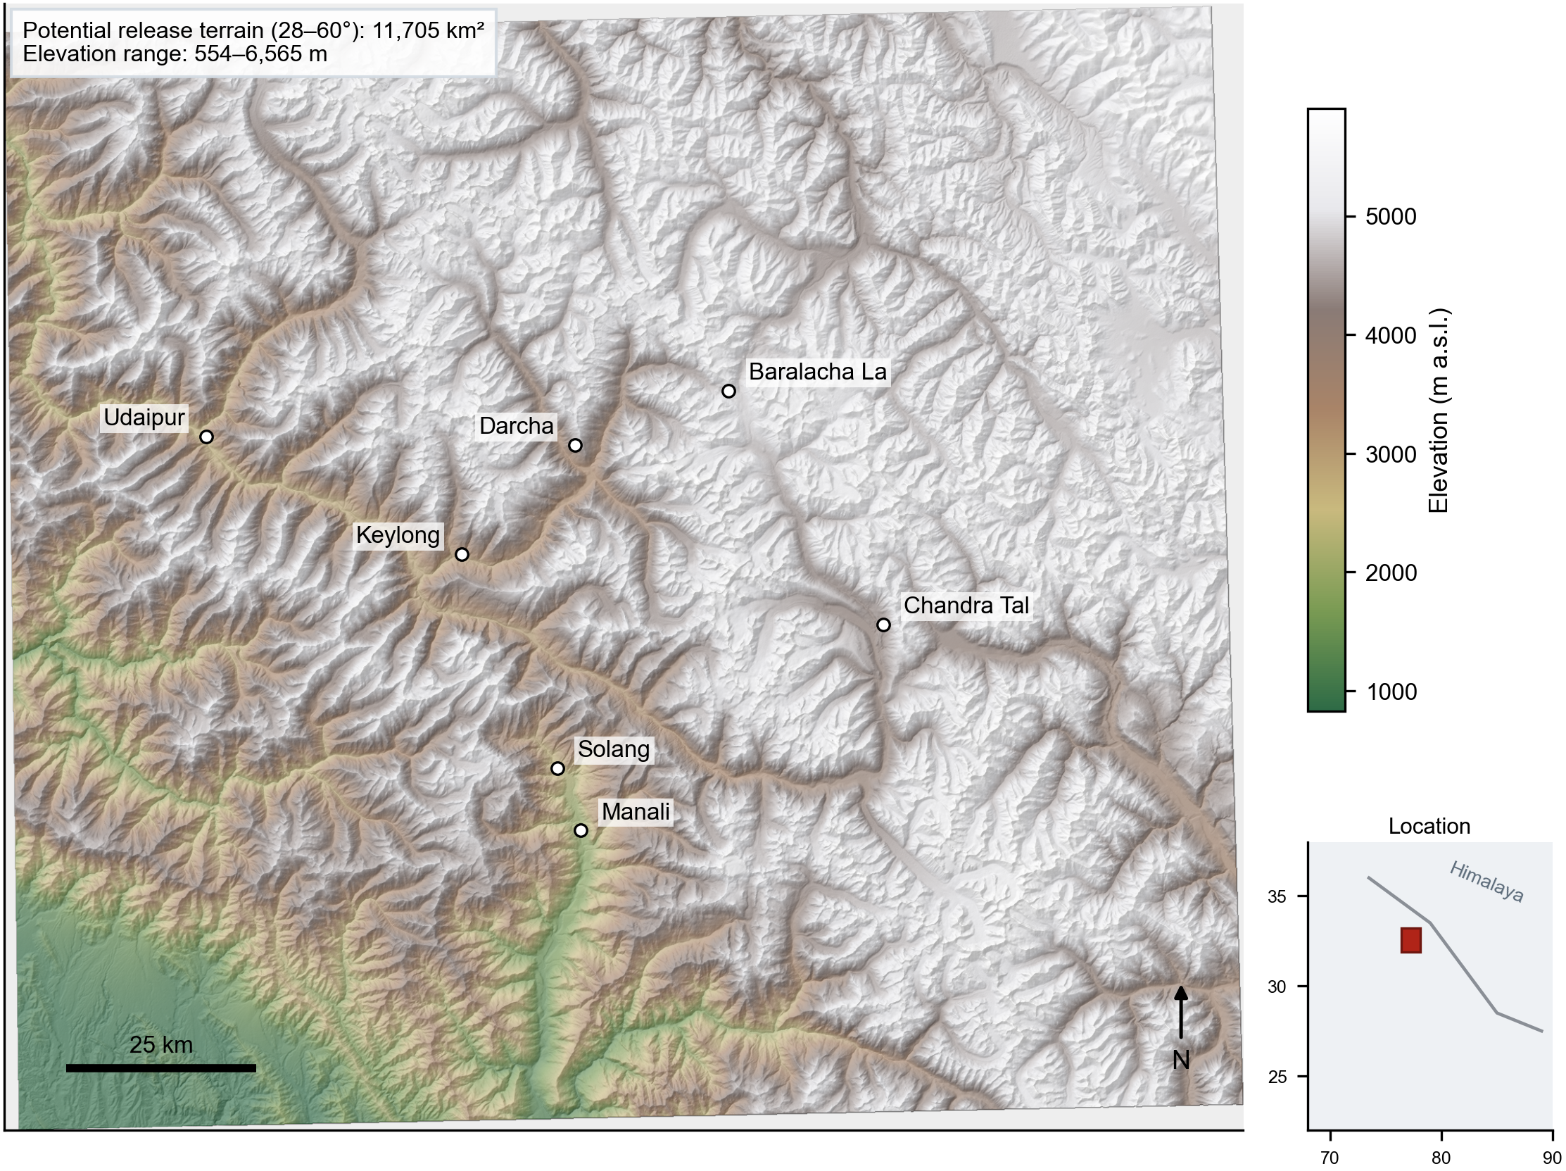
Figure 1. The analysis extent, with elevation over hillshade and the settlements and passes named in the regional avalanche literature. Avalanche terrain here spans more than five kilometres of relief.

3. Data and methods

3.1 Avalanche inventory from Sentinel-1
Avalanche debris roughens the snow surface and raises radar backscatter. We detect it as a seasonal increase in Sentinel-1 GRD backscatter between a stable mid-winter reference composite and a post-avalanche-season composite, computed independently for each winter from 2018 to 2025.
- A single relative orbit is used (descending, orbit 136) so that viewing geometry is identical between dates and static terrain backscatter cancels in the difference. Orbit 136 is the only orbit providing 100% coverage of the study area; the orbit with the most acquisitions covers just 13% of it.
- Composites are averaged in linear power and speckle-filtered; only increases are retained, since wet snow lowers backscatter and therefore has the opposite sign.
- Detections are restricted to avalanche-capable slopes (25–60°) and filtered by minimum connected area.
- Detections are stacked across winters to give a RECURRENCE count. Random change does not repeat on the same slope across eight winters, whereas avalanche paths do; recurrence therefore acts as a confidence score.
Deposits are traced upslope to the highest pixel on release-angle terrain (30–50°) within a 600 m search radius, because susceptibility models predict release, not runout. This yields 6,364 candidate release points, of which 3,188 are flagged in four or more winters. Occupied 10 km blocks cover 85% of the study area, so the inventory is not confined to road-accessible slopes.
One convention applies to every count reported below. A release point is discarded if any predictor is undefined at its cell, which happens at raster edges and on a small number of interior gaps. Inventory counts therefore exceed the sample sizes in the tables by a few points at each recurrence threshold: 6,364 detected against 6,344 analysed at recurrence ≥ 3, 3,188 against 3,179 at ≥ 4, 917 against 914 at ≥ 5, and 241 against 240 at ≥ 6. Figures quoted in the text are detections; figures in tables are the points that entered a model.

3.2 Predictive factors
Twenty predictors were assembled on a common 30 m UTM 43N grid: twelve topographic and two hydrological derivatives computed from NASADEM with WhiteboxTools; winter temperature and precipitation (WorldClim); snow-cover duration (MODIS); land cover (ESA WorldCover); and distances to roads, streams (OpenStreetMap) and active faults (GEM Global Active Faults). Distance to faults is computed from vector geometry, because every active fault lies outside the study area and a rasterised distance transform is therefore undefined within it.

3.3 Slope windows used at each stage
Four slope windows appear in the workflow and they are deliberately different, because they answer different questions. Detection retains change on 25–60° slopes, a deliberately broad window chosen to avoid discarding events near the margins. Release points are traced into 30–50° terrain, the slab-release window conventional in the avalanche literature. Background points are drawn from 25–55°, matching the detection window at its lower bound while excluding the steepest faces, which hold little snow and are not comparable terrain. The susceptibility map is masked to 28–60°, the potential-release-area definition of Bühler et al. (2018), so that areal statistics are comparable with other studies using that convention.
The background window sets the separability of the absence design directly, so the result was recomputed across four alternatives. Reported AUC moves with the choice — 0.844 at 20–60°, 0.866 at 25–55°, 0.873 at 28–60° and 0.875 at 30–50° — a range of 0.031 produced by a decision about which terrain counts as comparable, with the presences, predictors and model unchanged. This is the paper's argument appearing within a single study: a defensible-looking choice moves the reported number by more than the gap between several published models. The 25–55° window is used throughout, and the alternatives are reported so the sensitivity is visible rather than buried.

3.4 Sampling design
Two absence schemes are compared. The PAPER-STYLE scheme reproduces published practice: points drawn at random from low-slope terrain classified as tree cover, grassland, cropland, built-up or water. The TERRAIN-MATCHED scheme draws background points from avalanche-capable slopes (25–55°) outside a 1 km buffer around presences, matched to the joint elevation × slope × aspect distribution of the presences.
Aspect matching is required, not optional. Sentinel-1 is right-looking, so a single orbit over-detects on slopes facing the sensor: measured over this study area, descending orbit 136 places 34.8% of detections on south-east aspects against 12.6% of background terrain, while ascending orbit 27 peaks on north-west aspects. These are mirror images and therefore reflect viewing geometry rather than avalanche physics. Only the elevated south-facing fraction is consistent across both geometries. Matching background to the presence aspect distribution prevents the classifier from scoring on this artefact.

3.5 Validation and models
Models are evaluated under random k-fold cross-validation, as in published work, and under spatial-block cross-validation with 10 km blocks (246 blocks). Five classifiers are compared: Random Forest, Support Vector Machine and Logistic Regression, as used in the reference literature, plus XGBoost and LightGBM. Confidence intervals are percentile bootstraps (1,500 resamples) on pooled out-of-fold predictions.

4. Results

4.1 Reported AUC is a function of the absence design
Before examining any real inventory we establish what a reported AUC can mean. Synthetic presences are drawn from a region where a true susceptibility function is high, and absences from a distribution displaced by δ standard deviations ALONG A DIRECTION ORTHOGONAL to that function. Because the displacement is orthogonal it carries no information about susceptibility, so the model's genuine ability to rank susceptible sites is identical at every δ. In a second, null arm the predictors are made independent of the outcome, so true skill is exactly zero by construction and any AUC above 0.5 must come from the sampling alone.
Table 1. Reported AUC against absence displacement in synthetic data.
δ (SD) | AUC, informative model | AUC, null model (no skill)
0 | 0.977 | 0.496
0.5 | 0.978 | 0.607
1 | 0.981 | 0.739
1.5 | 0.986 | 0.840
2 | 0.991 | 0.910
3 | 0.997 | 0.974
4 | 0.999 | 0.993
5 | 1.000 | 0.998
6 | 1.000 | 1.000

The null model moves from 0.496 at δ = 0, correctly indicating no skill, to 0.910 at δ = 2 and 1.000 at δ = 6. A model that has learned nothing can therefore be made to report any AUC up to unity purely by choosing where its absences are drawn from. The informative arm is already near ceiling throughout, so once δ exceeds about 3 the two arms are indistinguishable: beyond that point a reported AUC cannot separate a model that works from one that does not.
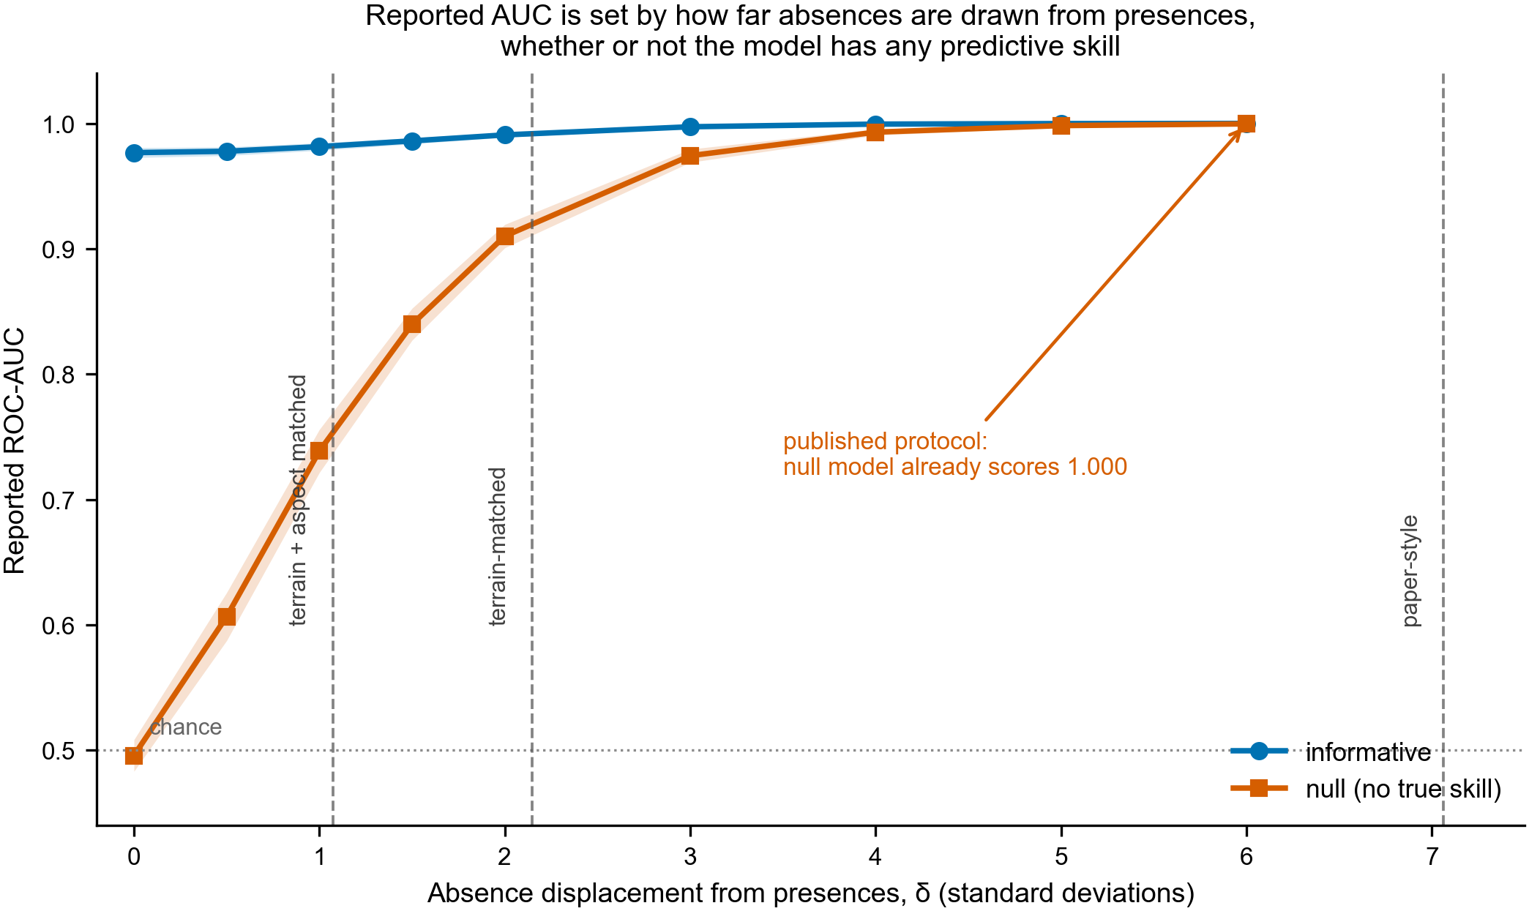
Figure 2. Reported AUC against absence displacement. Dashed lines mark where real absence designs fall on the same axis.
Measuring the three real designs used in this study on the same scale places the published protocol at δ = 7.06, terrain-matched absences at δ = 2.15, and terrain-and-aspect matching with corrected labels at δ = 1.07. At δ = 7.06 the simulation predicts that even a model with no information scores 1.000 — and 1.000 is what the published protocol returns on real data (Section 4.2). The artefact is therefore not incidental to one dataset; it is the expected consequence of the design.
A synthetic result invites the objection that it reflects the authors' construction rather than the problem, so the null arm was repeated while varying the learner, the number of predictors and the sample size. The inflation is essentially unchanged throughout: across six settings the null-model AUC differs by at most 0.030 at any displacement, and by 0.001 at δ = 6. The behaviour is a property of evaluating a presence-only model against constructed absences, not of this particular simulation.
Full results for both invariance checks are given in the supplementary material (Tables S1 and S2).

4.2 What a reported AUC cannot recover
The natural response to Section 4.1 is to remove the design's contribution and keep the remainder as the model's. We pursued that and report here why it cannot work, because the reason is more informative than the method would have been.
An AUC is a function of two class-conditional distributions and nothing else. A difference between presences and absences enters those distributions identically whether it arises because presences are genuinely different terrain or because the absences were drawn from elsewhere. No statistic computed from the two samples can attribute it, since the samples are all there is.
That this bites in practice, and not only in principle, can be shown by construction. Two synthetic worlds were built. In the first, predictors are strongly related to true susceptibility and absences are drawn from terrain like the presences. In the second, predictors are weakly related and absences are drawn from further away. Parameters were chosen so the observed clouds nearly coincide.
Table 2. Two worlds with nearly identical observable data and different true skill.
World | Observed presence–absence gap | Reported AUC | AUC against true absences
A informative predictors, honest absences | 2.405 | 0.950 | 0.987
B weak predictors, displaced absences | 2.383 | 0.908 | 0.707

The observed separations differ by 0.022 and the reported AUCs by 0.043. Measured against true absences — which no presence-only study possesses — the two differ by 0.281, roughly six times as much. Data that a study could not tell apart correspond to models that differ substantially in what a reader cares about.
Attempts to construct a null baseline from a study's own data fail for the same reason, and we report them so the obstacle is not mistaken for an oversight. Generating synthetic classes matched to the observed means and covariances yields a baseline of 0.989 for the corrected configuration, above its own reported AUC, because Gaussian clouds at those moments are easier to separate than the real data: the construction discards exactly the within-class overlap that makes the real problem hard. Resampling real rows within each class preserves the signal intact and is therefore not a null at all. Nor is the separability measure canonical — for the published protocol the diagonal form gives 7.06 standard deviations and the Mahalanobis form 4.64, so a baseline read off a δ axis inherits the choice of measure.
Two failed constructions do not establish that every conceivable null must fail, and we do not claim a general impossibility theorem. What the two-world construction establishes is sharper and sufficient: under the observational setup a presence-only study actually has — the presence sample, the absence sample, and the predictors — two models whose true skill differs by 0.281 can produce data a study could not tell apart. Any correction must therefore import information from outside that setup, such as verified true absences or a second independently designed absence set. Stating the null hypothesis precisely matters here: we test the hypothesis that predictors carry no information about occurrence beyond what the sampling design induces, which is not the same as testing for no association after conditioning on spatial structure.
We therefore withdraw our proposal to correct a reported AUC, and state the limit instead: the absolute skill of a presence-only susceptibility model is not recoverable from the data it was fitted to alone. What remains identifiable is the RELATIVE effect of the absence design, obtained by holding the presences, the predictors and the model fixed and varying only how absences are drawn. That comparison is the subject of the remaining sections, and it is available to any study at the cost of running its own pipeline a second time.

4.3 Whether label error can account for the result
Every configuration compared here uses identical labels, which controls for label quality only if the errors are distributed like the true events in predictor space. Checking our own, they are not: detections rejected on review sit 908 m lower than verified ones (3,186 m against 4,094 m, Mann-Whitney p = 0.038), which is what melt-out contamination should look like, since ablation begins at lower elevations. Slope and aspect differences are not significant, though with three verified events those tests have little power. Because background points are matched on elevation, this error structure is correlated with a variable the sampling design acts on, and the assumption that labels affect all designs equally cannot simply be asserted.
We therefore tested it. A fraction of synthetic presences was replaced by points drawn from the low end of the informative axis — the analogue of melt-out false positives at low elevation — and the displacement curve recomputed.
Table 3. Reported AUC under structured label contamination.
Contaminated presences | δ=0 | δ=1 | δ=2 | δ=3 | δ=4 | δ=6
0% | 0.979 | 0.984 | 0.994 | 0.999 | 1.000 | 1.000
20% | 0.891 | 0.932 | 0.976 | 0.994 | 0.999 | 1.000
50% | 0.766 | 0.868 | 0.953 | 0.986 | 0.996 | 1.000
80% | 0.629 | 0.798 | 0.932 | 0.980 | 0.995 | 0.999

At δ = 0 contamination matters a great deal: reported AUC falls from 0.979 to 0.629 as the contaminated fraction rises to 80%. By δ = 3 the spread across contamination rates is 0.019, and by δ = 6 it is 0.001. At the separability of the published protocol an inventory that is 80% false positives reports the same value as a clean one — the displacement overwhelms the label quality entirely. Structured label error therefore cannot account for the inflation result; if anything it sharpens it, since at high separability the reported score ceases to respond to label quality at all.
The corollary constrains our own empirical figures. The corrected configuration sits at δ ≈ 1, where contamination still moves reported AUC by up to 0.187. Its value of 0.866 is therefore sensitive to inventory precision in a way the published protocol's 1.000 is not, and should be read with that in mind.

4.4 Training against bad absences versus reporting against them
A distinction the preceding sections leave open is whether a model TRAINED on poorly chosen absences is itself damaged, or whether only the number it reports is. We separate the two by training on absences at varying displacement and evaluating every model on one fixed test set whose absences are drawn like the presences — the evaluation the study should have run.
Table 4. AUC on a fixed honest test set, by how the training absences were drawn.
Training δ | Ordinary classifier | PU-corrected | Presence-only (one-class)
0 | 0.975 | 0.975 | 0.819
1 | 0.969 | 0.969 | 0.819
2 | 0.959 | 0.959 | 0.819
3 | 0.952 | 0.952 | 0.819
4 | 0.955 | 0.955 | 0.819
6 | 0.964 | 0.964 | 0.819

Judged honestly, the ordinary classifier falls only from 0.975 to 0.952 as its training absences are displaced from zero to three standard deviations. The model is largely unharmed; what the displacement corrupts is the figure the study reports about itself. This is the more accurate statement of the problem, and a more generous one: published susceptibility maps may well be serviceable products whose accompanying statistics do not describe them.
Two established treatments of presence-only data behave as theory predicts. The Elkan and Noto (2008) correction divides scores by the estimated labelling frequency, a constant, so the ranking and hence the AUC are unchanged to three decimal places at every displacement: it repairs calibration, not design dependence. A one-class model fitted to the presences alone never sees the absences and is therefore perfectly design-independent, returning 0.819 at every displacement, but it pays about 0.15 AUC for that robustness.
The practical implication is narrower than 'redraw your absences'. If absences must be constructed, the evaluation set is where it matters: holding out absences drawn like the presences costs nothing and makes the reported number interpretable. Where that is impossible, a presence-only method trades discriminative power for a figure that does not depend on the analyst's choices.

4.5 What each correction costs
Two configurations recur below and must not be confused. CONFIGURATION C2 applies the melt-out filter and centroid-derived release points to the single-scale predictor set, and reaches AUC 0.841. CONFIGURATION C3 adds the multi-scale terrain predictors of Section 4.7 to C2 and reaches 0.866. The correction ladder ends at C2, because its purpose is to isolate the cost of each correction with the predictor set held fixed; C3 is the best-performing honest configuration and is the one quoted wherever a single current figure is needed. Both are reported throughout rather than silently interchanged.
Five corrections separate the published protocol from a defensible estimate. Applying them cumulatively to the same models and the same study area shows how much of the reported figure each one accounts for.
Table 5. Cumulative effect of each methodological correction (XGBoost).
Configuration | AUC | Δ | What it removes
Published protocol (flat/vegetated absences, random CV) | 1.000 | nan | nan
terrain-matched background | 0.954 | -0.046 | removes land-cover separability
spatial-block cross-validation | 0.939 | -0.015 | removes fold leakage
drop self-induced TPI artefact | 0.934 | -0.005 | removes our own bias
melt-out filter and unbiased release points | 0.841 | -0.094 | removes false-positive labels

The conventional protocol returns AUC 1.000 and the fully corrected configuration 0.841, a difference of 0.159. The largest single term is not the one the field has concentrated on. Spatial cross-validation, the standard methodological correction in this literature, accounts for 0.015; label quality — removing melt-out false positives and deriving release points without an extreme-value rule — accounts for 0.094, roughly six times as much. Inventory precision is not reported at all in the studies we reproduce, so this term is invisible in published work.
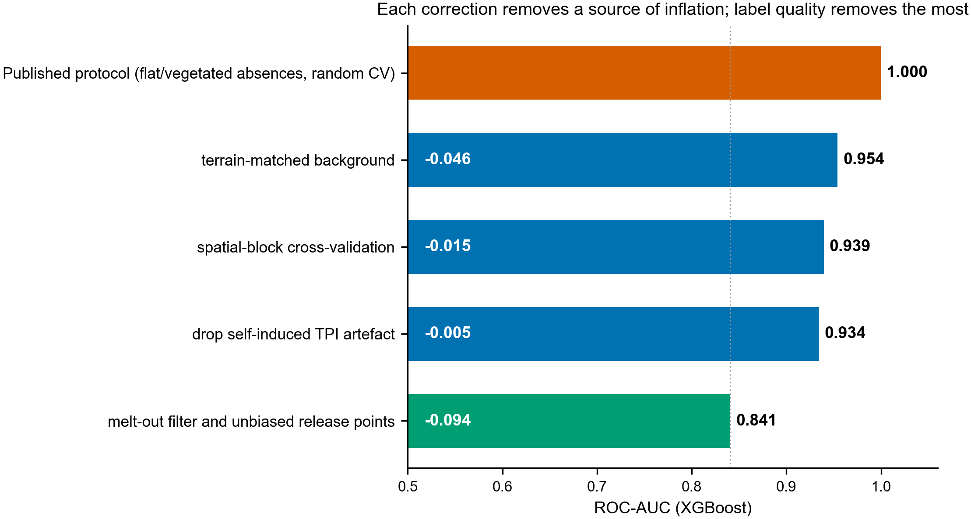
Figure 3. Cumulative effect of each correction. Label quality removes more apparent skill than sampling design and spatial validation combined.

4.6 Where reported performance comes from
Table 6. Controlled decomposition of reported performance.
Config | Absences | Cross-validation | AUC (RF) | AUC (XGBoost)
A | paper-style | random | 1.000 | 1.000
B | paper-style | spatial-block | 1.000 | 1.000
C | terrain-matched | random | 0.940 | 0.954
D | terrain-matched | spatial-block | 0.931 | 0.939

Configuration A, which reproduces published practice, achieves AUC = 1.000: the two classes are perfectly separable. Replacing the absences with terrain-matched background points (A→C) costs 0.046 AUC for XGBoost and 0.060 for Random Forest. Applying spatial-block cross-validation to the original sampling (A→B) changes performance by -0.000. The optimism is therefore attributable to sampling design, and essentially not at all to spatial autocorrelation.
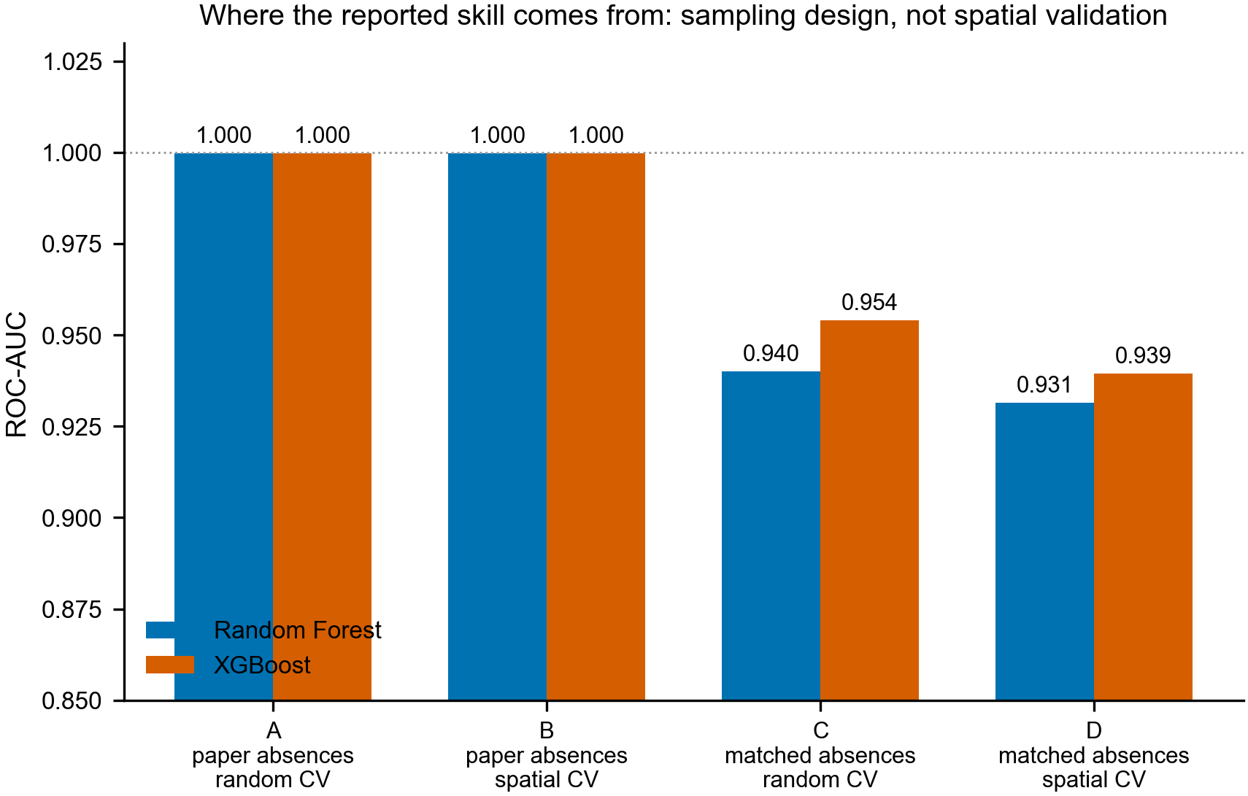
Figure 4. Decomposition of reported performance. Paper-style absences produce perfect separation regardless of the cross-validation scheme.
This result does not depend on the quality of our inventory. Repeating the contrast at four recurrence thresholds, configuration A remains at AUC 1.000 throughout, including at n = 240 presence points — comparable to the 118 points used in the reference study.
Table 7. Sensitivity of the decomposition to inventory confidence.
Recurrence | n presence | A (paper) | D (matched) | Difference
≥3 | 6,344 | 1.000 | 0.951 | 0.048
≥4 | 3,179 | 1.000 | 0.939 | 0.060
≥5 | 914 | 1.000 | 0.928 | 0.072
≥6 | 240 | 1.000 | 0.898 | 0.102

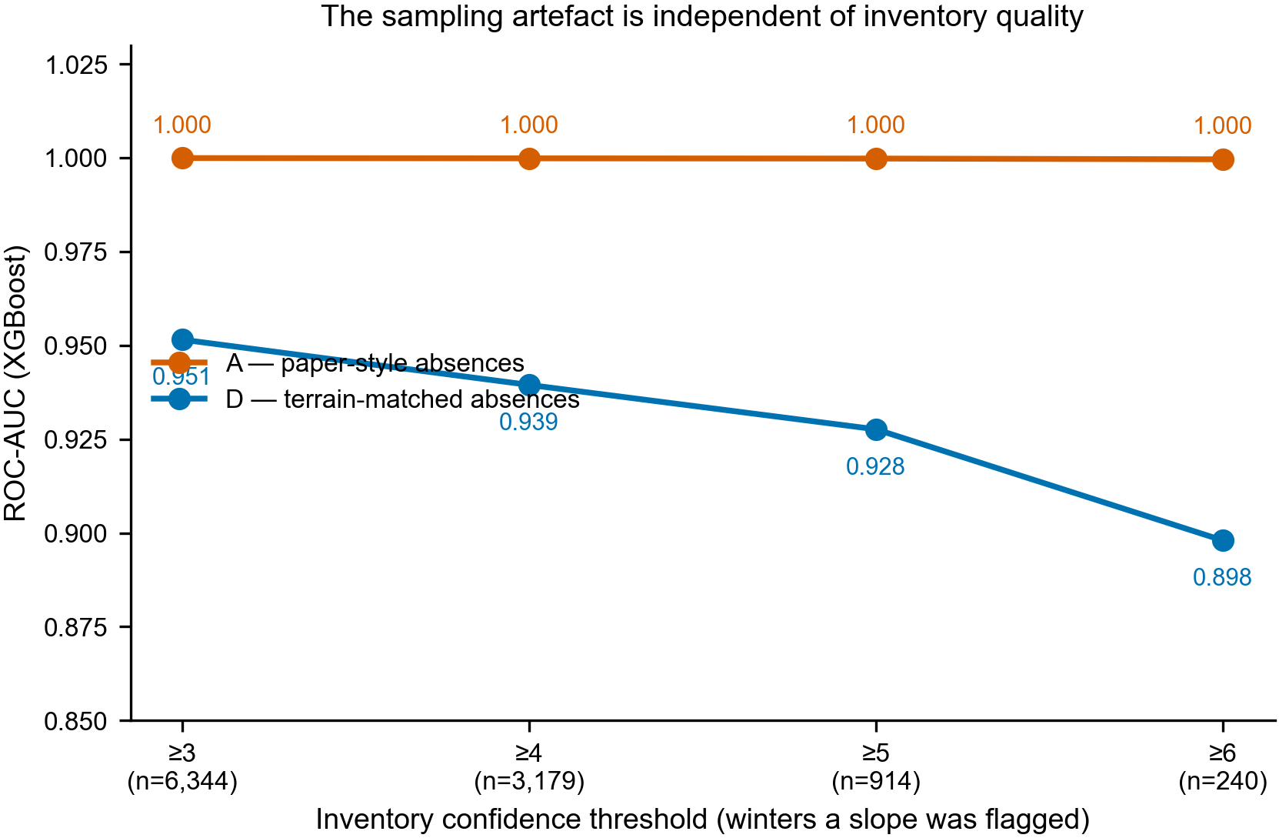
Figure 5. The sampling artefact is independent of inventory size and label confidence.

4.7 Coarse predictors encode geography, not snowpack
Table 8. Replacing coarse predictors with raw spatial coordinates.
Predictor set | n | AUC | 95% CI
full (all predictors) | 21 | 0.939 | [0.934, 0.944]
coarse REPLACED by x,y | 19 | 0.941 | [0.935, 0.946]
coarse REMOVED | 17 | 0.916 | [0.909, 0.922]
coarse ONLY | 4 | 0.772 | [0.762, 0.784]
x,y ONLY (pure geography) | 2 | 0.688 | [0.674, 0.701]

Substituting the 1 km climate, 500 m snow-cover and distance-to-fault layers with two raw coordinates changes performance from 0.939 to 0.941, a difference well within the confidence intervals. These predictors contribute to the model, but their contribution is positional rather than physical: at their native resolution they are smooth regional trend surfaces across release zones of 10²–10⁵ m². Published importance rankings that place snow-cover duration among the leading predictors may therefore be describing a geographic index rather than snowpack process.
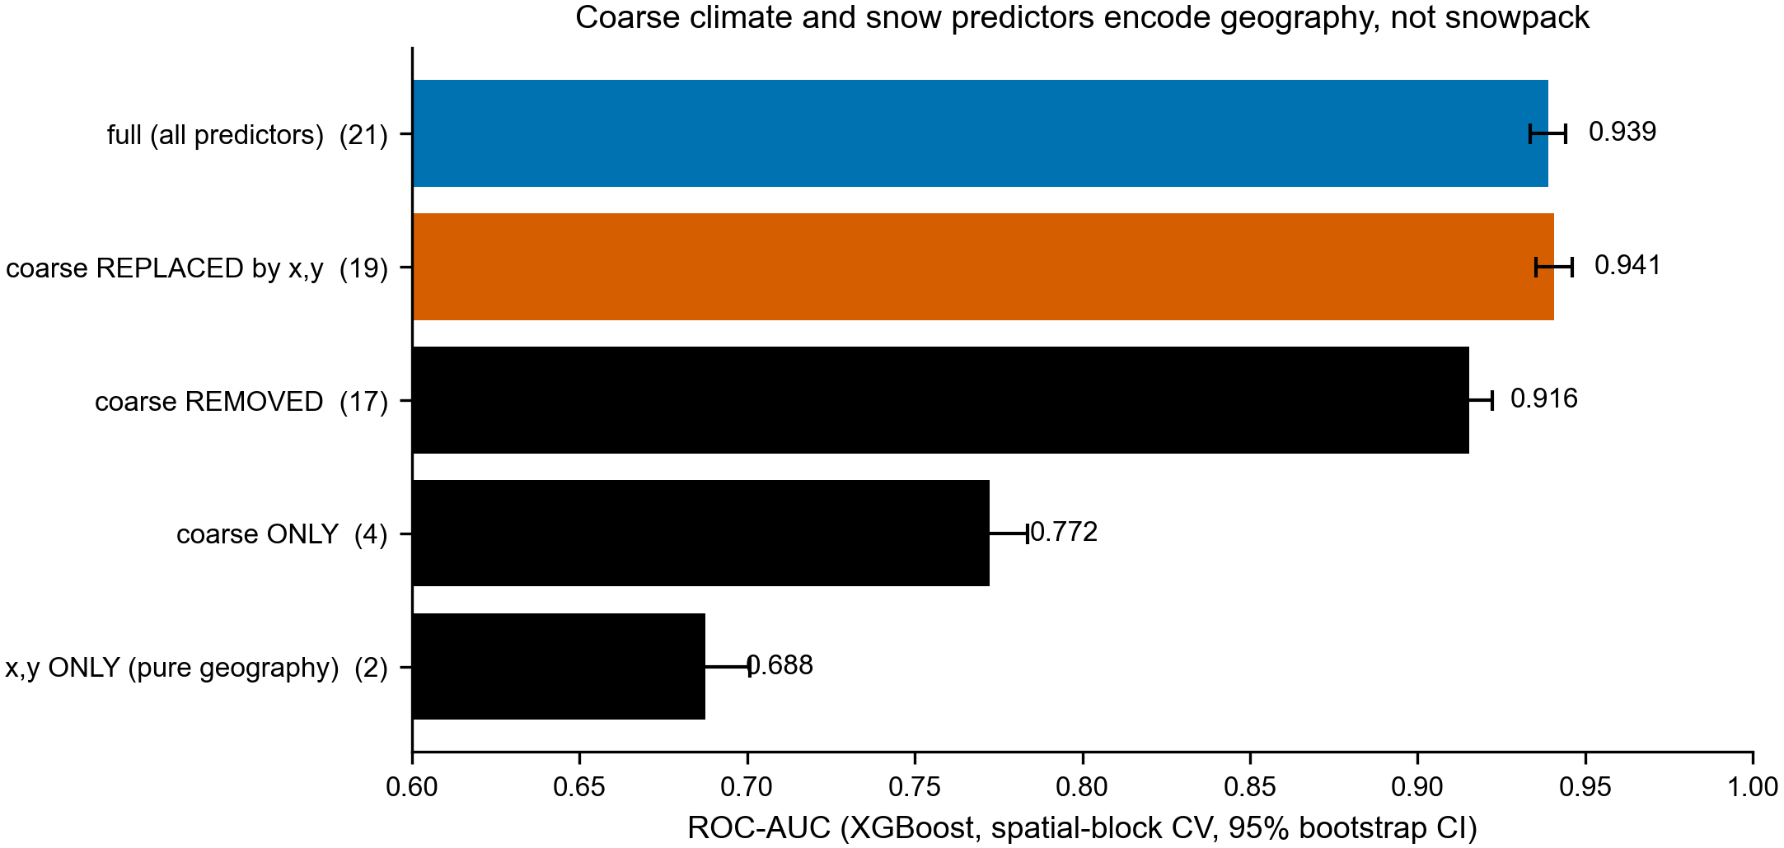
Figure 6. Coarse predictors are interchangeable with coordinates.

4.8 Reported AUC depends on the background sampling ratio
Table 9. Effect of the background sampling ratio.
Presence:background | Prevalence | AUC | PR-AUC | Brier
1:1 | 0.500 | 0.934 | 0.932 | 0.1034
1:5 | 0.166 | 0.943 | 0.804 | 0.0659
1:10 | 0.091 | 0.950 | 0.733 | 0.0431

Increasing the background ratio from 1:1 to 1:10 raises AUC from 0.934 to 0.950 while precision-recall AUC falls from 0.932 to 0.733. Because presence-background prevalence is a modelling choice rather than a property of the landscape, a headline AUC can be improved by a sampling decision while the model becomes less useful for the operational task. Precision-recall metrics should be reported alongside AUC.

4.9 What improves a corrected model, and what does not
Having removed the sources of inflation, we asked what genuinely raises performance. Four interventions were tried on the corrected inventory and evaluated identically.
Table 10. Interventions tested on the corrected model (XGBoost, spatial-block CV).
Intervention | AUC | Δ | Helped
Baseline: corrected inventory, single-scale terrain | 0.841 | — | —
Restore TPI (no longer artefactual after centroid fix) | 0.846 | +0.005 | yes
Add multi-scale terrain (90/300/900 m) | 0.866 | +0.025 | yes
Hyperparameter search (nested spatial CV, 24 candidates) | 0.857 | -0.009 | no
Ensemble XGBoost + LightGBM + RF | 0.860 | -0.006 | no

Terrain described at the scale of the process is what helps. A 30 m cell is smaller than the feature that decides whether a slope releases, so mean slope, topographic position and roughness were recomputed over 90, 300 and 900 m neighbourhoods — slab, start-zone and face scale. Those nine predictors add 0.025 AUC and 0.058 recall. Restoring TPI adds a further 0.005: its earlier dominance was an artefact of the highest-pixel release rule, and once release points are taken as the centroid of release-angle terrain the presence-to-background gap falls from +33.5 to +3.8, making it an ordinary predictor again.
Neither conventional route to a better score helped. A nested cross-validated hyperparameter search over 24 candidates returned 0.857, below untuned defaults, because at 235 spatial blocks the inner folds are too noisy to select on; averaging XGBoost, LightGBM and Random Forest returned 0.860, below XGBoost alone. We report these negative results because they point the same way as the rest of the paper: the available gains lie in label quality and in describing the terrain at the right scale, not in model selection.

5. Discussion

5.1 What a reported AUC can and cannot tell a reader
Susceptibility data are presence-only: the locations of past events are observed, and the absences are constructed by the analyst. Section 4.1 shows that this construction, not the model, sets most of the reported score — a model with no skill at all reaches 0.910 at two standard deviations of absence displacement and 1.000 at six. Section 4.2 shows that the contribution cannot be removed after the fact. Three consequences follow, and none is specific to avalanches.
First, AUC is not comparable between studies that drew their absences differently. A study reporting 0.97 with absences taken from flat farmland has not demonstrated more skill than one reporting 0.85 with absences on comparable terrain. Model comparisons, predictor rankings and claims of improvement over prior work all inherit this, because all rest on a quantity the sampling design has already largely determined.
Second, above roughly three standard deviations of separation the measure saturates and stops discriminating: in the simulation a model with genuine skill and a model with none both report values above 0.97. Much of the published literature appears to operate in that regime.
Third — and this is the limit that bites — the part of a reported AUC attributable to the model cannot be recovered by arithmetic. A difference between the presence and absence samples enters the statistic identically whether it arises from genuine terrain differences or from where the absences were drawn, and the samples are all the evidence there is. Any correction, including the one we attempted, requires assumptions that the data cannot supply.

5.2 A design-sensitivity diagnostic rather than an AUC correction
What a study can do instead is measure how much its own reported figure depends on a choice it made. Holding the presences, the predictors, the model and the evaluation protocol fixed, and varying only how absences are drawn, isolates the contribution of the sampling design. The result is not a corrected accuracy and should not be reported as one: it is a sensitivity, analogous to reporting how a result moves under a plausible alternative specification.
Concretely, we suggest four things. Report the absence rule explicitly, in enough detail that it could be reimplemented. Run the same pipeline under at least two defensible absence designs and report the range of AUC obtained. Where an independent evaluation set can be constructed whose absences are drawn like the presences, report performance against it, since that figure is interpretable in a way the in-sample one is not. And treat a large spread across designs as what it is — evidence that the headline number describes the experiment rather than the model.
On the data used here that spread is 0.031 across four absence designs, from 0.923 with absences matched on slope to 0.954 with absences drawn at random from the candidate pool, which is the common default. That range is wider than the differences typically reported between competing models in this literature. The comparison requires no new statistic and no simulation; it is one extra run of a pipeline a study has already built, and designcheck.py in the repository performs it on any presence-only dataset.

5.3 Applying the same standard to our own analysis
Two artefacts of our own are reported because the argument demands it. SHAP attributed the largest single contribution to the topographic position index; inspection showed presence points averaged TPI +36.4 against +2.9 for background, which follows mechanically from an earlier release-point rule that selected the highest qualifying pixel in a search radius. Deriving release points as the centroid of release-angle terrain instead reduced that gap to +3.8 and made the predictor ordinary again.
The second concerns the optical verification used to establish label quality for the corrected configuration. An unaided first pass over 100 detections accepted 24 as avalanches; re-scoring against an explicit rule — snow present beforehand, a localized rough feature appearing, surroundings unchanged — rejected 21 of those, most because the slope was bare rock before the event and acquired snow afterwards. Both scorings are reported in the companion paper, and the disagreement between them (Cohen's kappa 0.49) is treated there as a result rather than an embarrassment. Neither artefact changes the findings above, which compare sampling designs using identical labels, but a paper arguing that this field does not audit its own procedures cannot exempt itself.

5.4 Limitations
- The simulation establishes that absence displacement inflates AUC and characterises how the inflation behaves. It is not a calibration: Section 4.2 withdraws the proposal to read a baseline off it and subtract that from a real study's figure, and the simulated values should not be used that way. The construction also simplifies real predictor structure — spatial clustering, covariance and non-Gaussian marginals are all idealised — though the invariance checks in the supplementary material show the qualitative behaviour survives each of these.
- The separability measure aggregates standardised differences across predictors and therefore depends on which predictors a study uses. Two studies with identical absence rules but different predictor sets will report different δ.
- The empirical test uses one study area and one hazard. The mechanism is not specific to either, but demonstrating that requires replication on independent inventories, ideally for landslides, where open data are more plentiful. We regard this as the most valuable next step.
- The avalanche inventory underlying the empirical sections is derived from Sentinel-1 change detection and consists of candidate rather than confirmed events; its precision is quantified in the companion paper. Because every configuration compared here uses identical labels, label quality affects all arms equally and cannot produce the differences reported, as the sensitivity analysis in Section 4.3 confirms.

6. Conclusions
- Susceptibility data are presence-only, so absences are an analyst's choice. In synthetic data where that choice carries no information about the outcome, a model with no predictive skill reports AUC 0.739 at one standard deviation of absence displacement, 0.910 at two and 1.000 at six. Reported AUC is therefore a function of the sampling design.
- Above roughly three standard deviations the measure saturates: a model with genuine skill and one with none both report values above 0.97, so AUC no longer distinguishes them.
- A published avalanche susceptibility protocol places its absences 7.06 standard deviations from its presences on the diagonal measure, in a regime where the SIMULATION returns 1.000 for a model with no skill. Run on an independent inventory, the protocol OBSERVES 1.000. The agreement is informative but the two figures are different kinds of quantity, and the simulated one is not an estimate of the real model's skill.
- The absolute skill of a presence-only susceptibility model is not identifiable from the data it was fitted to. Two worlds with nearly indistinguishable observed samples differ by 0.281 in their ability to rank genuinely susceptible terrain, and no statistic computed from those samples can tell them apart. Proposals to correct a reported AUC, including our own, fail for this reason rather than for want of a better estimator.
- What is identifiable is the relative effect of the absence design, obtained by holding presences, predictors and model fixed and varying only how absences are drawn. Any study can run that comparison on its own pipeline.
- Training on poorly drawn absences harms the model far less than it harms the number: on a fixed honest test set performance falls only from 0.975 to 0.952 as displacement rises from zero to three standard deviations.
- Two independent diagnostics agree: 1 km climate and 500 m snow-cover predictors are statistically interchangeable with raw spatial coordinates, and reported AUC rises with the background sampling ratio while precision-recall performance falls.
- We recommend that susceptibility studies hold out an evaluation set whose absences are drawn like the presences. It costs nothing, needs no new statistic, and is the only step here that makes a reported number interpretable. Where that is impossible, a presence-only method gives a figure independent of the analyst's sampling choices at a cost of about 0.15 AUC.

Data and code availability
The design comparison this paper recommends is packaged as designcheck.py in the repository, which runs independently of the rest of the code. Given a table of predictor values at event locations and a pool of candidate absence locations, it scores one model against several absence designs and reports the spread, so any presence-only susceptibility study can measure how much of its reported figure the sampling accounts for. Supplementary Section S5 gives a worked example on the data used here.
All code is openly available at https://github.com/sanskarprime392-png/avalanche. The avalanche inventory derived in this study, the trained susceptibility rasters and all result tables are reproducible from that repository using openly licensed input data (NASADEM, Sentinel-1, Sentinel-2, WorldClim, MODIS, ESA WorldCover, OpenStreetMap, GEM Global Active Faults).

Author contributions
S.G. designed the study, built the Sentinel-1 inventory, carried out the analysis and the optical verification, and wrote the manuscript.

Competing interests
The author declares no competing interests.

Acknowledgements
The controlled decomposition in Section 4.1 — separating the contribution of absence sampling from that of spatial autocorrelation — was proposed in review by [SUPERVISOR NAME], whose comments also shaped the treatment of coarse-resolution predictors in Section 4.5. Analysis code was developed with the assistance of a large language model; the author designed the study, directed the analysis, performed the verification, and is responsible for all results and conclusions. This work received no specific funding.

References
[1] Abhinav, A. & Sattar, A. (2025). Snow avalanche susceptibility, hazard, and exposure assessment in the Western Himalaya using machine learning and numerical modelling. Scientific Reports, 15, 38093.
[2] Barbet-Massin, M., Jiguet, F., Albert, C. H. & Thuiller, W. (2012). Selecting pseudo-absences for species distribution models: how, where and how many? Methods in Ecology and Evolution, 3, 327-338.
[3] Bühler, Y., von Rickenbach, D., Stoffel, A., Margreth, S., Stoffel, L. & Christen, M. (2018). Automated snow avalanche release area delineation. Natural Hazards and Earth System Sciences, 18, 3235-3251.
[4] Cetinkaya, S. & Kocaman, S. (2023). Impact of learning set and sampling for snow avalanche susceptibility mapping with random forest. ISPRS Archives, XLVIII-M-1, 57-64.
[5] Eckerstorfer, M., Vickers, H., Malnes, E. & Grahn, J. (2019). Near-real time automatic snow avalanche activity monitoring system using Sentinel-1 SAR data in Norway. Remote Sensing, 11, 2863.
[6] Elkan, C. & Noto, K. (2008). Learning classifiers from only positive and unlabeled data. Proceedings of the 14th ACM SIGKDD International Conference on Knowledge Discovery and Data Mining, 213-220.
[7] Lobo, J. M., Jiménez-Valverde, A. & Real, R. (2008). AUC: a misleading measure of the performance of predictive distribution models. Global Ecology and Biogeography, 17, 145-151.
[8] Phillips, S. J., Dudík, M., Elith, J., Graham, C. H., Lehmann, A., Leathwick, J. & Ferrier, S. (2009). Sample selection bias and presence-only distribution models. Ecological Applications, 19, 181-197.
[9] Ploton, P. et al. (2020). Spatial validation reveals poor predictive performance of large-scale ecological mapping models. Nature Communications, 11, 4540.
[10] Roberts, D. R. et al. (2017). Cross-validation strategies for data with temporal, spatial, hierarchical, or phylogenetic structure. Ecography, 40, 913-929.
[11] Sahin, E. K., Ipbuker, C. & Kavzoglu, T. (2023). Strategies for sampling pseudo-absences of landslide locations for landslide susceptibility mapping in complex mountainous terrain of Northwest Himalaya. Bulletin of Engineering Geology and the Environment, 82, 397.
[12] Winstral, A., Elder, K. & Davis, R. E. (2002). Spatial snow modeling of wind-redistributed snow using terrain-based parameters. Journal of Hydrometeorology, 3, 524-538.

