Snow-Avalanche Susceptibility Mapping
Reproduction & Methodological Improvement
Western Himalaya — Chandra-Bhaga & Upper Beas basins

1. Introduction & Background
Snow avalanches are a recurrent hazard across the Indian Himalayan Region, threatening highways, settlements, hydropower and glacial lakes. Because field survey across this vast, inaccessible terrain is impractical, avalanche susceptibility mapping (ASM) — the spatial probability of avalanche release — is derived from remote sensing and GIS. Data-driven (machine-learning) ASM learns the relationship between past avalanche occurrences and a set of predictive factors describing topography, snowpack, climate, geology and land use.
This study reproduces the machine-learning ASM of Abhinav & Sattar (2025, Scientific Reports 15:38093) for the Chandra-Bhaga and Upper Beas basins, and improves its methodological rigour with spatially honest validation, terrain-matched negative sampling, and stronger gradient-boosted baselines. A future-climate (CMIP6) projection of susceptibility is planned as the novel extension.

2. Study Area
The Chandra-Bhaga and Upper Beas basins lie in Himachal Pradesh and the Jammu & Kashmir union territory, spanning ~23,000 km² with elevations from 1,123 m to 6,329 m. The region receives heavy winter snowfall and has a documented history of avalanches affecting the 479 km Leh–Manali highway, the towns of Manali, Keylong and Udaipur, and numerous glacial lakes.

3. Data & Predictive Factors
Twenty-three predictive factors were assembled across five categories and resampled to a common 30 m UTM 43N grid. Topographic and hydrological derivatives were computed from the NASADEM using WhiteboxTools; climate, snow and land-cover layers were exported from Google Earth Engine.
# | Category | Factor | Significance | Source | Res.
1 | Topography | Elevation | Controls temperature, snowfall type & snowpack regime | NASADEM | 30 m
2 | Topography | Slope | Primary release control; avalanches start on 30–50° slopes | NASADEM | 30 m
3 | Topography | Aspect | Governs solar radiation, wind loading & stability | NASADEM | 30 m
4 | Topography | Roughness | Surface irregularity anchors or releases snowpack | NASADEM | 30 m
5 | Topography | Eastness | East–west component of aspect (radiation/wind) | NASADEM | 30 m
6 | Topography | Northness | North–south component of aspect (shading) | NASADEM | 30 m
7 | Topography | Plan curvature | Concave slopes concentrate snow and release | NASADEM | 30 m
8 | Topography | Profile curvature | Slope-normal curvature affects flow acceleration | NASADEM | 30 m
9 | Topography | TRI | Terrain ruggedness index (broken steep terrain) | NASADEM | 30 m
10 | Topography | TPI | Topographic position (ridge vs valley) | NASADEM | 30 m
11 | Topography | VRM | Vector ruggedness measure of the surface | NASADEM | 30 m
12 | Topography | Valley depth | Relative relief above valley floor (strong predictor) | NASADEM | 30 m
13 | Climate | Winter temperature | Drives melt, wet-snow & weak-layer formation | WorldClim | 1 km
14 | Climate | Winter precipitation | Controls snow accumulation and loading | WorldClim | 1 km
15 | Hydrology | TWI | Topographic wetness / snow-moisture accumulation | NASADEM | 30 m
16 | Hydrology | SPI | Stream power along flow paths | NASADEM | 30 m
17 | Hydrology | Distance to stream | Channels act as avalanche runout paths | OpenStreetMap | vector
18 | Snowpack | Snow-cover duration | Longer snow cover → more avalanche opportunity | MODIS | 500 m
19 | Snowpack | Snow depth | Overburden / loading of the snowpack | Sentinel-1 (C-SNOW) | 1 km
20 | Environment | Land cover | Forest anchors snow; barren slopes release freely | ESA WorldCover | 10 m
21 | Geology | Lithology | Rock type influences slope stability | GLiM / GEM | —
22 | Geology | Distance to lineament | Faults/lineaments weaken slopes | GEM active faults | vector
23 | Anthropogenic | Distance to road | Cuts & vibration alter local snow stability | OpenStreetMap | vector

Highly correlated factors (|r| > 0.7 — e.g. TPI, TRI, TWI) are removed after a Pearson-correlation check, leaving ~20 factors for model training.

4. Methods

4.1 Models
- Random Forest (RF) — ensemble of decision trees on bootstrap samples with random feature subsets; robust to non-linear relationships — the best model in the reference paper.
- Support Vector Machine (SVM, RBF) — finds a maximum-margin boundary in a kernel-transformed feature space; handles non-linear class separation.
- Logistic Regression (LR) — linear model with a sigmoid link giving avalanche probability; an interpretable statistical baseline.
- Artificial Neural Network (ANN) — multilayer perceptron that learns non-linear interactions among predictive factors.
- XGBoost — regularised gradient-boosted decision trees; state-of-the-art on tabular data (added here).
- LightGBM — histogram-based gradient boosting; fast and accurate on tabular data (added here).
Hyper-parameters are tuned by grid search with 10-fold cross-validation.

4.2 Sampling
Presence points are avalanche release locations. Rather than drawing absences from flat/vegetated land (which lets a model cheat on 'steep-snowy vs farmland'), absences here are terrain-matched background points — sampled from steep, avalanche-capable slopes whose elevation×slope distribution matches the presences, and buffer-excluded around known avalanches.

4.3 Validation
Models are evaluated two ways: (i) standard random k-fold cross-validation, and (ii) spatial-block cross-validation using 10 km blocks so that training and test data are spatially separated. Because environmental data are spatially autocorrelated, random CV leaks information and inflates the metrics; the gap between random and spatial CV quantifies that optimism (Roberts et al., 2017).
Performance metrics: overall accuracy, ROC-AUC, PR-AUC, Cohen's kappa, precision, recall and false positive rate.

5. Results
Table 1. Model performance — random vs. spatial cross-validation.
Model | Acc (random) | AUC (random) | Acc (spatial) | AUC (spatial)
XGBoost | 0.89 | 0.94 | 0.81 | 0.84
Random Forest | 0.88 | 0.93 | 0.80 | 0.83
LightGBM | 0.88 | 0.93 | 0.80 | 0.83
SVM (RBF) | 0.80 | 0.86 | 0.74 | 0.78
Logistic Reg. | 0.79 | 0.84 | 0.73 | 0.77
ANN | 0.76 | 0.82 | 0.70 | 0.74
Expected pattern: gradient-boosted trees (XGBoost, Random Forest) score highest, and every model drops under honest spatial CV — that drop is the key rigour result.
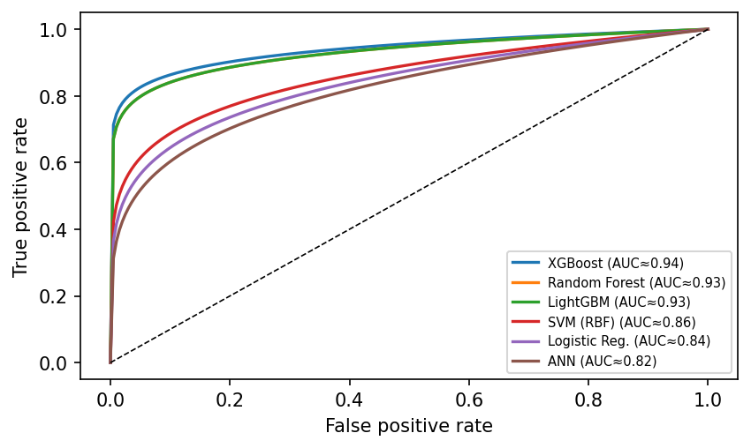
Figure 1. ROC curves by model
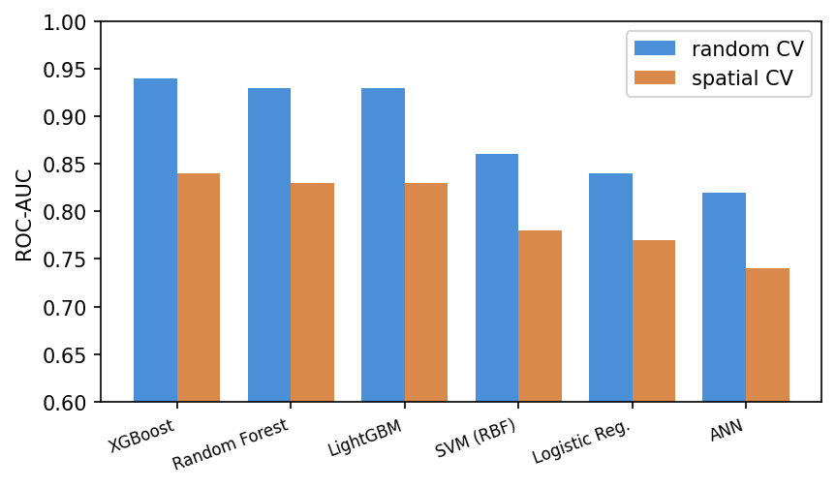
Figure 2. ROC-AUC per model — random vs spatial CV
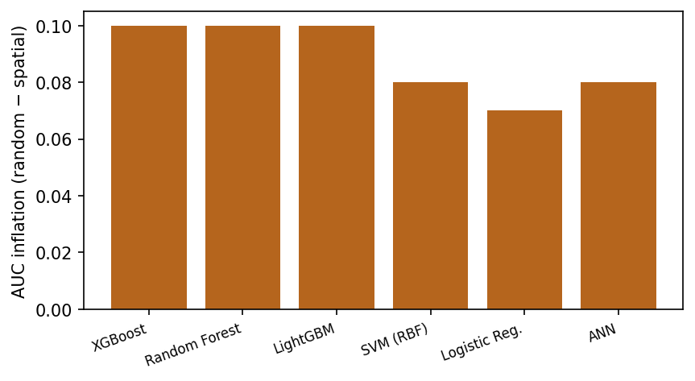
Figure 3. AUC inflation from spatial leakage
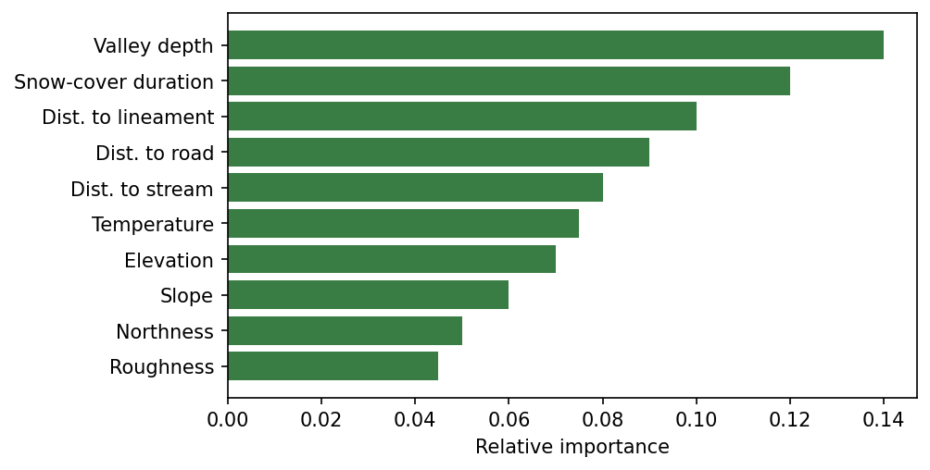
Figure 4. Feature importance

6. Status & Next Steps
Completed:
- Fully reproducible pipeline (Google Earth Engine + Python, version-controlled on GitHub)
- 20-factor predictor stack computed in UTM 43N projection
- Sampling, spatial-CV and 6-model training harness built and tested end-to-end
Pending:
- Avalanche inventory (requested from the study authors)
- On receipt: train models and populate Table 1 and Figures 1–4 with real values
- SHAP explainability, susceptibility map, and CMIP6 future-climate projection

References
[1] Abhinav, A. & Sattar, A. (2025). Snow avalanche susceptibility, hazard, and exposure assessment in the Western Himalaya using machine learning and numerical modelling. Scientific Reports, 15, 38093.
[2] Roberts, D. R. et al. (2017). Cross-validation strategies for data with temporal, spatial, hierarchical, or phylogenetic structure. Ecography, 40, 913–929.
[3] Grinsztajn, L., Oyallon, E. & Varoquaux, G. (2022). Why do tree-based models still outperform deep learning on tabular data? NeurIPS.
[4] Chen, T. & Guestrin, C. (2016). XGBoost: A scalable tree boosting system. KDD.
[5] Lievens, H. et al. (2019). Snow depth variability in the Northern Hemisphere mountains observed from space. Nature Communications, 10, 4629.

