****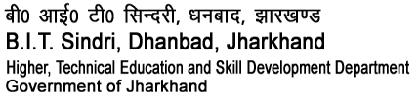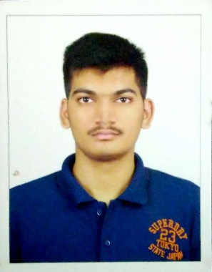

**(Higher Technical and Skill Development, Govt. of Jharkhand**

**SHIVAM KUMAR SUNDERAM**

B TECH. , ELECTRICAL ENGINEERING

**DOB:**-25 JUNE 1999 **Roll. No**: - 1801088

***To join an organisation where I can use and hone my skills to the betterment and upliftment of the organisation.***

|  |  |  |  |  |  |
| --- | --- | --- | --- | --- | --- |
|  | **Name of Examination** | **Year of passing** | **Board/**  **University** | **Institution** | **Percentage/**  **CGPA** |
| **Graduation** | **Bachelor's in technology** | **2022** | **JUT** | **B.I.T. Sindri** | **8.77** |
| **Senior Secondary(XII)** | **Intermediate** | **2017** | **CBSE** | **JVM SHYAMALI, Ranchi** | **91.6%** |
| **Secondary**  **School(X)** | **Matriculation** | **2015** | **CBSE** | **JVM SHYAMALI, Ranchi** | **10** |

* 
* Got Letter of appreciation from **HRD** minister **Smt. Smriti Irani** for securing 10 CGPA in class 10.



* Volunteer in the NGO PRAYAAS INDIA which work towards welfare of poor and underprivileged children.
* I Work as a Chemistry tutor on CHEGG Indias.
* I also work as a MATHEMATICS doubt solver for Solvelancer.



* Incharge of monthly money collection of PRAYAAS INDIA.
* Freelancer on Chegg.
* Content producer of Mathematics on Solvelancer.
* Teacher/ Volunteer at PRAYAAS INDIA.



* Watching TV series and movies.
* Current affairs.
* Mythology.
* Reading Books, Novels.



|  |  |  |
| --- | --- | --- |
| **Correspondence Address :-** | **NIRMALA KUNJ, MANSAROVAR ENCLAVE, KATHAL MORE, RANCHI, JHARKHAND,PIN-835303** | |
| **Permanent Address :-** | **NIRMALA KUNJ , KATHAL MORE, RANCHI, JHARKHAND** | |
| **Email id :-** | **shivamkumarsundaram@gmail.com** | |
| **Phone/Mob No :-** | **9065937549** | |
| **Father’s Name | Occupation:-** | **Mr. Ajay Kumar Mandal** | **Teacher** |
| **Mother’s Name | Occupation:-** | **Mrs. Nirmala Kumari** | **Housewife** |



|  |  |  |
| --- | --- | --- |
| **ORANIZATION** | **PERIOD** | **PROJECT TITLE** |
| Jharkhand Urja Utpadan Nigam Ltd | 14 days | Vocational Training |
| DesignTech Education (Siemens) | 50 hours | Basics of PLC |
| TPSDI Maithon | 4 weeks | TVAS certified Electrical skills professional |

*I hereby declare that all the above-mentioned information given by me is true and correct to the best of my knowledge and belief.*

NAME: _______Shivam Kumar Sunderam_____________

*(Signature of Student)*