**CSS**

CSS, or Cascading Style Sheets, is a stylesheet language to specify document presentation and design. If HTML represents the structure of a webpage, CSS represents its appearance specifically, its colors, font style, spacing, layout, and responsiveness. CSS allows developers to separate content from design which makes websites more visually appealing and much easier to maintain.

Types of CSS:

* Inline CSS

CSS is written directly inside an HTML element using the style attribute.

Used for quick styling of individual elements.

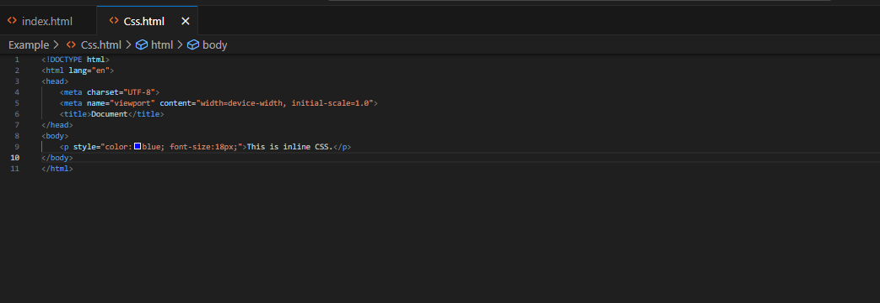  
Internal CSS

CSS is written inside a <style> tag within the <head> section of the HTML file.

Good for styling a single webpage.

* External CSS

CSS is written in a separate .css file and linked to the HTML file using <link>.

Best practice for large websites as it keeps code organized and reusable.

Example: 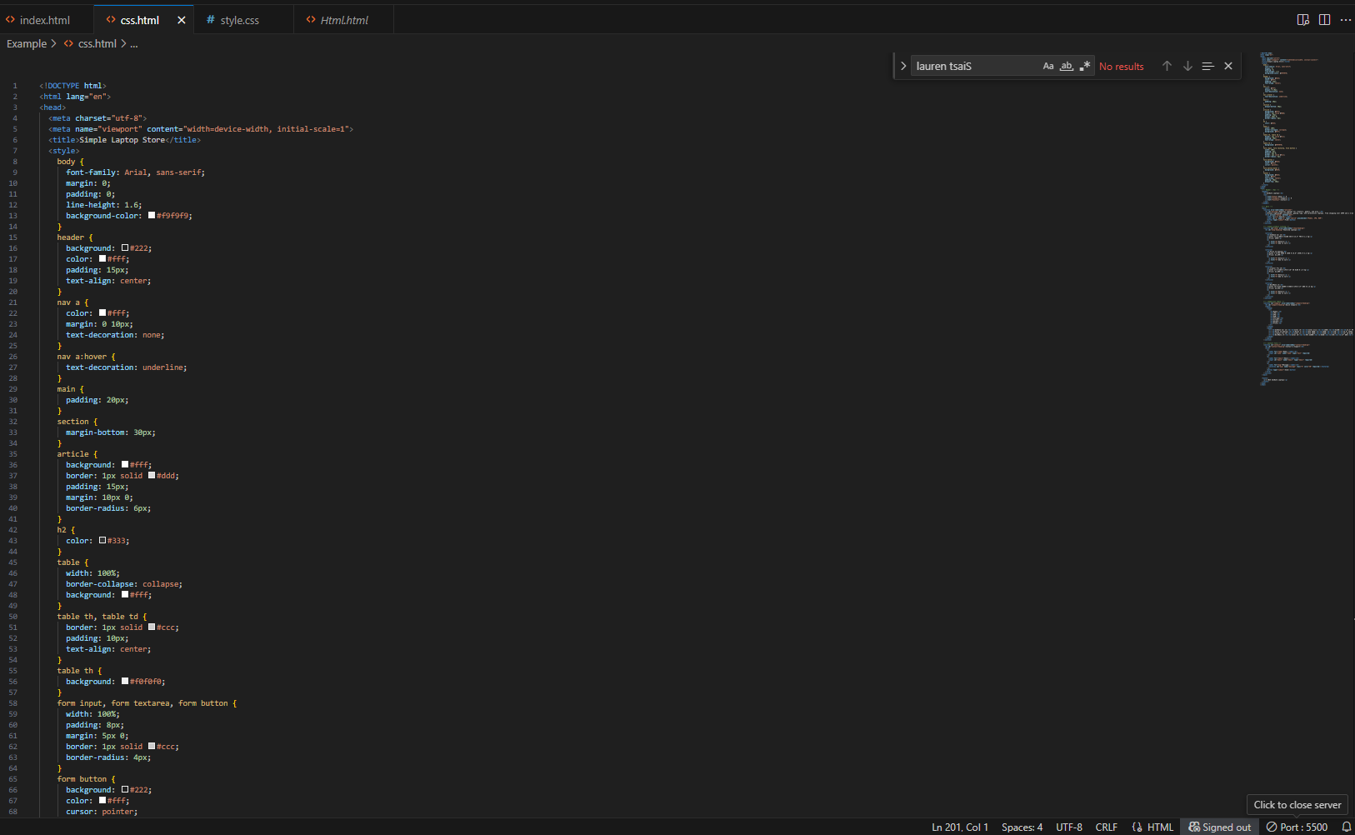

Output:

