**JavaScript**

JavaScript is a high-level, interpreted programming language that is most commonly used to develop interactive and dynamic web pages. JavaScript runs directly in the browser in which it was loaded and creates a more inviting experience for users. JavaScript, along with HTML and CSS, is considered one of the three mainstays of web development.

The role of JavaScript

In the world of development today, JavaScript has a multitude of roles. JavaScript handles the interactivity of items such as forms with validation, dropdowns, sliders, animations, etc. It also enables communication with servers using APIs and AJAX without needing to reload the page. And JavaScript can extend beyond the browser now to browser extensions (Chrome, Firefox, etc.), backend development with Node.js, mobile apps (React Native), and even desktop apps (ElectronJS).

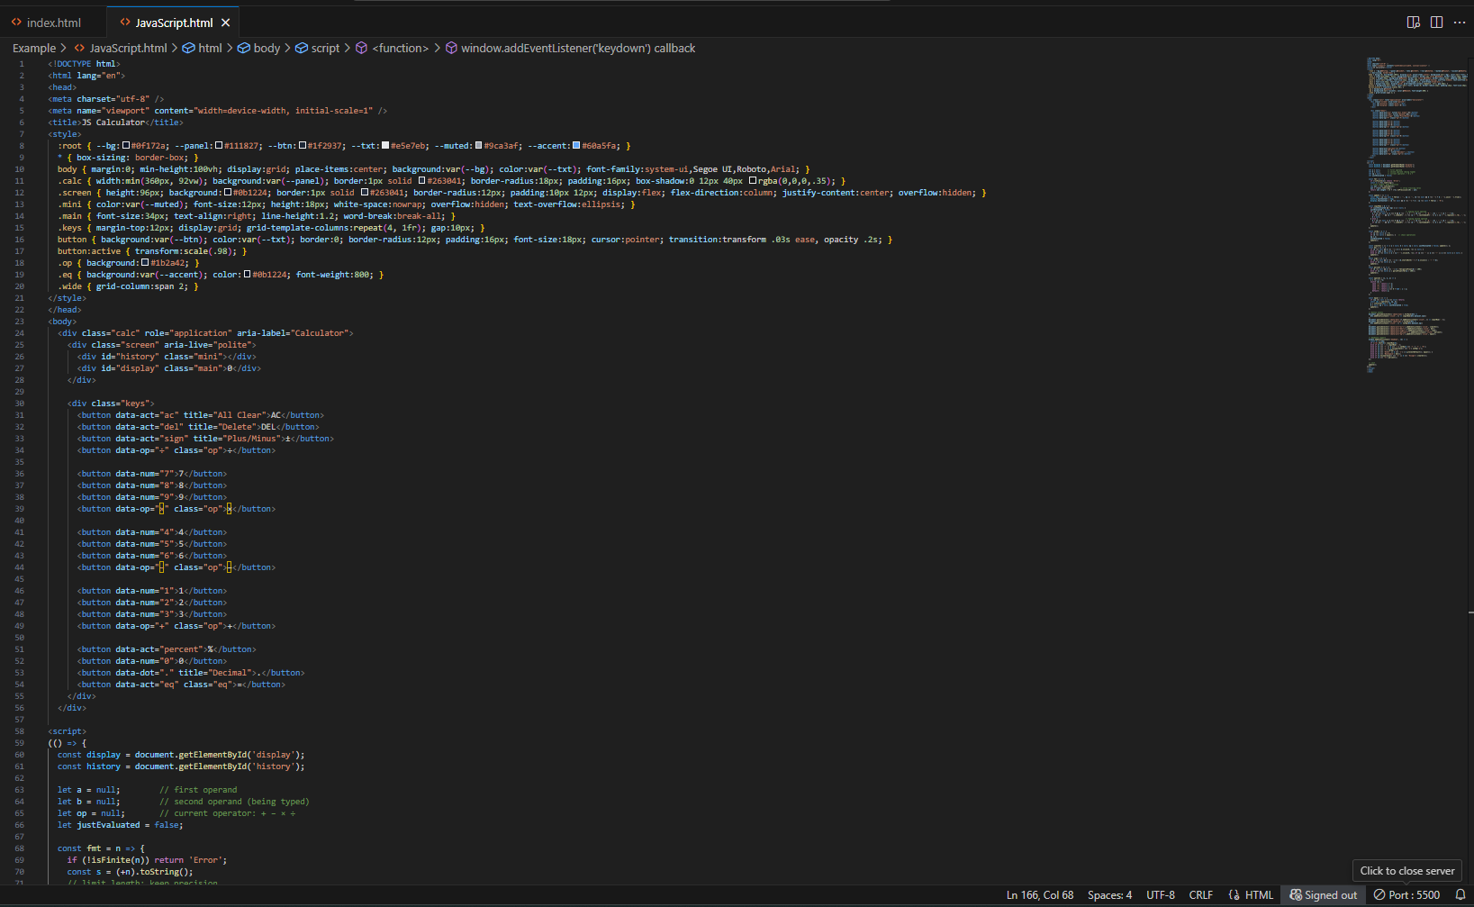

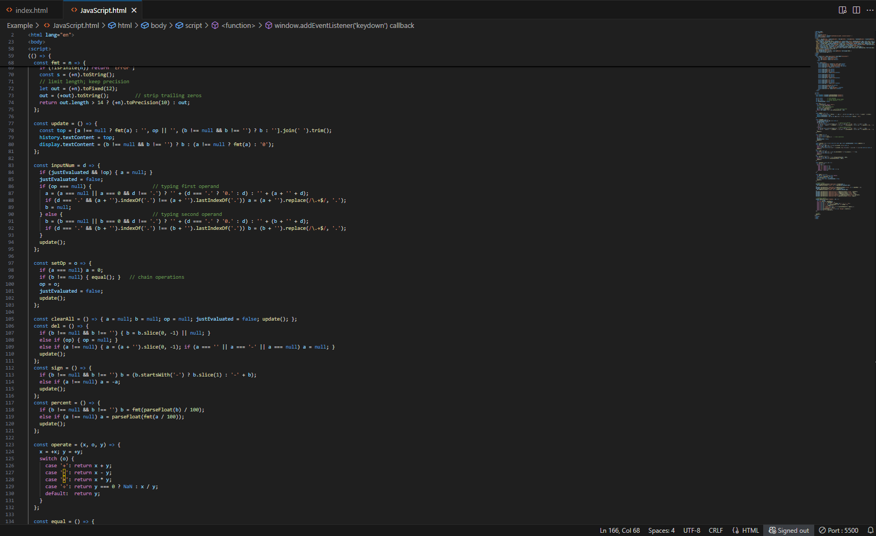

Output:

