**Experiment No. : 5**

|  |  |
| --- | --- |
| **Name:** Sanskar Tewatia | **Date:** 13/02/2021 |
| **Lab partner Name:** Sayantika Mandal | **Course Code:** EED-308 |

# AIM:

The objective of this experiment is to design and simulate electronics circuits involving the use of Arduino UNO R3 and to perform simple functions. The code is written and circuit is simulated on TinkerCad. Following tasks have been performed –

**OBJECTIVE 2 – LED BLINKING -** Learn how to enter, compile, and upload a Sketch on Arduino by going through the process for the given code, which generates a Blinking LED.

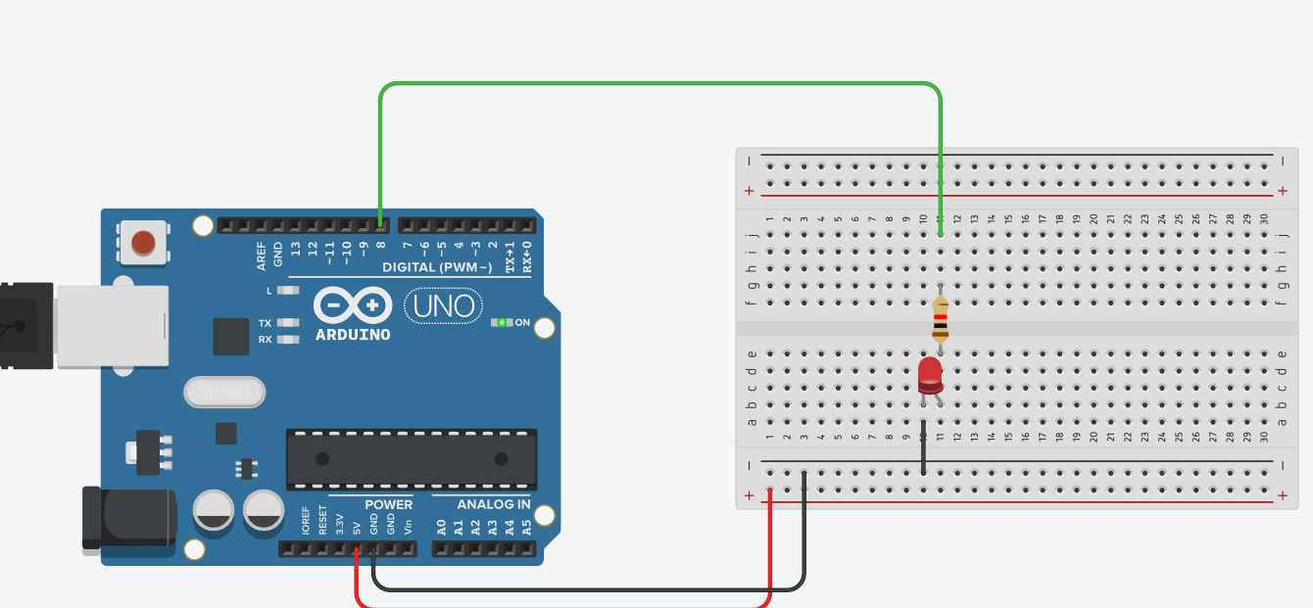

# CODE –

# int led = 8;

# void setup() {

# pinMode(led, OUTPUT);

# }

# void loop() {

# digitalWrite(led, HIGH);

# delay(400);

# digitalWrite(led, LOW);

# delay(400);

# }

**OBJECTIVE 3 – SERIAL MONITOR -** Set up the Laptop as the Serial Monitor for the Arduino. Enter and run the given example code for displaying “Hello world” on the Laptop.

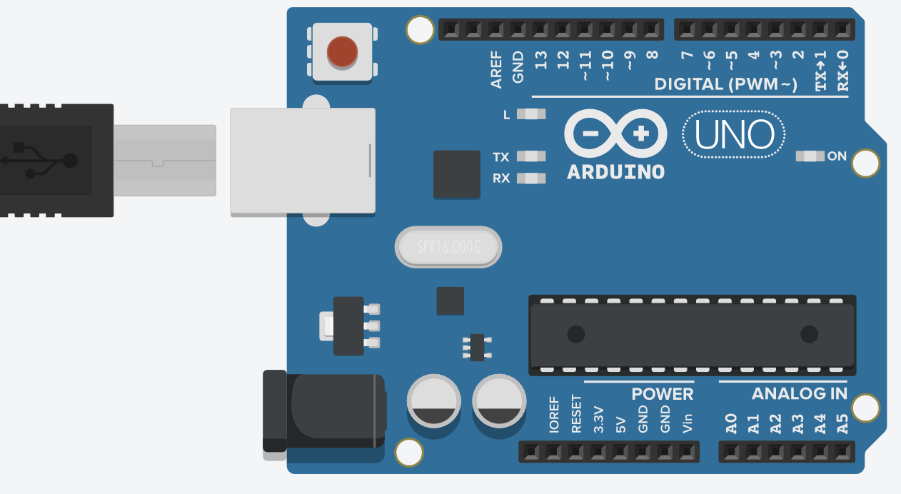

# CODE -

# void setup() {

# Serial.begin(9600);

# }

# void loop() {

# Serial.print("Hello World \n");

# }

**OBJECTIVE 4 – DIGITAL INPUT/OUTPUT–** Connect three switches from the Digital Kit to Pins 5, 6 and 7 of the Arduino board. Write, execute and demonstrate the result generated by a code to create a Full Adder with Inputs coming from Pins 5(C0), 6(A)and 7(B), and Outputs Carry and Sum displayed on two LEDs on the Digital Kit.

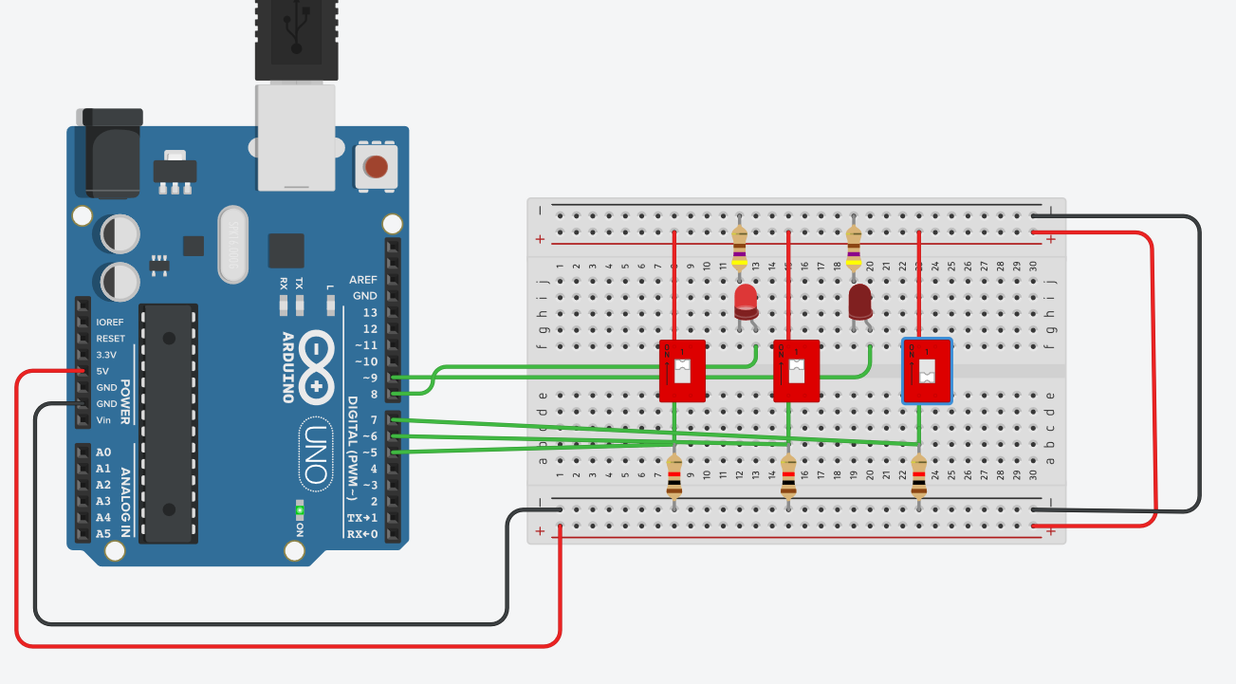

# CODE –

# const int SW1 = 5;

# const int SW2 = 6;

# const int SW3 = 7;

# 

# const int LED1 = 9;

# const int LED2 = 8;

# void setup()

# {

# pinMode(LED1, OUTPUT);

# pinMode(LED2, OUTPUT);

# pinMode(SW1, INPUT);

# pinMode(SW2, INPUT);

# pinMode(SW3, INPUT);

# }

# void loop()

# {

# short int s0 = (digitalRead(SW2) ^ digitalRead(SW3));

# short int c0 = (digitalRead(SW2) & digitalRead(SW3));

# short int c1 = (s0 & digitalRead(SW1));

# digitalWrite(LED1, s0 ^ digitalRead(SW1)); //OR

# digitalWrite(LED2, c0 | c1); //XOR

# }

**OBJECTIVE 5 – DIGITAL TO ANALOG CONVERSION –** Write and execute a code to generate a Pulse Width Modulated (PWM) output on Pin 9 corresponding to the values 1V, 2V, 3V and 4V according to the four different combinations of the bits applied to Pins 6 and 7 through two Switches on the Digital Kit. Using a multimeter, measure the average values of the PWM output voltage appearing on Pin 9 for the four digital inputs, and verify that they correspond to the respective binary-coded inputs.

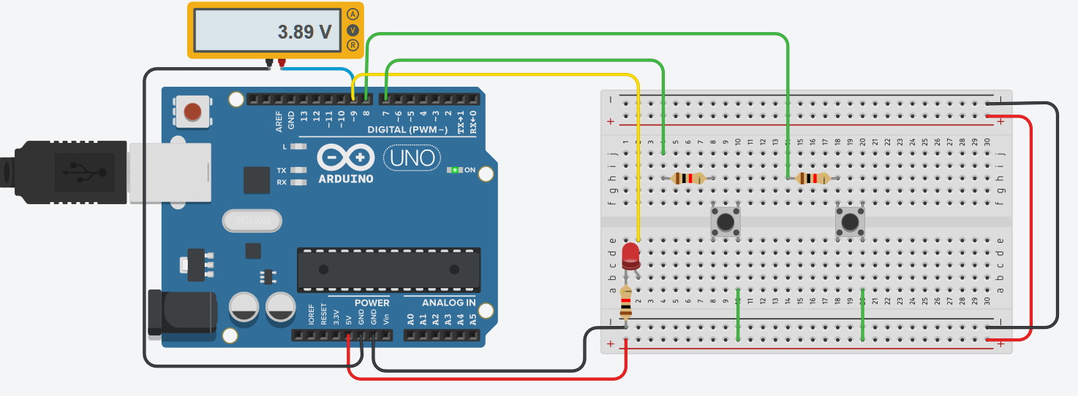

# CODE –

# const int SW1=7;

# const int SW2=8;

# const int LED1=9;

# void setup()

# {

# Serial.begin(9600);

# pinMode(SW1, INPUT);

# pinMode(SW2, INPUT);

# pinMode(LED1,OUTPUT);

# }

# void loop()

# { int val;

# int a = digitalRead(SW1);

# int b = digitalRead(SW2);

# if ( a==0 && b==0)

# val=51;

# else if (a==0 && b==1)

# val=102;

# else if(a==1 && b==0)

# val=153;

# else

# val=204;

# analogWrite(LED1,val);

# Serial.print("PWM output ");

# Serial.println(val);

# }

**OBJECTIVE 6 – ANALOG TO DIGITAL CONVERSION –**Apply a voltage adjustable over the range 0-5V generated by a 10kΩPotentiometer to one of the Analog Input Pins. Write and execute a code to display the Digital value (10-bit) of the voltage on your laptop. Use the myMultiply Function to perform the computation: Analog value = 5*(Digital Value)/1023. Tabulate these calculated analog values and the actual analog values of the voltage measured by a multimeter up to 3 significant digits for 5 different settings of the potentiometer.

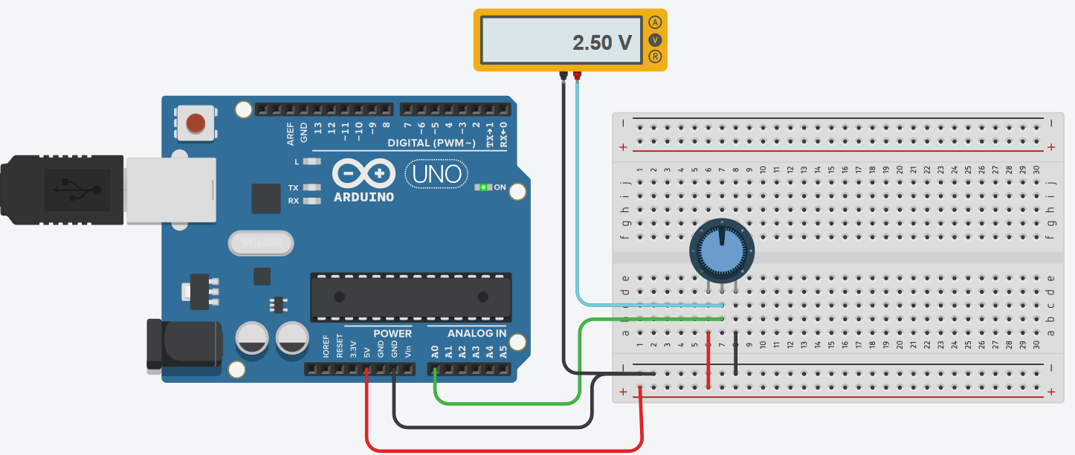

CODE –

# int potPin= A0;

# int LEDPin= 9;

# int readValue;

# int writeValue;

# void setup() {

# pinMode(potPin, INPUT);

# Serial.begin(9600);

# }

# int myMultiplyFunction(int val)

# {

# int wVal;

# wVal = (5./1023.) * val;

# return wVal;

# }

# void loop() {

# readValue = analogRead(potPin);

# writeValue = myMultiplyFunction(readValue);

# Serial.print("Analog value is ");

# Serial.println(writeValue);

# }

**OBJECTIVE 7 - ANALOG TO PWM CONVERSION -** Using the same setup as used in step 6, combine the codes written in steps 5 and 6 to generate a PWM output on Pin 9 corresponding to the value of the applied Analog voltage. Connect an LED with a 470Ωresistor in series to the PWM output and observe how the intensity of the LED changes as the Analog Input voltage is varied.

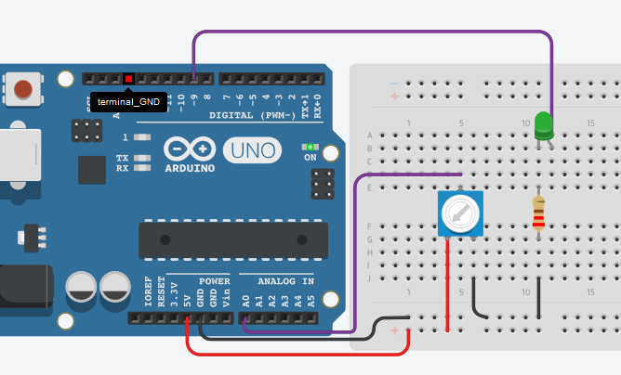

CODE -

# int potPin= A0; //Declare potPin to be analog pin A0

# int LEDPin= 9; // Declare LEDPin to be arduino pin 9

# int readValue; // Use this variable to read Potentiometer

# int writeValue; // Use this variable for writing to LED

# 

# void setup() {

# pinMode(potPin, INPUT); //set potPin to be an input

# pinMode(LEDPin, OUTPUT); //set LEDPin to be an OUTPUT

# Serial.begin(9600); // turn on Serial Port

# }

# int myMultiplyFunction(int val)

# {

# int wVal;

# wVal = (5./1023.) * val;

# return wVal;

# }

# void loop() {

# 

# readValue = analogRead(potPin); //Read the voltage on the Potentiometer

# writeValue = myMultiplyFunction(readValue);

# analogWrite(LEDPin, writeValue); //Write to the LED

# Serial.println(writeValue);

# }

# RESULT – The objectives were satisfied by writing appropriate code and the output was verified to be correct.