AWS EBS VOLUME
CREATION & MANAGEMENT
  - A step-by-step practical documentation based on the provided AWS Console screenshots
━━━━━━━━━━━━━━━━━━━━━━━━━━━━━━━━━━━━━━━━━━━━━━━━━━━━━━━━━━━━━━━━━━━━━━━━━━━━━━
AWS Service | Amazon EC2 — Elastic Block Store (EBS)
Region shown | Asia Pacific (Mumbai) — ap-south-1
Volume created | 100 GiB • gp3 • 5,000 IOPS • 250 MiB/s
Availability Zone | aps1-az1 (ap-south-1a)

Prepared as a practical AWS lab record

DOCUMENT OVERVIEW
- 1. Objective and EBS concept
- 2. Create Volume interface
- 3. Volume settings explained
- 4. Availability Zone, snapshot and encryption
- 5. Tags and snapshot summary
- 6. Successfully created volume — verification
- 7. Actions menu and volume lifecycle
- 8. Deleting the volume
- 9. Key observations and best practices
- 10. Final practical summary

Important cost note
An EBS volume is a billable AWS resource unless covered by applicable free-tier/credits or other pricing conditions. After a lab, verify that unused volumes, snapshots and other resources are removed or otherwise intentionally retained.

1. Objective & EBS Concept
The purpose of this practical exercise is to understand how to create, inspect, manage, and delete an Amazon Elastic Block Store (EBS) volume from the AWS EC2 console. The screenshots document a 100 GiB General Purpose SSD (gp3) volume created in the Mumbai region.
What is an EBS volume?
Amazon EBS provides persistent block storage that can be attached to EC2 instances. It behaves like a virtual disk: an EC2 instance can use it for application files, databases, logs, datasets, or other persistent data. The volume exists independently from the compute instance, although it is normally attached to an EC2 instance within the same Availability Zone.
- Persistent storage: data can remain on the EBS volume independently of the EC2 instance lifecycle.
- Block storage: the operating system can format and mount the volume as a disk.
- Performance can be configured through volume type, IOPS and throughput, depending on the selected EBS type.
- EBS volumes are Availability Zone scoped; the screenshot shows aps1-az1 (ap-south-1a).
2. Create Volume Interface
The first screenshot shows the AWS EC2 console's Create volume page. This page is used to define the storage characteristics before AWS creates the EBS volume.
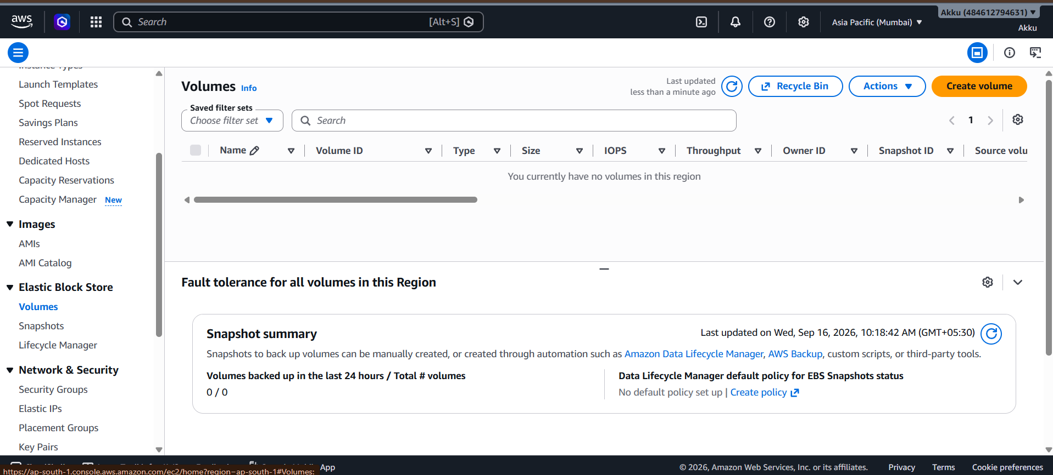
Figure 1 — Amazon EBS Create Volume interface
Main interface elements
Field | Value shown | Purpose
Volume type | General Purpose SSD (gp3) | Defines the storage/performance family.
Size | 100 GiB | Logical storage capacity of the volume.
IOPS | 5,000 | Input/output operations per second configured for the volume.
Throughput | 250 MiB/s | Configured maximum data transfer throughput.
Availability Zone | aps1-az1 (ap-south-1a) | Determines where the volume can be attached.

Practical interpretation
For a normal learning/lab workload, gp3 is a flexible choice because storage capacity and performance settings can be configured separately within the supported limits.

3. Volume Settings — Detailed Explanation
3.1 Volume Type — General Purpose SSD (gp3)
The selected type is gp3, a general-purpose SSD-backed EBS volume type designed for a broad range of workloads. In this screenshot, the volume is configured with 100 GiB capacity, 5,000 IOPS and 250 MiB/s throughput.
- Use case: general applications, development environments, web servers, application storage and many common workloads.
- Capacity and performance are separate concepts: increasing disk size does not automatically mean every performance setting must increase.
- The exact price depends on AWS pricing for the region and the provisioned capacity/performance.
3.2 Size — 100 GiB
The Size field is set to 100 GiB. This represents the provisioned storage capacity available to the operating system after the volume is attached and formatted. The screenshot displays a minimum of 1 GiB and a maximum of 65,536 GiB for the selected configuration.
- GiB means gibibyte, a binary unit of storage.
- Provisioned capacity is different from actual data used inside the filesystem.
- Choosing more capacity than required can increase cost, so size should match the workload and expected growth.
3.3 IOPS — 5,000
IOPS stands for Input/Output Operations Per Second. It describes the number of input/output operations the storage system can support per second under the relevant conditions. The screenshot shows 5,000 IOPS, with the console indicating a supported range of 3,000 to 80,000 IOPS for this configuration.
- Higher IOPS can be useful for workloads that perform many small random reads/writes.
- IOPS is not the same as throughput; a workload may be limited by one or the other.
- Actual application performance also depends on the EC2 instance, operating system, filesystem and workload pattern.
3.4 Throughput — 250 MiB/s
Throughput represents the amount of data that can be transferred per second. The screenshot shows 250 MiB/s and indicates a baseline of 125 MiB/s, with a displayed range from 125 to 2,000 MiB/s for the selected setup.
- Throughput matters especially for large sequential data transfers.
- IOPS focuses on operation rate; throughput focuses on data transfer volume.
- The effective performance of an application is constrained by the complete storage and compute path.
4. Availability Zone, Snapshot & Encryption
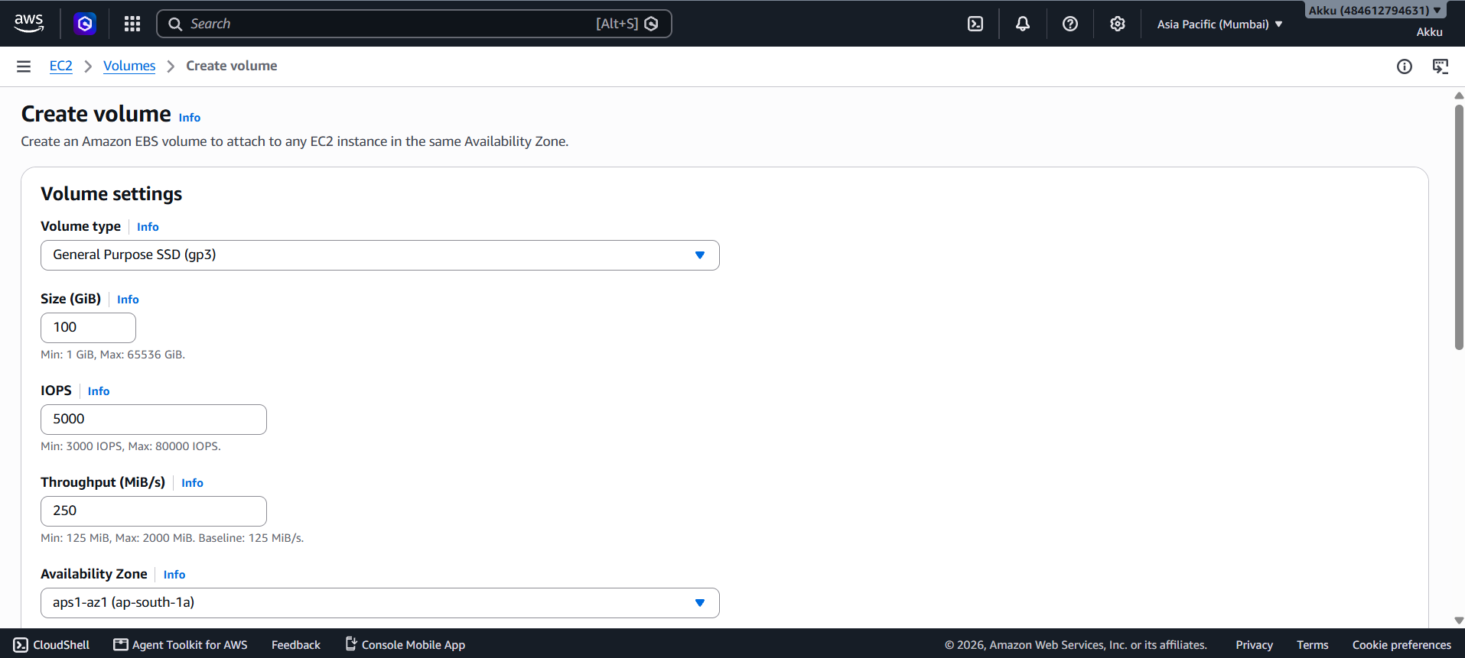
Figure 2 — Volume configuration and encryption section
4.1 Availability Zone
The Availability Zone shown is aps1-az1 (ap-south-1a). An EBS volume is created in a specific Availability Zone, and the volume can normally be attached to an EC2 instance in the same Availability Zone. This is an important planning consideration when attaching storage to an existing instance.
4.2 Snapshot ID — Optional
The screenshot shows “Don't create volume from a snapshot.” A snapshot is a point-in-time backup/reference of an EBS volume that can be used to create a new volume. Because no snapshot was selected here, the new volume was created as a fresh volume.
- Use a snapshot when you need to reproduce data or a previous disk state.
- A newly created blank volume does not automatically contain the files from another volume.
- Snapshots are separate AWS resources and can also incur storage costs.
4.3 Encryption
The “Encrypt this volume” checkbox is visible and is not selected in the screenshot. The final volume details also show “Not encrypted.” Encryption protects data at rest using AWS Key Management Service (KMS) keys.
Security recommendation
For production or sensitive workloads, evaluate encryption requirements before creating the volume. For a classroom demonstration, an unencrypted volume can be acceptable only when it matches the lab requirement and contains no sensitive data.

5. Tags & Snapshot Summary
The Tags section is optional. The screenshot shows that no tags are associated with the resource. Tags are key-value labels that can help identify resources, organize environments, filter resources, and support cost allocation.
- Example: Environment = Lab
- Example: Project = DataScience
- Example: Owner = Student
- Example: Purpose = EBS-Practical
Snapshot Summary
The Snapshot Summary area indicates that snapshots can be created manually or through automation such as Data Lifecycle Manager, AWS Backup, custom scripts, or third-party tools. In the screenshot, the displayed summary reports 0 volumes backed up in the last 24 hours out of 0 total volumes at that moment, and no default Data Lifecycle Manager policy is configured.
6. Successfully Created Volume — Verification
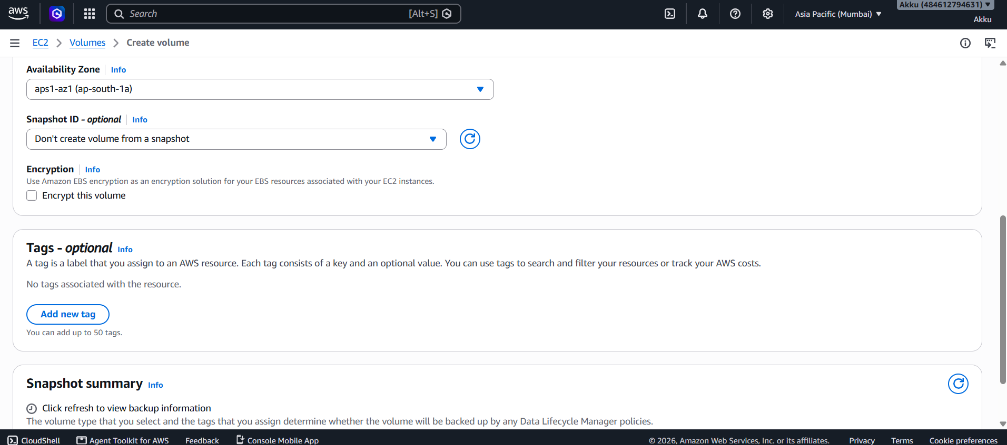
Figure 3 — Successfully created EBS volume
The third screenshot confirms successful creation. A green confirmation banner states that the volume was successfully created. The volume list contains one volume, and the selected row shows the configured gp3, 100 GiB, 5,000 IOPS and 250 MiB/s settings.
Important details visible after creation
Property | Observed value
Volume ID | vol-07fb3ad5ede783bfd
Type | gp3
Size | 100 GiB
IOPS | 5,000
Throughput | 250 MiB/s
Availability Zone | aps1-az1 (ap-south-1a)
Snapshot source | None
Encryption | Not encrypted
Multi-Attach | No
Status check | Okay
State vs. attachment
The volume being successfully created does not mean it is attached to an EC2 instance. Creation and attachment are separate steps. In the screenshot, the Actions menu shows Attach volume as unavailable, consistent with the volume not being attached at that moment.

7. Actions Menu & Volume Lifecycle
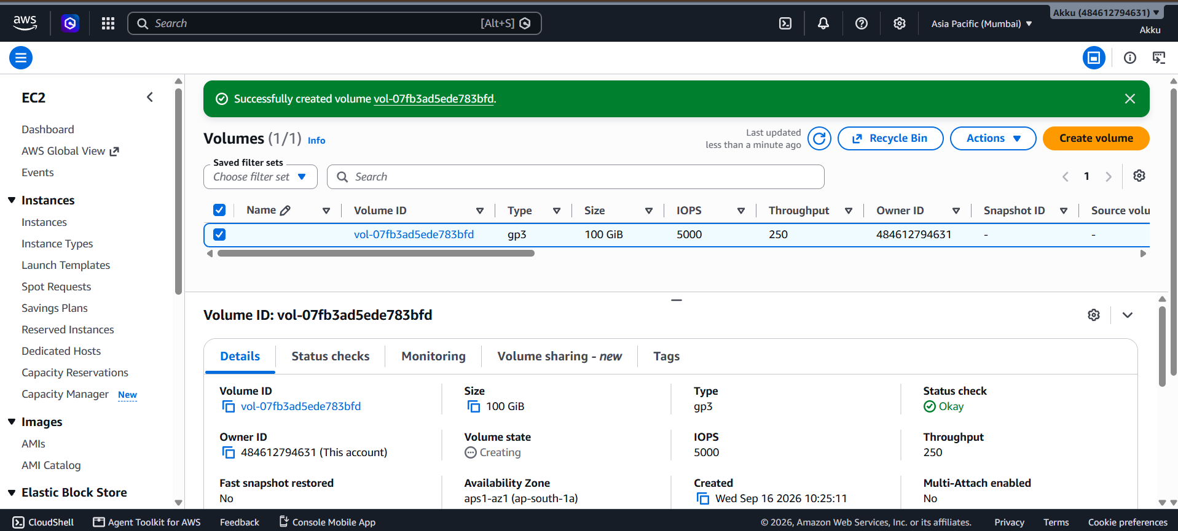
Figure 4 — Actions menu for the selected volume
The Actions menu provides management operations for the selected EBS volume. The screenshot shows options including creating a snapshot, deleting the volume, managing tags, and other storage-management operations.
Important actions shown
Action | Meaning
Create snapshot | Creates a point-in-time backup/reference of the EBS volume.
Create snapshot lifecycle policy | Provides an automation mechanism for snapshot management.
Delete volume | Removes the EBS volume resource. Data stored on the volume can be lost if no backup/snapshot exists.
Attach volume | Connects the volume to a compatible EC2 instance in the appropriate Availability Zone.
Detach volume | Disconnects an attached volume from an EC2 instance when the volume is in a suitable state.
Manage tags | Adds or changes resource labels used for organization and management.
8. Deleting the Volume
The final screenshot shows the volume list after the created volume was deleted. The console displays “You currently have no volumes in this region,” indicating that the volume is no longer present in the selected region.
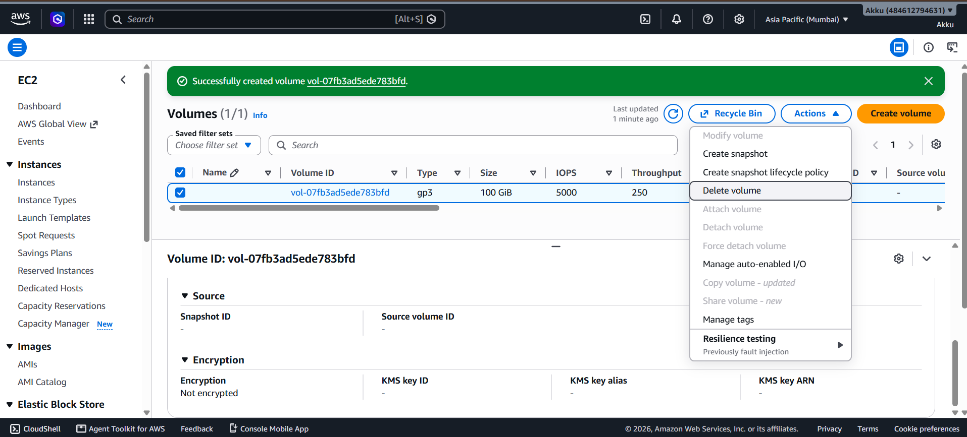
Figure 5 — Volume list after deletion
Safe deletion workflow
- Confirm the volume is no longer required.
- If the data must be retained, create an appropriate snapshot/backup before deletion.
- If the volume is attached to an EC2 instance, follow the correct detach procedure first and ensure applications/filesystems are safely stopped or unmounted as appropriate.
- Select the volume in EC2 → Volumes.
- Open Actions → Delete volume.
- Confirm the deletion in the AWS console.
- Refresh the Volumes page and verify that the volume no longer appears.
Data-loss warning
Deleting an EBS volume is destructive to the data stored on that volume. A snapshot or other backup should be retained first if the data may be needed later.

9. Key Observations & Best Practices
Practice | Why it matters
Choose the right volume type | gp3 is intended as a general-purpose SSD option, but workload requirements should determine the final storage design.
Match AZ before attachment | Check the EC2 instance Availability Zone before creating an EBS volume intended for that instance.
Separate capacity from performance | Storage size, IOPS and throughput address different workload requirements.
Use encryption deliberately | For sensitive or production data, establish an encryption standard and select an appropriate KMS key strategy.
Use tags | Tags make resources easier to identify and manage, especially when multiple labs or environments exist.
Back up important data | Snapshots can provide a recovery point, but they should be part of a broader backup and recovery strategy.
Clean up lab resources | Delete unused volumes and other billable resources after practice sessions, and verify snapshots are also intentionally retained or removed.
10. Final Practical Summary
In this practical, an Amazon EBS gp3 volume was configured in the Mumbai AWS region with 100 GiB of capacity, 5,000 IOPS and 250 MiB/s throughput. The volume was created in the aps1-az1 (ap-south-1a) Availability Zone without using a snapshot and without encryption, as shown in the provided screenshots. The resulting volume was then inspected through the EC2 Volumes page and its Actions menu. Finally, the volume was deleted and the Volumes page showed no remaining volumes in the region.
One-line workflow
EC2 → Elastic Block Store → Volumes → Create volume → Configure gp3 → Select AZ → Review → Create → Verify → Manage/Attach as required → Snapshot if needed → Delete when no longer required.

Figure 1 — Amazon EBS Create Volume interface

Figure 2 — Volume configuration and encryption section

Figure 3 — Successfully created EBS volume

Figure 4 — Actions menu for the selected volume

Figure 5 — Volume list after deletion

