AWS
How to Create an IAM User
Step-by-Step Guide with Screenshots
AWS Identity and Access Management (IAM)

STEP 1 OF 11
Open the IAM Dashboard
Sign in to the AWS Management Console and search for IAM.
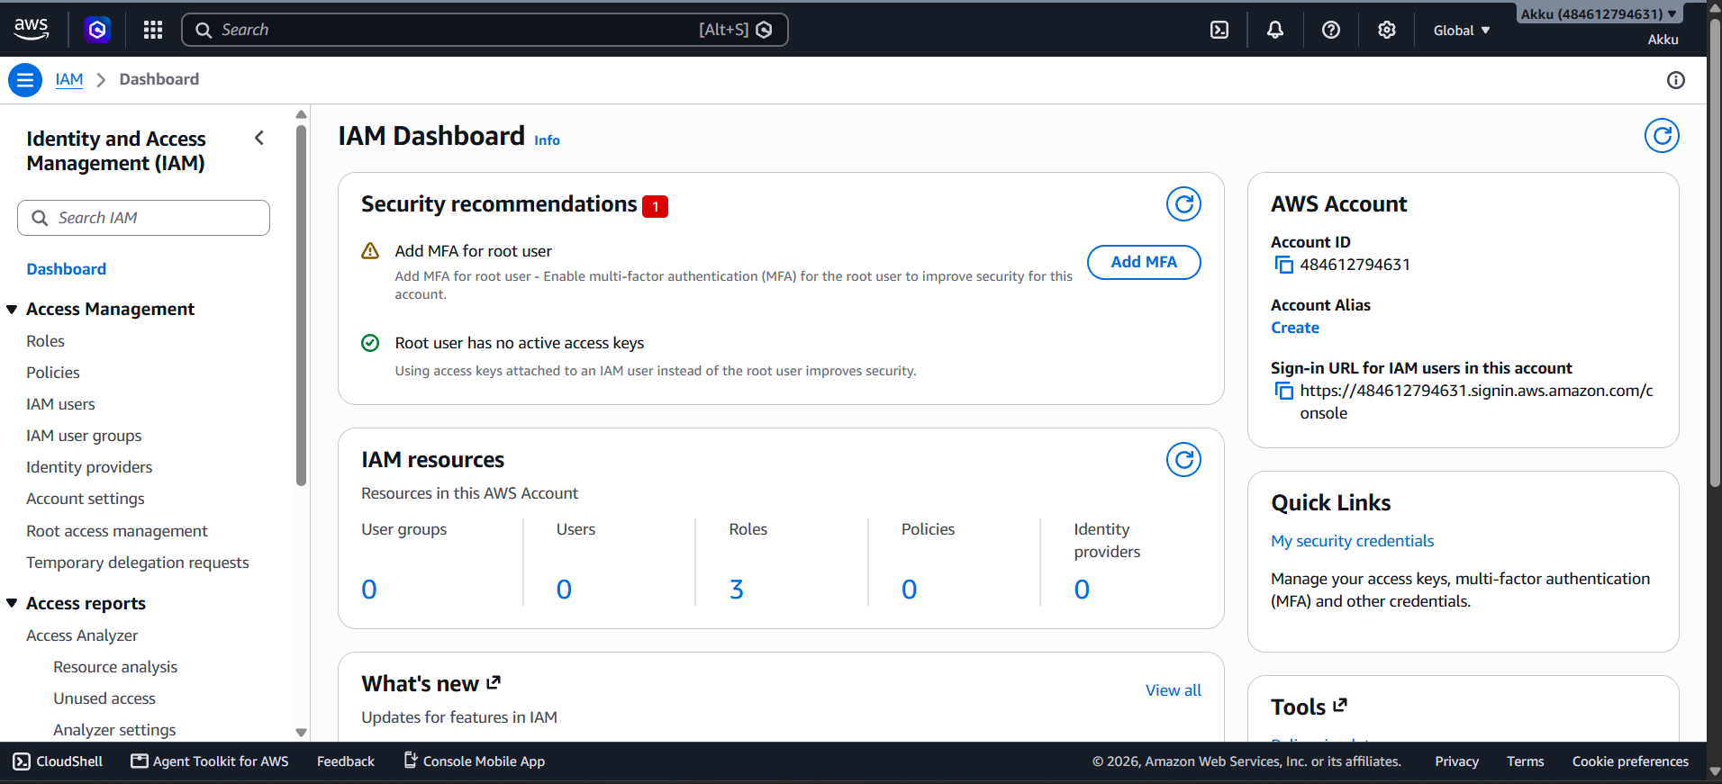
What to do in this step
- Log in to the AWS Management Console with your root or admin account.
- In the top search bar, type IAM and open Identity and Access Management.
- The IAM Dashboard opens and shows an overview of your account security.
- The Security recommendations box warns you to add MFA for the root user.
- The IAM resources box shows User groups, Users, Roles, Policies and Identity providers.
- Here the account currently has 0 users, 0 groups and 3 roles.
- The AWS Account box shows your Account ID: 484612794631.
- It also shows the sign-in URL that IAM users will use to log in.
- The left menu contains Roles, Policies, IAM users and User groups.
- Click IAM users in the left menu to continue to the next step.

STEP 2 OF 11
Open the IAM Users List
From the left menu, click IAM users to see all users.
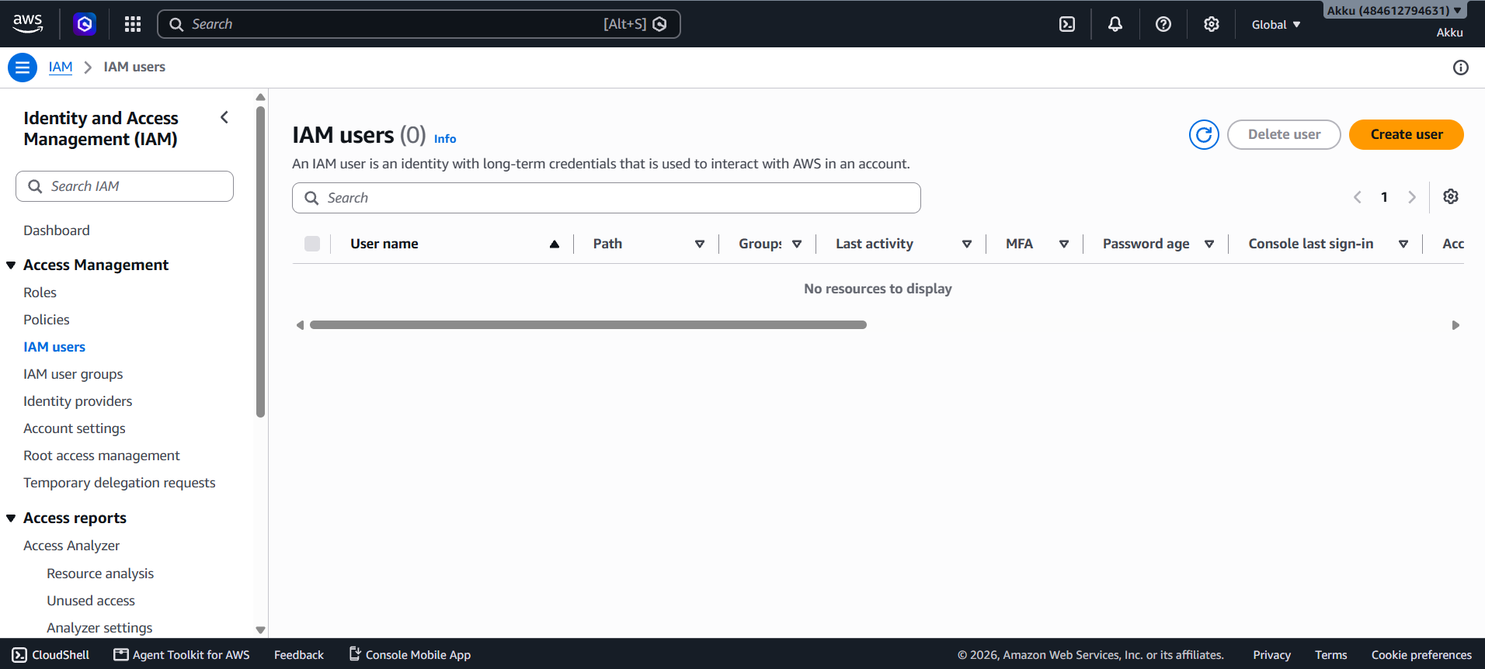
What to do in this step
- Click IAM users under Access Management in the left navigation menu.
- The IAM users page opens and shows the total count in brackets.
- An IAM user is an identity with long-term credentials to use AWS.
- Currently the count is (0), so the message No resources to display appears.
- The table has columns: User name, Path, Groups, Last activity and MFA.
- More columns are Password age and Console last sign-in.
- You can use the Search box to find any user by name.
- The Delete user button is used to remove selected users.
- The orange Create user button is used to add a new user.
- Click Create user to start the user creation wizard.

STEP 3 OF 11
Specify User Details (Step 1)
Enter the user name and set the console password options.
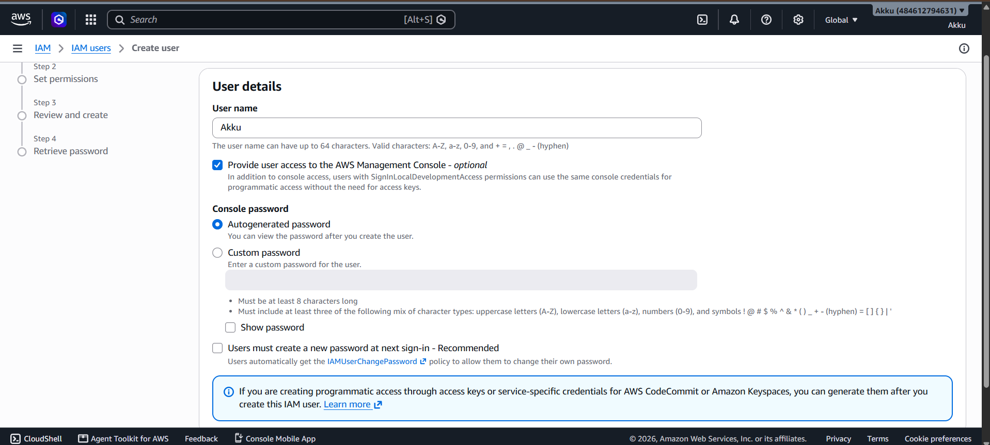
What to do in this step
- The Create user wizard opens with four steps shown on the left side.
- In User name, type the name of the user (for example: Akku).
- A user name can have up to 64 characters using letters, numbers and symbols.
- Tick Provide user access to the AWS Management Console to allow console login.
- Under Console password, select Autogenerated password to let AWS create one.
- Or select Custom password and type your own strong password.
- A custom password needs 8+ characters and a mix of character types.
- Use Show password to check what you typed.
- Users must create a new password at next sign-in is recommended for security.
- After filling in the details, scroll down and click Next.

STEP 4 OF 11
Set Permissions (Step 2)
Choose how the new user will get access to AWS services.
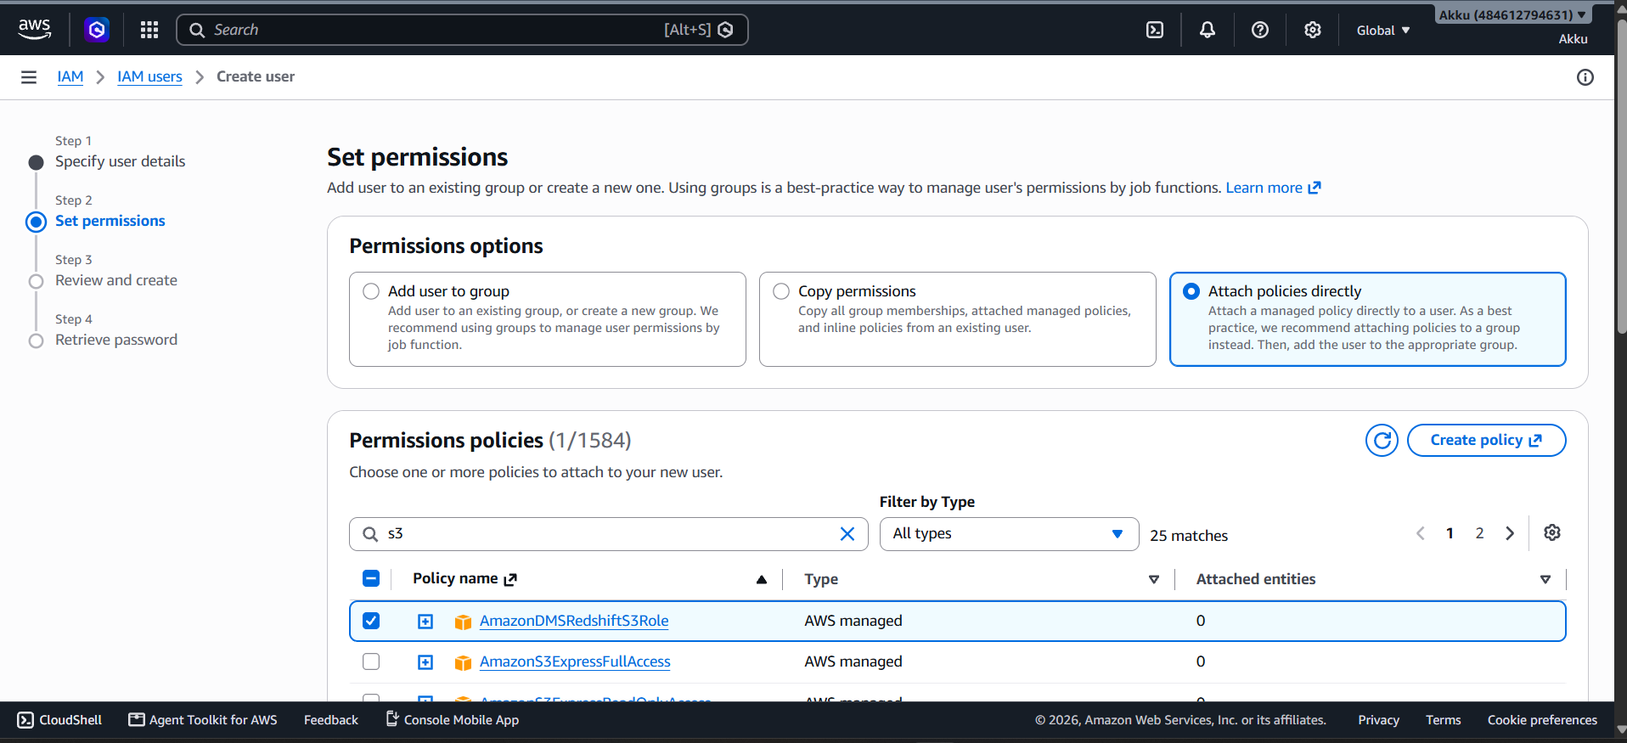
What to do in this step
- Step 2 is Set permissions, where you decide what the user can access.
- Add user to group is the best practice for managing job-based permissions.
- Copy permissions copies groups and policies from an existing user.
- Attach policies directly gives permissions straight to this user.
- In this example, Attach policies directly is selected.
- The Permissions policies list shows 1584 available policies.
- Type s3 in the search box to filter, which gives 25 matches.
- Filter by Type lets you choose AWS managed or Customer managed policies.
- Tick the checkbox of the policy you want, e.g. AmazonDMSRedshiftS3Role.
- Use the arrows or page numbers to view more policies in the list.

STEP 5 OF 11
Select Policy and Continue
Scroll down, choose policies, and click Next.
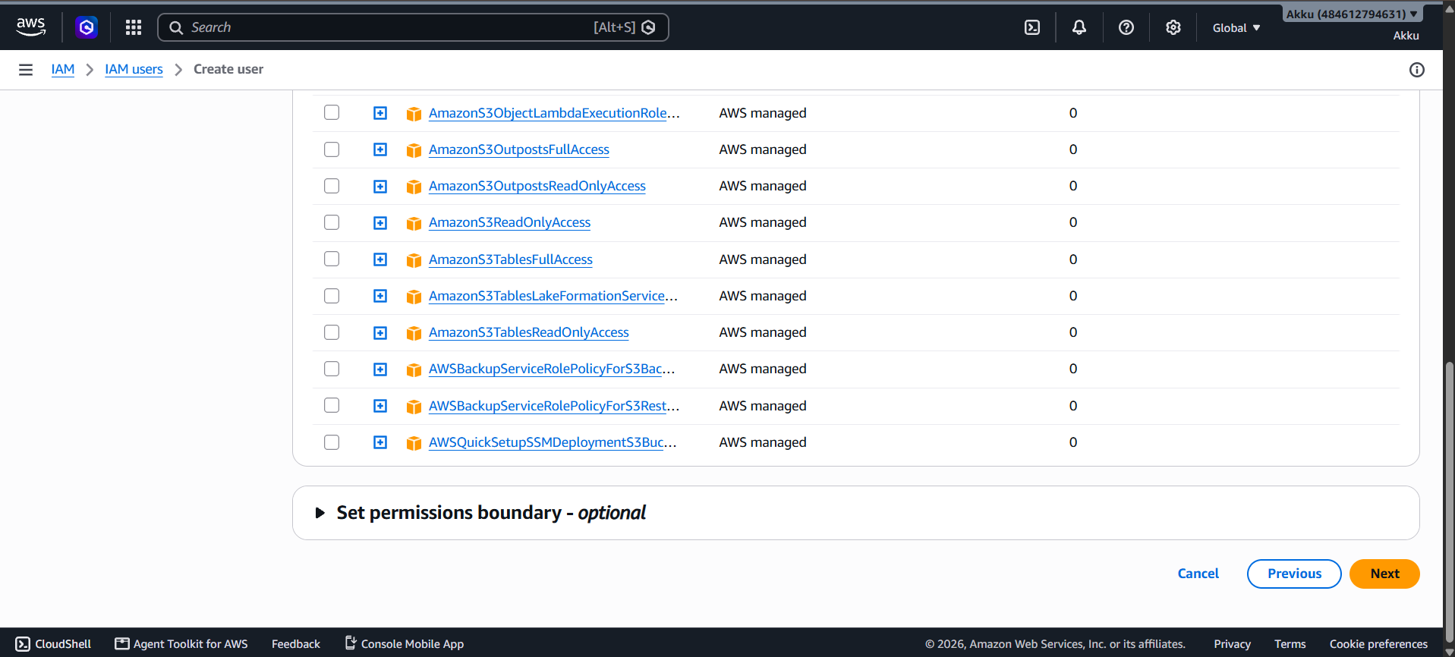
What to do in this step
- Scroll down the policy list to see more S3-related policies.
- Examples are AmazonS3ReadOnlyAccess and AmazonS3OutpostsFullAccess.
- Each row shows the Policy name, Type and Attached entities count.
- All these policies are AWS managed, created and maintained by AWS.
- Click the plus (+) icon before a policy name to preview its permissions.
- Always give only the minimum permissions needed (least privilege).
- Set permissions boundary is optional and limits the maximum permissions.
- Leave the permissions boundary closed if you do not need it.
- The Cancel button stops the process and Previous goes back one step.
- Click the orange Next button to go to the review page.

STEP 6 OF 11
Review and Create - Summary (Step 3)
Check all details before creating the user.
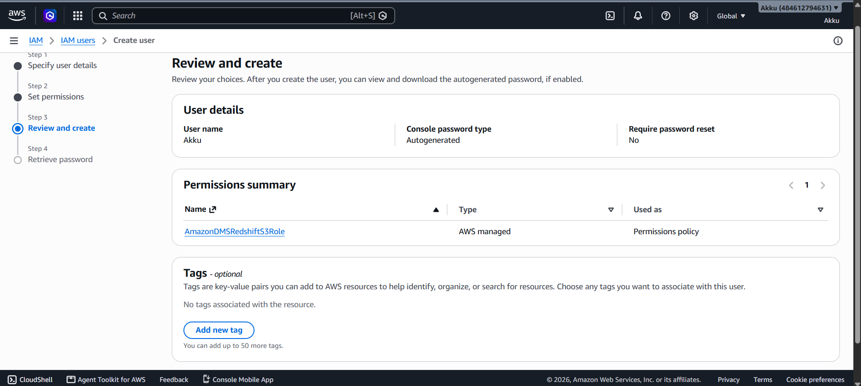
What to do in this step
- Step 3 is Review and create, a final check of your choices.
- User details shows the User name, here: Akku.
- Console password type shows Autogenerated.
- Require password reset shows No for this user.
- Permissions summary lists the attached policy: AmazonDMSRedshiftS3Role.
- The policy Type is AWS managed and it is used as a Permissions policy.
- The Tags section is optional and helps you organize resources.
- Click Add new tag to add key-value pairs; up to 50 tags are allowed.
- Here no tags are added, which is fine for a basic user.
- Scroll down to find the Create user button.

STEP 7 OF 11
Click Create User
Confirm the settings and create the IAM user.
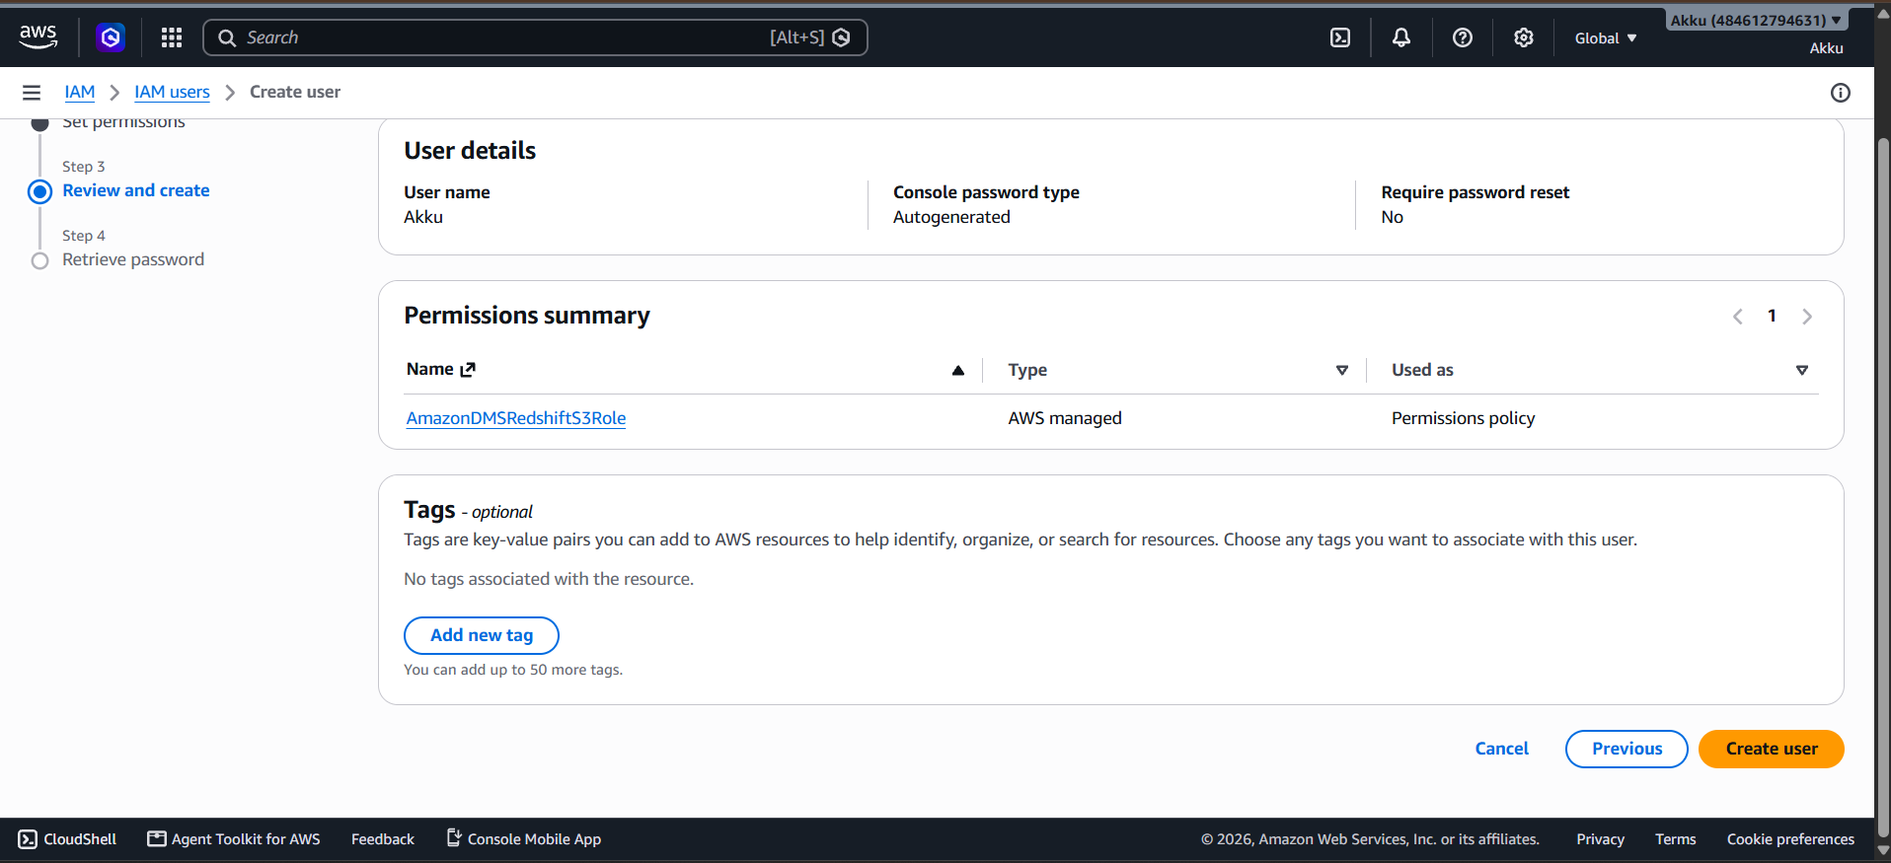
What to do in this step
- Scroll to the bottom of the Review and create page.
- Re-check the user name, password type and permissions summary once more.
- Three buttons are shown: Cancel, Previous and Create user.
- Cancel stops the whole process without creating anything.
- Previous lets you go back and change the earlier settings.
- Create user is the orange button that finishes the process.
- Click Create user to create the IAM user in your AWS account.
- AWS will create the user with the selected password and permissions.
- The permissions policy is attached to the user automatically.
- After a few seconds, the Retrieve password page will open.

STEP 8 OF 11
Retrieve Password (Step 4)
Save the sign-in details of the new user safely.
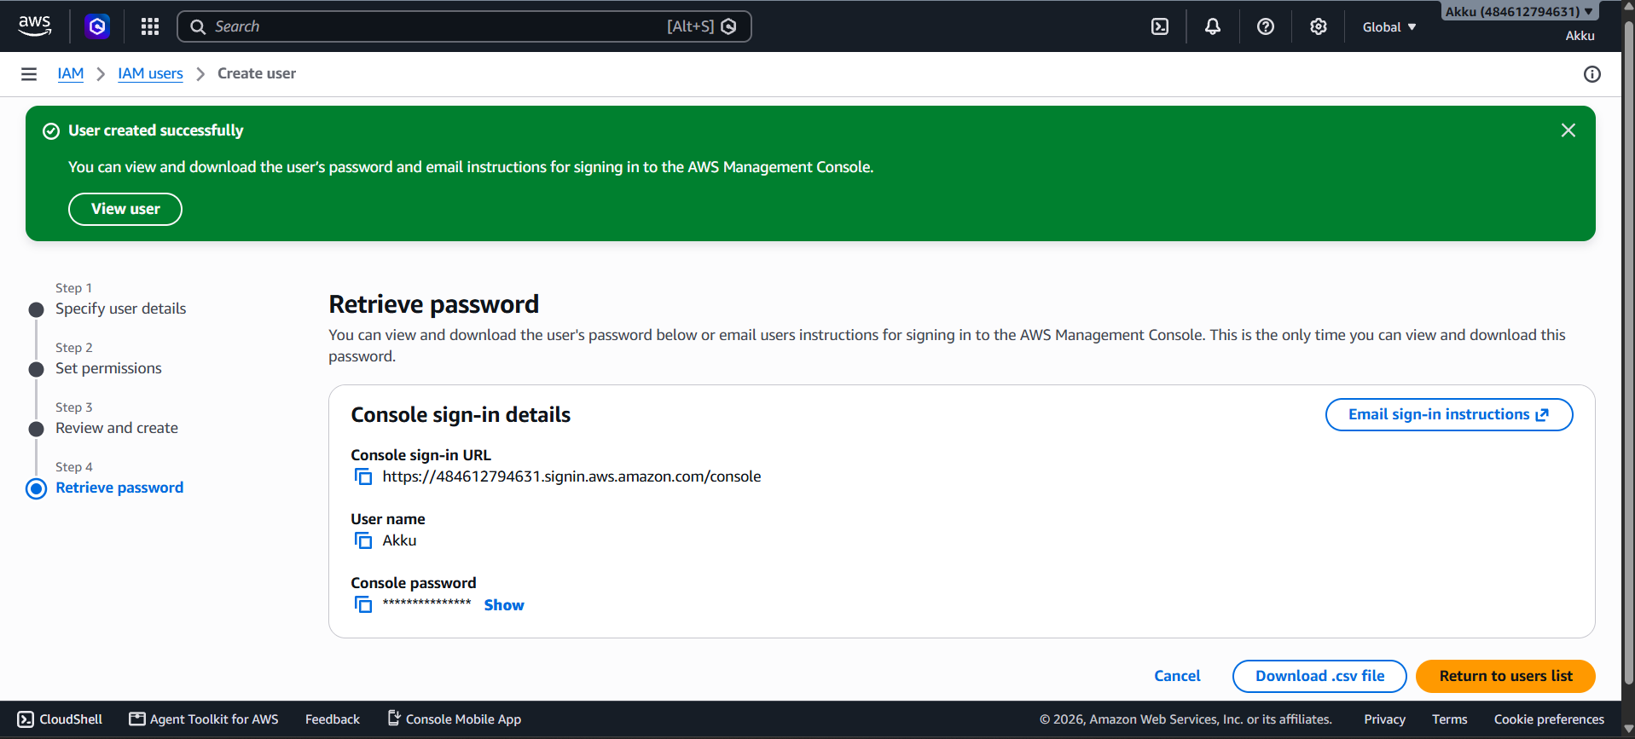
What to do in this step
- A green banner shows User created successfully.
- Step 4 is Retrieve password with the Console sign-in details.
- Console sign-in URL is https://484612794631.signin.aws.amazon.com/console.
- User name shows the new user name, here: Akku.
- Console password is hidden; click Show to see the password.
- Use the copy icons to copy the URL, user name or password.
- Click Download .csv file to save all sign-in details on your computer.
- Or click Email sign-in instructions to send details to the user.
- This is the only time you can view and download this password.
- Click Return to users list when you are done.

STEP 9 OF 11
Verify the New User in the List
Confirm that the user now appears in the IAM users list.
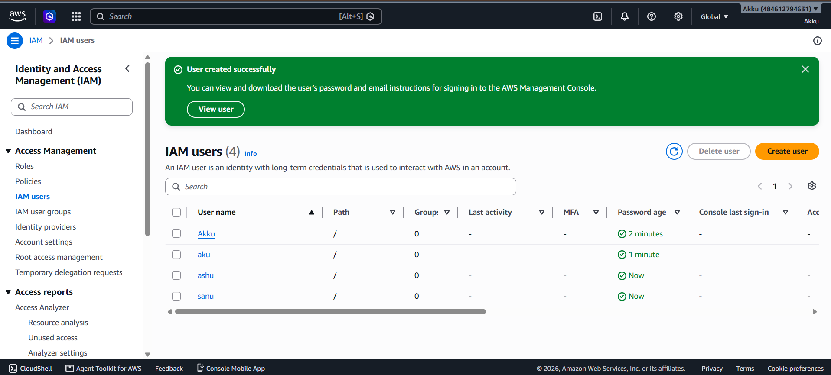
What to do in this step
- The IAM users page opens again with a green success message.
- The list now shows IAM users (4) instead of zero.
- The new user Akku appears in the User name column.
- Other users such as aku, ashu and sanu are also visible.
- The Password age column shows how recently each password was created.
- For example, Akku shows 2 minutes and ashu shows Now.
- Groups shows 0, because the users were not added to any group.
- Last activity and Console last sign-in show a dash until the first login.
- Click a user name to view details, add MFA or create access keys.
- The IAM user has been created successfully.

STEP 10 OF 11
Test Access: EC2 (Access Denied)
Log in as the new user and open EC2 to check the permissions.
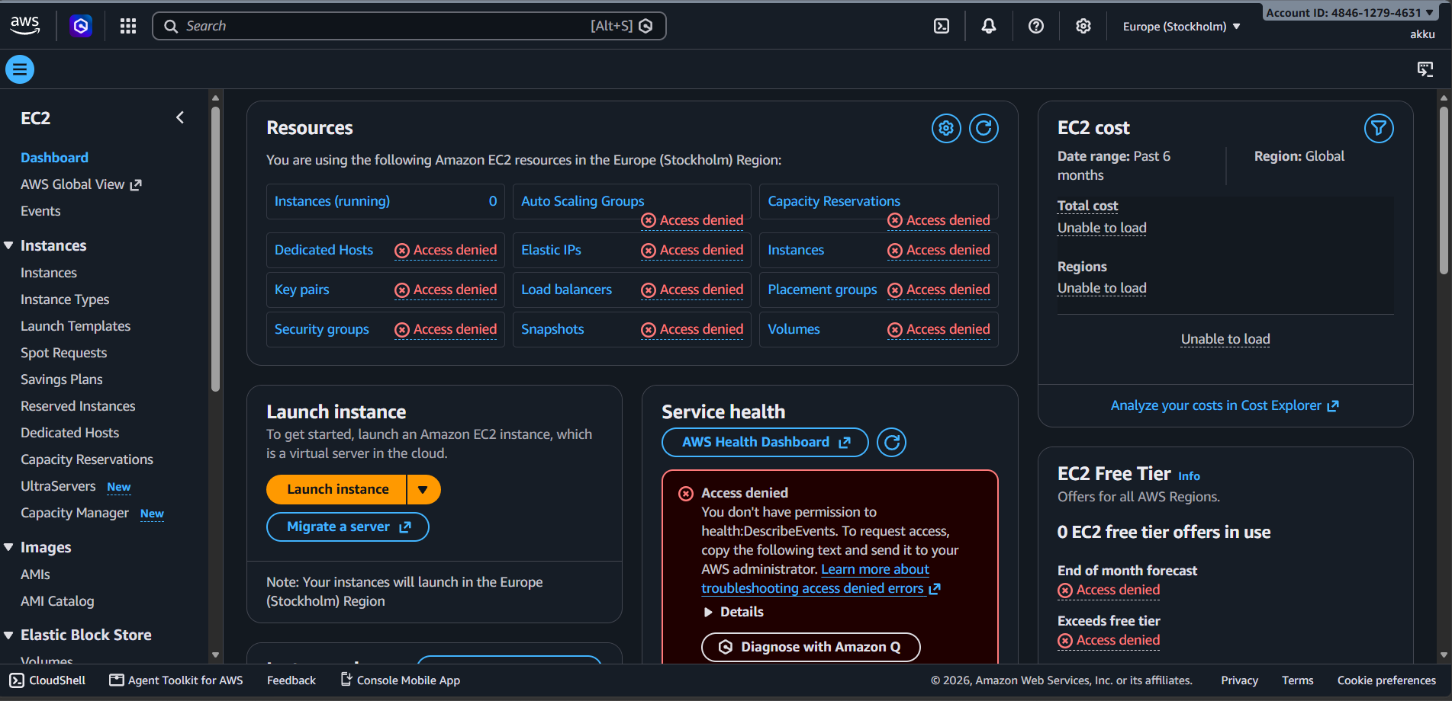
What to do in this step
- Sign in with the new IAM user (akku) using the console sign-in URL.
- Search for EC2 and open the EC2 Dashboard in Europe (Stockholm).
- The Resources box shows Access denied for almost every item.
- Instances, Key pairs, Security groups, Volumes and Snapshots are denied.
- Auto Scaling Groups, Elastic IPs and Load balancers are also denied.
- Service health shows: you don't have permission to health:DescribeEvents.
- EC2 cost and EC2 Free Tier sections show Unable to load.
- The reason is that no EC2 policy was attached to this user.
- The user only got the S3-related policy in the permissions step.
- Result: EC2 access is NOT given to this user.

STEP 11 OF 11
Test Access: Amazon S3 (Access Given)
Open Amazon S3 with the same user to check that access works.
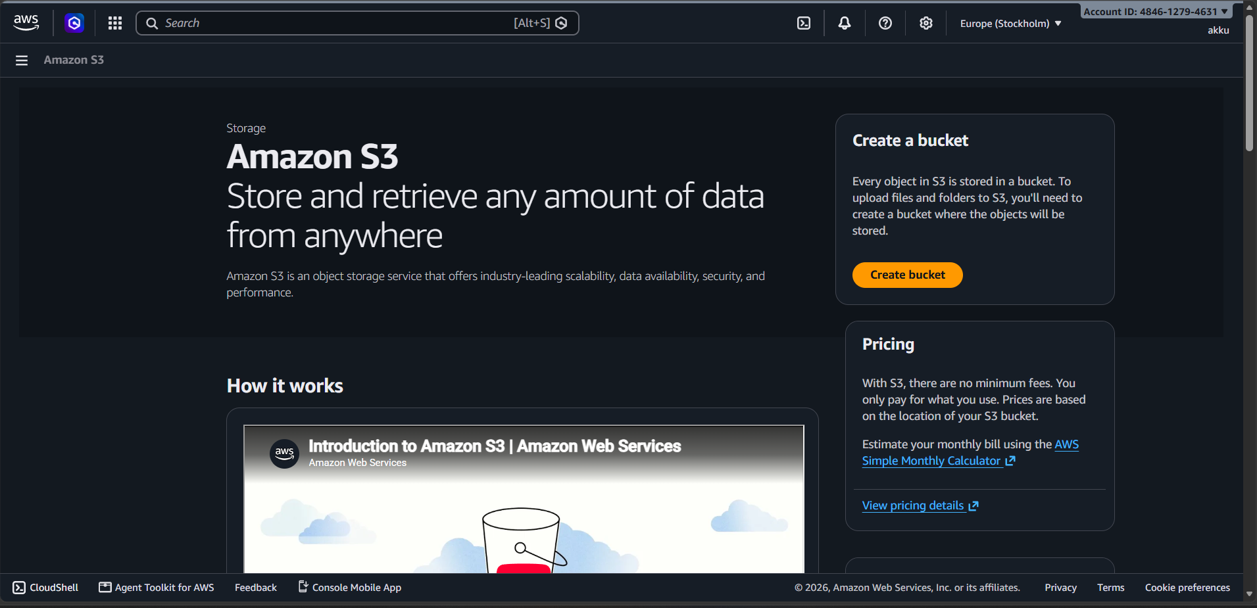
What to do in this step
- With the same user (akku), search for S3 in the top search bar.
- Open Amazon S3, the object storage service of AWS.
- The S3 home page opens normally, with no Access denied error.
- The page says: store and retrieve any amount of data from anywhere.
- The Create a bucket box with the orange Create bucket button is visible.
- Every object in S3 is stored inside a bucket that you create.
- The Pricing box explains there are no minimum fees; pay only for use.
- The How it works section shows an introduction video about S3.
- This works because an S3-related policy was attached to the user.
- Result: Amazon S3 access IS given to this user.

