AWS
AWS IAM Project
Users, Access Testing and User Groups
AWS Identity and Access Management (IAM)
A complete step-by-step project with screenshots: creating IAM users, testing their access and creating user groups.
Total Steps: 14 | Console: AWS Management Console | Service: IAM
Account ID: 484612794631

PROJECT OVERVIEW
About This Project
Objective, services used and contents.
Objective
This project shows how to manage access in AWS using IAM. We create IAM users, give them permissions, test what they can and cannot access (S3 and EC2), and then create user groups to manage users together.
Services Used
AWS IAM (users, policies, user groups), Amazon S3 and Amazon EC2 (for access testing). Region: Global for IAM, Europe (Stockholm) for S3 and EC2.
Contents
Part | Step | Page
1 - User Creation | 1. Open the IAM Dashboard | 3
1 - User Creation | 2. Open the IAM Users List | 4
1 - User Creation | 3. Specify User Details (Step 1) | 5
1 - User Creation | 4. Set Permissions (Step 2) | 6
1 - User Creation | 5. Select Policy and Continue | 7
1 - User Creation | 6. Review and Create - Summary (Step 3) | 8
1 - User Creation | 7. Click Create User | 9
1 - User Creation | 8. Retrieve Password (Step 4) | 10
1 - User Creation | 9. Verify the New User in the List | 11
2 - Access Testing | 10. Test Access: EC2 (Access Denied) | 12
2 - Access Testing | 11. Test Access: Amazon S3 (Access Given) | 13
3 - User Groups | 12. IAM User Groups - Empty List | 14
3 - User Groups | 13. Create User Group (Name and Users) | 15
3 - User Groups | 14. User Groups Created Successfully | 16
Summary | Access and Groups Summary | 17

PART 1 - USER CREATION | STEP 1 OF 14
Open the IAM Dashboard
Sign in to the AWS Management Console and search for IAM.
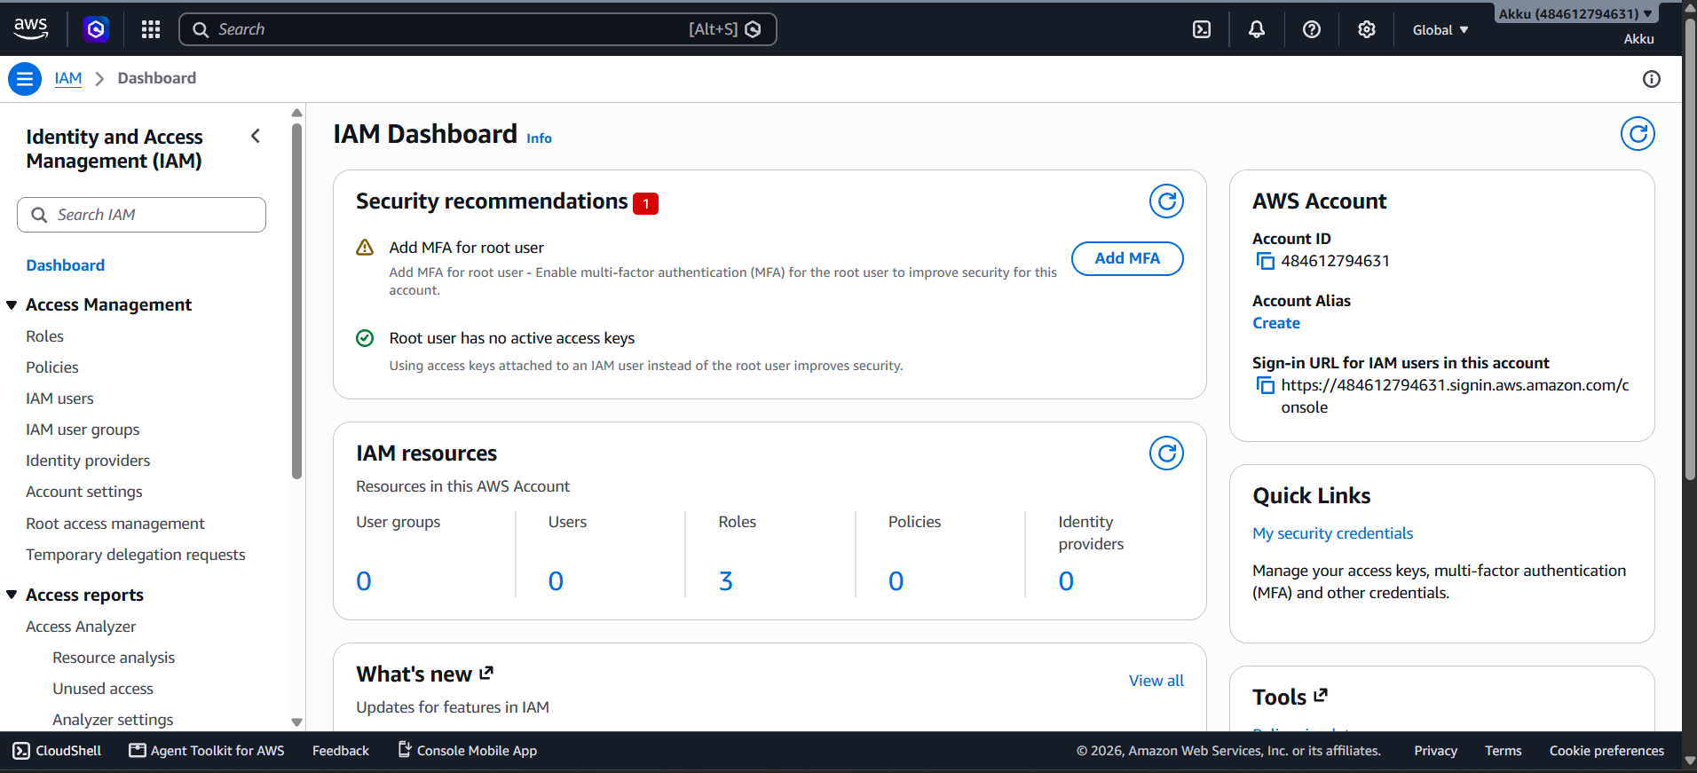
What to do in this step
- Log in to the AWS Management Console with your root or admin account.
- In the top search bar, type IAM and open Identity and Access Management.
- The IAM Dashboard opens and shows an overview of your account security.
- The Security recommendations box warns you to add MFA for the root user.
- The IAM resources box shows User groups, Users, Roles, Policies and Identity providers.
- Here the account currently has 0 users, 0 groups and 3 roles.
- The AWS Account box shows your Account ID: 484612794631.
- It also shows the sign-in URL that IAM users will use to log in.
- The left menu contains Roles, Policies, IAM users and User groups.
- Click IAM users in the left menu to continue to the next step.

PART 1 - USER CREATION | STEP 2 OF 14
Open the IAM Users List
From the left menu, click IAM users to see all users.
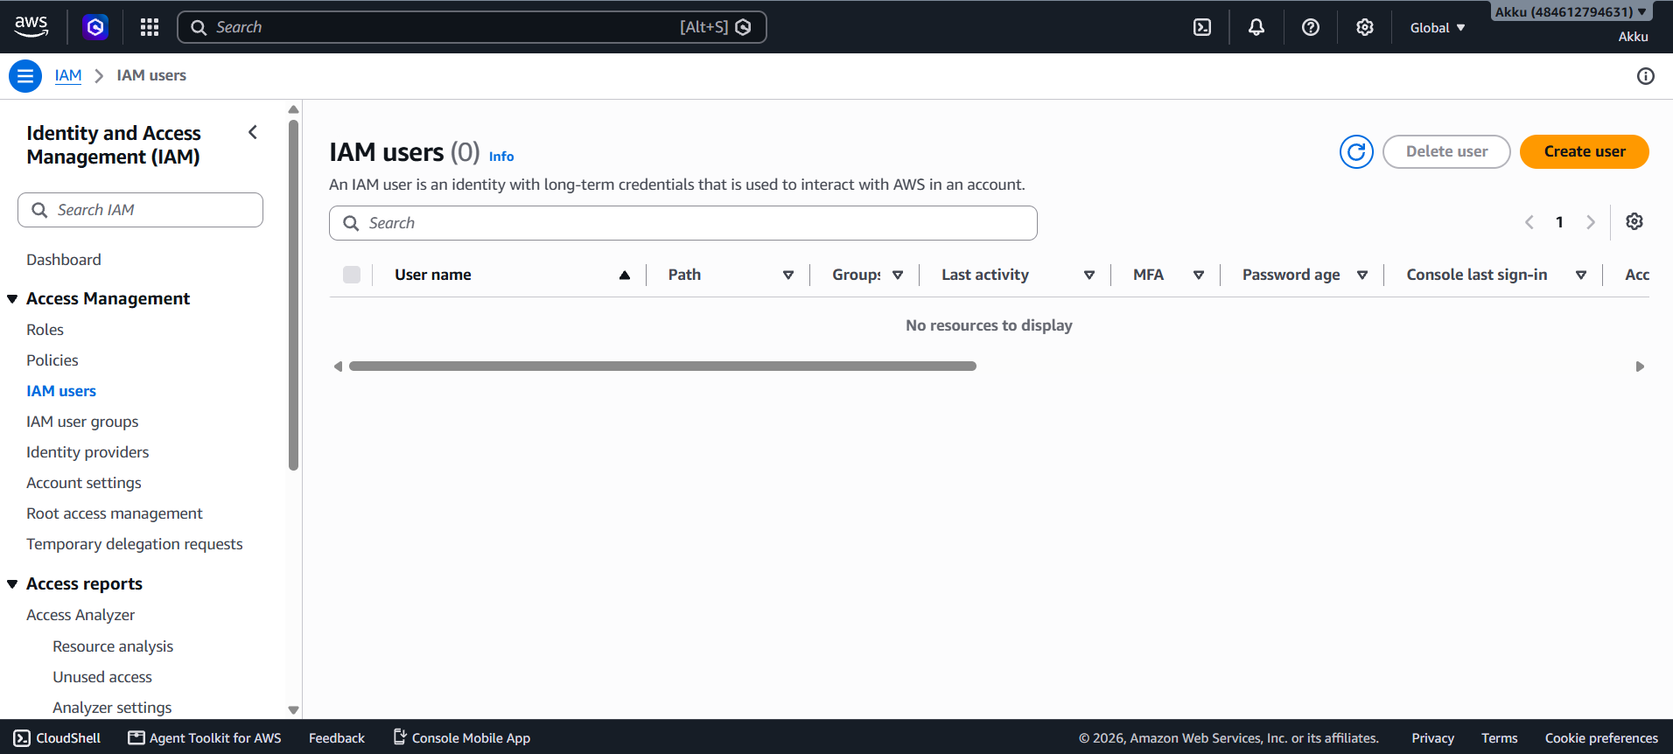
What to do in this step
- Click IAM users under Access Management in the left navigation menu.
- The IAM users page opens and shows the total count in brackets.
- An IAM user is an identity with long-term credentials to use AWS.
- Currently the count is (0), so the message No resources to display appears.
- The table has columns: User name, Path, Groups, Last activity and MFA.
- More columns are Password age and Console last sign-in.
- You can use the Search box to find any user by name.
- The Delete user button is used to remove selected users.
- The orange Create user button is used to add a new user.
- Click Create user to start the user creation wizard.

PART 1 - USER CREATION | STEP 3 OF 14
Specify User Details (Step 1)
Enter the user name and set the console password options.
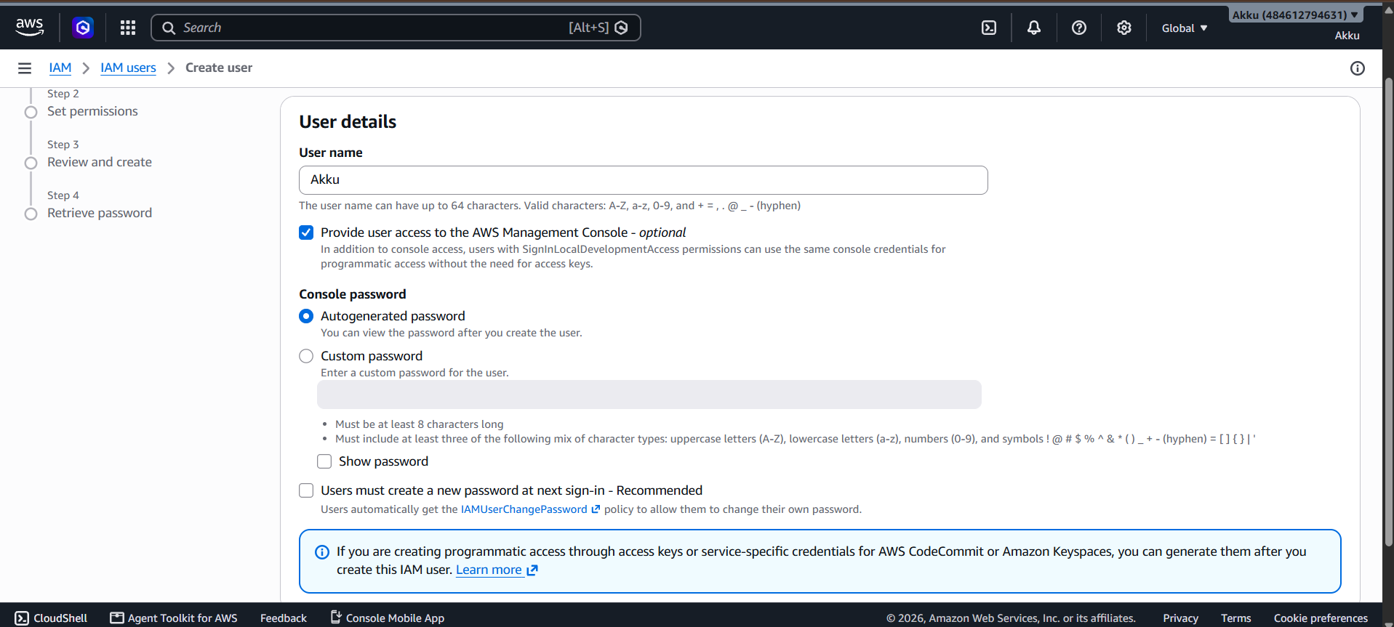
What to do in this step
- The Create user wizard opens with four steps shown on the left side.
- In User name, type the name of the user (for example: Akku).
- A user name can have up to 64 characters using letters, numbers and symbols.
- Tick Provide user access to the AWS Management Console to allow console login.
- Under Console password, select Autogenerated password to let AWS create one.
- Or select Custom password and type your own strong password.
- A custom password needs 8+ characters and a mix of character types.
- Use Show password to check what you typed.
- Users must create a new password at next sign-in is recommended for security.
- After filling in the details, scroll down and click Next.

PART 1 - USER CREATION | STEP 4 OF 14
Set Permissions (Step 2)
Choose how the new user will get access to AWS services.
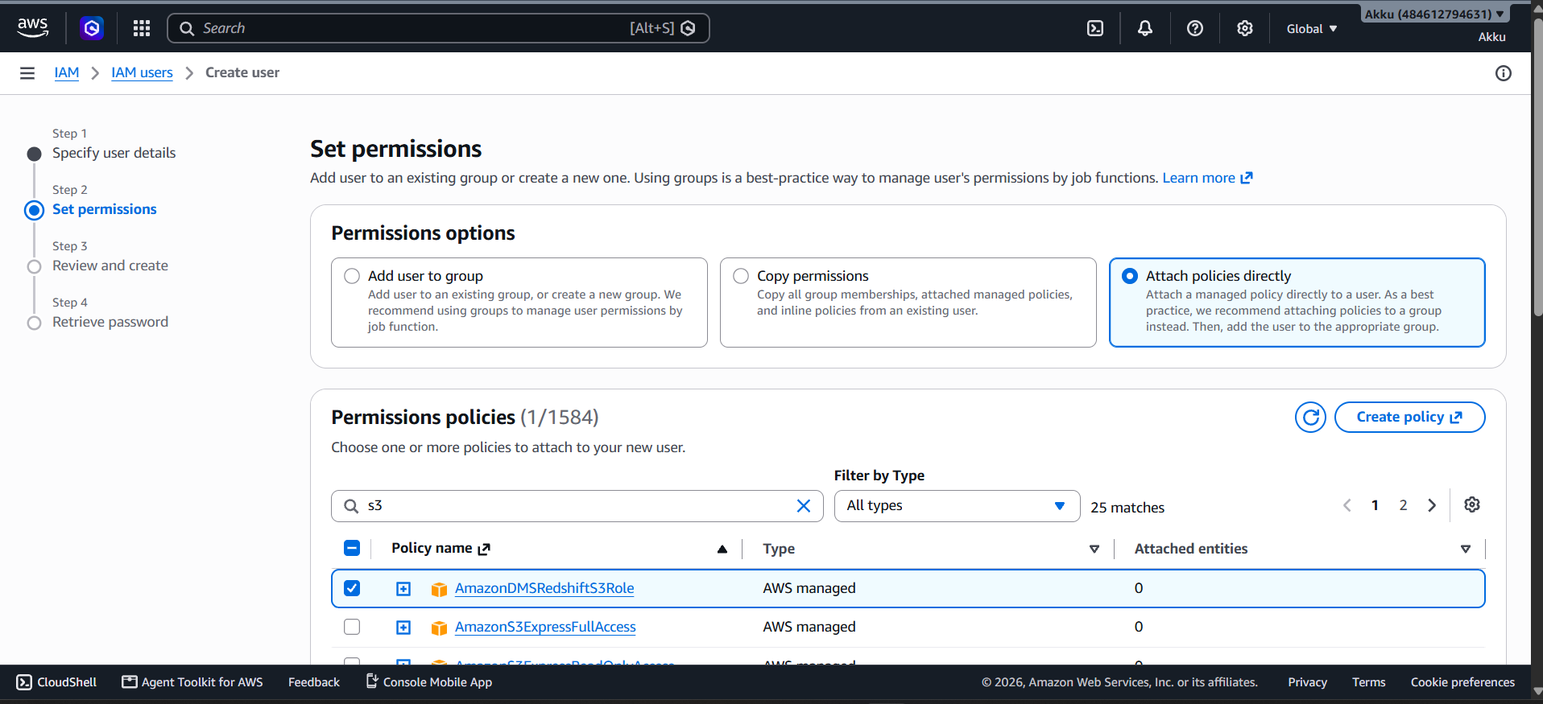
What to do in this step
- Step 2 is Set permissions, where you decide what the user can access.
- Add user to group is the best practice for managing job-based permissions.
- Copy permissions copies groups and policies from an existing user.
- Attach policies directly gives permissions straight to this user.
- In this example, Attach policies directly is selected.
- The Permissions policies list shows 1584 available policies.
- Type s3 in the search box to filter, which gives 25 matches.
- Filter by Type lets you choose AWS managed or Customer managed policies.
- Tick the checkbox of the policy you want, e.g. AmazonDMSRedshiftS3Role.
- Use the arrows or page numbers to view more policies in the list.

PART 1 - USER CREATION | STEP 5 OF 14
Select Policy and Continue
Scroll down, choose policies, and click Next.
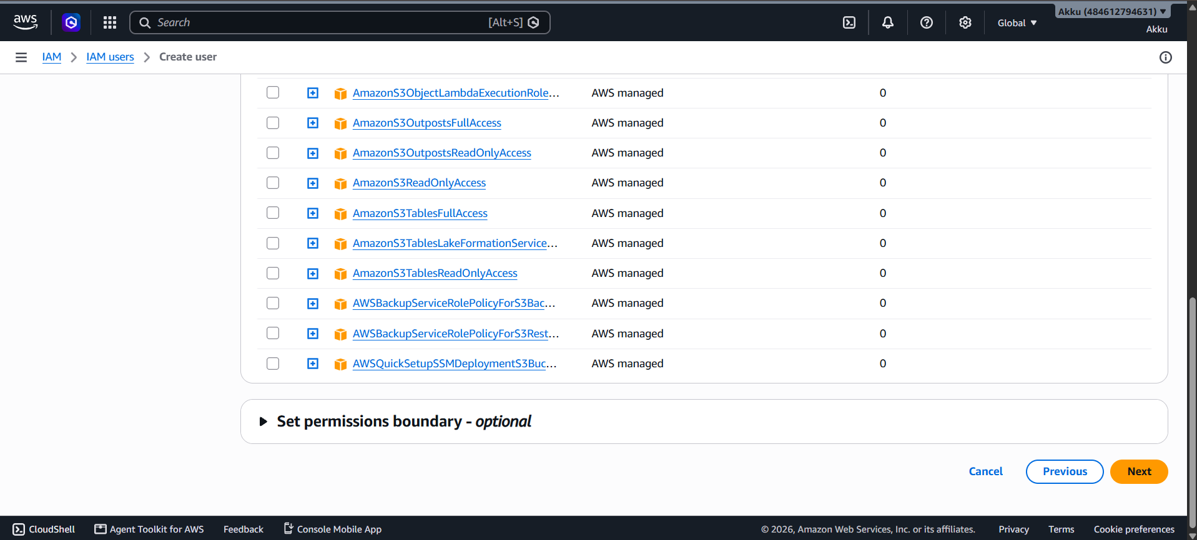
What to do in this step
- Scroll down the policy list to see more S3-related policies.
- Examples are AmazonS3ReadOnlyAccess and AmazonS3OutpostsFullAccess.
- Each row shows the Policy name, Type and Attached entities count.
- All these policies are AWS managed, created and maintained by AWS.
- Click the plus (+) icon before a policy name to preview its permissions.
- Always give only the minimum permissions needed (least privilege).
- Set permissions boundary is optional and limits the maximum permissions.
- Leave the permissions boundary closed if you do not need it.
- The Cancel button stops the process and Previous goes back one step.
- Click the orange Next button to go to the review page.

PART 1 - USER CREATION | STEP 6 OF 14
Review and Create - Summary (Step 3)
Check all details before creating the user.
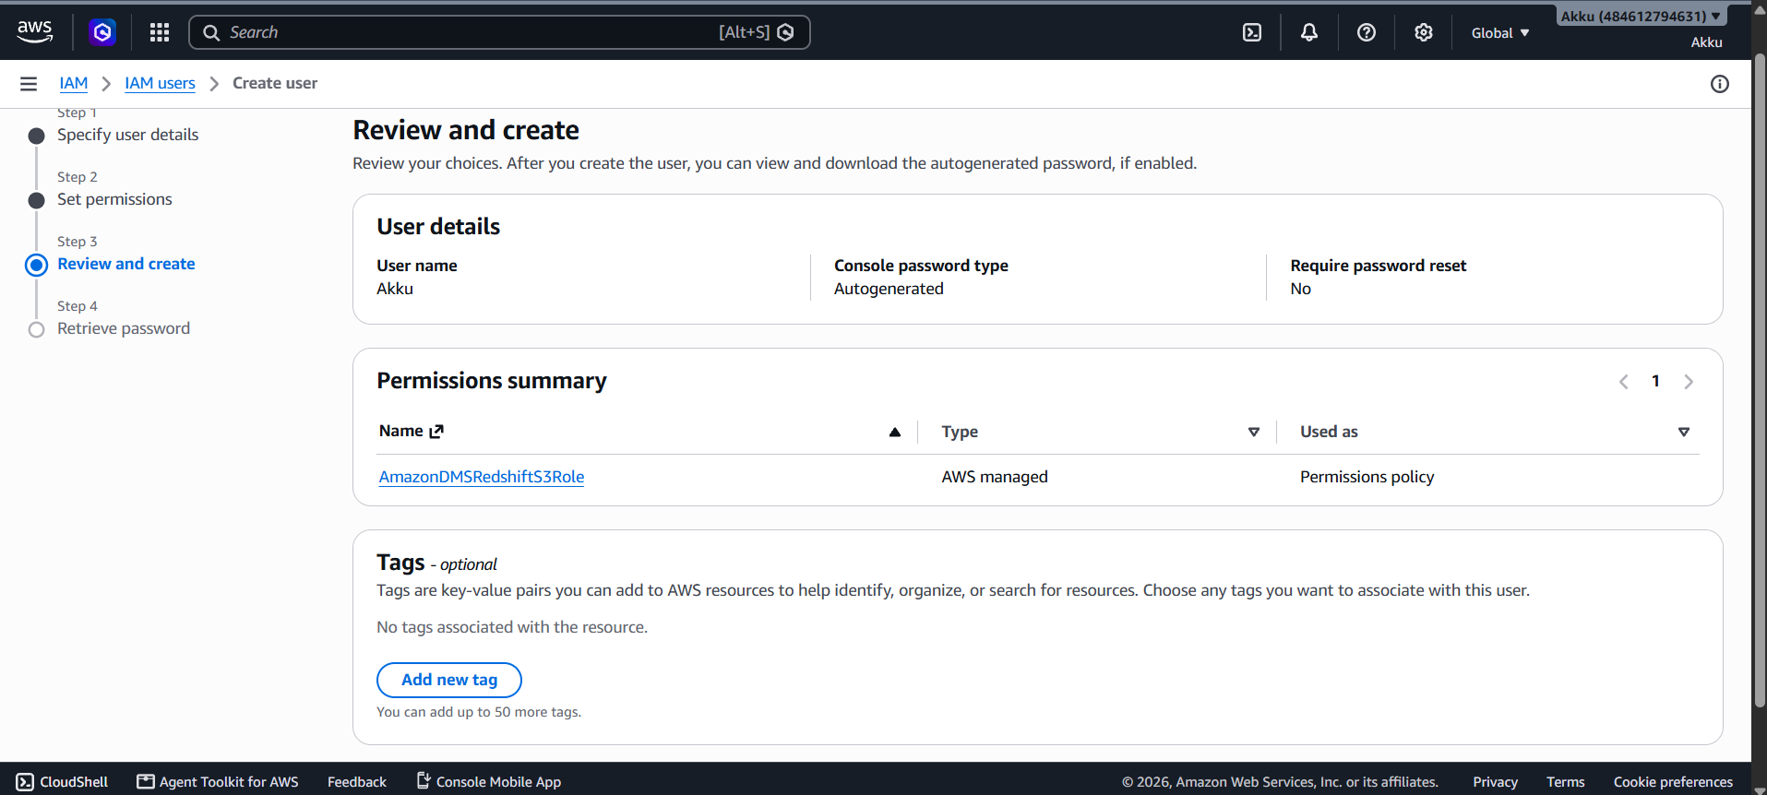
What to do in this step
- Step 3 is Review and create, a final check of your choices.
- User details shows the User name, here: Akku.
- Console password type shows Autogenerated.
- Require password reset shows No for this user.
- Permissions summary lists the attached policy: AmazonDMSRedshiftS3Role.
- The policy Type is AWS managed and it is used as a Permissions policy.
- The Tags section is optional and helps you organize resources.
- Click Add new tag to add key-value pairs; up to 50 tags are allowed.
- Here no tags are added, which is fine for a basic user.
- Scroll down to find the Create user button.

PART 1 - USER CREATION | STEP 7 OF 14
Click Create User
Confirm the settings and create the IAM user.
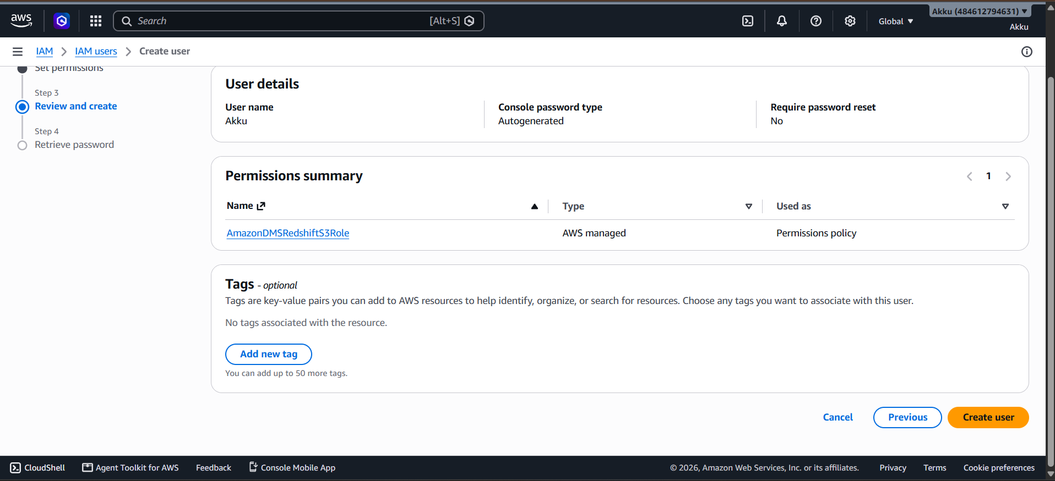
What to do in this step
- Scroll to the bottom of the Review and create page.
- Re-check the user name, password type and permissions summary once more.
- Three buttons are shown: Cancel, Previous and Create user.
- Cancel stops the whole process without creating anything.
- Previous lets you go back and change the earlier settings.
- Create user is the orange button that finishes the process.
- Click Create user to create the IAM user in your AWS account.
- AWS will create the user with the selected password and permissions.
- The permissions policy is attached to the user automatically.
- After a few seconds, the Retrieve password page will open.

PART 1 - USER CREATION | STEP 8 OF 14
Retrieve Password (Step 4)
Save the sign-in details of the new user safely.
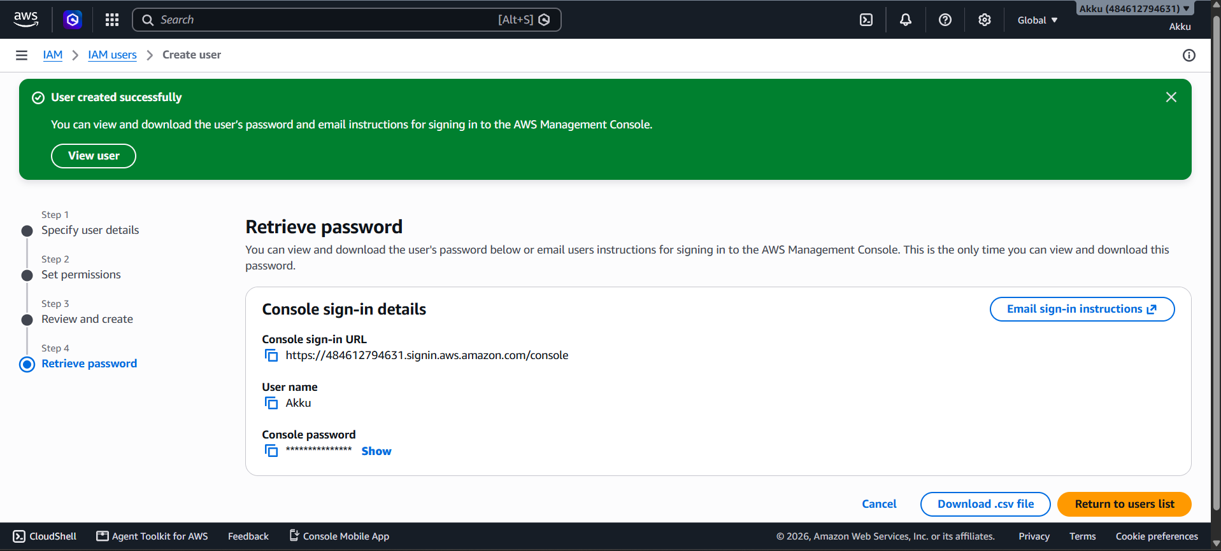
What to do in this step
- A green banner shows User created successfully.
- Step 4 is Retrieve password with the Console sign-in details.
- Console sign-in URL is https://484612794631.signin.aws.amazon.com/console.
- User name shows the new user name, here: Akku.
- Console password is hidden; click Show to see the password.
- Use the copy icons to copy the URL, user name or password.
- Click Download .csv file to save all sign-in details on your computer.
- Or click Email sign-in instructions to send details to the user.
- This is the only time you can view and download this password.
- Click Return to users list when you are done.

PART 1 - USER CREATION | STEP 9 OF 14
Verify the New User in the List
Confirm that the user now appears in the IAM users list.
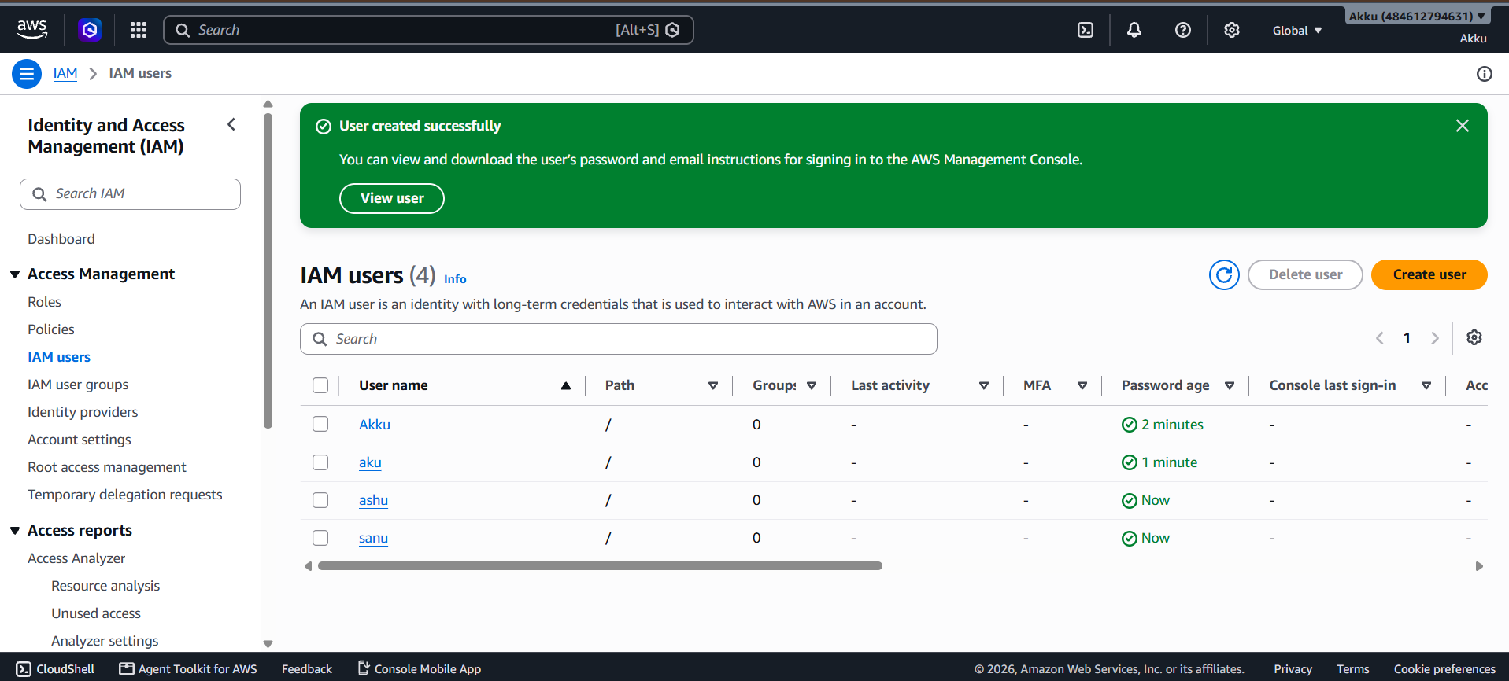
What to do in this step
- The IAM users page opens again with a green success message.
- The list now shows IAM users (4) instead of zero.
- The new user Akku appears in the User name column.
- Other users such as aku, ashu and sanu are also visible.
- The Password age column shows how recently each password was created.
- For example, Akku shows 2 minutes and ashu shows Now.
- Groups shows 0, because the users were not added to any group.
- Last activity and Console last sign-in show a dash until the first login.
- Click a user name to view details, add MFA or create access keys.
- The IAM user has been created successfully.

PART 2 - ACCESS TESTING | STEP 10 OF 14
Test Access: EC2 (Access Denied)
Log in as the new user and open EC2 to check the permissions.
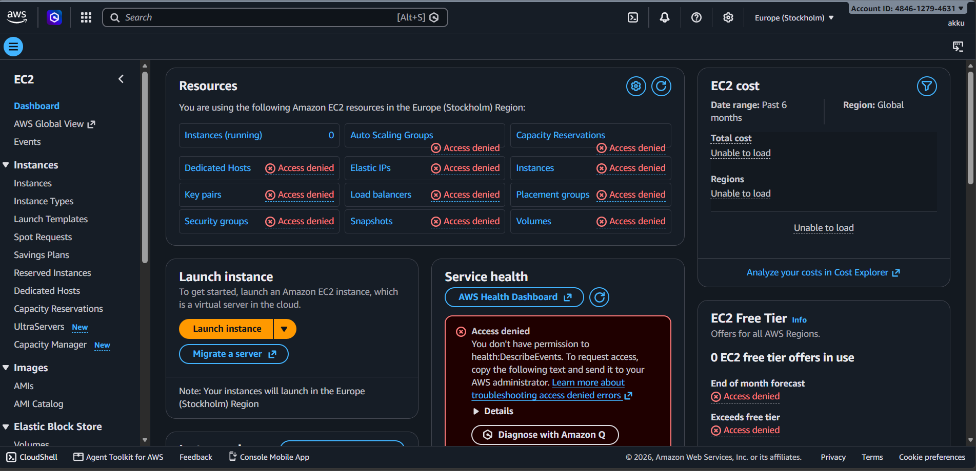
What to do in this step
- Sign in with the new IAM user (akku) using the console sign-in URL.
- Search for EC2 and open the EC2 Dashboard in Europe (Stockholm).
- The Resources box shows Access denied for almost every item.
- Instances, Key pairs, Security groups, Volumes and Snapshots are denied.
- Auto Scaling Groups, Elastic IPs and Load balancers are also denied.
- Service health shows: you don't have permission to health:DescribeEvents.
- EC2 cost and EC2 Free Tier sections show Unable to load.
- The reason is that no EC2 policy was attached to this user.
- The user only got the S3-related policy in the permissions step.
- Result: EC2 access is NOT given to this user.

PART 2 - ACCESS TESTING | STEP 11 OF 14
Test Access: Amazon S3 (Access Given)
Open Amazon S3 with the same user to check that access works.
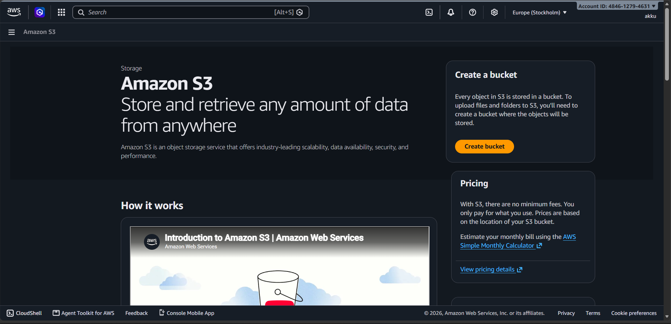
What to do in this step
- With the same user (akku), search for S3 in the top search bar.
- Open Amazon S3, the object storage service of AWS.
- The S3 home page opens normally, with no Access denied error.
- The page says: store and retrieve any amount of data from anywhere.
- The Create a bucket box with the orange Create bucket button is visible.
- Every object in S3 is stored inside a bucket that you create.
- The Pricing box explains there are no minimum fees; pay only for use.
- The How it works section shows an introduction video about S3.
- This works because an S3-related policy was attached to the user.
- Result: Amazon S3 access IS given to this user.

PART 3 - USER GROUPS | STEP 12 OF 14
IAM User Groups - Empty List
Open the User groups page to manage users together.
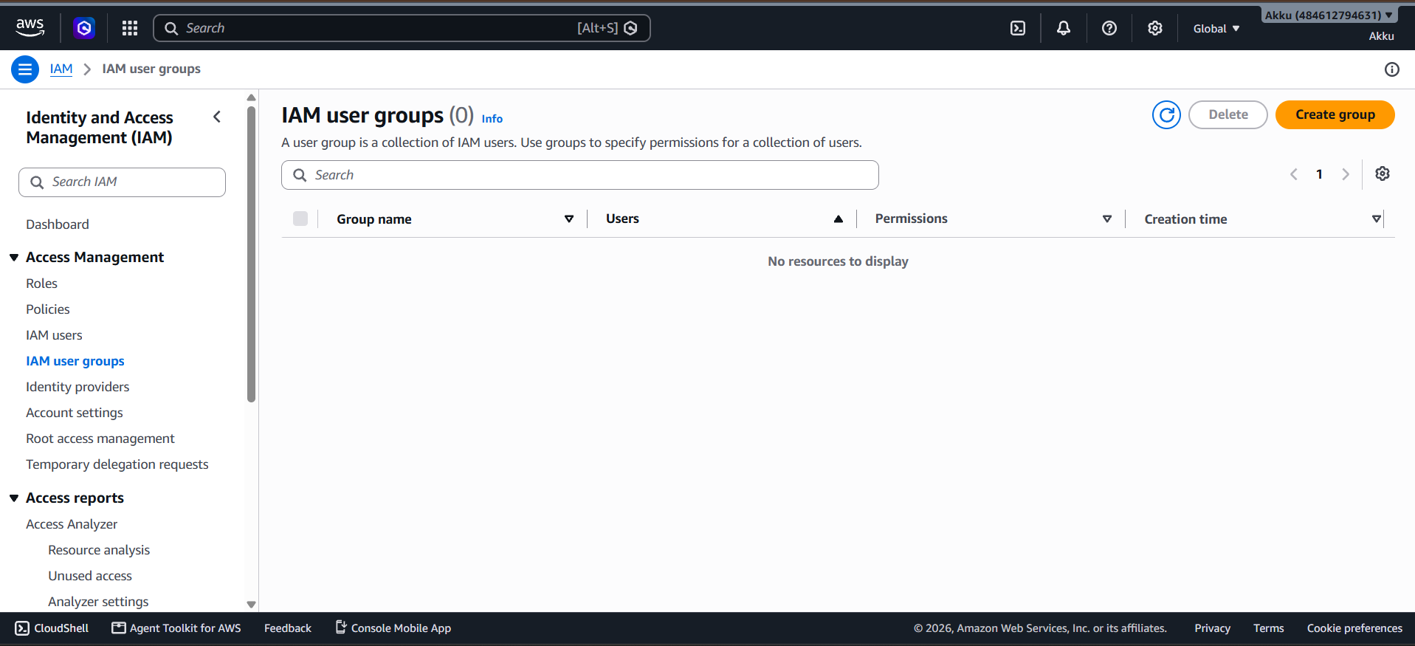
What to do in this step
- In the IAM left menu, click IAM user groups under Access Management.
- The page shows IAM user groups (0), so no group exists yet.
- A user group is a collection of IAM users.
- Groups are used to give permissions to many users at the same time.
- The table has columns: Group name, Users, Permissions and Creation time.
- The message No resources to display confirms the list is empty.
- Use the Search box to find a group by its name later.
- The Delete button removes a selected group.
- The orange Create group button is used to make a new group.
- Click Create group to start creating the first group.

PART 3 - USER GROUPS | STEP 13 OF 14
Create User Group (Name and Users)
Give the group a name and add users to it.
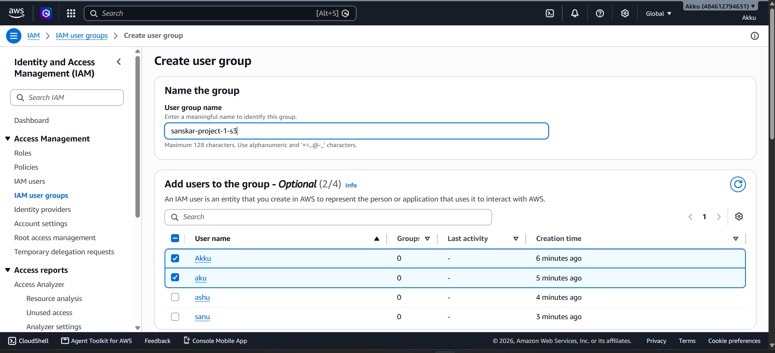
What to do in this step
- The Create user group page opens with the section Name the group.
- In User group name, type a meaningful name: sanskar-project-1-s3.
- The name can have up to 128 characters (letters, numbers and + = , . @ - _).
- The name shows that this group is meant for S3 access.
- Below, the section Add users to the group - Optional lists all IAM users.
- The list shows 4 users: Akku, aku, ashu and sanu.
- Tick the checkbox of each user to add to the group.
- Here Akku and aku are selected, shown as (2/4).
- Scroll down to attach permissions policies and other options.
- Click Create user group at the bottom to finish.

PART 3 - USER GROUPS | STEP 14 OF 14
User Groups Created Successfully
Verify that both groups now appear in the list.
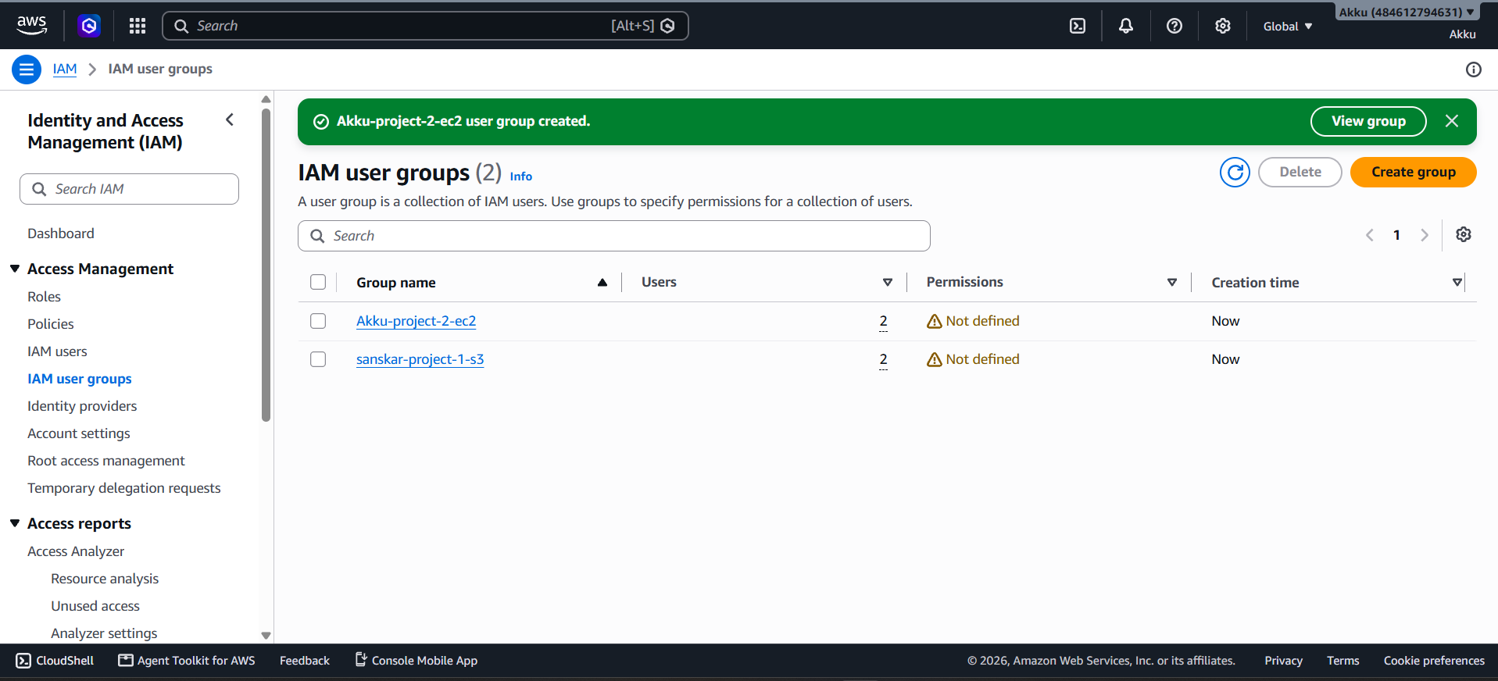
What to do in this step
- A green banner shows: Akku-project-2-ec2 user group created.
- The list now shows IAM user groups (2).
- The first group is Akku-project-2-ec2, meant for EC2 access.
- The second group is sanskar-project-1-s3, meant for S3 access.
- The Users column shows 2 users in each group.
- The Permissions column shows Not defined for both groups.
- Not defined means no policy is attached to the groups yet.
- The Creation time column shows Now, as the groups are just created.
- Click a group name to open it and attach policies such as S3 or EC2 access.
- Once policies are attached, all group members get those permissions.

SUMMARY
Access and Groups Summary
Which services the user can use, and the groups created.
Service | Access | Reason
Amazon S3 | ALLOWED | S3 page opens; S3 policy is attached to the user.
EC2 Dashboard | DENIED | No EC2 policy attached; resources show Access denied.
EC2 Instances / Key pairs / Volumes | DENIED | Not included in the attached permissions policy.
EC2 Load balancers / Elastic IPs | DENIED | Not included in the attached permissions policy.
AWS Health / Cost data | DENIED | health:DescribeEvents and cost permissions are missing.
User Groups Created
Group name | Users | Permissions | Purpose
sanskar-project-1-s3 | 2 | Not defined yet | S3 access group
Akku-project-2-ec2 | 2 | Not defined yet | EC2 access group
Next step: attach an S3 policy to sanskar-project-1-s3 and an EC2 policy to Akku-project-2-ec2, so all group members get the right access.

