Amazon S3
Bucket Creation • File Upload • Object Verification • Bucket Deletion

Service | Amazon Simple Storage Service (Amazon S3)
Region shown | Asia Pacific (Mumbai) — ap-south-1
Bucket used | sanskar-s3-1
Uploaded object | AWS_EBS_Create_Volume_Report.docx

Purpose
This practical report documents the S3 workflow shown in the supplied screenshots. Each screenshot is placed in sequence with a short explanation so the procedure can be reviewed or submitted as a step-by-step practical record.

Contents
Series 1 Create an Amazon S3 bucket
Series 1A Configure bucket settings
Series 1B Upload and verify a file
Series 2 Delete the S3 bucket

Practical Result
Create: Bucket sanskar-s3-1 was successfully created in the Mumbai region.
Upload: The document AWS_EBS_Create_Volume_Report.docx was uploaded successfully.
Delete: The final screenshot confirms that the bucket was successfully deleted.

Series 1 — Create an Amazon S3 Bucket
Objective: Create a general-purpose S3 bucket in the Asia Pacific (Mumbai) region, keep public access blocked, use the default S3-managed encryption option, and then store a document inside the bucket.

SERIES 1 / STEP 1

Step 1 — Open Amazon S3

Open the Amazon S3 console. The S3 landing page provides the option to create a new bucket. A bucket is the container in which S3 objects are stored.

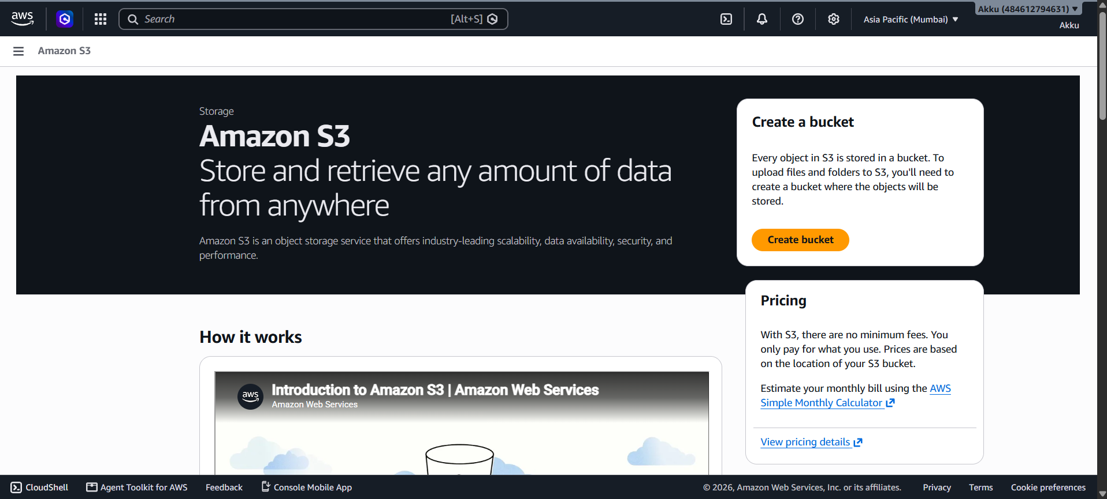
Figure 1. Step 1 — Open Amazon S3

SERIES 1 / STEP 2

Step 2 — Open Create bucket

Select Create bucket. The screenshot shows the Mumbai region (ap-south-1), the General purpose bucket type, and the bucket name field containing “sanskar-s3-1”.

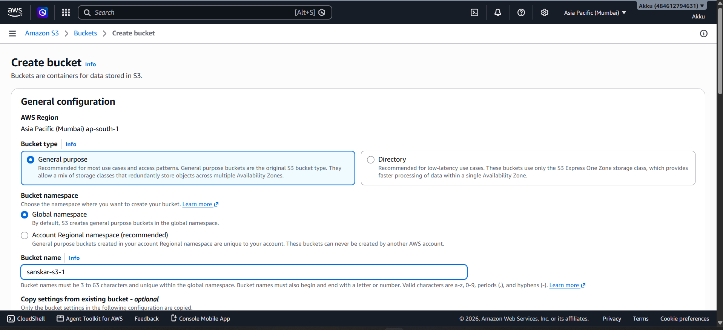
Figure 2. Step 2 — Open Create bucket

SERIES 1 / STEP 3

Step 3 — Configure Object Ownership

Review Object Ownership. “ACLs disabled (recommended)” is selected, so access is managed through policies rather than object ACLs.

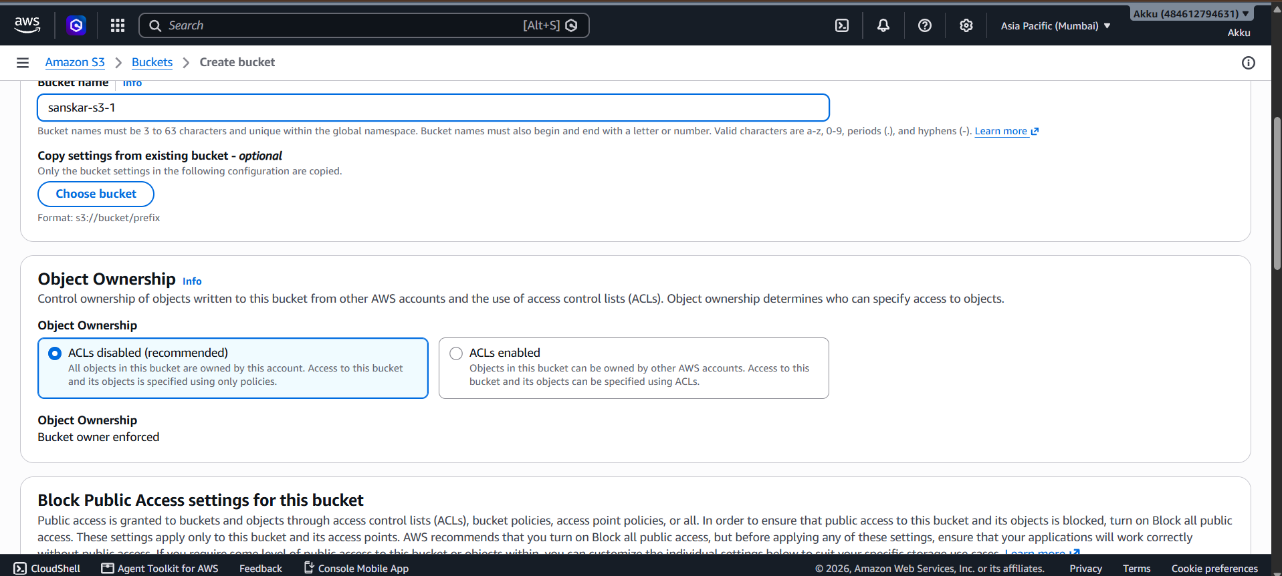
Figure 3. Step 3 — Configure Object Ownership

SERIES 1 / STEP 4

Step 4 — Configure Block Public Access

Review Block Public Access. “Block all public access” is enabled, which is the safer default for a private practice bucket unless public access is specifically required.

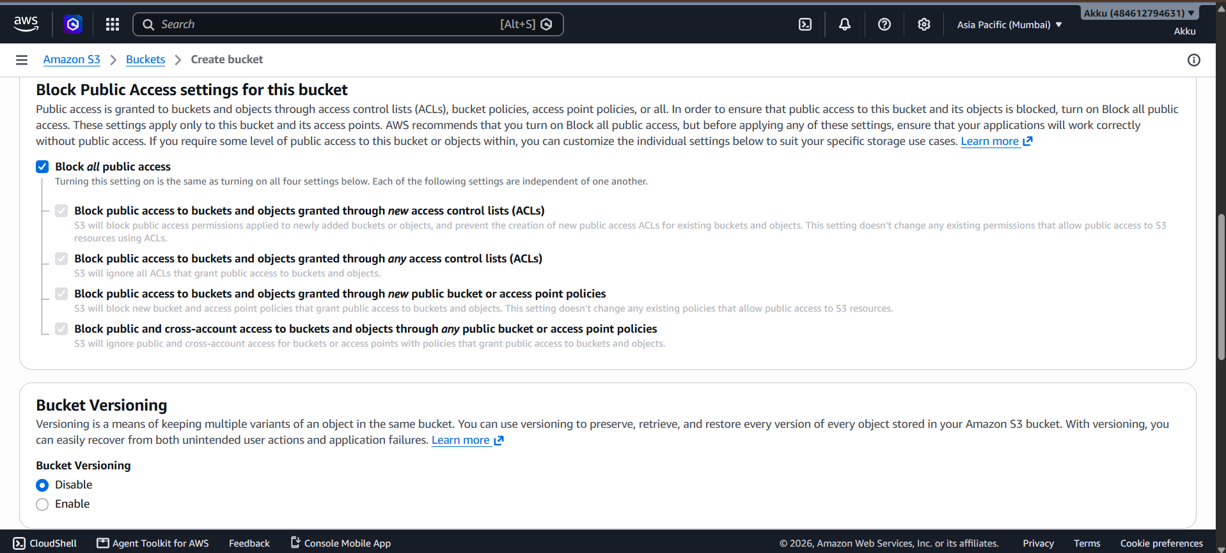
Figure 4. Step 4 — Configure Block Public Access

SERIES 1 / STEP 5

Step 5 — Review Tags

Tags are optional. No tags were added in this workflow, so the configuration can continue without creating any tag entries.

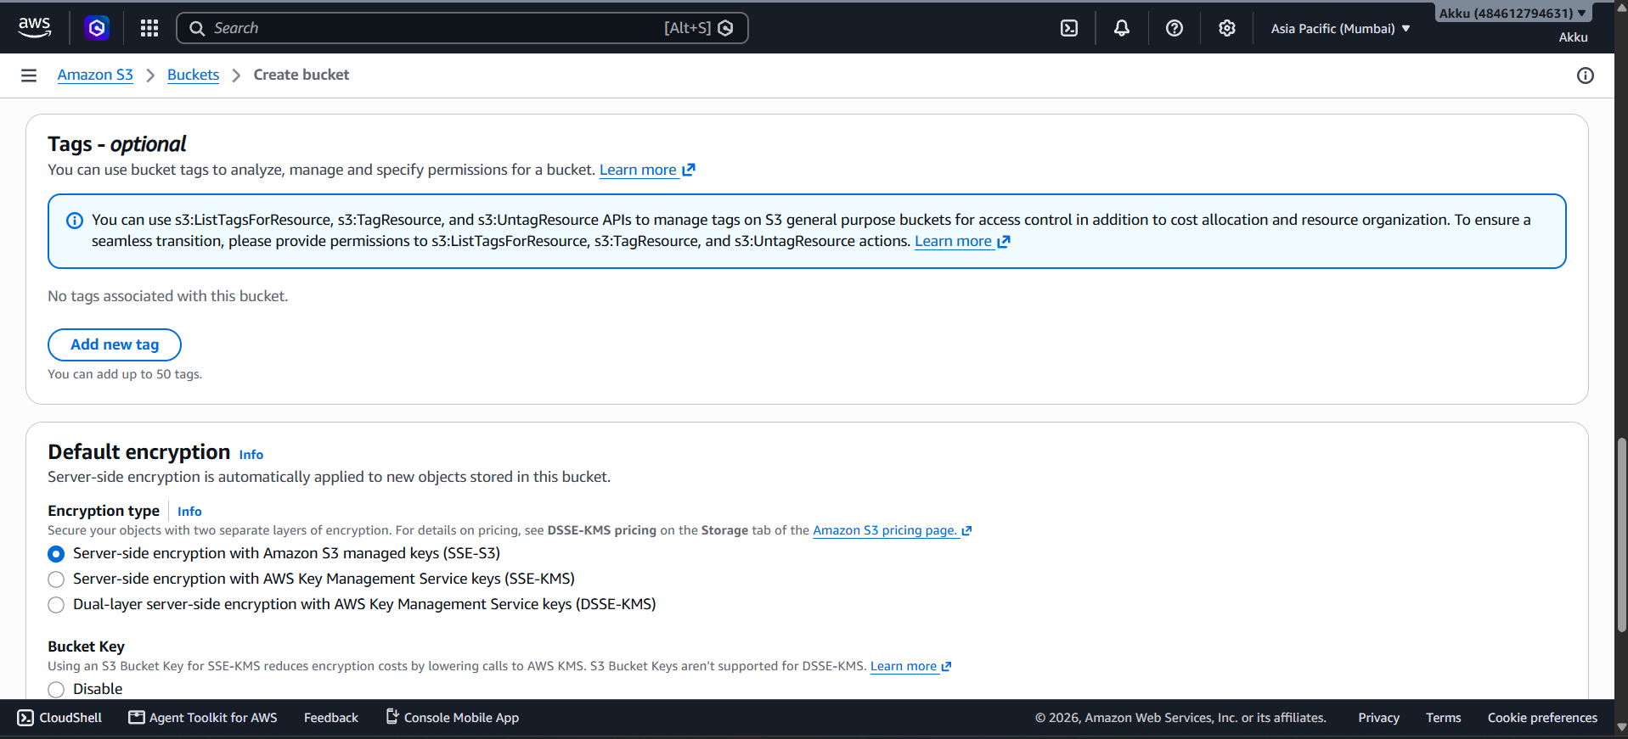
Figure 5. Step 5 — Review Tags

SERIES 1 / STEP 6

Step 6 — Configure Default Encryption

Review Default Encryption. The screenshot shows SSE-S3 (Amazon S3 managed keys) selected. Bucket Key is enabled in the shown configuration.

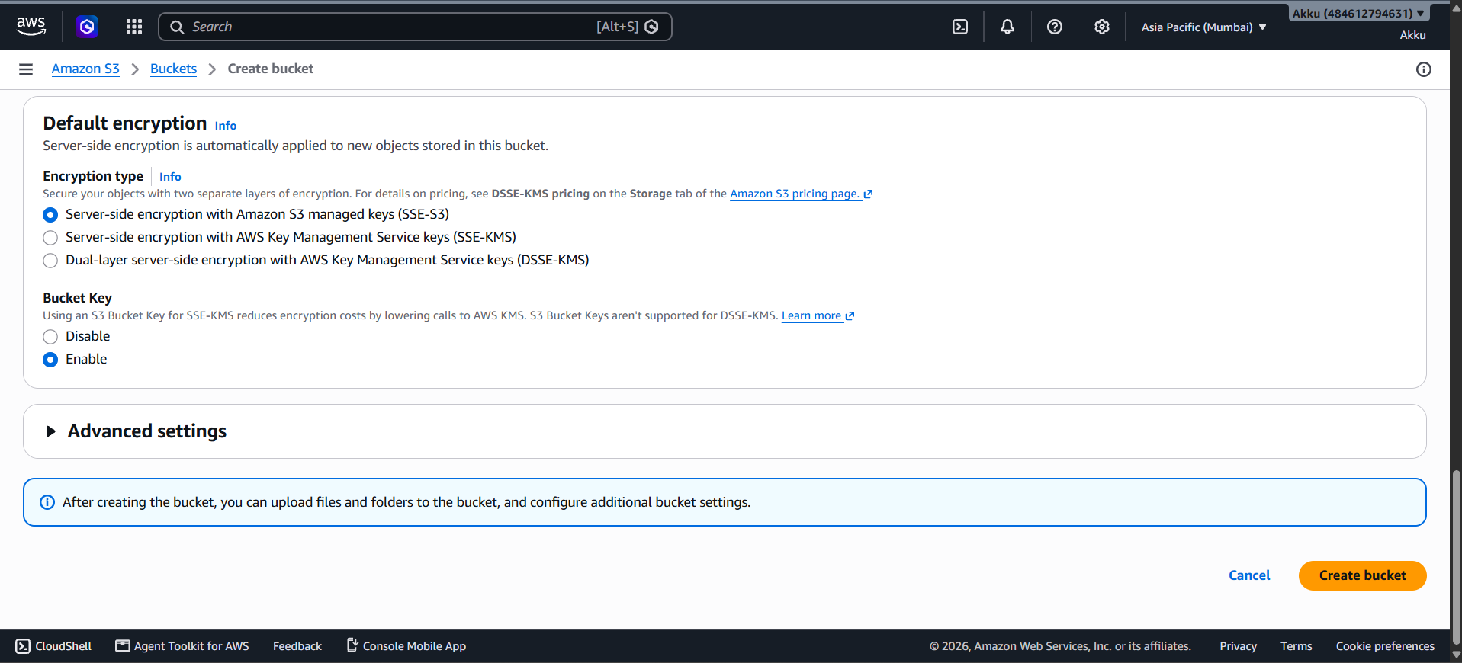
Figure 6. Step 6 — Configure Default Encryption

SERIES 1 / STEP 7

Step 7 — Create the S3 bucket

Click Create bucket. The green success message confirms that “sanskar-s3-1” was created successfully.

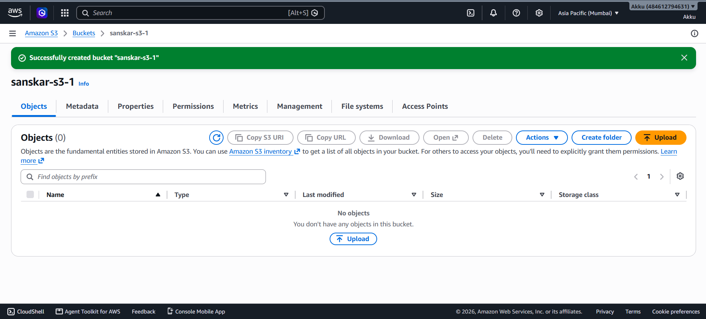
Figure 7. Step 7 — Create the S3 bucket

SERIES 1 / STEP 8

Step 8 — Upload a document

Open the bucket's Upload page and add the document AWS_EBS_Create_Volume_Report.docx. The destination is shown as s3://sanskar-s3-1.

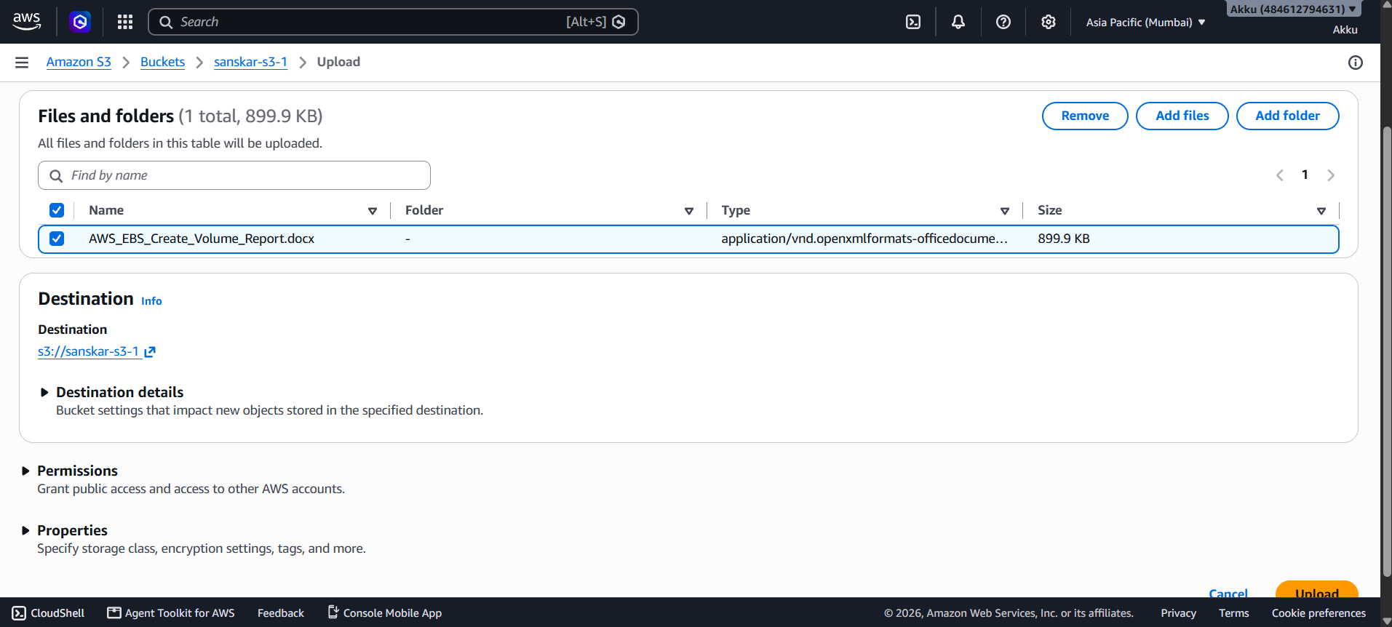
Figure 8. Step 8 — Upload a document

SERIES 1 / STEP 9

Step 9 — Verify the upload

Start the upload. The success summary shows 1 file uploaded, 899.9 KB, with 100% success and 0 failed files.

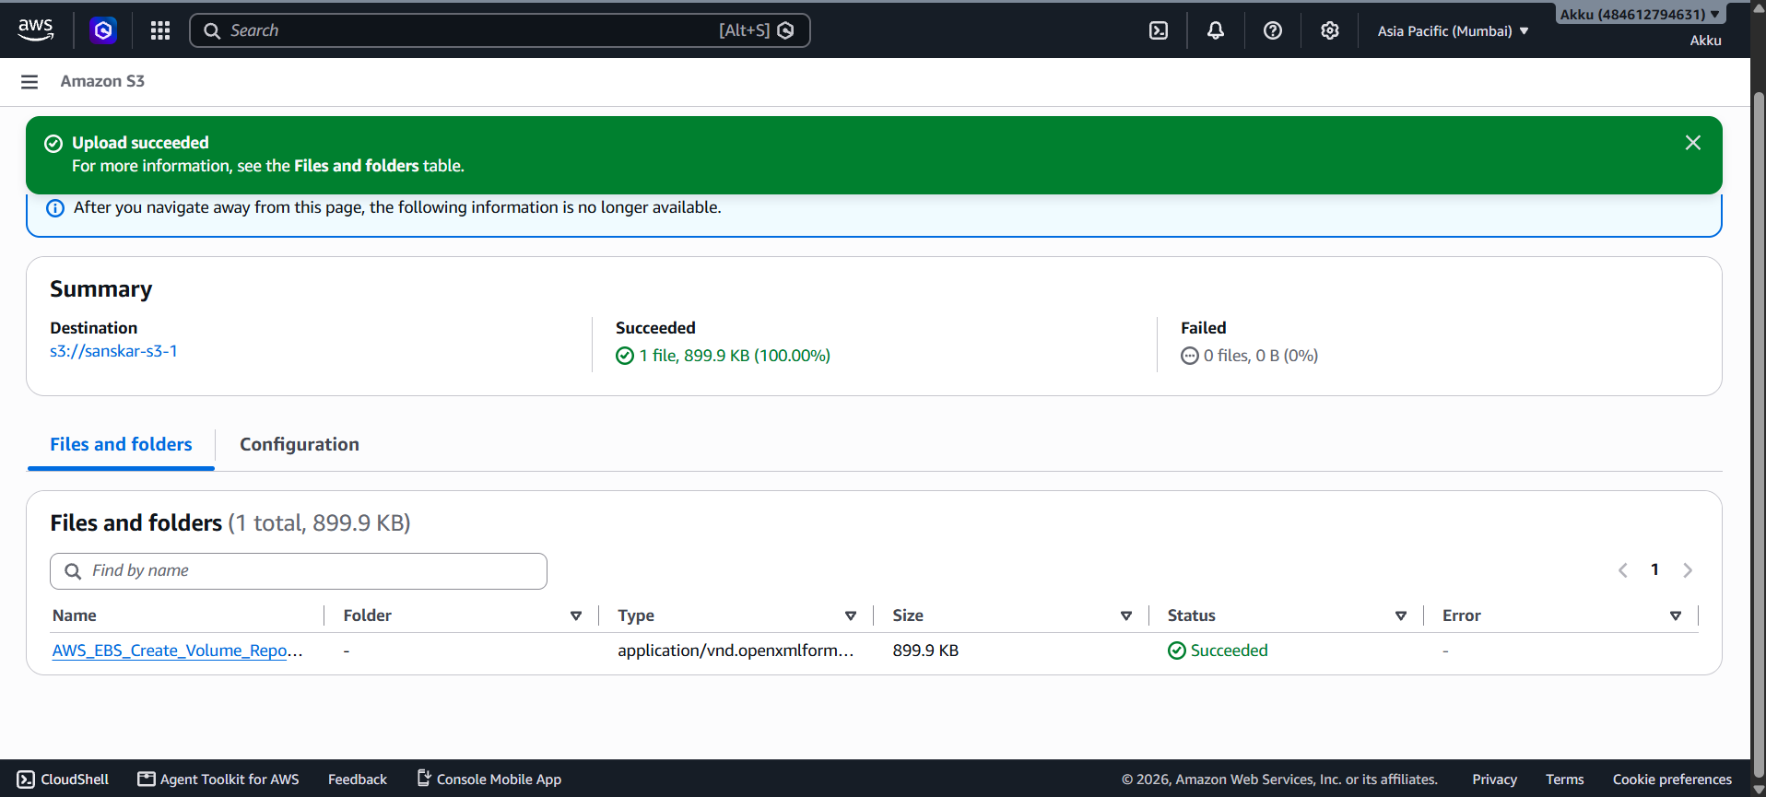
Figure 9. Step 9 — Verify the upload

SERIES 1 / STEP 10

Step 10 — Open the uploaded object

Open the uploaded object. The object details show the S3 URI, ARN, object URL, region, size, type, and last-modified time.

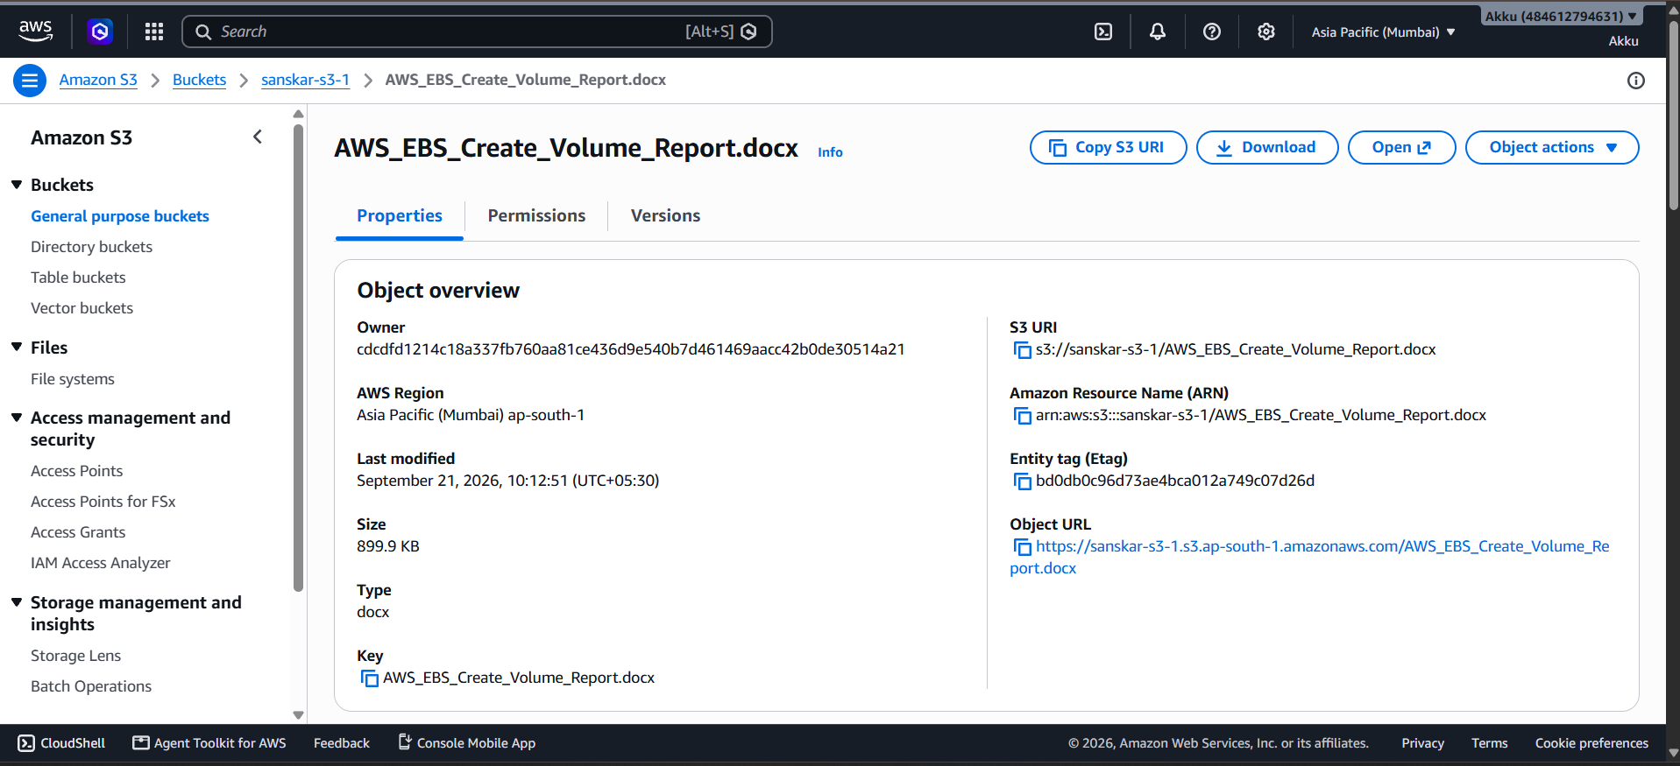
Figure 10. Step 10 — Open the uploaded object

SERIES 1 / STEP 11

Step 11 — Verify the object in the bucket

Return to the bucket's Objects view. The document appears in the object list with Storage class Standard, confirming that the object is stored in the bucket.

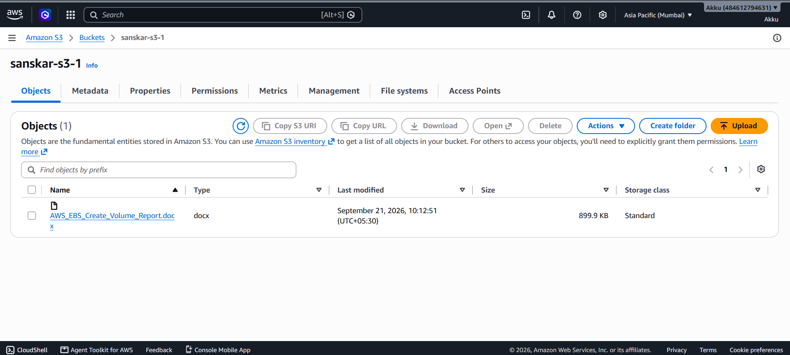
Figure 11. Step 11 — Verify the object in the bucket

Series 2 — Delete the Amazon S3 Bucket

Objective: Remove the S3 bucket after the practical work is complete. The supplied screenshot is the final confirmation screen showing that the bucket was successfully deleted.

SERIES 2 / FINAL RESULT

Step 12 — Confirm bucket deletion

The green confirmation banner states that the bucket “sanskar-s3-1” was successfully deleted. This is the final state of the supplied workflow. Note: the uploaded screenshots do not include the intermediate Delete/confirmation dialog itself, so this report does not invent an additional screenshot for that step.

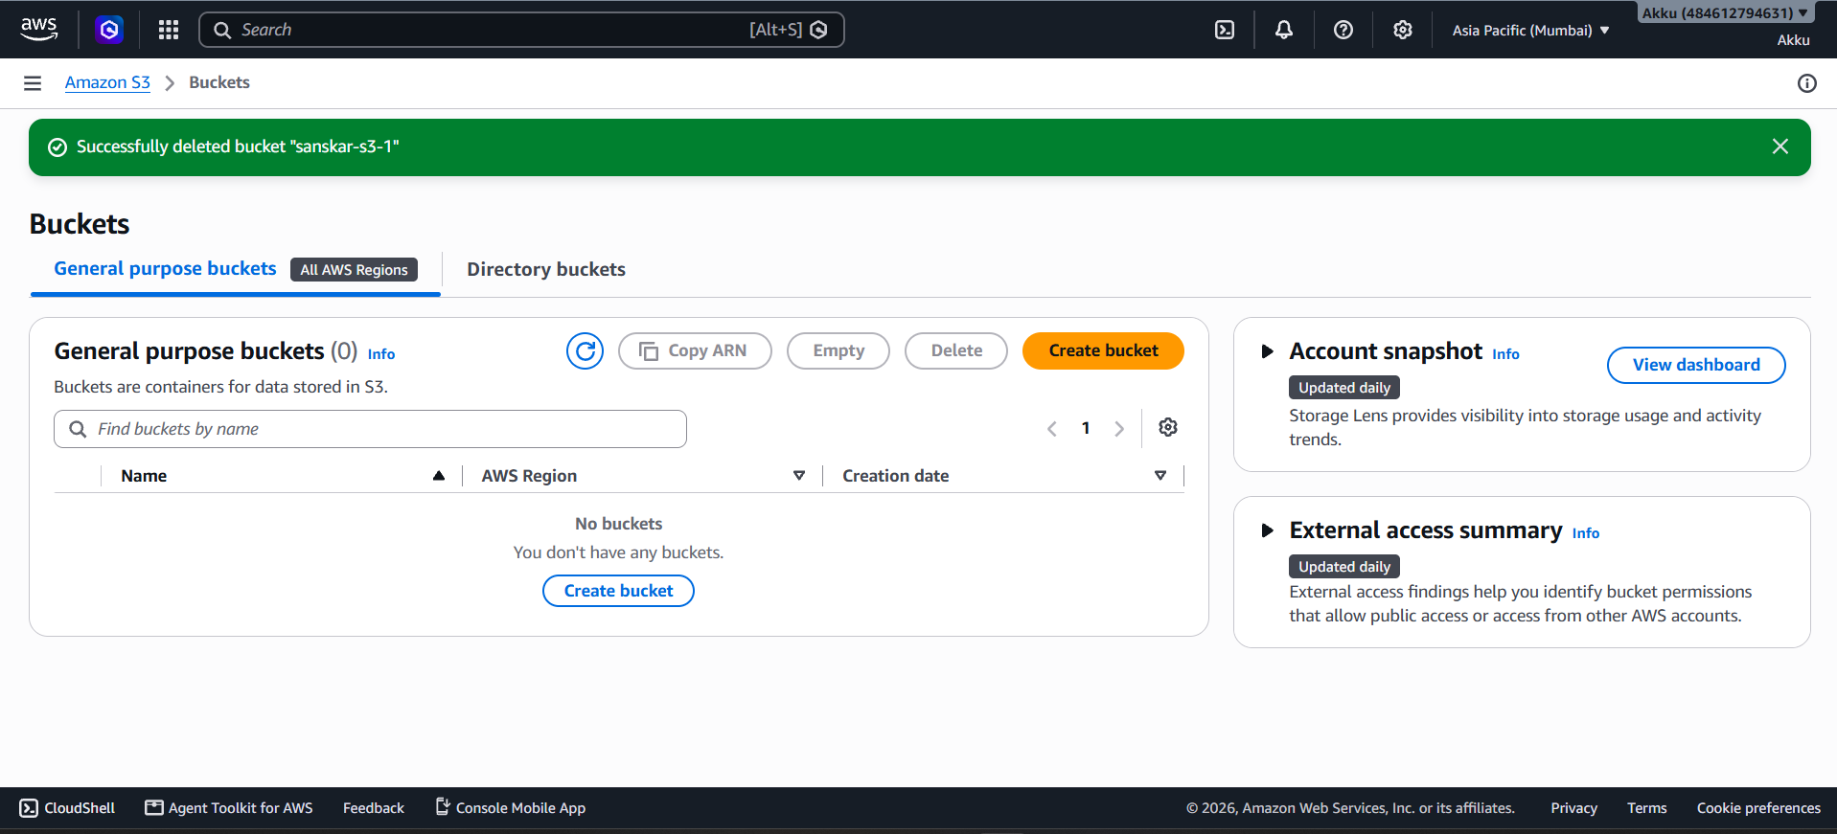
Figure 12. Successful deletion of the S3 bucket

Final Practical Summary
Bucket | sanskar-s3-1
Region | Asia Pacific (Mumbai), ap-south-1
Bucket type | General purpose
Object ownership | ACLs disabled
Public access | Block all public access enabled
Encryption | SSE-S3 selected
Uploaded file | AWS_EBS_Create_Volume_Report.docx
Upload result | 1 file succeeded; 0 files failed
Storage class shown | Standard
Final bucket status | Successfully deleted

End of Practical Report

