AMAZON S3
Public Bucket
Creation Guide
A step-by-step walkthrough for creating a public S3 bucket from the AWS Management Console

Prepared for: Sanskar Yadav
AWS Region: Asia Pacific (Mumbai) — ap-south-1
Document Date: 23 September 2026

Introduction
Amazon S3 is used to store files, images and backups in the cloud. Sometimes those files need to be reachable by anyone on the internet, like website assets or public downloads. This guide covers exactly that: creating a bucket and opening it up for public access.
The bucket used here is named statics.5556, created in the Asia Pacific (Mumbai) region. Each step below shows the actual console screen along with what was clicked and why.
A quick word of caution before starting: only make a bucket public if you actually intend to share its contents with the world. Public buckets are a common cause of accidental data exposure, so double-check what's inside before flipping this switch.

Step 1: Open the S3 Buckets Page
Log into the AWS Management Console and open the Amazon S3 service. You'll land on the Buckets page, shown here with the General purpose buckets tab selected.
Right now there are 0 buckets in this account and region, so it's a clean starting point. On the right you'll notice the Account snapshot and External access summary panels — worth glancing at occasionally for security.
To get started, click the orange Create bucket button in the top-right corner. That opens the setup form we'll walk through next.

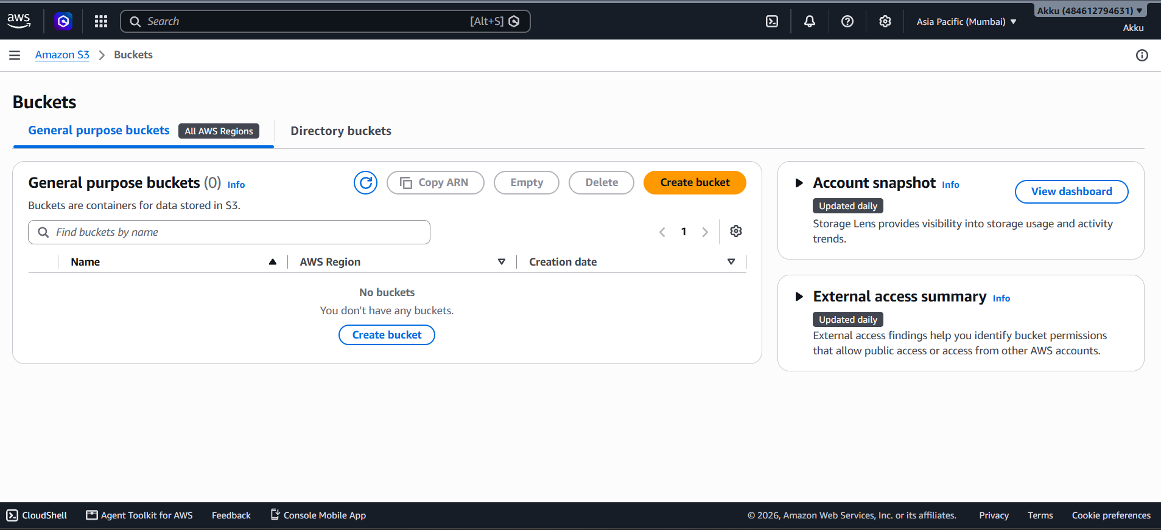

Step 2: Set the Region, Type and Name
Under General configuration, the region is set to Asia Pacific (Mumbai), which decides where the bucket's data physically lives.
For Bucket type, General purpose is selected — it's the right choice for most use cases and spreads data across multiple Availability Zones. The Directory option is only needed for low-latency, single-AZ workloads.
Global namespace is chosen here, meaning the bucket name has to be unique across all of AWS, not just this account.
The bucket is named statics.5556. Names must be 3–63 characters, lowercase only, and can include numbers, dots and hyphens.
The 'Copy settings from existing bucket' option is skipped since this bucket is being built from scratch.

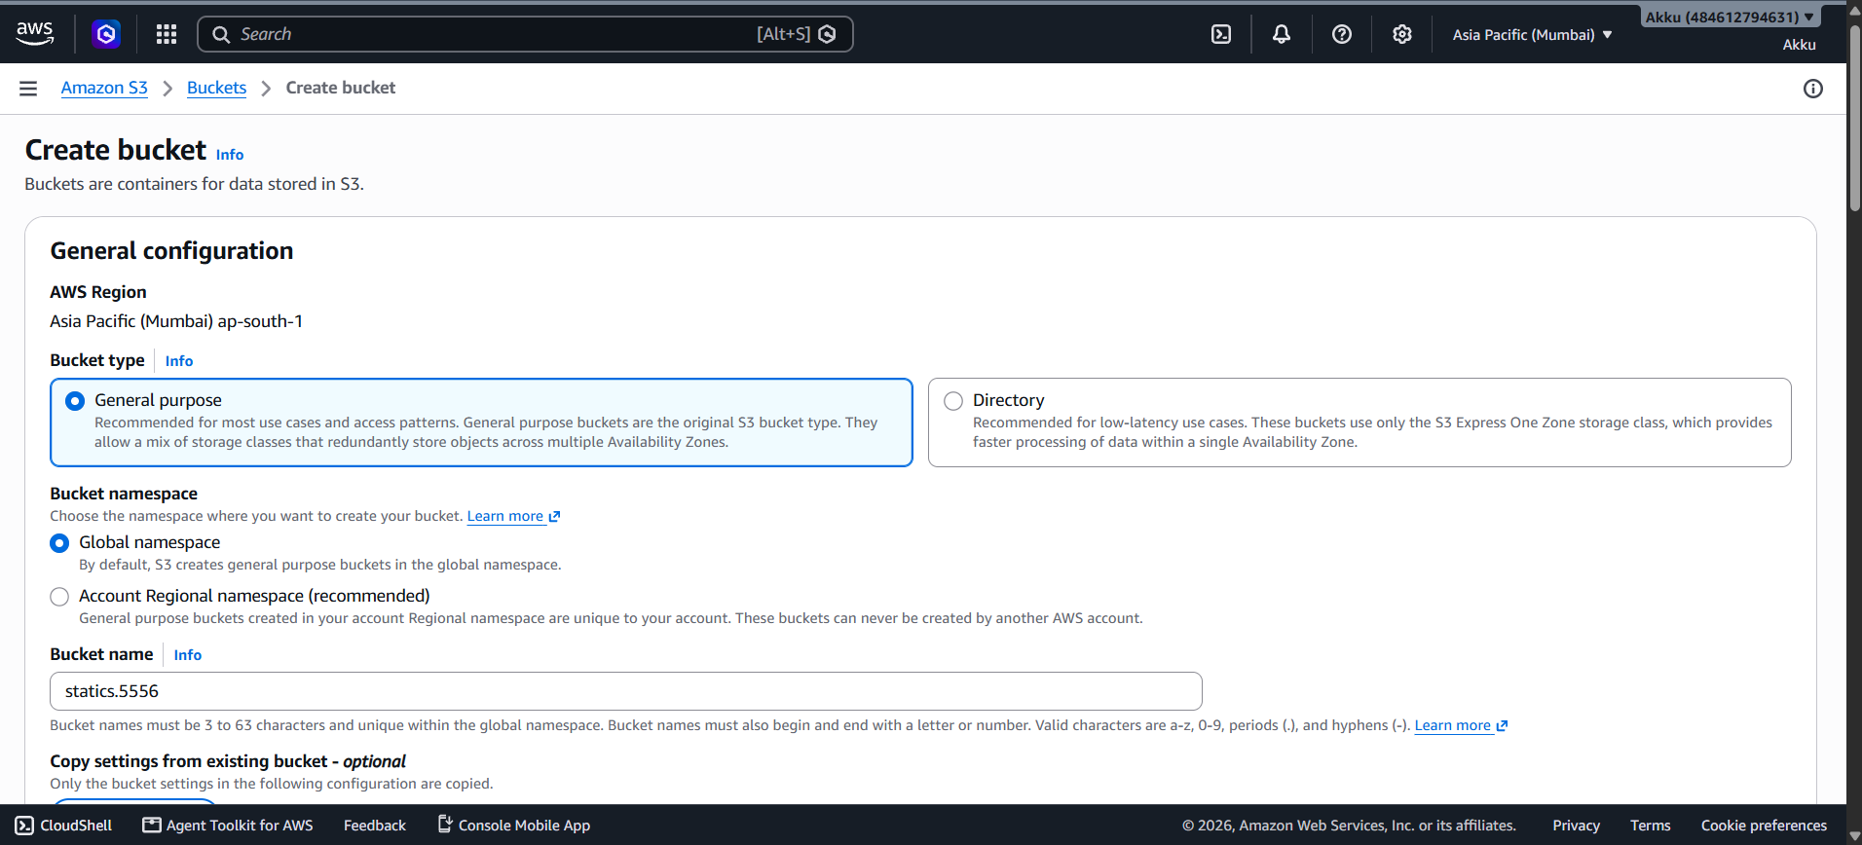

Step 3: Configure Object Ownership
Object Ownership controls how access to objects is managed and whether ACLs (Access Control Lists) come into play.
AWS recommends ACLs disabled by default, since bucket policies alone are simpler to manage. Here though, ACLs enabled is selected, which allows access to be defined per object.
This is useful when other AWS accounts need to own or access specific objects, or when public access needs finer control.
Bucket owner preferred is chosen as well — new objects stay owned by the bucket owner unless the uploader explicitly hands over control.
AWS shows a small warning here reminding you that disabling ACLs is usually the safer, simpler path unless you have a specific reason not to.

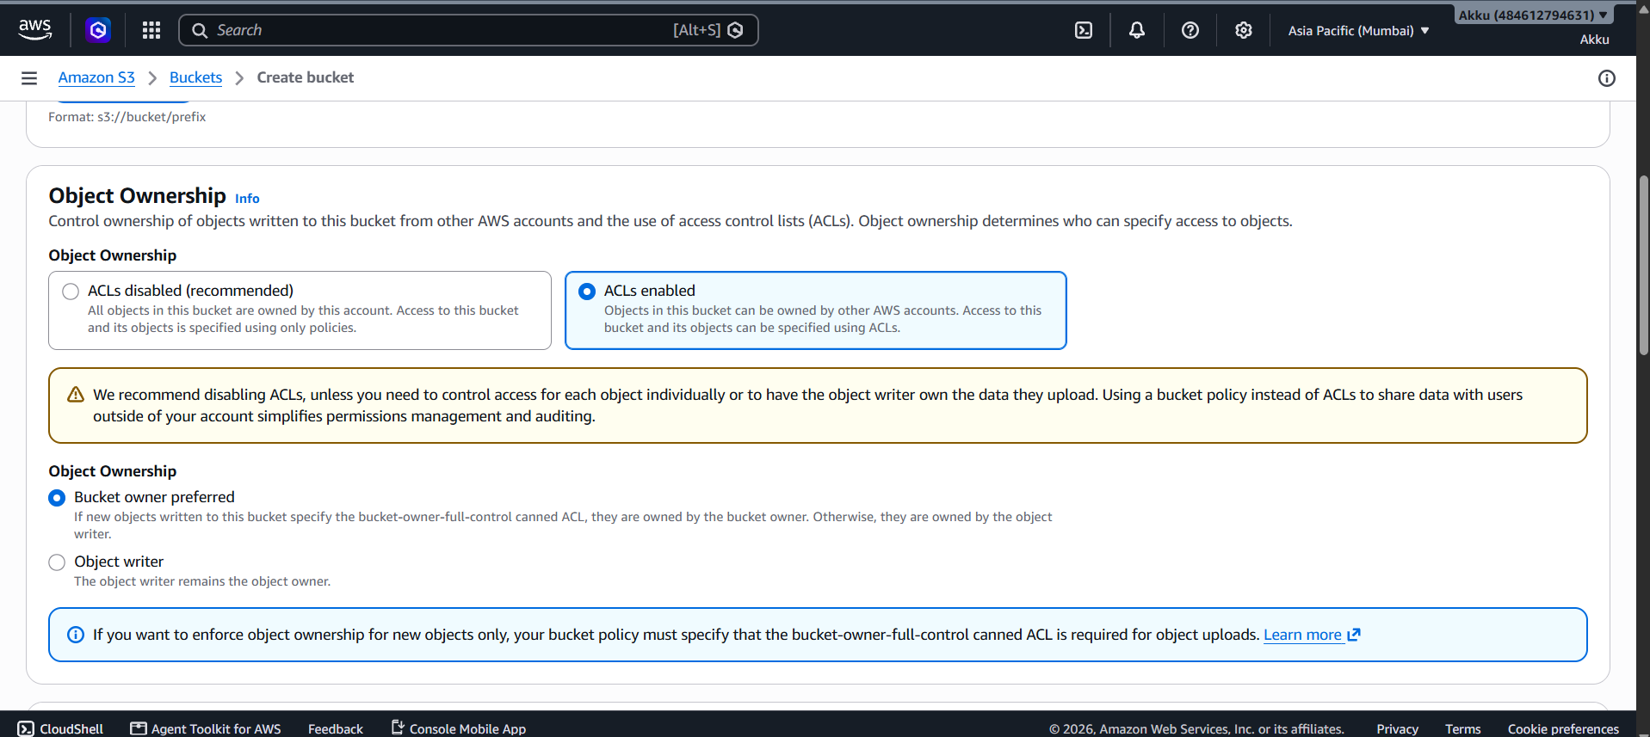

Step 4: Turn Off Block Public Access
This is the step that actually makes the bucket public. By default AWS blocks all public access — all four checkboxes are ticked to keep things private.
To allow public access, every checkbox here is unchecked: no new ACLs blocked, no existing ACLs blocked, no new policies blocked, and no public/cross-account access blocked.
AWS immediately flags this with a warning that the bucket and its objects could become public.
The acknowledgement box below the warning is checked to confirm this is intentional, not accidental.
This setting deserves real caution — only do this for buckets that genuinely need to be public, never for anything holding private data.

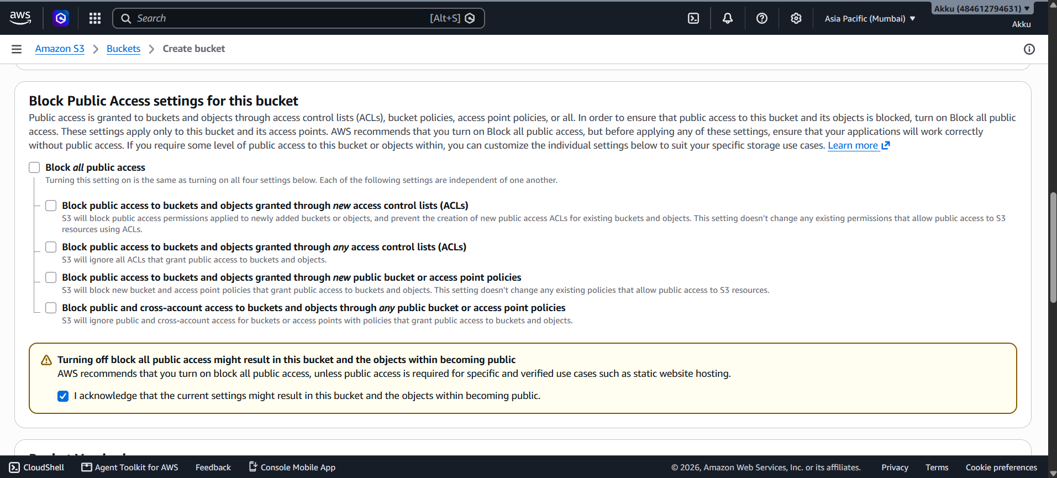

Step 5: Versioning and Tags
Bucket Versioning keeps multiple copies of an object over time, which makes recovering from accidental deletes or overwrites easy.
Versioning is left Disabled here since this is a simple public bucket without a need for version history. For production data, enabling it is usually a good idea.
The Tags section lets you attach key-value labels to the bucket for cost tracking or organization — none are added in this example.
AWS also notes that managing tags needs a few specific IAM permissions if you plan to use them later.
Up to 50 tags can be added per bucket whenever they're needed, just click Add new tag.

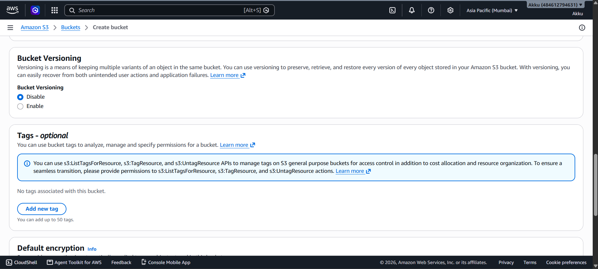

Step 6: Set Encryption and Create the Bucket
Default encryption applies automatically to every new object, even if the uploader doesn't set it manually.
SSE-S3 is selected here — Amazon-managed keys, the simplest option. SSE-KMS and DSSE-KMS exist for more control and stronger layered encryption respectively.
Bucket Key is enabled too, which cuts down on KMS calls and lowers encryption costs (though it isn't available for DSSE-KMS).
Advanced settings are left collapsed since the defaults work fine for this case.
With everything set, clicking the orange Create bucket button at the bottom finishes the job — the public bucket is now live and ready for uploads.

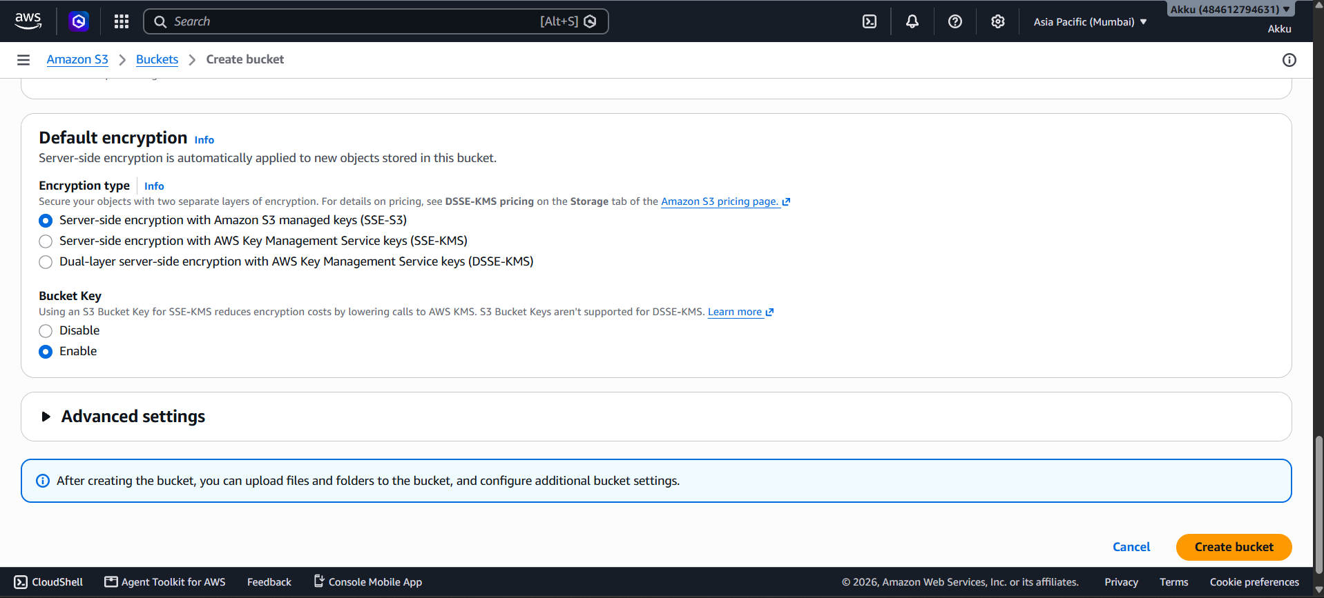

Summary & Best Practices
That's the whole process — a public S3 bucket, created in six straightforward steps. A few things worth keeping in mind going forward:
- Only make objects public that are actually meant to be shared publicly.
- Never store sensitive or confidential data in a public bucket.
- Review bucket policies and ACLs from time to time to catch anything unintended.
- Keep an eye on Storage Lens and the External Access Summary for early warnings.
- If public access was only needed temporarily, turn Block Public Access back on once done.

