AMAZON S3
Publish Website
in AWS
A step-by-step guide to uploading and hosting a website using an S3 bucket

Prepared for: Sanskar Yadav
Bucket Used: statics.5556 (Asia Pacific — Mumbai)
Document Date: 23 September 2026

Introduction
Once a public S3 bucket is ready, hosting a website on it is just a matter of uploading the HTML file and opening its public URL. No servers, no deployment pipeline — S3 handles the delivery on its own.
This guide picks up right after the bucket statics.5556 has been created and made public, and walks through uploading a file called AWS website.html and viewing it live in the browser.
Step 1: Open the S3 Buckets Page
Log into the AWS Management Console and open the Amazon S3 service. You'll land on the Buckets page, shown here with the General purpose buckets tab selected.
Right now there are 0 buckets in this account and region, so it's a clean starting point. On the right you'll notice the Account snapshot and External access summary panels — worth glancing at occasionally for security.
To get started, click the orange Create bucket button in the top-right corner. That opens the setup form we'll walk through next.

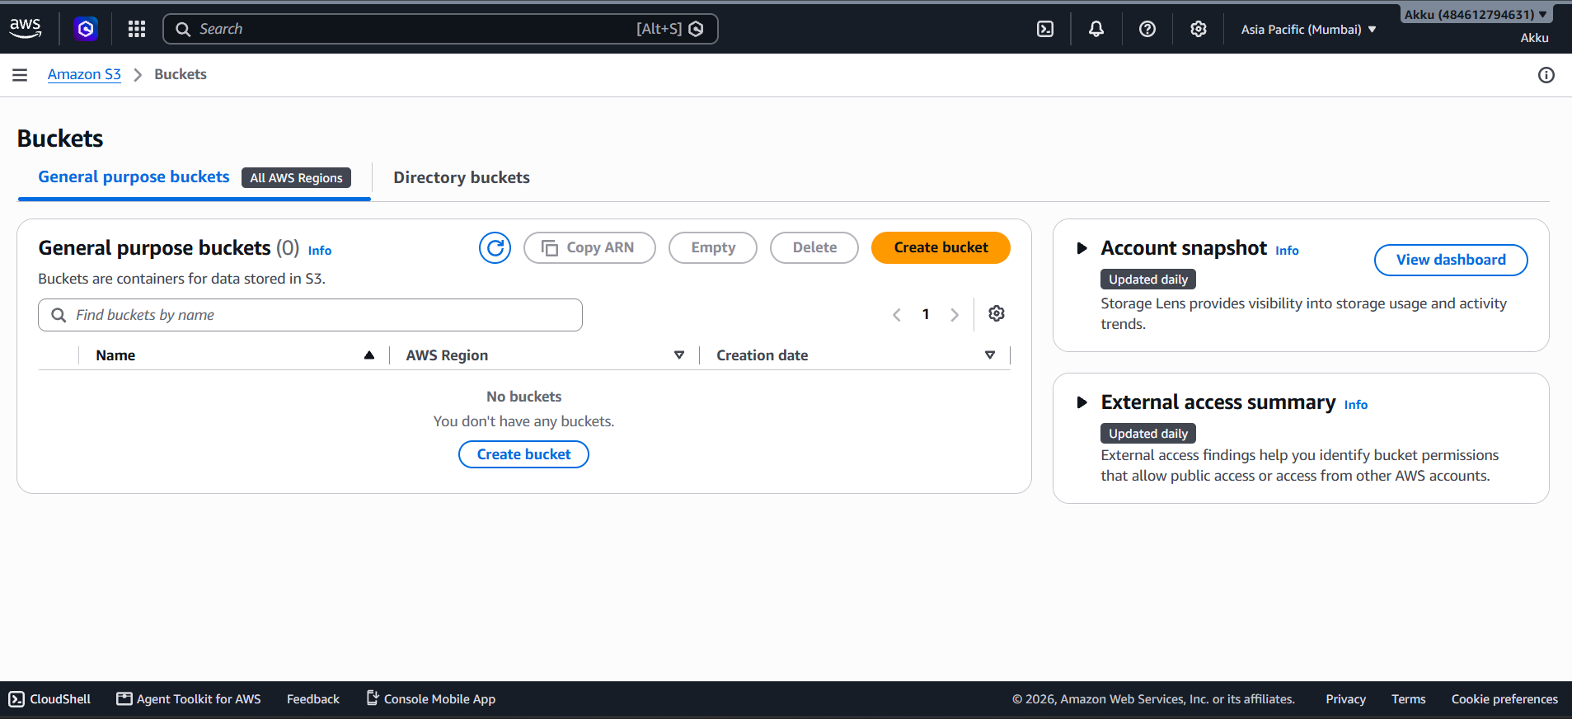

Step 2: Set the Region, Type and Name
Under General configuration, the region is set to Asia Pacific (Mumbai), which decides where the bucket's data physically lives.
For Bucket type, General purpose is selected — it's the right choice for most use cases and spreads data across multiple Availability Zones. The Directory option is only needed for low-latency, single-AZ workloads.
Global namespace is chosen here, meaning the bucket name has to be unique across all of AWS, not just this account.
The bucket is named statics.5556. Names must be 3–63 characters, lowercase only, and can include numbers, dots and hyphens.
The 'Copy settings from existing bucket' option is skipped since this bucket is being built from scratch.

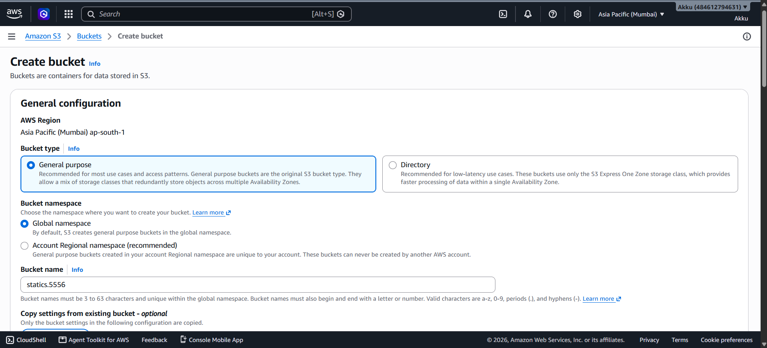

Step 3: Configure Object Ownership
Object Ownership controls how access to objects is managed and whether ACLs (Access Control Lists) come into play.
AWS recommends ACLs disabled by default, since bucket policies alone are simpler to manage. Here though, ACLs enabled is selected, which allows access to be defined per object.
This is useful when other AWS accounts need to own or access specific objects, or when public access needs finer control.
Bucket owner preferred is chosen as well — new objects stay owned by the bucket owner unless the uploader explicitly hands over control.
AWS shows a small warning here reminding you that disabling ACLs is usually the safer, simpler path unless you have a specific reason not to.

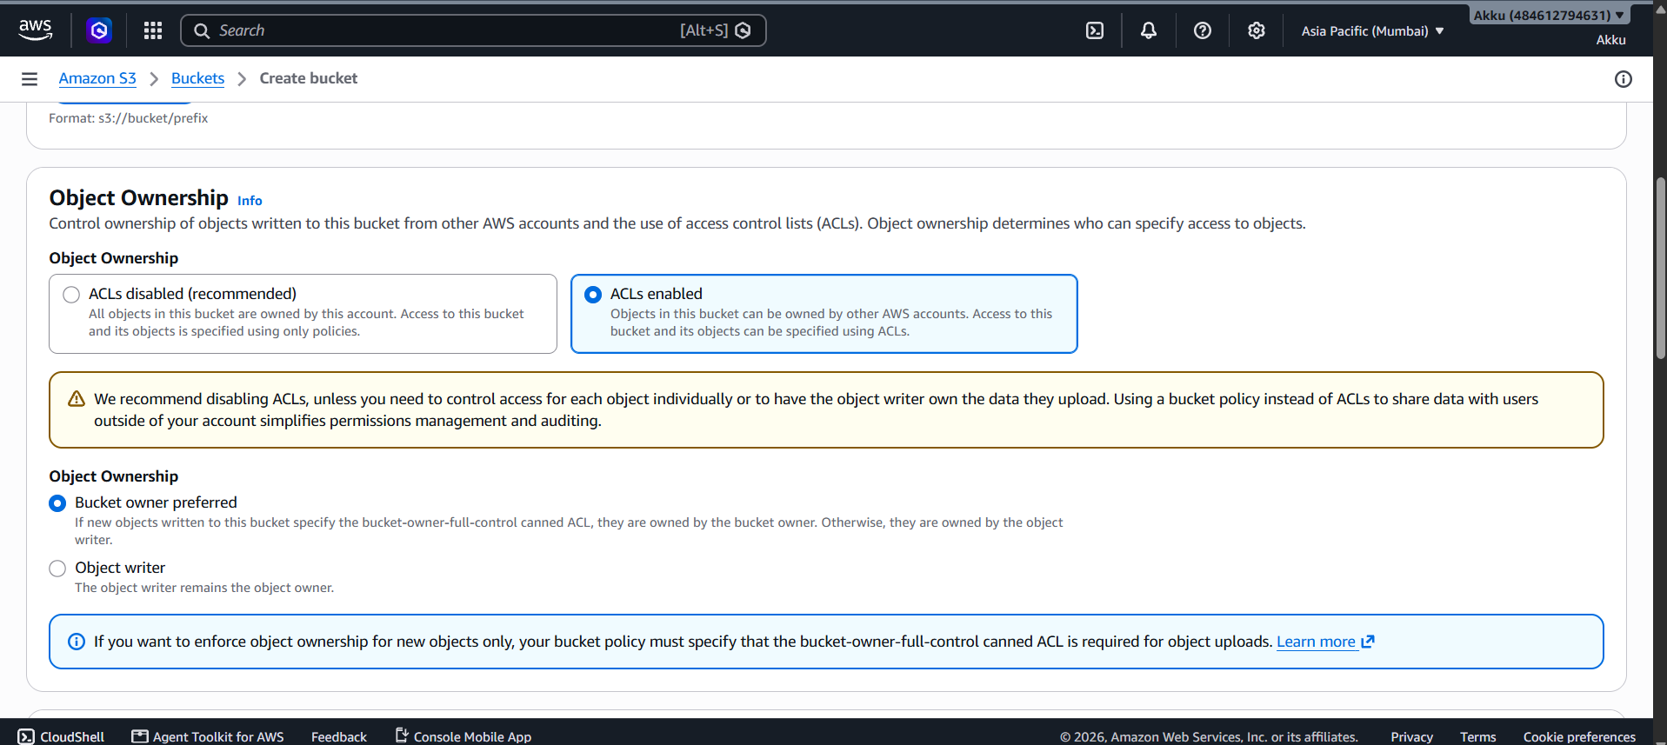

Step 4: Turn Off Block Public Access
This is the step that actually makes the bucket public. By default AWS blocks all public access — all four checkboxes are ticked to keep things private.
To allow public access, every checkbox here is unchecked: no new ACLs blocked, no existing ACLs blocked, no new policies blocked, and no public/cross-account access blocked.
AWS immediately flags this with a warning that the bucket and its objects could become public.
The acknowledgement box below the warning is checked to confirm this is intentional, not accidental.
This setting deserves real caution — only do this for buckets that genuinely need to be public, never for anything holding private data.

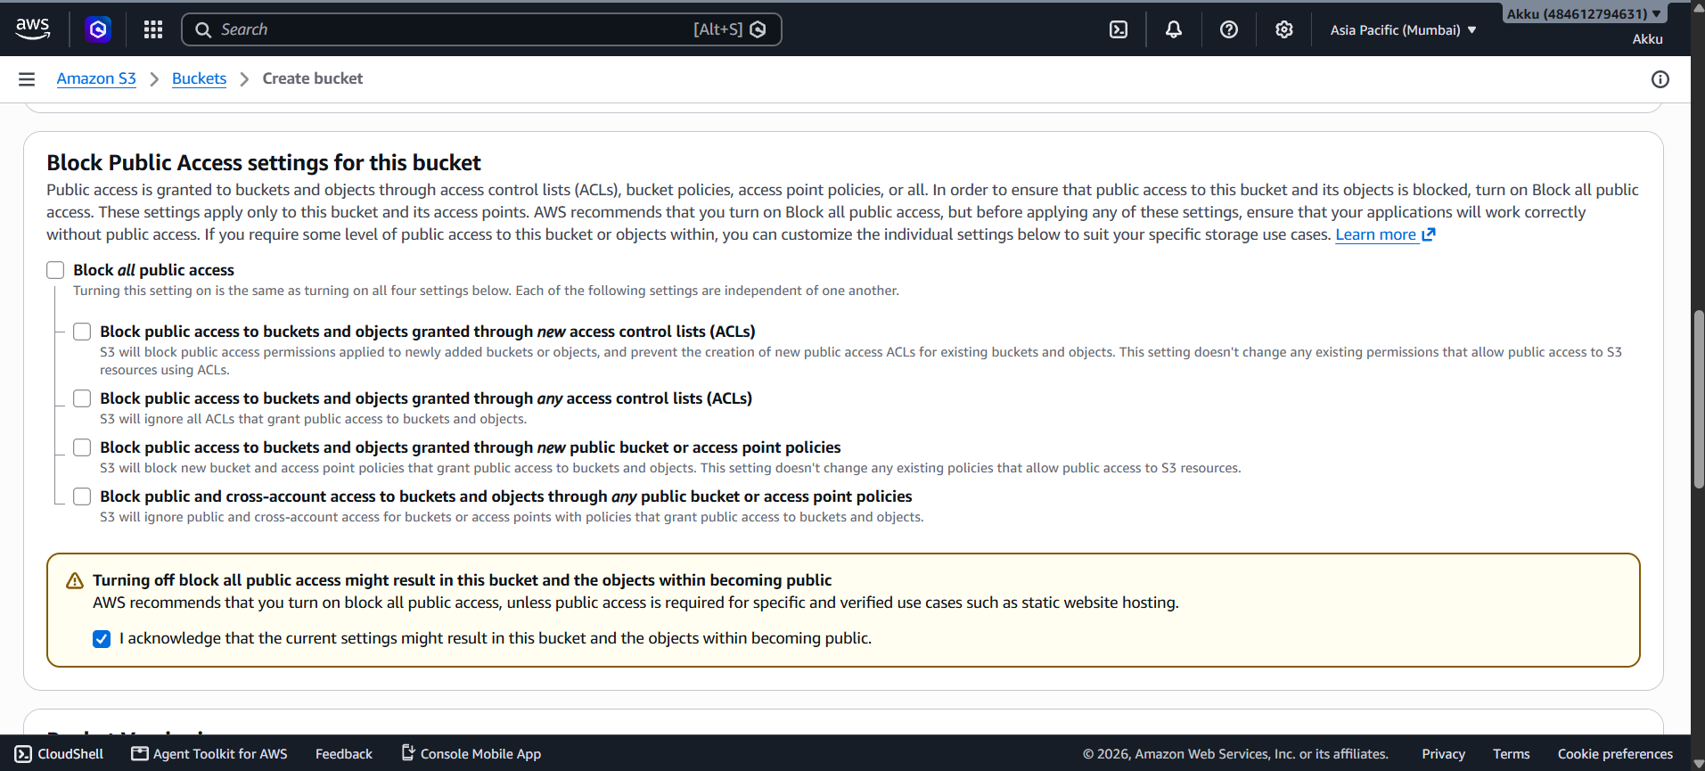

Step 5: Versioning and Tags
Bucket Versioning keeps multiple copies of an object over time, which makes recovering from accidental deletes or overwrites easy.
Versioning is left Disabled here since this is a simple public bucket without a need for version history. For production data, enabling it is usually a good idea.
The Tags section lets you attach key-value labels to the bucket for cost tracking or organization — none are added in this example.
AWS also notes that managing tags needs a few specific IAM permissions if you plan to use them later.
Up to 50 tags can be added per bucket whenever they're needed, just click Add new tag.

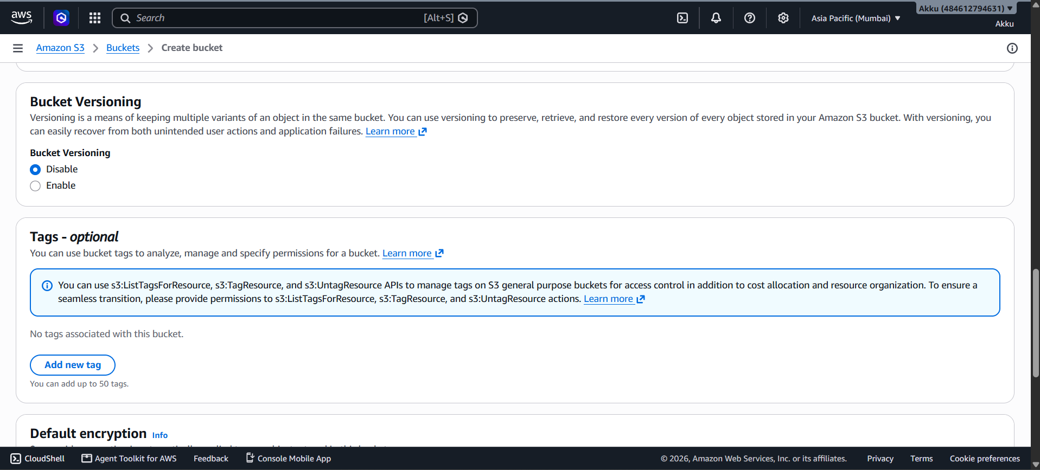

Step 6: Set Encryption and Create the Bucket
Default encryption applies automatically to every new object, even if the uploader doesn't set it manually.
SSE-S3 is selected here — Amazon-managed keys, the simplest option. SSE-KMS and DSSE-KMS exist for more control and stronger layered encryption respectively.
Bucket Key is enabled too, which cuts down on KMS calls and lowers encryption costs (though it isn't available for DSSE-KMS).
Advanced settings are left collapsed since the defaults work fine for this case.
With everything set, clicking the orange Create bucket button at the bottom finishes the job — the public bucket is now live and ready for uploads.

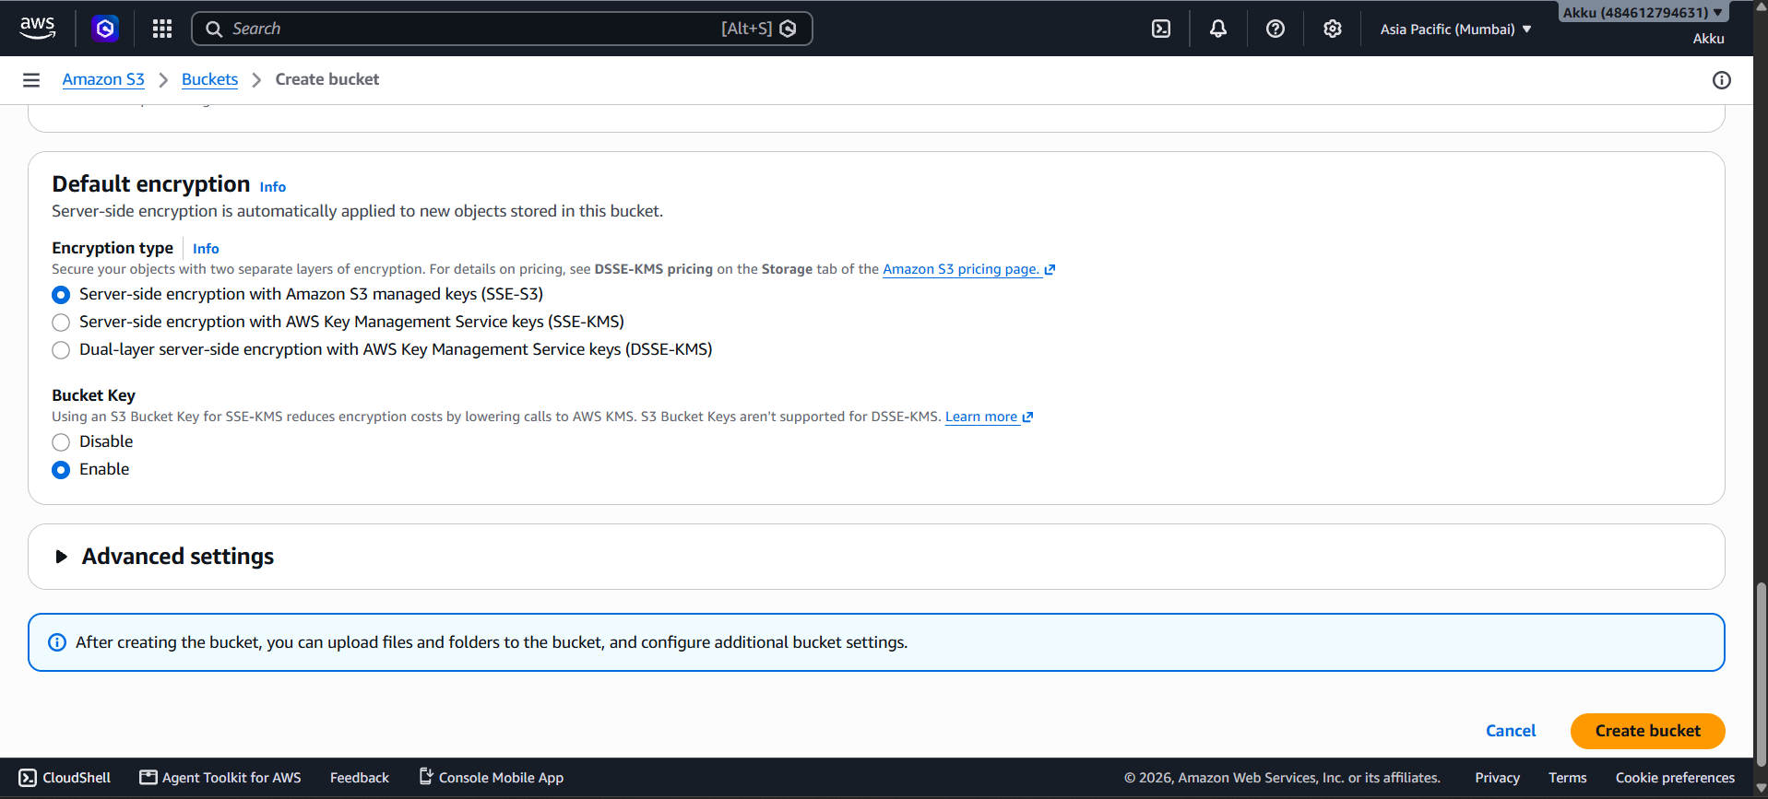

Step 7: Open the Bucket and Start an Upload
Inside the statics.5556 bucket, the Objects tab shows 0 objects — nothing has been uploaded yet.
The Objects section is where every file stored in the bucket will eventually show up.
Clicking the orange Upload button in the top-right corner opens the upload screen.
This is the same button shown again at the bottom of the empty state for convenience.

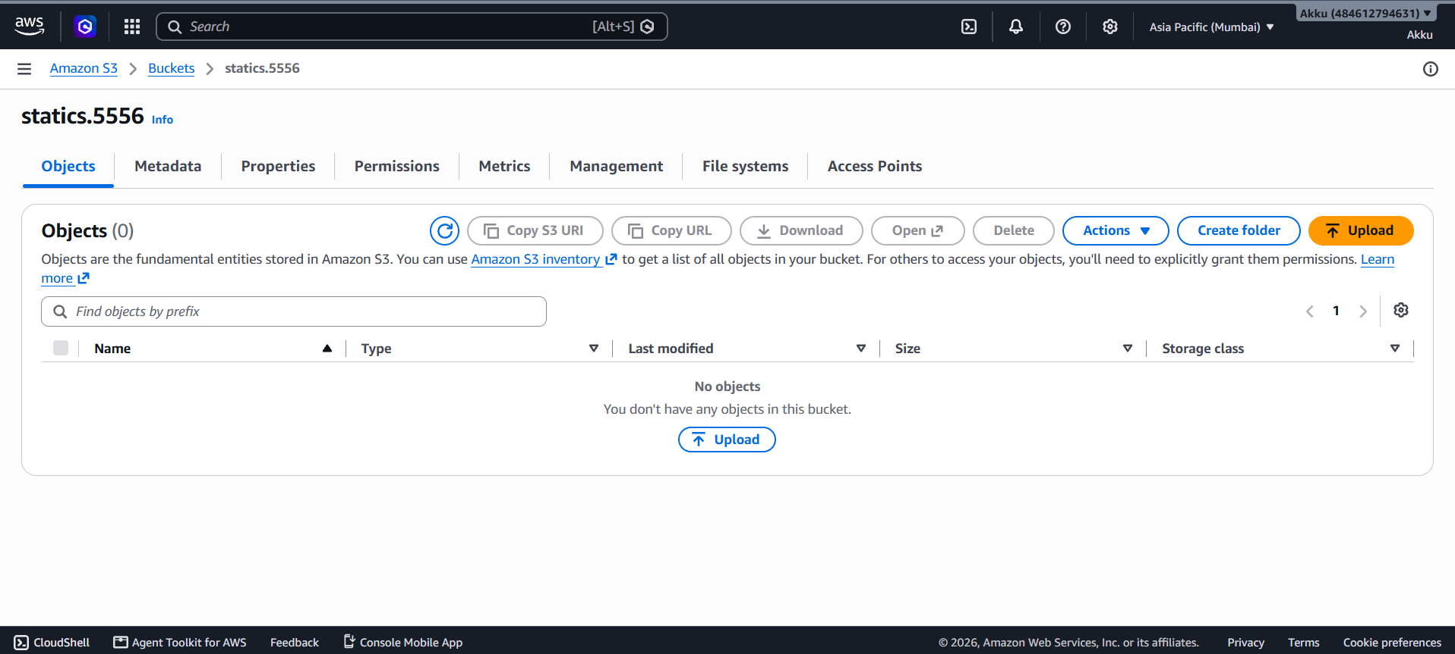

Step 8: The Upload Screen
The Upload page lets files or entire folders be dragged in, or added using the Add files button.
Right now the Files and folders table is empty, showing 0 items chosen.
The Destination section below confirms the file will go to s3://statics.5556.
A note on this page mentions that files larger than 160GB need the AWS CLI, SDKs or REST API instead.

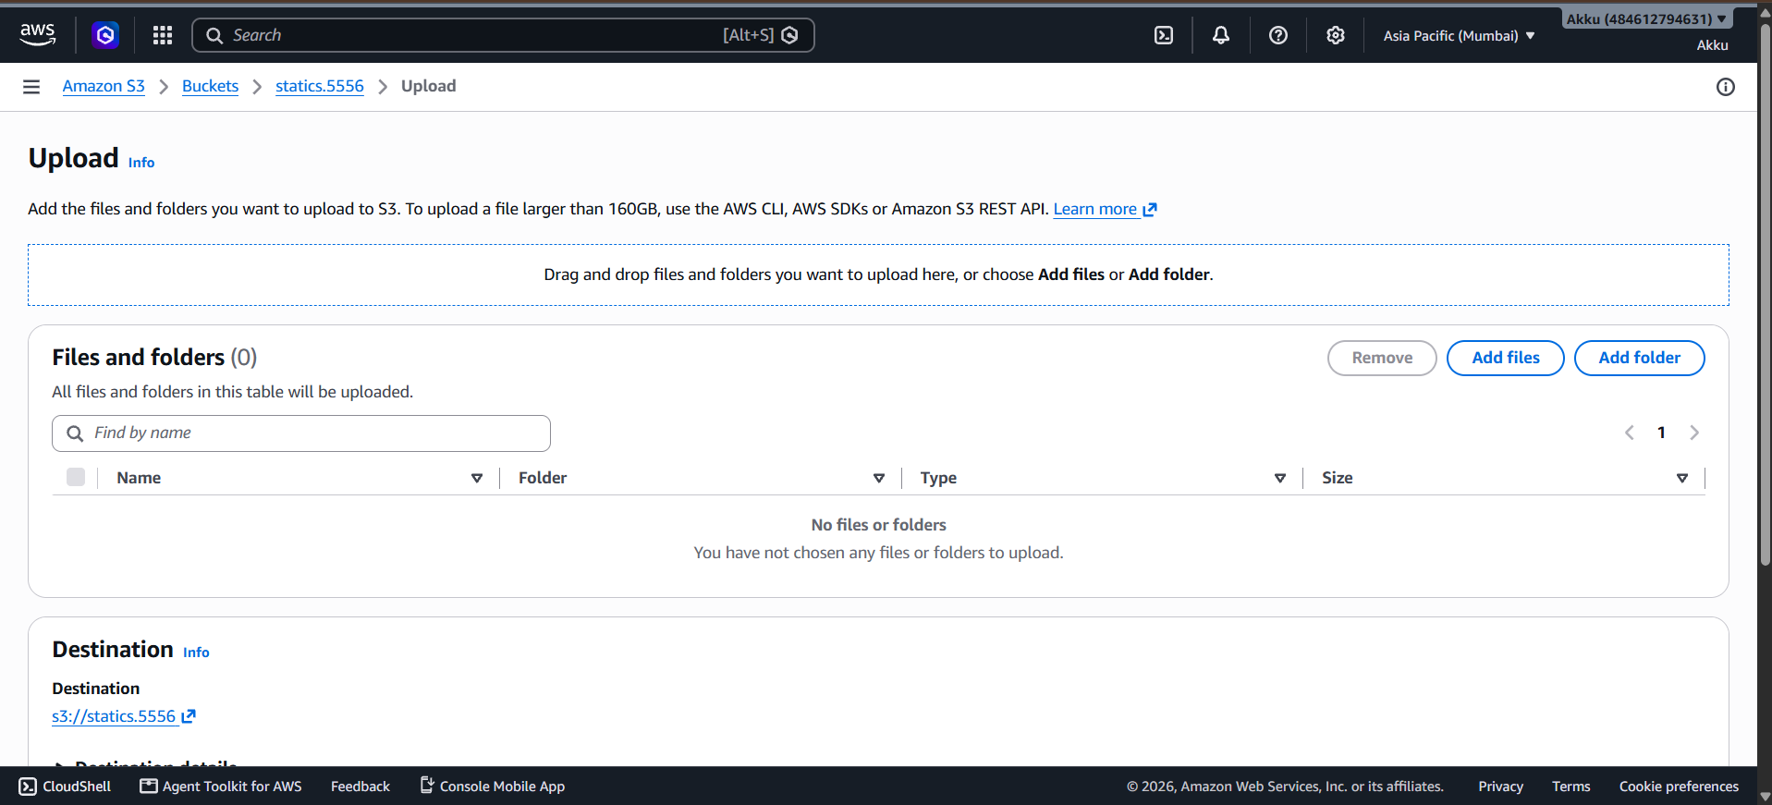

Step 9: Add the Website File
After clicking Add files, AWS website.html has been added to the upload list.
The table now shows 1 file totaling 7.2 KB, with its type listed as text/html.
The destination remains s3://statics.5556, so the file will land right at the bucket's root.
Everything looks correct here, so this is the point where the actual upload gets triggered.

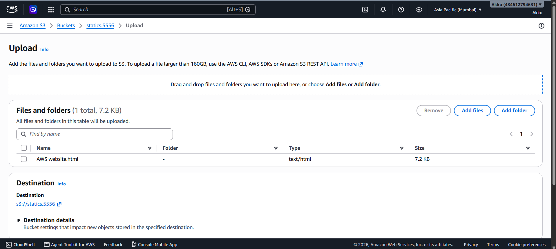

Step 10: Upload Completes Successfully
A green banner confirms Upload succeeded once the file finishes transferring.
The Summary section shows 1 file, 7.2 KB, and a 100% success rate with 0 failures.
The Files and folders table below lists AWS website.html with a Succeeded status and no errors.
Clicking the file name here opens straight into its object details.

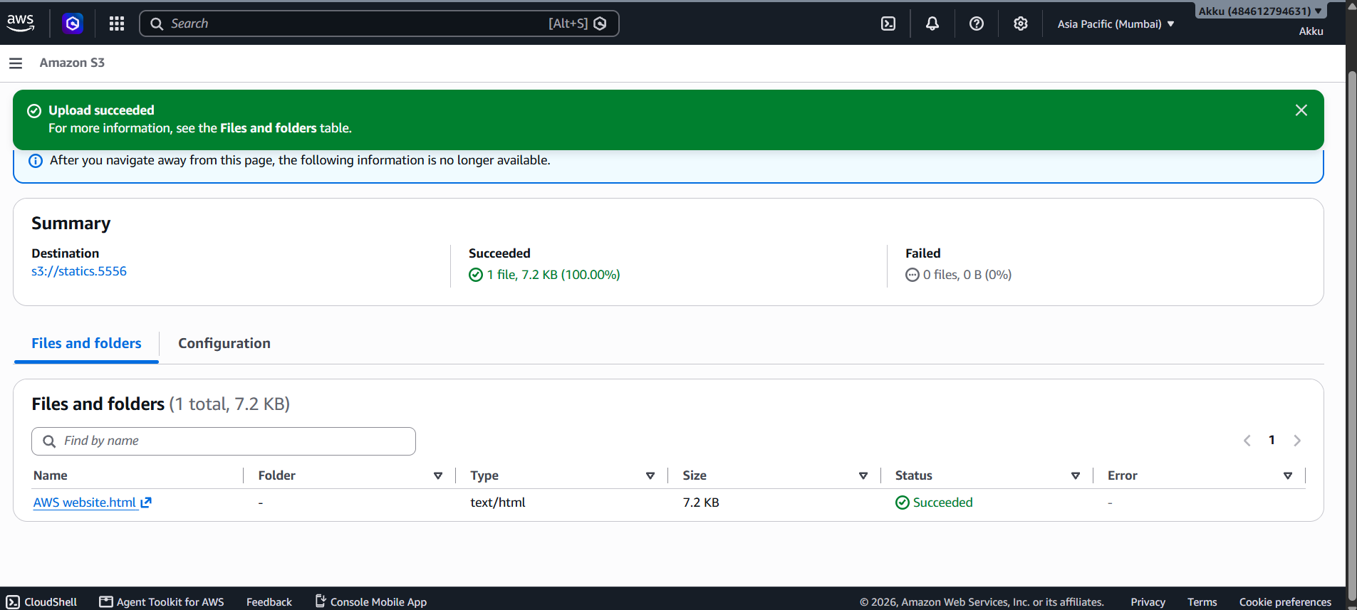

Step 11: Check the Object Properties and URL
The object overview page shows details like owner, region, size, and last modified time for AWS website.html.
The Object URL field is the key piece here — this is the public link the website will be served from.
The S3 URI and ARN are also listed, useful for referencing the file from the CLI or other AWS services.
Buttons at the top allow downloading the file, opening it directly, or copying its S3 URI.

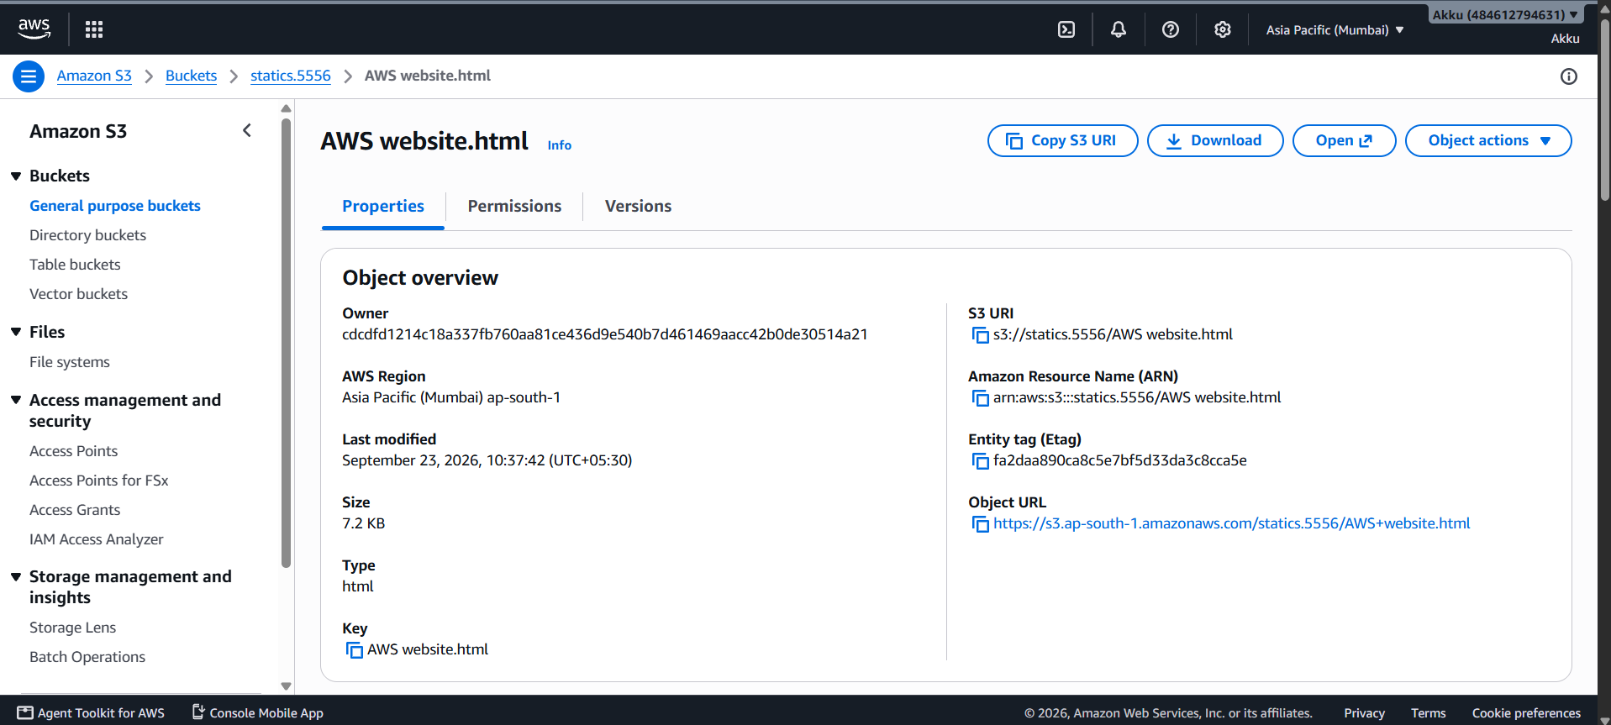

Step 12: View the Live Website
Opening the Object URL in a browser loads the page directly from S3, no extra setup needed.
The site shown here is a simple Data Science themed page with a navigation bar and skill cards.
The browser address bar confirms the page is being served straight from the s3.ap-south-1.amazonaws.com domain.
At this point the website is fully live and publicly reachable by anyone with the link.

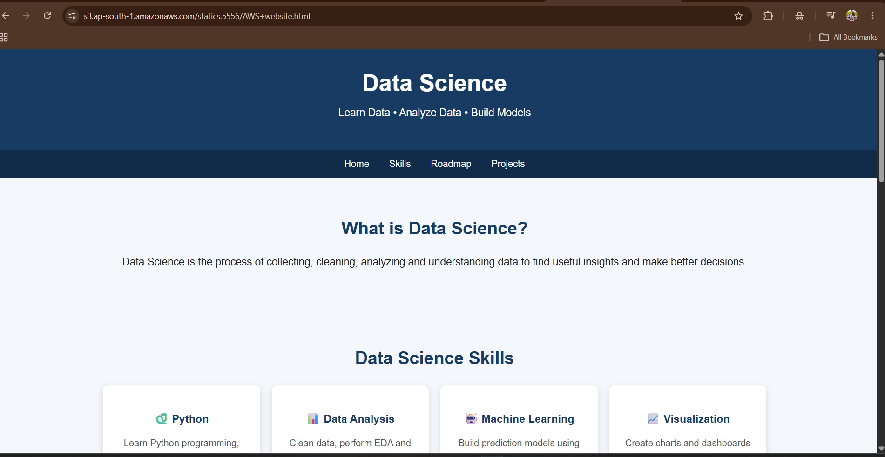

Summary
That covers the full flow — from an empty bucket to a live, publicly accessible website hosted on S3. A few points worth remembering:
- The Object URL is what visitors will actually use to reach the page.
- Any updates to the site just mean re-uploading the changed HTML file.
- For a real domain name instead of the S3 URL, S3 Static Website Hosting or CloudFront can be layered on top.
- Keep the bucket's public access limited to only the files meant to be shared.

