Mongo DB (Assignment C)
Que :- Collections Name: students
db.students.insertMany([{student_id:1,name:"Amit",age:20,marks:85,department:"CSE",subjects:["DBMS","OS","CN"],email:"amit@gmail.com"},
{student_id:2,name:"Neha",age:22,marks:72,department:"ECE",subjects:["Signals","VLSI"],email:null},
{student_id:3,name:"Rahul",age:19,marks:90,department:"CSE",subjects:["DBMS","AI","ML"]},
{students_id:4,name:"Sneha",age:21,marks:65,department:"IT",subjects:["Web","DBMS"],email:"sneha@gmail.com"},
{student_id:5,name:"Karan",age:23,marks:78,department:"CSE",subjects:["CN","OS"],email:"karan@gmail.com"}]
Que.1 :- Find students with marks greater than 80.
Query :- db.students.find({marks:{$gt:80}})
Output :-
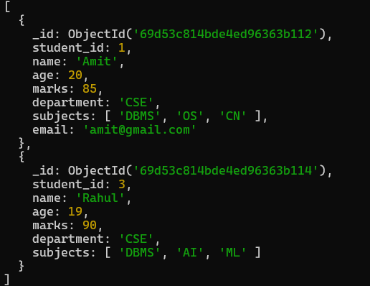
Que.2 :- Find students aged less than or equal to 20.
Query :- db.students.find({age:{$lte:20}})
Output :-
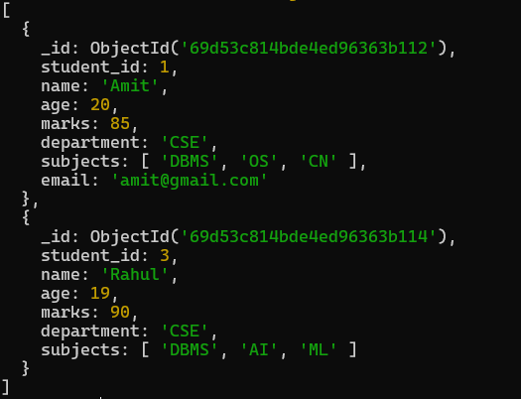
Que.3 :- Find students with marks between 70 and 85.
Query :- db.students.find({marks:{$gte:70,$lte:85}})
Output :-
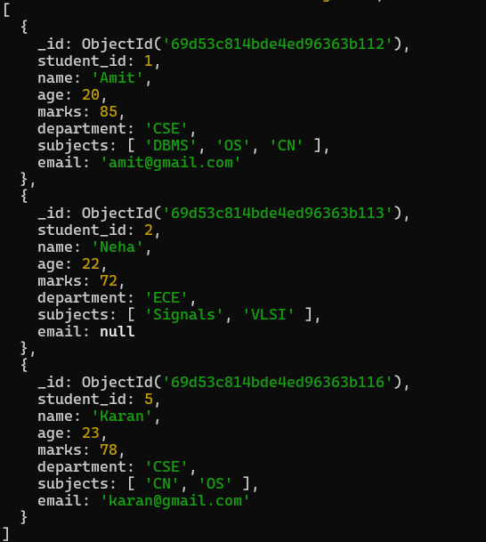
Que.4 :- Find students not belonging to CSE department.
Query :- db.students.find({department:{$ne:"CSE"}})
Output :-
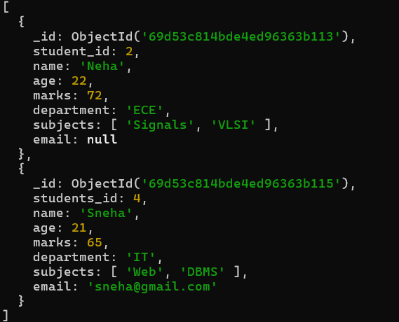
Que.5 :- Find students whose age is exactly 21.
Query :- db.students.find({age:21})
Output :-
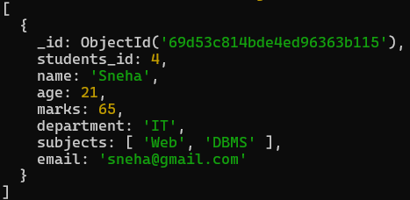
Que.6 :- Find students with marks less than 75.
Query :- db.students.find({marks:{$lt:75}})
Output :-
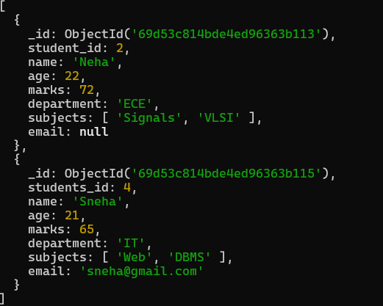
Que.7 :- Find students whose department is either CSE or IT.
Query :- db.students.find({department:{$in:["CSE","IT"]}})
Output :-
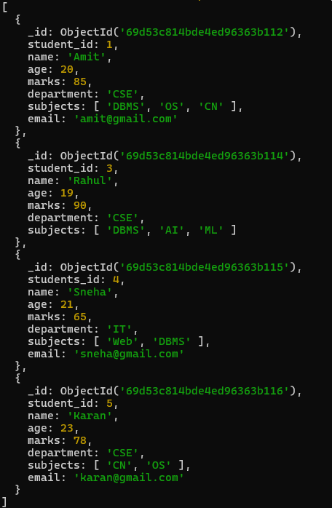
Que.8 :- Find CSE students with marks above 80.
Query :- db.students.find({department:"CSE",marks:{$gt:80}})
Output :-
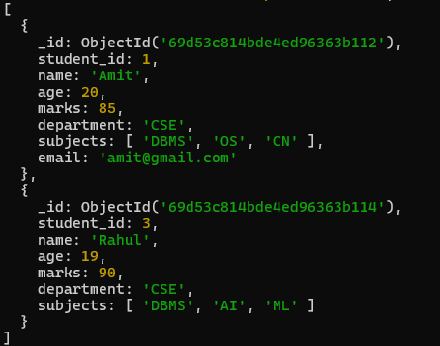
Que.9 :- Find students who are in CSE or have marks above 85.
Query :- db.students.find({$or:[{department:"CSE"},{marks:{$gt:85}}]})
Output :-
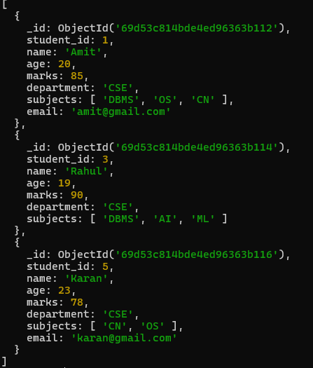
Que.10 :- Find students who are NOT in IT department.
Query :- db.students.find({department:{$ne:"IT"}})
Output :-
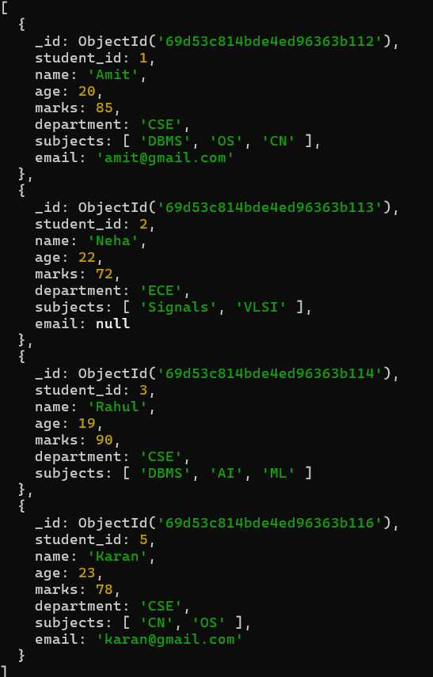
Que.11 :- Find students with marks not between 70 and 85.
Query :- db.students.find({marks:{$not:{$gte:70,$lte:85}}})
Output :-
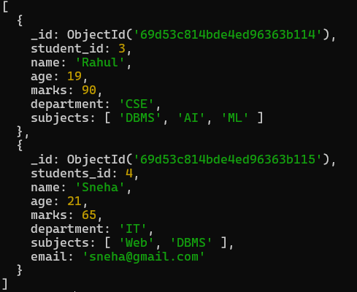
Que.12 :- Find students aged above 20 and not in ECE.
Query :- db.students.find({age:{$gt:20},department:{$ne:"ECE"}})
Output :-
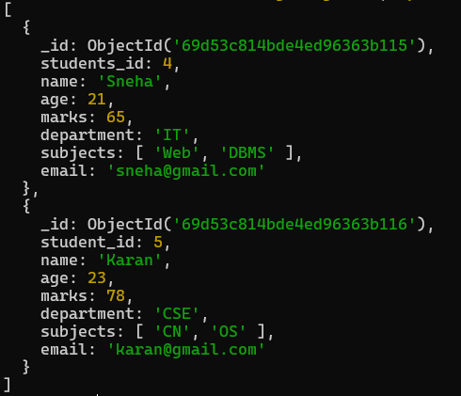
Que.13 :- Find students who are either IT students or have marks less than 70.
Query :- db.students.find({$or:[{department:"IT"},{marks:{$lt:70}}]})
Output :-
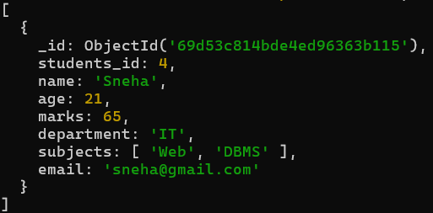
Que.14 :- Find students who are not CSE and not IT.
Query :- db.students.find({department:{$nin:["IT","CSE"]}})
Output :-
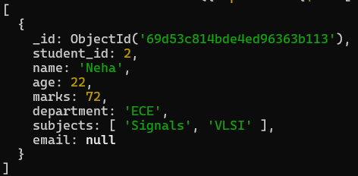
Que.15 :- Find students who have an email field.
Query :- db.students.find({email:{$exists:true}})
Output :-
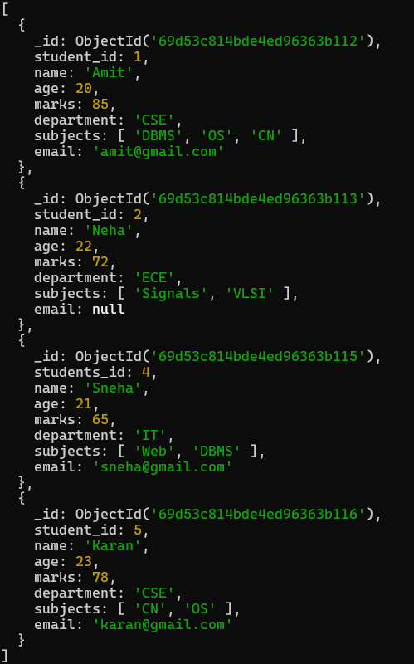
Que.16 :- Find students who do not have an email field.
Query :- db.students.find({email:{$exists:false}})
Output :-
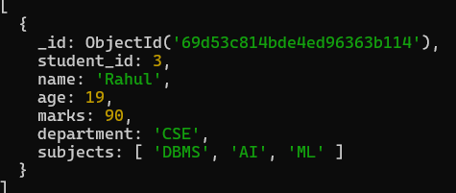
Que.17 :- Find students whose email value is null.
Query :- db.students.find({email:{$type:"null"}})
Output :-
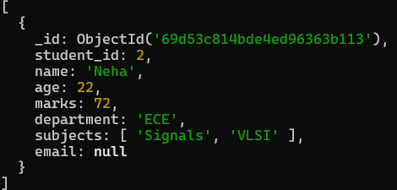
Que.18 :- Find students whose marks field is of type integer.
Query :- db.students.find({marks:{$type:"int"}})
Output :-
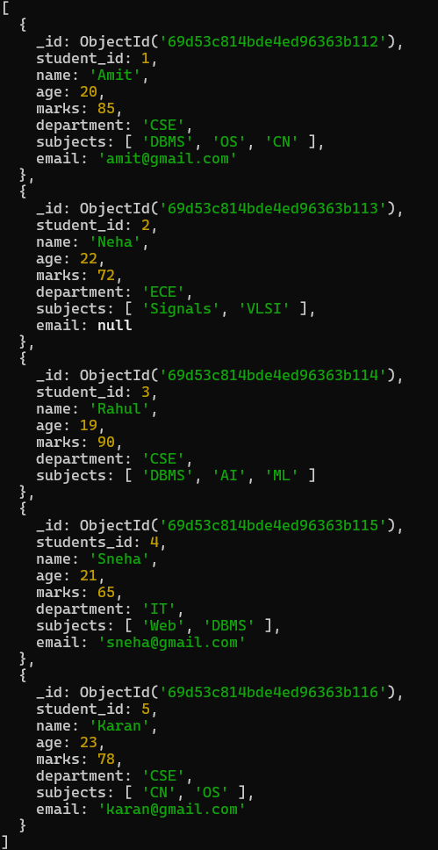
Que.19 :- Find students who have subjects’ field.
Query :- db.students.find({subjects:{$exists:true}})
Output :-
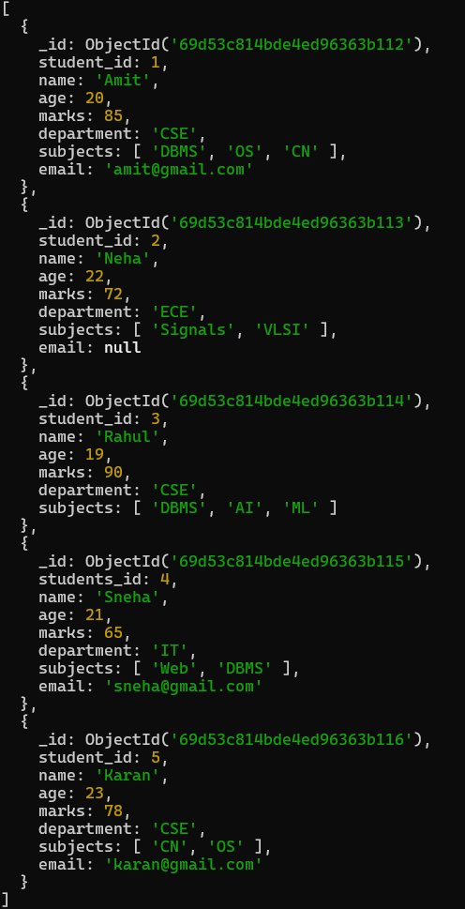
Que.20 :- Find students whose age field is missing.
Query :- db.students.find({age:{$exists:false}})
Output :- There is no students whose age field is missing.
Que.21 :- Find students where marks modulo 5 equals 0.
Query :- db.students.find({marks:{$mod:[5,0]}})
Output :-
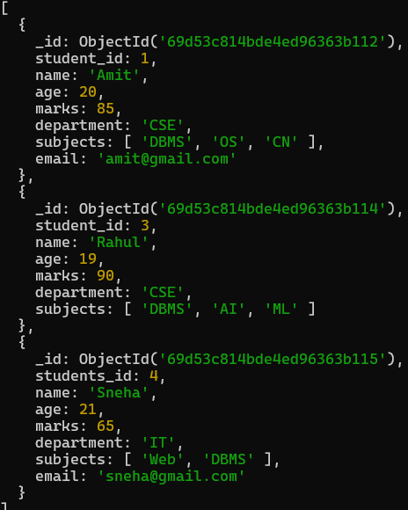
Que.22 :- Find students whose name starts with letter “A”.
Query :- db.students.find({name:{$regex:"^A"}})
Output :-
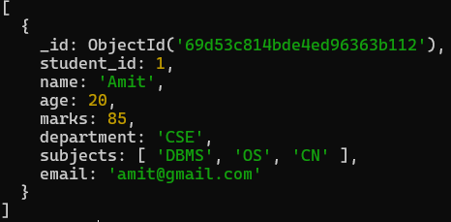
Que.23 :- Find students whose email ends with gmail.com.
Query :- db.students.find({email:{$regex:"gmail.com$"}})
Output :-
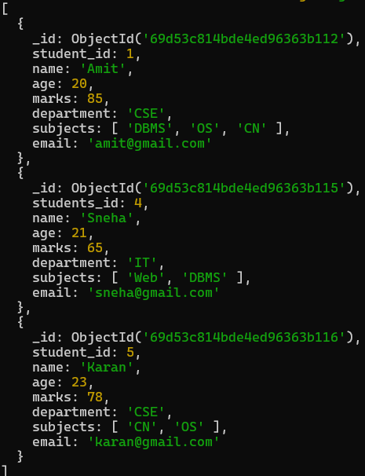
Que.24 :- Find students who have more than 2 subjects.
Query :- db.students.find({"subjects.2":{$exists:true}})
Output :-
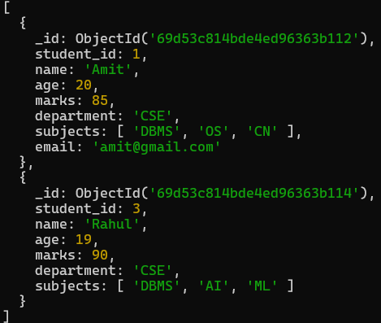
Que.25 :- Find students whose marks are greater than their age × 3.
Query :- db.students.find({$expr:{$gt:["$marks",{$multiply:["$age",3]}]}})
Output :-
