MongoDB Assignment_D
- Display all employees who have MongoDB skill

db.employee.find({skills: "MongoDB"})
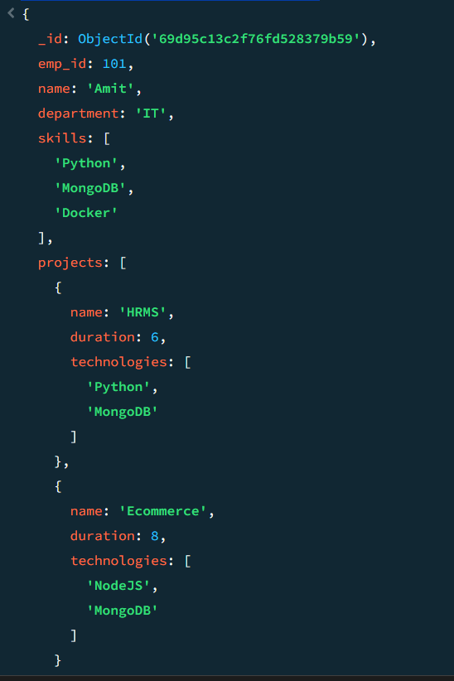

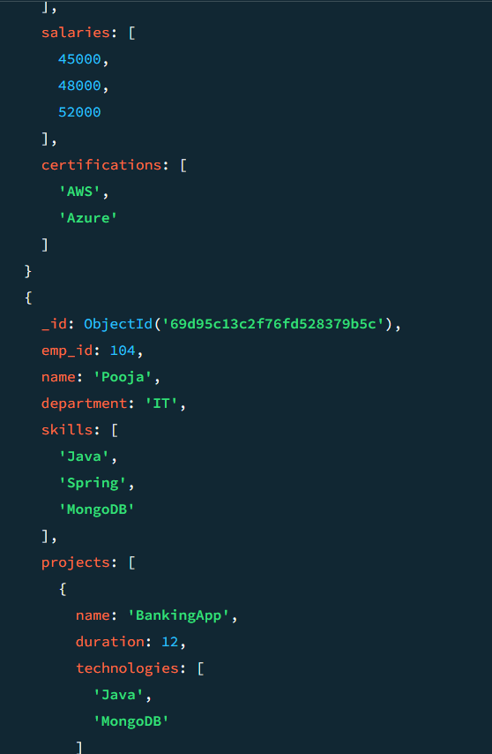

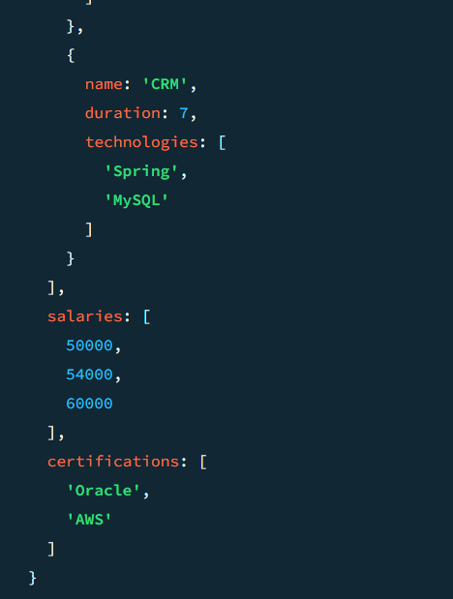

- Find employees having both Python and MongoDB skills

db.employee.find({skills:{$all:["Python","MongoDB"]}})
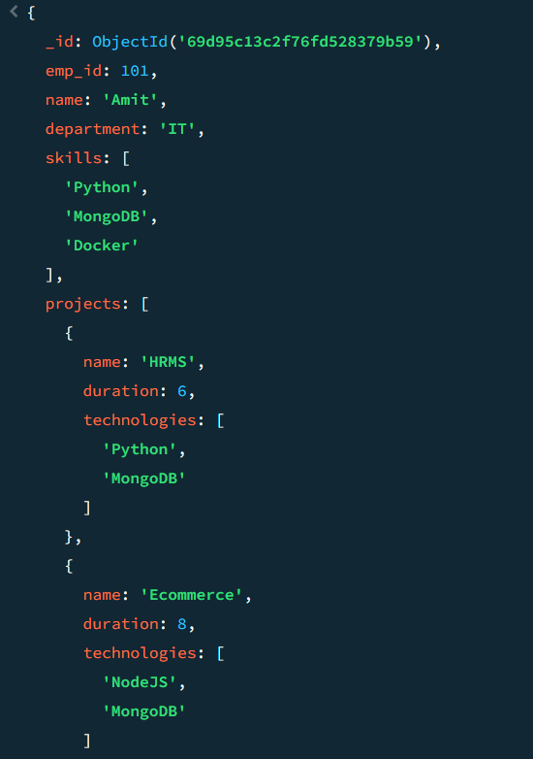

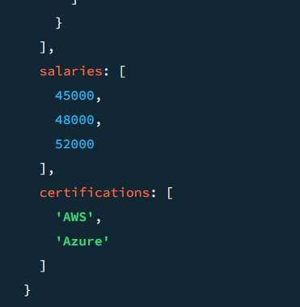

- Display employees with more than 2 skills

db.employee.find({skills:{$exists:true},$expr:{$gt:[{$size:"$skills"},2]}})
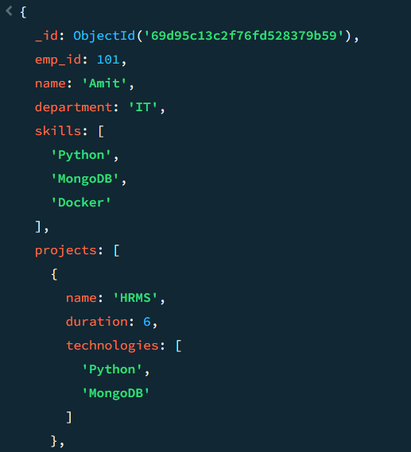

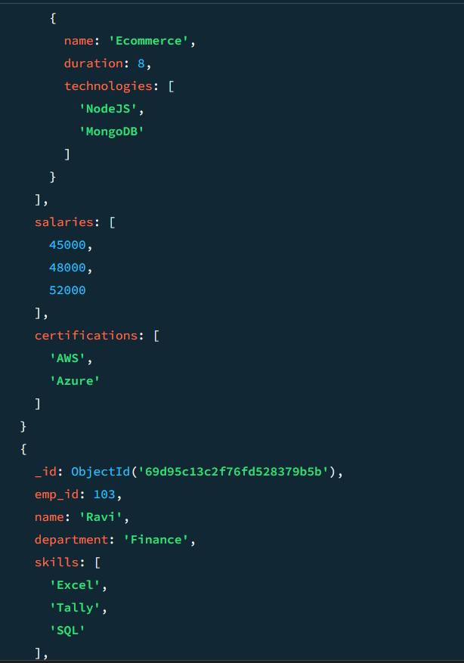

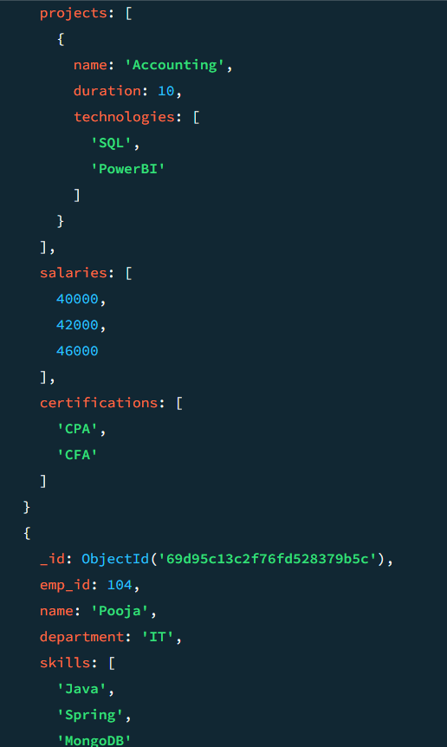

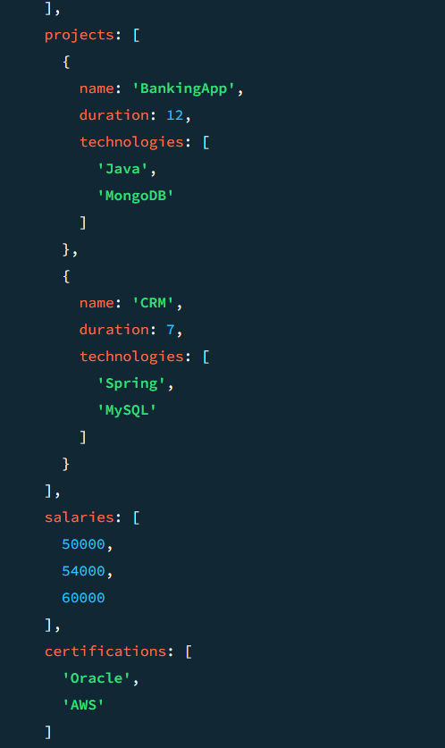

- Add a new skill "Kubernetes" to Amit

db.employee.updateOne({name:"Amit"},{$push:{skills:"Kubernetes"}})

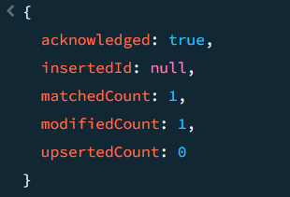

- Add multiple skills to Pooja

db.employee.updateOne({name:"Pooja"},{$push:{skills:{$each:["Docker","AWS"]}}})

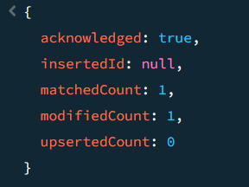

- Add a certification only if not already present

db.employee.updateOne(
{ name: "Amit" },
{ $addToSet: { certifications: "AWS Certified" } }
)

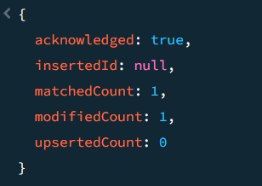

- Remove "Docker" skill from Amit

db.employee.updateOne(
{ name: "Amit" },
{ $pull: { skills: "Docker" } }
)

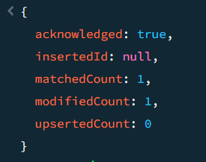

- Remove multiple salaries less than 45000

db.employee.deleteMany({
salary: { $lt: 45000 }
})

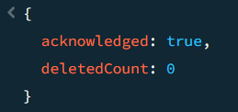

- Find employees who worked on MongoDB projects

db.employee.find({
"projects.tech": "MongoDB"
})

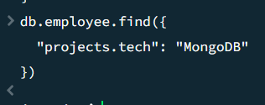

- Use $elemMatch to find project duration > 6 using MongoDB
db.employee.find({
projects: {
$elemMatch: {
duration: { $gt: 6 }
}
}
})

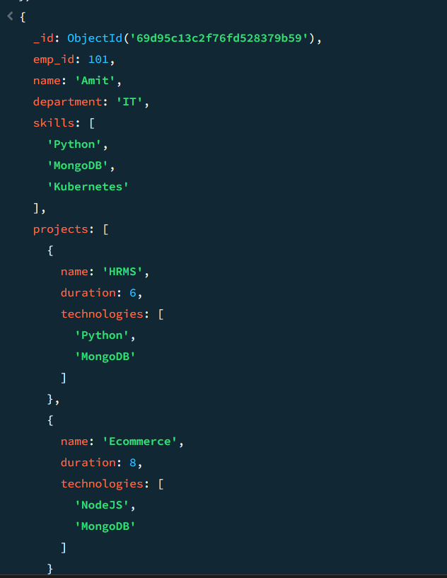

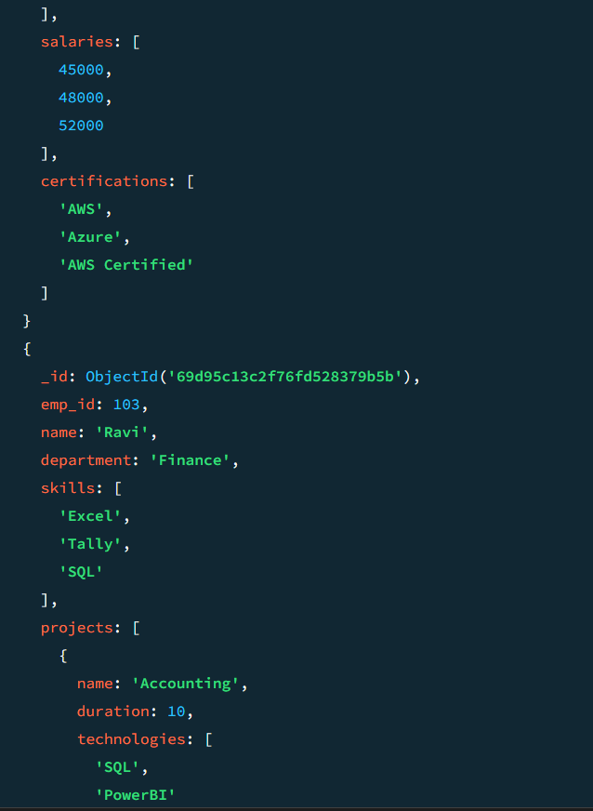

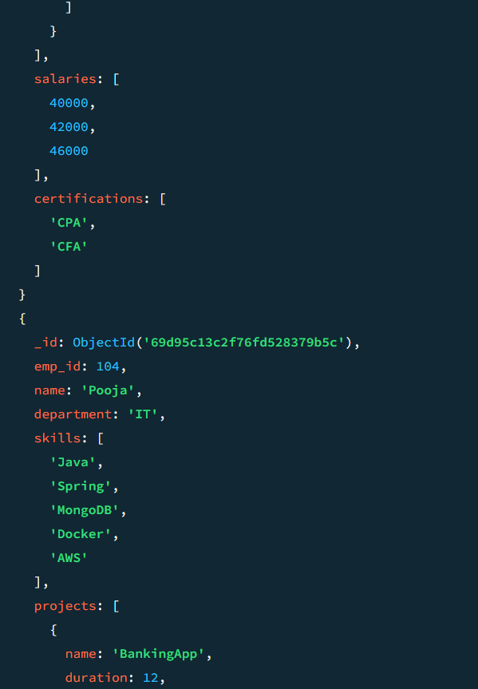

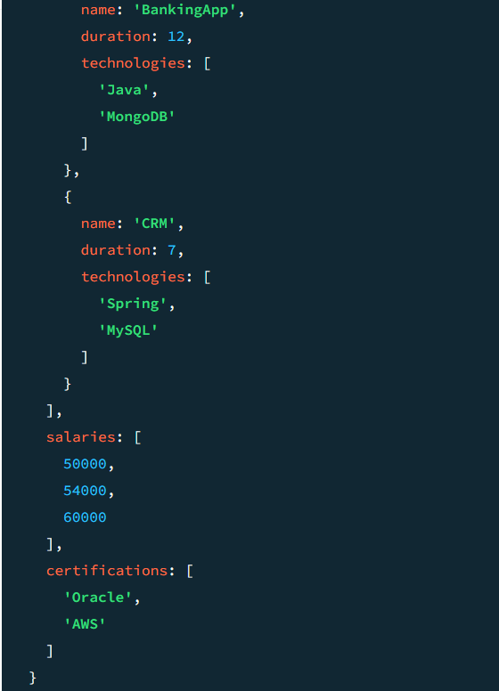

- Count number of projects for each employee

db.employee.aggregate([
{
$project: {
name: 1,
totalProjects: { $size: "$projects" }
}
}
])

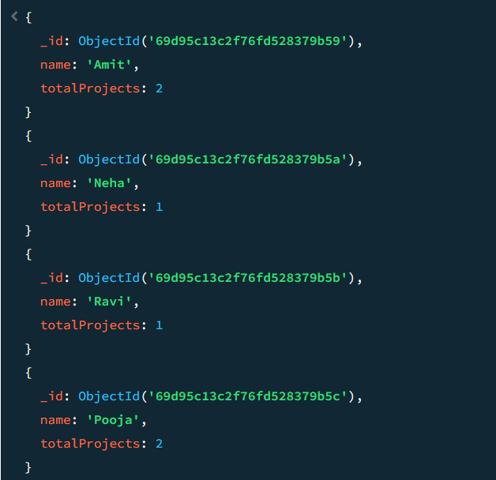

- Unwind skills array

db.employee.aggregate([
{ $unwind: "$skills" }
])

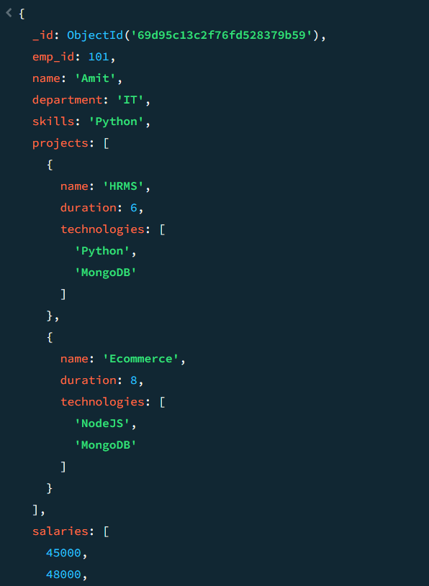

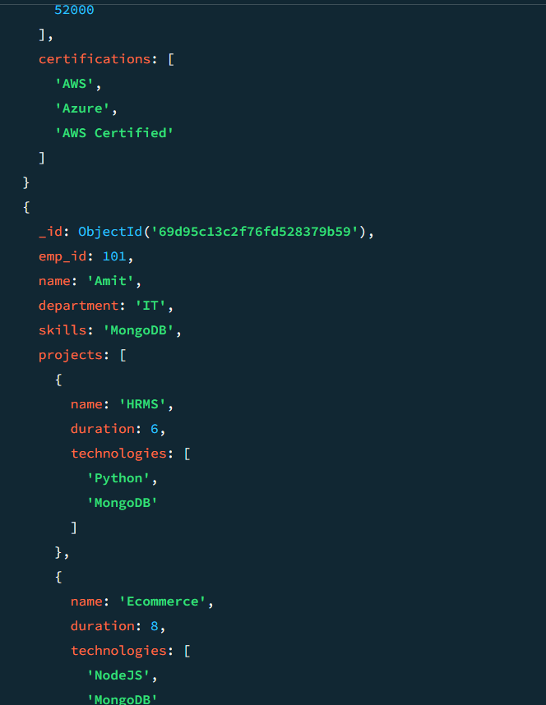

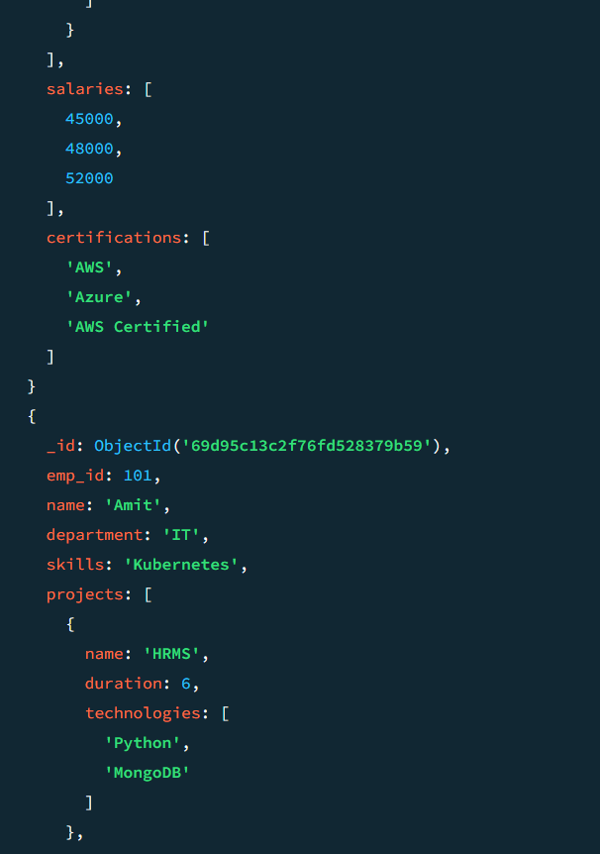

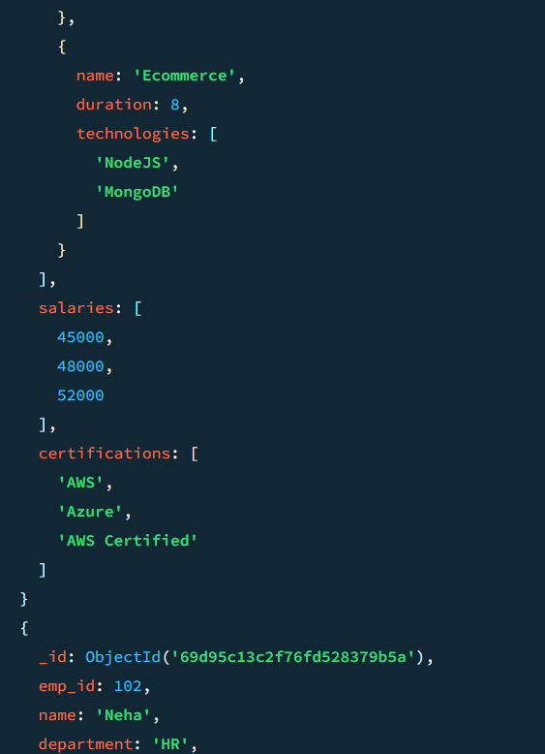

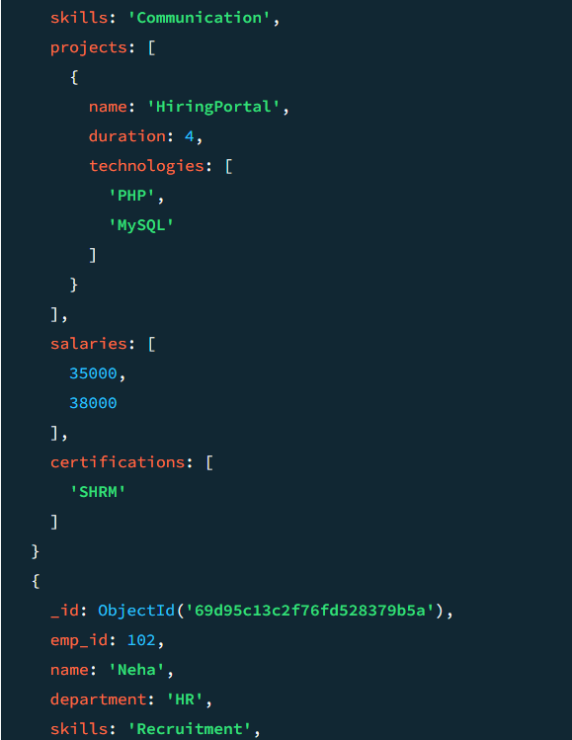

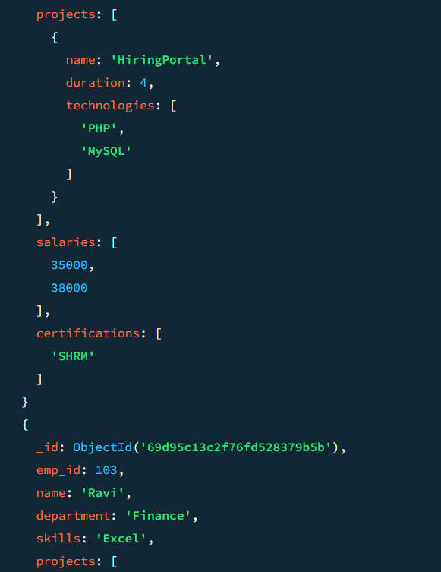

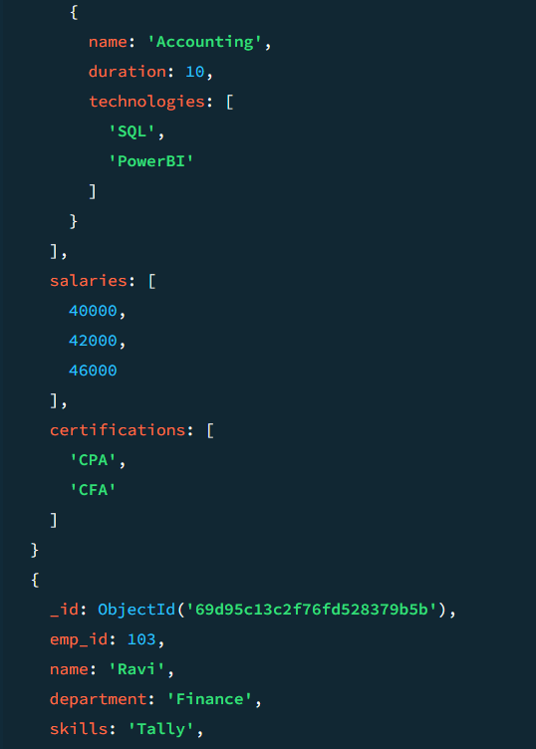

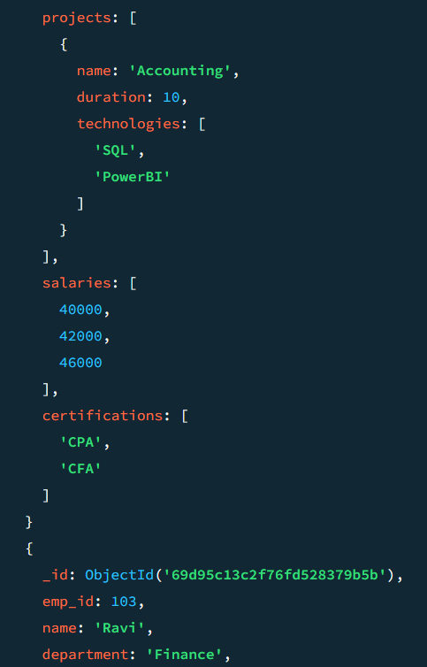

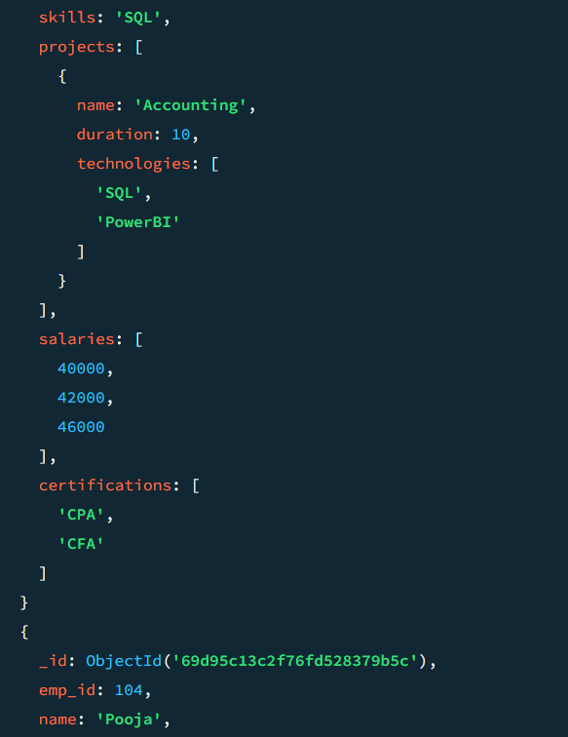

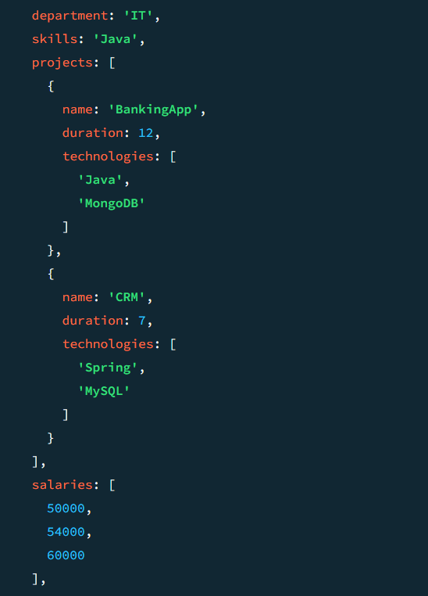

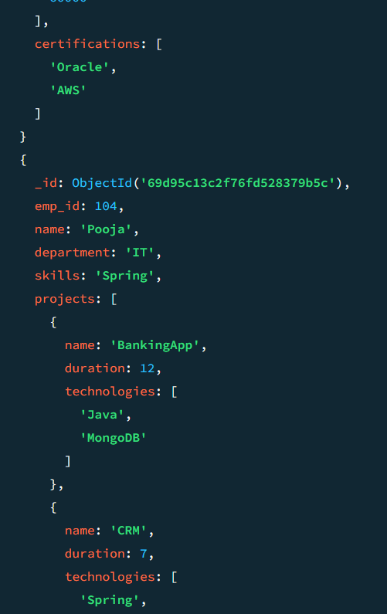

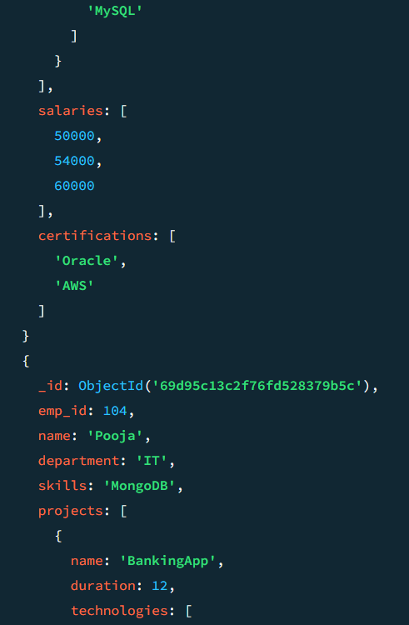

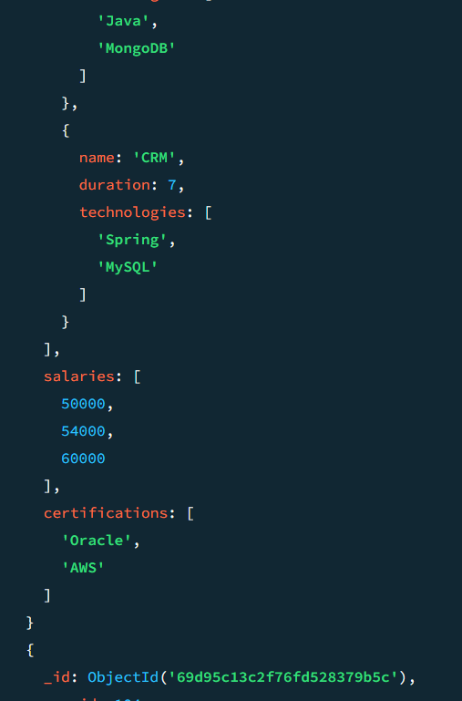

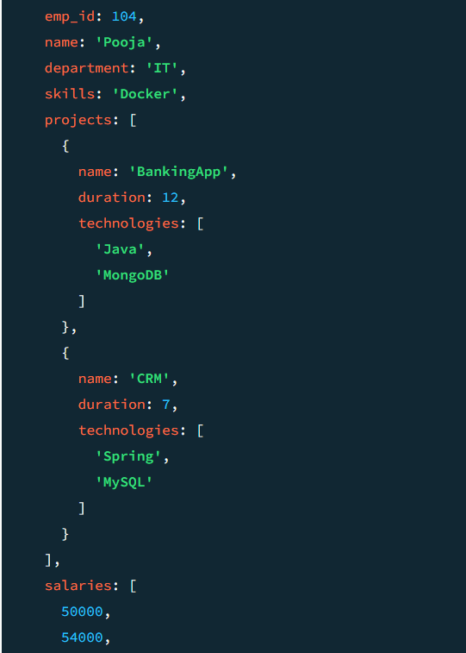

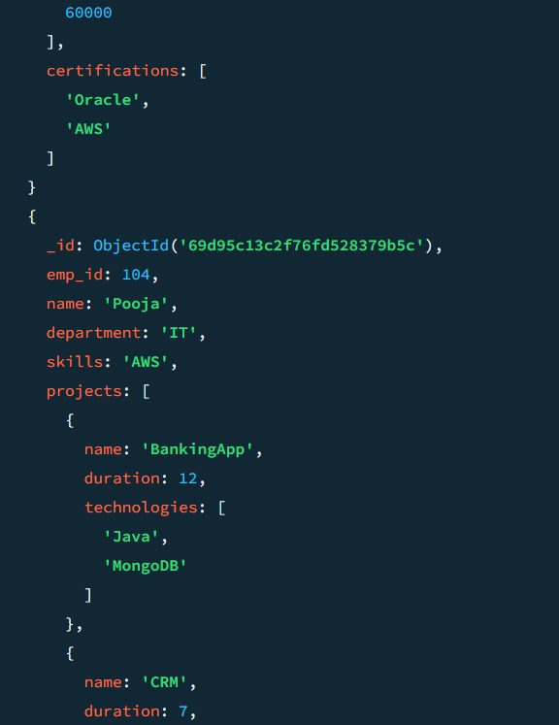

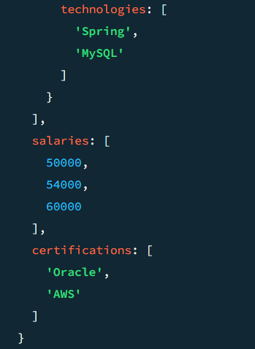

- List unique skills across company

db.employees.aggregate([
{ $unwind: "$skills" },
{ $group: { _id: "$skills" } }
])

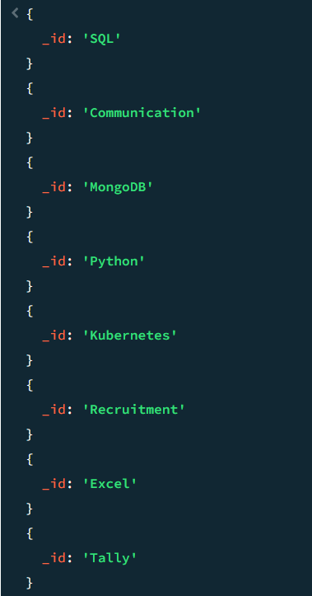

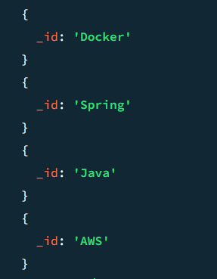

- Find employees with salary greater than 50000

db.employee.find({
salary: { $gt: 50000 }
})

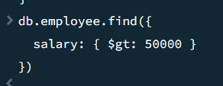

- Find employees with exactly 2 certifications

db.employee.find({
certifications: { $size: 2 }
})

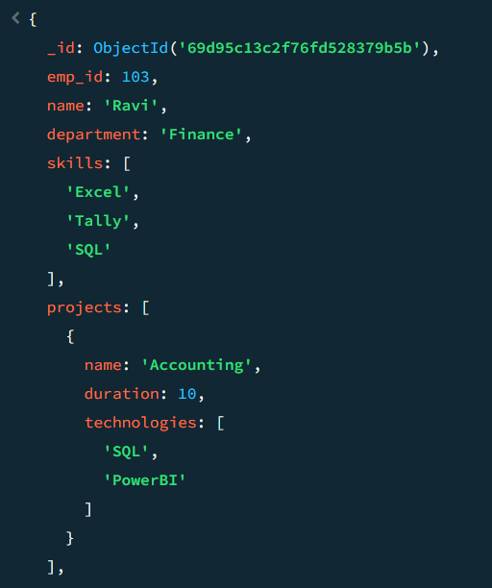
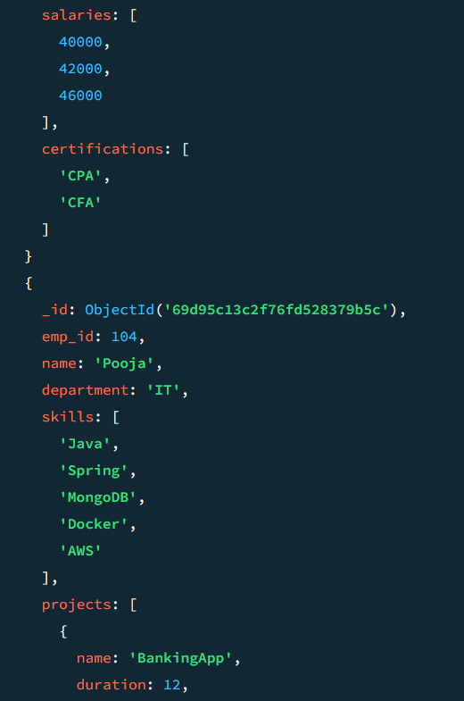

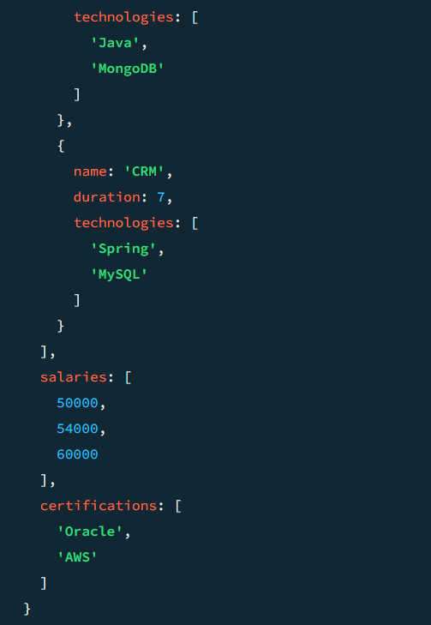

- Add new project to Ravi

db.employee.insertOne({
employee_name: "Ravi",
project_name: "New Project"
})

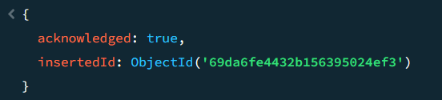

- Increase all salaries by 10% (array update)

db.employee.updateMany(
{},
{ $mul: { salary: 1.10 } }
)

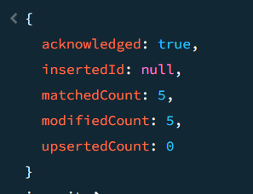

- Find highest salary of each employee

db.employee.aggregate([
{
$group: {
_id: "$employee_name",
highest_salary: { $max: "$salary" }
}
}
])

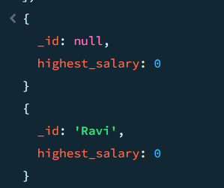

- Find average salary of employees

db.employee.aggregate([
{
$group: {
_id: null,
average_salary: { $avg: "$salary" }
}
}
])

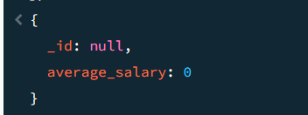

- Filter projects longer than 6 months

db.employee.find({
duration_months: { $gt: 6 }
})

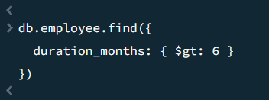

- Find employees who have any of these skills: Java or Python

db.employee.find({
skills: { $in: ["Java", "Python"] }
})

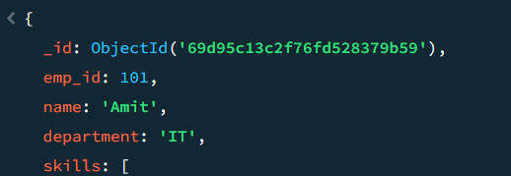

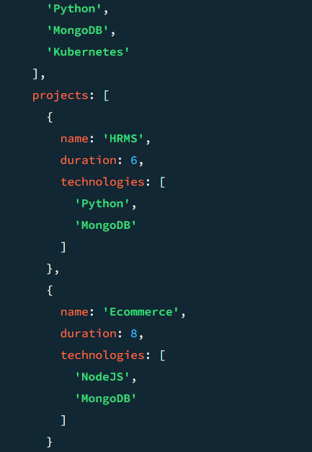

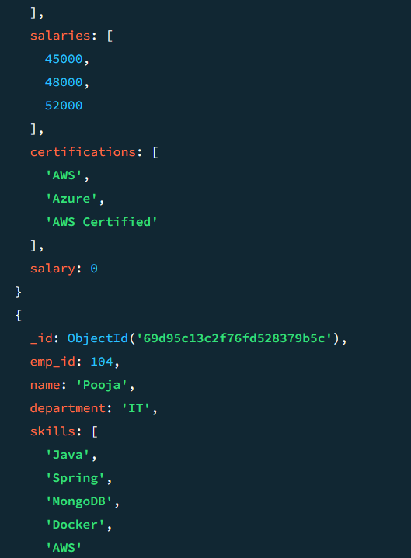

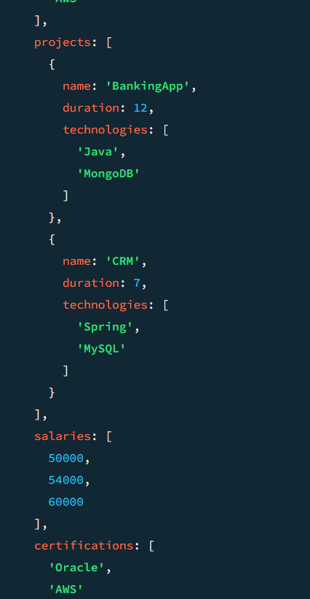

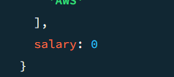

- Remove last salary entry

db.employee.updateMany(
{},
{ $pop: { salaries: 1 } }
)

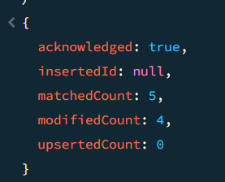

- Remove first salary entry

db.employee.updateMany(
{},
{ $pop: { salaries: -1 } }
)

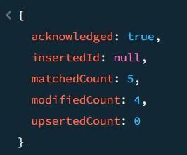

- Sort salaries array

db.employee.updateMany(
{},
{ $push: { salaries: { $each: [], $sort: 1 } } }
)

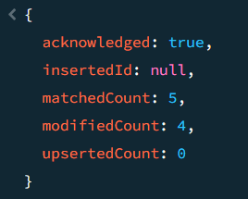

- Limit salaries array to last 2 entries

db.employee.updateMany(
{},
{ $push: { salaries: { $each: [], $slice: -2 } } }
)
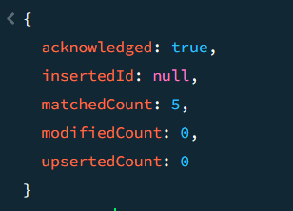

- Find total salary paid to each employee

db.employee.aggregate([
{
$project: {
employee_name: 1,
total_salary: { $sum: "$salaries" }
}
}
])

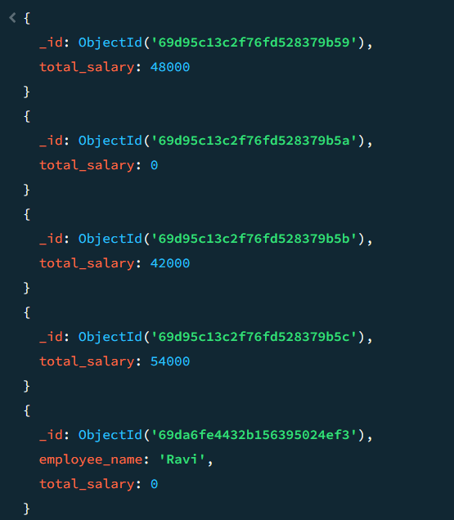

- Convert skills to uppercase

db.employee.updateMany(
{},
[
{
$set: {
skills: {
$map: {
input: "$skills",
as: "s",
in: { $toUpper: "$$s" }
}
}
}
}
]
)

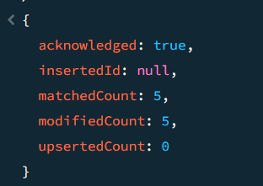

- Find employees with more than one project

db.employee.find({
$expr: { $gt: [ { $size: "$projects" }, 1 ] }
})

- Count employees per skill

db.employee.aggregate([
{ $unwind: "$skills" },
{
$group: {
_id: "$skills",
employee_count: { $sum: 1 }
}
}
])

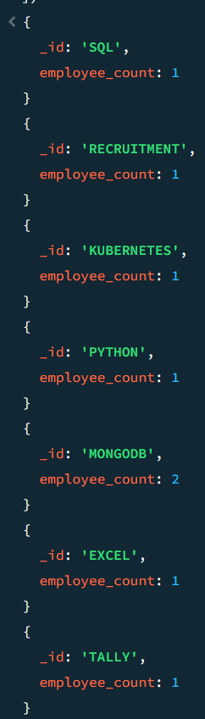

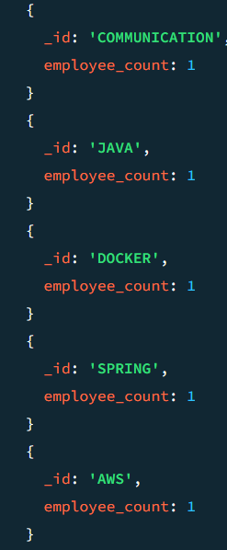

- Find employees whose all projects use MongoDB

db.employee.find({
projects: {
$not: {
$elemMatch: { technology: { $ne: "MongoDB" } }
}
}
})

