Assignment 01
Q1. Create a new database called student_management.
Query. use student_management
Output. switched to db student_management

Q2. Create a collection called students in the student_management database.
Query. db.createCollection("students”)
Output. { ok: 1 }

Q3. Insert at least five student records into the students collection. Each record should have the following fields:
- student_id (integer)
- name (string)
- age (integer)
- department (string)
- courses (array of strings)
- grade (string)
Query. db.students.insertMany([
- {student_id:101,name:"Alice",age:20,department:"Physics",courses:["Mechanics"],grade:"B"},
- {student_id:102,name:"Bob",age:22,department:"Computer Science",
courses:["Database Systems","Algorithms"],grade:"A"},
- {student_id:103,name:"Charlie",age:23,department:"Mathematics",courses:["Calculus"],grade:"C"},
- {student_id:104,name:"Diana",age:21,department:"Computer Science",
courses:["Operating Systems"],grade:"A"},
- {student_id:105,name:"Eve",age:19,department:"Biology",courses:["Genetics"],grade:"D"}
])
Output. {
acknowledged: true,
insertedIds: {
'0': ObjectId('69bc3fe8e51e1d79d263b112'),
'1': ObjectId('69bc3fe8e51e1d79d263b113'),
'2': ObjectId('69bc3fe8e51e1d79d263b114'),
'3': ObjectId('69bc3fe8e51e1d79d263b115'),
'4': ObjectId('69bc3fe8e51e1d79d263b116')
}
}
Check Query. db.students.find()
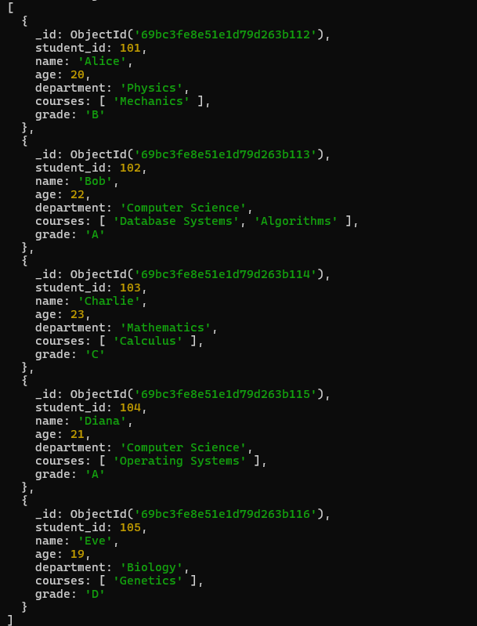

Q4. Query the Collections:
Write queries to perform the following tasks:
(i). Retrieve all students who are in the “Computer Science” department.
Query. db.students.find({department:"Computer Science"})
Output.
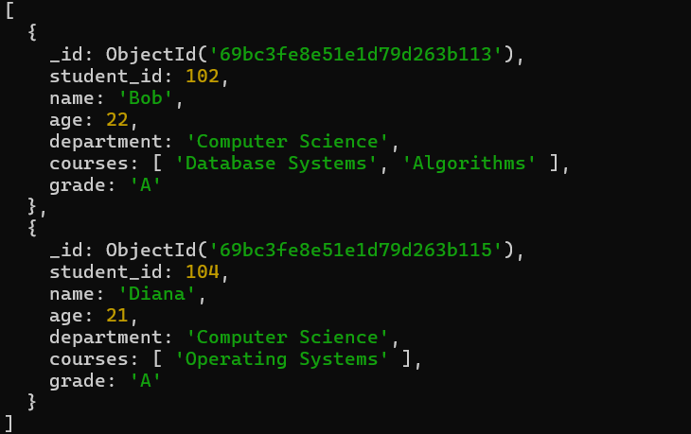

(ii). Retrieve students who have an age greater than 21.
Query. db.students.find({age:{$gt:21}})
Output.
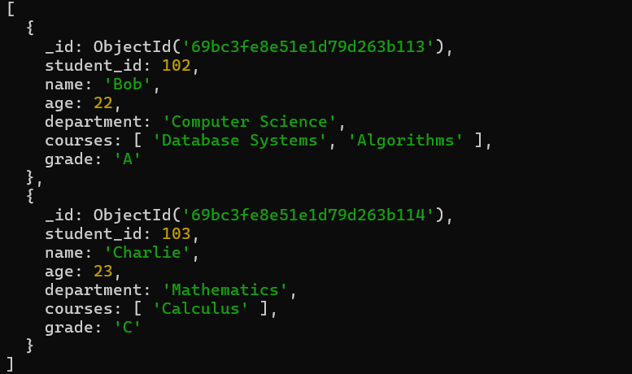

(iii). Retrieve students who are taking the "Database Systems" course.
Query. db.students.find({courses:"Database Systems"})
Output.
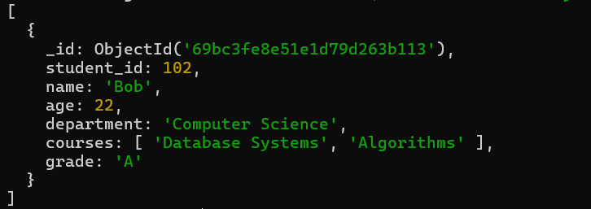

(iv). Retrieve students with a grade of "A".
Query. db.students.find({grade:"A"})
Output.
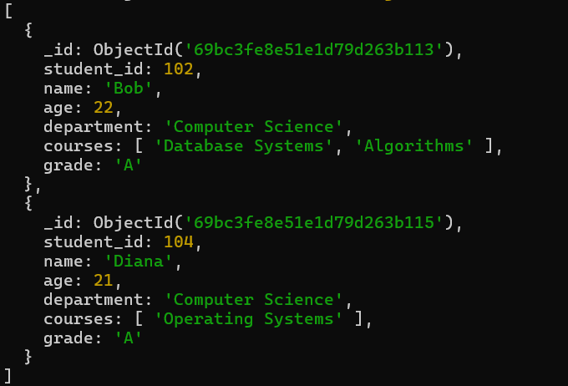

Q5. Update Documents:
(i). Update the age of a student with student_id 101 to 21.
Query. db.students.updateOne({student_id:101},{$set:{age:21}})
Output. {
acknowledged: true,
insertedId: null,
matchedCount: 1,
modifiedCount: 1,
upsertedCount: 0
}
Check Query. db.students.find()
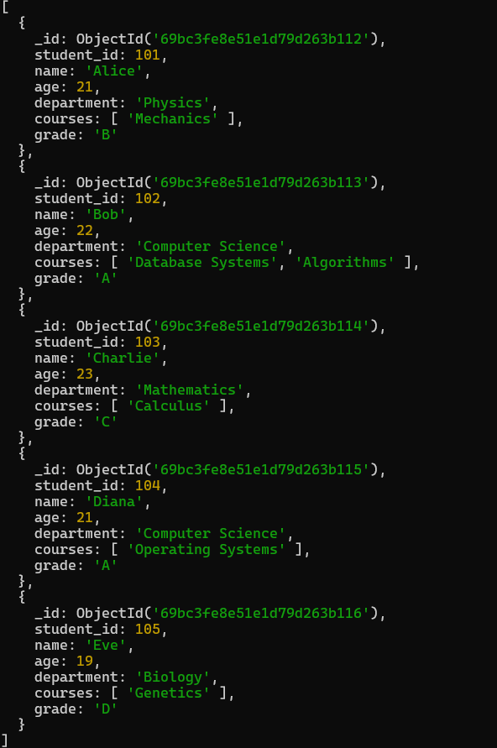

(ii). Add a new course, "Machine Learning", to the courses array for students in the "Computer Science" department.
Query. db.students.updateMany({department:"Computer Science"},{$push:{courses:"Machine Learning"}})
Output. {
acknowledged: true,
insertedId: null,
matchedCount: 2,
modifiedCount: 2,
upsertedCount: 0
}
Check Query. db.students.find()
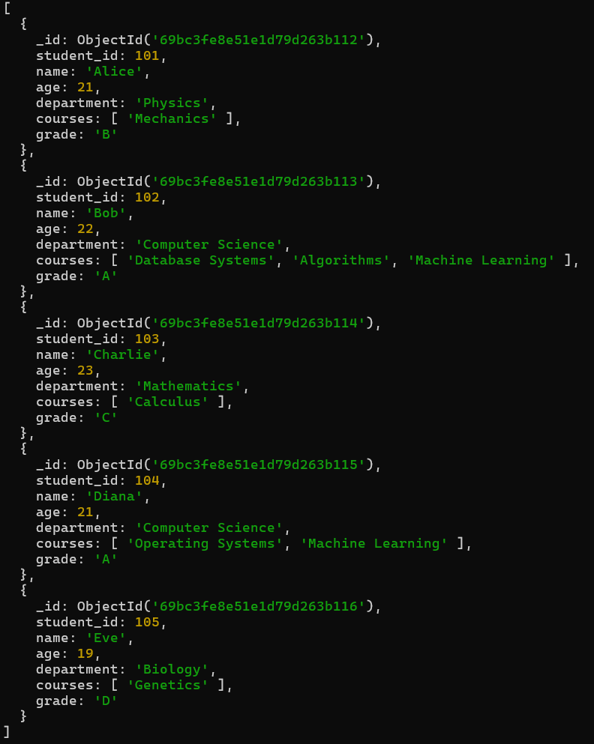

Q6. Delete Document:
(i). Delete a student record with student_id 105.
Query. db.students.deleteOne({student_id:105})
Output. { acknowledged: true, deletedCount: 1 }
Check Query. db.students.find()
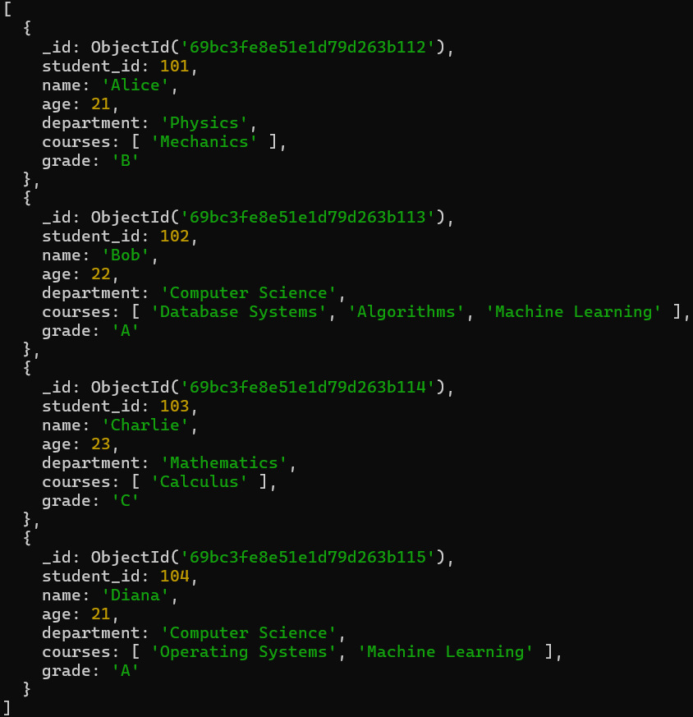

(ii). Delete all students who have a grade lower than "C".
Query. db.students.deleteMany({ grade: { $in: ["D", "F"] } })
Output. { acknowledged: true, deletedCount: 0 }
Check Query. db.students.find()
