Devanagari Transliterator:
1. http://indology.info/links/soft/
https://code.google.com/p/sktutilities/downloads/list [Jar file]
- This work contains set of Utilities for Sanskritists including the Monier Williams Dictionary, ITRANS-SLP-Harvard Kyoto Devanagari Transliterator, Sandhi Engine, Metric Analyzer etc.
- Downloaded jar for Transliterator which provides the following ui for translation
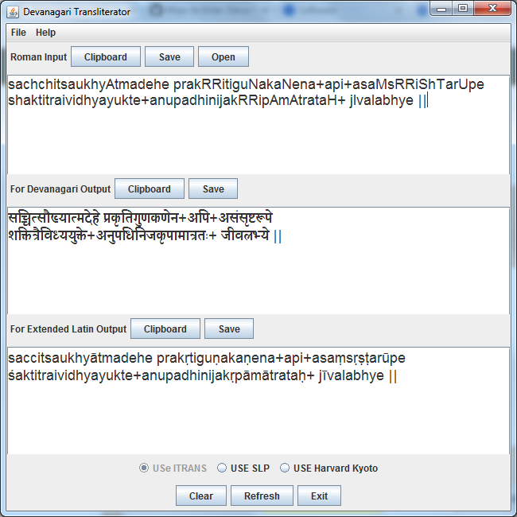

Demerits:
- Only translates Roman Inputs into Devanagari but other way is not possible. Very limited options they are providing.
- Java source code is available.
2. http://learnsanskrit.org/tools
It contains three tools (some online and others offline tools which works only in windows)
A. ITRANS
B. SanScript
C. Itranslator
A. ITRANS online interface: (http://www.aczoom.com/itrans/online/#help)
Has support for all Indian languages, But it can only translate from ITRANS to Indian languages other transliterations are not allowed.
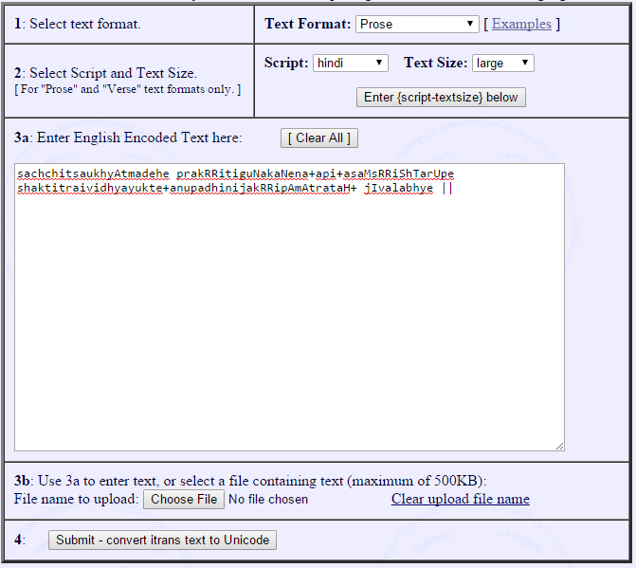
Output:
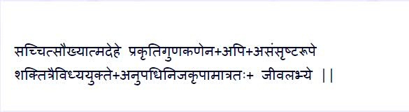
Demerits:
Only option to translate from ITRANS to any other Indian language other options are not available.
B. Sanscript: (http://learnsanskrit.org/tools/sanscript)
It has support for all the systems related to Devanagari.
Very close to what we were thinking
A web tool – not able to locate the source code.

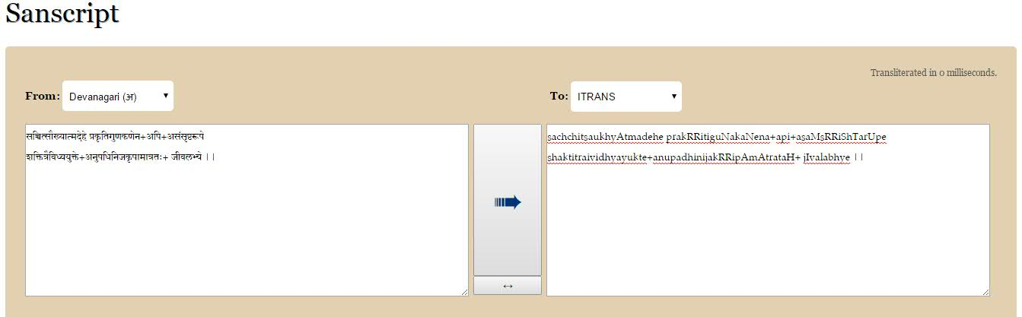

Demerits: Not able to locate the source code otherwise it can serve our purpose.
C. Itranslator: (http://www.omkarananda-ashram.org/Sanskrit/itranslator2003.htm):
A windows tool that converts ITRANS to Devanagari converter.
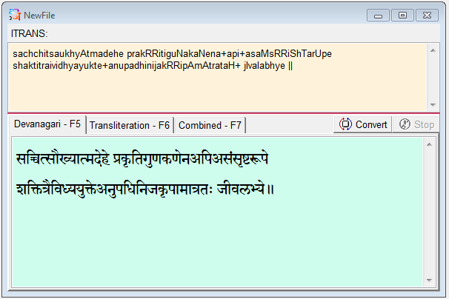
Demerits: May not be useful, as itconverts only from ITRANS to Devanagari.
3. http://kevincarmody.com/
They provide both Devanāgarī editor, Romanization editor but have very limited support
Romanization editor
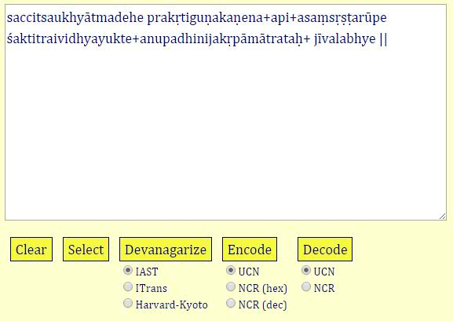
Devanāgarī Editor
Other related tools:
- http://mylanguages.org/sanskrit_romanization.php
- http://www.cfilt.iitb.ac.in/mitweb/process.jsp?verse=
- http://www.devanagarifonts.net/tools/romantodevanagari.html

