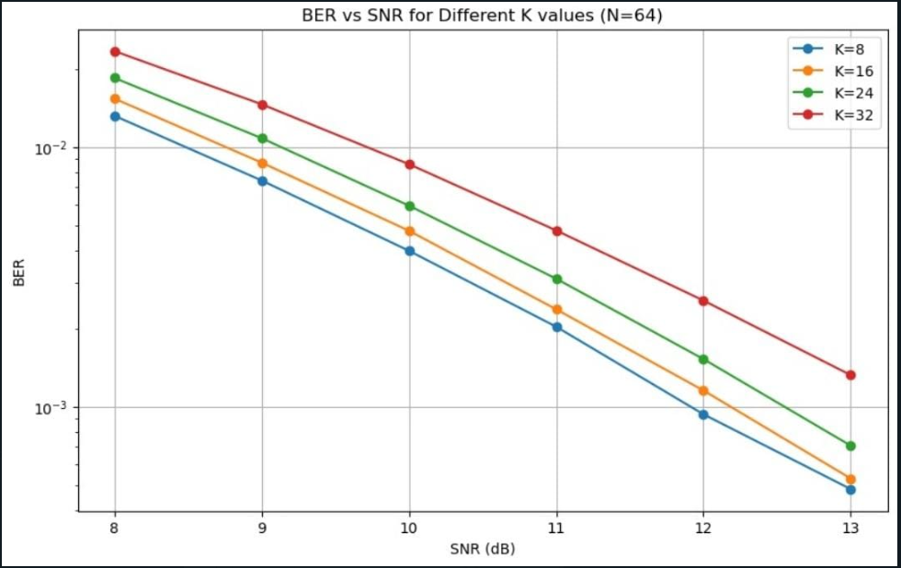

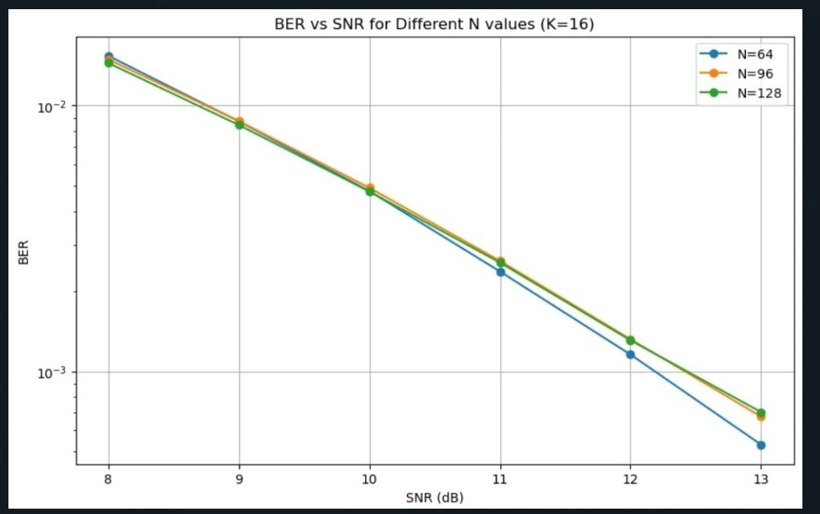

**Combine of zero forcing and mmse**

import numpy as np

import matplotlib.pyplot as plt

# Function to generate additive white Gaussian noise (AWGN)

def awgn_noise(signal, noise_power):

noise = np.random.randn(*signal.shape) * np.sqrt(noise_power)

return noise

# Function to simulate Massive MIMO system with Zero Forcing (ZF) detection

def simulate_mimo_system_zf(H, num_users, snr_values_db, num_trials=10000):

# Generate random symbol vector x_true

num_symbols = num_users

x_true = np.random.randint(0, 2, num_symbols) * 2 - 1 # BPSK symbols {-1, 1}

ber_values_zf = []

for snr_db_val in snr_values_db:

# Convert SNR from dB to linear scale

snr_lin = 10**(snr_db_val / 10)

noise_power = 1 / snr_lin

num_errors = 0

for _ in range(num_trials):

# Generate received signal with AWGN

y = np.dot(H, x_true) + awgn_noise(np.dot(H, x_true), noise_power)

# Zero Forcing (ZF) detection

H_pinv = np.linalg.pinv(H)

x_demod_zf = np.sign(np.dot(H_pinv, y.real)) # Demodulate symbols

# Calculate Bit Error Rate (BER) for ZF

num_errors += np.sum(x_demod_zf != x_true)

ber = num_errors / (num_trials * num_symbols)

ber_values_zf.append(ber)

return ber_values_zf

# Function to simulate Massive MIMO system with MMSE detection

def simulate_mimo_system_mmse(H, num_users, snr_values_db, num_trials=10000):

# Generate random symbol vector x_true

num_symbols = num_users

x_true = np.random.randint(0, 2, num_symbols) * 2 - 1 # BPSK symbols {-1, 1}

ber_values_mmse = []

for snr_db_val in snr_values_db:

# Convert SNR from dB to linear scale

snr_lin = 10**(snr_db_val / 10)

noise_power = 1 / snr_lin

num_errors = 0

for _ in range(num_trials):

# Generate received signal with AWGN

y = np.dot(H, x_true) + awgn_noise(np.dot(H, x_true), noise_power)

# MMSE detection

part1_w = np.conj(H.T) @ H

part2_W = np.linalg.inv(part1_w + noise_power * np.eye(num_users))

W_mmse = part2_W @ np.conj(H.T)

x_demod_mmse = np.sign(W_mmse @ y.real) # Demodulate symbols

# Calculate Bit Error Rate (BER) for MMSE

num_errors += np.sum(x_demod_mmse != x_true)

ber = num_errors / (num_trials * num_symbols)

ber_values_mmse.append(ber)

return ber_values_mmse

# Parameters

num_antennas = 8

num_users = 4 # Change this to the desired number of users

modulation_order = 2 # BPSK modulation

num_trials = 10000

# SNR in dB (from 2 dB to 20 dB)

snr_values_db = np.arange(2, 21, 2)

# Generate random channel matrix H

H = np.random.randn(num_antennas, num_users) + 1j * np.random.randn(num_antennas, num_users)

H = H / np.sqrt(2) # Scale every element by 1/sqrt(2)

# Simulate Massive MIMO system with Zero Forcing (ZF) detection for BPSK

ber_values_zf = simulate_mimo_system_zf(H, num_users, snr_values_db, num_trials)

# Simulate Massive MIMO system with MMSE detection for BPSK

ber_values_mmse = simulate_mimo_system_mmse(H, num_users, snr_values_db, num_trials)

# Plot SNR vs BER for both ZF and MMSE

plt.figure(figsize=(10, 6))

plt.semilogy(snr_values_db, ber_values_zf, marker='o', linestyle='-', label='ZF', color='blue')

plt.semilogy(snr_values_db, ber_values_mmse, marker='s', linestyle='--', label='MMSE', color='red')

plt.title('SNR vs Bit Error Rate (BER) for Massive MIMO with ZF and MMSE detection (BPSK)')

plt.xlabel('SNR (dB)')

plt.ylabel('Bit Error Rate (BER)')

plt.legend()

plt.grid(True)

plt.show()

16X8

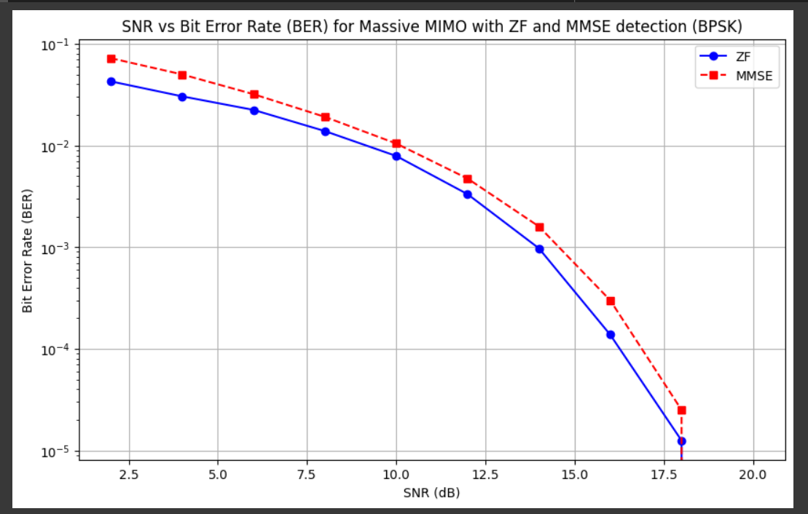

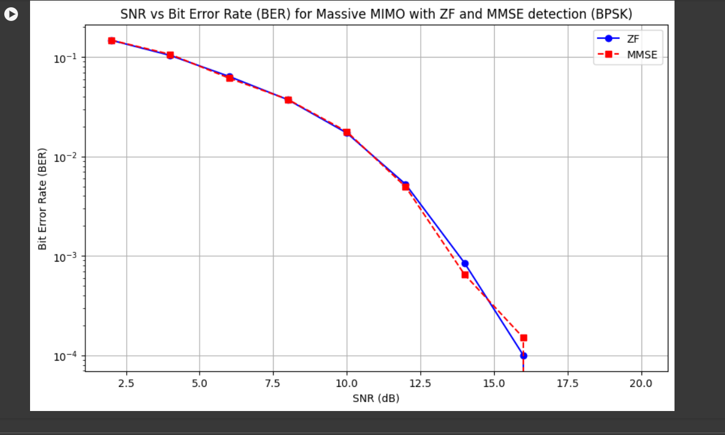

2X4

***Zero Forcing***

***Code :***

import numpy as np

import matplotlib.pyplot as plt

# Function to generate additive white Gaussian noise (AWGN)

def awgn_noise(signal, noise_power):

    noise = np.random.randn(*signal.shape) * np.sqrt(noise_power)

    return noise

# Function to simulate Massive MIMO system with Zero Forcing (ZF) detection

def simulate_mimo_system(num_antennas, num_users, modulation_order, snr_db, num_trials=10000):

    # Generate random channel matrix H

    H = np.random.randn(num_antennas, num_users) + 1j * np.random.randn(num_antennas, num_users)

    H = H / np.sqrt(2)  # Scale every element by 1/sqrt(2)

    # Generate random symbol vector x_true

    num_symbols = num_users

    x_true = np.random.randint(0, 2, num_symbols) * 2 - 1  # BPSK symbols {-1, 1}

    # Generate AWGN noise power from SNR

    snr_lin = 10**(snr_db / 10)

    noise_power = 1 / snr_lin

    # Initialize lists to store Bit Error Rate (BER) for each SNR value

    snr_values_db = np.arange(0, 16, 2)  # SNR range from -10 dB to 15 dB

    ber_values = []

    for snr_db in snr_values_db:

        # Convert SNR from dB to linear scale

        snr_lin = 10**(snr_db / 10)

        noise_power = 1 / snr_lin

        num_errors = 0

        for _ in range(num_trials):

            # Generate received signal with AWGN

            y = np.dot(H, x_true) + awgn_noise(np.dot(H, x_true), noise_power)

            # Zero Forcing (ZF) detection

            part1_w = np.conj(H.T) @ H

            part2_W = np.linalg.inv(part1_w)

            W_zf = part2_W @ np.conj(H.T)

            x_demod = np.sign(W_zf @ y.real)  # Demodulate symbols

            # Calculate Bit Error Rate (BER)

            num_errors += np.sum(x_demod != x_true)

        ber = num_errors / (num_trials * num_symbols)

        ber_values.append(ber)

    return snr_values_db, ber_values

# Parameters

num_antennas = 64

num_users = 32  # Change this to the desired number of users

modulation_order = 2  # BPSK modulation

num_trials = 10000

snr_db = 10 # Initial SNR value in dB

# Simulate Massive MIMO system with Zero Forcing (ZF) detection for BPSK

snr_values_db, ber_values = simulate_mimo_system(num_antennas, num_users, modulation_order, snr_db, num_trials)

# Plot SNR vs BER

plt.figure(figsize=(10, 6))

plt.semilogy(snr_values_db, ber_values, marker='o', linestyle='-')

plt.title('SNR vs Bit Error Rate (BER) for Massive MIMO with Zero Forcing (ZF) detection (BPSK)')

plt.xlabel('SNR (dB)')

plt.ylabel('Bit Error Rate (BER)')

plt.grid(True)

plt.show()

**2x4**

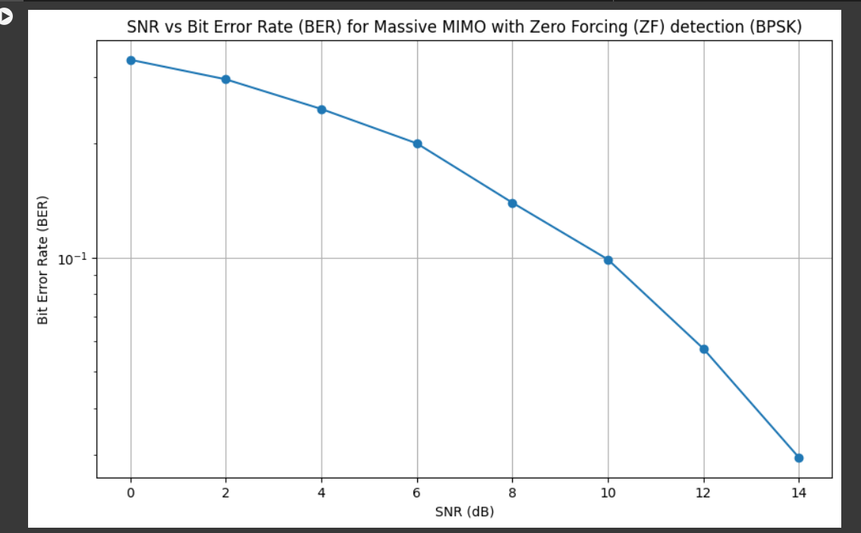

8X 16

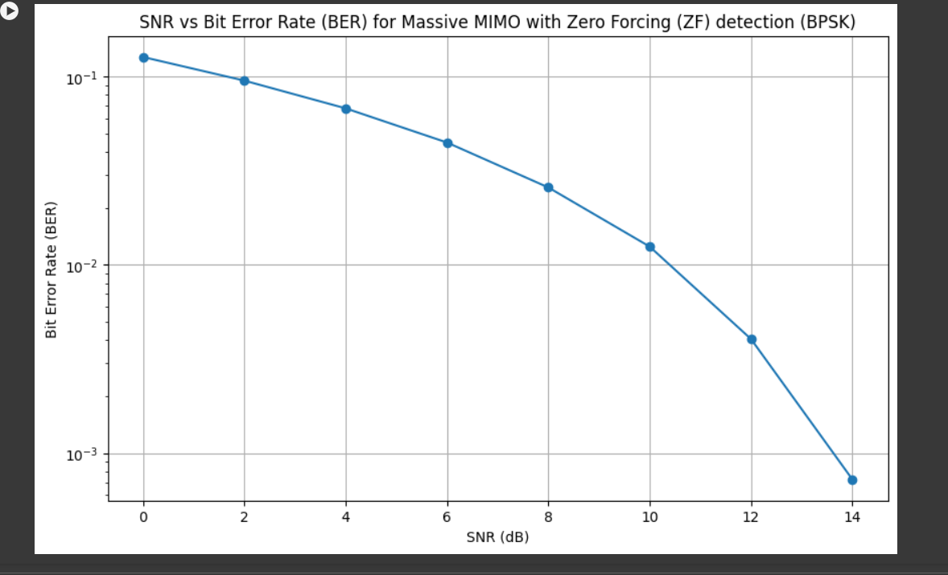

16X32

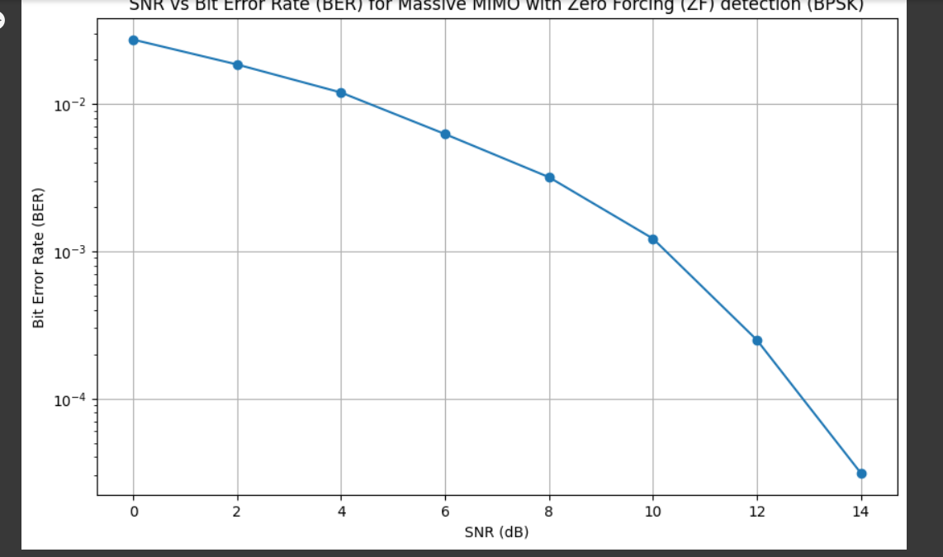

**16 x 64**

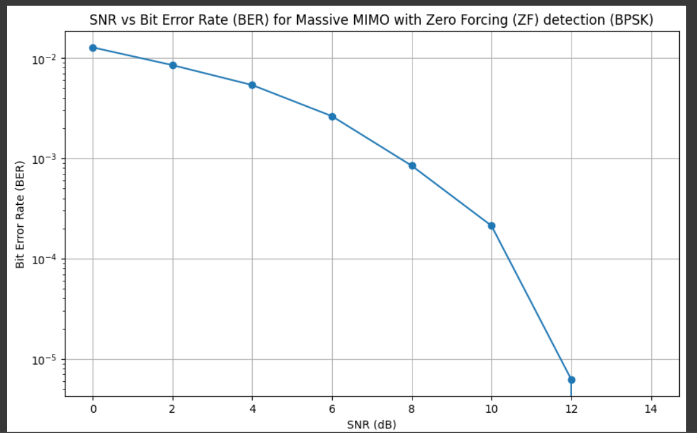

32X64

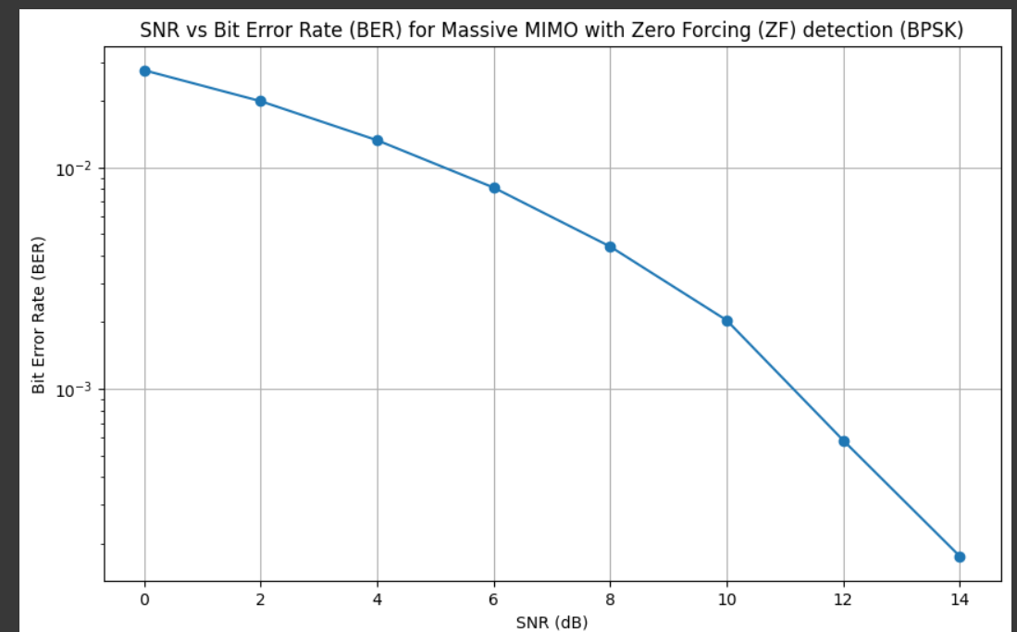

MMSE

import numpy as np

import matplotlib.pyplot as plt

# Function to generate additive white Gaussian noise (AWGN)

def awgn_noise(signal, noise_power):

    noise = np.random.randn(*signal.shape) * np.sqrt(noise_power)

    return noise

# Function to simulate Massive MIMO system with MMSE detection

def simulate_mimo_system(num_antennas, num_users, modulation_order, snr_db, num_trials=10000):

    # Generate random channel matrix H

    H = np.random.randn(num_antennas, num_users) + 1j * np.random.randn(num_antennas, num_users)

    H = H / np.sqrt(2)  # Scale every element by 1/sqrt(2)

    # Generate random symbol vector x_true

    num_symbols = num_users

    x_true = np.random.randint(0, 2, num_symbols) * 2 - 1  # BPSK symbols {-1, 1}

    # Generate AWGN noise power from SNR

    snr_lin = 10**(snr_db / 10)

    noise_power = 1 / snr_lin

    # Initialize lists to store Bit Error Rate (BER) for each SNR value

    snr_values_db = np.arange(0, 16, 2)  # SNR range from -10 dB to 15 dB

    ber_values = []

    for snr_db in snr_values_db:

        # Convert SNR from dB to linear scale

        snr_lin = 10**(snr_db / 10)

        noise_power = 1 / snr_lin

        num_errors = 0

        for _ in range(num_trials):

            # Generate received signal with AWGN

            y = np.dot(H, x_true) + awgn_noise(np.dot(H, x_true), noise_power)

            # MMSE detection

            part1_w = np.conj(H.T) @ H

            part2_W = np.linalg.inv(part1_w + noise_power * np.eye(num_users))

            W_mmse = part2_W @ np.conj(H.T)

            x_demod = np.sign(W_mmse @ y.real)  # Demodulate symbols

            # Calculate Bit Error Rate (BER)

            num_errors += np.sum(x_demod != x_true)

        ber = num_errors / (num_trials * num_symbols)

        ber_values.append(ber)

    return snr_values_db, ber_values

# Parameters

num_antennas = 4

num_users = 2 # Change this to the desired number of users

modulation_order = 2  # BPSK modulation

num_trials = 10000

snr_db = 10  # Initial SNR value in dB

# Simulate Massive MIMO system with MMSE detection for BPSK

snr_values_db, ber_values = simulate_mimo_system(num_antennas, num_users, modulation_order, snr_db, num_trials)

# Plot SNR vs BER

plt.figure(figsize=(10, 6))

plt.semilogy(snr_values_db, ber_values, marker='o', linestyle='-')

plt.title('SNR vs Bit Error Rate (BER) for Massive MIMO with MMSE detection (BPSK)')

plt.xlabel('SNR (dB)')

plt.ylabel('Bit Error Rate (BER)')

plt.grid(True)

plt.show()

2X4

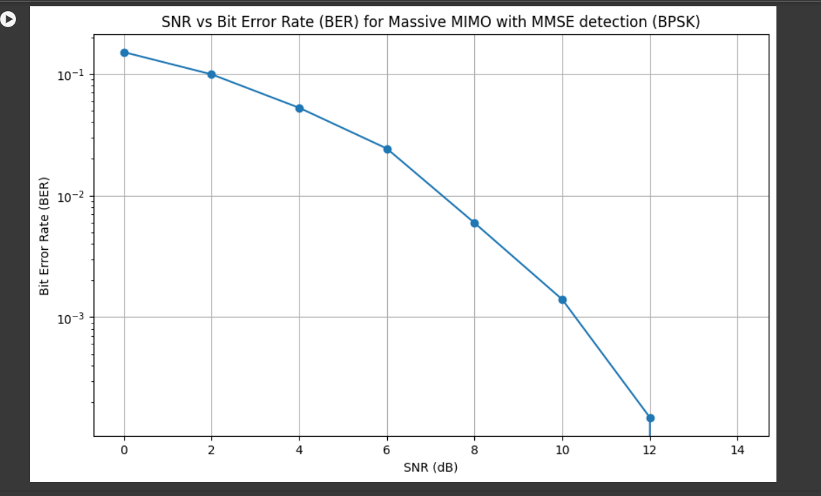

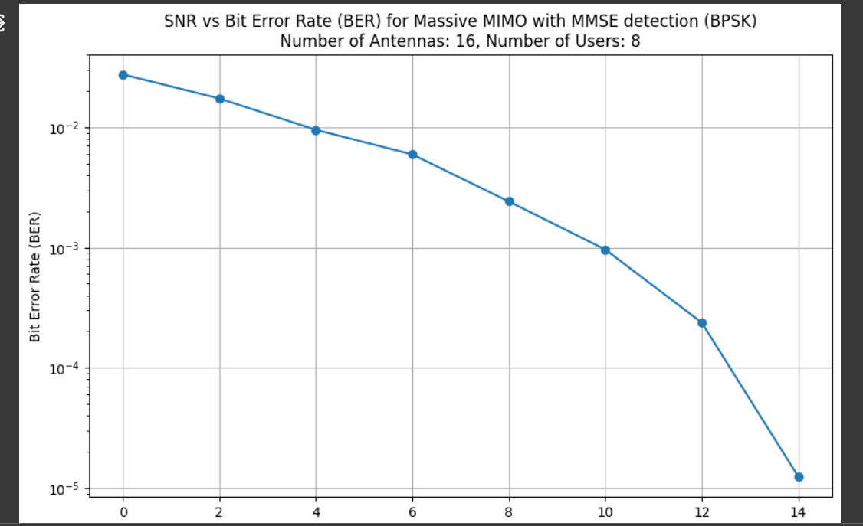

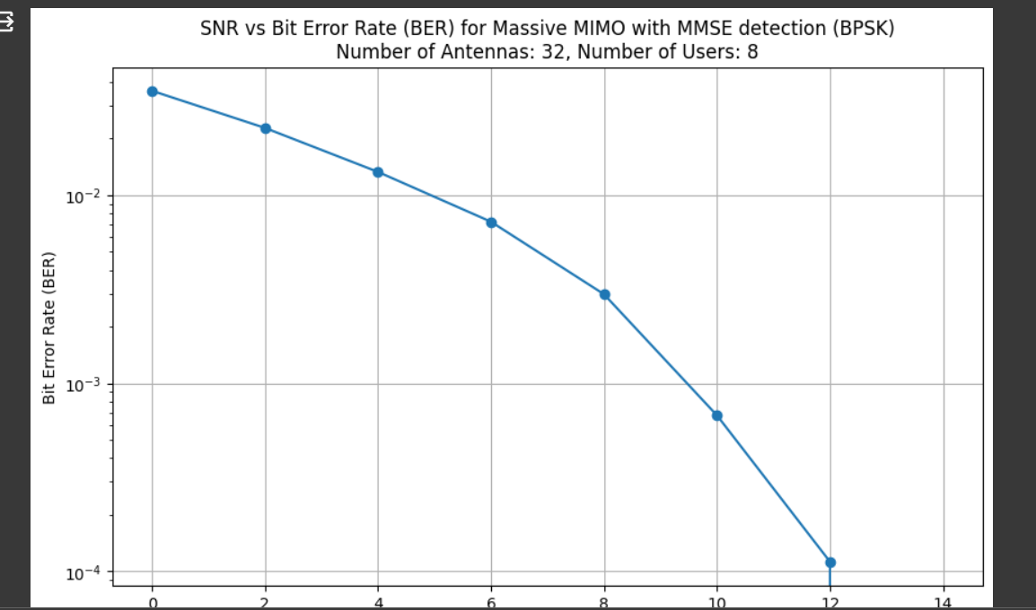

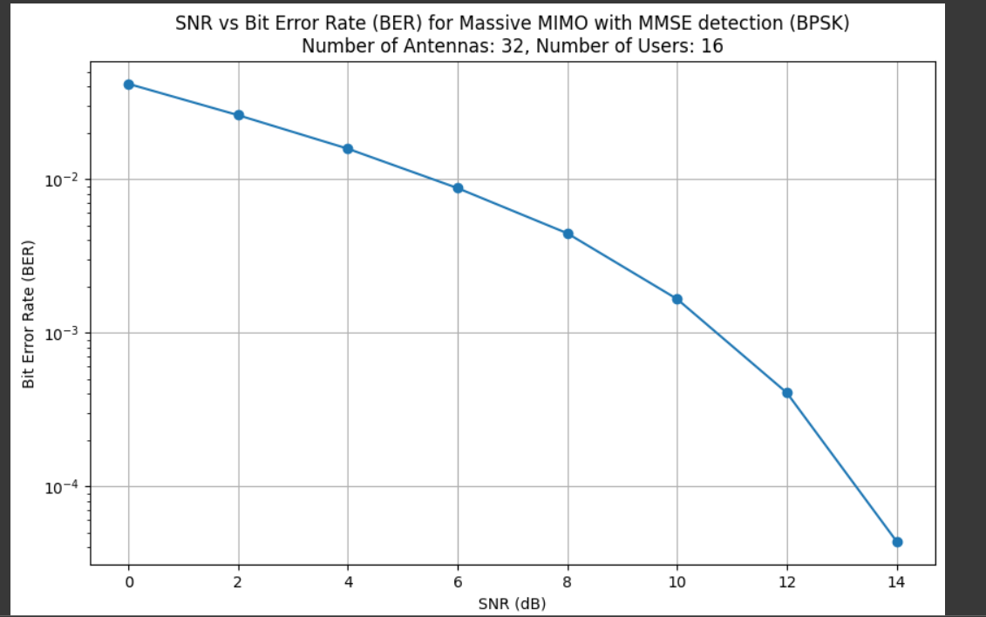

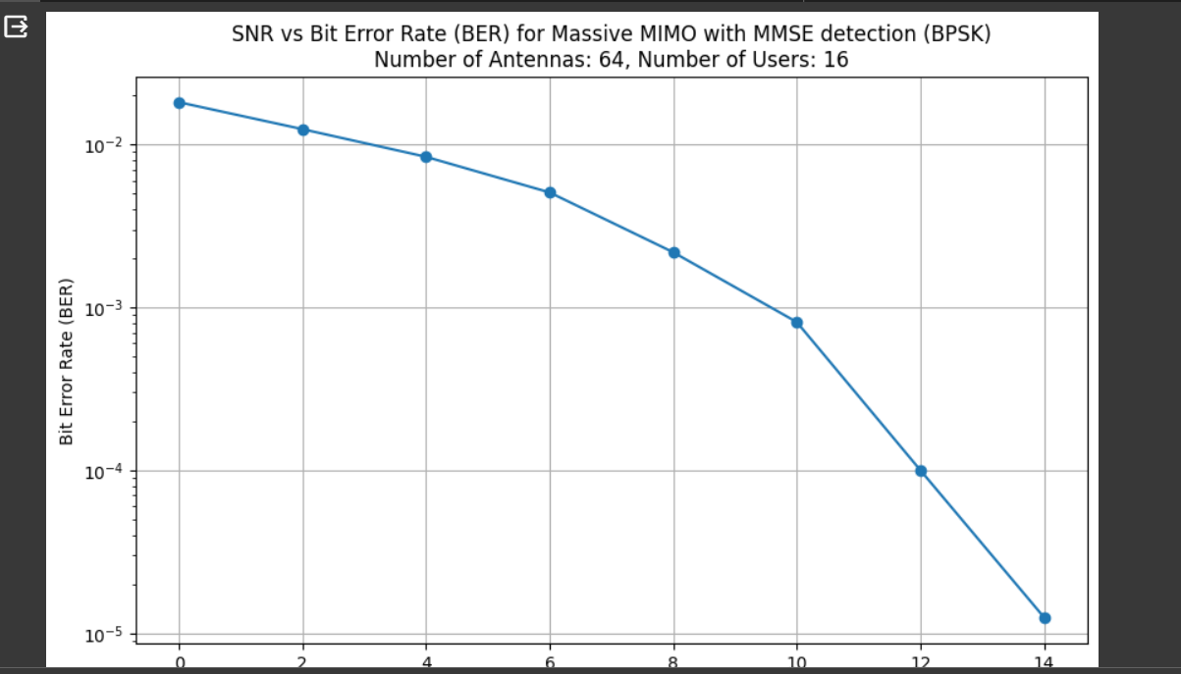

Detnet

