**ASSIGNMENT NUMBER: 2**

VLSI Design and Technology

**VLSI Design and Technology**

**Name: SANSKRITI**

**Faculty Number: 20ELB270**

**Enrolment Number: GK8667**

**Serial Number :36**

**Schematic:**

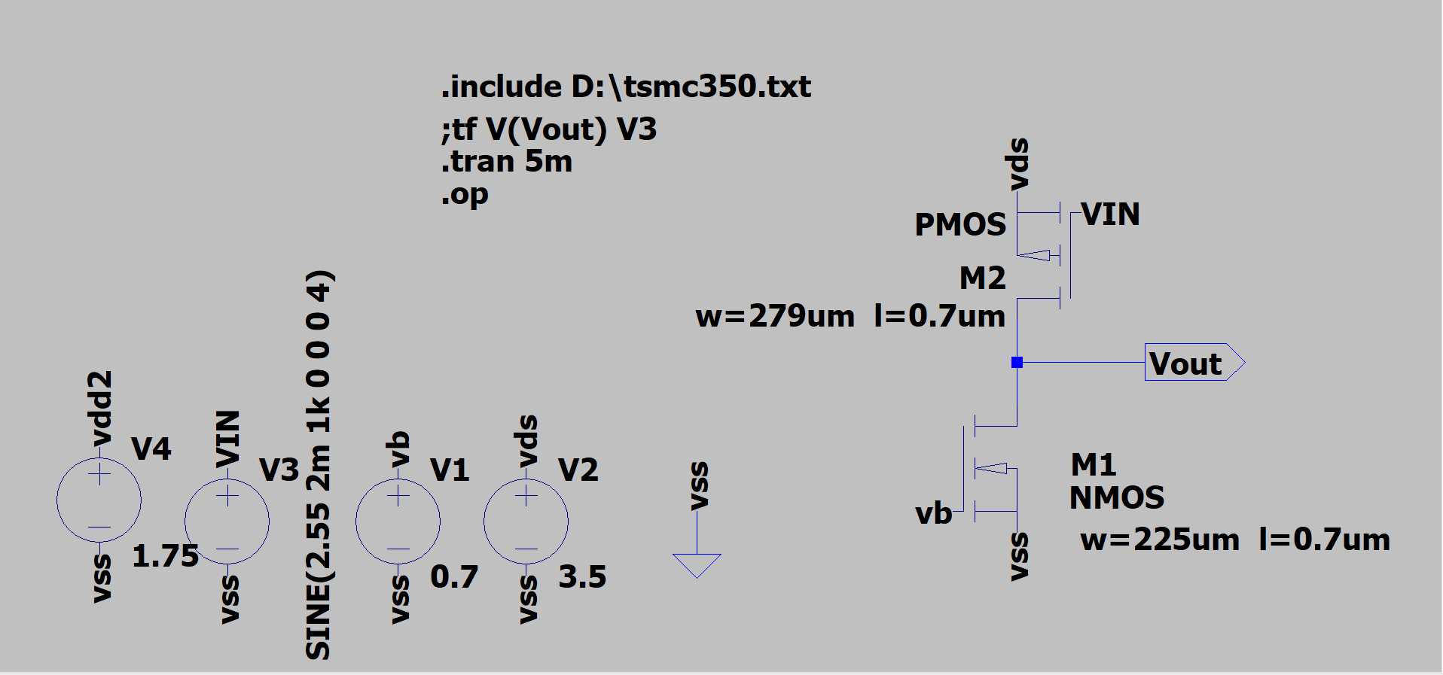

. **Transient analysis waveform:**

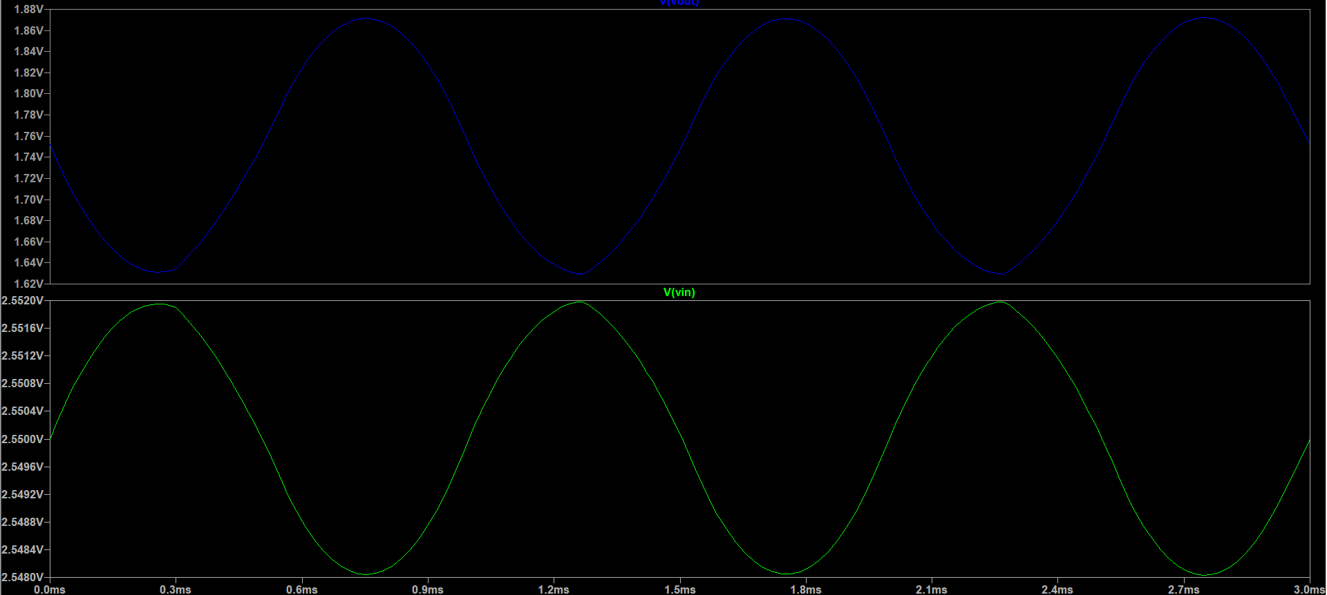

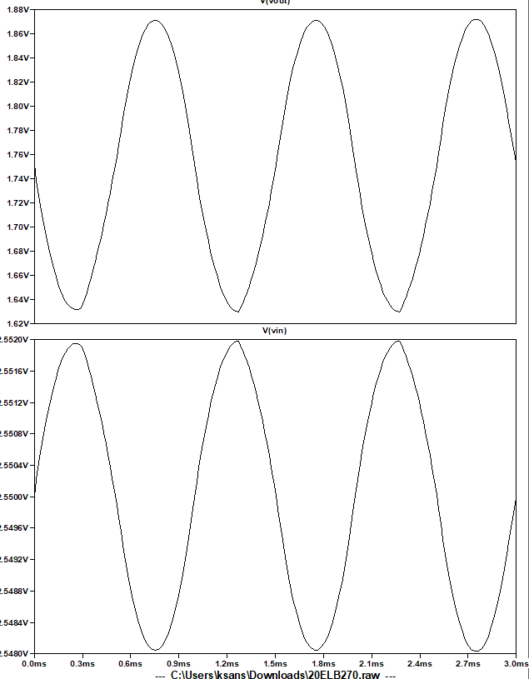

**Operation point:**

