A Project Synopsis on
CoreSight
AI-Powered Institutional Management and
Attendance Intelligence System
Submitted for fulfillment of award of
Bachelor of Technology
In
CSE-AI&ML
By
Manvi Mishra
Sanskriti Mishra

Under the Guidance of
<GuideName>


BANSAL INSTITUTE OF ENGINEERING & TECHNOLOGY, LUCKNOW
2026-27

TABLE OF CONTENT

Chapters Page No

1. Problem Statement 3
2. Purpose 3
3. Objective and Scope of the Project 3
4. Feasibility Study 4
5. Methodology 5
6. Requirement Analysis 10
7. Industry Impact 11

1. Problem Statement
Most colleges still take attendance by calling out roll numbers or passing around a paper sheet. This is slow, it eats into teaching time, and it is easy to mark a friend present who is not actually in the room (this is commonly called “proxy attendance”). Once the class is over, the same attendance sheet has to be typed into a register or spreadsheet by hand, which takes more time and often introduces mistakes.
On top of the daily attendance problem, an institute also has to manage a large amount of paperwork around students: enrolling them into the system, sorting them into the correct batch, keeping their records safe, and giving different levels of access to admins, faculty, and students so that no one sees or changes information they should not. Doing all of this by hand, or through several disconnected tools, makes the whole process slow and error-prone, and it becomes very hard to get a clear, trustworthy picture of attendance across the institute.
CoreSight is built to solve this problem. It replaces manual roll-call with automatic face recognition, replaces manual data entry with a connected registration and database system, and replaces guesswork with a rule-based decision engine that decides, in a controlled and auditable way, when a student should actually be marked present.

2. Purpose
The purpose of CoreSight is to give an educational institute a single, connected system that manages the full journey of a student — from registration, to face enrollment, to day-to-day attendance, to analytics — without relying on manual paperwork or unreliable self-reported attendance.
In simple terms, CoreSight exists to:
- Save classroom time by removing manual roll-call.
- Stop proxy attendance using face recognition combined with a liveness (real-person) check.
- Keep one clean, reliable digital record of every student and every attendance event.
- Give admins and faculty a clear, role-appropriate view of attendance and performance data.
- Keep a traceable log of important actions, so the system stays accountable.

3. Objective and Scope of the Project

3.1 Objectives
- To design a role-based system where Admin, Faculty, and Student each get access only to what they need (Role-Based Access Control).
- To automate student registration using Google Forms, and to safely bring that data into the system's database without creating duplicate records.
- To build a face-enrollment process that converts a student's face into a secure numerical identity (a “face embedding”).
- To build an automatic attendance pipeline that detects a face, confirms the person is physically present (not a photo or video), matches the face to an enrolled identity, and only then marks attendance.
- To separate “recognition” (who is this person) from “attendance” (should this count officially), so that a low-confidence or suspicious match never becomes an official record.
- To provide analytics dashboards for attendance percentage, batch performance, and recognition statistics.
- To maintain an audit log of sensitive actions for accountability and traceability.

3.2 Scope
The scope of CoreSight covers institutional-level attendance and student-record management for a single institute. It covers three roles — Admin, Faculty, and Student — and covers the complete cycle of registration, face enrollment, attendance recognition, attendance decision-making, and analytics.
The current scope does not include payroll, examination management, fee management, or hostel/library systems. The face-based liveness (anti-spoofing) check is included in the pipeline, but as explained in the Feasibility Study, its thresholds still need further calibration before it can be treated as a fully hardened security boundary. This is stated honestly so that the project's real, current capability is clear.

4. Feasibility Study
A feasibility study checks whether a project is realistic to build and use. CoreSight was checked from three angles: technical, operational, and economic.

4.1 Technical Feasibility
CoreSight is built using widely available, well-supported technology: React with TypeScript for the interface, FastAPI (Python) for the backend, and a PostgreSQL database hosted on Supabase for storage. The face-recognition pipeline uses established, open models — SCRFD for face detection, an ArcFace/AdaFace-style model for generating a 512-dimensional face embedding, and MiniFASNetV2 for liveness detection. Because these are proven building blocks rather than untested experiments, the technical risk of the project is low to moderate.
The backend and integration layers have already been tested, with 93 out of 93 backend tests passing, a successful frontend build, and a full-stack smoke test on a fresh database. This shows the core pipeline genuinely runs, rather than existing only as a design on paper.

4.2 Operational Feasibility
Operationally, the system fits naturally into how a college already works. Admin and faculty tasks (creating batches, starting an attendance session) map directly onto real day-to-day jobs. Google Forms is something staff and students already understand, so registration does not require new training. Attendance capture through a classroom camera is a low-effort action for faculty compared to manual roll-call.

4.3 Economic Feasibility
CoreSight is built mostly on free or low-cost components: open-source AI models, a generous free tier on Supabase for small-to-medium institutes, and Google Forms at no extra cost. The main investment is development effort and, at deployment scale, moderate cloud hosting costs. Compared to the recurring cost of staff time spent on manual attendance and data entry, the system is expected to pay for itself over time.

4.4 Known Limitation (Stated Honestly)
The liveness-detection model (MiniFASNetV2) is integrated and running with real weights, but its calibration has not yet been validated enough to be called a final, production-grade security boundary. In other words: the model exists and works, but it has not yet been proven secure against every kind of spoofing attempt. Proper calibration, false-acceptance/false-rejection testing, and spoof-attack testing are identified as the next steps before full production rollout.

5. Methodology
CoreSight follows a layered, modular methodology. The system is split into three layers — a presentation layer (what the user sees), an application layer (the rules and decisions), and a data/AI layer (storage and recognition). Keeping these separate means the interface never makes an attendance decision by itself; every decision passes through the backend, which is easier to test, secure, and audit.
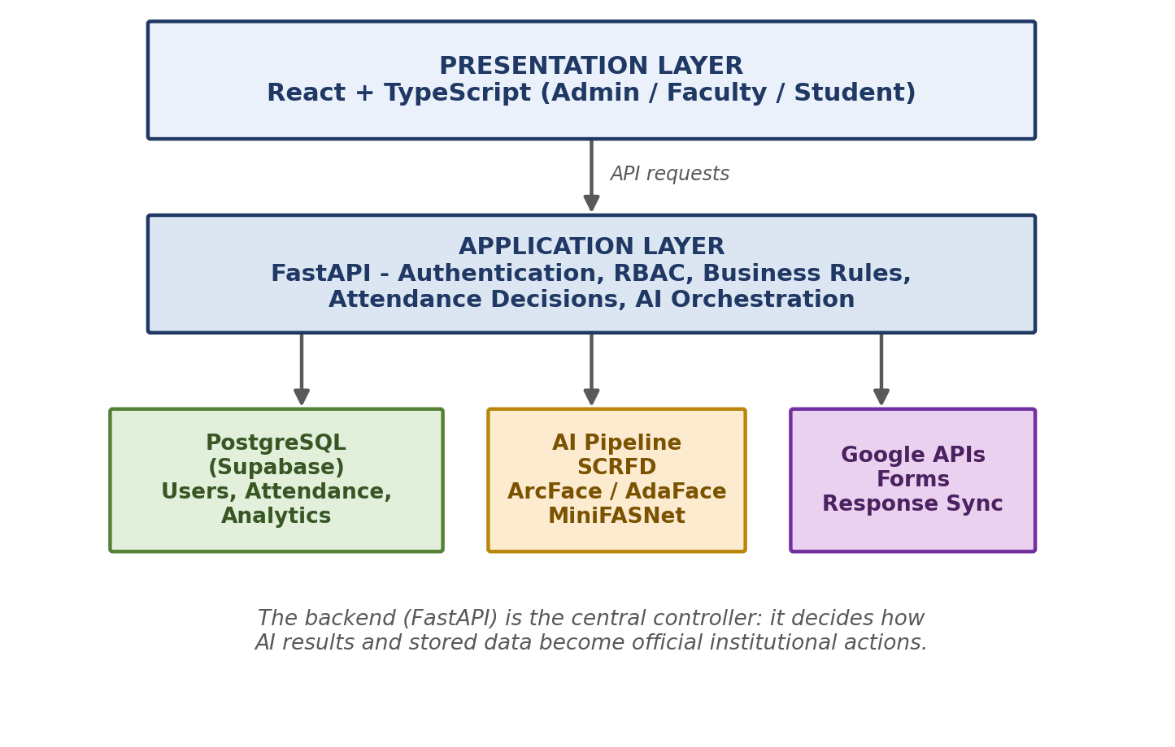
Fig 5.1: Three-Layer System Architecture of CoreSight

5.1 Data Flow – Context Level (DFD Level 0)
At the highest level, CoreSight sits between three types of people — Admin, Faculty, and Student — and two outside services — Google Forms and the classroom camera. The diagram below shows what information moves in and out of the system as a whole, without going into internal detail.
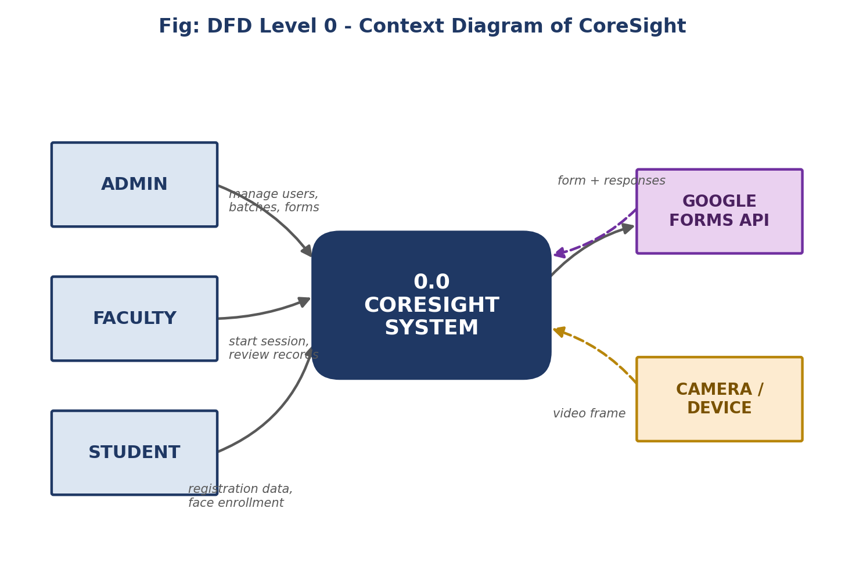
Fig 5.2: DFD Level 0 – Context Diagram

5.2 Data Flow – Major Processes (DFD Level 1)
Zooming in one level, the system's work can be grouped into five major processes: registration and sync, face enrollment, attendance recognition, decision and audit, and analytics. Each process reads from and writes to its own dedicated part of the database, which keeps responsibilities clean and easy to maintain.

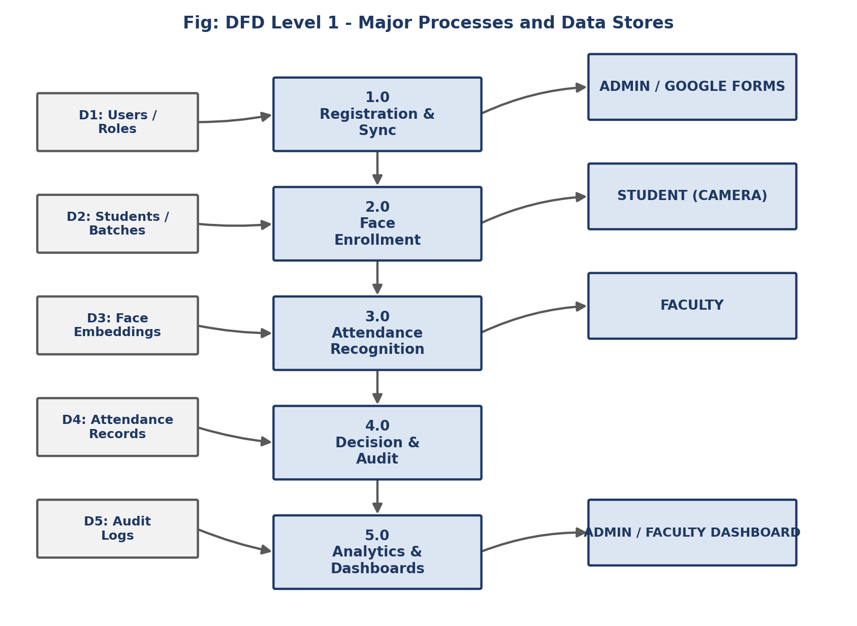
Fig 5.3: DFD Level 1 – Major Processes and Data Stores

5.3 Database Design (ER Diagram)
The database is normalized into around 22 tables so that no single table tries to hold everything. A simplified version of the entity-relationship design is shown below, covering users, students, faculty, batches, registration forms, face embeddings, attendance sessions, attendance records, and recognition events.
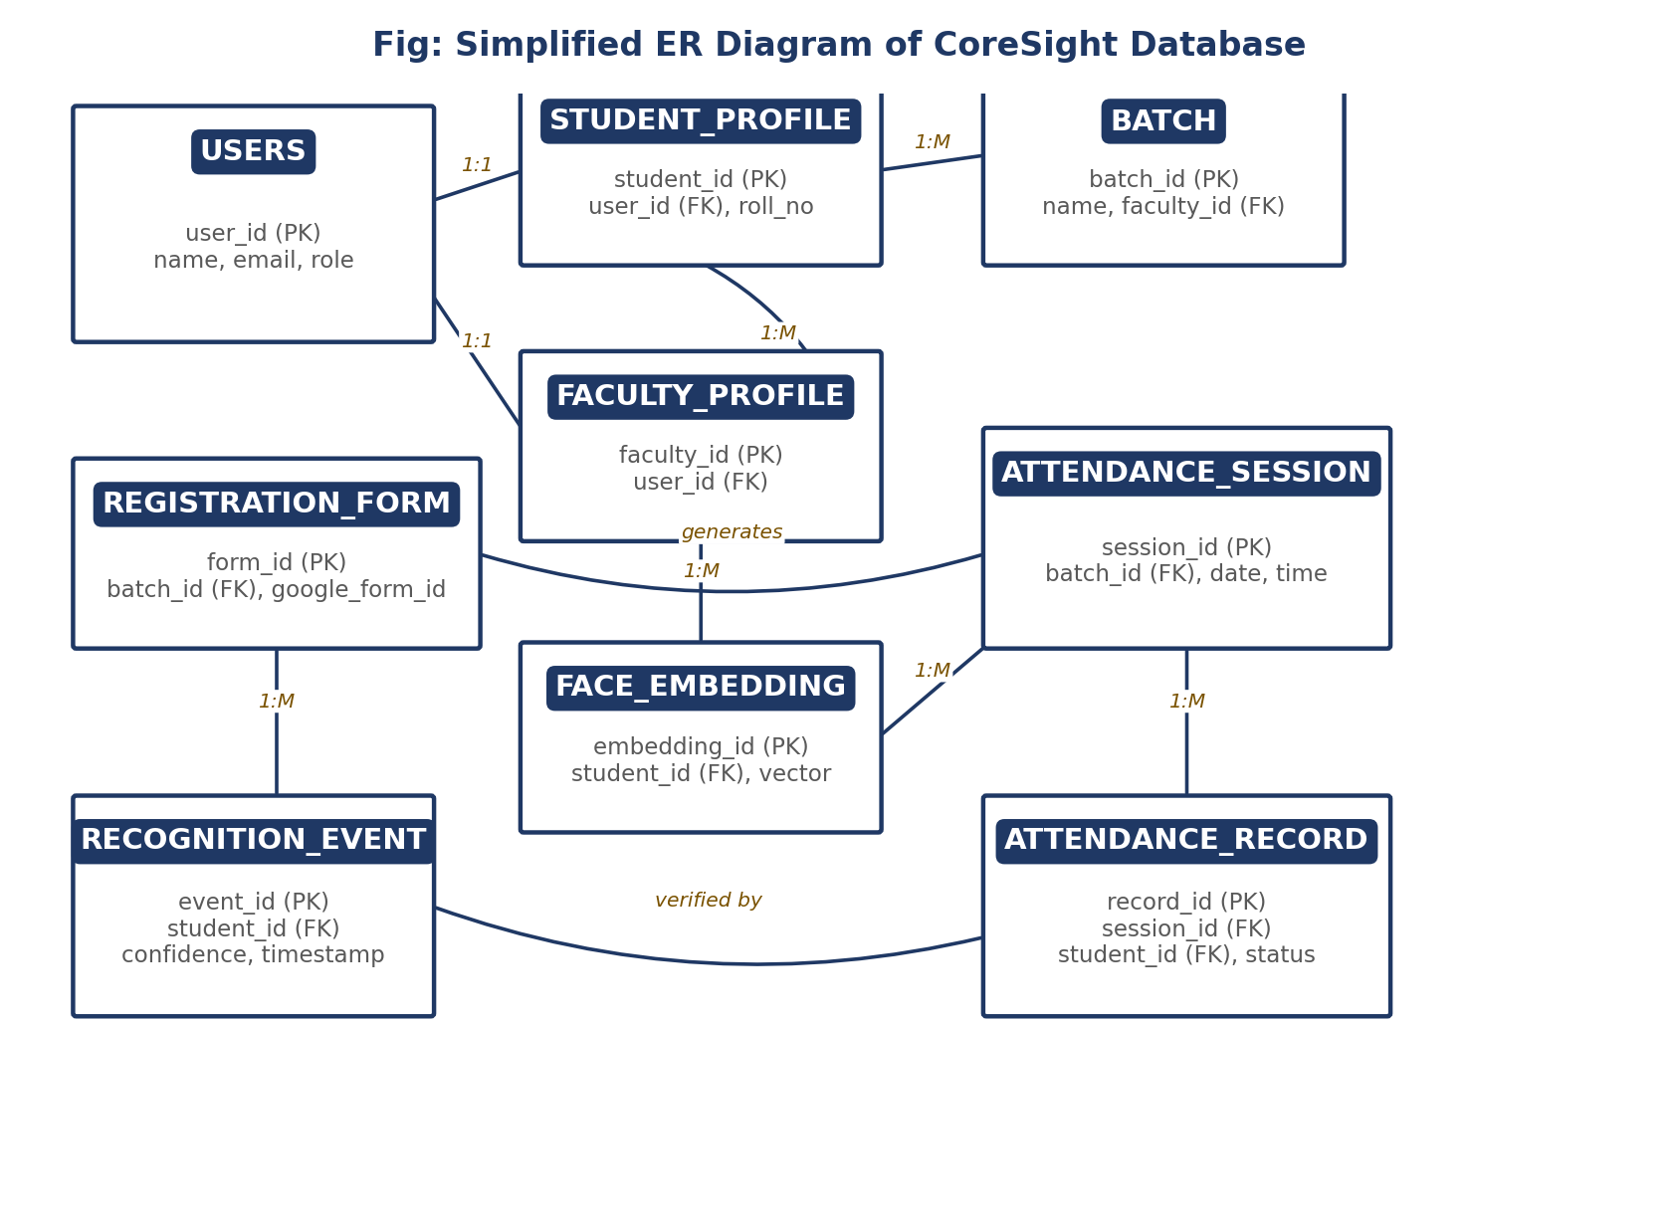
Fig 5.4: Simplified ER Diagram of the CoreSight Database

5.4 Student Registration and Enrollment
Registration starts when the Admin selects a batch and CoreSight automatically generates a Google Form for that batch. Once students submit the form, a backend sync service pulls in the responses, cleans them up (for example, trimming extra spaces from names and converting emails to lowercase), and checks whether each student already exists before creating a new record. This check makes the process idempotent — running the sync again will never create duplicate students.
After a student account is created, the student goes through face enrollment: the system detects the face using SCRFD, aligns it, and converts it into a 512-dimensional face embedding — a list of numbers that mathematically represents the face. This embedding, not the photo itself, is what gets compared during attendance.

5.5 Attendance Recognition and Decision-Making
The most important design decision in CoreSight is that recognizing a face and marking attendance are treated as two separate steps. Recognition only answers “who might this be?”. Attendance asks a stricter question: “should this person officially be marked present, according to all the rules?”. This separation stops a shaky or low-confidence match from turning into an official record.
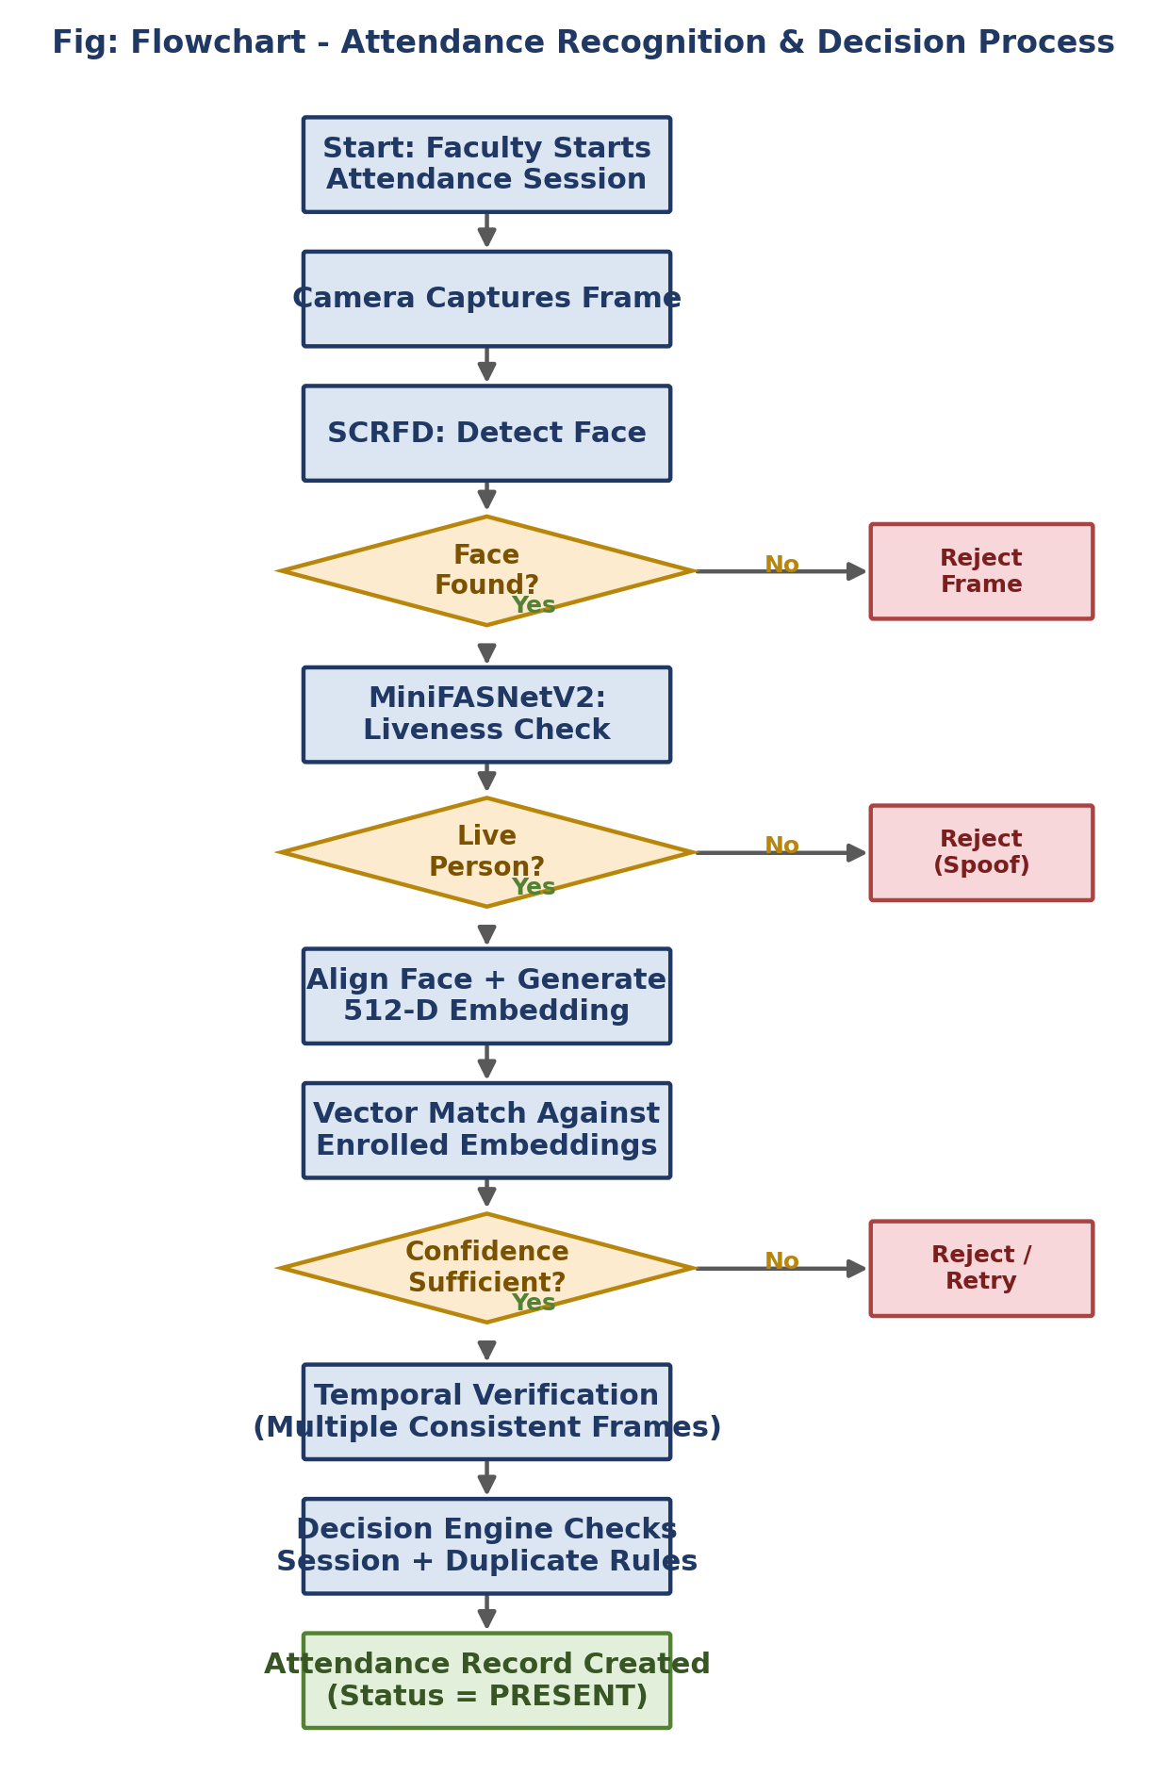
Fig 5.5: Flowchart – Attendance Recognition and Decision Process
As shown above, a captured frame must pass face detection, then a liveness check (to block photos and video-replay spoofing), then face matching with sufficient confidence, and then temporal verification (checking the same identity across several consecutive frames, not just one). Only after all of these checks pass does the decision engine verify the session is valid and the student has not already been marked present, before finally creating the attendance record.

6. Requirement Analysis

6.1 Functional Requirements
- The system shall allow Admin to create, update, and manage students, faculty, and batches.
- The system shall generate a Google Form automatically for a chosen batch and synchronize its responses.
- The system shall detect a face in an image and generate a 512-dimensional face embedding during enrollment.
- The system shall detect liveness before accepting a face for recognition.
- The system shall match a live face against enrolled embeddings and compute a confidence score.
- The system shall apply temporal verification before accepting a recognition result.
- The system shall prevent duplicate attendance entries for the same session.
- The system shall restrict every action according to the user's role (Admin, Faculty, Student).
- The system shall log sensitive administrative actions in an audit trail.
- The system shall provide attendance and recognition analytics on a dashboard.

6.2 Non-Functional Requirements
- Security: passwords and sessions must be securely handled; role checks must be enforced on every request.
- Reliability: synchronization from Google Forms must be idempotent and must not corrupt existing records.
- Performance: face detection and matching should complete quickly enough for real-time classroom use.
- Scalability: the normalized database design should support a growing number of students and batches.
- Auditability: every sensitive action should be traceable to a specific user, time, and outcome.
- Maintainability: the layered architecture should allow the AI models to be upgraded without redesigning the whole system.

6.3 Hardware Requirements
Component | Requirement
Server | Cloud-hosted backend (FastAPI) with GPU/CPU sufficient to run face-detection and embedding models.
Database | Managed PostgreSQL instance (Supabase) with storage for images and embeddings.
Client Device | Any computer, tablet, or phone with a browser and camera access.
Camera | A standard webcam or classroom camera capable of reasonable image quality.

6.4 Software Requirements
Component | Requirement
Frontend | React, TypeScript
Backend | Python, FastAPI
Database | PostgreSQL (Supabase), pgvector for embedding search
AI Models | SCRFD (detection), ArcFace/AdaFace-compatible model (recognition), MiniFASNetV2 (liveness)
External Services | Google Forms API for registration
Others | Modern web browser; standard OS (Windows/Linux/macOS) for development and hosting

7. Industry Impact
Attendance and student-record management are everyday problems for almost every school, college, and training institute, so a working solution has a wide potential audience. CoreSight's impact can be looked at from a few angles.

7.1 Time and Cost Savings
By removing manual roll-call and manual data entry, CoreSight gives back classroom time to teaching and reduces the administrative staff-hours spent maintaining attendance registers. Over a term or academic year, this adds up to a meaningful saving for the institute.

7.2 Accuracy and Trust
Because attendance is based on face recognition with a liveness check and temporal verification, rather than a self-marked sheet, the resulting records are harder to fake and easier to trust. Combined with audit logging, the institute gets a defensible, traceable record for accreditation, parent queries, or scholarship eligibility checks.

7.3 A Reusable Institutional Pattern
The architecture behind CoreSight — role-based access, a clear separation between AI “observations” and system “decisions”, and a normalized database — is not specific to attendance. The same pattern could be adapted for other identity-verification needs in an institute, such as examination-hall verification or secure access to labs and libraries.

7.4 Responsible Deployment
CoreSight's own documentation is honest about a current limitation: the liveness model works, but its thresholds are not yet fully calibrated for production-grade security. This kind of transparency matters for real-world impact — institutes adopting biometric attendance systems need to know exactly what has been validated and what still requires testing (false-acceptance testing, false-rejection testing, and spoof-attack testing) before it is treated as a hardened security feature. Highlighting this distinction, rather than overstating the system's readiness, reflects good engineering practice and builds long-term trust with the institutions that would adopt it.

