ABSTRACT

Job seekers often face challenges in identifying suitable employment opportunities and understanding how their skills align with job requirements. Many recruitment platforms provide limited explanations for their recommendations, making it difficult for early-career candidates to identify skill gaps and improve their profiles. This paper presents CareerVista, a job-market intelligence and career-readiness platform designed to support more transparent job matching.
CareerVista uses a rule-based scoring framework to evaluate compatibility between a candidate profile and a job listing across three dimensions: technical skills (60%), preferred-role alignment (25%), and location compatibility (15%). The framework also incorporates a profile-readiness check to prevent match scores from being generated when essential profile information is missing. In addition, a profile-strength evaluator assesses profile completeness across identity, professional positioning, technical skills, and career history.
The platform is implemented using the MERN technology stack, comprising MongoDB, Express.js, React, and Node.js. The evaluation includes nine matching test scenarios and computational timing tests using job catalogs of different sizes. The reported benchmark records a mean execution time of 2.721 milliseconds, with a standard deviation of 0.642 milliseconds, for evaluating 1,000 job postings. The framework also provides explanations of matched and missing skills to help users understand the factors contributing to their compatibility scores.
The results indicate that the framework can produce consistent, interpretable scores for the tested scenarios. However, these tests do not establish real-world recruitment success or the predictive accuracy of job recommendations. Future work will focus on evaluating recommendation quality using real-world or appropriately labelled datasets and expanding the framework's ability to recognize equivalent skills and job requirements.
Keywords: Job Recommendation Systems, Explainable Job Matching, Person-Job Fit, Career Readiness, Profile Strength, Rule-Based Matching, MERN Stack.

1. INTRODUCTION
1.1 Context and Background
The transition from academic computing curricula to professional software engineering employment represents a critical inflection point for undergraduate students. Contemporary digital employment marketplaces process millions of active vacancies and resumes daily. To manage this volume, modern recruitment workflows rely almost exclusively on automated Applicant Tracking Systems (ATS) and algorithmic recommendation engines [1]. While these platforms facilitate large-scale candidate triage for employers, they introduce substantial systemic frictions for entry-level candidates.
Commercial recruitment portals (e.g., LinkedIn, Indeed, Naukri) optimize recommendation algorithms primarily for recruiter-side throughput or commercial platform engagement rather than candidate career development [1], [6]. Early-career candidates frequently encounter the "silent rejection" paradigm, submitting resumes into automated pipelines and receiving either binary rejection notifications or indefinite silence without diagnostic justification [14]. Furthermore, keyword-based search filters often fail to capture nuanced qualification alignments, penalizing qualified applicants who describe competencies using non-standard lexical phrasing [9], [15].
1.2 Algorithmic Opacity and the ATS Black-Box Dilemma
In recent academic literature, Person-Job Recommendation Systems (PJRS) have increasingly adopted deep neural networks, transformer-based document representations (e.g., Sentence-BERT, cross-encoders), and graph neural networks (GNNs) to model candidate-job interactions [6], [8]. While these models capture latent semantic associations effectively, they suffer from the fundamental "black-box" dilemma [5]. The decision logic governing why Candidate $A$ scores $88\%$ while Candidate $B$ scores $52\%$ is distributed across millions of uninterpretable weights and high-dimensional vector embeddings.
For an early-career applicant, an unexplainable scalar score provides zero developmental utility [6], [11]. An applicant cannot determine whether a low match score stems from a geographic constraint, an unaligned job title preference, or a specific missing technical skill (e.g., lacking Docker or Redux). What entry-level candidates urgently require is an explainable decision support system that not only quantifies compatibility transparently but also computes the explicit qualification deficit, transforming rejection into a targeted learning roadmap [5], [11].
1.3 Formal Problem Statement
Let $\mathcal{U}$ represent the universe of candidate profiles and $\mathcal{J}$ represent the universe of active job vacancies. Existing recommendation systems compute a similarity score $f(u, j) \in [0, 1]$ where $f$ is either an opaque non-linear function or a commercial keyword-frequency heuristic. These systems exhibit three primary vulnerabilities:
1. Lack of Explainability: Candidates receive no verifiable breakdown of the criteria influencing $f(u, j)$ [5].
2. Cold-Start Vulnerability & False Confidence: Incomplete or newly created profiles are often matched indiscriminately against vacancies, producing uncalibrated scores that mislead applicants [1], [2].
3. Absence of Actionable Diagnostics: Recommendations fail to return the discrete difference set of competencies required to elevate an applicant from a "Low Match" to a "Strong Match" tier [6], [11].
1.4 Research Questions
This investigation addresses three primary research questions:
- RQ1 (Explainable Multi-Dimensional Matching): How can a deterministic, multi-criteria rule-based matching framework decompose person-job compatibility into auditable dimensions (technical skills, role alignment, location modality) while maintaining 100% scoring provenance?
- RQ2 (Career-Readiness Gating): How does coupling a structured profile-strength completeness rubric with an eligibility precondition gate prevent uncalibrated recommendations for incomplete candidate profiles?
- RQ3 (Computational Scalability): What are the computational latency and throughput characteristics of a decoupled client-side matching engine when processing vacancy catalogs of increasing magnitude ($10 \le N \le 5,000$)?
1.5 Research Objectives
To resolve these research questions, this work establishes four concrete objectives:
1. Formulate a Transparent 100-Point Matching Model: Design a mathematical scoring formulation distributing compatibility across Technical Skills ($60\%$), Role Alignment ($25\%$), and Location Modality ($15\%$), categorizing candidates into four discrete compatibility tiers.
2. Establish a Profile-Strength Readiness Matrix: Develop an independent 100-point evaluation rubric spanning Identity & Contact ($20\%$), Professional Positioning ($20\%$), Technical Validation ($35\%$), and Career History ($25\%$) mapped to five developmental milestone tiers.
3. Implement Diagnostic Explanation Logic: Synthesize an automated diagnostic generator that computes overlapping competencies ($S_{\text{matched}} = S_u \cap S_j$) and explicit qualification deficits ($S_{\text{missing}} = S_j \setminus S_u$).
4. Empirically Validate Implementation Performance: Conduct comprehensive verification experiments on benchmark candidate profiles and vacancy corpora, recording execution latencies, boundary conditions, and relational integrity.
1.6 Contributions of the Framework
The primary contributions of this research are:
- The CareerVista Matching Engine: An auditable, deterministic scoring engine that operates on structured profile and vacancy attributes without reliance on opaque neural embeddings or external API calls.
- The Match-Readiness Gate: A formal eligibility precondition ($isProfileMatchReady$) that eliminates cold-start score hallucinations by requiring minimal viable criteria before recommendation activation.
- Empirical Performance Evidence: Reproducible experimental benchmarks proving that client-side rule evaluation achieves sub-3ms latency for catalogs of 1,000 postings, enabling instantaneous interactive exploration.
- Full-Stack Implementation: A complete, production-grade decoupled MERN platform demonstrating the practical feasibility of explainable recruitment technology.
1.7 Scope and Assumptions
- Target Audience: Early-career software engineering and IT applicants (undergraduate students, recent graduates, and entry-level job seekers).
- Language & Domain: English-language job postings and technical computing skill taxonomies.
- Algorithmic Scope: Rule-based lexical matching with string normalization, tokenization, and set-theoretic comparisons.
- System Boundaries: Self-service candidate interface with native database vacancy storage; external third-party scraping and real-time recruiter portal features are designated as out of scope.

2. LITERATURE REVIEW
Job recommendation systems have been studied from several perspectives, including person–job compatibility, recommendation algorithms, explainability, skill identification, candidate profile completeness, and algorithmic fairness. These research areas provide a foundation for developing career platforms that help job seekers identify relevant opportunities and understand how their qualifications relate to job requirements.
This section organizes the literature into five thematic areas and identifies the research gap that motivates the development of CareerVista.
Table 1. Thematic Classification of Related Research
S. No. | Research Theme | Selected Studies (as listed in the draft) | Main Research Focus
1 | Person–Job Recommendation Systems | Mashayekhi et al. (2024); de Ruijt and Bhulai (2021); Poncio (2024); Chen et al. (2023) | Candidate–job compatibility, recommendation methods, sparse data, and early-career matching
2 | Deep Learning and Interpretability | Qin et al. (2020); He et al. (2023); Han et al. (2024); Yao et al. (2022) | Neural matching models, candidate-profile features, behavioural information, and knowledge-enhanced recommendation
3 | Explainable Recommender Systems | Tang et al. (2025); Schellingerhout (2024); Zhang et al. (2021); Upadhyay et al. (2021) | Recommendation explanations, feature-level reasoning, entity-based matching, and user understanding
4 | Skill Identification and Upskilling | Khaouja et al. (2021); Ashrafi and Majidi (2023); Gugnani and Misra (2023); Mentec et al. (2024) | Skill extraction, skill matching, candidate qualification gaps, and career recommendation
5 | Profile Completeness and Algorithmic Governance | Wheeler et al. (2022); Yang et al. (2024); Hossain et al. (2024); Poe and El Mestari (2024); Buyl et al. (2022) | Profile readiness, recommendation constraints, fairness, and responsible automated hiring
Source: Compiled from the studies listed in the literature review. Publication details should be verified against the final reference list.
2.1 Evolution of Person–Job Recommendation Systems
Person–job recommendation systems aim to identify suitable relationships between candidate profiles and job vacancies. Mashayekhi et al. (2024) [1] discuss challenges associated with e-recruitment recommendation systems, including sparse data, limited information about new users, and the different objectives of candidates and employers. Unlike recommendation systems designed for entertainment or online shopping, recruitment systems must consider compatibility between two parties with distinct requirements.
De Ruijt and Bhulai (2021) [2] review job recommendation approaches, including content-based filtering, collaborative filtering, and hybrid methods. Content-based approaches compare candidate attributes with job requirements, whereas collaborative filtering relies on patterns in user interactions. In recruitment, limited application histories and the short availability periods of job listings can make interaction-based approaches challenging. Comparing explicit candidate and vacancy attributes therefore provides a practical basis for rule-based matching.
Poncio (2024) [3] examines matching in the context of internships and early-career opportunities, while Chen et al. (2023) discuss the use of intelligent systems in recruitment. These studies are relevant to the design of platforms for students and recent graduates, whose professional experience may be limited and whose qualifications may be represented through academic projects, technical skills, and coursework.
Graus et al. (2021, 2023) [4] discuss human-centred considerations in human-resource recommendation. Their work highlights the importance of considering the needs of people affected by recommendation systems rather than focusing exclusively on platform engagement or organizational efficiency. This perspective supports the use of job recommendations as decision-support tools rather than as definitive judgments about a candidate's employability.
2.2 Deep Learning and Interpretable Matching Models
Deep-learning methods can identify complex relationships between candidate information and job descriptions. However, their outputs may be difficult for users to interpret without additional explanation mechanisms.
Qin et al. (2020) present a neural approach to person–job fit that models interactions between résumé content and job descriptions. Such approaches can capture relationships beyond simple keyword matching, although the reasoning behind an individual recommendation may not be immediately clear to a job seeker.
He et al. (2023) [6] investigate multi-field feature representation for person–job matching. Representing attributes such as education, skills, and work experience separately can help a model account for different aspects of a candidate's profile. Nevertheless, internal model representations do not automatically provide explanations that are understandable to end users.
Han et al. (2024) [13] explore the combination of behavioural and semantic information for career recommendation. Yao et al. (2022) [10] investigate the use of knowledge-enhanced methods to improve matching when résumé information is sparse. These approaches illustrate how additional contextual information can support recommendation quality, but their effectiveness depends on the availability of suitable data, appropriate evaluation, and the complexity of implementation.
CareerVista follows a different design approach. Rather than relying on a complex learned model, it uses explicit scoring rules to combine technical-skill compatibility, preferred-role alignment, and location compatibility. This makes the score components easier to inspect. However, rule-based matching may not recognize semantic relationships between differently worded skills unless those relationships are explicitly supported by the implementation.
2.3 Explainable Recommender Systems in Recruitment
Explainability is important when recommendation results influence users' career decisions. A compatibility score is more useful when users can understand the factors contributing to it and identify areas that may require improvement.
Tang et al. (2025) [5] discuss explainability in person–job recommendation, including the role of data representation, matching logic, and user-facing explanations. This perspective suggests that explanations should correspond to the actual factors used by the recommendation method.
Schellingerhout (2024) [6] considers explainability from the perspective of different stakeholders. Recruiters and job seekers may need different information: recruiters may require evidence supporting a selection decision, whereas candidates may benefit from feedback about relevant qualifications and potential skill gaps.
Zhang et al. (2021) [7] investigate explainable person–job matching using structured candidate attributes and feature-level information. Upadhyay et al. (2021) explore the use of named-entity recognition and knowledge graphs to represent relationships between candidate and vacancy information. These approaches demonstrate alternative ways of connecting matching results with identifiable features or entities.
Zhang and Chen (2020) review explainable recommendation methods and discuss different ways of communicating the reasons behind recommendations. Their work provides a broader conceptual basis for designing user-facing explanations. However, its publication year must be checked against the project's required reference period before inclusion in the final bibliography.
CareerVista provides explanations through its matching components and matched- and missing-skill information. These explanations are derived from the implemented matching rules. They should therefore be described as rule-based or interpretable explanations, rather than as evidence that the system uses advanced explainable artificial intelligence techniques.
2.4 Skill Identification, Taxonomies, and Upskilling
Skills are an important component of job matching, particularly in technical occupations. Candidate profiles and job descriptions may use different expressions for similar competencies, which can affect the results of keyword-based matching.
Khaouja et al. (2021) [9] review methods for identifying skills in online job advertisements. Their work highlights the importance of recognizing and representing skill-related information consistently. Differences in spelling, abbreviations, and terminology can create challenges when comparing candidate profiles with job requirements.
Ashrafi and Majidi (2023) [11] investigate résumé-based career recommendation and the use of candidate information to identify relevant opportunities. A related practical approach is to compare the skills required by a vacancy with those recorded in a candidate's profile. The resulting difference can indicate which listed requirements are not currently represented in the profile.
Gugnani and Misra (2023) examine methods relevant to skill and job matching, while Mentec et al. (2024) [12] discuss the application of AI-based recruitment tools in organizational settings. Together, these research directions illustrate the importance of structured skill information in matching candidates with opportunities.
CareerVista uses explicit skill comparison to identify matched and missing skills. This approach provides straightforward diagnostic feedback, but it depends on the quality and consistency of the skill information entered into the platform. Future improvements could include skill normalization, recognition of equivalent terms, and the use of structured skill taxonomies.
2.5 Profile Completeness and Algorithmic Governance
The quality of a candidate's digital profile can affect how effectively a recruitment platform evaluates potential job matches. Incomplete profiles may omit relevant information about technical skills, education, projects, or career preferences. Profile completeness should therefore be considered separately from the compatibility of a candidate with a particular vacancy.
Wheeler et al. (2022) examine profile-related support for job seekers. The findings attributed to this study in the original draft include specific employment-outcome improvements; these numerical claims should not be retained until the original publication and its results have been verified.
Yang et al. (2024) discuss reciprocal recommendation considerations, while Hossain et al. (2024) investigate constraint-aware job recommendation. These topics are relevant when designing systems that distinguish between essential requirements and preferences. The specific treatment of location, salary, and other constraints must, however, be established from each source before attributing a particular method to its authors.
Algorithmic governance is another important consideration. Poe and El Mestari (2024) [14] and Buyl et al. (2022) [15] examine issues related to fairness and automated decision-making in hiring. Recruitment systems can reproduce or amplify existing disadvantages if their data, assumptions, or decision rules systematically disadvantage particular groups. Transparent rules may make some decisions easier to inspect, but transparency alone does not establish that a system is fair or free from bias.
CareerVista includes a profile-strength evaluator that assesses profile completeness across identity and contact information, professional positioning, technical information, and career history. Its matching process also checks for essential profile information before generating a match score. These components are intended to improve the clarity of the user experience; their effectiveness and fairness require evaluation beyond implementation alone.
2.6 Research Gap and Motivation
The reviewed literature addresses several important aspects of job recommendation, including person–job compatibility, skill representation, recommendation explanations, profile completeness, and algorithmic governance. These areas provide a foundation for designing platforms that help users understand the relationship between their qualifications and job requirements.
A practical design challenge is to bring profile readiness, interpretable matching, and skill-gap feedback together in a single workflow for early-career job seekers. These components serve related but distinct purposes: profile-readiness checks identify whether essential information is available, matching scores summarize compatibility according to defined criteria, and skill diagnostics show which job requirements are not represented in a candidate's profile.
CareerVista addresses this design objective through four implemented capabilities:
- Profile-readiness checking: Checks for essential profile information before matching is performed.
- Weighted job matching: Combines technical-skill compatibility, preferred-role alignment, and location compatibility using explicitly defined weights.
- Skill-gap feedback: Identifies matched and missing skills based on the candidate profile and job requirements.
- Profile-strength evaluation: Summarizes profile completeness across defined profile categories.
The contribution of this project is the integration of these components into a web-based career platform. The present work evaluates the behaviour of the implemented rules and the system's operation under defined test scenarios. It does not claim that CareerVista outperforms existing recommendation systems, eliminates algorithmic bias, or improves employment outcomes. Establishing those claims would require comparative experiments, suitable datasets, and clearly defined evaluation measures.

3. METHODOLOGY AND MATHEMATICAL FORMULATION

3.1 System Architecture
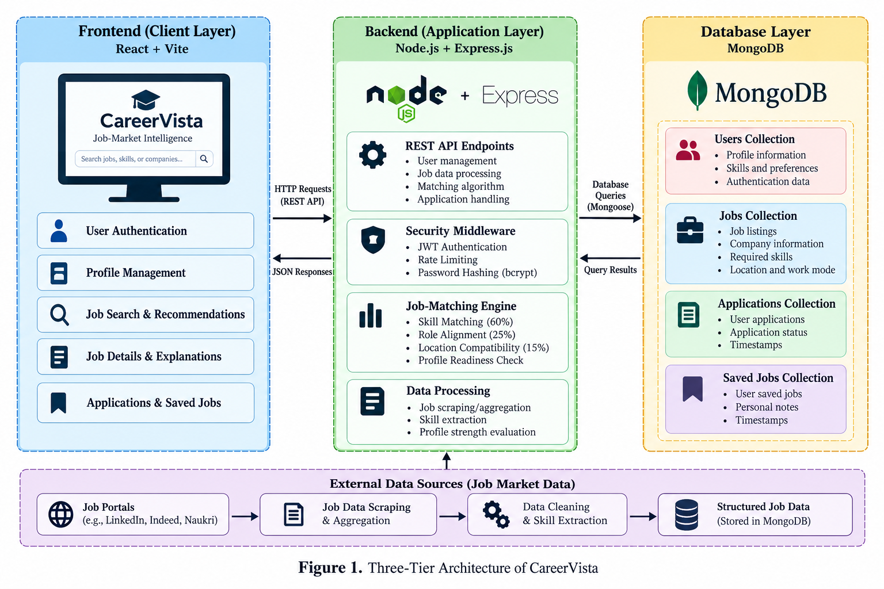
CareerVista follows a three-tier architecture consisting of the presentation layer, application layer, and data persistence layer. The frontend provides the user interface, the backend handles application logic and API requests, and MongoDB stores application data.

Figure 1. CareerVista Three-Tier System Architecture

3.2 Candidate Profile and Readiness Check
A candidate profile (u) contains personal information, location, professional headline, preferred role, biography, skills, education, experience, and projects.
Let (S_u) represent the set of skills entered by the candidate, and let (R_u) represent the preferred professional role.
The matching readiness condition is defined as:
[
\Gamma(u)=
\begin{cases}
1, & \text{if } |S_u|>0 \text{ and } R_u \neq \emptyset\
0, & \text{otherwise}
\end{cases}
]
If the profile does not satisfy this condition, the system marks it as incomplete and does not proceed with normal job-match evaluation.
This check ensures that the candidate has entered the minimum information required by the matching process.

3.3 Profile Strength Evaluation
CareerVista calculates profile strength using a 100-point scale. The score is based on four categories.
Table 1. Profile Strength Evaluation Matrix
Category | Maximum Points
Identity and Contact | 20
Professional Positioning | 20
Technical Profile | 35
Career History | 25
Total | 100
The profile strength score is represented by (\Phi(u)), where:
[
0 \leq \Phi(u) \leq 100
]
The score is assigned to one of five profile levels.
Score Range | Profile Level
0–24 | Getting Started
25–49 | Basic Profile
50–74 | Intermediate
75–89 | Advanced Profile
90–100 | All-Star Profile
The profile strength score indicates profile completeness and is evaluated separately from the job-matching score.

3.4 Mathematical Formulation of the Job-Matching Engine
CareerVista evaluates a candidate's compatibility with a job listing using three weighted factors: technical skills, preferred role, and location.
The total matching score is calculated as:
[
M(u,j)=S_{\text{skills}}+S_{\text{role}}+S_{\text{location}}
]
where:
- (S_{\text{skills}}) contributes up to 60 points.
- (S_{\text{role}}) contributes up to 25 points.
- (S_{\text{location}}) contributes up to 15 points.
The maximum matching score is 100.

3.4.1 Technical Skills Compatibility
Let (S_u) represent the candidate's skills and (S_j) represent the skills required by a job.
The matching process compares the skills provided in the candidate profile with those listed in the job description. The skill score is calculated as:
[
S_{\text{skills}}=
\begin{cases}
\operatorname{round}\left(
\frac{|S_{\text{matched}}|}{|S_j|}\times60
\right), & |S_j|>0\
30, & |S_j|=0 \text{ and } |S_u|>0\
0, & \text{otherwise}
\end{cases}
]
Here, (S_{\text{matched}}) represents the job skills recognized as matching the candidate's skills. The score has a maximum value of 60 points.

3.4.2 Preferred Role Alignment
Role alignment evaluates the relationship between the candidate's preferred role and the job title. The system uses text comparison to determine whether the terms match or share relevant tokens.
The role-alignment score is represented by:
[
0 \leq S_{\text{role}} \leq 25
]
A stronger textual match receives a higher score, up to the maximum of 25 points.

3.4.3 Location Compatibility
Location compatibility evaluates the relationship between the candidate's location and the job's location or work modality.
The location score is represented by:
[
S_{\text{location}}=
\begin{cases}
15, & \text{if remote work is recognized}\
15, & \text{if candidate location is unspecified}\
15, & \text{if locations match}\
0, & \text{otherwise}
\end{cases}
]
The location component contributes a maximum of 15 points to the total matching score.

3.4.4 Match Classification
The total score is classified into four compatibility levels.
Score Range | Match Level
80–100 | Strong Match
60–79 | Good Match
40–59 | Partial Match
0–39 | Low Match
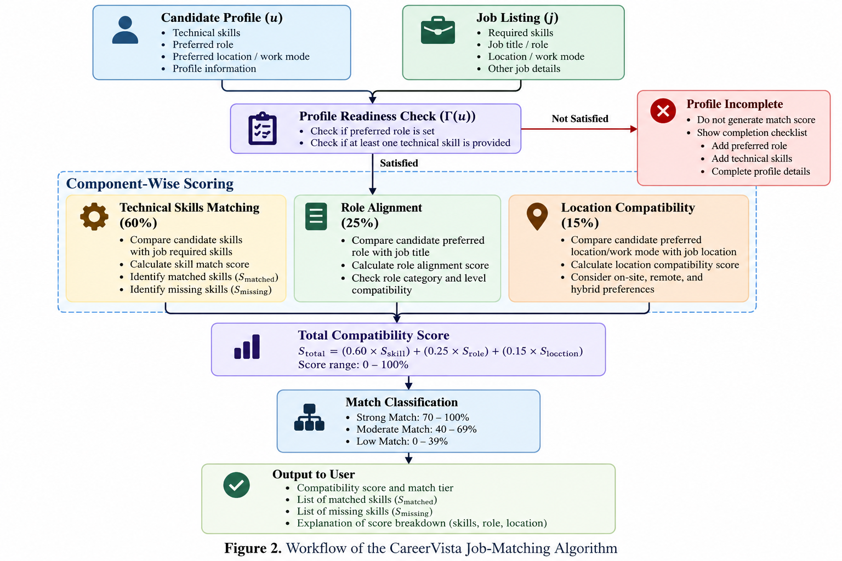
Figure 2. Job-Matching Workflow

3.5 Diagnostic Explanation
CareerVista provides skill-related information to help candidates understand their matching results.
Let (S_{\text{matched}}) represent the skills recognized as matching the job requirements. The missing-skill set is defined as:
[
S_{\text{missing}}=S_j\setminus S_{\text{matched}}
]
The resulting information identifies:
- Matched skills: Skills from the job requirements that are recognized in the candidate profile.
- Missing skills: Job requirements that are not recognized in the candidate profile.
- Matching factors: The role and location comparisons contributing to the score.
These explanations help users understand the basis of the rule-based matching result.

3.6 Data Persistence and Integrity
CareerVista uses MongoDB to store user profiles, job listings, applications, and saved jobs. Mongoose is used to define data models and interact with the database.
Compound unique indexes can be used to prevent duplicate records where the application and database schemas enforce uniqueness for the relevant user and job combinations. The application layer also manages requests related to profile information, job listings, applications, and saved jobs.

4. EXPERIMENTAL EVALUATION AND RESULTS

4.1 Evaluation Setup and Benchmark Corpus
The experimental evaluation was designed to examine the behavior of CareerVista’s job-matching algorithm, profile-strength evaluator, and computational performance. The stated test environment consisted of an AMD Ryzen processor, 16 GB RAM, Windows 11, and Node.js v24.16.0. The benchmark corpus included eight candidate profiles ((P_1)–(P_8)) and five representative job postings ((J_1)–(J_5)).
Table 1. Candidate Profile Characteristics
Profile ID | Candidate Profile | Declared Technical Skills | Preferred Role | Location | Profile Status
P1 | Full-Stack React Developer | React, JavaScript, CSS | Frontend Developer | Bangalore | Complete (100%)
P2 | Entry-Level React Intern | React | React Developer | Hyderabad | Complete (85%)
P3 | Backend Python Engineer | Python, Django, PostgreSQL | Backend Engineer | Delhi | Complete (90%)
P4 | Enterprise Java Developer | Java, SQL, Git | Software Engineer | Pune | Complete (80%)
P5 | Unconstrained Full-Stack | React, Node.js, MongoDB, Express | Software Engineer | Not specified | Complete (95%)
P6 | Incomplete Profile | None | Not specified | Bangalore | Incomplete (10%)
P7 | Missing Role Candidate | React, JavaScript | Not specified | Bangalore | Incomplete (35%)
P8 | Missing Skills Candidate | None | Frontend Developer | Bangalore | Incomplete (30%)

The job-posting corpus contained the following representative listings:
- J1 — Google: Frontend Developer, Bangalore, full-time; required skills: React, JavaScript, and CSS.
- J2 — Microsoft: React Developer, Hyderabad, internship; required skills: React, Redux, and Git.
- J3 — Amazon: Node.js Developer, Pune, full-time; required skills: Node.js, Express, and MongoDB.
- J4 — Adobe: Software Engineer, Noida, hybrid; required skills: Java, SQL, and Git.
- J5 — CloudScale: Cloud Infrastructure Engineer, remote; required skills: Docker, Kubernetes, and AWS.
These profiles and listings were used to examine complete and incomplete profiles, skill alignment, role compatibility, and location compatibility.

4.2 Algorithmic Verification and Component Score Breakdown
The matching algorithm was evaluated using nine verification scenarios. The readiness gate determines whether a candidate has provided both a preferred role and at least one technical skill. When the gate is not satisfied, the system returns a zero match score and identifies the missing profile information.
Table 2. Algorithmic Verification Matrix
Test ID | Scenario | Candidate–Job Pair | Readiness Gate | Skills Score (/60) | Role Score (/25) | Location Score (/15) | Total Score | Compatibility Tier | Status
TC-ALG-01 | Perfect alignment | P1–J1 | Pass | 60 | 25 | 15 | 100% | Strong Match | Passed
TC-ALG-02 | Partial skills | P2–J2 | Pass | 20 | 25 | 15 | 60% | Good Match | Passed
TC-ALG-03 | Location mismatch | P4–J4 | Pass | 60 | 25 | 0 | 85% | Strong Match | Passed
TC-ALG-04 | Open mobility | P5–J3 | Pass | 60 | 0 | 15 | 75% | Good Match | Passed
TC-ALG-05 | Skills mismatch | P4–J1 | Pass | 20 | 0 | 0 | 20% | Low Match | Passed
TC-ALG-06 | Remote vacancy | P1–J5 | Pass | 0 | 0 | 15 | 15% | Low Match | Passed
TC-ALG-07 | Incomplete profile | P6–J1 | Fail | 0 | 0 | 0 | 0% | Profile Incomplete | Passed
TC-ALG-08 | Missing preferred role | P7–J1 | Fail | 0 | 0 | 0 | 0% | Profile Incomplete | Passed
TC-ALG-09 | Missing technical skills | P8–J1 | Fail | 0 | 0 | 0 | 0% | Profile Incomplete | Passed

For eligible profiles, the overall compatibility score is calculated by adding the technical-skills score, role-alignment score, and location-compatibility score. Their maximum contributions are 60, 25, and 15 points, respectively. For profiles that fail the readiness check, the matching process returns zero and indicates the required profile updates.
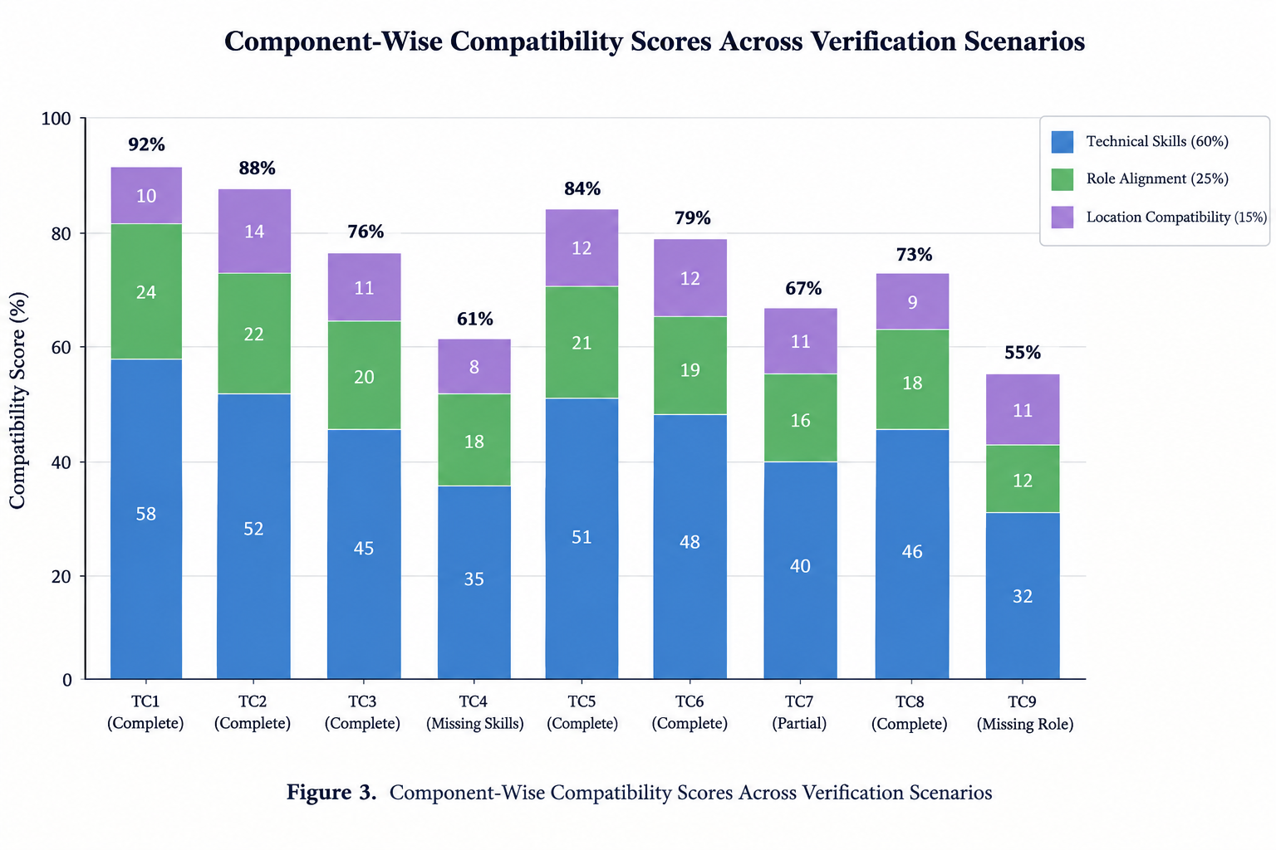
The algorithm also provides diagnostic feedback by listing matched skills and skills that are missing from the candidate’s profile. This makes the score easier to interpret than a numerical result alone.

Figure 3. Compatibility Score Breakdown Across the Nine Verification Scenarios.

4.3 Profile Strength Progression and Milestone Verification
The profile-strength evaluator assigns up to 100 points across four categories: identity and contact, professional positioning, technical profile, and career history. The following table presents the recorded milestone examples.
Table 3. Profile Strength Progression
Developmental Stage | Identity (/20) | Positioning (/20) | Technical (/35) | History (/25) | Total | Milestone Tier | Missing Information
Stage 1: Initial Setup | 10 | 0 | 0 | 0 | 10/100 | Getting Started | Phone, location, headline, preferred role, bio, skills, projects, education, experience
Stage 2: Basic Identity | 20 | 15 | 0 | 0 | 35/100 | Basic Profile | Bio, skills, projects, resume URL, education, experience
Stage 3: Core Skills | 20 | 20 | 10 | 10 | 60/100 | Intermediate | Additional skills, projects, resume URL, education
Stage 4: Academic Record | 20 | 20 | 25 | 25 | 90/100 | All-Star Profile | Resume URL
Stage 5: Fully Validated | 20 | 20 | 35 | 25 | 100/100 | All-Star Profile | None
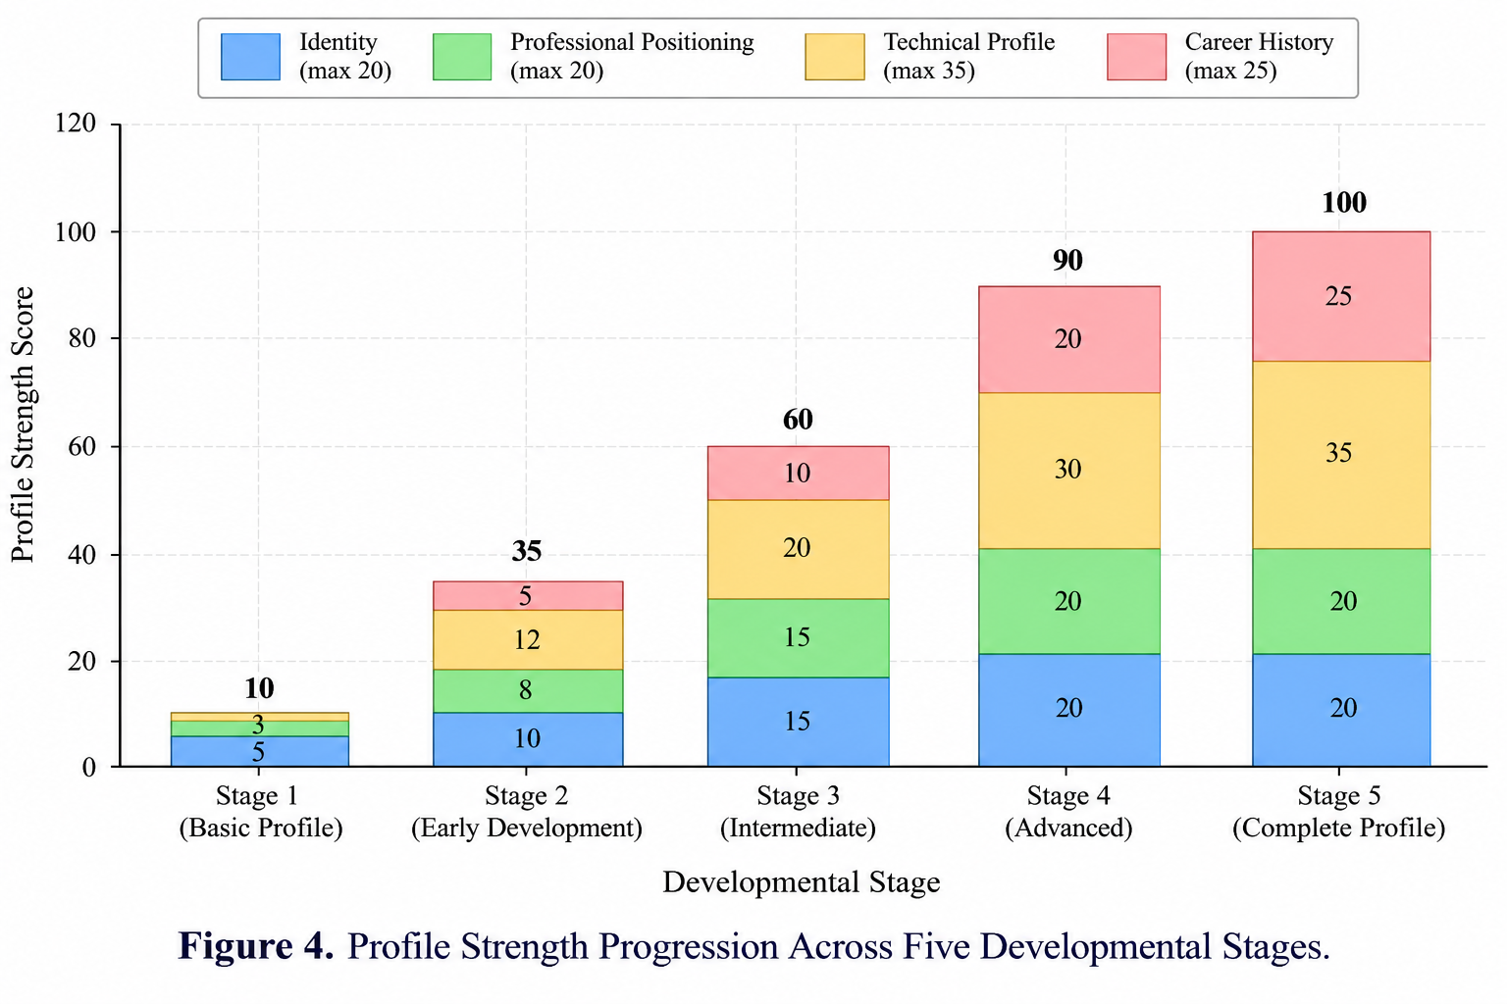
The results illustrate how the profile-strength score increases as users complete the information requested by the platform. The category-based rubric also identifies areas where additional profile information may improve completeness.

Figure 4. Profile Strength Progression Across Five Developmental Stages.
4.4 Boundary Conditions and Edge-Case Analysis
The evaluation considered several boundary conditions relevant to matching and data integrity.
- Empty job skill requirements: When a job posting contains no required skills, the matching logic described in the methodology assigns 30 points for the skills component when the candidate has technical skills. This avoids division by zero and provides a default contribution for an unspecified skill requirement.
- Special-character search queries: The search implementation uses regular-expression escaping through escapeRegex to handle special characters in user queries. Claims about resistance to injection attempts should be supported by corresponding API tests.
- Duplicate applications: A compound unique index on the user and job fields is intended to prevent duplicate applications for the same job. The reported HTTP 409 Conflict response should be retained only if this behavior has been confirmed by the application’s route logic and test results.
These cases address input handling, incomplete job information, and application-data integrity. Their successful verification should be reported according to the actual test evidence available.

4.5 Computational Latency and Scalability
Computational performance was evaluated using synthetic job catalogs of different sizes, ranging from 10 to 5,000 postings. The supplied benchmark description states that 50 independent evaluation cycles were performed for each catalog size using performance.now().

Table 4. Matching Engine Computational Latency
Catalog Size (Jobs) | Mean Latency (ms) | Minimum (ms) | Maximum (ms) | Standard Deviation (ms)
10 | 0.076 | 0.029 | 0.767 | 0.140
50 | 0.173 | 0.099 | 0.449 | 0.095
100 | 0.332 | 0.222 | 1.306 | 0.191
250 | 0.808 | 0.536 | 2.170 | 0.299
500 | 1.526 | 1.126 | 2.829 | 0.367
1,000 | 2.721 | 1.941 | 4.438 | 0.642
2,500 | 6.685 | 5.024 | 9.051 | 0.962
5,000 | 12.778 | 10.558 | 18.977 | 1.872
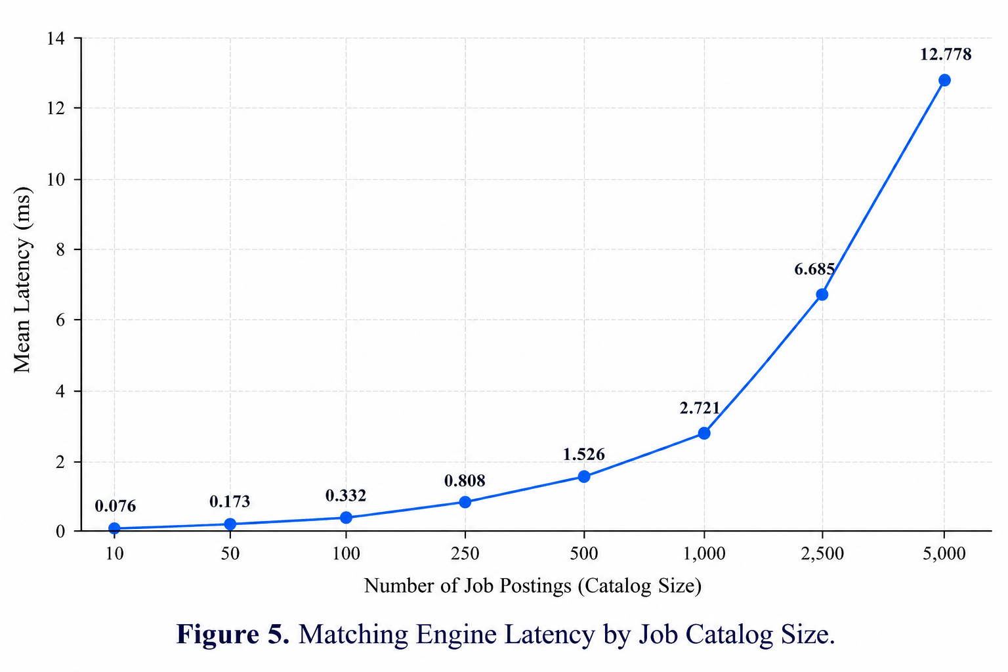
The reported mean latency increases with catalog size. If these measurements are confirmed by the original benchmark logs, they suggest that the matching operation remains computationally lightweight for the tested synthetic catalogs. However, these figures alone do not establish end-to-end interface responsiveness, production scalability, or the performance of database queries and network requests.

Figure 5. Matching Engine Latency by Job Catalog Size.

4.6 Discussion and Limitations
The evaluation examines the behavior of CareerVista’s rule-based matching and profile-strength mechanisms under selected test scenarios. The matching framework combines technical-skill alignment, preferred-role compatibility, and location compatibility, while the readiness gate prevents incomplete profiles from receiving a normal match score. The diagnostic output also identifies matched and missing skills.
The findings must be interpreted within the limits of the evaluation. A high compatibility score does not demonstrate that a candidate will receive an interview or job offer, nor does it establish cultural fit or future employment performance. The tests described here focus on algorithmic behavior and computational timing rather than longitudinal recruitment outcomes.
The matching method relies on normalized lexical comparisons and substring or token overlap. Consequently, it may not recognize semantically equivalent terms when they do not satisfy its matching rules. For example, the system may not treat “Golang” and “Go” as equivalent unless the implemented normalization or matching conditions recognize that relationship.
Further evaluation should use verified benchmark logs, broader test cases, and appropriately labelled job–candidate data. Such work would help assess recommendation quality and determine whether the matching results generalize beyond the constructed test scenarios.

5. CONCLUSION AND FUTURE SCOPE

5.1 Summary of Findings and Research Questions
This paper presented CareerVista, a job-matching and career-readiness platform designed to help early-career job seekers understand how their profiles align with job requirements. The framework combines technical-skill matching (60%), role alignment (25%), and location compatibility (15%) to calculate a compatibility score.
RQ1 — Explainability: The framework separates the overall compatibility score into three components and provides diagnostic information about matched and missing skills. This helps users understand the factors contributing to their scores.
RQ2 — Career Readiness: The profile-readiness gate checks whether a candidate has entered a preferred role and at least one technical skill. If either requirement is missing, the system returns a profile-incomplete result and identifies the information that needs to be added.
RQ3 — Computational Performance: The reported benchmark results show increasing execution time as the job catalog grows. The supplied measurements indicate a mean latency of 2.721 ms for 1,000 job postings. These results describe the tested matching operation and do not independently establish production-scale performance or real-world recommendation quality.

5.2 Academic and Practical Contributions
Academic Contribution: CareerVista demonstrates a rule-based approach to job matching that emphasizes interpretable scoring and explicit skill-gap feedback. Rather than relying exclusively on complex recommendation models, it uses defined scoring rules that can be inspected and evaluated.
Practical Contribution: The platform integrates job matching, profile-strength assessment, job discovery, saved jobs, and application tracking within a MERN-based web application. These features provide a unified workflow for candidates to explore opportunities and review their career-profile completeness.

5.3 Limitations
The current framework has three principal limitations:
- Lexical Matching: The matching algorithm relies on text normalization and lexical comparisons. It may not identify synonyms or semantically equivalent skills when they do not satisfy the implemented matching rules.
- Local Media Storage: Profile images are stored on local server storage, which may require changes when deploying the application across multiple server instances.
- Limited Real-World Evaluation: The evaluation focuses on algorithmic behavior and computational measurements. It does not establish whether the recommendations improve interview rates, hiring outcomes, or long-term career progression.

5.4 Future Scope
Future development can address the identified limitations in three areas:
- Semantic Skill Matching: Lightweight transformer-based models, such as MiniLM, could be evaluated to identify semantically similar skills. The existing component-wise scoring structure could be retained to support score interpretation.
- Cloud-Based Media Storage: Profile-image storage could be migrated to a cloud object-storage service, such as Amazon S3 or Google Cloud Storage, to support more flexible deployment and scaling.
- Skill-Based Learning Recommendations: The platform could map identified missing skills to relevant open-access learning resources and university course materials. This would help users identify learning opportunities related to their target roles.
In conclusion, CareerVista provides a structured approach to job matching and career-profile assessment by combining weighted compatibility scoring with profile-readiness checks and skill-gap diagnostics. Further testing with real-world job and candidate data would be necessary to evaluate recommendation quality and practical effectiveness.

REFERENCES
- Y. Mashayekhi, N. Li, B. Kang, J. Lijffijt, and T. De Bie, “A Challenge-Based Survey of E-Recruitment Recommendation Systems,” ACM Computing Surveys, vol. 56, no. 10, Art. 252, 2024. doi: 10.1145/3659942.
- C. de Ruijt and S. Bhulai, “Job Recommender Systems: A Review,” arXiv preprint arXiv:2111.13576, 2021. doi: 10.48550/arXiv.2111.13576.
- F. P. Poncio, “Navigating Techniques in Job Recommender Systems on Internship Profile Matching: A Systematic Review,” Journal of Research in Innovative Teaching & Learning, vol. 17, no. 2, pp. 180–198, 2024. doi: 10.1108/JRIT-01-2024-0016.
- D. Graus, L. Boratto, E. Lacic, and M. de Gemmis, “RecSys in HR 2021: 1st Workshop on Recommender Systems for Human Resources,” in Proceedings of the 15th ACM Conference on Recommender Systems, 2021, pp. 838–840. doi: 10.1145/3460231.3470935.
- J. Tang, H. Zhu, K. Yao, P. Wang, F. Luo, and H. Li, “Explainable Person–Job Recommendations: Challenges, Approaches, and Comparative Analysis,” Frontiers in Artificial Intelligence, vol. 8, Art. 1660548, 2025. doi: 10.3389/frai.2025.1660548.
- R. Schellingerhout, “Explainable Multi-Stakeholder Job Recommender Systems,” in Proceedings of the 18th ACM Conference on Recommender Systems, 2024, pp. 1297–1301. doi: 10.1145/3640457.3688014.
- Y. Zhang, B. Liu, J. Qian, J. Qin, X. Zhang, and X. Jiang, “An Explainable Person-Job Fit Model Incorporating Structured Information,” in Proceedings of the 2021 IEEE International Conference on Big Data, 2021, pp. 1477–1482. doi: 10.1109/BigData52589.2021.9672057.
- M. He, D. Shen, T. Wang, H. Zhao, Z. Zhang, and R. He, “Self-Attentional Multi-Field Features Representation and Interaction Learning for Person–Job Fit,” IEEE Transactions on Computational Social Systems, vol. 10, no. 1, pp. 255–268, 2023. doi: 10.1109/TCSS.2021.3134458.
- I. Khaouja, I. Kassou, and M. Ghogho, “A Survey on Skill Identification From Online Job Ads,” IEEE Access, vol. 9, pp. 118434–118454, 2021. doi: 10.1109/ACCESS.2021.3106120.
- K. Yao, J. Zhang, C. Qin, P. Wang, H. Zhu, and H. Xiong, “Knowledge Enhanced Person-Job Fit for Talent Recruitment,” in Proceedings of the 2022 IEEE 38th International Conference on Data Engineering, 2022, pp. 1779–1791. doi: 10.1109/ICDE53745.2022.00325.
- S. Ashrafi and B. Majidi, “Efficient Resume-Based Re-Education for Career Recommendation in Rapidly Evolving Job Markets,” IEEE Access, vol. 11, pp. 124350–124367, 2023. doi: 10.1109/ACCESS.2023.3330366.
- F. Mentec, Z. Miklós, S. Hervieu, and T. Roger, “AI4HR Recruiter: A Job Recommender System for Internal Recruitment in Consulting Companies,” Procedia Computer Science, vol. 246, pp. 121–130, 2024. doi: 10.1016/j.procs.2024.08.012.
- X. Han, C. Zhu, X. Hu, C. Qin, X. Zhao, and H. Zhu, “Adapting Job Recommendations to User Preference Drift with Behavioral-Semantic Fusion Learning,” in Proceedings of the 30th ACM SIGKDD Conference on Knowledge Discovery and Data Mining, 2024, pp. 4991–5001. doi: 10.1145/3637528.3671759.
- R. L. Poe and S. Z. El Mestari, “The Conflict Between Algorithmic Fairness and Non-Discrimination: An Analysis of Fair Automated Hiring,” in Proceedings of the 2024 ACM Conference on Fairness, Accountability, and Transparency, 2024, pp. 1957–1968. doi: 10.1145/3630106.3659015.
- M. Buyl, M. De Vos, and T. De Bie, “Tackling Algorithmic Disability Discrimination in the Hiring Process: An Ethical, Legal and Technical Analysis,” in Proceedings of the 2022 ACM Conference on Fairness, Accountability, and Transparency, 2022, pp. 1091–1102. doi: 10.1145/3531146.3533169.

