***Full Stack Assignment***

**Software Engineering Asignment**

**Module : 1 (SDLC)**

* **What is software? What is software engineering?**

**Ans :**  Software is a set of instructions, data or programs used to operate computers and execute specific test. It is opposite of hardware, which describes the physical aspects of a computer. Software is a generic term used to refer to applications, scripts and programs that run on a device.

Software engineering is a detailed study of engineering to the design, development and maintenance of software. Software engineering was introduced to address the issues of low-quality software projects. Problem arise when a software generally exceeds timelines, budgets and reduced level of quality.

* **Explain types of software.**

**Ans :**

* **System Software :** System software is software designed to provide a platform for other software. Examples of system software include operating systems like macOS, Linux, Android and Microsoft Windows, computational science software, game engines, search engines, industrial automation, and software as a service applications.

There are 4 types of System Software :-

* **Operating System Software :** Operating System Software is an interface between user and hardware.
* **Programming Language Translator :** It converts high level language to low level language or machine code.
* **Communication Software :** This software supports communication among the computers in the network.
* **Utility Program :** This is the program which perform the maintenance work of the computer.
* **Application Software :** Application software is a type of computer program that performs a specific personal, educational, and business function. Each application is designed to assist end-users in accomplishing a variety of tasks, which may be related to productivity, creativity, or communication.

There are 2 types of Application Software :-

* **Special Purpose Application Software :** They are used to perform a special task. **For example –** Tally is used by account for keeping all the account details.
* **General Purpose Application Software :** This software is used by many people for various task. **For example –** M.S Office, Web Browser.
* **Utility Software :** Utility software is the software which perform maintenance work like disk formatting or scanning a computer virus or any other purpose. Some examples are antivirus software, file management tools, compression tools, disk management tools, etc.
* **What is SDLC? Explain each phase of SDLC.**

**Ans :** The Software Development Life Cycle(SDLC) is a process used by software development organization to plan, design, develop, test, deploy, and maintain software applications.

The SDLC typically includes the following phases:

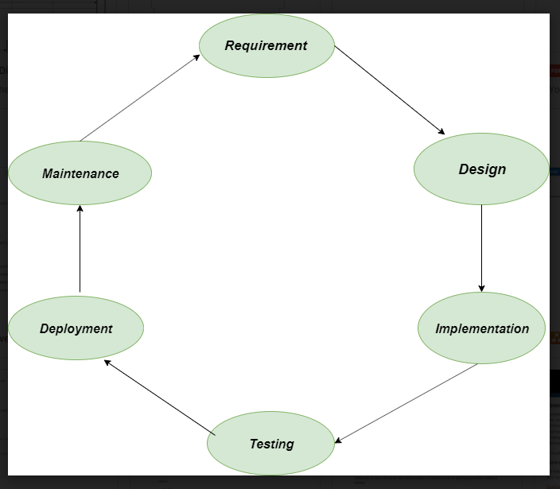

1. **Requirements gathering and analysis:**This phase involves gathering information about the software requirements from stakeholders, such as customers, end-users, and business analysts.

**2. Design:** In this phase, the software design is created, which includes the overall architecture of the software, data structures, and interfaces. It has two steps:

* **High-level design (HLD):** It gives the architecture of software products.
* **Low-level design (LLD):** It describes how each and every feature in the product should work and every component.

**3. Implementation or coding:** The design is then implemented in code, usually in several iterations, and this phase is also called as Development.

things you need to know about this phase:

* This is the longest phase in SDLC model.
* This phase consists of Front end + Middleware + Back-end.
* **In front-end:**Development of coding is done even SEO settings are done.
* **In Middleware:** They connect both the front end and back end.
* **In the back-end:** A database is created.

**4. Testing:**The software is thoroughly tested to ensure that it meets the requirements and works correctly.

**5. Deployment:** After successful testing, The software is deployed to a production environment and made available to end-users.

**6. Maintenance:**This phase includes ongoing support, bug fixes, and updates to the software.

* **What is DFD? Create a DFD diagram on Flipkart.**

**Ans :**

* DFD is the abbreviation for Data Flow Diagram.
* The flow of data of a system or a process is represented by DFD.
* It also gives insight into the inputs and outputs of each entity and the process itself.
* DFD does not have control flow and no loops or decision rules are present.
* Specific operations depending on the type of data can be explained by a flowchart.

**DFD Diagram on Flipkart :-**

**

**Level 1:**

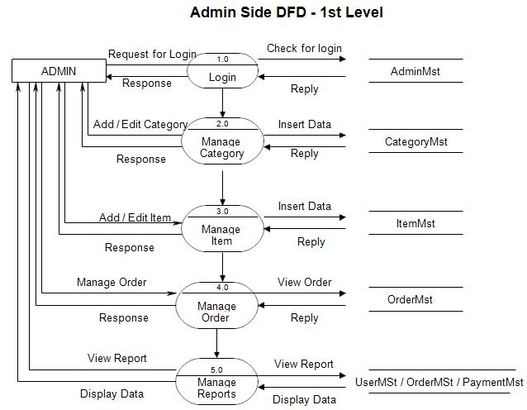

**Level 2:**

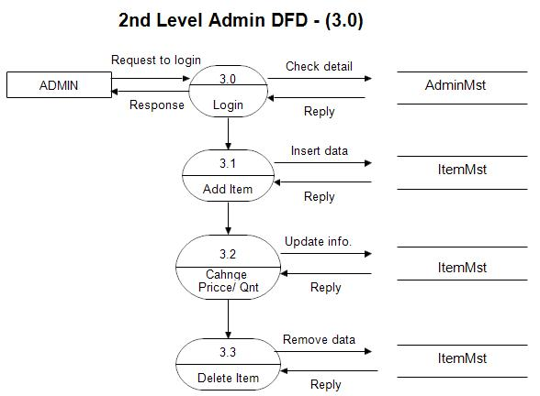

* **What is Flow chat? Create a flowchart to make addition of two numbers.**

**Ans :** A flowchart is a type of diagram that represents a workflow or process. A flowchart can also be defined as a diagrammatic representation of an algorithm, a step-by-step approach to solving a task. The flowchart shows the steps as boxes of various kinds, and their order by connecting the boxes with arrows.

**Flowchart to make addition of two numbers :**

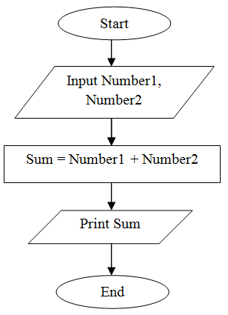

* **What is Use case Diagram? Create a use-case on bill payment on paytm.**

**Ans :** A use case diagram is a graphical depiction of a user's possible interactions with a system. A use case diagram shows various use cases and different types of users the system has and will often be accompanied by other types of diagrams as well. The use cases are represented by either circles or ellipses.

