**ASSIGNMENT 3**

**Roll No: 31448**

**1. Find the Student details and Placement details using NATURAL JOIN.**

SELECT * FROM Student NATURAL JOIN PlacementDrive;

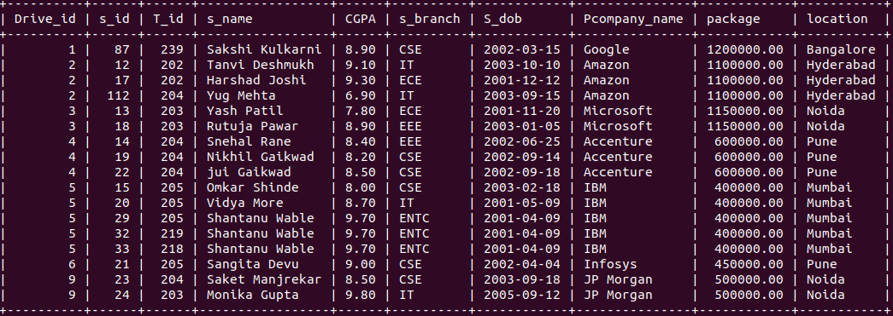

**2. Find all the student details with company_name who have conducted in same drive**

SELECT s.*,p.Pcompany_name FROM Student s JOIN PlacementDrive p ON p.Drive_id =

s.Drive_id;

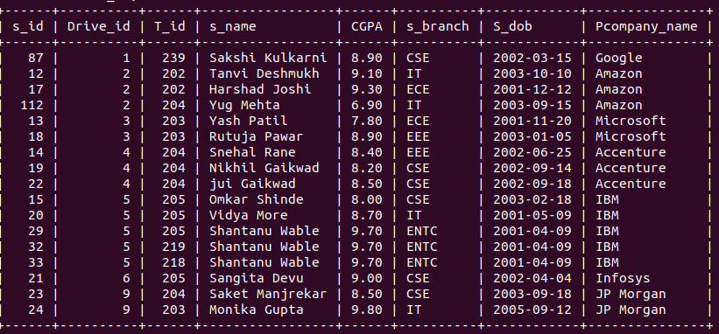

**3.List all the Student name and Student branch of Student having package 5 LPA**

SELECT s_name,s_branch from Student s JOIN PlacementDrive p ON p.Drive_id = s.Drive_id

WHERE p.package=500000;

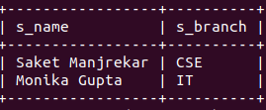

**4.List all the student names ,company_name having T_fee more than 20000**

SELECT s_name,t.Tcompany_name FROM Student s JOIN Training t ON s.T_id=t.T_id WHERE

t.T_Fee>20000;

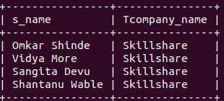

**5. Display all training details attended by “shantanu” in year 2011**

SELECT t.* FROM Training t JOIN Student s ON t.t_id = s.t_id WHERE s.s_name LIKE

“Shantanu%” AND t.t_year=2011;

// i should have taken date as 2022-06-9 but i just took year, YEAR(t.t_date)=2011 my field is also

t_year instead of t_date

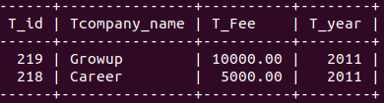

**6. list the total number of companies who conduct training before 2015**

SELECT COUNT(DISTINCT Tcompany_name) AS Company_count FROM Training WHERE

t_year<2015;

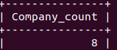

**7. List the students name with company ‘Microsoft’ and location ’Thane’**

SELECT s.s_name FROM Student s JOIN PlacementDrive p ON p.Drive_id=s.Drive_id WHERE

p.Pcompany_name = "Microsoft" AND p.location = "Thane";

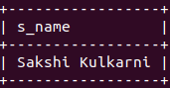

**8. Find the names of all Students who have joined ‘Microsoft ‘ training in 2015 .**

SELECT s.s_name FROM Student s JOIN Training t ON s.T_id = t.T_id WHERE

t.Tcompany_name = 'Microsoft' AND t.T_year = 2015;

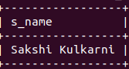

**9. Create a view showing the Student and Training details.**

CREATE VIEW stud_training AS SELECT s.s_id,s.s_name,t.Tcompany_name,t.T_Fee FROM Student s JOIN Training t ON s.T_id = t.T_id;

SELECT * FROM stud_training

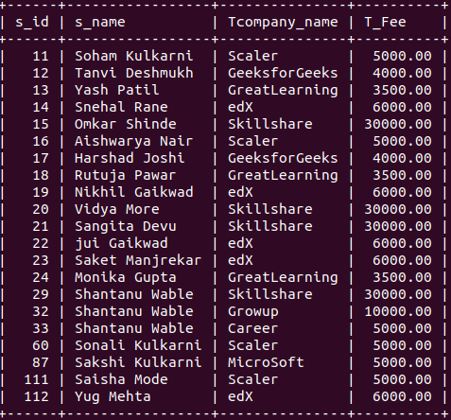

**10. Perform Manipulation on simple view-Insert, update, delete, drop view.**

**Note:** inorder to manipulate view there are rule:

1. Single table(No join)

2. All not null value.

3. No complex or subquery.

**CREATE:**

CREATE VIEW training_view AS SELECT T_id,Tcompany_name,T_Fee,T_year FROM Training;

SELECT * FROM training_view;

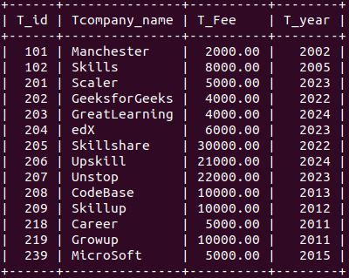

**INSERT:**

INSERT INTO training_view(T_id,Tcompany_name,T_Fee,T_year) VALUES (101,'hustle',2000,2002),

(102,'liftup',8000,2005);

SELECT * FROM training_view;

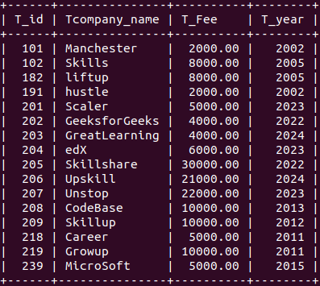

**UPDATE:**

SELECT * FROM training_view WHERE Tcompany_name = "Scaler";

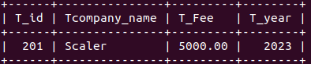

UPDATE training_view SET T_Fee=10000 WHERE Tcompany_name ="Scaler";

SELECT * FROM training_view WHERE Tcompany_name = "Scaler";

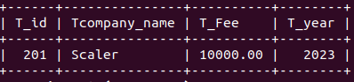

**DELETE:**

SELECT * FROM training_view WHERE Tcompany_name = "Scaler";

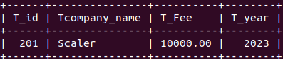DELETE FROM training_view WHERE Tcompany_name = "Scaler";

SELECT * FROM training_view WHERE Tcompany_name = "Scaler";

**Empty set (0.001 sec)**

**DROP:**

DROP view training_view;

SELECT * FROM training_view;

**ERROR 1146 (42S02): Table 'te31448_db.training_view' doesn't exist**