**Assignment 4 : PL/SQL**

**Roll No: 31448**

**1) Create Procedure**

DELIMITER $$

CREATE OR REPLACE PROCEDURE Issue_Book(

IN p_roll_no INT,

IN p_name VARCHAR(100),

IN p_issue_date DATE,

IN p_book_name VARCHAR(200)

)

BEGIN

-- Error handler for SQL exceptions

DECLARE EXIT HANDLER FOR SQLEXCEPTION

BEGIN

ROLLBACK;

SELECT 'Error Occurred' AS msg;

END;

START TRANSACTION;

INSERT INTO borrow(Roll_no, Name, Date_of_Issue, Name_of_Book, Status)

VALUES (p_roll_no, p_name, p_issue_date, p_book_name, 'I');

COMMIT;

SELECT 'BOOK ISSUED SUCCESSFULLY' AS msg;

END $$

DELIMITER ;

**2) Call Procedure**

CALL Issue_Book(201,'Mokshada Sheth','2025-08-05','Discovery of India');

CALL Issue_Book(201,'Mokshada Sheth','2025-08-05','Discovery of India');

CALL Issue_Book(202,'Sayali Pawar','2025-02-01','Diary of Anne Frank');

CALL Issue_Book(203,'Gauri Wagh','2025-06-01','It ends with us');

CALL Issue_Book(204,'Shradha Kokare','2025-05-11','Biography of Kiran Bedi');

CALL Issue_Book(205,'Mayuri Sable','2025-03-21','The 5AM Club');

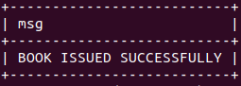

**3) Exception Handler**

CALL Issue_Book('205','Mayuri Sable','2025-03-13','The Pysology of Money');

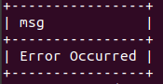

**4) Display Records**

SELECT * FROM borrow;

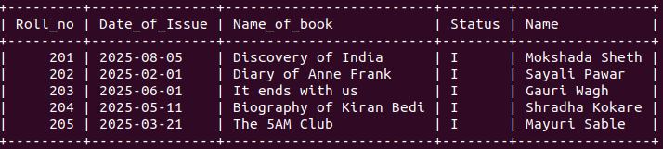

**5) Procedure to set fine if between 15 and 30 Rs 5/- per day. If >30 then Rs 50/- per day**

DELIMITER $$

MariaDB [te31448_db]> CREATE OR REPLACE PROCEDURE Return_Book(

-> IN p_roll_no INT,

-> IN p_return_date DATE)

-> BEGIN

-> DECLARE v_days INT;

-> DECLARE v_issue_date DATE;

-> DECLARE v_fine_amount DECIMAL(8,2);

-> SELECT Date_of_Issue INTO v_issue_date FROM borrow WHERE Roll_no = p_roll_no;

-> SET v_days = DATEDIFF(p_return_date,v_issue_date);

-> SET v_fine_amount = 0;

-> IF v_days BETWEEN 15 AND 30 THEN

-> SET v_fine_amount= (v_days-14)*5;

-> ELSEIF v_days>30 THEN

-> SET v_fine_amount= ((v_days-30)*50)+((v_days-14-(v_days-30))*5);

-> -- fiine=(days beyond 30×50)+(days between 15 and 30×5)

-> END IF;

-> UPDATE borrow SET Status='R' WHERE Roll_NO = p_roll_NO AND Status='I';

-> IF v_fine_amount>0 THEN

-> INSERT INTO fine(Roll_no,Fine_date,Amt) VALUES(p_roll_no,p_return_date,v_fine_amount);

-> END IF;

-> SELECT CONCAT('Return Processed.Fine amount: Rs ',v_fine_amount) AS msg;

-> END

-> $$ DELIMITER

**6) Call Return Book**

**-- No fine**

CALL Return_Book(203,'2025-06-12');

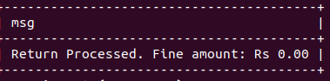

**-- days between 15-30**

CALL Return_Book(204,'2025-05-30');

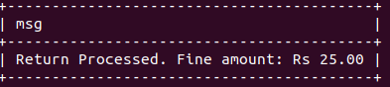

**-- days >30**

CALL Return_Book(205,'2025-04-30');

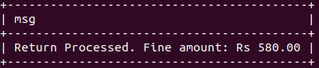

**7) Status updated**

SELECT * FROM borrow;

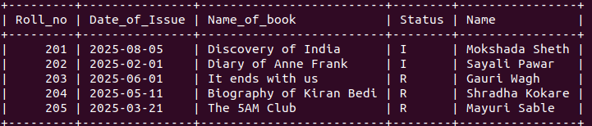

**8) Fine table**

SELECT * FROM fine;

