CREATE TABLE New_Roll(id INT PRIMARY KEY, name VARCHAR(400), dept VARCHAR(300));

Query OK, 0 rows affected (0.186 sec)

CREATE TABLE Old_Roll(id INT PRIMARY KEY, name VARCHAR(400), dept VARCHAR(300));

Query OK, 0 rows affected (0.182 sec)

INSERT INTO New_Roll values (101,'Sayali','IT'),(102,'Naveli','CE'),(103,'Sara','CE');

INSERT INTO Old_Roll values (201,'Mayur','ENTC'),(202,'Sakshi','AIDS'),(203,'Mokshada','CE'),(101,'Sayali','IT'),(103,'Sara','CE');

SELECT * FROM New_Roll;

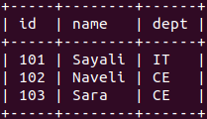

SELECT * FROM Old_Roll;

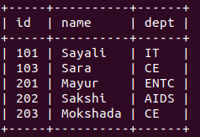

DELIMITER $$

CREATE PROCEDURE add_to_Old()

BEGIN

-- Variables to hold fetched row values

DECLARE v_id INT;

DECLARE v_name VARCHAR(30);

DECLARE v_dept VARCHAR(20);

-- flag for cursor end

DECLARE done INT DEFAULT FALSE;

-- cursor declaration

DECLARE cur CURSOR FOR SELECT id, name, dept FROM New_Roll;

-- Handler to set done = TRUE when no more rows

DECLARE CONTINUE HANDLER FOR NOT FOUND SET done = TRUE;

-- Open cursor

OPEN cur;

get_data: WHILE NOT done DO

FETCH cur INTO v_id, v_name, v_dept;

-- If there’s no row, return 1

IF NOT EXISTS (SELECT 1 FROM O_RollCall WHERE id = v_id) THEN INSERT INTO Old_Roll(id, name, dept) VALUES (v_id, v_name, v_dept);

END IF;

END WHILE;

CLOSE cur;

END$$

DELIMITER ;

CALL add_to_Old();