**Name: Sanskruti Patil**

**Roll No: 31448**

1. CREATE TABLE Library(book_id INT PRIMARY KEY, book_name varchar(30), price float, is_issued BOOLEAN DEFAULT FALSE);
2. INSERT INTO Library(book_id, book_name, price) VALUES(1, 'DBMS' , 200.10),(2,'SPOS',500.10),(3,'TOC',700.50),(4,'OOP',350.10);
3. SELECT * FROM Library;

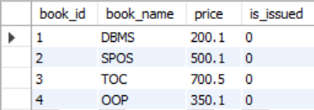

1. DELIMITER $$

CREATE TRIGGER updateAudit

BEFORE

UPDATE

ON Library

FOR EACH ROW

BEGIN

INSERT INTO Library_Audit(book_id, book_name, price, is_issued, action) VALUES

(OLD.book_id, OLD.book_name, OLD.price, OLD.is_issued, 'Update');

END $$

1. DELIMITER $$

CREATE TRIGGER deleteAudit

BEFORE

DELETE

ON Library

FOR EACH ROW

BEGIN

INSERT INTO Library_Audit(book_id, book_name, price, is_issued, action) VALUES

(OLD.book_id, OLD.book_name, OLD.price, OLD.is_issued, 'Delete');

END $$

DELIMITER ;

1. DELETE FROM Library WHERE book_id = 2;
2. SELECT * FROM Library_Audit;

1. UPDATE Library SET price = 300 WHERE book_id = 4;
2. SELECT * FROM Library_Audit;

