**Roll No: 31448**

CREATE TABLE TEACHER(id INT PRIMARY KEY,name VARCHAR(20),salary INT);

Insert into TEACHER(id,name,salary) values

-> (1,"Mayuri",57000),

-> (2,"Sakshi",60000),

-> (3,"Amit",55000),

-> (4,"Sai",80000),

-> (106,"Saksham",55000),

-> (107,"Sayali",60000);

SELECT * FROM TEACHER;

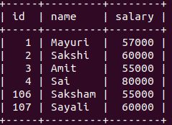

CREATE TABLE COURSE(c_id INT PRIMARY KEY, c_name VARCHAR(20), id INT, FOREIGN KEY(id) REFERENCES TEACHER(id) );

Insert into COURSE(c_id,id,c_name) values

-> (101,1,"Maths"),

-> (102,4,"Science"),

-> (103,2,"Physics"),

-> (104,4,"Bio"),

-> (106,3,"History");

SELECT * FROM COURSE;

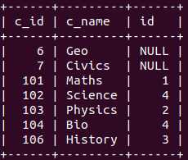

**INNER JOIN:**

Return all rows with same spacified column value.

SELECT t.name,c.c_name FROM TEACHER t INNER JOIN COURSE c ON t.id = c.id;

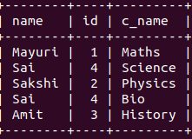

**NATURAL JOIN**

Join 2 tables by common column name no need to specify column name eplicitly

SELECT * FROM TEACHER natural join COURSE;

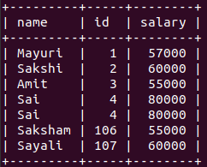

**LEFT JOIN**

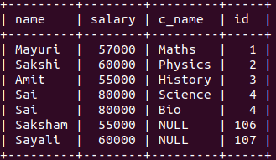select t.name,t.salary,c.c_name,t.id from TEACHER t LEFT JOIN COURSE c ON t.id=c.id;

**RIGHT JOIN**

SELECT t.name,c.c_name from TEACHER t RIGHT JOIN COURSE c ON t.id=c.id;

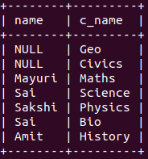

**OUTER JOIN**

select t.name as teacher_id, c.c_name as c_name from TEACHER t LEFT JOIN COURSE c ON t.id = c.id UNION select t.name, c.c_name as c_name from TEACHER t RIGHT JOIN COURSE c ON t.id=c.id;

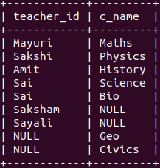

**SELF JOIN**

SELECT * FROM directory;

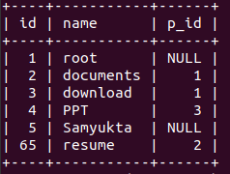

SELECT p.name as Parent, c.name as Child FROM directory c JOIN directory p on p.id = c.p_id;

