ASSIGNMENT 3
Roll No: 31448

1. Find the Student details and Placement details using NATURAL JOIN.
SELECT * FROM Student NATURAL JOIN PlacementDrive;
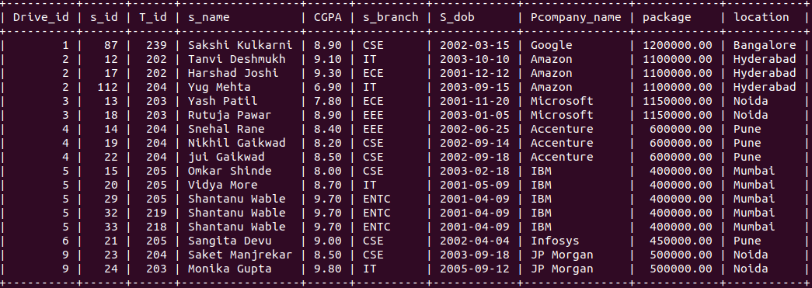
2. Find all the student details with company_name who have conducted in same drive
SELECT s.*,p.Pcompany_name FROM Student s JOIN PlacementDrive p ON p.Drive_id =
s.Drive_id;
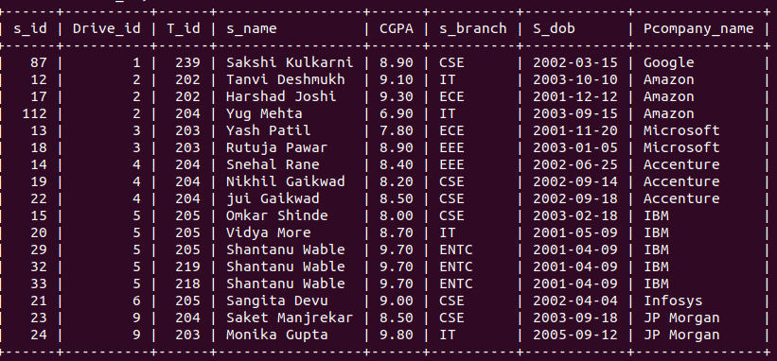
3.List all the Student name and Student branch of Student having package 5 LPA
SELECT s_name,s_branch from Student s JOIN PlacementDrive p ON p.Drive_id = s.Drive_id
WHERE p.package=500000;
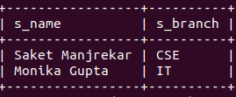
4.List all the student names ,company_name having T_fee more than 20000
SELECT s_name,t.Tcompany_name FROM Student s JOIN Training t ON s.T_id=t.T_id WHERE
t.T_Fee>20000;
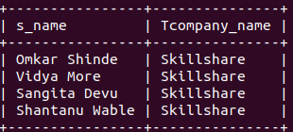
5. Display all training details attended by “shantanu” in year 2011
SELECT t.* FROM Training t JOIN Student s ON t.t_id = s.t_id WHERE s.s_name LIKE
“Shantanu%” AND t.t_year=2011;
// i should have taken date as 2022-06-9 but i just took year, YEAR(t.t_date)=2011 my field is also
t_year instead of t_date
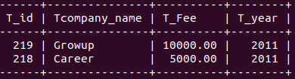
6. list the total number of companies who conduct training before 2015
SELECT COUNT(DISTINCT Tcompany_name) AS Company_count FROM Training WHERE
t_year<2015;
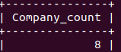
7. List the students name with company ‘Microsoft’ and location ’Thane’
SELECT s.s_name FROM Student s JOIN PlacementDrive p ON p.Drive_id=s.Drive_id WHERE
p.Pcompany_name = "Microsoft" AND p.location = "Thane";
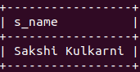
8. Find the names of all Students who have joined ‘Microsoft ‘ training in 2015 .
SELECT s.s_name FROM Student s JOIN Training t ON s.T_id = t.T_id WHERE
t.Tcompany_name = 'Microsoft' AND t.T_year = 2015;

9. Create a view showing the Student and Training details.
CREATE VIEW stud_training AS SELECT s.s_id,s.s_name,t.Tcompany_name,t.T_Fee FROM Student s JOIN Training t ON s.T_id = t.T_id;
SELECT * FROM stud_training

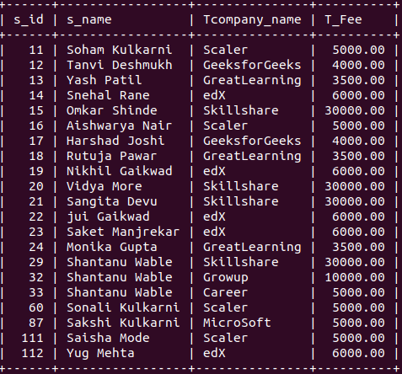

10. Perform Manipulation on simple view-Insert, update, delete, drop view.
Note: inorder to manipulate view there are rule:
1. Single table(No join)
2. All not null value.
3. No complex or subquery.
CREATE:
CREATE VIEW training_view AS SELECT T_id,Tcompany_name,T_Fee,T_year FROM Training;
SELECT * FROM training_view;

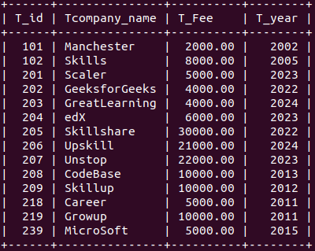

INSERT:
INSERT INTO training_view(T_id,Tcompany_name,T_Fee,T_year) VALUES (101,'hustle',2000,2002),
(102,'liftup',8000,2005);
SELECT * FROM training_view;

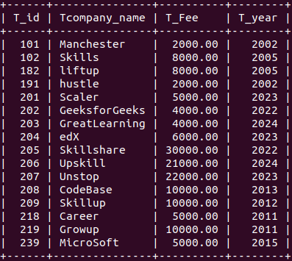

UPDATE:
SELECT * FROM training_view WHERE Tcompany_name = "Scaler";

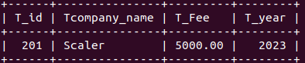

UPDATE training_view SET T_Fee=10000 WHERE Tcompany_name ="Scaler";
SELECT * FROM training_view WHERE Tcompany_name = "Scaler";
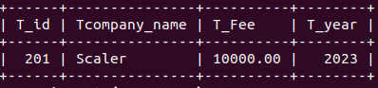

DELETE:
SELECT * FROM training_view WHERE Tcompany_name = "Scaler";
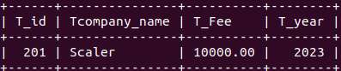
DELETE FROM training_view WHERE Tcompany_name = "Scaler";

SELECT * FROM training_view WHERE Tcompany_name = "Scaler";
Empty set (0.001 sec)

DROP:
DROP view training_view;
SELECT * FROM training_view;
ERROR 1146 (42S02): Table 'te31448_db.training_view' doesn't exist

