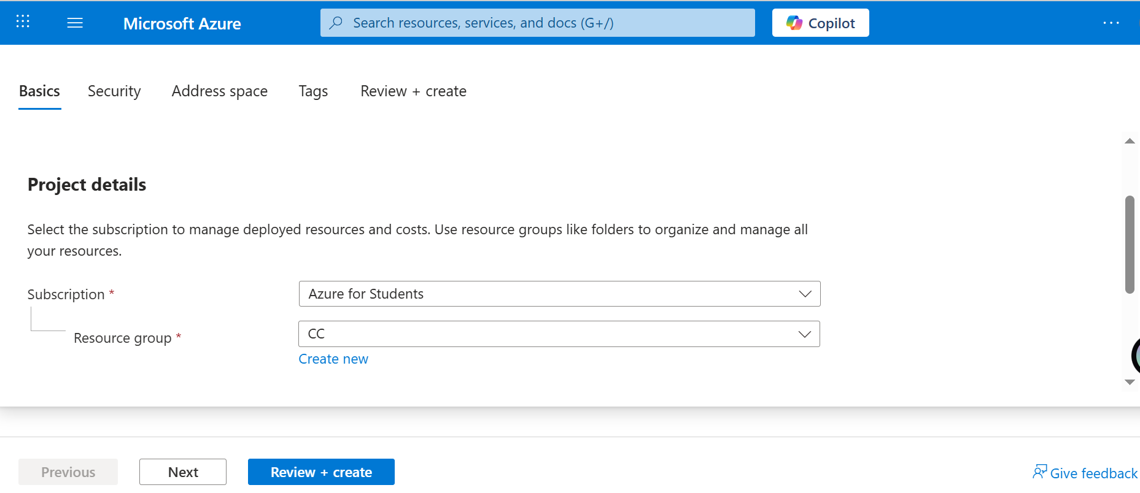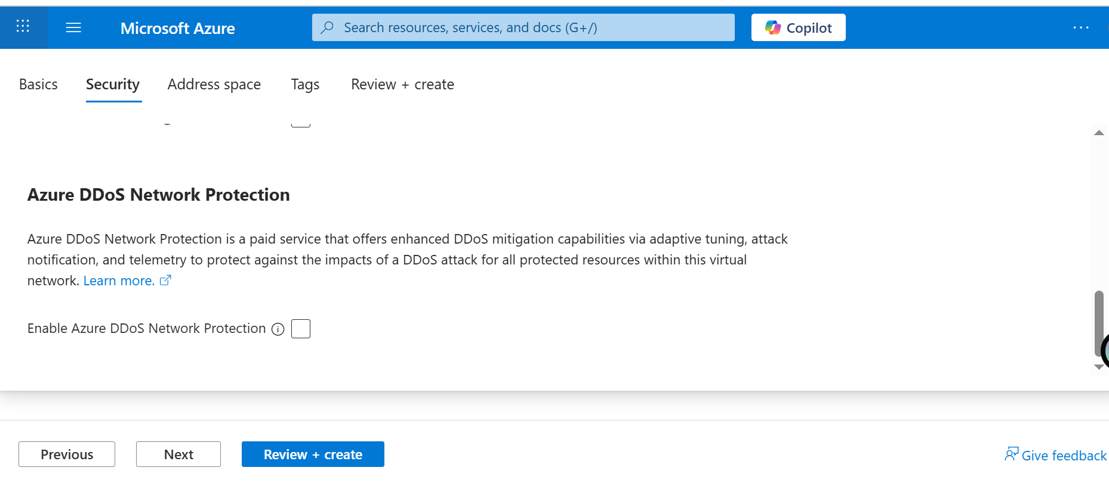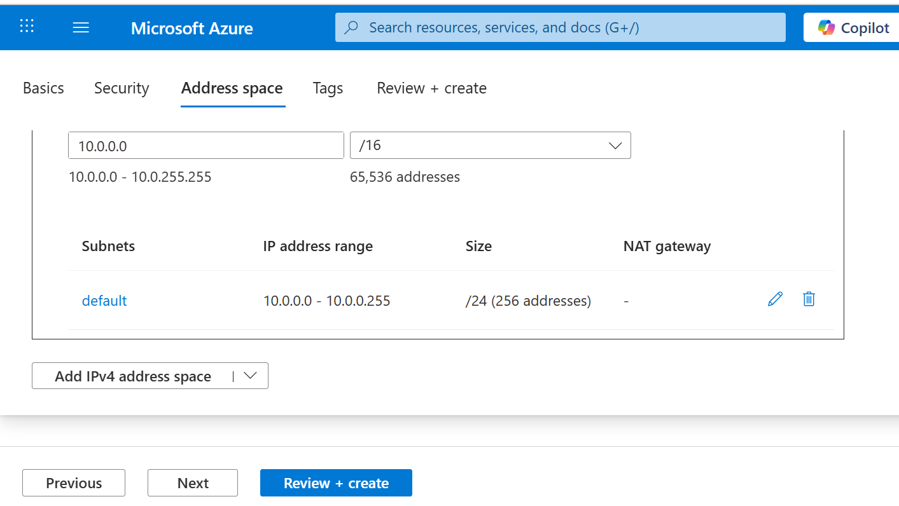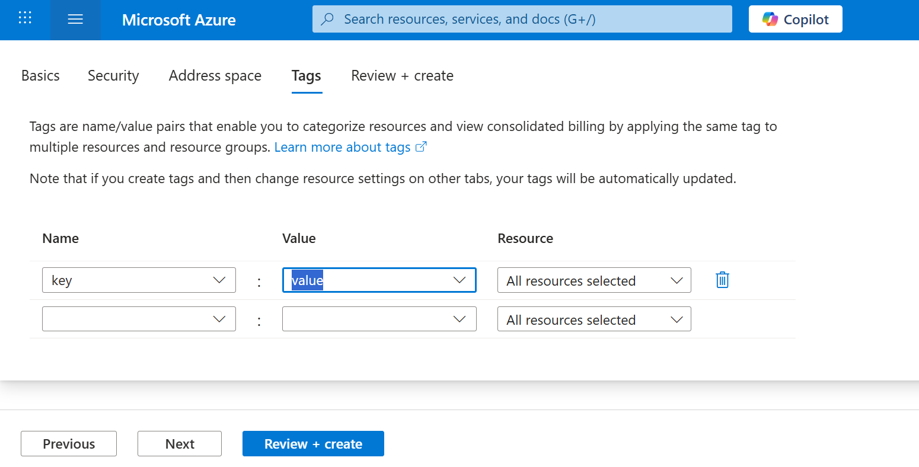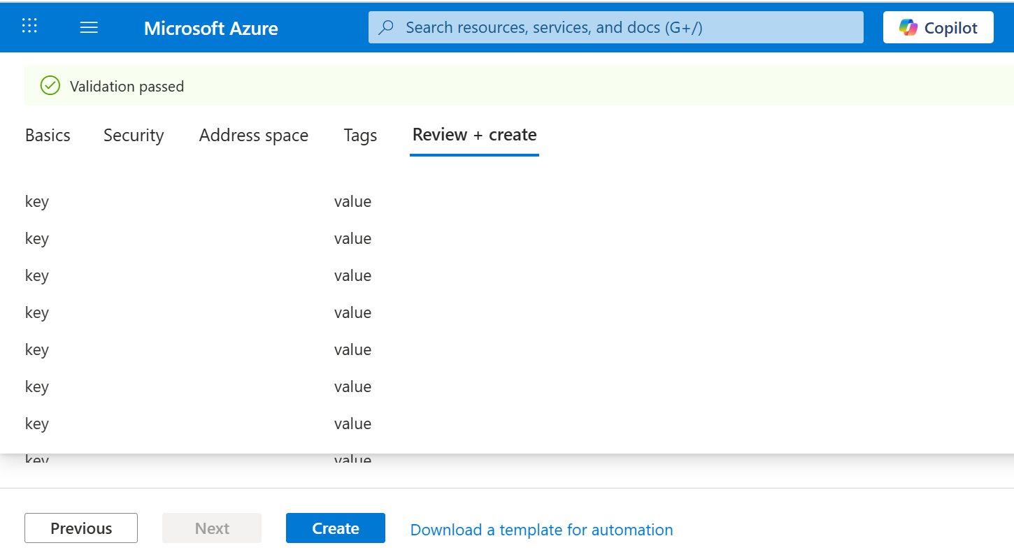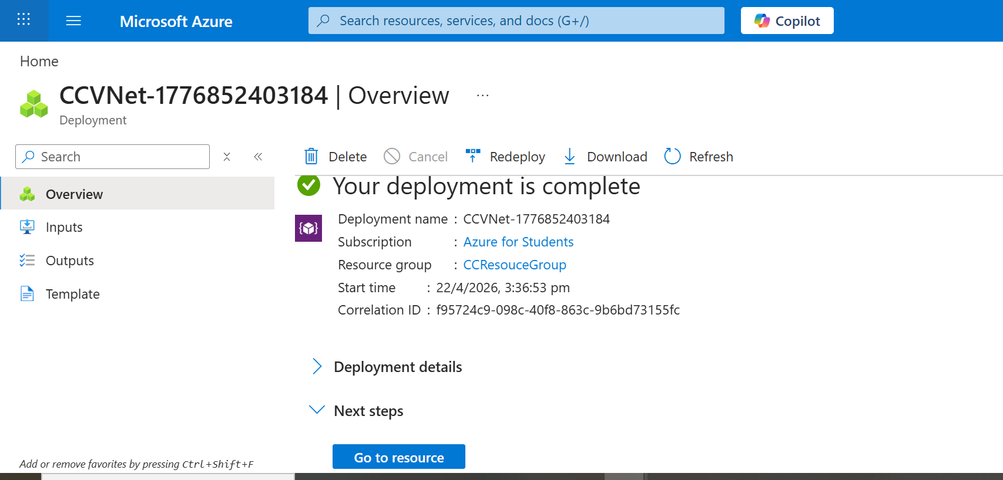

Create Virtual Machine
Go to Virtual Machine options in 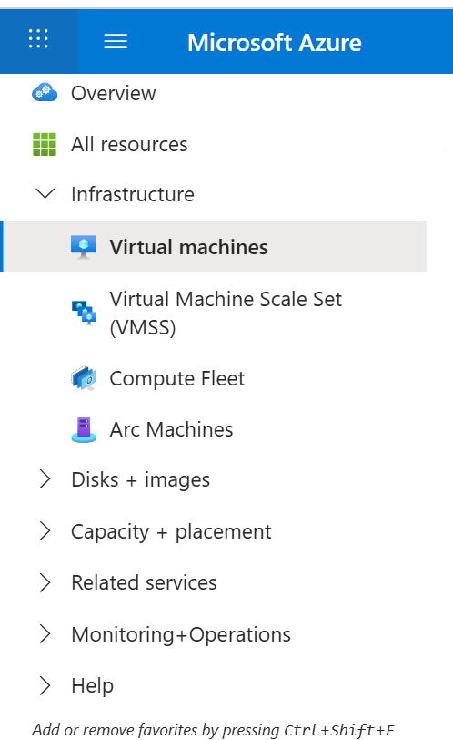
Clicl on Create
Virtual Machine
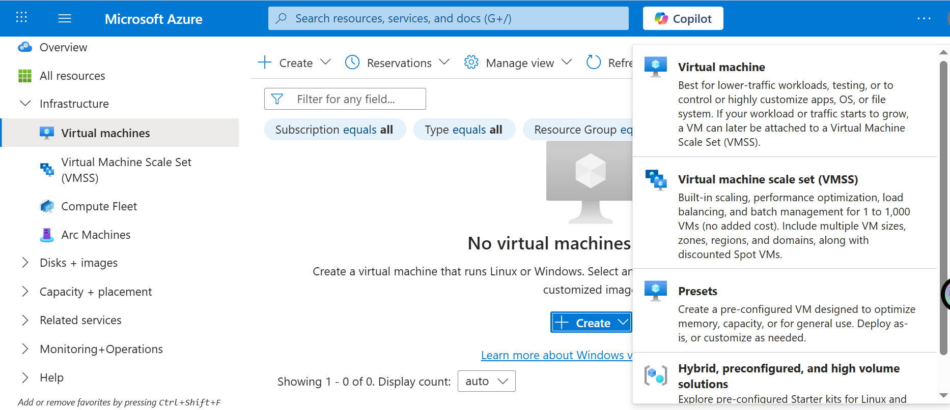

Select Your ResourceGroup
Name VM
Image Ubuntu 2024
Change Size to B1
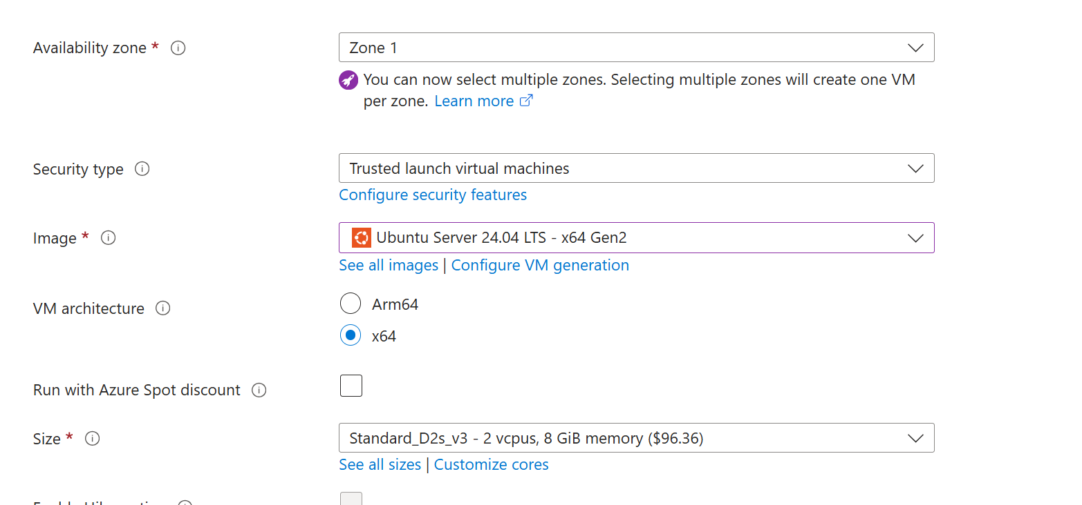
Keep below records the same
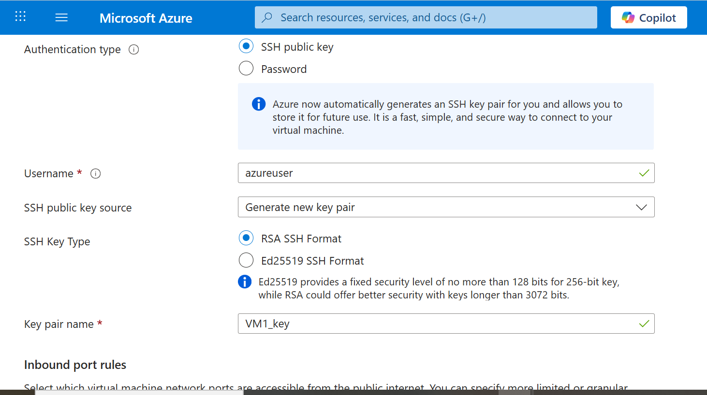
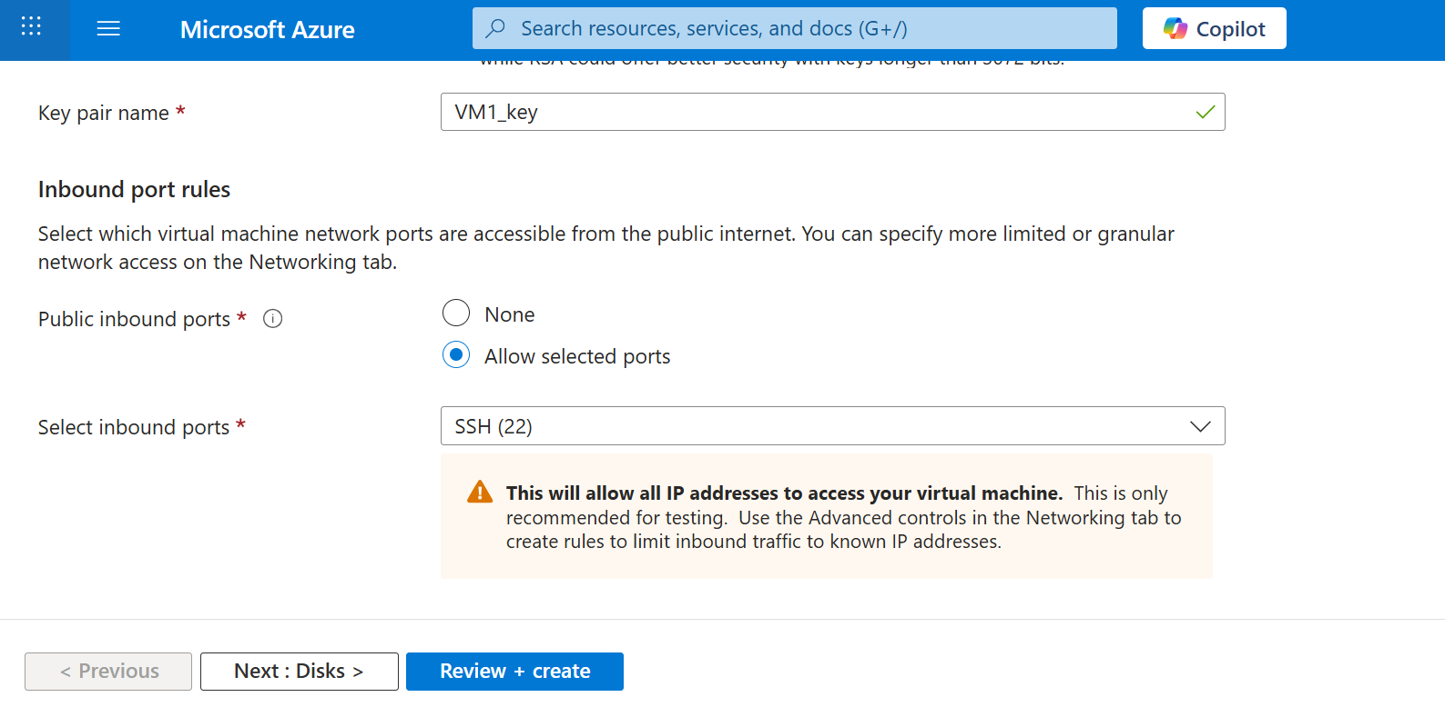
Do next -> again next
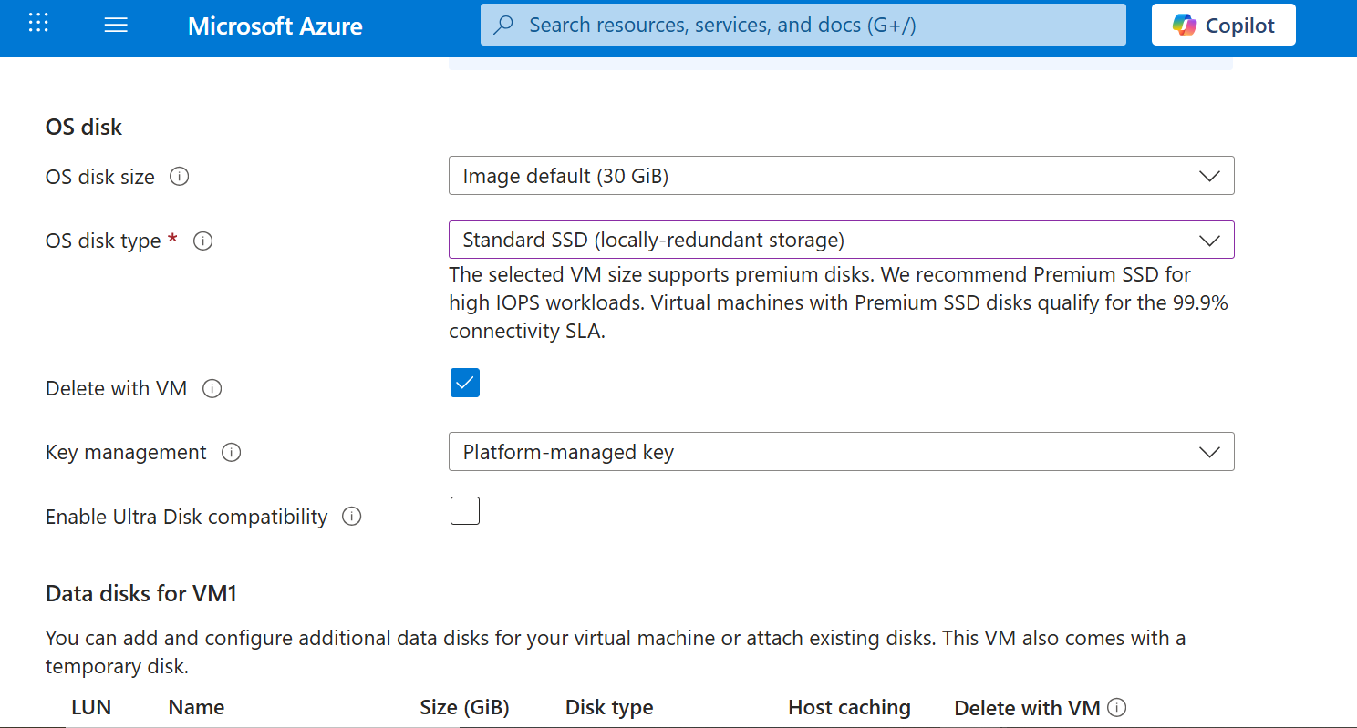
Just set OS disk type: Standard SSD
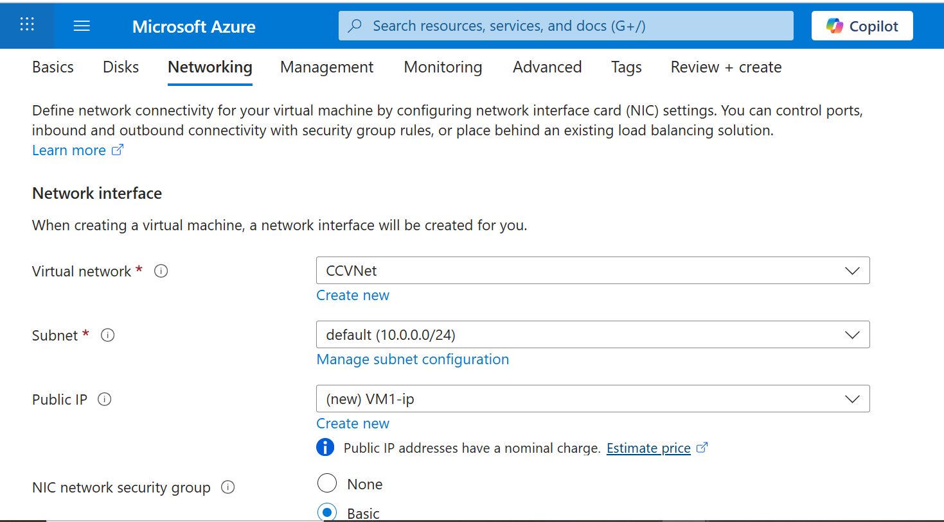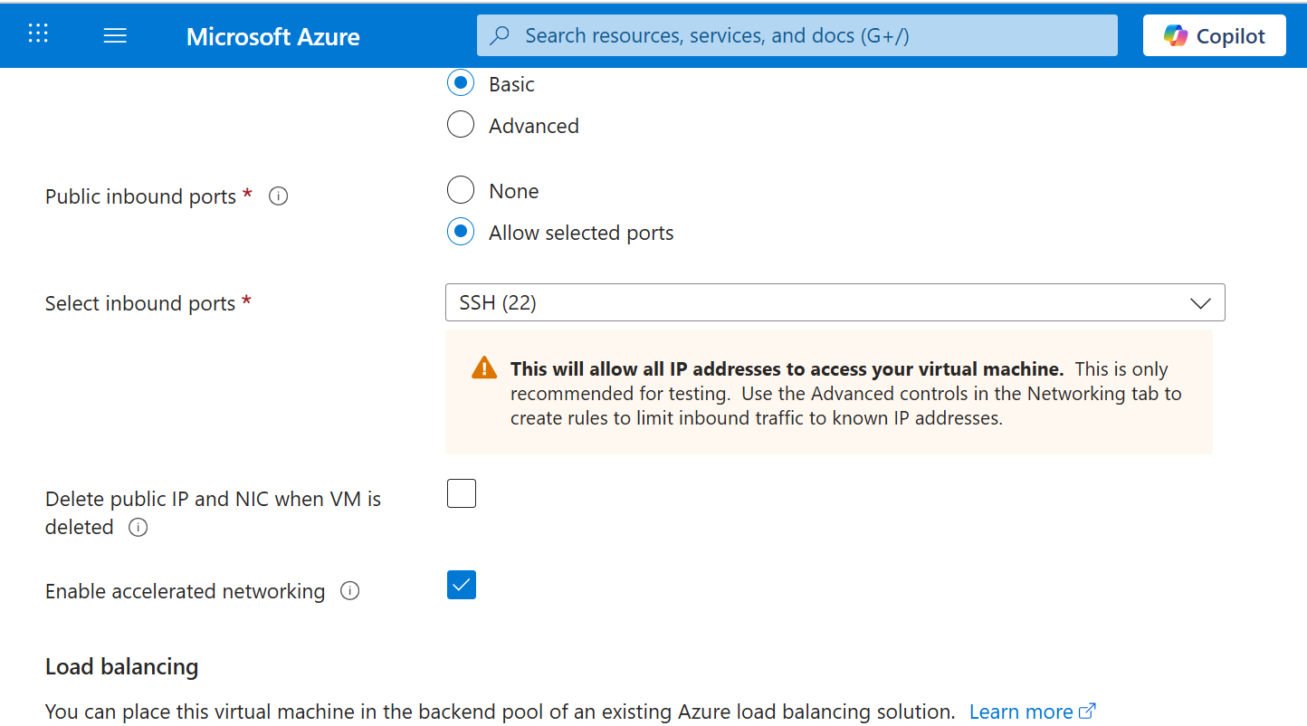
After Networking Click review+create

Download .pem file

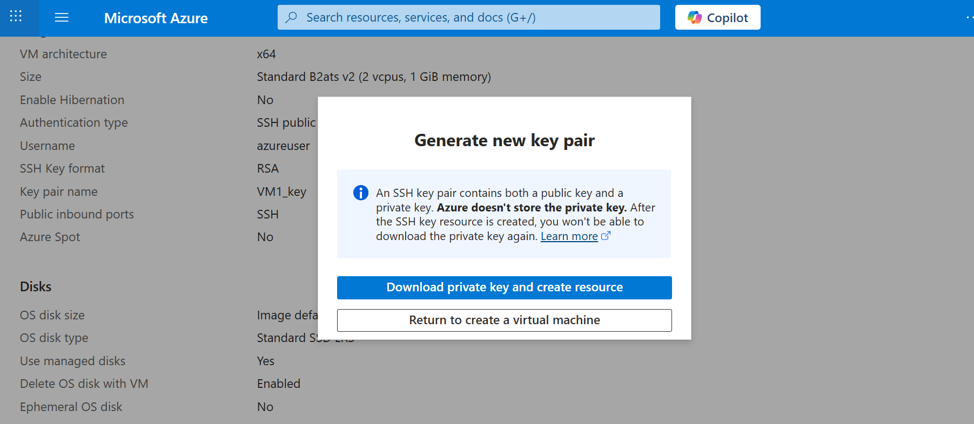

Create one more Virtual machine in same Way

- Go to Virtual Machine

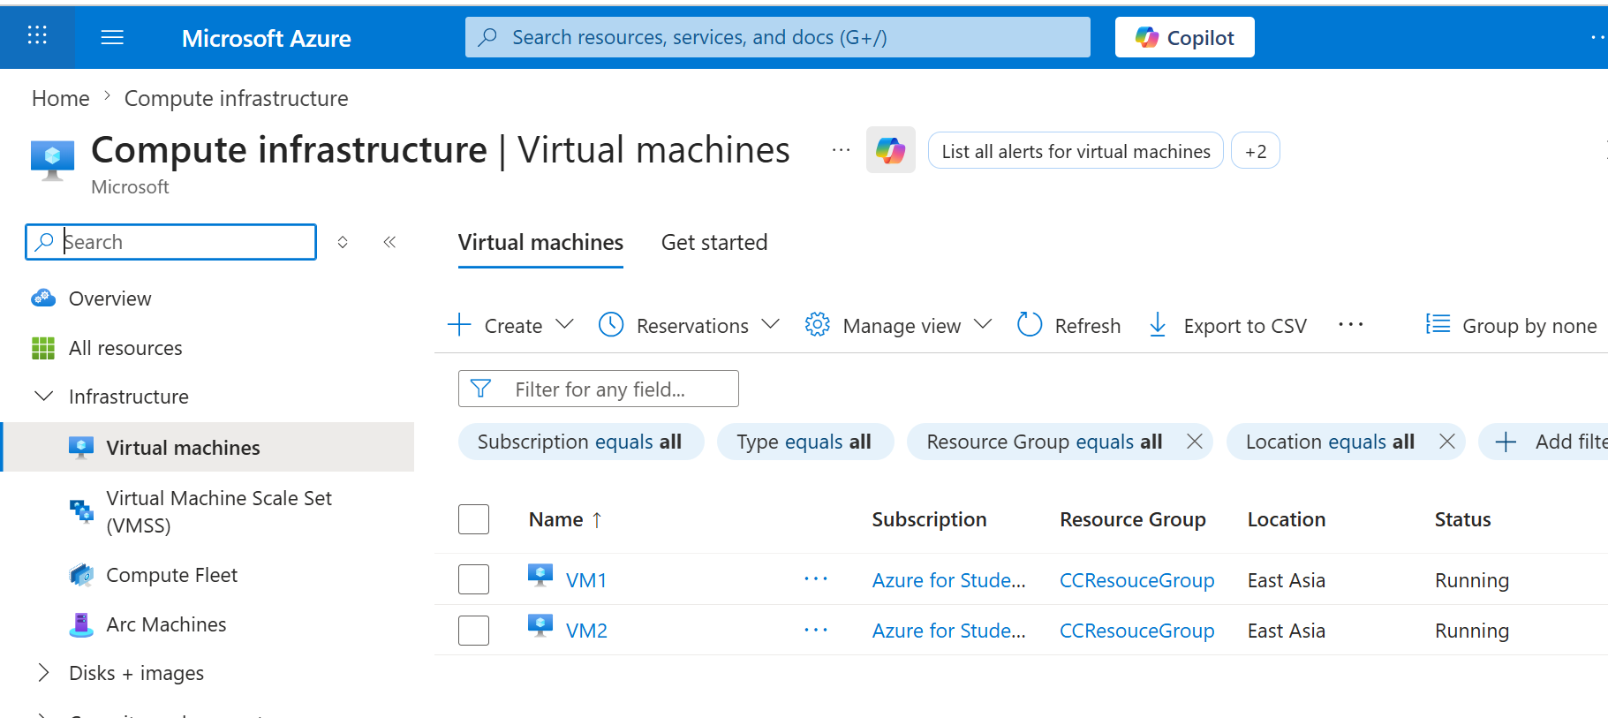

Click on VM1
Click on Connect option top left corner
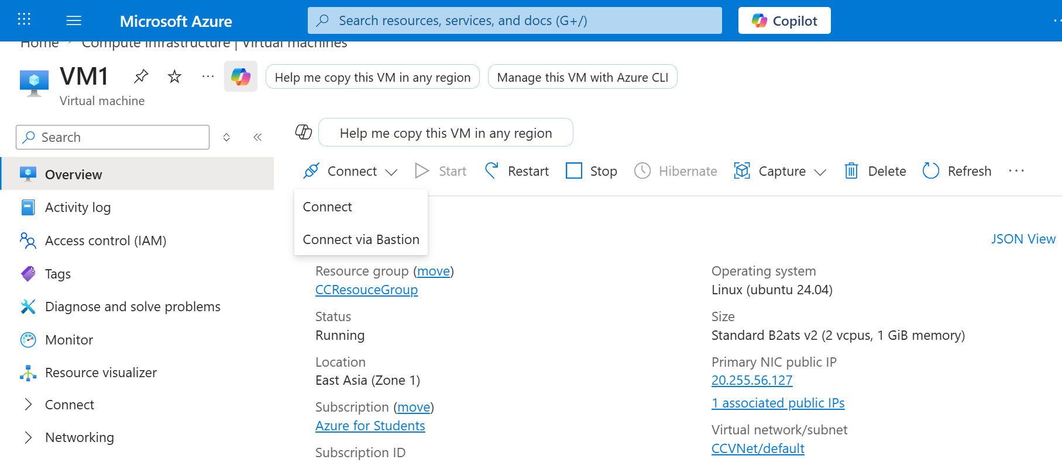

Open Command Prompt

Terminal 1
// your VM1_key.pem should be in downloads or move to the folder where they are present.

- cd Downloads
- scp -i VM1_key.pem VM2_key.pem azureuser@20.255.56.127:/home/azureuser/
// here 20.255.56.127 is Public key of VM1 uploading VM2_key to VM1
- ssh -i VM1_key.pem azureuser@20.255.56.127
// Login to VM1
- Now inside ubuntu window:
chmod 400 VM2_key.pem //secure the key
- echo "Hello from VM1" > test.txt // create the file
- scp -i VM2_key.pem test.txt azureuser@10.0.0.5:/home/azureuser/
// transfer file to VM2 using private IP of VM1

Terminal 2
- cd downloads
- ssh -i VM2_key.pem azureuser@10.0.0.5
- ls
- cat test.txt //read the file
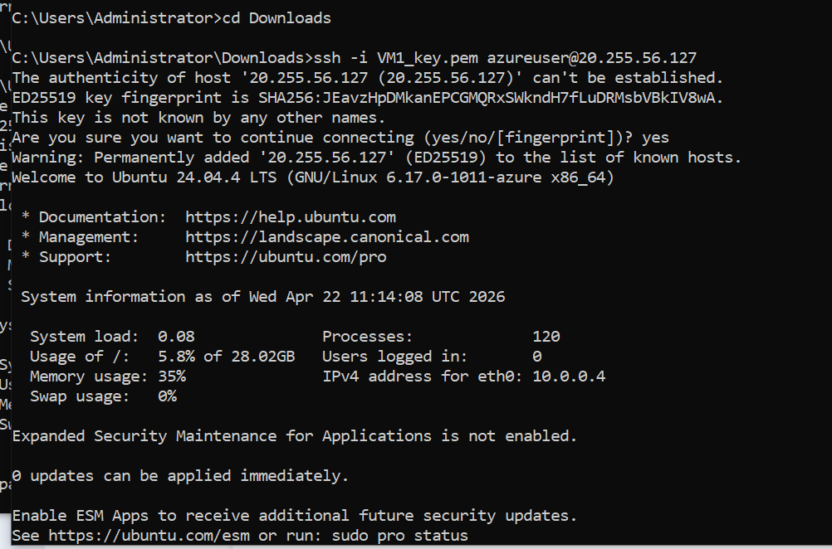
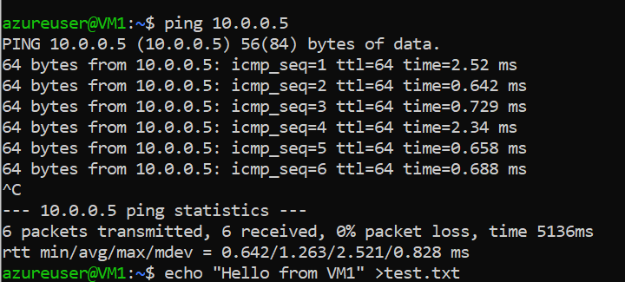

- Microsoft Windows [Version 10.0.19045.6466]
- (c) Microsoft Corporation. All rights reserved.

- C:\Users\Administrator>cd Downloads

- C:\Users\Administrator\Downloads>ssh -i VM1_key.pem azureuser@20.255.56.127
- The authenticity of host '20.255.56.127 (20.255.56.127)' can't be established.
- ED25519 key fingerprint is SHA256:JEavzHpDMkanEPCGMQRxSWkndH7fLuDRMsbVBkIV8wA.
- This key is not known by any other names.
- Are you sure you want to continue connecting (yes/no/[fingerprint])? yes
- Warning: Permanently added '20.255.56.127' (ED25519) to the list of known hosts.
- Welcome to Ubuntu 24.04.4 LTS (GNU/Linux 6.17.0-1011-azure x86_64)

- * Documentation: https://help.ubuntu.com
- * Management: https://landscape.canonical.com
- * Support: https://ubuntu.com/pro

- System information as of Wed Apr 22 11:14:08 UTC 2026

- System load: 0.08 Processes: 120
- Usage of /: 5.8% of 28.02GB Users logged in: 0
- Memory usage: 35% IPv4 address for eth0: 10.0.0.4
- Swap usage: 0%

- Expanded Security Maintenance for Applications is not enabled.

- 0 updates can be applied immediately.

- Enable ESM Apps to receive additional future security updates.
- See https://ubuntu.com/esm or run: sudo pro status

- The programs included with the Ubuntu system are free software;
- the exact distribution terms for each program are described in the
- individual files in /usr/share/doc/*/copyright.

- Ubuntu comes with ABSOLUTELY NO WARRANTY, to the extent permitted by
- applicable law.

- To run a command as administrator (user "root"), use "sudo <command>".
- See "man sudo_root" for details.

- azureuser@VM1:~$ ping 10.0.0.5
- PING 10.0.0.5 (10.0.0.5) 56(84) bytes of data.
- 64 bytes from 10.0.0.5: icmp_seq=1 ttl=64 time=2.52 ms
- 64 bytes from 10.0.0.5: icmp_seq=2 ttl=64 time=0.642 ms
- 64 bytes from 10.0.0.5: icmp_seq=3 ttl=64 time=0.729 ms
- 64 bytes from 10.0.0.5: icmp_seq=4 ttl=64 time=2.34 ms
- 64 bytes from 10.0.0.5: icmp_seq=5 ttl=64 time=0.658 ms
- 64 bytes from 10.0.0.5: icmp_seq=6 ttl=64 time=0.688 ms
- ^C
- --- 10.0.0.5 ping statistics ---
- 6 packets transmitted, 6 received, 0% packet loss, time 5136ms
- rtt min/avg/max/mdev = 0.642/1.263/2.521/0.828 ms
- azureuser@VM1:~$ echo "Hello from VM1" >test.txt
- azureuser@VM1:~$ scp test.txt azureuser@10.0.0.5:/home/azureuser/
- The authenticity of host '10.0.0.5 (10.0.0.5)' can't be established.
- ED25519 key fingerprint is SHA256:dE4x5nFIZMg6CXyKcM5m1qUhIG7t4LranPJspzb2BxM.
- This key is not known by any other names.
- Are you sure you want to continue connecting (yes/no/[fingerprint])? yes
- Warning: Permanently added '10.0.0.5' (ED25519) to the list of known hosts.
- azureuser@10.0.0.5: Permission denied (publickey).
- scp: Connection closed
- azureuser@VM1:~$ ls
- test.txt
- azureuser@VM1:~$ cd..
- cd..: command not found
- azureuser@VM1:~$ ls
- VM1_key.pem test.txt
- azureuser@VM1:~$ scp test.txt azureuser@10.0.0.5:/home/azureuser/
- azureuser@10.0.0.5: Permission denied (publickey).
- scp: Connection closed
- azureuser@VM1:~$ chmod 400 VM1_key.pem
- azureuser@VM1:~$ scp -i VM1_Key.pem test.txt azureuser@10.0.0.5:/home/azureuser/
- Warning: Identity file VM1_Key.pem not accessible: No such file or directory.
- azureuser@10.0.0.5: Permission denied (publickey).
- scp: Connection closed
- azureuser@VM1:~$ scp -i VM1_key.pem test.txt azureuser@10.0.0.5:/home/azureuser/
- azureuser@10.0.0.5: Permission denied (publickey).
- scp: Connection closed
- azureuser@VM1:~$ scp -i VM1_key.pem test.txt azureuser@10.0.0.5:~/
- azureuser@10.0.0.5: Permission denied (publickey).
- scp: Connection closed
- azureuser@VM1:~$ scp -i VM1_key.pem test.txt azureuser@57.158.24.49:~/
- The authenticity of host '57.158.24.49 (57.158.24.49)' can't be established.
- ED25519 key fingerprint is SHA256:dE4x5nFIZMg6CXyKcM5m1qUhIG7t4LranPJspzb2BxM.
- This host key is known by the following other names/addresses:
- ~/.ssh/known_hosts:1: [hashed name]
- Are you sure you want to continue connecting (yes/no/[fingerprint])? yes
- Warning: Permanently added '57.158.24.49' (ED25519) to the list of known hosts.
- azureuser@57.158.24.49: Permission denied (publickey).
- scp: Connection closed
- azureuser@VM1:~$ client_loop: send disconnect: Connection reset

- C:\Users\Administrator\Downloads>scp -i VM1_key.pem VM2_key.pem azureuser@20.255.56.127:/home/azureuser/
- VM2_key.pem 100% 2498 27.1KB/s 00:00

- C:\Users\Administrator\Downloads>ssh -i VM1_key.pem azureuser@20.255.56.127
- Welcome to Ubuntu 24.04.4 LTS (GNU/Linux 6.17.0-1011-azure x86_64)

- * Documentation: https://help.ubuntu.com
- * Management: https://landscape.canonical.com
- * Support: https://ubuntu.com/pro

- System information as of Wed Apr 22 15:19:48 UTC 2026

- System load: 0.0 Processes: 117
- Usage of /: 5.9% of 28.02GB Users logged in: 0
- Memory usage: 35% IPv4 address for eth0: 10.0.0.4
- Swap usage: 0%

- * Strictly confined Kubernetes makes edge and IoT secure. Learn how MicroK8s
- just raised the bar for easy, resilient and secure K8s cluster deployment.

- https://ubuntu.com/engage/secure-kubernetes-at-the-edge

- Expanded Security Maintenance for Applications is not enabled.

- 0 updates can be applied immediately.

- Enable ESM Apps to receive additional future security updates.
- See https://ubuntu.com/esm or run: sudo pro status

- Last login: Wed Apr 22 11:14:09 2026 from 42.108.227.184
- To run a command as administrator (user "root"), use "sudo <command>".
- See "man sudo_root" for details.

- azureuser@VM1:~$ chmod 400 VM2_key.pem
- azureuser@VM1:~$ scp -i VM2_key.pem test.txt azureuser@10.0.0.5:/home/azureuser/
- test.txt

new terminal
C:\Users\Administrator>cd Downloads

C:\Users\Administrator\Downloads>ssh -i VM2_key.pem azureuser@57.158.24.49
The authenticity of host '57.158.24.49 (57.158.24.49)' can't be established.
ED25519 key fingerprint is SHA256:dE4x5nFIZMg6CXyKcM5m1qUhIG7t4LranPJspzb2BxM.
This key is not known by any other names.
Are you sure you want to continue connecting (yes/no/[fingerprint])? yes
Warning: Permanently added '57.158.24.49' (ED25519) to the list of known hosts.
Welcome to Ubuntu 24.04.4 LTS (GNU/Linux 6.17.0-1011-azure x86_64)

* Documentation: https://help.ubuntu.com
* Management: https://landscape.canonical.com
* Support: https://ubuntu.com/pro

System information as of Wed Apr 22 15:23:04 UTC 2026

System load: 0.0 Processes: 121
Usage of /: 5.9% of 28.02GB Users logged in: 0
Memory usage: 35% IPv4 address for eth0: 10.0.0.5
Swap usage: 0%

Expanded Security Maintenance for Applications is not enabled.

0 updates can be applied immediately.

Enable ESM Apps to receive additional future security updates.
See https://ubuntu.com/esm or run: sudo pro status

To run a command as administrator (user "root"), use "sudo <command>".
See "man sudo_root" for details.

azureuser@VM2:~$ ls
test.txt
azureuser@VM2:~$

