Phase 1: GETTING THE DATA OF THE MAVEN FUZZY FACTORY IN THE SYSTEM AND ANALYSING IT
Objective
The objective of this phase was to understand the business problem, study the dataset, identify the purpose of each table, and understand the relationships between them before beginning data analysis.
Business Problem
Maven Fuzzy Factory is an e-commerce company that wants to analyze its website traffic, customer purchasing behavior, product performance, and sales trends. The goal of this project is to build an interactive Power BI dashboard that provides meaningful business insights to support decision-making.
Business Objectives
The dashboard aims to answer the following business questions:
- What is the total revenue generated?
- How many orders were placed?
- Which products generate the highest revenue?
- Which marketing channels drive the most traffic and sales?
- What is the website conversion rate?
- Which products have the highest refund rate?
- What are the monthly sales trends?
- Which landing pages and devices perform the best?

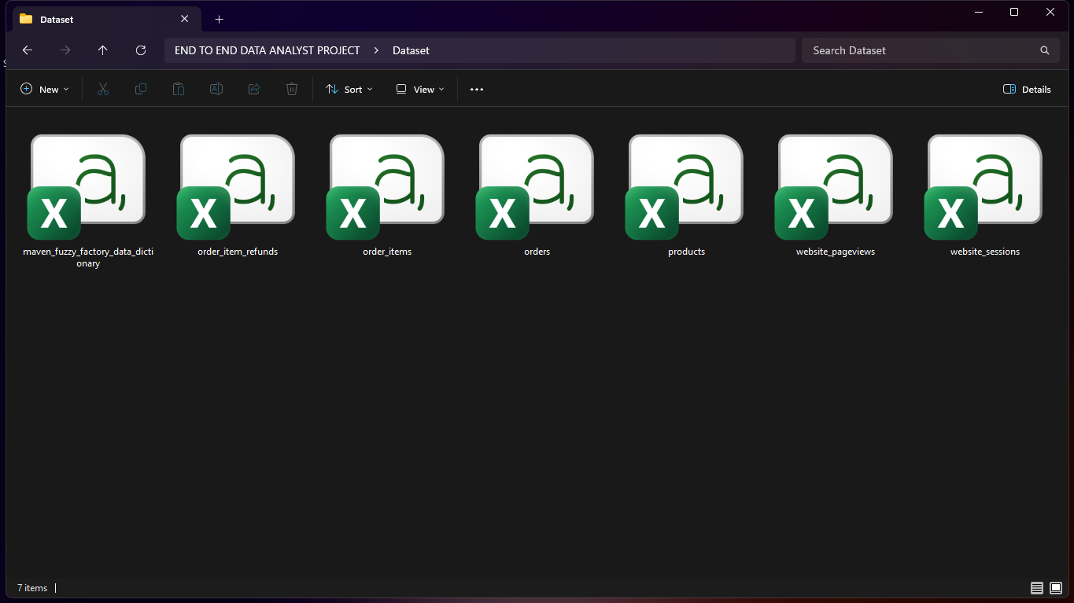
DATASET TO BE USED FOR ANALYSIS

Phase 2: IMPORTING THE DATA TO THE MS SQL SERVER AND CREATING A DATABASE FOR ANALYSIS
Objective
The objective of this phase was to create a SQL Server database, import the dataset, and prepare the environment for SQL analysis.
Activities Performed
- Created a new SQL Server database named MavenFuzzyFactory.
- Imported all six CSV files into SQL Server using SQL Server Management Studio (SSMS).
- Verified that each table was successfully imported.
- Ensured appropriate SQL Server data types were assigned during the import process.
- Confirmed that the imported tables were available for querying.
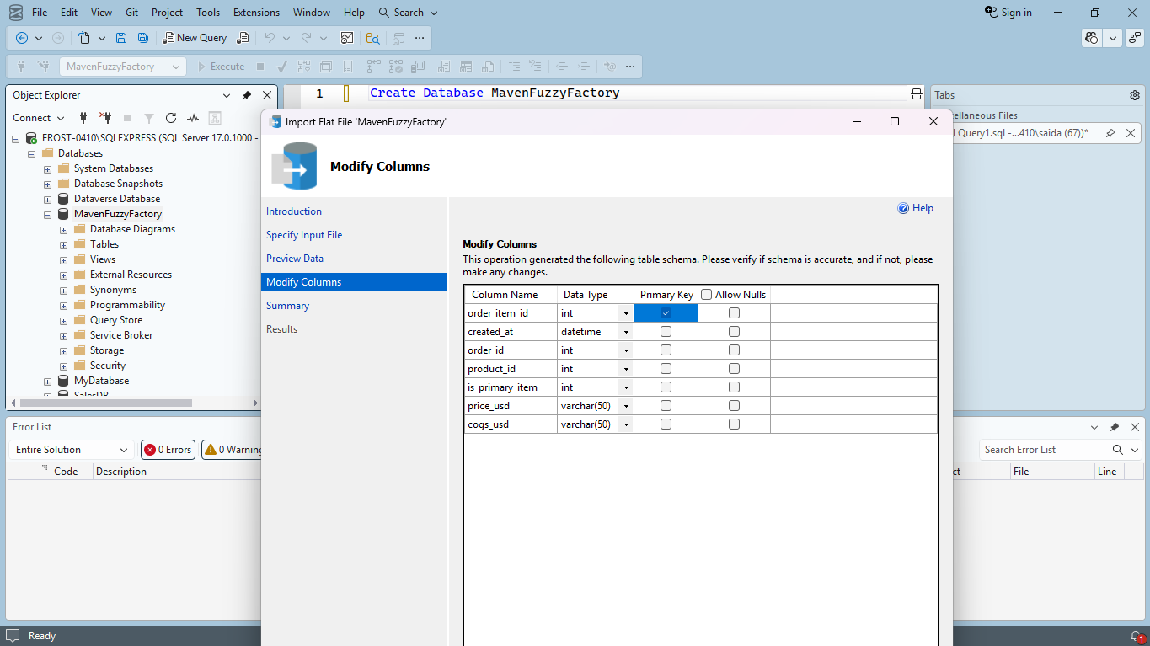
FILES BEING IMPORTED INTO THE SQL SERVER
Phase 3: DATA PROFILING
- Verify Row Count
- Inspect Sample Data
- Validate Primary Keys
- Check NULL Values
- Verify Data Types
- Validate Relationships
Observation:
All six tables were imported successfully into SQL Server and primary keys were unique and suitable for establishing relationships. Data types were correctly assigned during the import process. The relational structure of the database was successfully verified. The dataset appeared complete and suitable for exploratory data analysis and dashboard development.

Phase 4: EXPLORATORY DATA ANALYSIS:
- Order Table:
Total orders: 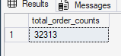 Total Revenue: 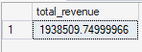
Total Gross Profit: 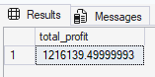 Avg order value: 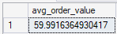
single order 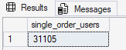 multiple orders: 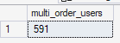
user segregation basis of order counts: 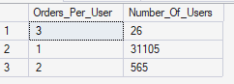
min and max order value: 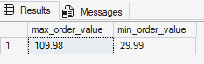
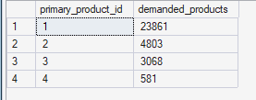
Month on month analysis:
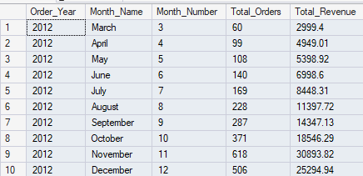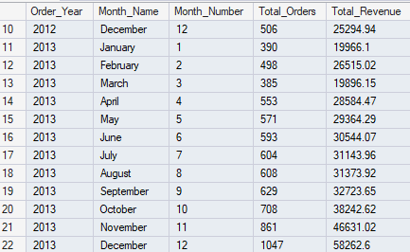
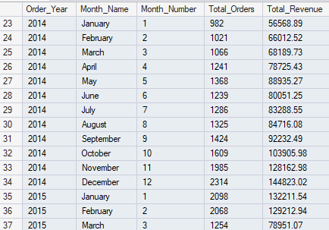
- Product Table:
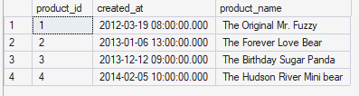

- Order Item Table:
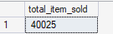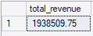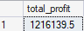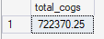
Revenue, cogs and profit same as that of order table
Product sold on demand: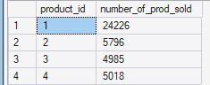
Product sold as primary: 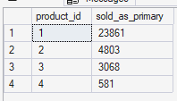
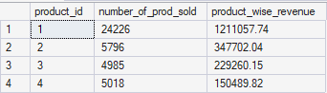
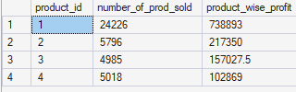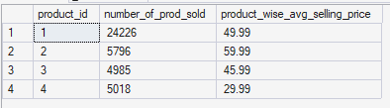

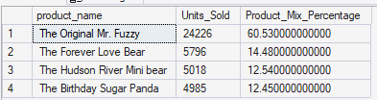

- Order Item Refunds Table:
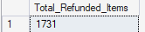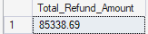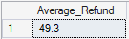
Refund trend:
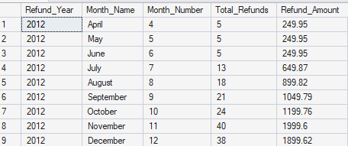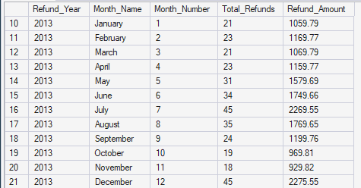
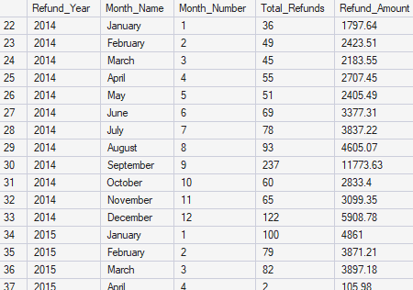
- Website session table:
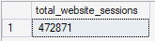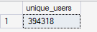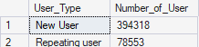

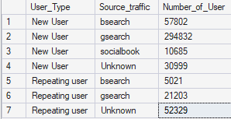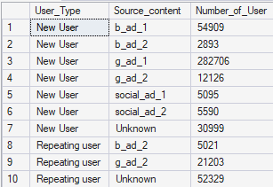
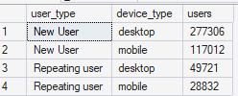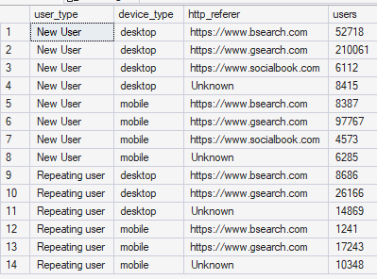
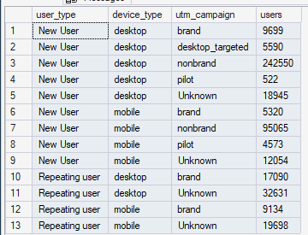
--month on month analysis
Pasting the code coz the row is too long
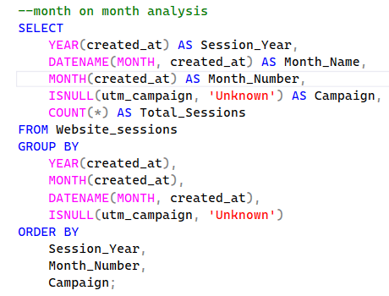

- Website pageview Table:
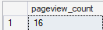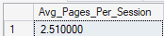
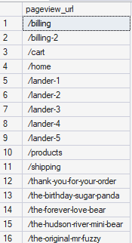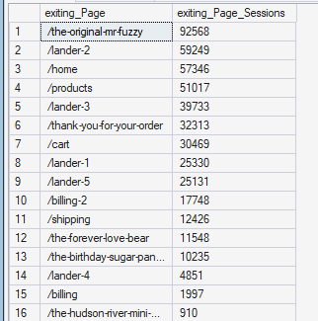
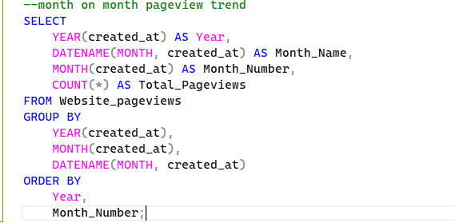
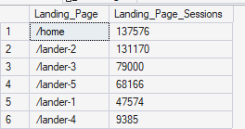

PHASE 5: BUISNESS RELATION ANALYSIS:
- Module 1 Customer Analytics:
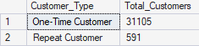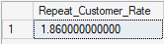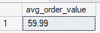
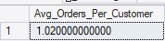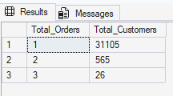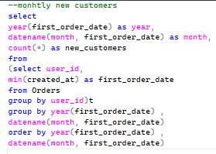
- Module 2 Sales Analytics:
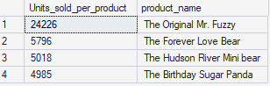
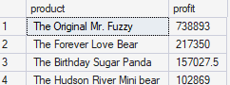
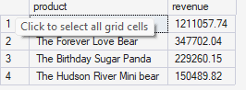
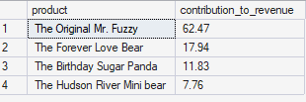
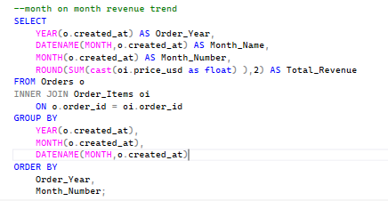
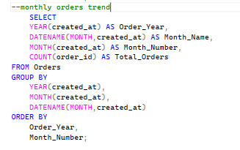
- Module 3 Refund Analysis:
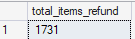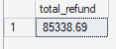
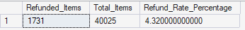
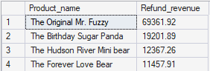
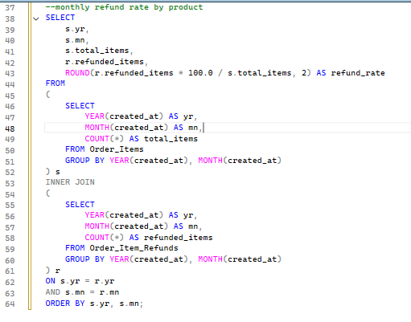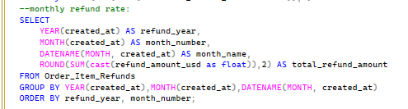

- Module 4: Website Analysis:
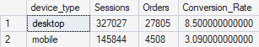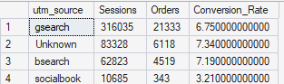
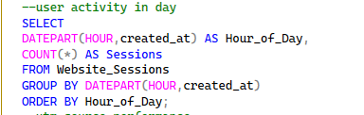
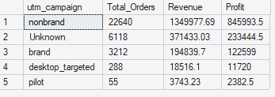
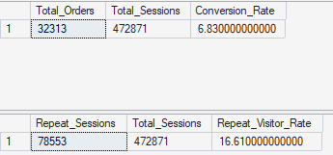
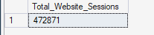

Data Modelling and Dashboard Designing:


