STATISTICAL BUSINESS ANALYSIS
Sales Data Statistical Analysis Report
Prepared by: Sanskruti Hande
Statistical analysis using Python, Pandas, SciPy, Matplotlib, Seaborn and Scikit-learn.
1. Executive Summary
This report presents a statistical analysis of a 100-record business sales dataset. The analysis covers descriptive statistics, distribution analysis, normality testing, correlation analysis, hypothesis testing, confidence intervals, regional comparisons, and linear regression. The objective is to understand sales behaviour and translate statistical results into practical business insights.
The average Total_Sales is ₹123,650.48 and the median is ₹97,955.50. A one-sample t-test indicates that the average sales value is statistically different from the ₹100,000 benchmark (p = 0.020172). Quantity and Price show positive relationships with Total_Sales, while the regional tests do not provide sufficient evidence of statistically significant differences at the 5% significance level.

2. Project Objectives
- Calculate descriptive statistics for key numerical business variables.
- Analyze variable distributions using histograms and density plots.
- Test normality using the Shapiro-Wilk test.
- Measure relationships using Pearson correlation.
- Perform at least three hypothesis tests.
- Calculate a 95% confidence interval and margin of error.
- Build a linear regression model for Price versus Total_Sales.
- Translate statistical findings into business insights and recommendations.

3. Dataset and Data Quality
The dataset contains 100 observations and 7 columns: Date, Product, Quantity, Price, Customer_ID, Region, and Total_Sales.
Data Quality Check | Result
Rows | 100
Columns | 7
Missing values | 0 across all columns
Duplicate rows | 0
Regions | East, North, South, West

4. Descriptive Statistics
Variable | Count | Mean | Std Dev | Min | 25% | Median | 75% | Max | Mode
Quantity | 100 | 4.78 | 2.5882 | 1 | 2.75 | 5.00 | 7.00 | 9 | 4
Price | 100 | 25,808.51 | 13,917.63 | 1,308 | 14,965.25 | 24,192 | 38,682.25 | 49,930 | 1,308
Total_Sales | 100 | 123,650.48 | 100,161.09 | 6,540 | 39,517.50 | 97,955.50 | 175,792.50 | 373,932 | 6,540
Interpretation: Total_Sales has substantial variability because its standard deviation (₹100,161.09) is large relative to its mean. The mean is higher than the median, indicating that higher-value transactions are influencing the average.

5. Distribution and Normality Analysis
Histograms and KDE plots were used to visually examine Quantity, Price, and Total_Sales. The Shapiro-Wilk test was then applied with α = 0.05. The null hypothesis states that the data follows a normal distribution.
Variable | Statistic | p-value | Conclusion
Quantity | 0.9304 | 0.0001 | Not normally distributed
Price | 0.9475 | 0.0006 | Not normally distributed
Total_Sales | 0.8989 | <0.0001 | Not normally distributed

6. Correlation Analysis
Pearson correlation was used to measure linear relationships among Quantity, Price, and Total_Sales.
Variable Pair | Pearson Correlation
Quantity vs Price | 0.01
Quantity vs Total_Sales | 0.6881
Price vs Total_Sales | 0.6461
Interpretation: Quantity and Price each have moderately strong positive linear relationships with Total_Sales. Quantity and Price themselves have almost no linear relationship (0.01). Correlation describes association and should not by itself be interpreted as proof of causation.

7. Hypothesis Testing

7.1 One-Sample t-Test
Question: Is the average Total_Sales different from ₹100,000? H₀: μ = ₹100,000. H₁: μ ≠ ₹100,000. The sample mean is ₹123,650.48, t = 2.3612, and p = 0.020172. Because p < 0.05, H₀ is rejected. The average Total_Sales is statistically different from the benchmark.

7.2 Independent Two-Sample Welch t-Test
Question: Is average Total_Sales different between North and South? North mean = ₹142,272.68; South mean = ₹138,438.96; t = 0.1299; p = 0.897152. Because p > 0.05, H₀ is not rejected. There is insufficient evidence of a statistically significant difference.

7.3 One-Way ANOVA
Question: Is average Total_Sales different among East, North, South, and West? F = 2.1644; p = 0.097237. Because p > 0.05, H₀ is not rejected. The observed regional differences are not statistically significant at the 5% level.

8. Regional Analysis
Region | Records | Mean Total_Sales | Std Dev
East | 19 | ₹132,612.58 | ₹77,107.09
North | 28 | ₹142,272.68 | ₹99,202.38
South | 27 | ₹138,438.96 | ₹118,423.996
West | 26 | ₹81,689.31 | ₹87,843.60

9. 95% Confidence Interval
The 95% confidence interval for the population mean Total_Sales is ₹103,776.35 to ₹143,524.61. The estimated margin of error is ₹19,874.13 and the standard error is ₹10,016.11. This interval provides a range of plausible values for the population mean under the assumptions of the interval estimation method.

10. Linear Regression
A simple linear regression was fitted with Price as the independent variable and Total_Sales as the dependent variable.
Regression equation: Total_Sales = 3,640.54 + (4.65 × Price)
The coefficient for Price is 4.65, indicating a positive fitted relationship. The R-squared value is 0.4175, meaning approximately 41.75% of the observed variation in Total_Sales is explained by Price in this simple linear model. The remaining variation is associated with other factors and random variation.

11. Business Insights
- Average sales are above the ₹100,000 benchmark and the difference is statistically significant.
- Quantity has a positive association with Total_Sales (r = 0.6881).
- Price has a positive association with Total_Sales (r = 0.6461).
- North has the highest observed average sales, while West has the lowest observed average, but ANOVA does not establish a statistically significant regional difference.
- The sales variables are not normally distributed according to the Shapiro-Wilk tests.
- Price alone provides moderate explanatory power in the regression model (R² = 0.4175).

12. Business Recommendations
- Track quantity and pricing together because both are positively associated with sales.
- Use statistical significance, not only observed regional averages, when making regional performance decisions.
- Investigate additional drivers such as product, discounts, customer behaviour, seasonality, and marketing expenditure when available.
- Consider multiple regression in future analysis to improve explanatory and predictive power.
- Continue monitoring high-value transactions because they materially affect the mean Total_Sales.

13. Visual Analysis
The following figures document the distribution, relationship, regional comparison, and regression analysis performed in the project.
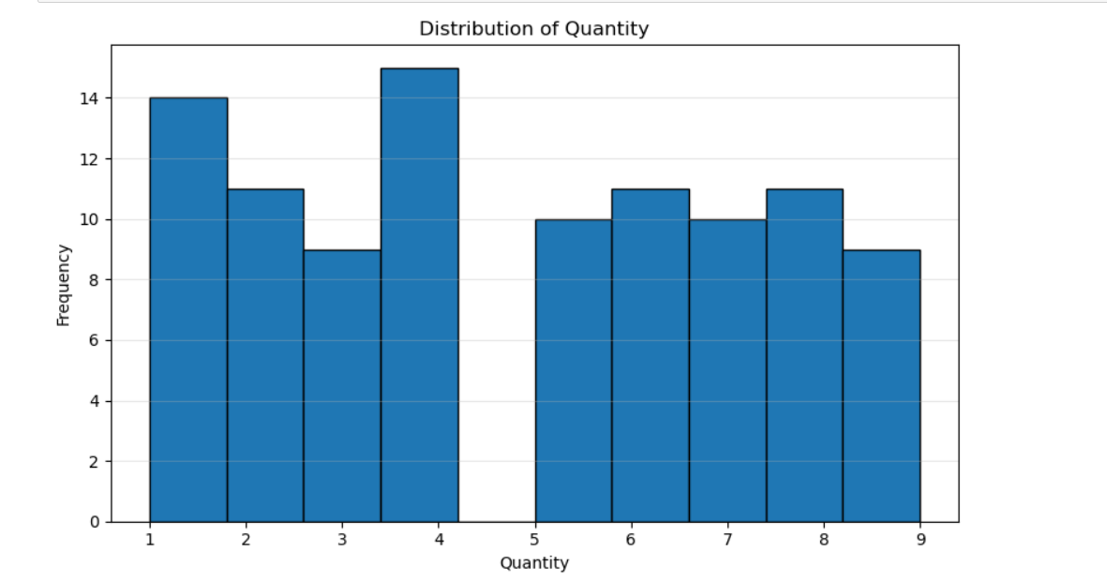
Figure 1: Distribution of Quantity
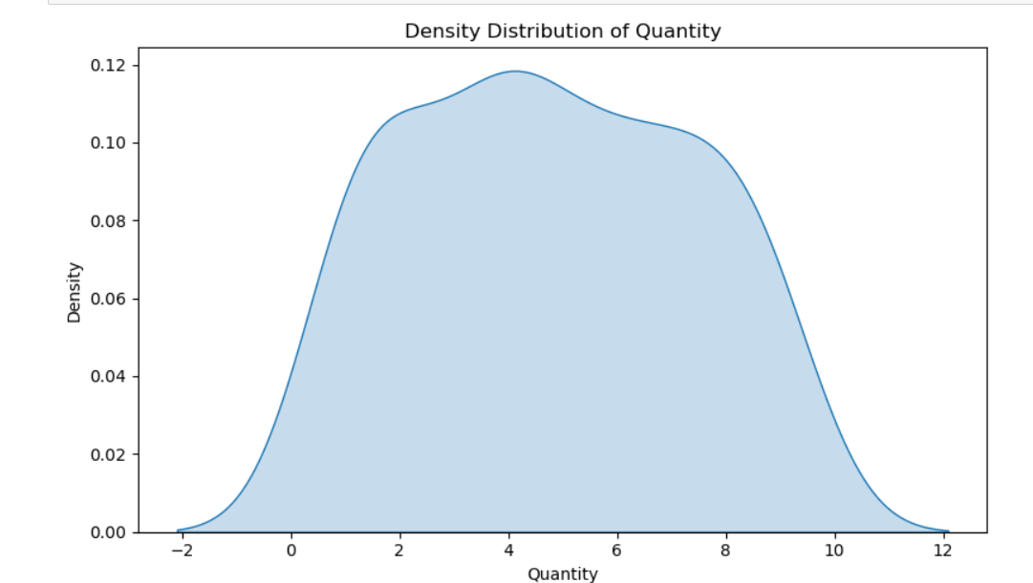
Figure 2: Density Distribution of Quantity

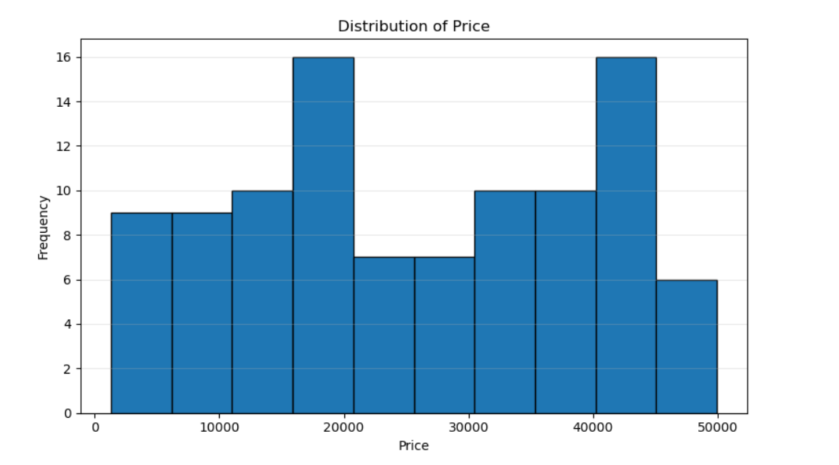
Figure 3: Distribution of Price
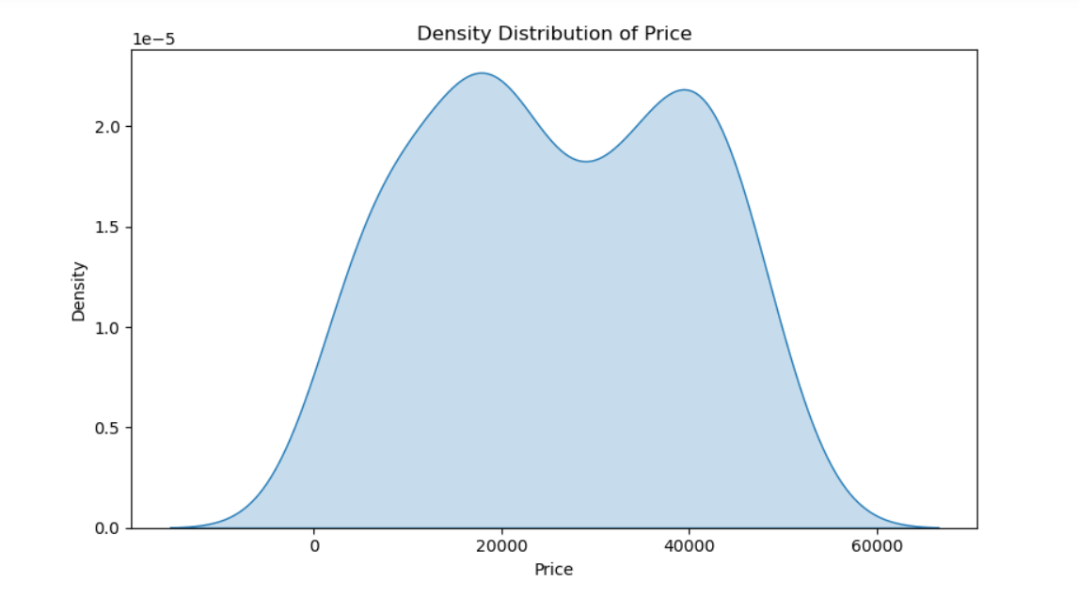
Figure 4: Density Distribution of Price

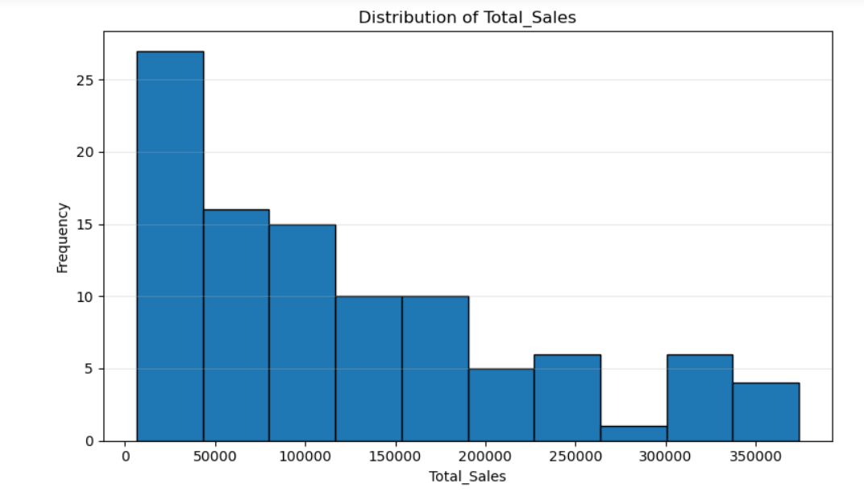
Figure 5: Distribution of Total Sales
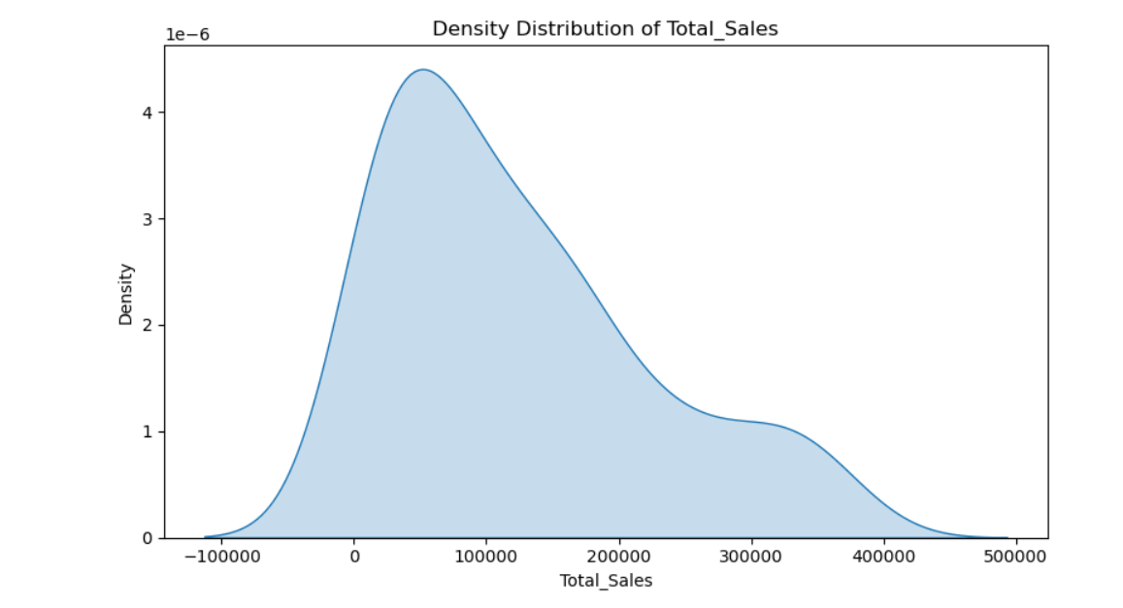
Figure 6: Density Distribution of Total Sales

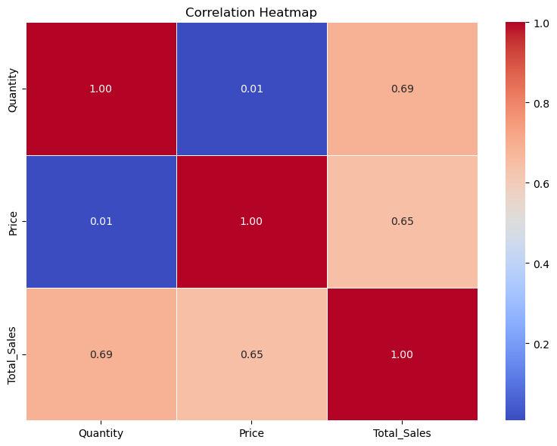
Figure 7: Correlation Heatmap
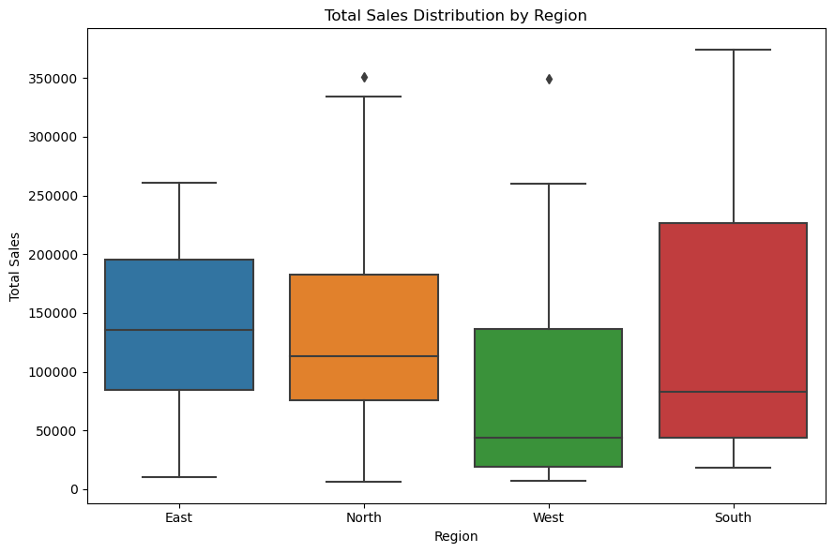
Figure 8: Total Sales Distribution by Region
S
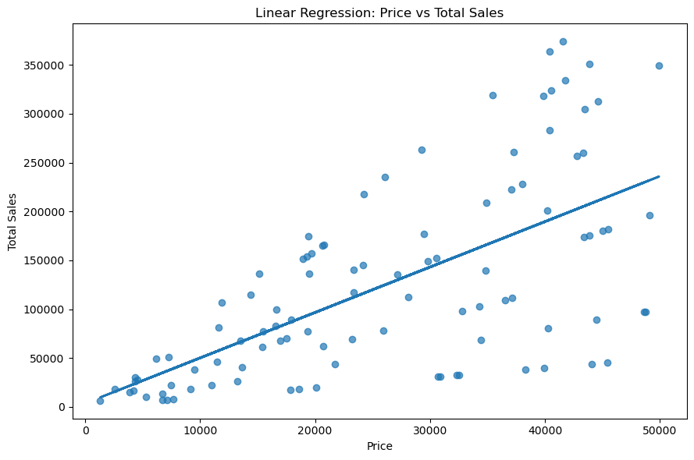
Figure 9: Linear Regression: Price vs Total Sales

14. Conclusion
This project demonstrates how statistical methods can be applied to business sales data. The analysis combines descriptive statistics, distribution analysis, correlation, hypothesis testing, confidence intervals, and regression to produce evidence-based findings. The results show meaningful positive associations between Quantity, Price, and Total_Sales, while the regional comparisons do not reach statistical significance at α = 0.05. Future analysis should incorporate more explanatory variables and a larger dataset to strengthen business decision-making.

