METALMAN AUTO ENGINEER
Functional & Technical Architecture Document
NPD & PPAP Engineering Documentation Automation Platform

Prepared: 19 July 2026 | Version 1.0 | Repository: metalman-auto-engineer

Table of Contents
1. Executive Summary & Objective
2. Scope
3. Technology Stack
3.1 Backend Stack
3.2 Frontend Stack
4. System Architecture
5. End-to-End Functional Flow
6. Backend — Component Details
6.1 Application Entry Point
6.2 API Endpoints
6.3 Document Generator Services
6.4 Utility Modules
6.5 Data Model & Authentication
6.6 Configuration / Environment Variables
7. Frontend — Component Details
7.1 Pages & Routes
7.2 Key Reusable Components
7.3 API Integration Layer
7.4 Authentication Flow
7.5 State Management
8. Deployment & Infrastructure
9. File Storage & Retention Policy
10. External Dependencies Summary
11. Observations, Risks & Recommendations
12. Glossary

1. Executive Summary & Objective
Metalman Auto Engineer is a full-stack engineering-documentation automation platform built for Metalman Auto Pvt. Ltd., an automotive sheet-metal/assembly manufacturer. Its purpose is to eliminate the manual, error-prone process of producing New Product Development (NPD) and Production Part Approval Process (PPAP) documentation by generating a complete set of production-ready engineering Excel documents automatically from two source inputs: a 3D CAD assembly (STEP file) and a structured "Feasibility Matrix" Excel workbook.
From those two inputs, the system produces up to seven standardised engineering documents in one automated run: the Bill of Materials (BOM), Process Flow Diagram (PFD), Tooling Master List, Part Fitment Checksheet, Process FMEA (PFMEA), Control Plan, and Fixture PM (Preventive Maintenance) Master Plan — each populated with the correct part data, process steps, and even auto-extracted reference photographs cropped directly from the engineering drawings using computer vision and AI.

Objectives
- Remove manual, repetitive Excel drafting for NPD/PPAP documentation.
- Guarantee consistency of part identity (part number, part name/description) across every generated document.
- Provide a single web-based workflow: upload CAD + feasibility data → track live progress → download/preview/correct results.
- Automate CAD-to-image and CAD-to-3D-preview conversion so engineers do not need desktop CAD software to review a submission.
- Support flexible, swappable AI vision providers (local Ollama or cloud Gemini) so the tool works both offline in a dev environment and in a cloud deployment.

2. Scope
This document describes the current state of the codebase in the metalman-auto-engineer repository as of the most recent inspection. It covers the backend API service, the frontend single-page application, the document-generation pipeline, data storage, authentication, third-party/AI integrations, and the deployment options currently configured in the repository. It is intended for engineering, DevOps, and product stakeholders who need a working understanding of how the system is built and how its pieces fit together.

3. Technology Stack

3.1 Backend Stack
The backend is a Python 3.10 FastAPI service. Key libraries and their role in this codebase:
Library | Role in this application
FastAPI + Uvicorn | Core web framework and ASGI server; all HTTP endpoints and the app bootstrap (main.py).
SQLAlchemy | ORM for the authentication database (users, roles, permissions).
Pydantic | Request/response validation models used by FastAPI.
passlib[bcrypt] / python-jose | Password hashing (pbkdf2_sha256) and JWT issuance/validation for login.
pandas | Reads the Feasibility Matrix Excel workbook — the primary structured input parsed by nearly every generator.
openpyxl | Primary Excel engine: cloning templates, writing cells, styling, merges, and embedding images into every generated workbook.
cadquery 2.7.0 (+ OCP) | CAD kernel: imports STEP assemblies, exports STL for the 3D viewer, and traverses STEP part-trees for per-stage PFD renders.
PyMuPDF (fitz) | Rasterises PDF engineering drawings to images so isometric views can be located and cropped.
OpenCV (opencv-python-headless) + NumPy | Contour-based image cleanup: isolates a part's silhouette and strips dimension lines/text from a cropped drawing region.
Pillow | Image drawing/cropping, including the AI-vision grid overlay used to guide isometric-view detection.
openai (SDK) | Used purely as an OpenAI-compatible HTTP client pointed at a local or cloud Ollama endpoint (not OpenAI's own API).
google-generativeai | Alternate cloud vision-AI backend (Gemini) selectable via configuration.
python-dotenv | Loads .env configuration values.
pywin32 (Windows only) | Optional Excel COM automation for high-fidelity Excel→PDF preview and "open in Excel" editing.
Celery + Redis | Declared as the intended async task-queue backend but currently stubbed out (MockCelery); the real pipeline runs via FastAPI BackgroundTasks instead.

3.2 Frontend Stack
The frontend is a TypeScript + React single-page application scaffolded from a shadcn/ui + Vite starter template.
Library | Role in this application
React 18 + TypeScript | Core UI framework and type system.
Vite (+ SWC plugin) | Development server and production bundler.
react-router-dom | Client-side routing across all 7 pages.
Radix UI + shadcn/ui pattern | ~35 accessible, unstyled UI primitives (dialog, table, sidebar, tabs, etc.) styled via Tailwind.
Tailwind CSS + class-variance-authority | Utility-first styling and design-token-based theming.
@tanstack/react-query | Installed and wired via a QueryClientProvider, but not currently used by any page for data fetching.
axios / native fetch | HTTP calls to the backend; most calls use a custom fetchWithRetry helper with exponential backoff for cold-start resilience.
three.js + @react-three/fiber + drei | Renders an interactive, auto-rotating 3D STL preview of the generated CAD part.
pdfjs-dist | Client-side PDF rendering for the drawing-cropping tool.
react-hook-form + zod (+ resolvers) | Present as shadcn boilerplate but not actively used — current forms (Login, Correction) use plain useState.
sonner / shadcn toast | Toast notifications for success, error, and retry states.
vitest + Testing Library | Unit/component test tooling.

4. System Architecture
The system follows a classic three-tier web architecture: a React single-page application served by Nginx, a stateless-per-request FastAPI backend that runs the document-generation pipeline as background jobs, and a persistent data layer combining a small SQLite database (authentication only) with flat-file JSON task state and a file-system store for uploads and generated documents. An external, swappable AI vision provider is called once per pipeline run to assist with locating reference images inside engineering drawings.
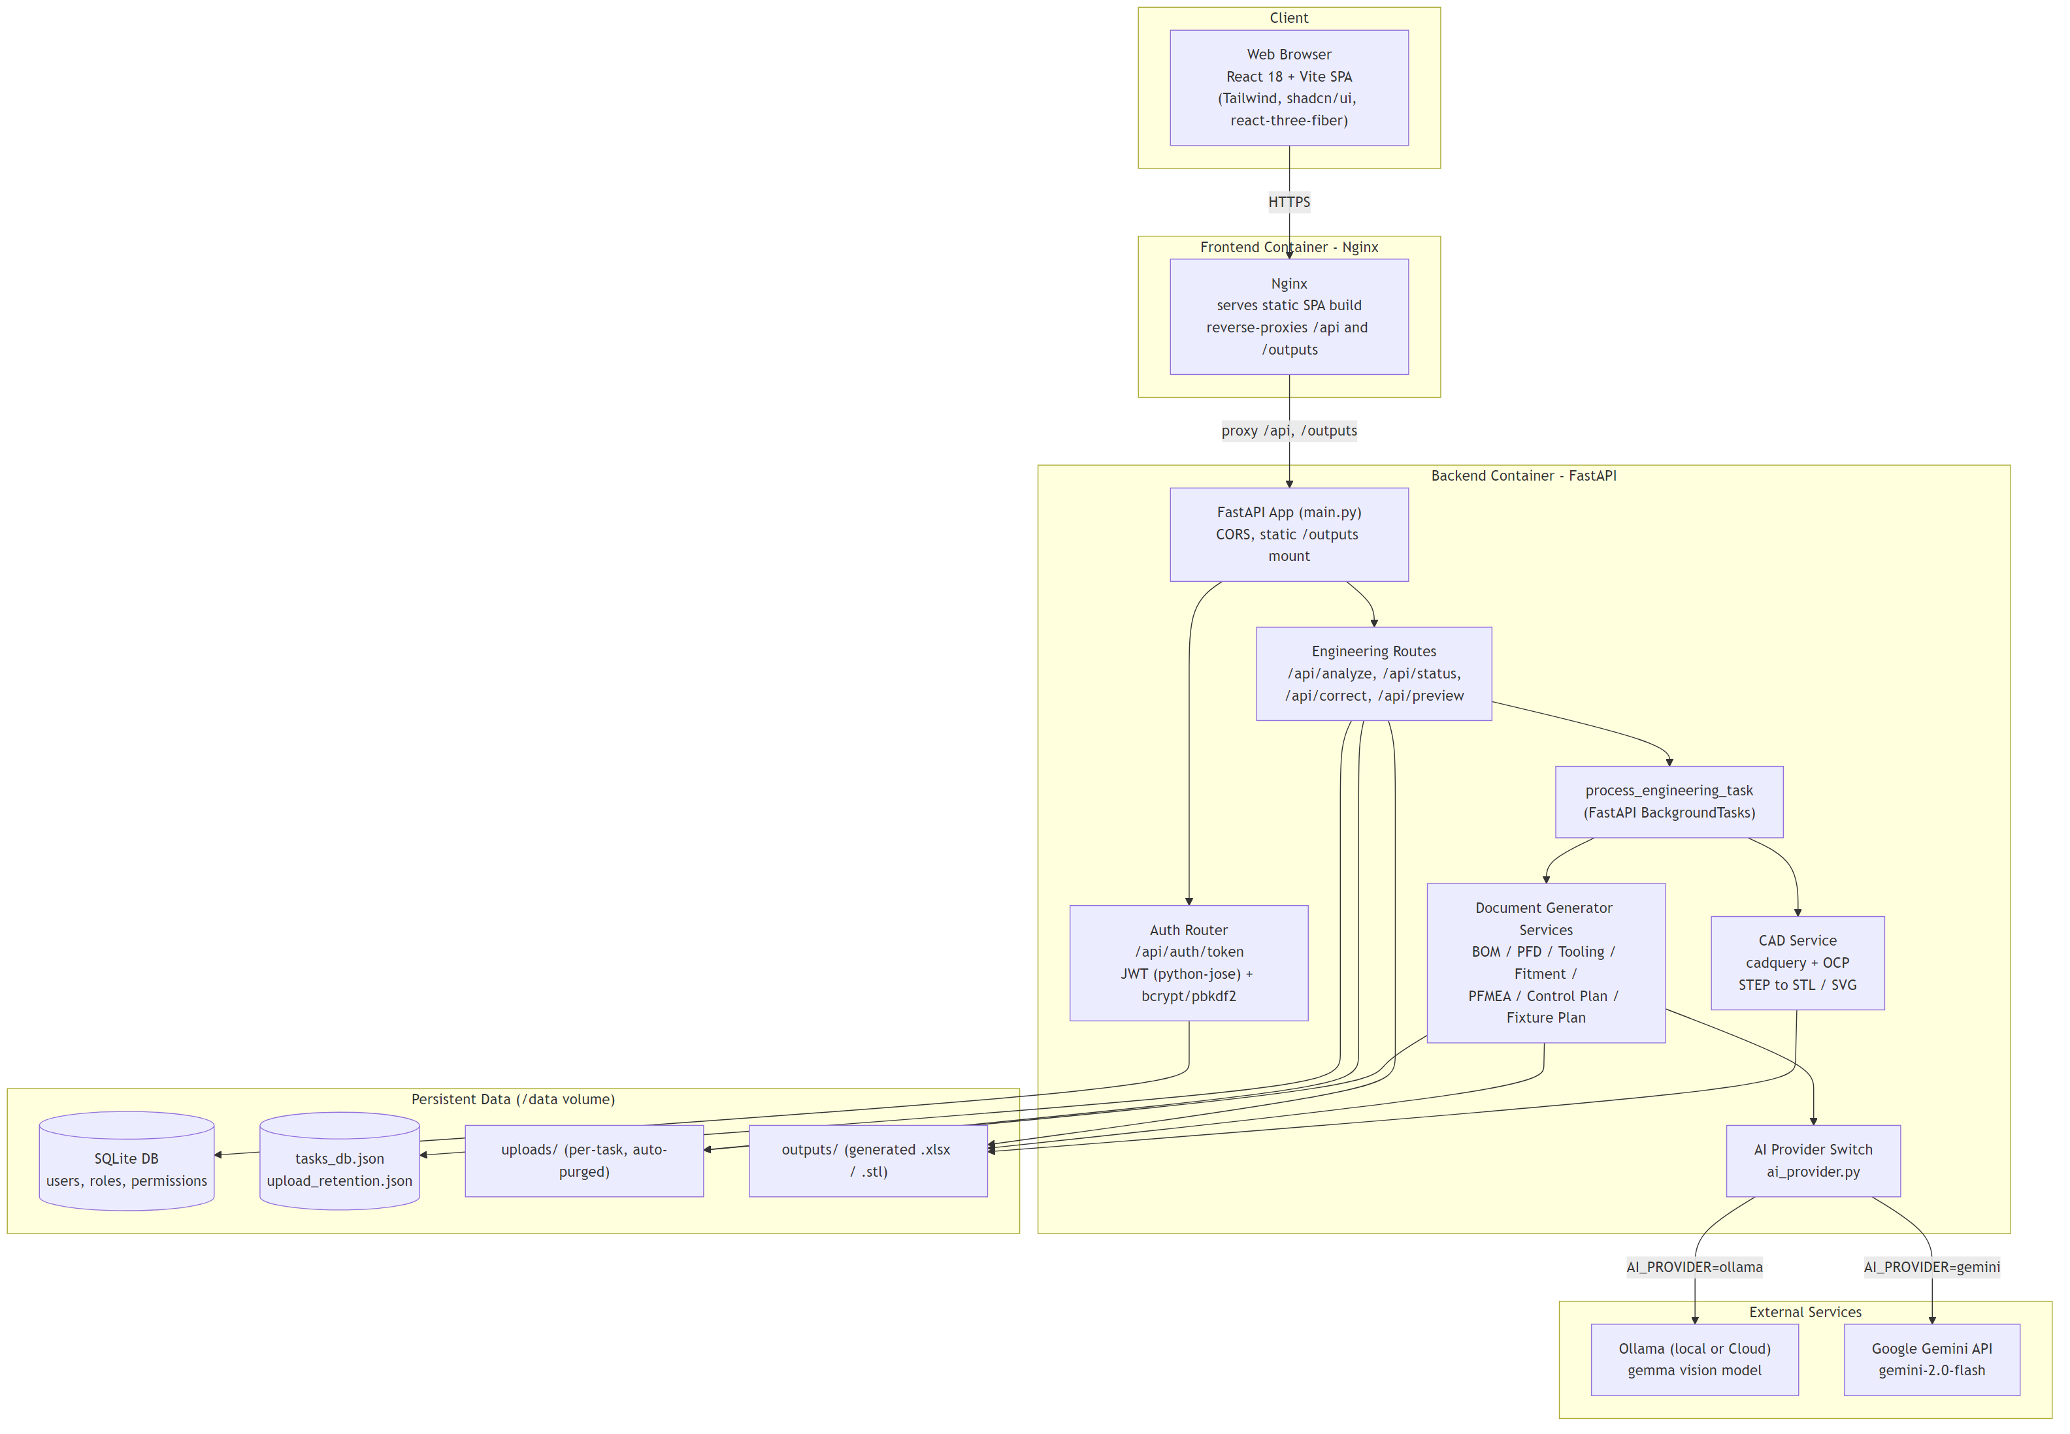
Figure 1 — System architecture: client, containers, persistent data, and external AI services.

In containerised deployments, the frontend and backend run as two separate Docker containers behind an Nginx reverse proxy that also serves the built React bundle; all state that must survive a restart (uploads, generated outputs, the SQLite database, and task-tracking JSON files) lives under a single mounted /data volume owned by the backend container.

5. End-to-End Functional Flow
The core user journey is: log in, upload a CAD assembly and feasibility spreadsheet, choose which documents to generate, and watch a live progress view while the backend works through an eight-step generation pipeline in the background. Figure 2 shows this flow end to end.
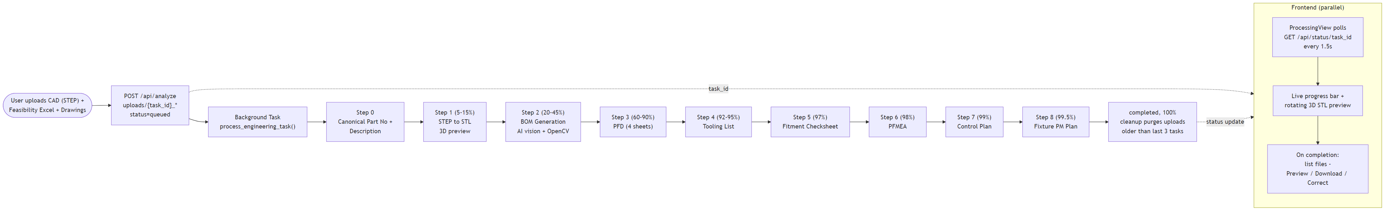
Figure 2 — The 8-step document-generation pipeline (process_engineering_task) and frontend polling loop.

Pipeline detail
Step | What happens | Output
0 | Canonical part number and part description are extracted once from the feasibility file and reused by every downstream generator, guaranteeing every document reports the same part identity. | —
1 | The uploaded STEP assembly is tessellated to STL via CadQuery for the browser 3D viewer. | model_{part_no}.stl
2 | BOM rows are parsed from the feasibility sheet; for each part, its isometric view is located inside the matching drawing PDF (text search → heuristic → AI vision fallback) and cleaned up with OpenCV before being embedded. | BOM_Result_{part_no}.xlsx
3 | Four Process Flow Diagram sheets are rendered (Sub-Assembly Index, Sub-Assembly Flow, Sheetmetal Flow, BOP List), including per-stage CAD renders. | PFD_Result_{part_no}.xlsx
4 | Fixture/tooling photos embedded in the feasibility workbook are matched to their fixture records and compiled into a master tooling list. | Tooling_List_{part_no}.xlsx
5 | The Part Fitment Checksheet is generated, reusing part photos already extracted in Step 2. | Fitment_Checksheet_{part_no}.xlsx
6 | Process FMEA sheets are generated for Assembly, Sheet Metal, and BOP parts using JSON failure-mode dictionaries. | PFMEA_Result_{part_no}.xlsx
7 | The Control Plan is generated across 4 sheets, cross-referencing the already-generated PFD output for operation sequencing. | Control_Plan_{part_no}.xlsx
8 | The Fixture PM Master Plan is generated from feasibility fixture records. | Fixture_Plan_{part_no}.xlsx

Every step updates a shared in-memory task record (persisted to tasks_db.json after each write) with a status, a progress percentage, a human-readable message, and the growing list of completed output files. The frontend polls GET /api/status/{task_id} every 1.5 seconds to drive a live progress bar and reveal the rotating 3D preview as soon as the STL is ready. Once complete, the user can preview each document (rendered as PDF or an HTML data view), download it, or open the bulk-correction tool to fix specific cells without regenerating the whole document.

6. Backend — Component Details

6.1 Application Entry Point (main.py)
- Configures logging so pipeline progress prints are flushed immediately to the terminal/log stream.
- Creates the SQLite schema on startup and idempotently seeds two roles (Admin, Engineer) and two demo user accounts.
- Applies a permissive CORS policy (flagged in-code as needing tightening before production).
- Mounts the auth router at /api/auth and the engineering routes at /api.
- Serves generated files as static content at /outputs and a set of static demo pages at /stitch-demo.
- In local/dev mode, auto-selects a free port and writes it into the frontend's .env.development.local so the Vite dev server always points at the right backend port.

6.2 API Endpoints
Method & Path | Purpose
POST /api/auth/token | Login (OAuth2 password flow). Verifies credentials, returns a signed JWT plus user info.
POST /api/analyze | Main pipeline trigger. Accepts CAD file, feasibility file, drawings, and requested-output flags; schedules the background generation job and returns a task_id immediately.
GET /api/status/{task_id} | Polls current pipeline status, progress %, message, 3D preview URL, and completed file list.
POST /api/correct | Applies a batch of user-submitted cell-level corrections to already-generated documents.
GET /api/preview/{filename} | Returns a rendered preview (PDF via Excel COM automation on Windows, or an HTML data view fallback on Linux) of a generated document.
POST /api/edit/{filename} | Opens a generated file directly in desktop Excel (Windows-only).
POST /api/save-crop | Manual drawing-cropper tool: saves a user-selected crop into the working Welding Check Sheet.
POST /api/welding/set-reference-image | Auto-locates and inserts a drawing's reference isometric view into the Welding Check Sheet.
GET /api/download-excel / POST /api/reset-excel | Download or reset the in-progress Welding Check Sheet working file.
GET /api/demo-folders | Lists available prototype UI demo modules for the Stitch Demo page.

Observation: None of the engineering endpoints (/api/analyze, /api/status, /api/correct, etc.) currently enforce authentication, even though a full JWT/role-based auth system exists and is used for login. See Section 11 for details.

6.3 Document Generator Services (backend/services/)
Module | Produces | Notable technique
bom_generator.py | Bill of Materials with embedded reference photos | Multi-tier isometric-view detection: caption text search → ink-blob heuristic → AI vision fallback on a labelled grid overlay, followed by OpenCV-based silhouette cleanup.
pfd_renderer.py | 4-sheet Process Flow Diagram | Two alternate STEP sub-assembly extraction paths — a pure-Python OCP/OpenCascade tree traversal, and an optional Windows-only FreeCAD subprocess fallback — feeding CadQuery-rendered per-stage images.
tooling_generator.py | Tooling / Fixture Master List | Fuzzy row-offset search to correctly associate loosely-anchored embedded photos with their Fixture No.
fitment_generator.py | Part Fitment Checksheet | Precise EMU/pixel-based image placement so photos are exactly centred within template cells; reuses part images already extracted for the BOM.
pfmea_generator.py | Process FMEA (3 sheets) | Builds a fresh workbook and populates it from JSON failure-mode dictionaries keyed by normalised process-function name.
control_plan_generator.py | Control Plan (4 sheets) | "Transfuse" pattern: clones header/column/footer structure from the template into a new workbook with precise row-offset shifting; cross-references the already-generated PFD output.
fixture_plan_generator.py | Fixture PM Master Plan | Same template-transfuse approach as the Control Plan, with a style baseline copied from a template data row.
cad_service.py | STL export for the 3D viewer | CadQuery import/export with tessellation tolerances tuned for thin sheet-metal features.
ai_provider.py | Shared vision-AI abstraction | Provider switch (Ollama vs. Gemini) behind one function, get_vision_completion(), so calling code is provider-agnostic.
correction_service.py | Applies bulk cell corrections | Maps a logical document type + column convention to the correct output file and worksheet before writing values directly.

Observation: Three additional service files exist (feasibility_parser.py, tooling_extractor.py, cad_slicer.py) but are not called anywhere in the active pipeline — they appear to be superseded early drafts or placeholder stubs. See Section 11.

6.4 Utility Modules (backend/utils/)
Module | Purpose
image_utils.py | Aspect-preserving image scaling, whitespace trimming, and pixel-accurate centred image placement into Excel cells (correctly accounting for merged ranges).
part_info.py | The single canonical source of part number/description used across every generator, plus a helper that extracts a trailing customer/program code (e.g. "952-NX") from a part description.
file_handler.py | Generic upload-save and temp-file cleanup helpers (largely superseded by inline logic in routes.py).

6.5 Data Model & Authentication
The only relational data in the system is the authentication schema, managed by SQLAlchemy against a SQLite database by default (overridable via DATABASE_URL to any SQLAlchemy-supported engine).
Table | Key Fields | Relationships
users | id, username, email (unique), hashed_password, role_id | Many-to-one → roles
roles | id, name (unique) | One-to-many ← users; many-to-many ↔ permissions
permissions | id, name (unique) | Many-to-many ↔ roles
role_permissions | role_id, permission_id | Association table

Authentication uses the OAuth2 password flow: POST /api/auth/token verifies the submitted email/password against passlib pbkdf2_sha256 hashes and returns an HS256 JWT (8-hour expiry) embedding the user's email and role. Two roles are seeded at startup — Admin and Engineer — each with a demo account. A get_current_user dependency and a check_role() factory exist for enforcing authentication/authorisation on routes, but per Section 6.2, they are not yet applied to the pipeline endpoints.
The engineering pipeline itself has no SQL-backed model — task state (status, progress, output file list) lives in a flat tasks_db.json file, and upload retention state lives in upload_retention.json, both managed directly by routes.py.

6.6 Configuration / Environment Variables
Variable | Purpose | Default
DATABASE_URL | SQLAlchemy connection string for the auth database. | sqlite:///./metalman.db
JWT_SECRET_KEY | Signing secret for issued JWTs — must be overridden in production. | hardcoded dev value
AI_PROVIDER | Selects the vision-AI backend: "ollama" or "gemini". | ollama
OLLAMA_BASE_URL / OLLAMA_API_KEY / OLLAMA_VISION_MODEL | Ollama (local or Cloud) connection details. | localhost:11434/v1, "ollama", gemma4:31b-cloud
GEMINI_API_KEY / GEMINI_VISION_MODEL | Google Gemini connection details (required only if AI_PROVIDER=gemini). | unset / gemini-2.0-flash
PORT | Dev-server port seed (auto free-port discovery). | 8001

7. Frontend — Component Details

7.1 Pages & Routes
Route | Page | Purpose
/ | Index.tsx | Public marketing/landing page with feature highlights and a call-to-action into login.
/login | Login.tsx | Login form; stores the returned JWT and user info, with resilience UX for a cold-starting backend.
/dashboard (protected) | Dashboard.tsx | Core workflow page: upload CAD + feasibility + drawings, choose output documents, launch the pipeline.
/correction (protected) | Correction.tsx | Post-generation bulk cell-correction tool for a given task's documents.
/cropper (protected) | Cropper.tsx | Standalone PDF viewer/cropping tool for manually extracting reference views from drawings.
/stitch (protected) | StitchDemo.tsx | Lists and renders prototype UI modules (design-preview shell, not fully wired into the main app).
* (catch-all) | NotFound.tsx | 404 page.

All routes except / and /login are wrapped in a ProtectedRoute guard that redirects unauthenticated users to /login.

7.2 Key Reusable Components
Component | Description
UploadZone | Drag-and-drop / click-to-browse file upload widget, reused for the CAD file, feasibility file, and drawings.
ProcessingView | The live job-progress screen: polls task status, shows a staged progress bar, streams the 3D STL preview, and lists results on completion.
CADWireframe | A react-three-fiber canvas that loads, auto-centres, auto-fits, and slowly rotates the generated STL mesh.
ExcelPreviewModal | Modal dialog that iframes a server-rendered document preview with download / "edit in Excel" actions.
PdfCropper | Full PDF viewer and rectangular-selection cropping tool with zoom, high-resolution capture, and direct upload of crops to the backend.
ProtectedRoute | Route guard reading auth state and optionally restricting access by role.
Logo | Shared Metalman brand mark used across all authenticated and public pages.

7.3 API Integration Layer
There is no centralised Axios instance or interceptor layer. The API base URL is resolved once from the Vite env var VITE_API_URL (empty string in the Docker/Nginx deployment, so requests stay relative and are proxied by Nginx). Most calls go through a custom fetchWithRetry() helper that adds exponential-backoff retries on network failure and on HTTP 502/503/504 — purpose-built to ride out free-tier hosting "cold start" delays and surface retry attempts to the user via toast notifications.
Main calls: login, start pipeline (/api/analyze), poll status, download/preview/edit generated files, submit bulk corrections, and the drawing-cropper endpoints.

7.4 Authentication Flow
- Login posts credentials to POST /api/auth/token; on success the JWT and user object are persisted to localStorage by a custom useAuth() hook.
- ProtectedRoute reads authentication state from that hook to gate protected pages.
- There is no shared React Context for auth — every component calling useAuth() independently re-reads localStorage.
Observation: The stored JWT is never attached as an Authorization header to any subsequent API call. Combined with the backend not enforcing auth on the pipeline endpoints (Section 6.2), authentication currently gates frontend page access only, not the API itself.

7.5 State Management
There is no global store (no Redux/Zustand/app-wide Context). State is deliberately local: each page owns its own useState for file selections, form fields, and job progress. @tanstack/react-query is installed and its provider wraps the app, but no page currently uses useQuery/useMutation — it appears to be unused starter-template scaffolding available for future adoption.

8. Deployment & Infrastructure
Three deployment topologies are configured side by side in the repository, giving the team flexibility in choice of hosting provider.
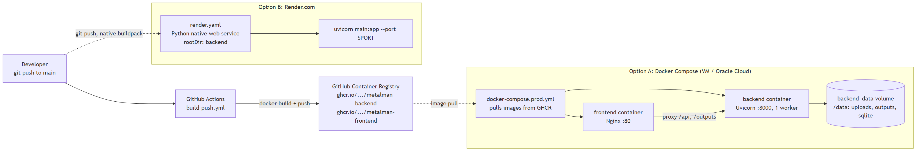
Figure 3 — CI image pipeline and the two supported deployment topologies.

Topology | Mechanism | Notes
Docker Compose (VM / Oracle Cloud) | docker-compose.prod.yml pulls prebuilt images from GitHub Container Registry, published by .github/workflows/build-push.yml on every push to main. | Recommended for a persistent VM. Nginx (frontend container) is the single public-facing reverse proxy; only port 80 needs to be opened. Persistent data lives on a named backend_data volume mounted at /data.
Render.com | render.yaml configures a native Python web service for the backend only (rootDir: backend, pip install + uvicorn start command). | No frontend service is declared in render.yaml — the React app needs a separate static hosting target. No persistent disk is declared, so uploads/outputs/DB fall back to the ephemeral container filesystem unless a Render Disk is attached.
Local development | Backend run directly via its own virtual environment (uvicorn main.py); frontend via npm run dev (Vite). | The backend auto-writes the frontend's .env.development.local with its resolved port on every local start.

The single most important deployment decision is the AI_PROVIDER setting: Ollama Cloud is typically not reachable from a bare VM or Render instance, so cloud deployments should set AI_PROVIDER=gemini with a valid GEMINI_API_KEY. The backend container is also intentionally pinned to a single Uvicorn worker, because pipeline task state is held in an in-process Python dictionary — running multiple workers would give each one an inconsistent view of task progress.

9. File Storage & Retention Policy
Uploads and generated outputs share a base directory resolved once at startup: /data if that path exists (true inside containers, where it is a mounted volume), otherwise the local backend/ folder. Uploaded files are namespaced per task (e.g. {task_id}_{filename}), and generated documents are named by document type and part number (e.g. BOM_Result_92187158.xlsx).
A retention mechanism automatically deletes the raw uploaded CAD/feasibility/drawing files for a task once three newer tasks have completed (nothing downstream reads uploads after generation finishes), keeping disk usage bounded without a scheduled cron job — cleanup runs inline as part of the pipeline's completion step. Generated output documents are not subject to this cleanup and persist until manually removed.

10. External Dependencies Summary
- AI vision provider — one of: self-hosted/local Ollama, Ollama Cloud, or Google Gemini (selected via AI_PROVIDER); required only for the isometric-view extraction step of BOM generation.
- Database — SQLite by default, overridable to any SQLAlchemy-supported engine.
- CAD geometry engine — CadQuery/OCP (bundled Python package, no external service, but requires Linux system libraries in the container image).
- FreeCAD (FreeCADCmd.exe) — optional, Windows-only local development fallback; not used in any Linux-based deployment target.
- Microsoft Excel (via pywin32 COM automation) — optional, Windows-only, used for high-fidelity preview/edit; gracefully falls back on Linux.
- GitHub Container Registry — image registry used by the CI pipeline and the Docker Compose production deployment.
- Hosting platform — Render.com, or any Docker-capable VM (e.g. Oracle Cloud).

11. Observations, Risks & Recommendations
The following points were noted during this review as worth the team's attention. None of these are blockers to normal single-user/demo operation, but they matter for scaling, security hardening, or long-term maintainability.

11.1 Security
- The JWT/role-based auth system is fully implemented (login, token issuance, get_current_user, check_role) but not enforced on any of the engineering pipeline endpoints (/api/analyze, /api/status, /api/correct, /api/preview, /api/edit). Anyone who can reach the API can trigger generation and download results without logging in.
- The frontend never attaches the stored JWT as an Authorization header to any request, so even adding auth checks to the backend today would immediately break the current frontend calls — both sides need to be updated together.
- CORS is currently wide open (allow_origins=["*"]) — flagged in-code as a placeholder that should be tightened to the real frontend origin(s) before production exposure.
- The JWT signing secret and default seeded passwords (admin123, password123) fall back to hardcoded values if not overridden by environment variables — these must be set explicitly in any real deployment.

11.2 Scalability & Concurrency
- The backend is pinned to a single Uvicorn worker because task progress is tracked in an in-process Python dictionary. This caps the service to processing pipeline runs one at a time in the current architecture.
- Celery and Redis are declared as dependencies for background task processing but are currently mocked out (MockCelery no-op decorator); the real pipeline runs via FastAPI's BackgroundTasks. Wiring up a real task queue would be the natural next step to support multiple concurrent users and horizontal scaling.

11.3 Dead / Vestigial Code
- backend/services/feasibility_parser.py, tooling_extractor.py, and cad_slicer.py are not called anywhere in the active pipeline — they look like early drafts or placeholder stubs superseded by the real logic in the per-document generators.
- The xlsx2html dependency is imported but effectively unused — the live preview fallback path builds its own HTML table with pandas instead.
- react-hook-form, zod, and its resolvers are declared as frontend dependencies but the only usage is inside the generic (unused) shadcn form.tsx primitive; both current forms (Login, Correction) manage state with plain useState.
- @tanstack/react-query is wired up app-wide via a provider but not used by any page for data fetching yet.

11.4 Deployment Configuration Gaps
- render.yaml only declares a backend service — there is no matching frontend deployment configuration for Render, so a Render-only deployment currently needs a separately configured static hosting target for the React app.
- render.yaml does not declare a persistent disk, so uploads/outputs/the SQLite DB would not survive a redeploy or restart on Render unless a Disk is attached separately.
- render.yaml does not set AI_PROVIDER, GEMINI_API_KEY, DATABASE_URL, or JWT_SECRET_KEY — a Render deployment would silently fall back to Ollama at localhost:11434 (unreachable from Render) unless these are added manually in the dashboard.

11.5 Recommendations (priority order)
- Decide and document the intended auth model for the pipeline endpoints — either enforce get_current_user/check_role on /api/analyze and friends and wire the frontend to send the Authorization header, or explicitly document that these endpoints are intentionally open for the current single-tenant deployment.
- Tighten CORS to explicit allowed origins before any public-facing deployment.
- If the app needs to support more than one concurrent generation job, replace the BackgroundTasks + in-memory dict pattern with the already-declared Celery + Redis stack, and move task state into Redis or the SQL database so multiple Uvicorn workers can share it safely.
- Complete the Render deployment configuration (frontend static site block, persistent disk, and the missing environment variables) or consolidate on the Docker Compose path as the single supported production topology.
- Remove or clearly mark the dead code files (feasibility_parser.py, tooling_extractor.py, cad_slicer.py, unused xlsx2html import) to reduce onboarding confusion for new contributors.
- Decide whether react-query and react-hook-form should be adopted properly (they are already installed) or removed to shrink the dependency surface.

12. Glossary
Term | Meaning
NPD | New Product Development — the engineering process of taking a part from design to production readiness.
PPAP | Production Part Approval Process — an automotive-industry standard set of documents proving a part is ready for mass production.
BOM | Bill of Materials — the structured list of every part/sub-part in an assembly.
PFD | Process Flow Diagram — documents the sequence of manufacturing operations for a part.
PFMEA | Process Failure Mode and Effects Analysis — a structured risk assessment of each manufacturing step.
Control Plan | A document specifying the controls, inspections, and reaction plans for each manufacturing process step.
BOP | Bought-Out Parts — components sourced externally rather than manufactured in-house (e.g. fasteners, hardware).
Fixture PM Plan | Preventive Maintenance schedule for the tooling/fixtures used in production.
Feasibility Matrix | The structured input Excel workbook describing part numbers, operations, fixtures, and material specifications.
STEP / STL | STEP: a standard CAD interchange format for 3D assemblies. STL: a tessellated mesh format used for 3D preview rendering.
Isometric view | The 3D pictorial view of a part on an engineering drawing, as opposed to flat 2D orthographic views.

— End of Document —

