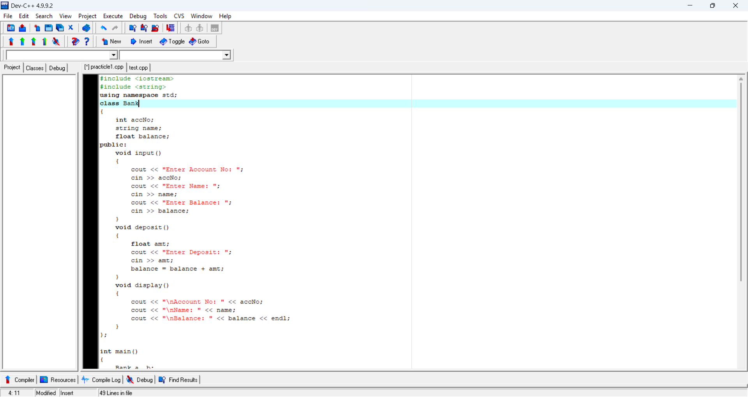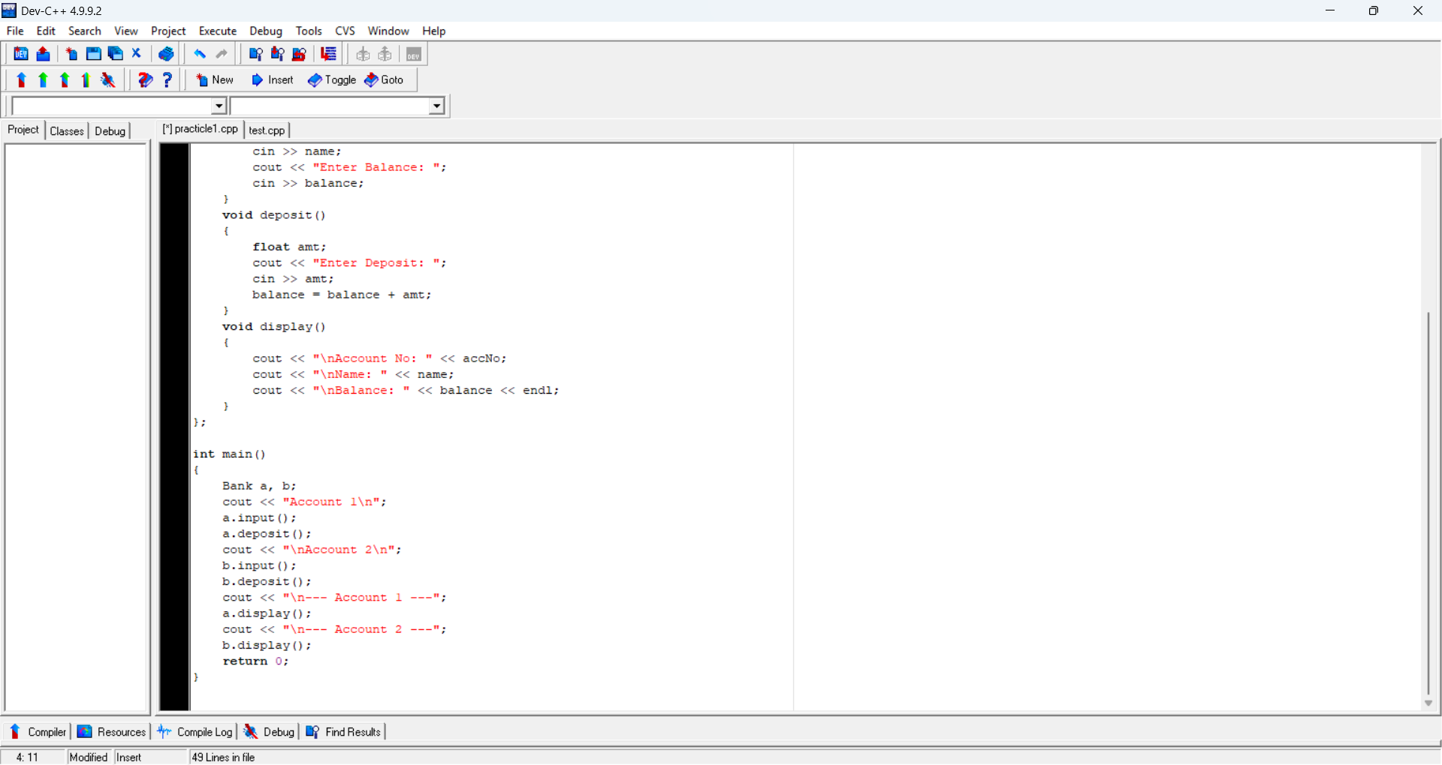#include <iostream>
PRN : 202501070174
Name: Sanskruti shelke
Batch :C1
#include <string>
using namespace std;
class Bank
{
int accNo;
string name;
float balance;
public:
void input()
{
cout << "Enter Account No: ";
cin >> accNo;
cout << "Enter Name: ";
cin >> name;
cout << "Enter Balance: ";
cin >> balance;
}
void deposit()
{
float amt;
cout << "Enter Deposit: ";
cin >> amt;
balance = balance + amt;
}
void display()
{
cout << "\nAccount No: " << accNo;
cout << "\nName: " << name;
cout << "\nBalance: " << balance << endl;
}
};

int main()
{
Bank a, b;
cout << "Account 1\n";
a.input();
a.deposit();
cout << "\nAccount 2\n";
b.input();
b.deposit();
cout << "\n Account 1 ";
a.display();
cout << "\n Account 2 ";
b.display();
return 0;
}

