# 1. ASTM Protocol

## 1.1. Background

ASTM (American Society of Testing and Material) has a plan for communications between automatic analyzers and host computers for standards E1381-91 (Specification for Low-Level Protocol to Transfer Messages Between Clinical Laboratory Instruments and Computer Systems) and E1394-91 (Standard Specifications for Transferring Information Between Clinical Instruments and Computer Systems). The basic specifications of the standards are regulated on X12 of ANSI.

## 1.2. Communication Processing Layers

The communication process between the system and the host is divided into three layers as shown below. This specification explains the processing and operation methods for the

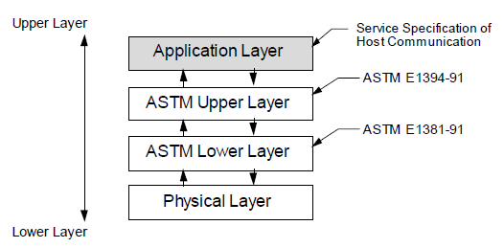

**Figure 7: Host Communication Processing Layers**

Details of the ASTM protocol can be found in the Annual Book of ATSM Standards.

Copyright American Society for Testing and Materials, 100 Barr Harbor Drive, West

Conshohocken, PA 19428-2959, USA.

• **ASTM E1381-91 Low Level Protocol**

Specification for Low Level Protocol to Transfer Messages Between Clinical Laboratory

Instruments and Computer Systems

• **ASTM E1394-91 High Level Protocol**

Standard Specification for Transferring Information Between Clinical Instruments and Computer Systems.

## 1.3. ASTM Lower Layer

ASTM lower layer receives messages for a transmission request from the upper layer. These messages are then split into frames and sent to a communication medium to be transmitted to other parties. ASTM lower layer also constructs frames received from a communication medium to recreate messages to be transferred to the ASTM upper layer as reception messages. Configuration and communication procedures for transmission and reception of frames are explained in the following chapters.

|  |  |  |
| --- | --- | --- |
| **Item** | **Method** | **Explanation** |
| **Frame Configurations** | For Middle Frame  <STX> FN text  <ETB> C1 C2  <CR><LF>  For Last Frame  <STX> FN text  <ETX> C1 C2  <CR><LF> | • Control character (characters enclosed in <>):  <STX> is control character (HEX 02)  <ETB> is control character (HEX 17)  <CR> is control character (HEX 0D)  <LF> is control character (HEX 0A)  <ETX> is control character (HEX 03)  • FN: FN is a single ASCII number. FN indicates the sequence number for a frame (the frame number modulus 8). Frames of a single transmission phase are consecutively numbered beginning with 1, so FN runs from 1 to 7, then continues with 0, 1, and so on.  • Text: the data content of a frame (maximum 240 characters). Records are sub-divided into intermediate (middle) frames with 240 or fewer characters. Text is part of a split message.  • C1 and C2: When 1 byte resulting from adding each byte, FN to <ETB> for the middle frame and FN to <EXT> for the last frame, is expressed in hexadecimal, the upper character (161) is C1 and the lower character (160) is C2. Characters used are ‘0’ to ‘9’ or ‘A’ to ‘F’. |
| **Frame**  **Character**  **Configuration of**  **Text** | Characters other than  <SOH><STX><ETX>  <EOT><ENQ><ACK>  <DLE><NAK><SYN>  <ETB><CR><LF>  <DC1><DC2><DC3>  <DC4> | <SOH> is control character (HEX 01)  <EOT> is control character (HEX 04)  <ENQ> is control character (HEX 05)  <ACK> is control character (HEX 06)  <DLE> is control character (HEX 10)  <NAK> is control character (HEX 15)  <SYN> is control character (HEX 16)  <DC1> ~ <DC4> are control characters (HEX 11 ~ 14) |
| **Maximum**  **Length of the**  **Frame** | 247 characters | For one frame, maximum of 240 characters for text, 7 characters for frame control characters. Messages equal to or less than 240 characters are transmitted as one final frame. Messages greater than 240 characters are split into frames that have character lengths that fall within the 240-character limit. The only or final remaining frame becomes the last frame and is indicated by <ETX>. All others are intermediate (middle) frames and are indicated by <ETB>. |
|  |  |  |

**Table 8: ASTM Lower Layer Communication Methods**

## 1.4. ASTM Syntax

The structure of the sentences to be transferred, according to ASTM Communication Regulation, is explained in this section. Between the analyzer and the host, various data such as Test Requests and Results are transferred back and forth. All of these data conform to this syntax.

### 1.4.1. Definitions

* **Message :** A message is constructed with an arrangement of several records (refer to the next item). It is the smallest unit of information transferred between a host and an analyzer. Messages begin with a ‘Message Header Record’ that indicates the beginning of a message and end with a ‘Message Termination Record’ that indicates the end of a message.
* **Record :** A record is constructed from several fields and expresses a single purpose (such as to specify result reports or test requests). A record may be repeated or used singularly in a message. Code that indicates the purpose of a record is noted in the first character of that record.
* **Field :** A field is the ASTM’s smallest element to construct information. Attributes for a field (name, format, and meanings) are defined in units in a record.

### 1.4.2. Coding Rules for the Messages

This section deals with message coding rules as well as special characters, such as delimiters, used to develop messages provided by records and fields.

#### 1.4.2.1. End of Record Character

The ASCII CR character (HEX 0D) is always used to indicate the end of a record.

#### 1.4.2.2. Field Delimiter = Vertical Bar ‘|’

A Field delimiter is a character used to separate fields that are next to each other in a record. This is also a delimiter for the first Record ID (character that appears in the beginning of a record) and the next field. According to the 2nd character that appears in the Message Header Record (record that appears in the front of a message), a Field delimiter can be defined with an optional character through the Message Header Record; however, it is recommended that a vertical bar ‘|’ be used.

#### 1.4.2.3. Repeat Delimiter = Backslash ‘\’

When a field is constructed by the same data repeated several times, it is referred to as a Repeated Field. The delimiter between the repeated items for the Repeated Field is called the Repeat delimiter. Repeat delimiters can be defined with an optional character through the Message Header Record; however, it is recommended that a backslash ‘\’ be used.

#### 1.4.2.4. Component Delimiter = caret ‘^’

When a field is constructed by several elements, it is referred to as a Component Field. The delimiter between these elements is the Component delimiter. The Component delimiter can be defined with an optional character through the Message Header Record; however, it is recommended that a caret ‘^’ be used.

#### 1.4.2.5. Escape Character = Ampersand ‘&’

An Escape character is provided to indicate a delimiter for the fields that include general text. When this character occurs in a relevant field, the next character holds a special meaning (discussed below). An Escape character can be defined with an optional character through the Message Header Record; however, it is recommended that an ampersand ‘&’ be used.

#### 1.4.2.6. Expression of Special Characters with Escape Character

The following Escape sequence (starting with & and ending with &) is defined. When this sequence is detected in a field, it is changed to a corresponding character and deleted.

Escape sequences other than these are skipped and treated as NULL value.

&F& Indicates Field delimiter

&S& Indicates Component delimiter

&R& Indicates Repeat delimiter

&E& Indicates Escape

#### 1.4.3. Message Transmission Phases

To establish which system sends and which system receives information and to assure the actions of sender and receiver are well coordinated, there are three distinct phases in transferring information:

• Establishment Phase

• Transfer Phase

• Termination Phase

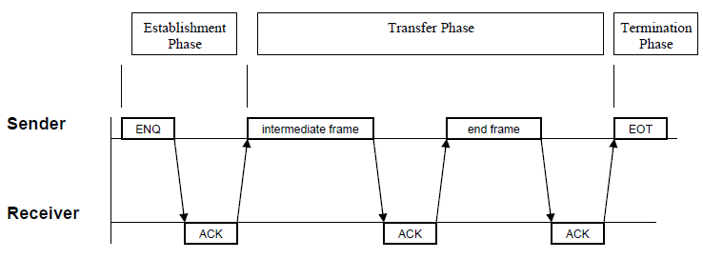

**Figure 8: Message Transmission Phases**

Within the transfer phase, all records of the corresponding message are grouped into longer frames to increase speed. The records are separated through a **[CR]** character. Therefore, to obtain pure ASTM records again, the receiver must concatenate all the frames and wait for a **[EOT]** character. Then, finally, he can process the frame and split it into different records using the **[CR]** as separator.

## 1.5. Checksum Calculation/ Message Frame

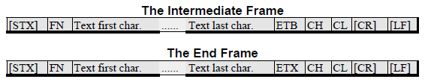

* **[STX] :** The ASCII code 2, indicating the beginning of a frame transmission.
* **FN :** The frame number modulus 8. Frames of a single Transmission Phase are consecutively numbered beginning with 1. So FN runs from 1 to 7, continues with 0, 1, and so on. Use ASCII codes for the digits ‘0’ to ‘7’ (48-55).
* **Text :** The data content of a frame (max. 240 characters). Records are sub-divided into intermediate frames with 240 characters. Maximum is indicated by **[ETB]**. The only or last remaining frame is indicated by **[ETX]**. Different records must be sent in different frames.
* **[ETB] :** The ASCII code 23 (17hex), indicating the end of the text block of an intermediate frame.
* **[ETX] :** The ASCII code 3, indicating the end of the text block of an end frame.
* **CH, CL :** Represents the high nibble (= most significant 4 bit) respectively, the low nibble (=least significant 4 bit) of the 8-bit checksum. CH and CL are represented as two digits of hex numbers. The checksum is the modulus 8 of the sum of ASCII values of the frame characters starting with and including ‘FN’ and completing with **[ETX]** respectively **[ETB]**.

**Example for Checksum Calculation**

* **[STX]**1Test**[ETX]**

|  |  |
| --- | --- |
| **Character** | **Value Sum (hex)** |
| **[STX]** | 02h 00h |
| ‘1’ | 31h 31h |
| ‘T’ | +54h 85h |
| ‘e’ | +65h EAh |
| ‘s’ | +73h 15Dh |
| ‘t’ | +74h 1D1h |
| **[ETX]** | +03h 1D4h |
|  | = 1D4h |
|  | Mod 100h |
|  | = **D4**h |

to be sent:

* **[STX]**1Test**[ETX]**D4**[CR][LF]**

# 2. ASTM Contents Explanation.

## 4.1. Header

|  |  |  |  |
| --- | --- | --- | --- |
| Field Name | Reference | Example | Comments |
| Record Type ID | 07.1.01 | H | fixed |
| Delimiter Definition | 07.1.02 | |\^& | fixed |
| Message Control ID | 07.1.03 | 201506091416280 | Test DateTime + SampleWindowIndex |
| Access Password | 07.1.04 |  |  |
| Sender Name or ID | 07.1.05 | aqzen | DeviceID |
| Sender Street Address | 07.1.06 |  |  |
| Reserved Field | 07.1.07 |  |  |
| Sender Telephone Number | 07.1.08 |  |  |
| Characteristics of Sender | 07.1.09 |  |  |
| Receiver ID | 07.1.10 | host | fixed |
| Comment or Special Instructions | 07.1.11 |  |  |
| Processing ID | 07.1.12 | P | fixed |
| Version No. | 07.1.13 | 1.210 | fixed |
| Date and Time of Message | 07.1.14 | 20150609141628 | Message DateTime |

## 4.2. Inquiry

|  |  |  |  |
| --- | --- | --- | --- |
| Field Name | Reference | Example | Comments |
| Record Type ID | 12.4.01 | Q | fixed |
| Sequence Number | 12.4.02 | 1 |  |
| Starting Range ID Number | 12.4.03 |  |  |
| Ending Range Id Number | 12.4.04 |  |  |
| Universal Test ID | 12.4.05 | ALL | fixed |
| Nature of Request Time Limits | 12.4.06 |  |  |
| Beginning Request Results Data and Time | 12.4.07 |  |  |
| Ending Request Results Date and Time | 12.4.08 |  |  |
| Requesting Physician Name | 12.4.09 |  |  |
| Requesting Physician Telephone Number | 12.4.10 |  |  |
| User Field No. 1 | 12.4.11 |  |  |
| User Field No. 2 | 12.4.12 |  |  |
| Request Information Status codes | 12.4.13 |  |  |

## 4.3. Termination

|  |  |  |  |
| --- | --- | --- | --- |
| Field Name | Reference | Example | Comments |
| Record Type ID | 13.1.01 | L | fixed |
| Sequence Number | 13.1.02 | 1 |  |
| Termination Code | 13.1.03 | N | N : Normal termination  Q : Request error for the last reception (request is rejected) |

## 4.4 Patient

|  |  |  |  |
| --- | --- | --- | --- |
| Field Name | Reference | Example | Comments |
| Record Type ID | 08.1.01 | P | fixed |
| Sequence Number | 08.1.02 | 1 |  |
| Practice Assigned Patient ID | 08.1.03 |  |  |
| Laboratory Assigned Patient ID | 08.1.04 |  |  |
| Patient ID | 08.1.05 | pid | Patient ID |
| Patient Name | 08.1.06 | pname | Patient Name |
| Mothers Maiden Name | 08.1.07 |  |  |
| Date of Birth | 08.1.08 | 19811014 | YYYYMMDD |
| Patient Sex | 08.1.09 | M | M / F / N |
| Patient Race-Ethnic Origin | 08.1.10 |  |  |
| Patient Address | 08.1.11 |  |  |
| Reserved Field | 08.1.12 |  |  |
| Patient Telephone Number | 08.1.13 |  |  |
| Attending Physician ID | 08.1.14 | a | Operator ID |
| Special Field 1 | 08.1.15 |  |  |
| Special Field 2 | 08.1.16 |  |  |
| Patient Height (in cm) | 08.1.17 |  |  |
| Patient Weight in kg | 08.1.18 |  |  |
| Patient’s Known or Suspected Diagnosis | 08.1.19 |  |  |
| Patient Active Medications | 08.1.20 |  |  |
| Patient’s Diet | 08.1.21 |  |  |
| Practice Field No.1 | 08.1.22 |  |  |
| Practice Field No.2 | 08.1.23 |  |  |
| Admission and Discharge Dates | 08.1.24 |  |  |
| Admission Status | 08.1.25 |  |  |
| Location | 08.1.26 |  |  |
| Nature of Alternative Diagnostic Code and Classifiers | 08.1.27 |  |  |
| Alternative Diagnostic Code and Classification | 08.1.28 |  |  |
| Patient Religion | 08.1.29 |  |  |
| Marital Status | 08.1.30 |  |  |
| Isolation Status | 08.1.31 |  |  |
| Language | 08.1.32 |  |  |
| Hospital Service | 08.1.33 |  |  |
| Hospital Institution | 08.1.34 |  |  |
| Dosage Category | 08.1.35 |  |  |

## 4.5 Order

|  |  |  |  |
| --- | --- | --- | --- |
| Field Name | Reference | Example | Comments |
| Record Type ID | 09.4.01 | O | fixed |
| Sequence Number | 09.4.02 | 1 |  |
| Specimen ID | 09.4.03 | lot123 | Lot Number |
| Instrument Specimen ID | 09.4.04 | AMI 3in1 | KitType Name |
| Universal Test ID | 09.4.05 | ^^^Myo | ^^^test name |
| Priority | 09.4.06 | R | R: routine (fixed) |
| Requested/Or dered Date and Time | 09.4.07 |  |  |
| Specimen Collection Date and Time | 09.4.08 | 20150609141628 | YYYYMMDDHHmmSS |
| Collection End Time | 09.4.09 |  |  |
| Collection Volume | 09.4.10 |  |  |
| Collector ID | 09.4.11 |  |  |
| Action Code∗ | 09.4.12 | N | N : Transmit by the analyzer (fixed) |
| Danger Code | 09.4.13 |  |  |
| Relevant Clinical Information | 09.4.14 |  |  |
| Date/Time Specimen Received | 09.4.15 |  |  |
| Specimen Descriptor∗ | 09.4.16 |  |  |
| Ordering Physician | 09.4.17 |  |  |
| Physician’s Telephone Number | 09.4.18 |  |  |
| User Field No. 1 | 09.4.19 |  |  |
| User Field No. 2 | 09.4.20 |  |  |
| Laboratory Field No. 1 | 09.4.21 |  |  |
| Laboratory Field No. 2 | 09.4.22 |  |  |
| Date/Time Results Reported or Last Modified | 09.4.23 |  |  |
| Instrument Charge to Computer System | 09.4.24 |  |  |
| Instrument Section ID | 09.4.25 |  |  |
| Report Types | 09.4.26 | F | F: Transmit by the analyzer (fixed) |
| Reserved Field | 09.4.27 |  |  |
| Location or Ward of Specimen Collection | 09.4.28 |  |  |
| Nosocomial Infection Flag | 09.4.29 |  |  |
| Specimen Service | 09.4.30 |  |  |
| Specimen Institution | 09.4.31 |  |  |

## 4.6. Results

|  |  |  |  |
| --- | --- | --- | --- |
| Field Name | Reference | Example | Comments |
| Record Type ID | 10.4.01 | R | fixed |
| Sequence Number | 10.4.02 | 1 |  |
| Universal Test ID | 10.4.03 | ^^^Myo | ^^^test name |
| Data or Measurement Value | 10.4.04 | 3325.95 | Data Value |
| Units | 10.4.05 | ng/ml | Unit |
| Reference Ranges | 10.4.06 | 423.32 | Height Value |
| Result Abnormal Flags | 10.4.07 | N | fixed |
| Nature of Abnormality Testing | 10.4.08 |  |  |
| Result Status | 10.4.09 | > 1000 ng/ml | Data as same as UI. |
| Date of Change in Instrument Normative Values Units | 10.4.10 | Positive | Result string  If test type qualitative. |
| Operator Identification | 10.4.11 |  |  |
| Date/Time Test Started | 10.4.12 |  |  |
| Date/Time Test Completed | 10.4.13 |  |  |
| Instrument Identification | 10.4.14 |  |  |

## 4.7. Comments

|  |  |  |  |
| --- | --- | --- | --- |
| Field Name | Reference | Example | Comments |
| Record Type ID | 11.1.01 | C | fixed |
| Sequence Number | 11.1.02 | 1 |  |
| Comment Source | 11.1.03 | I | I : from Analyzer(fixed) |
| Comment Text | 11.1.04 | No TestResults | Error Message |
| Comment Type | 11.1.05 | G | G : generic/free text comment(fixed) |

# 3. Analyzer’s Data structure.

Each kit has different own number of Sample Window and Peak Result.

The device’s overall data structure is below.

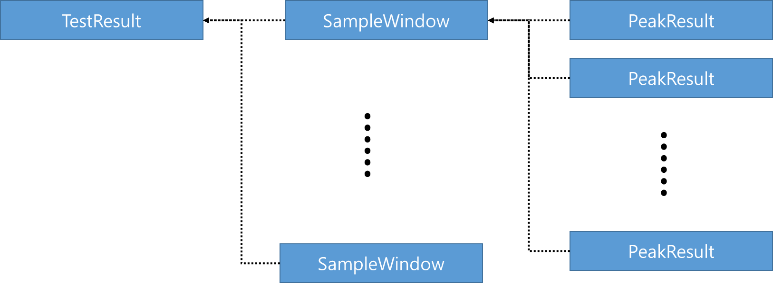

## 3.1. SampleWindow

SmapleWindow is like a kit. it has a layer or multi layers.

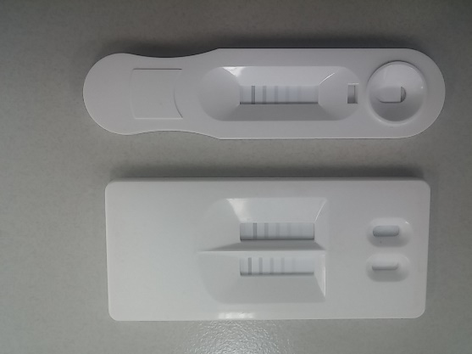

If a kit has one layer, SampleWindow is one. The analyzer sends one ASTM message.

If a kit has multi layers, SampleWindow is also multi. The analyzer sends a ASTM messages repeatedly.

In ASTM, SampleWindow’s name is “Instrument Specimen ID”, in order.

* **Instrument Specimen ID** in order
  + rule) |Instrument_Specimen_ID|
  + ex) |AMI 3in1|
  + sample) O|1|lot123|**AMI 3in1**|^^^Myo|R||20150609141628||||N||||||||||||||F

## 3.2. PeakResult

PeakResult is test data of each line in a layer.

In ASTM, PeakResult’s name is “Universal Test ID”, in order and result.

* **Universal Test ID** in order and Result
  + rule) |^^^Universal_Test_ID|
  + ex) Myo
  + sample) O|1|lot123|AMI 3in1|**^^^Myo**|R||20150609141628||||N||||||||||||||F
  + sample) R|1|**^^^Myo**|3325.95|ng/ml|550.33|N||> 1000 ng/ml|Positive

# 4. Analyzer’s Communication Example

## 3.1 Inquiry ( LIS -> Analyzer )

* LIS request last test result data.
  + Analyzer determines “ALL” in “Q” section as a request.

|  |  |
| --- | --- |
| **Contents** | |
| H|\^&||host|||||aQzen||P|1|  Q|1|||ALL||||||||  L|1|N | |
| **Sender** | **data** |
| LIS | **[ENQ]** |
| Analyzer | **[ACK]** |
| LIS | **[STX]1**H|\^&||host|||||aQzen||P|1|**[CR]**Q|1|||ALL||||||||**[CR]**L|1|N**[CR][ETX]7F[CR][LF]** |
| Analyzer | **[ACK]** |
| LIS | **[EOT]** |

## 3.2 Test Results ( Analyzer to LIS )

* Device ID : Test
* Patient ID : 0000
* Patient Male : None
* Lot Number :
* Test Time : 201510141731420 ( yyyyMMddhhmmss )
* Kit’s name : 150831 256DL
* Unit :
* 150831 256DL has 3 peaks : FluA, FluB, Control
  + FluA peak : 267.04 | Positive
  + FluB peak : 348.58 | Positive
  + Control peak : 596.28 | Valid

|  |  |
| --- | --- |
| **Contents** | |
| H|\^&|201510141731420|12|||||host||P|1.209|20151014173142  P|1|||0000|||2015/10/14|N|||||1  O|1||150831 256DL|^^^FluA|R||20151014173142||||N||||||||||||||F  R|1|^^^FluA|267.04||267.04|N||267.04 |Positive  O|2||150831 256DL|^^^FluB|R||20151014173142||||N||||||||||||||F  R|2|^^^FluB|348.58||348.58|N||348.58 |Positive  O|3||150831 256DL|^^^Control|R||20151014173142||||N||||||||||||||F  R|3|^^^Control|596.28||596.28|N||596.28 |Valid  L|1|N | |
| **Sender** | **Contents** |
| Analyzer | **[ENQ]** |
| LIS | **[ACK]** |
| Analyzer | **[STX]1**H|\^&|201510141731420|12|||||host||P|1.209|20151014173142**[CR]**P|1|||0000|||2015/10/14|N|||||1**[CR]**O|1||150831 256DL|^^^FluA|R||20151014173142||||N||||||||||||||F**[CR]**R|1|^^^FluA|267.04||267.04|N||267.04 |Positive**[CR]**O|2||150831 256DL|^^^FluB|R||20151014**[ETB]46[CR][LF]** |
| LIS | **[ACK]** |
| Analyzer | **[STX]2**173142||||N||||||||||||||F**[CR]**R|2|^^^FluB|348.58||348.58|N||348.58 |Positive**[CR]**O|3||150831 256DL|^^^Control|R||20151014173142||||N||||||||||||||F **[CR]** R|3|^^^Control|596.28||596.28|N||596.28 |Valid**[CR]**R|3|^^^Tn I|17.25|ng/ml|945.33|N||17.25 ng/ml**[CR]**L|1|N**[ETX]24[CR][LF]** |
| LIS | **[ACK]** |
| Analyzer | **[EOT]** |

## 3.3 Inquiry Error ( Analyzer to LIS )

|  |  |
| --- | --- |
| **Contents** | |
| H|\^&||||||||||1|  C|1|I|No TestResult|G  L|1|Q | |
| **Sender** | **Contents** |
| Analyzer | **[ENQ]** |
| LIS | **[ACK]** |
| Analyzer | **[STX]1**H|\^&||||||||||1|**[CR]**C|1|I|No TestResult|G**[CR]**L|1|Q**[CR][ETX]3A[CR][LF]** |
| LIS | **[ACK]** |
| Analyzer | **[EOT]** |