SOLUTION DESIGN DOCUMENT (SDD)
Healthcare Insurance Analytics Platform
Big Data Pipeline & Cloud Warehouse Architecture

DOCUMENT METADATA & CONTROL
Prepared By: Keshab Rai
Project Reference: Template-Solution Design Document_2.docx
Date of Creation: June 22, 2026
Document Version: 1.0 (Architecture Baseline)
Status: Approved for Engineering Sprint

TABLE OF CONTENTS
1. Executive Summary & Core Solution Strategy...............1
2. Project Lifecycle Timeline & 14-Day Scrum Sprint.........1
3. High-Level Process Workflow (Step-by-Step)...............2
4. Solution Applicability & Core Business Use Cases.........3
5. Target AWS Redshift Database Design & Key Constraints....5
5.1 Analytical Target Workspace Schema (`project_output`)…8
5.2 Logical Schema Architecture ER Mapping Flow…9
6. Integrated Technology Stack Ecosystem....................11
7. Architectural Conclusion & Sign-Off......................12

1. Executive Summary & Core Solution Strategy
This Solution Design Document details the end-to-end technical blueprints for deploying an enterprise Big Data ecosystem tailored for a Health Care insurance company. Facing clear marketplace challenges in boosting revenue streams and profiling customer segments, the company requires a robust architectural solution to ingest web-scraped competitor data and third-party feeds. The strategy centers on building resilient, decoupled in-memory PySpark pipelines that automate data quality auditing, remove systemic redundancies and persist the resulting business matrices into an isolated schema inside AWS Redshift. This technical engine directly drives revenue growth by enabling personalized policy adjustments and precisely tracking customer behavior metrics.
2. Project Lifecycle Timeline & 14-Day Scrum Sprint
The engineering, staging, and deployment lifecycles are governed via Jira Software utilizing a formal 2-week (14-day) Scrum sprint cadence. The schedule is explicitly balanced between core conceptual mapping tasks and distributed data engineering execution code development:
Duration / Days | Sprint Phase | Operational Milestones & Technical Deliverables
Days 1 - 2 | Week 1: Documentation & Governance | Formulate and baseline the formal Requirement Specification Document (SRS) and the initial Solution Design Document (SDD) layout configurations.
Days 3 - 4 | Week 1: Agile Setup & Stories | Configure the Jira project track. Build out the master Epic, map explicit User Stories, and create sub-tasks for individual analytics use cases.
Days 5 - 7 | Week 1: Redshift Target Schema Design | Model the physical target structures, database relationships, and primary/foreign key constraint boundaries inside AWS Redshift.
Days 8 - 9 | Week 2: ETL Ingestion & Cleansing Code | Construct the PySpark Data Cleansing Module. Engineer automated dataframe processing scripts to count and replace null values and execute record deduplication.
Days 10 - 11 | Week 2: Analytics Metric Aggregations | Develop the PySpark Result Generation Module. Script all 13 core query optimization routines to derive structural corporate metrics.
Days 12 - 13 | Week 2: Validation & Dashboard Setup | Run comprehensive pipeline integration and quality validation test cases. Compile interactive Databricks dashboard visual summaries for key data stakeholders.
Day 14 | Week 2: Production Release & Class Demo | Commit and push final code modules via PyCharm to the central GitHub repository. Deliver the live operational platform demonstration.
3. High-Level Process Workflow (Step-by-Step)
- Step 1: Landing Zone Object Ingestion: Raw datasets (Patients, Subscriber, Claims, Group_subgroup) compiled from web scraping scripts are routinely landed as uncompressed CSV file streams inside the Amazon S3 landing zone bucket partition ('input-data/').
- Step 2: DataFrame Schema Enforcement: A distributed Spark Session is initialized via Databricks notebooks or AWS EMR Studio nodes, programmatically reading source objects into distributed dataframes with strict data type formatting.
- Step 3: Quality Profiling & Auditing: The cleansing runtime engine processes each dataframe column vector to capture, record, and log absolute column-level null value tallies before execution.
- Step 4: Algorithmic Transformation & Deduplication: Character null entries are uniformly substituted with a standardized string token ('NA'). The system applies a global drop duplicates filter to guarantee record uniqueness across rows.
- Step 5: Relational Schema Mapping: Clean structures are moved across high-speed secure cloud connectors directly into targeted relational warehouse tables inside AWS Redshift, bound by primary and foreign key constraints.
- Step 6: Metric Aggregation & Isolation: The result generation module executes advanced analytical aggregations, building individual use-case tables and saving them under a dedicated, secure database schema called 'Project-Output'.
4. Solution Applicability & Core Business Use Cases
The target business intelligence data pipeline solution natively supports the computation, extraction, and isolated storage of the following 13 core operational business intelligence inquiries:
ID | Use Case Reference Title | Analytical Extraction Logic Strategy & Target Goal | Source Entities
UC-01 | Max Claims Disease Analysis | Identify which specific disease registers the highest absolute count of insurance claims to guide portfolio risk modeling. | Claims, Patients
UC-02 | Under-30 Policy Segment Tracking | Filter and isolate active policyholders under the age of 30 who subscribe to any sub-policy category option. | Subscriber, Group_subgroup
UC-03 | Group Hierarchy Subgroup Density | Determine which primary insurance group contains the maximum absolute count of operational subgroups. | Group_subgroup
UC-04 | Provider Delivery & Facility Volume Index | Isolate and identify the explicit medical facility or hospital serving the highest absolute number of unique patients. | Patients, Claims
UC-05 | Subgroup Demand Popularity Ranking | Isolate and rank specific insurance sub-policy offerings that manifest the highest absolute subscriber sign-up frequency. | Subscriber, Group_subgroup
UC-06 | Financial Loss Administrative Rejections | Quantify the cumulative total volume of insurance claims flagged as rejected by core administrative systems. | Claims
UC-07 | Geographical Claims Density Spotting | Extract claim volume distributions aggregated by patient city of origin to uncover geographic high-density healthcare hotspots. | Claims, Patients
UC-08 | Policy Sector Preference Metrics | Evaluate the structural distribution split between policyholders subscribing to Government-sponsored vs Private-sector lines. | Subscriber, Group_subgroup
UC-09 | Premium Yield Baseline Evaluation | Calculate the true mathematical average monthly premium yield paid by active subscribers to establish core income baselines. | Subscriber
UC-10 | Product Line Profitability Analysis Matrix | Cross-reference premium revenue fields, operating costs, and claim charges to isolate the single highest-margin group. | Claims, Group_subgroup
UC-11 | Pediatric Oncology Cohort Extraction | Generate a clean, targeted operational registry of all active patients below the age of 18 admitted for Cancer. | Patients

5. Target AWS Redshift Database Design & Key Constraints
This document outlines the structured relational data warehouse schema designed inside Amazon Redshift to support high-performance business intelligence and financial auditing metrics for the Healthcare Insurance Analytics Platform. The data layer integrates historical transactional claims, subscriber demographics and healthcare infrastructure assets processed via a local containerized PySpark pipeline (PyCharm + Docker Desktop) and targets optimized analytical access patterns.
The core transaction tables preserve strict standard relational models, ensuring data entity integrity and proper relational links.
Table: group_table
Column Name | Data Type | Constraints / Key | Description
grp_id | VARCHAR(50) | PRIMARY KEY | Unique identifier for the high-level policy group.
grp_name | VARCHAR(100) | NULLABLE | Name of the operational corporate/organizational account.
grp_type | VARCHAR(100) | NULLABLE | Classification type (e.g., 'Government', 'Private').
Table: subgroup
Column Name | Data Type | Constraints / Key | Description
subgrp_id | VARCHAR(50) | PRIMARY KEY | Unique identifier for the individual plan tier product.
subgrp_name | VARCHAR(100) | NULLABLE | Marketing or operational plan name.
monthly_premium | NUMERIC(10, 2) | NULLABLE | Monthly payment amount required per premium subscriber.
Table: grpsubgrp
Column Name | Data Type | Constraints / Key | Description
grp_id | VARCHAR(50) | FOREIGN KEY | References group_table.grp_id to map policy hierarchy.
subgrp_id | VARCHAR(50) | FOREIGN KEY | References subgroup.subgrp_id to map policy hierarchy.
Table: subscribers
Column Name | Data Type | Constraints / Key | Description
sub_id | VARCHAR(50) | PRIMARY KEY | Unique primary key for individual policy holders.
first_name | VARCHAR(100) | NULLABLE | First name of subscriber.
last_name | VARCHAR(100) | NULLABLE | Last name of subscriber.
birth_date | TIMESTAMP | NULLABLE | Date of birth used for demographic age extraction.
city | VARCHAR(100) | NULLABLE | Geographic residential city location.
subgrp_id | VARCHAR(50) | FOREIGN KEY | References subgroup.subgrp_id for policy ownership.
Table: hospital
Column Name | Data Type | Constraints / Key | Description
hospital_id | VARCHAR(50) | PRIMARY KEY | Unique identifier for the medical treatment facility.
hospital_name | VARCHAR(255) | NULLABLE | Commercial brand name of the hospital facility.
hospital_type | VARCHAR(100) | NULLABLE | Operational model type description.
Table: patients
Column Name | Data Type | Constraints / Key | Description
patient_id | VARCHAR(50) | PRIMARY KEY | Unique identification number for clinical patient rows.
patient_name | VARCHAR(255) | NULLABLE | Full legal name of the clinical patient.
patient_gender | VARCHAR(20) | NULLABLE | Gender variable for demographic modeling ('Female', 'Male').
patient_birth_date | TIMESTAMP | NULLABLE | Date of birth for pediatric or geriatric medical grouping.
patient_phone | VARCHAR(50) | NULLABLE | Contact phone metadata.
disease_name | VARCHAR(255) | NULLABLE | Primary diagnosis description for hospital admission.
hospital_id | VARCHAR(50) | FOREIGN KEY | References hospital.hospital_id.
Table: claims
Column Name | Data Type | Constraints / Key | Description
claim_id | BIGINT | PRIMARY KEY | Unique ledger transaction ID for insurance claims.
sub_id | VARCHAR(50) | FOREIGN KEY | References subscribers.sub_id.
patient_id | VARCHAR(50) | FOREIGN KEY | References patients.patient_id.
claim_amount | NUMERIC(12, 2) | NULLABLE | Gross monetary cost claimed by the healthcare provider.
claim_date | TIMESTAMP | NULLABLE | Transactional date when claim was processed.
claim_or_rejected | VARCHAR(5) | NULLABLE | Status outcome code ('Y' = Paid, NULL or 'NaN' = Rejected).
claim_type | VARCHAR(100) | NULLABLE | Payment classification string (e.g., 'claims of policy').
admission_dt | TIMESTAMP | NULLABLE | Clinical hospital admission reference date.
5.1 Analytical Target Workspace Schema (`project_output`)
These target structures house the optimized metric aggregates created by your analytical engine. They serve as the direct backend for project deliverables, KPI dashboards, and presentation deck components.
Target Output Table | Key Analytical Attributes | Strategic Business Objective
max_disease_claims | disease_name, total_claims | Identifies the clinical disease generating the absolute maximum approved claim records to optimize medical risk management.
subscribers_under_30 | sub_id, first_name, last_name, birth_date, subgrp_id | Filters corporate demographic cohorts under the age of 30 to target young professional product tiers.
group_max_subgroups | grp_id, total_subgroups | Determines which structural parent group possesses the maximum diversified policy configurations.
top_hospital_patients | hospital_name, total_patients | Exposes high-traffic network facility volumes to pinpoint provider utilization scaling benchmarks.
top_subscribed_subgroups | subgrp_id, total_subscriptions | Highlights the specific commercial policy subclass preferred most frequently by consumers.
rejected_claims_count | total_rejected_claims | Calculates overall rejected transactions to quantify transaction error boundaries and denial leakages.
top_claim_cities | city, total_claims | Isolates geographical claims volume hubs to track regional resource demand allocations.
most_subscribed_policy_type | policy_type, total_subscriptions | Aggregates market metrics to contrast absolute volume share between Government and Private programs.
avg_monthly_premium | overall_average_premium | Computes the geometric mean baseline of recurring premium cash flows generated per consumer segment.
most_profitable_group | grp_id, calculated_profit | Measures net financial sustainability by balancing premium revenues against approved clinical payouts.
minor_cancer_patients | patient_id, patient_name, disease_name | Isolates highly vulnerable pediatric oncology cases (under age 18) for specialized clinical oversight audits.
cashless_high_charges | patient_id, patient_name, total_charges | Tracks systemic risk footprints for massive cashless transactions exceeding a cost threshold of Rs. 50,000.
female_knee_surgery_over_40 | patient_id, patient_name, disease_name | Exposes a specialized subset of clinical records identifying female clients over the age of 40 treated for knee conditions.

5.2 Logical Schema Architecture ER Mapping Flow

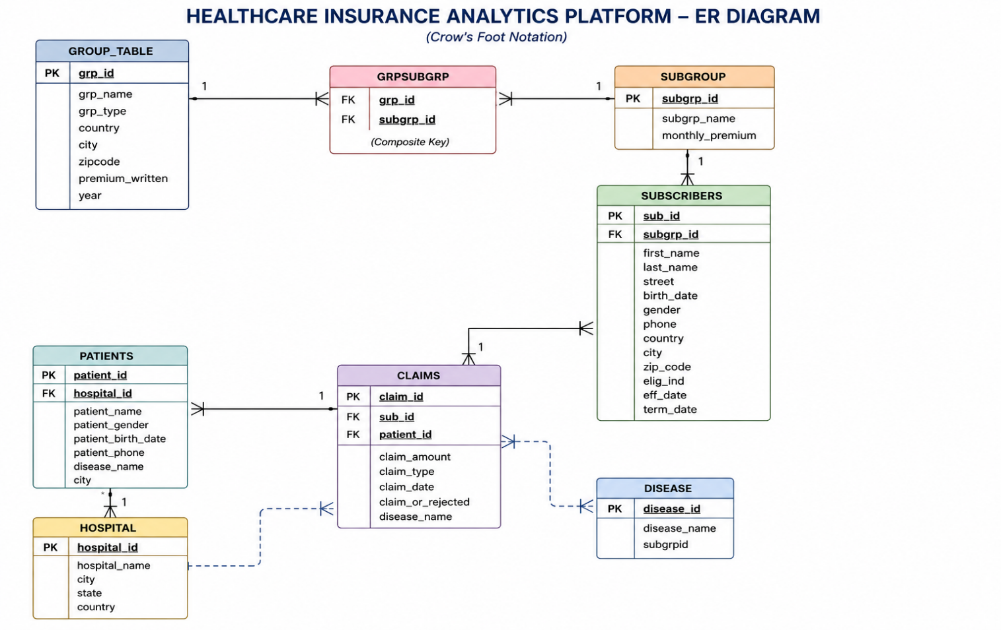
6. Integrated Technology Stack Ecosystem
- Apache Spark / PySpark: Distributed big data compute engine used to load source arrays from cloud tiers into parallel dataframes for rapid null validation and global deduplication transforms.
- Amazon S3: Highly durable object repository acting as the immutable cloud staging area ('input-data/' directory partition) for scraped raw files.
- Amazon Redshift: Enterprise analytical cloud data warehouse built for running fast parallel queries, supporting primary/foreign key relations and the isolated schema layout ('Project-Output').
- Databricks (incl. Community Edition): Interactive multi-node analytics development space used to construct PySpark modules, verify query states, and deliver visual data reporting summaries.
- AWS EMR Studio: Fully managed target multi-cluster compute platform utilized to schedule and run production execution bundles seamlessly via automated pipelines.
- GitHub & PyCharm IDE: Unified code control environment and professional development workspace used to engineer clean data classes, execute unit test workflows, and manage deployment branches.
- Jira Software: Agile scrum sprint management platform driving workflow transparency across the explicit 2-week, 14-day schedule partition.
7. Architectural Conclusion & Sign-Off
The specifications established within this professional Solution Design Document build a secure, fault-tolerant and production-ready data architecture blueprint for the Healthcare Insurance Analytics Platform. By organizing code bases into decoupled modules and planning workloads across an explicit 14-day Scrum sprint timeline, the technical architecture directly supports the delivery of clean analytics. The structured data models empower business stakeholders to quickly track subscriber trends, configure personalized insurance incentives and generate new operational revenue streams.

