**MSCS-533- Final Software Development Project: Build Multiplatform “Location Tracker" App with .NET MAUI**

------------------------------------------------------------------------------------------------------------------------------------------

Sandesh Pokharel  
Professor: Dr. Ulrich Vouama

University of Cumberlands

MSCS-533: Software Engineering and Multiplatform App Development

**Screenshot of Simulation for Android Pho**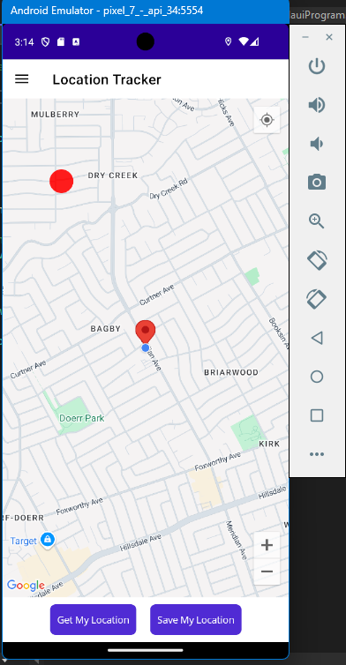  
  
**Project link**  
  
**The github link of project is :**   
<https://github.com/sanspokharel26677/MSCS-533-Final_Project-Location_Tracker/tree/main/LocationTracker/LocationTracker>

<https://github.com/sanspokharel26677/MSCS-533-Final_Project-Location_Tracker/tree/main/LocationTracker>