**MSCS-533-Hands-on Assignment 2 – Construct Your First Bio Sketch App with React Native and Snack Simulator**

------------------------------------------------------------------------------------------------------------------------------------------

Sandesh Pokharel  
ID: 005026677

University of Cumberlands

MSCS-533: Software Engineering and Multiplatform App Development

**Project link**  
  
The snack project link is given below:   
<https://snack.expo.dev/@spokharel26677/5c1894>**Screenshots of simulations**  
  
1. **Android**  
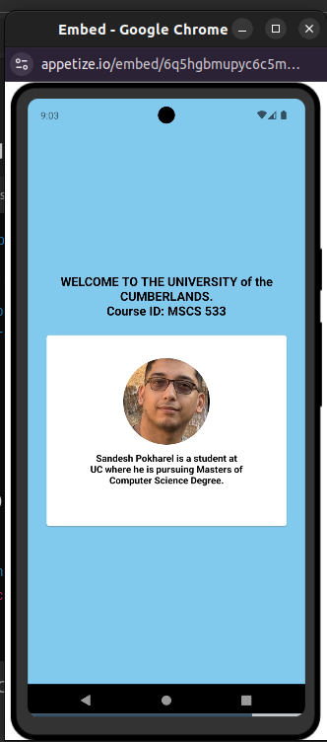

2. **ios**  
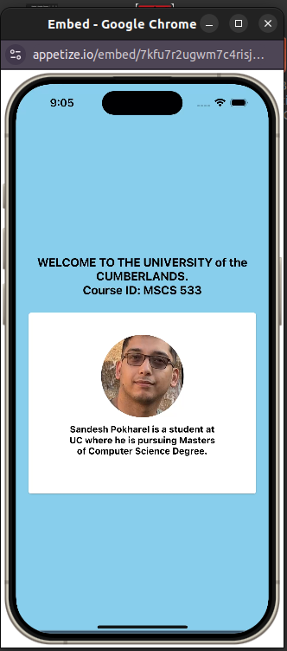

3. **Web**

