**MSCS-633: Assignment: Report: Q&A Chatbot using Python**

------------------------------------------------------------------------------------------------------------------------------------------

Sandesh Pokharel

University of the Cumberlands

MSCS-633 Advance Artificial Intelligence  
Dr. Primus Vekuh

June 08, 2025

# **Introduction**

This report documents the development of a terminal-based chatbot using Django and the ChatterBot library. The objective of this assignment was to create a Python-based Q&A system that can understand and respond to user input based on previous conversation training. The chatbot operates in a terminal interface and uses the English corpus for training.

**GitHub Repository**

**https://github.com/sanspokharel26677/MSCS-633-Assignment3/tree/main**

# **Development Process**

The following technologies were used in the development of this chatbot:  
 - Python 3.10  
 - Django  
 - ChatterBot  
 - ChatterBot Corpus  
 - SQLite  
 - spaCy (en_core_web_sm)  
   
The chatbot was implemented inside a custom Django management command. The ChatterBotCorpusTrainer was used to train the bot on a predefined English corpus.

# **Screenshots**

**Successful installation of ChatterBot and dependencies**  
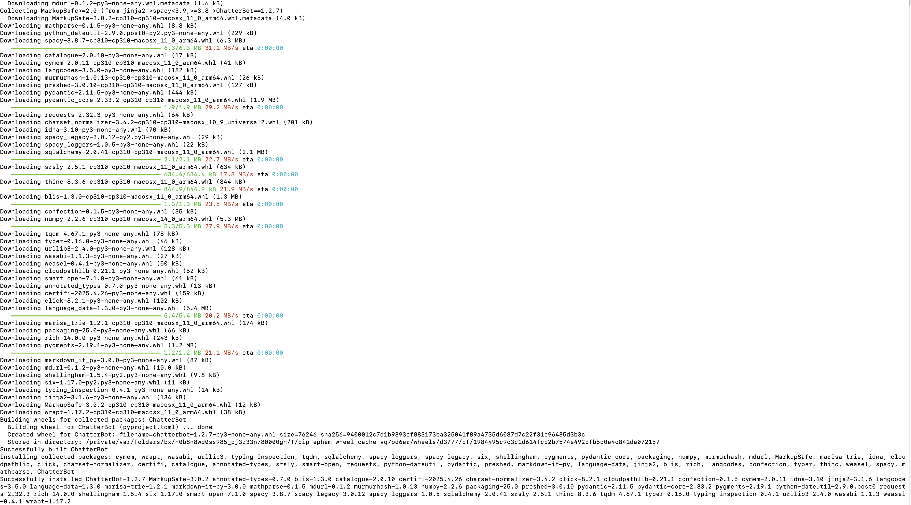**Output showing chatbot is ready and user interaction**

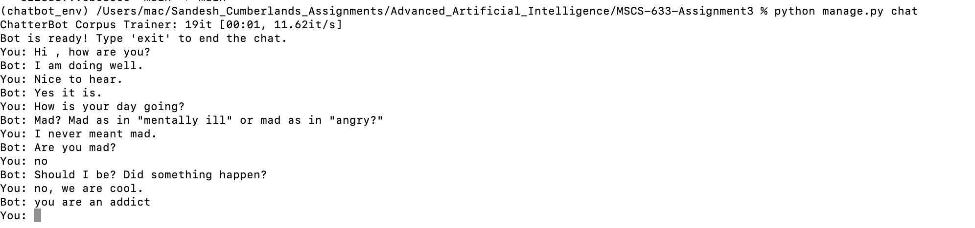

**Project files structure in terminal or VS Code**

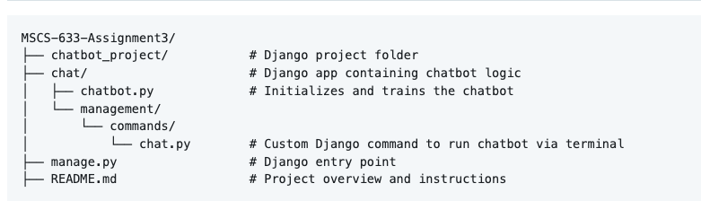

# **Observations and Results**

The chatbot was able to successfully engage in simple conversations. Responses were generated based on prior conversation examples from the training corpus. The bot could respond to greetings, simple questions, and expressions of emotion. Performance was acceptable for a basic terminal chatbot.

# **Conclusion**

This assignment successfully demonstrated the use of natural language processing libraries in Python to create a conversational chatbot. The integration of ChatterBot with Django using a custom management command proved to be an effective approach for terminal-based interaction. The assignment helped strengthen my understanding of chatbot architecture and dependency management.