这次上机4 我采用的是前后端分离样式 写的一个 学生管理系统
前端技术： Vite + Vue3 + tailwindcss
后端技术： SpringBoot + Mysql + Hibernate (jpa)

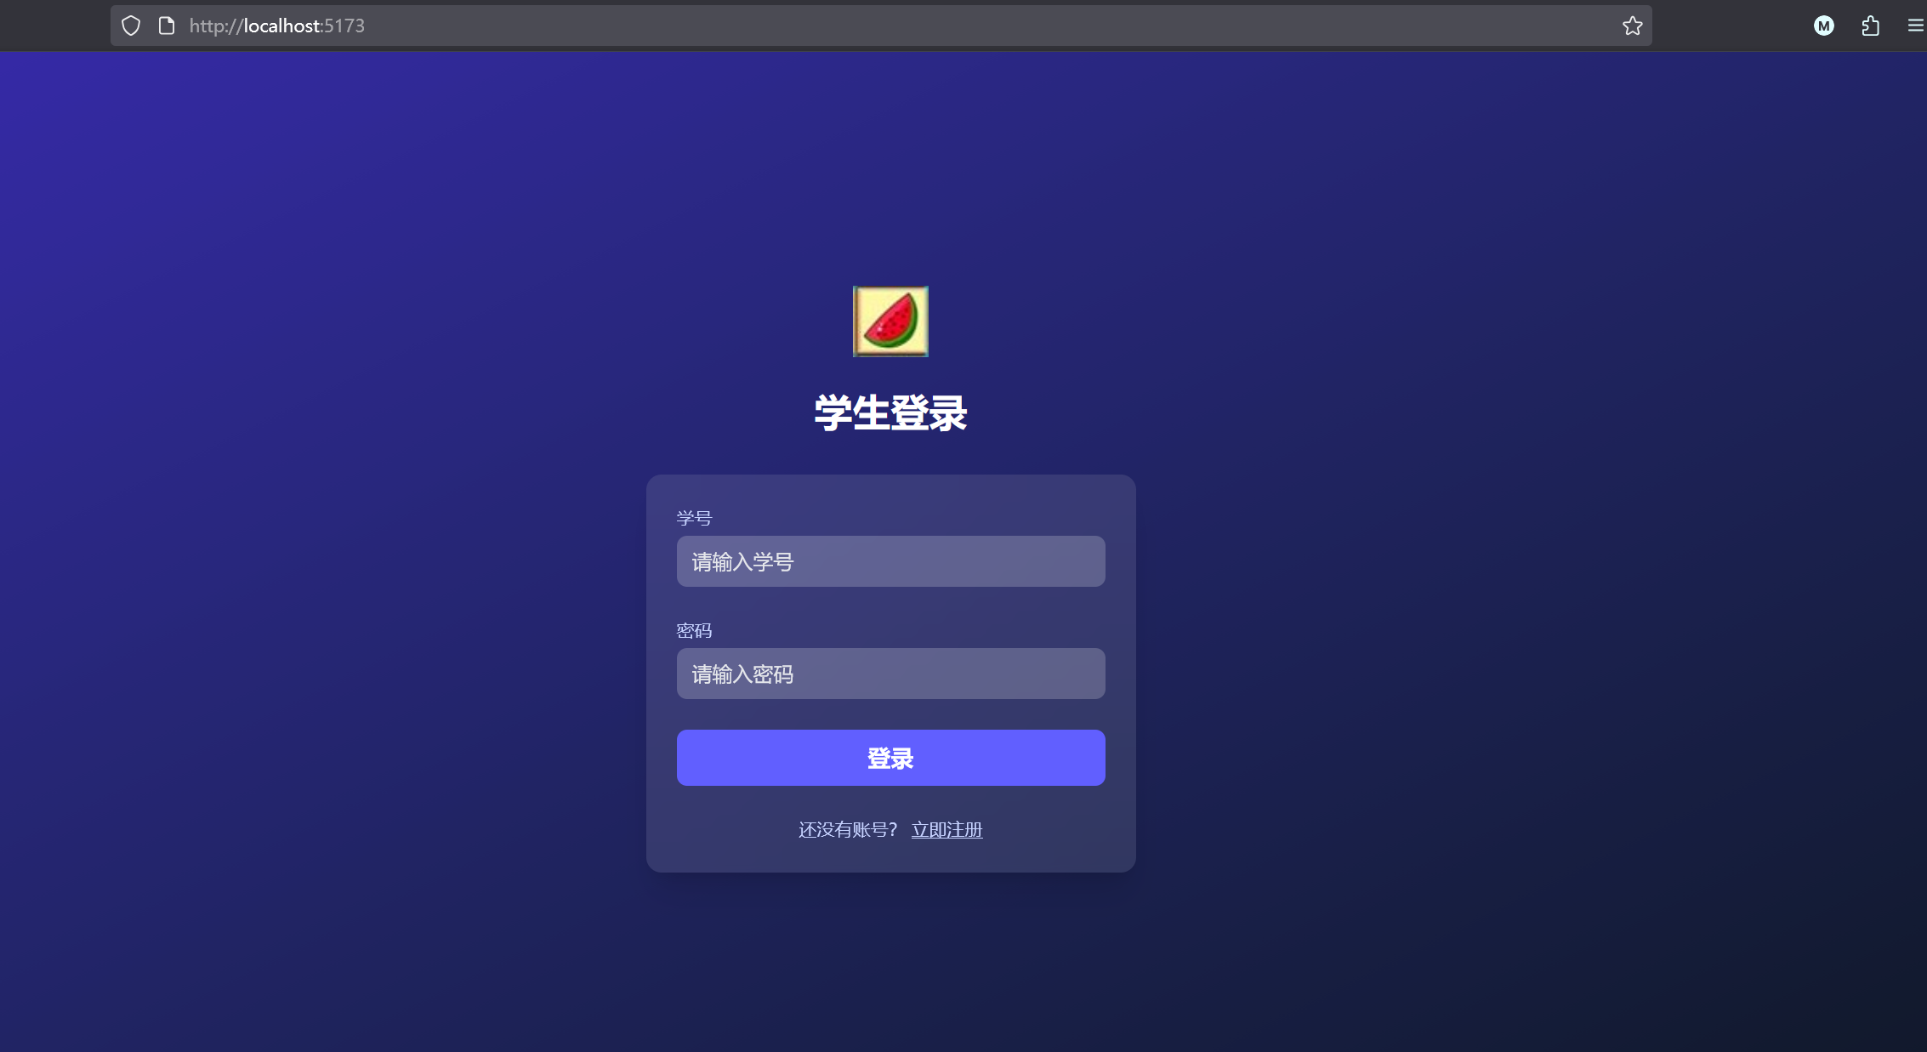
图1：Vue3 + tailwindcss 写的一个登录界面
前端页面在5173 默认端口，当用户输入正确账号和密码就能正常登录，数据库信息有两种访问途径 ：
- 通过第三方工具 Navicat 可视化查看 （图2）
- 用cmd/ powershell 登录Mysql ，通过sql命令 show 来查看
- 在后端应用设置 http://localhost:8081/ 端口，数据映射到/api/students 中，通过Hibernate 连接数据库，简化数据库链接操作（图3）
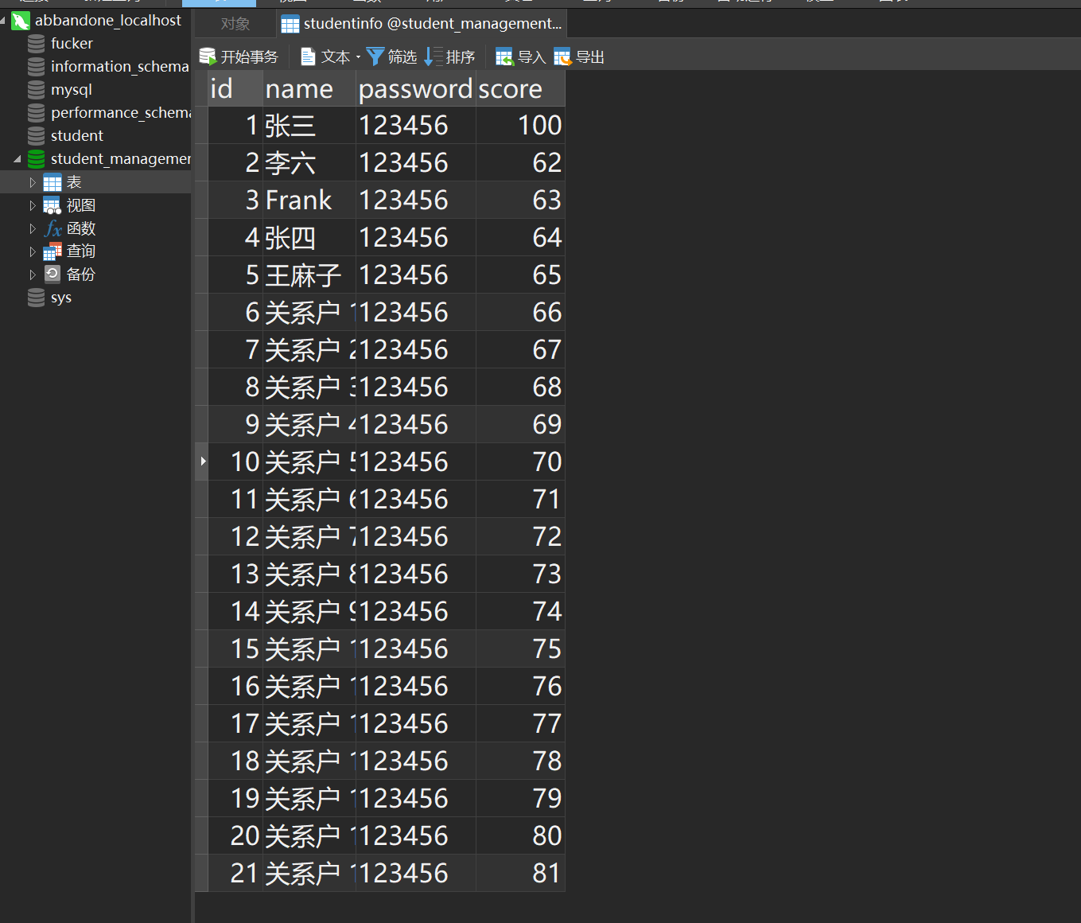
图2：Navicat 查询数据库存储信息

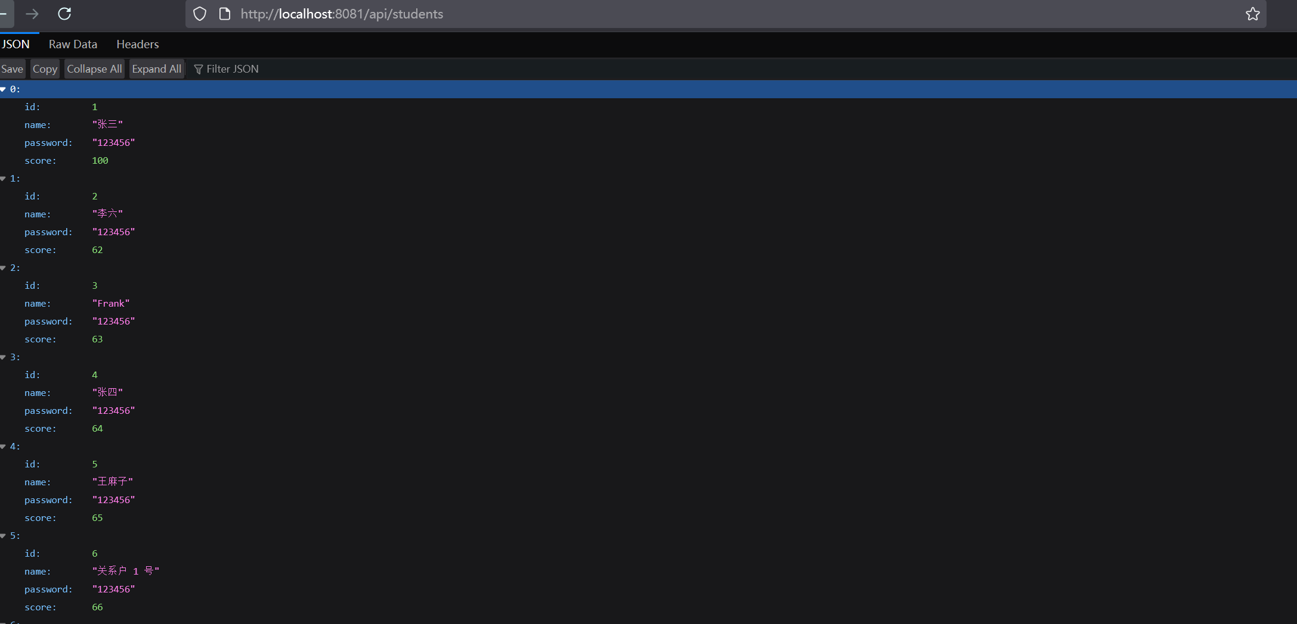
图3：本地8081端口 api/students 查看获取的数据信息

下面是用户交互性的描述：
当用户输入正确账号密码（id,password）
跳转 5173端口的score界面（对应 studentManagement.vue）

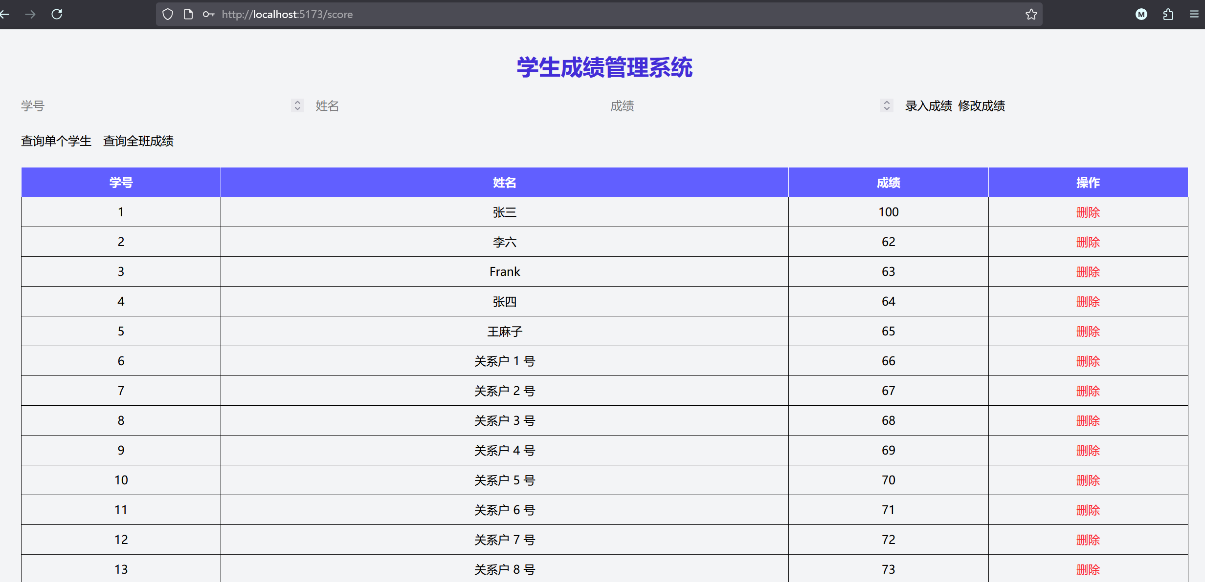
图4：登录成功跳转数据库操纵界面
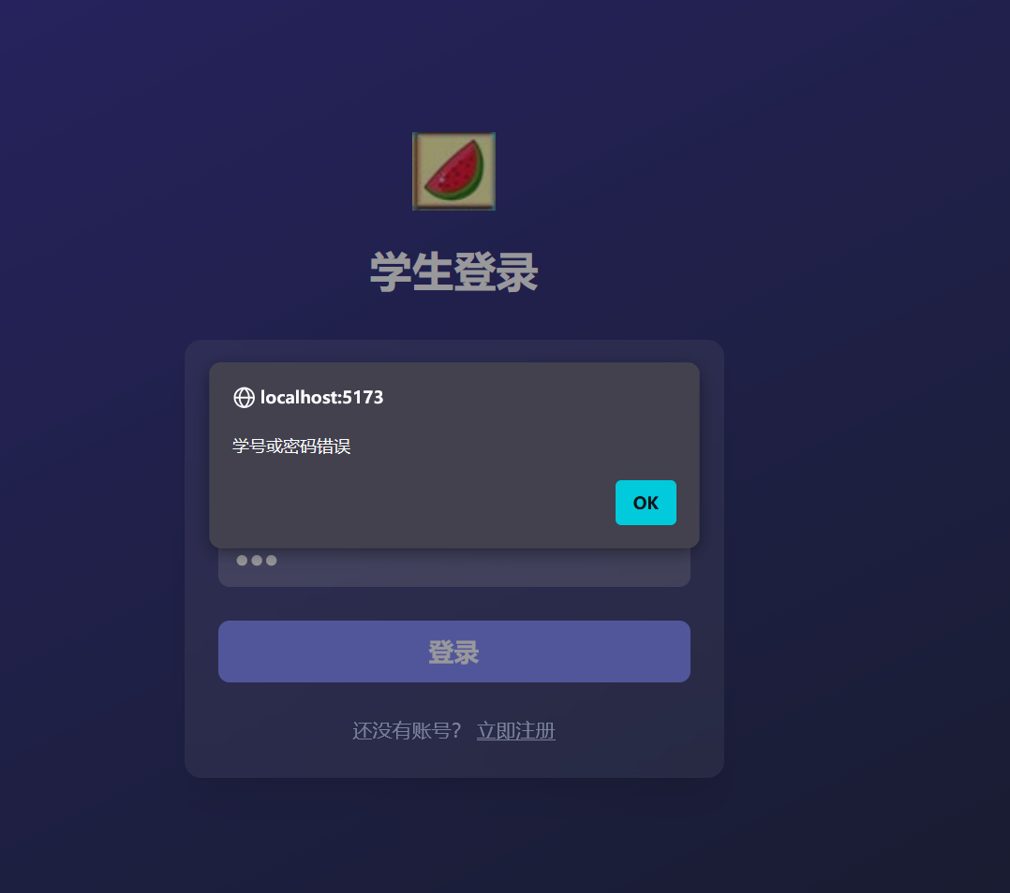
图5：账号或密码输入错误alert提示
当用户成功进入到数据库操作界面时：
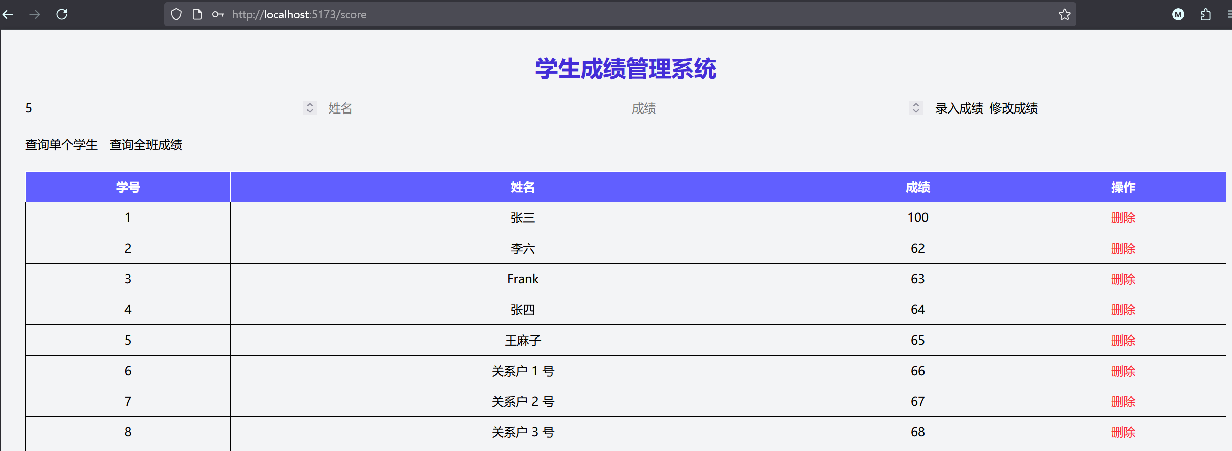
图6：数据库GUI基本操作
点击查询单个学生后：
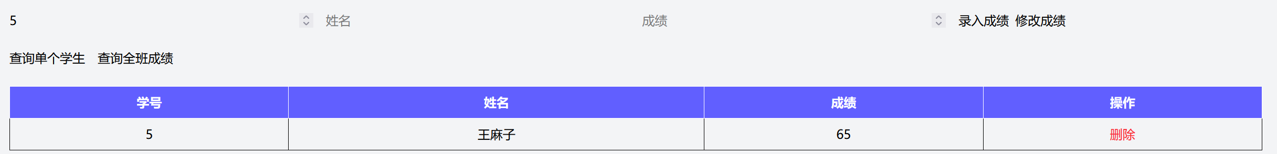
图7：返回单个学生信息
同理，当点击查询全班成绩的时候，会自动恢复原来状态，呈现所有数据库的学生信息

当我们输入学号或姓名（二选一）,在上方输入框输入新成绩的时候
点击上方最右侧的修改成绩按钮

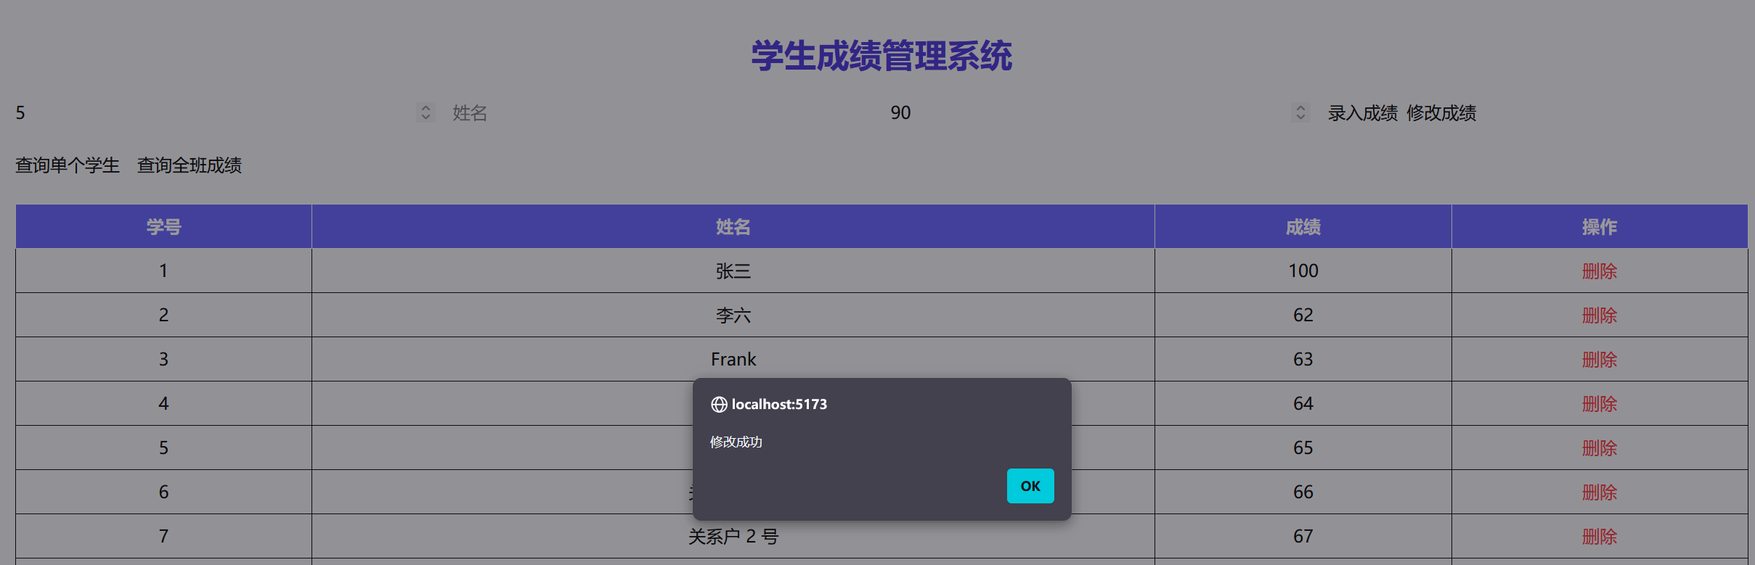
图8：修改单个学生成绩
因为原先批量插入了30个学生，从第31个学生学号进行插入
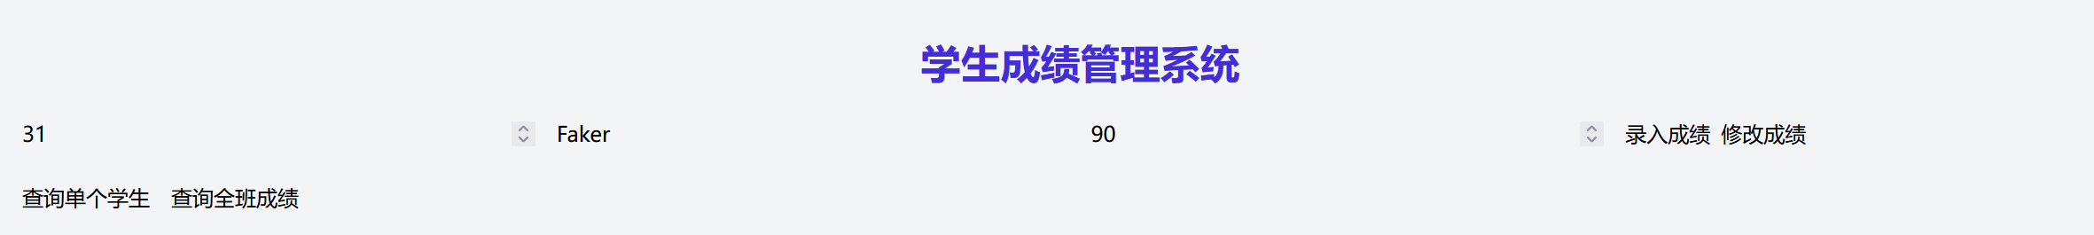
图9：录入学生成绩

当我们想删除这个学生的时候，我们只需要往下滑到底部，找到此学生的信息，点击右侧的删除操作即可

图10：删除学生操作

下面分前端和后端粘贴本次上机所有代码并标记

后端：

//CorsConfig.java (处理前后端交互问题)
package com.example.config;

import org.springframework.context.annotation.Configuration;
import org.springframework.web.servlet.config.annotation.CorsRegistry;
import org.springframework.web.servlet.config.annotation.WebMvcConfigurer;
import org.springframework.lang.NonNull;

@Configuration
public class CorsConfig implements WebMvcConfigurer {
@Override
public void addCorsMappings(@NonNull CorsRegistry registry) {
registry.addMapping("/api/**").allowedOrigins("http://localhost:5173").allowedMethods("GET", "POST", "PUT",
"DELETE", "OPTIONS").allowedHeaders("*").allowCredentials(true).maxAge(3600);
}
}

//LoginController.java(处理登录界面数据交互)
package com.example.controller;

import java.util.Map;
import java.util.Optional;
import org.springframework.beans.factory.annotation.Autowired;
import org.springframework.http.ResponseEntity;
import org.springframework.web.bind.annotation.CrossOrigin;
import org.springframework.web.bind.annotation.PostMapping;
import org.springframework.web.bind.annotation.RequestBody;
import org.springframework.web.bind.annotation.RequestMapping;
import org.springframework.web.bind.annotation.RestController;

import com.example.Entity.Student;
import com.example.services.studentService;

@RestController
@RequestMapping("/api")
@CrossOrigin(origins = "http://localhost:5173")
public class LoginController {
@Autowired
private studentService service;

@PostMapping("/login")
public ResponseEntity<Map<String, Object>> login(@RequestBody Map<String, String> loginRequest) {
String idString = loginRequest.get("id");
String password = loginRequest.get("password");

if (idString == null || password == null) {
return ResponseEntity.badRequest().body(Map.of("success", false, "message", "缺少学号或密码"));
}

try {
Long id = Long.parseLong(idString);
Optional<Student> studentOpt = service.getStudentById(id);

if (studentOpt.isPresent() && password.equals(studentOpt.get().getPassword())) {
return ResponseEntity.ok(Map.of(
"success", true,
"student", studentOpt.get()
));
} else {
return ResponseEntity.ok(Map.of("success", false, "message", "学号或密码错误"));
}
} catch (NumberFormatException e) {
return ResponseEntity.badRequest().body(Map.of("success", false, "message", "学号格式错误"));
}
}
}

//StudentController.java
package com.example.controller;
import org.springframework.web.bind.annotation.RestController;
import com.example.Entity.Student;
import com.example.services.studentService;
import org.springframework.beans.factory.annotation.Autowired;
import org.springframework.http.ResponseEntity;
import org.springframework.web.bind.annotation.RequestMapping;
import org.springframework.web.bind.annotation.PostMapping;
import org.springframework.web.bind.annotation.PutMapping;
import org.springframework.web.bind.annotation.RequestBody;
import org.springframework.web.bind.annotation.CrossOrigin;
import org.springframework.web.bind.annotation.DeleteMapping;
import org.springframework.web.bind.annotation.GetMapping;
import java.net.URI;
import java.util.List;
@RestController
@RequestMapping("/api/students")
@CrossOrigin(origins = "http://localhost:5173")
public class StudentController {
@Autowired
private studentService studentService;

@PostMapping
public ResponseEntity<Student> createStudent(@RequestBody Student student) {
Student savedStudent = studentService.saveStudent(student);
return ResponseEntity.created(URI.create("/api/students/" + savedStudent.getId())).body(savedStudent);
}
@GetMapping
public ResponseEntity<List<Student>> getAllStudents() {
List<Student> students = studentService.getAllStudents();
return ResponseEntity.ok(students);
}
@GetMapping("/{id}")
public ResponseEntity<Student> getStudentById(@org.springframework.web.bind.annotation.PathVariable Long id) {
return studentService.getStudentById(id)
.map(ResponseEntity::ok)
.orElse(ResponseEntity.notFound().build());
}
@PutMapping("/{id}")
public ResponseEntity<Student> updateStudent(@org.springframework.web.bind.annotation.PathVariable Long id,
@RequestBody Student updatedStudent) {
Student student = studentService.updateStudent(id, updatedStudent);
return ResponseEntity.ok(student);
}
@DeleteMapping("/{id}")
public ResponseEntity<Void> deleteStudent(@org.springframework.web.bind.annotation.PathVariable Long id) {
studentService.deleteStudent(id);
return ResponseEntity.noContent().build();
}
}

//Student.java

package com.example.Entity;

import jakarta.persistence.Entity;
import jakarta.persistence.GeneratedValue;
import jakarta.persistence.GenerationType;
import jakarta.persistence.Id;
import jakarta.persistence.Table;
import lombok.Getter;
import lombok.Setter;
@Entity
@Getter
@Setter
@Table(name = "studentinfo")
public class Student {
@Id
@GeneratedValue(strategy = GenerationType.IDENTITY)
private Long id;

private String name;
private String password;
private int score;

public Student() {
};
public Student(String name, int score,String password) {
this.name = name;
this.score = score;
this.password = password;
}

@Override
public String toString() {
return "Student [name=" + name + ", password=" + password + ", id=" + id + ", score=" + score + "]";
}
}

//StudentRepository.java

package com.example.repository;
import com.example.Entity.Student;
import org.springframework.data.jpa.repository.JpaRepository;

public interface studentRepository extends JpaRepository<Student, Long> {

}

//StudentService.java
package com.example.services;

import org.springframework.beans.factory.annotation.Autowired;
import org.springframework.stereotype.Service;
import java.util.List;
import java.util.Optional;

import com.example.Entity.Student;
import com.example.repository.studentRepository;

@Service

public class studentService {

@Autowired
private studentRepository studentConnector;

public List<Student> getAllStudents() {
return studentConnector.findAll();
}

public Optional<Student> getStudentById(Long id) {
return studentConnector.findById(id);
}

public Student saveStudent(Student student) {
return studentConnector.save(student);
}

public void deleteStudent(Long id) {
studentConnector.deleteById(id);
}

public Student updateStudent(Long id, Student updated) {
return studentConnector.findById(id).map(s -> {
s.setName(updated.getName());
s.setPassword(updated.getPassword());
s.setScore(updated.getScore());
return studentConnector.save(s);
}).orElseGet(() -> {
updated.setId(id);
return studentConnector.save(updated);
});
}

}

//StudentManagement.java
SpringBoot 启动文件

package com.example;

import org.springframework.boot.SpringApplication;
import org.springframework.boot.autoconfigure.SpringBootApplication;

@SpringBootApplication
public class StudentManagementApplication {

public static void main(String[] args) {
SpringApplication.run(StudentManagementApplication.class, args);
}
}

Pom.xml
<?xml version="1.0" encoding="UTF-8"?>
<project xmlns="http://maven.apache.org/POM/4.0.0" xmlns:xsi="http://www.w3.org/2001/XMLSchema-instance"
xsi:schemaLocation="http://maven.apache.org/POM/4.0.0 https://maven.apache.org/xsd/maven-4.0.0.xsd">
<modelVersion>4.0.0</modelVersion>
<parent>
<groupId>org.springframework.boot</groupId>
<artifactId>spring-boot-starter-parent</artifactId>
<version>3.5.7</version>
<relativePath/> <!-- lookup parent from repository -->
</parent>
<groupId>com.example</groupId>
<artifactId>student_management</artifactId>
<version>0.0.1-SNAPSHOT</version>
<name>student_management</name>
<description>Demo project for Spring Boot</description>
<properties>
<java.version>21</java.version>
</properties>
<dependencies>
<dependency>
<groupId>org.springframework.boot</groupId>
<artifactId>spring-boot-starter-web</artifactId>
</dependency>

<dependency>
<groupId>org.springframework.boot</groupId>
<artifactId>spring-boot-starter-test</artifactId>
<scope>test</scope>
</dependency>

<dependency>
<groupId>org.projectlombok</groupId>
<artifactId>lombok</artifactId>
<version>1.18.32</version>
<scope>provided</scope>
</dependency>

<dependency>
<groupId>com.mysql</groupId>
<artifactId>mysql-connector-j</artifactId>
<scope>runtime</scope>
</dependency>

<dependency>
<groupId>org.hibernate.orm</groupId>
<artifactId>hibernate-community-dialects</artifactId>
<version>6.4.4.Final</version>
</dependency>

<dependency>
<groupId>org.springframework.boot</groupId>
<artifactId>spring-boot-starter-data-jpa</artifactId>
</dependency>
</dependencies>

<build>
<plugins>
<plugin>
<groupId>org.springframework.boot</groupId>
<artifactId>spring-boot-maven-plugin</artifactId>
</plugin>
</plugins>
</build>
</project>

MainPage.vue
src/components/MainPage.vue
<script>
import axios from "axios";

export default {
name: "MainPage",
data() {
return {
id: "",
password: "",
};
},
methods: {
async login() {
if (!this.id || !this.password) {
alert("请填写学号和密码");
return;
}

try {
const res = await axios.post("http://localhost:8081/api/login", {
id: this.id,
password: this.password,
});

if (res.data.success) {
this.$router.push("/score");
} else {
alert("学号或密码错误");
}
} catch (err) {
console.error(err);
alert("登录失败，请检查后端服务");
}
},
},
};
</script>
<template>
<div
class="min-h-screen flex flex-col justify-center bg-linear-to-br from-indigo-800 to-gray-900 px-6 py-12"
>
<div class="mx-auto w-full max-w-sm">
<img src="../assets/five.jpg" alt="Logo" class="mx-auto h-14" />
<h2 class="mt-6 text-center text-3xl font-bold text-white">学生登录</h2>
</div>
<div
class="mt-8 mx-auto w-full max-w-sm bg-white/10 backdrop-blur-xl p-6 rounded-xl shadow-xl"
>
<div class="space-y-6">
<div>
<label class="block text-sm font-medium text-indigo-200">学号</label>
<input
v-model="id"
type="text"
placeholder="请输入学号"
class="mt-1 w-full rounded-lg px-3 py-2 bg-white/20 text-white placeholder-gray-200 outline-none"
/>
</div>

<div>
<label class="block text-sm font-medium text-indigo-200">密码</label>
<input
v-model="password"
type="password"
placeholder="请输入密码"
class="mt-1 w-full rounded-lg px-3 py-2 bg-white/20 text-white placeholder-gray-200 outline-none"
/>
</div>

<button
@click="login"
class="w-full py-2 rounded-lg bg-indigo-500 text-white text-lg font-bold hover:bg-indigo-400"
>
登录
</button>

<p class="text-center text-sm text-indigo-200">
还没有账号？
<span class="underline cursor-pointer hover:text-white"
>立即注册</span
>
</p>
</div>
</div>
</div>
</template>
<style scoped></style>

studentManagement.vue
src/components/studentManagemet.vue
<script>
import axios from "axios";
import { reactive, ref, onMounted } from "vue";
import "../style.css";
export default {
setup() {
const students = ref([]);
const student = reactive({ id: "", name: "", score: "" });

const apiBase = "http://localhost:8081/api/students";

const getAllStudents = async () => {
const res = await axios.get(apiBase);
students.value = res.data;
};

const searchStudent = async () => {
if (!student.id) {
alert("请输入学号");
return;
}
try {
const res = await axios.get(`${apiBase}/${student.id}`);
students.value = [res.data];
} catch (err) {
alert("未找到该学生");
}
};

const addStudent = async () => {
if (!student.name || !student.score) {
alert("请输入姓名和成绩");
return;
}
await axios.post(apiBase, { name: student.name, score: student.score });
alert("录入成功");
getAllStudents();
};

const updateStudent = async () => {
if (!student.id || !student.score) {
alert("请输入学号和新成绩");
return;
}
await axios.put(`${apiBase}/${student.id}`, {
name: student.name,
score: student.score,
});
alert("修改成功");
getAllStudents();
};

const deleteStudent = async (id) => {
if (!confirm("确定删除该学生？")) return;
await axios.delete(`${apiBase}/${id}`);
alert("删除成功");
getAllStudents();
};

onMounted(() => {
getAllStudents();
});

return {
students,
student,
getAllStudents,
searchStudent,
addStudent,
updateStudent,
deleteStudent,
};
},
};
</script>
<template>
<div class="min-h-screen bg-gray-100 p-8">
<h1 class="text-3xl font-bold text-center text-indigo-700 mb-6">
学生成绩管理系统
</h1>

<!-- 操作表单 -->
<div class="grid grid-cols-1 md:grid-cols-4 gap-4 mb-6">
<input
v-model="student.id"
type="number"
placeholder="学号"
class="inputStyle"
/>
<input
v-model="student.name"
type="text"
placeholder="姓名"
class="inputStyle"
/>
<input
v-model="student.score"
type="number"
placeholder="成绩"
class="inputStyle"
/>
<div class="flex space-x-2">
<button @click="addStudent" class="btn-indigo">录入成绩</button>
<button @click="updateStudent" class="btn-green">修改成绩</button>
</div>
</div>

<!-- 查询按钮 -->
<div class="flex space-x-4 mb-6">
<button @click="searchStudent" class="btn-yellow">查询单个学生</button>
<button @click="getAllStudents" class="btn-blue">查询全班成绩</button>
</div>

<!-- 表格显示 -->
<table class="min-w-full border">
<thead>
<tr class="bg-indigo-500 text-white">
<th class="py-2 border">学号</th>
<th class="py-2 border">姓名</th>
<th class="py-2 border">成绩</th>
<th class="py-2 border">操作</th>
</tr>
</thead>
<tbody>
<tr v-for="s in students" :key="s.id">
<td class="py-2 border text-center">{{ s.id }}</td>
<td class="py-2 border text-center">{{ s.name }}</td>
<td class="py-2 border text-center">{{ s.score }}</td>
<td class="py-2 border text-center">
<button
@click="deleteStudent(s.id)"
class="text-red-500 hover:underline"
>
删除
</button>
</td>
</tr>
</tbody>
</table>
</div>
</template>
<style scoped></style>

Index.js
处理路由
src/router/index.js
import { createRouter, createWebHistory } from "vue-router";
import MainPage from "../components/MainPage.vue";
import studentManagement from "../components/studentManagement.vue";

const routes = [
{ path: "/", name: "login", component: MainPage },
{ path: "/score", name: "studentManagement", component: studentManagement },
];

const router = createRouter({
history: createWebHistory(),
routes,
});

export default router;

package.json
{
"name": "student_fronted",
"private": true,
"version": "0.0.0",
"type": "module",
"scripts": {
"dev": "vite",
"build": "vite build",
"preview": "vite preview"
},
"dependencies": {
"@tailwindcss/vite": "^4.1.17",
"axios": "^1.13.2",
"vue": "^3.5.24",
"vue-router": "^4.6.3"
},
"devDependencies": {
"@vitejs/plugin-vue": "^6.0.1",
"autoprefixer": "^10.4.22",
"postcss": "^8.5.6",
"tailwindcss": "^4.1.17",
"vite": "^7.2.2"
}
}

