Table of Contents

**Introduction**……….1

**Wire framing**2

homepage2

biography4

CV6

Contact8

**Screen Mock-up** 9

Home page9

biography10

CV11

Contact12

**Testing**3

Home page3

biography4

CV5

Contact6

**Conclusion**……….1

**Reference**……….1

Introduction

An assignment was given to us to create our own website using only HTML5 and CSS3. Before creating my portfolio, I searched for other peoples portfolios and got inspiration about how I could make and style my own portfolio. I got different ideas to create the website and started creating the wireframe for it. Initially, I chose a simple design and then through lecture and tutorial class and taking inspiration from others I found myself doing a more complex designs which I had never done before. Making mobile responsive was not an easy task.

Making a web page with only HTML5 and CSS3 without the help J Query and JavaScript was not easy. Though there were many problems that were faced while making the website. The problem was overcome by research and discussion with friends and teacher. I dedicated total of 60 hours on this assignment.

**Wire framing**

These are the different stages of wire framing that was done to make my portfolio. Initial contains preliminary stage and final contains the final design of the website.

Home page

Home page contains a menu bar which consist links of bio, CV and contact page. Footer contains different social media buttons on the left of Facebook, pinterest, instagram, twitter and copyright information on the right.

Initial

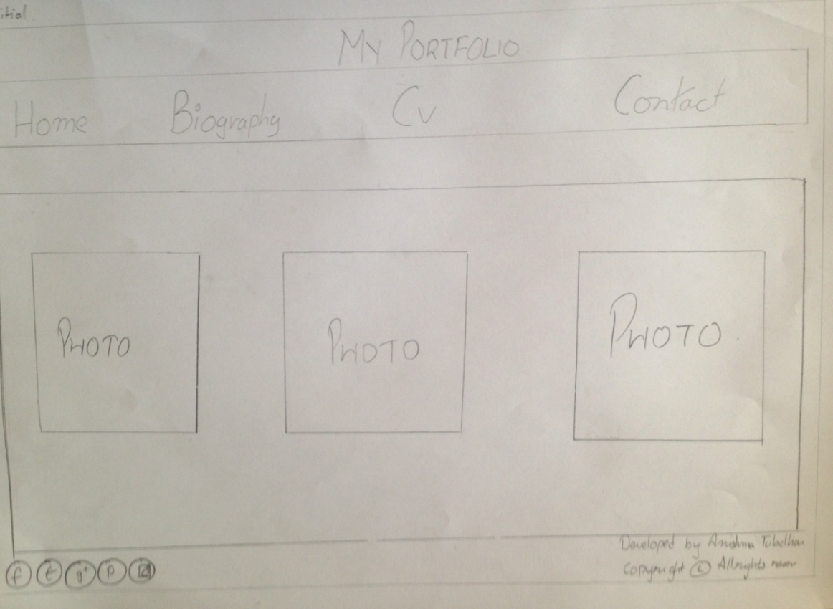

Initially the section contained three images of the places that I had visited over the years. First picture is the view of peace pagoda. Second page contains the view of phewa-taal. The third image is of Anapurna range. The picture flips from x-axis one time.

Final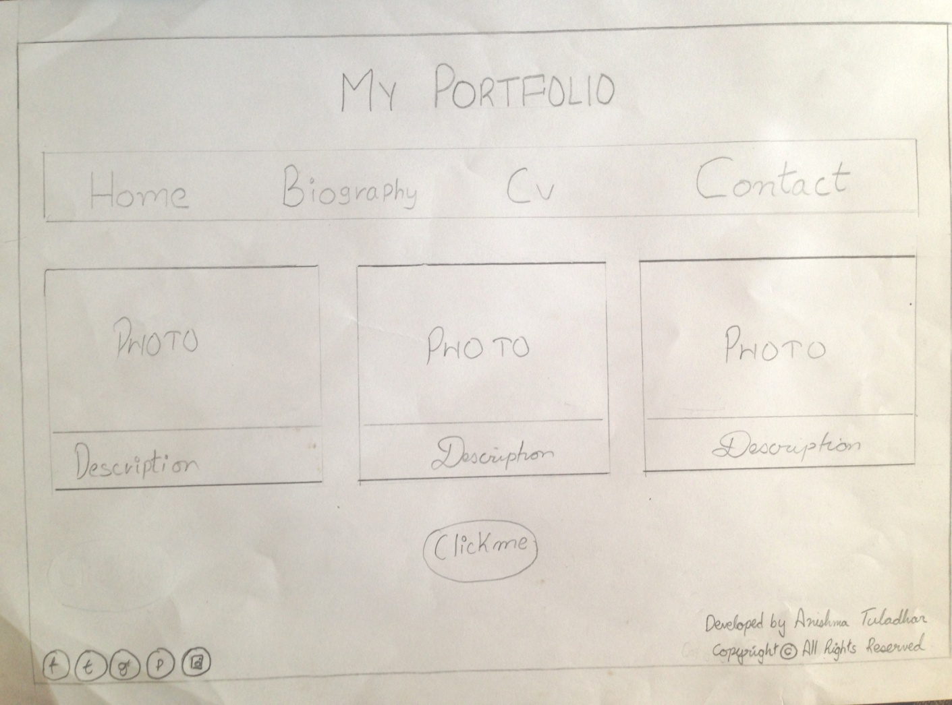

The page looked very simple and dull. So, after a lot of thoughts and research I decided to put a border for the image and write short description about the photos. The photo flips two times. Initially the homepage did not contain any information about me. I added a button when clicked displayed some information about me.

Biography

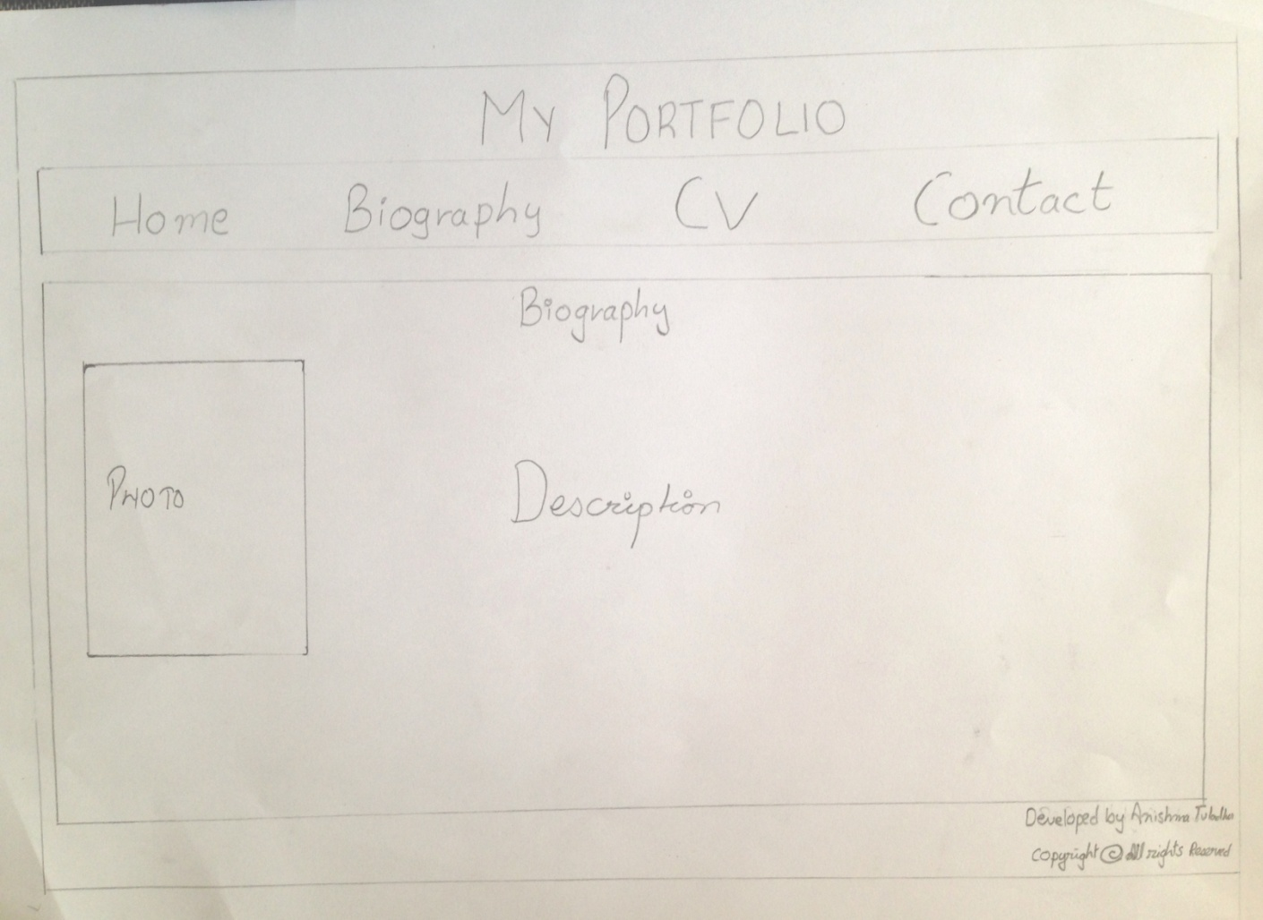

Biography contains a menu bar which consist links of bio, CV and contact page. Footer contains different social media buttons on the left of Facebook, pinterest, instagram, twitter and copyright information on the right. Section contains a photo on the left and some a short description on the right. In the footer there are different social media buttons and copyright information.

CV

CV (curriculum Vitae) contains a menu bar which consist links of home, biography and contact page. Footer contains different social media buttons on the left of Facebook, pinterest, instagram, twitter and copyright information on the right.

Initial

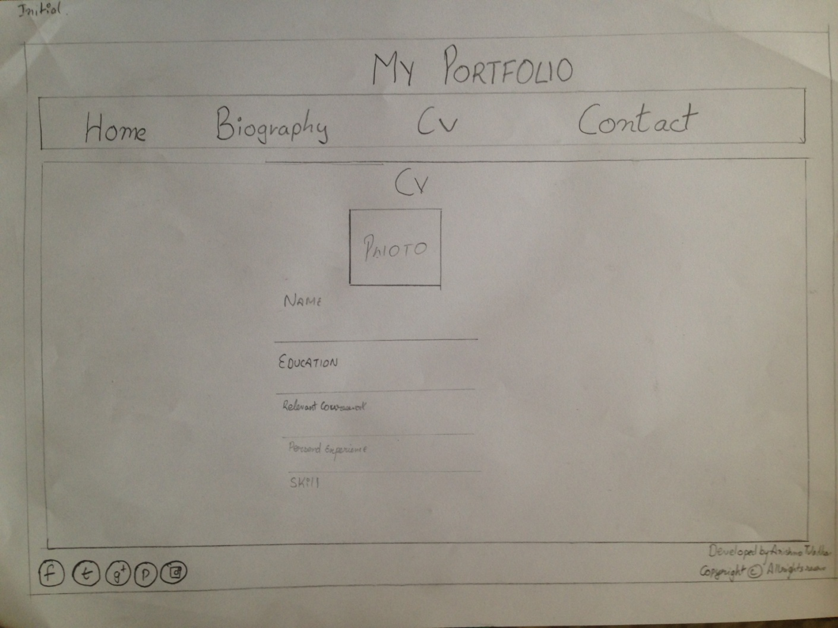

Initially, in the CV page. The section contained a photo and resume which contained name, education, relevant coursework, personal experience and skills

Final

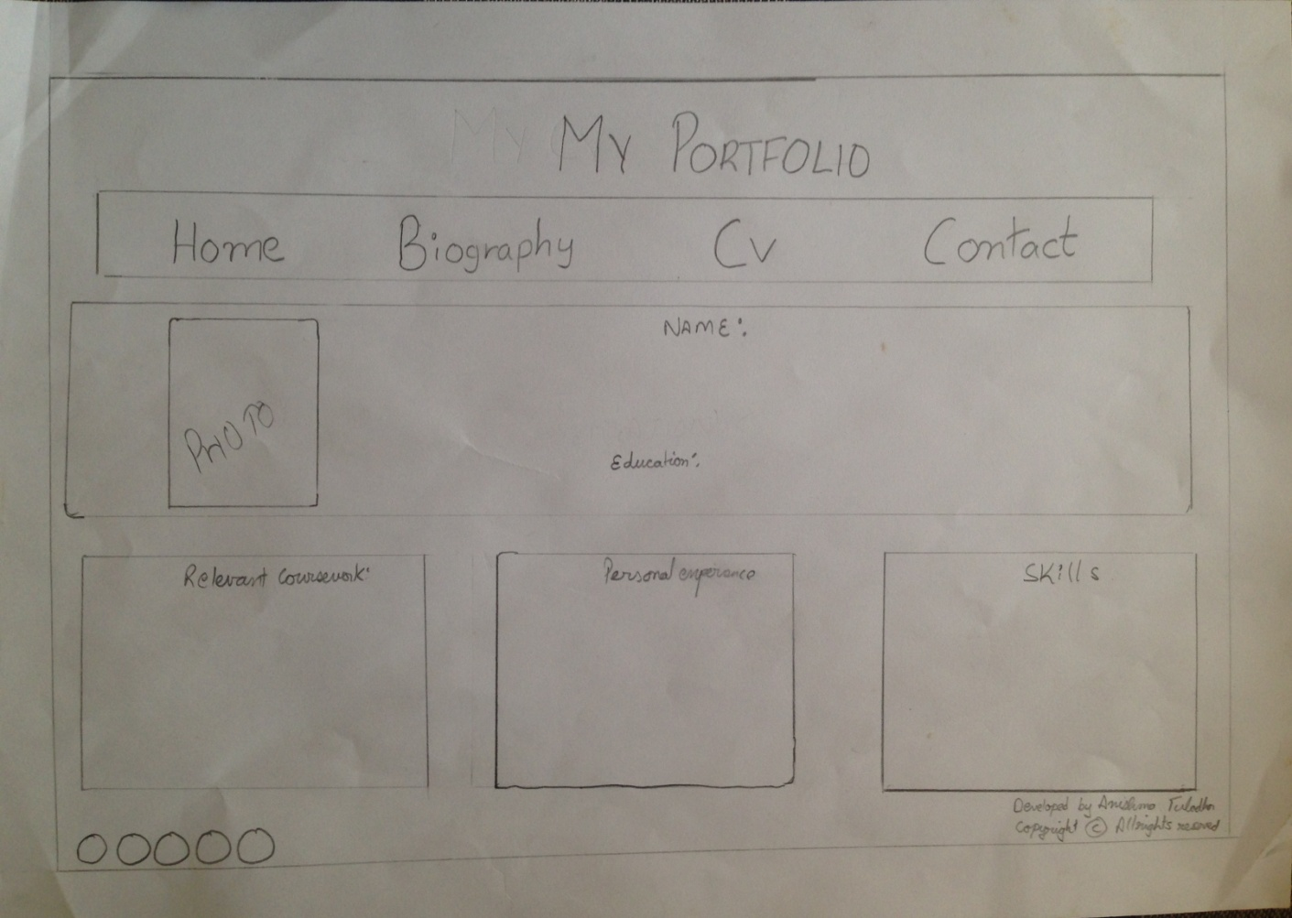I adapted the main design from the initial page and kept basic information to the right and kept extra information like skill, personal experience and relevant coursework in separate boxes on the bottom.

Contact

Contact contains a menu bar which consist links of home, biography and CV page. Footer contains different social media buttons on the left of Facebook, pinterest, instagram, twitter and copyright information on the right.

Initial

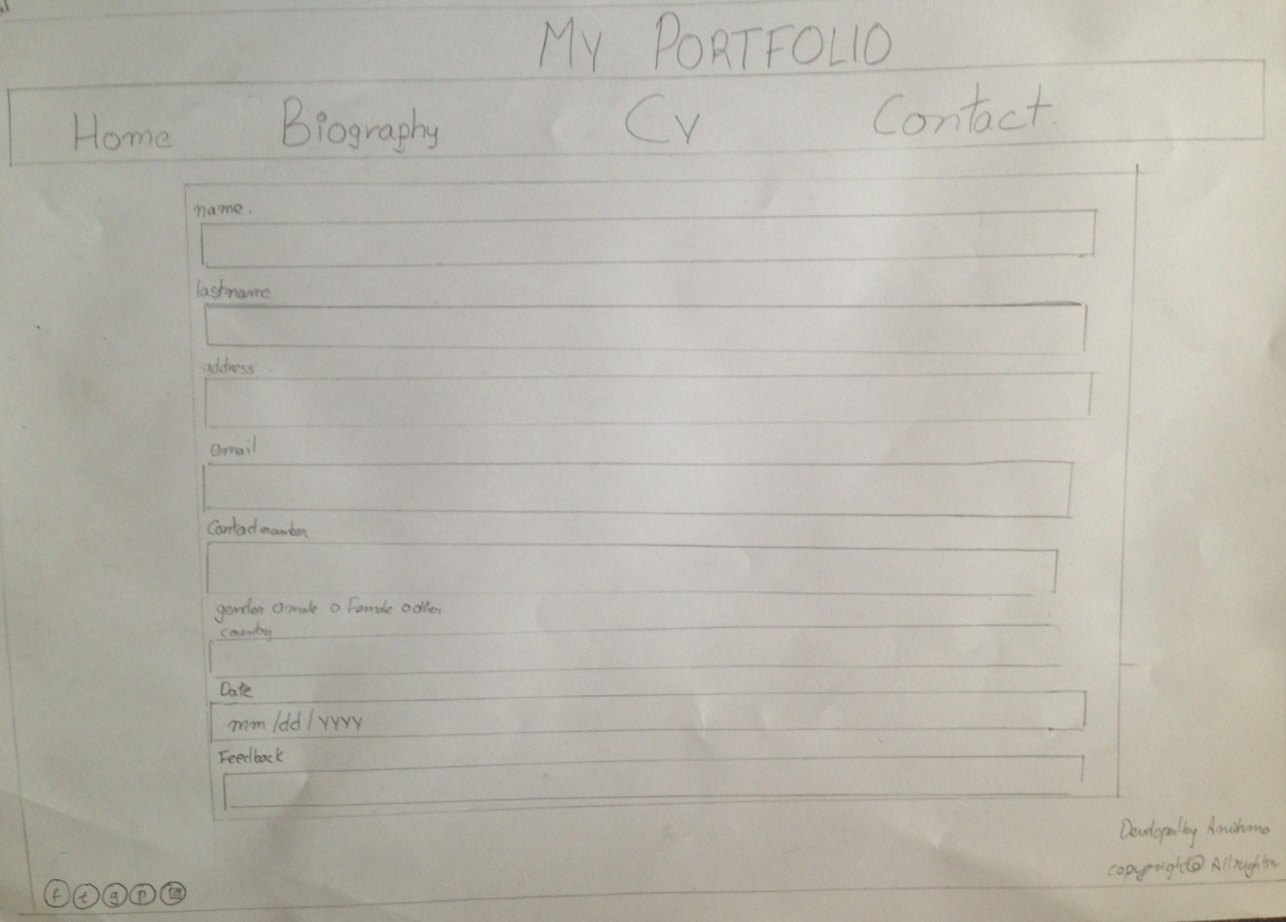

Initially, the section contained a static form to contact me and a send button to submit the form.

Final

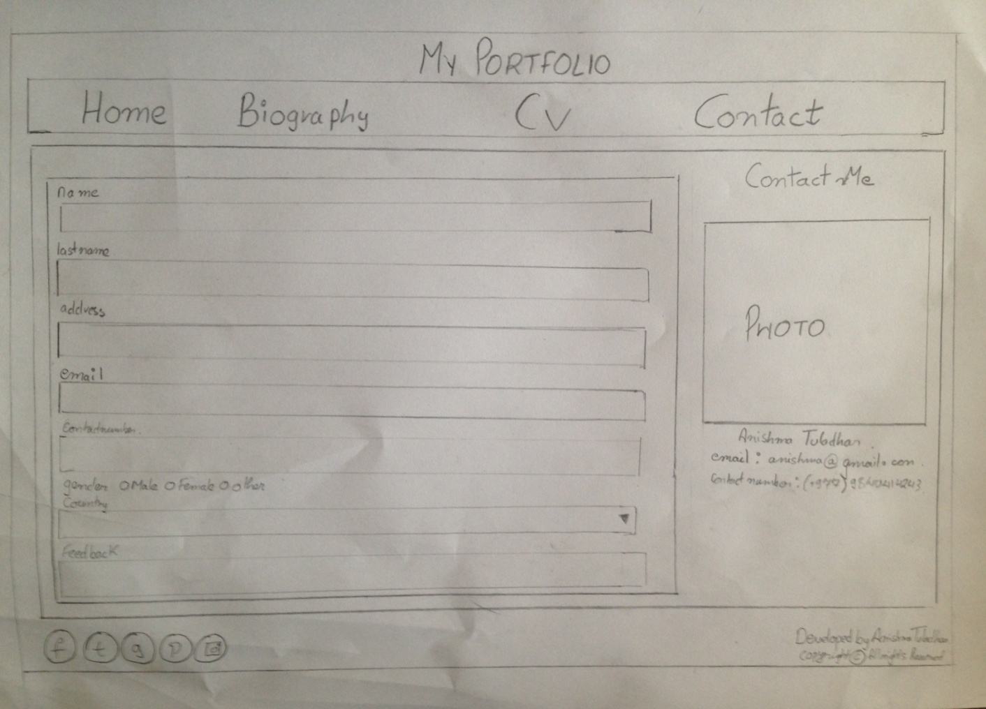

The page looked empty. To make it more attractive a photo and contact information was added to the right side of the contact form.

**Screen Mockup**

**Home Page**

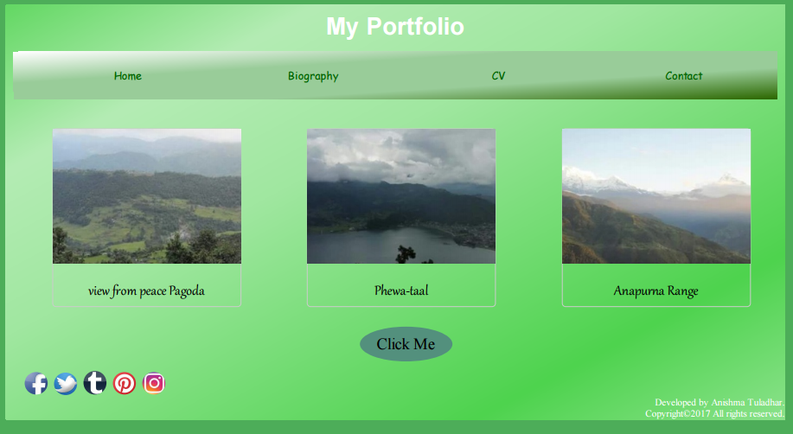

# This is the home page. Header contains the menu bar which has links to other pages. Linear gradient is used in the background of color hex code #2C6700, #99CC99 and white. When hovered the color of that link will change into color #006400.Section contain three pictures that were taken when I visited Pokhara. When the picture is hovered it rotates at y-axis in 360deg, two times. A short description is present in the bottom of the picture. Click me button is present in the page. When the click me button is pressed information about me is displayed. The footer contains buttons for Facebook, Twitter, Tumblr, Pinterest and Instagram on the left and copyright information is present on the right.

# Biography

# 

# This is the Biography page. Header contains the menu bar which has links to other pages. Linear gradient is used in the background of color hex code #2C6700, #99CC99 and white. When the color of that link is hovered will change into color #006400.section contains a photo on the left which rotates 360deg when hovered. A short is written on the right about my education, my hobbies achievement. The footer contains buttons for Facebook, Twitter, Tumblr, Pinterest and Instagram on the left and copyright information is present on the right.

# CV

# 

# This is the CV page. Header contains the menu bar which has links to other pages. Linear gradient is used in the background of color hex code #2C6700, #99CC99 and white. When the color of that link is hovered will change into color #006400.Section contains 4 blocks. The first block contains a picture on the left and some information on the right. Block second, third and fourth contain relevant coursework, Personal experience, skills respectively. The footer contains buttons for Facebook, Twitter, Tumblr, Pinterest and Instagram on the left and copyright information is present on the right.

**Contact**

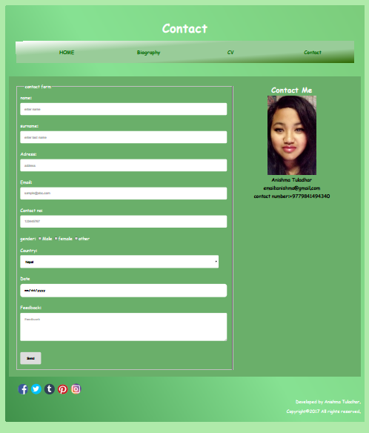

# This is the Contact page. Header contains the menu bar which has links to other pages. Linear gradient is used in the background of color hex code #2C6700, #99CC99 and white. When the color of that link is hovered will change into color #006400.Section contains a staic form on the left and contact information is present on the right. The footer contains buttons for Facebook, Twitter, Tumblr, Pinterest and Instagram on the left and copyright information is present on the right.

# Mobile Responsive

# When the website is opened in mobile the menu bar is displayed in column and all the pictures are also displayed in column and footer is also displayed in column.

# 

**Testing.**

Homepage

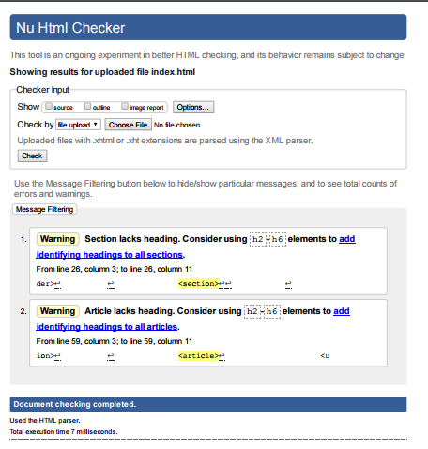

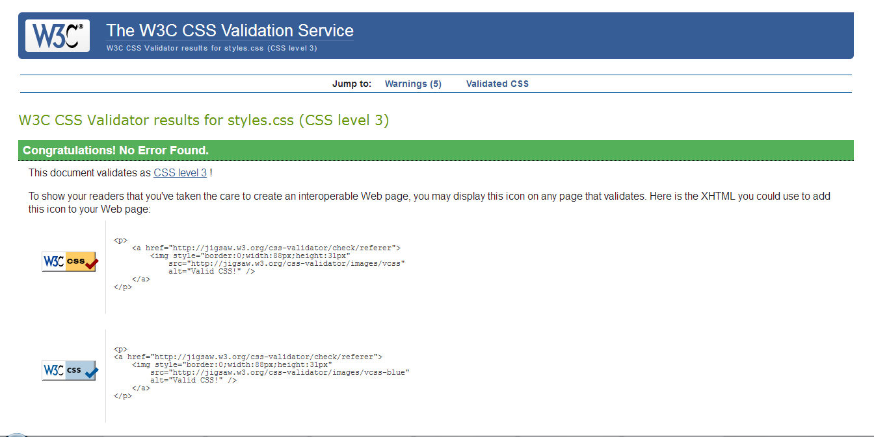

biography

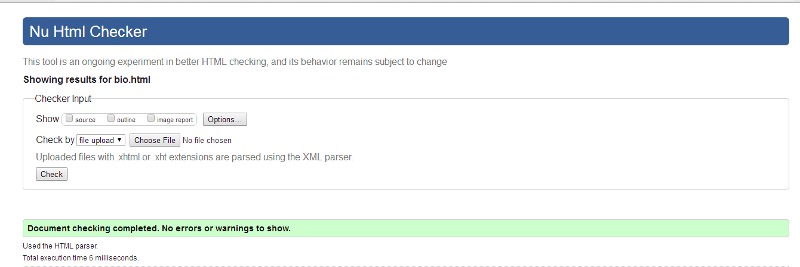

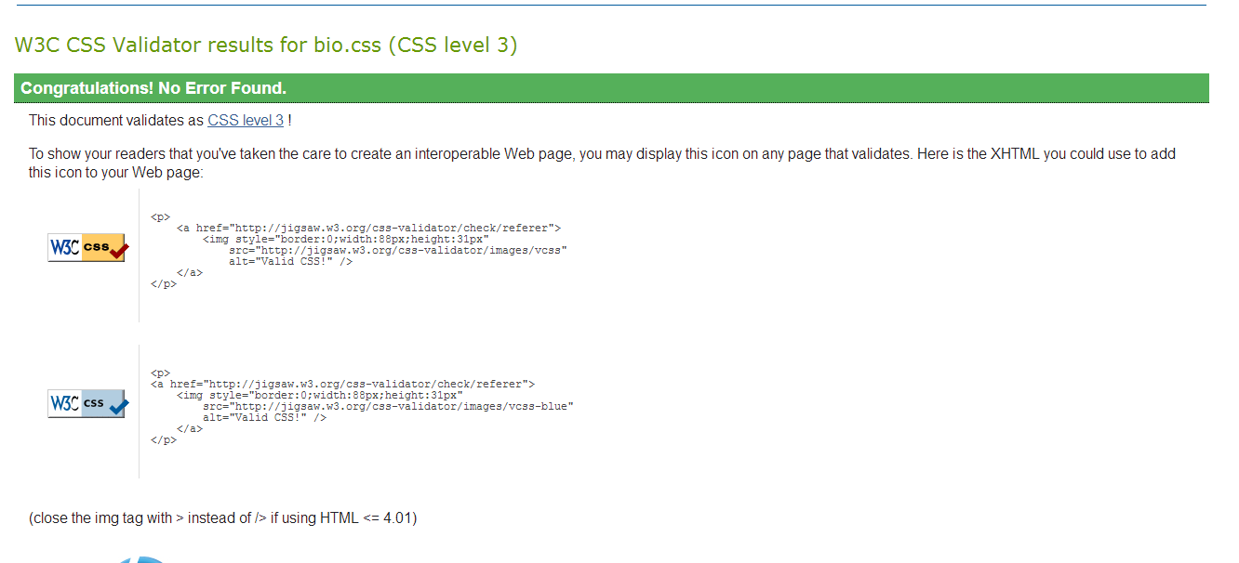

cv

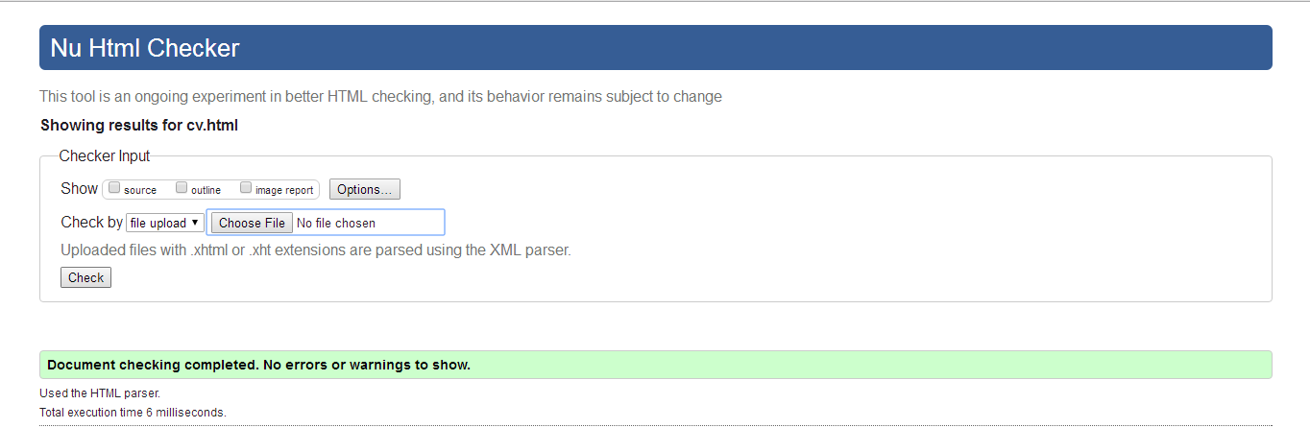

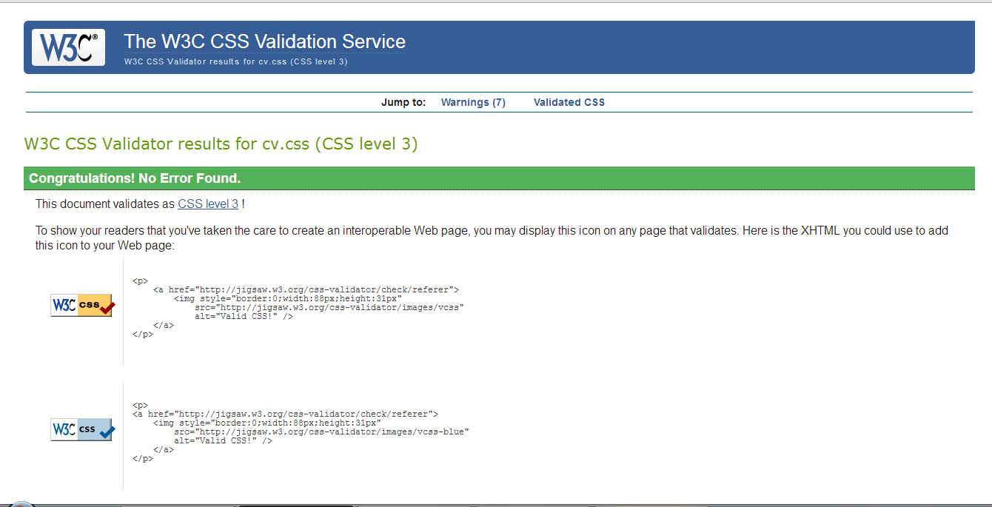

contact

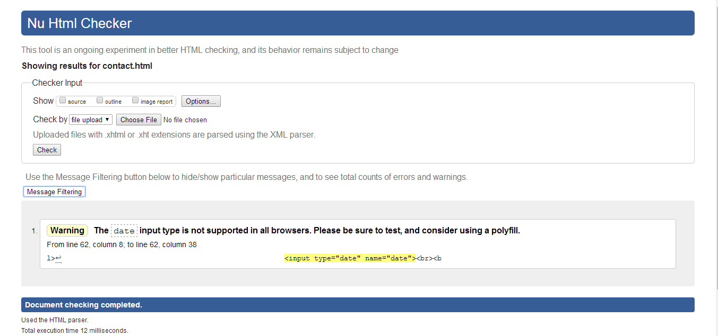

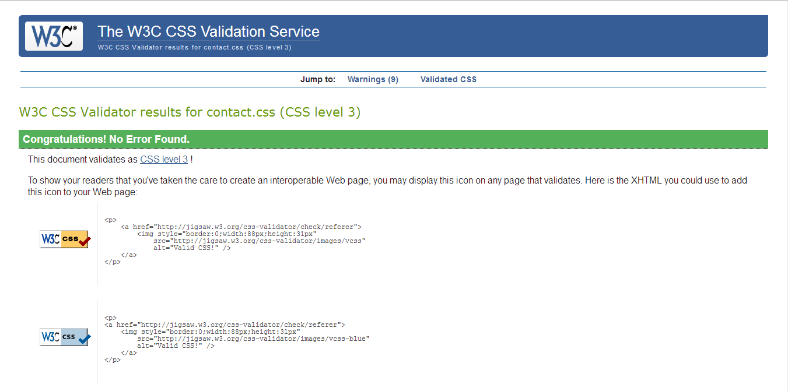

**Conclusion**

It was very challenging to make the website. Lot of research had to done to make the website.

I wanted to keep image slider in the home page but due to limited time I could not keep it.I wanted.

**References**

1. The W3C CSS Validation Service. 2017. The W3C CSS Validation Service. [ONLINE] Available at: https://jigsaw.w3.org/css-validator. [Accessed 08 April 2017].
2. CSSForms. 2017. CSS Forms. [ONLINE] Available at: https://www.w3schools.com/css/css_form.asp. [Accessed 08 April 2017].