Simple Home Styling

Easy Decorating

**T**

o get started, just tap or click this placeholder text and begin typing. You can view and edit this document on your Mac, iPad, iPhone, or on iCloud.com.

It’s easy to edit text, change fonts, and add beautiful graphics. Use paragraph styles to get a consistent look throughout your document. For example, this paragraph uses Body style. You can change it in the Text tab of the Format controls.

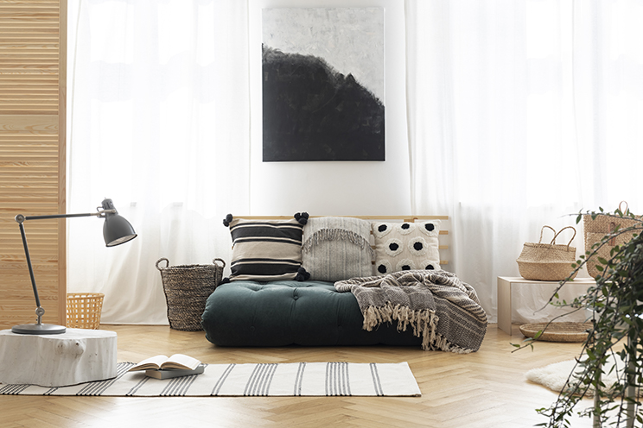

Drag your own photo onto the image placeholder above, then crop or resize it if you wish.

Tap or click this placeholder and start typing to replace the image caption, or turn it off in the Format controls.

To add photos, image galleries, audio clips, videos, charts, or any of more than 700 customizable shapes, tap or click one of the insert buttons in the toolbar or drag and drop the objects onto the page. You can layer objects, resize them, and place them anywhere on the page. To change how an object moves with text, select the object and then tap or click the Arrange tab in the Format controls.

# Heading

You can use Pages for both word processing and page layout. This Contemporary Report template is set up for word processing, so your text flows from one page to the next as you type, with new pages created automatically when you reach the end of a page.

In page layout documents, you can manually rearrange pages and freely position text boxes, images, and other objects on the page. To create a page layout document, choose a page layout template in the template chooser. You can also change this document to page layout on your Mac, iPad, or iPhone by turning off Document Body in the Document controls.