# Head

**HEAD** is a reference to the last commit in the currently check-out branch. You can think of the**HEAD** as the "current branch". When you switch branches with **git** checkout, the **HEAD** revision changes to point to the tip of the new branch.

# Git caret and tilde HEAD~ and HEAD^

ref~ is shorthand for ref~1 and means the commit's first parent. ref~2 means the commit's first parent's first parent. ref~3 means the commit's first parent's first parent's first parent. And so on.

ref^ is shorthand for ref^1 and means the commit's first parent. But where the two differ is that ref^2 means the commit's second parent(remember, commits can have two parents when they are a merge).

The ^ and ~ operators can be combined.

Here's a diagram showing how to reference various commits using HEAD as the starting point.

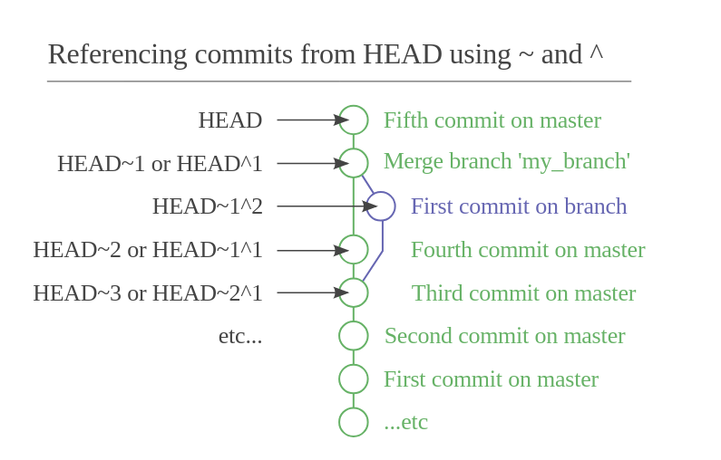

************

HEAD~ is shorthand for HEAD~1, but here this means the first ancestor of HEAD – HEAD~2 is not the second parent of HEAD but the grandparent of HEAD:

**************

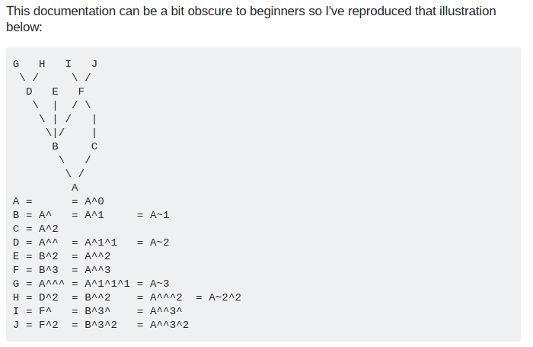

************** https://stackoverflow.com/a/29120883/2897115

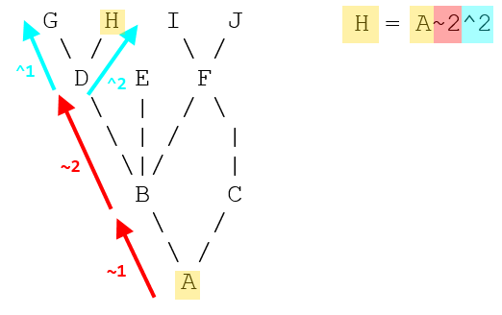

*************** https://stackoverflow.com/a/48465635/2897115

~ is what you want most of the time, it references past commits to the current branch

^ references parents (git-merge creates a 2nd parent or more)

A~ is always the same as A^

A~~ is always the same as A^^, and so on

A~2 is not the same as A^2 however,

because ~2 is shorthand for ~~

while ^2 is not shorthand for anything, it means the 2nd parent

****************

way to remember: '~' is "fuzzy" or "approximate" (i.e., you only get the first parent) while '^' is precise (so goes through every single commit).

************

## HEAD@{}

It is worth noting that git also has a syntax for tracking "from-where-you-came"/"want-to-go-back-now" - for example, HEAD@{1} will reference the place from where you jumped to new commit location.

Basically HEAD@{} variables capture the history of HEAD movement, and you can decide to use a particular head by looking into reflogs of git using the command git reflog.

Example:

0aee51f HEAD@{0}: reset: moving to HEAD@{5} 290e035 HEAD@{1}: reset: moving to HEAD@{7}

0aee51f HEAD@{2}: reset: moving to HEAD@{3} 290e035 HEAD@{3}: reset: moving to HEAD@{3}

9e77426 HEAD@{4}: reset: moving to HEAD@{3} 290e035 HEAD@{5}: reset: moving to HEAD@{3}

0aee51f HEAD@{6}: reset: moving to HEAD@{3} 290e035 HEAD@{7}: reset: moving to HEAD@{3}

9e77426 HEAD@{8}: reset: moving to HEAD@{3} 290e035 HEAD@{9}: reset: moving to HEAD@{1}

0aee51f HEAD@{10}: reset: moving to HEAD@{4} 290e035 HEAD@{11}: reset: moving to HEAD^

9e77426 HEAD@{12}: reset: moving to HEAD^ eb48179 HEAD@{13}: reset: moving to HEAD~

f916d93 HEAD@{14}: reset: moving to HEAD~ 0aee51f HEAD@{15}: reset: moving to HEAD@{5}

f19fd9b HEAD@{16}: reset: moving to HEAD~1 290e035 HEAD@{17}: reset: moving to HEAD~2

eb48179 HEAD@{18}: reset: moving to HEAD~2 0aee51f HEAD@{19}: reset: moving to HEAD@{5}

eb48179 HEAD@{20}: reset: moving to HEAD~2 0aee51f HEAD@{21}: reset: moving to HEAD@{1}

f916d93 HEAD@{22}: reset: moving to HEAD@{1} 0aee51f HEAD@{23}: reset: moving to

HEAD@{1} f916d93 HEAD@{24}: reset: moving to HEAD^ 0aee51f HEAD@{25}: commit (amend): 3rd commmit 35a7332 HEAD@{26}: checkout: moving from temp2_new_br to temp2_new_br

35a7332 HEAD@{27}: commit (amend): 3rd commmit 72c0be8 HEAD@{28}: commit (amend): 3rd commmit

An example could be that I did local-commits a->b->c->d and then I went back discarding 2 commits to check my code - git reset HEAD~2 - and then after that I want to move my HEAD back to d - git reset HEAD@{1}.

# git commit --amend:: Changing the Last/previous Commit git commit --amend: git commit --amend

|  |
| --- |
| The git commit --amend command is a convenient way to modify the most recent commit.  *** It lets you combine staged changes with the previous commit instead of creating an entirely new commit.  Now lets suppose we want to remove a line from the previous commit. So we change the file (remove the desired line) and then  git add -A or git add file to stage the changes.  NOw using this staged changes we amend the previous commit  git commit --amend (it opens vim then do :wq!)  Vi editor is opened so that you can change the commit message. But if you think you want to quit vim and still do some more changes in files then q! Will not work, it will create a commit. So to avoid that  in vim you can perform this with  :cq!  It can also be used to simply edit the previous commit message without changing its snapshot.  But, amending does not just alter the most recent commit, it replaces it entirely, meaning the amended commit will be a new entity with its own ref.  To Git, it will look like a brand new commit, which is visualized with an asterisk (*) in the diagram below.  # after amend check the status which files are modified  git --no-pager show --stat  HOw to push:  Git push ( will not work )  $ git push  Enter passphrase for key '/home/simha/.ssh/id_rsa':  To github.com:sant527/django_basic_documentation.git  ! [rejected] master -> master (non-fast-forward)  error: failed to push some refs to 'git@github.com:sant527/django_basic_documentation.git'  hint: Updates were rejected because the tip of your current branch is behind  hint: its remote counterpart. Integrate the remote changes (e.g.  hint: 'git pull ...') before pushing again.  hint: See the 'Note about fast-forwards' in 'git push --help' for details.  Solution: (https://stackoverflow.com/questions/39399804/updates-were-rejected-because-the-tip-of-your-current-branch-is-behind)  git push -f  The -f is actually required because of the rebase. Whenever you do a rebase you would need to do a force push becasue the remote branch cannot be fast-forwarded to your commit. |

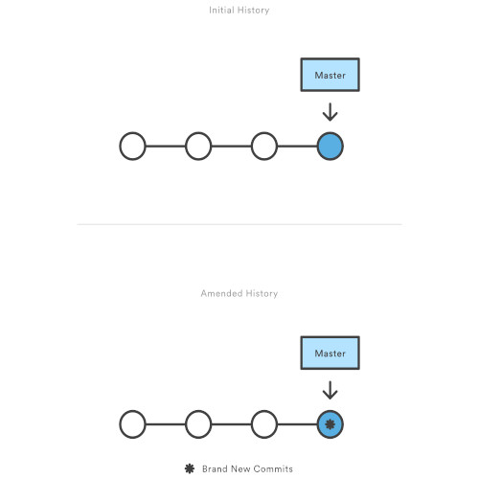

# Checkout: Understanding how "checkout" works

With the "**git checkout**" command, you determine which revision of your project you want to work on. Git then places all of that revision's files in your working copy folder.

Normally, you use a *branch name* to communicate with "git checkout":

$ git checkout development

# What's a "detached HEAD"

However, you *can* also provide the *SHA1 hash* of a specific commit instead:

$ git checkout 56a4e5c08

Note: checking out '56a4e5c08'.

You are in 'detached HEAD' state...

This exact state - when a specific *commit* is checked out instead of a *branch* - is what's called a "detached HEAD".

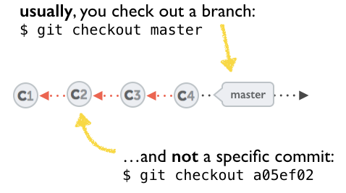

## The problem with a detached HEAD

The HEAD pointer in Git determines your current working revision (and thereby the files that are placed in your project's working directory). Normally, when checking out a proper branch name, Git automatically moves the HEAD pointer along when you create a new commit. You are automatically on the newest commit of the chosen branch.

When you instead choose to check out a *commit hash*, Git won't do this for you. The consequence is that when you make changes and commit them, these **changes do NOT belong to any branch**.

This means they can easily get lost once you check out a different revision or branch: not being recorded in the context of a branch, you lack the possibility to access that state easily (unless you have a brilliant memory and can remember the commit hash of that new commit...).

# Merge Commit or Rebase

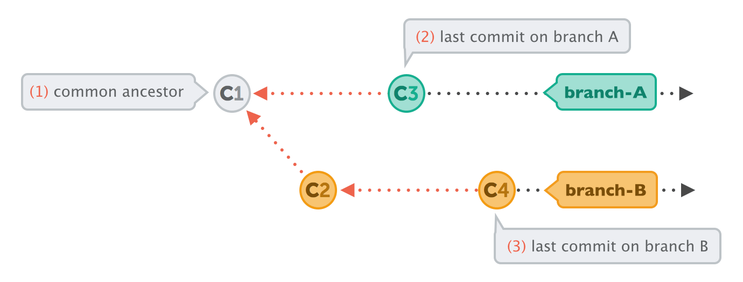

To make an integration, Git will have to create a new commit that contains the differences between them - the merge commit.

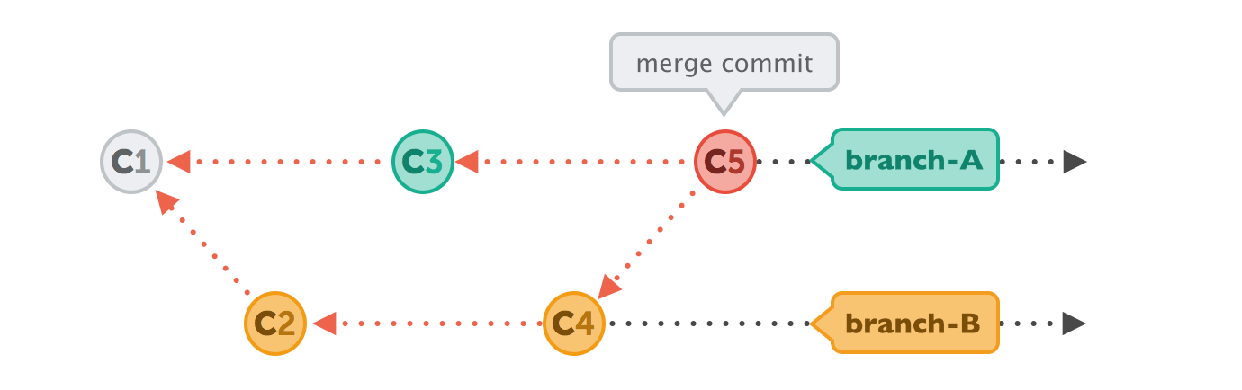

## Human Commits & Merge Commits

## Normally, a commit is carefully created by a human being. It's a meaningful unit that wraps only related changes and annotates them with a comment.

## A merge commit is a bit different: instead of being created by a developer, it gets created *automatically* by Git. And instead of wrapping a set of related changes, its purpose is to connect two branches, just like a knot. If you want to understand a merge operation later, you need to take a look at the history of *both* branches and the corresponding commit graph.

## Integrating with Rebase

Some people prefer to go without such automatic merge commits. Instead, they want the project's history to look as if it had evolved in a single, straight line. No indication remains that it had been split into multiple branches at some point.

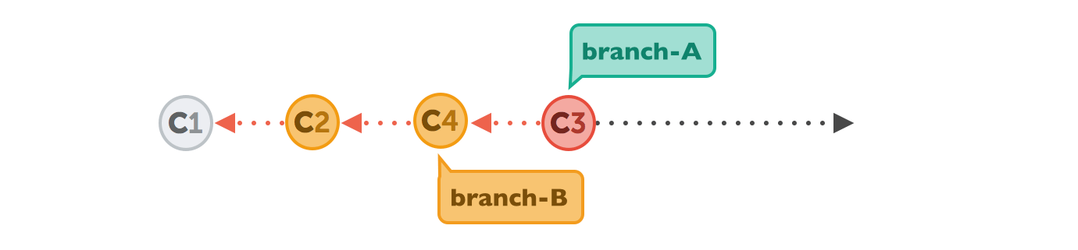

Let's walk through a rebase operation step by step. The scenario is the same as in the previous examples: we want to integrate the changes from branch-B into branch-A, but now by using rebase.

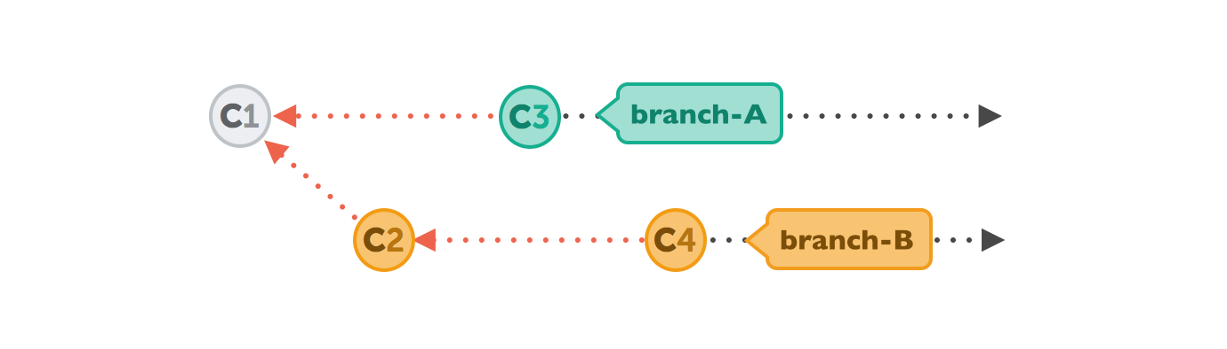

The command for this is very plain:

$ git rebase branch-B

First, Git will "undo" all commits on branch-A that happened after the lines began to branch out (after the common ancestor commit). However, of course, it won't discard them: instead you can think of those commits as being "*saved away temporarily*".

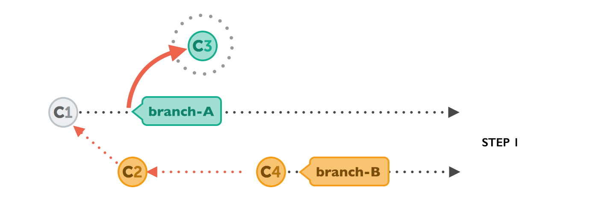

Next, it applies the commits from branch-B that we want to integrate. At this point, both branches look exactly the same.

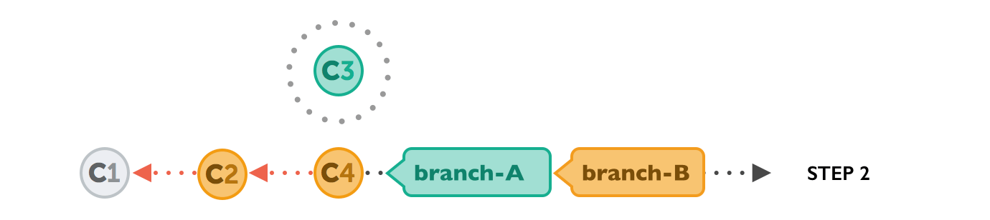

In the final step, the new commits on branch-A are now reapplied - but on a new position, on top of the integrated commits from branch-B (they are *re-based*).

The result looks like development had happened in a straight line. Instead of a merge commit that contains all the combined changes, the original commit structure was preserved.

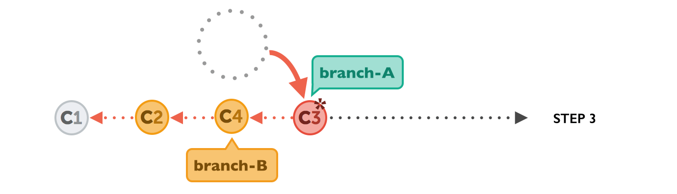

## The Pitfalls of Rebase

Of course, using rebase isn't just sunshine and roses. You can easily shoot yourself in the foot if you don't mind an important fact: **rebase rewrites history**.

As you might have noticed in the last diagram above, commit "C3*" has an asterisk symbol added. This is because, although it has the same contents as "C3", it's effectively a different commit. The reason for this is that it now has a new parent commit (C4, which it was rebased onto, compared to C1, when it was originally created).

A commit has only a handful of important properties like the author, date, changeset - and who its parent commit is. Changing any of this information effectively creates a completely new commit, with a new hash ID.

Rewriting history in such a way is unproblematic as long as it only affects commits that haven't been published, yet. If instead you're rewriting commits that have already been pushed to a public server, danger is at hand: another developer has probably already based work on the original C3 commit, making it indispensable for other newer commits. Now you introduce the contents of C3 another time (with C3*), and additionally try to remove the original C3 from the timeline with your rebase. This smells like trouble...

Therefore, you should use rebase only for cleaning up your local work - but never to rebase commits that have already been published.

# Git log, Branch and checkout

To test a specific commit, you need the hash. To get the hash you can run git log , then you get this output:

|  |
| --- |
| $ git log  commit 566b923a16548c22ab958b650c0f7acd0580d492 (HEAD -> master, basicdjango/master)  Author: santhosh <simharupa.rns@gmail.com>  Date: Fri Apr 5 13:41:20 2019 +0530  Second Commit: django-environ and .env and setttings.py and sensitive information secure  commit 7931de35c661351d7cc6168bd50e6658c9a416dd  Author: santhosh <simharupa.rns@gmail.com>  Date: Fri Apr 5 00:41:48 2019 +0530  First Commit: Fresh virtualenv with pipenv and install django and remove SECRETKEY |

More ways to see log:

|  |
| --- |
| $ git log --oneline --decorate  566b923 (HEAD -> master, basicdjango/master) Second Commit: django-environ and .env and setttings.py and sensitive information secure  7931de3 First Commit: Fresh virtualenv with pipenv and install django and remove SECRETKEY |

Git branch

<https://git-scm.com/book/en/v2/Git-Branching-Branches-in-a-Nutshell>

|  |
| --- |
| Git doesn’t store data as a series of changesets or differences, but instead as a series of *snapshots*. |

|  |
| --- |
| When you make a commit, Git stores a commit object that contains a pointer to the snapshot of the content you staged. This object also contains the author’s name and email address, the message that you typed, and pointers to the commit or commits that directly came before this commit (its parent or parents): zero parents for the initial commit, one parent for a normal commit, and multiple parents for a commit that results from a merge of two or more branches. |

|  |
| --- |
| If you make some changes and commit again, the next commit stores a pointer to the commit that came immediately before it. |

|  |
| --- |
| A branch in Git is simply a lightweight movable pointer to one of these commits. The default branch name in Git is master. As you start making commits, you’re given a master branch that points to the last commit you made. Every time you commit, the master branch pointer moves forward automatically. |

|  |
| --- |
| Creating a New Branch What happens when you create a new branch? Well, doing so creates a new pointer for you to move around. Let’s say you want to create a new branch called testing. You do this with the git branchcommand:  $ git branch testing  This creates a new pointer to the same commit you’re currently on. |

|  |
| --- |
| How does Git know what branch you’re currently on? It keeps a special pointer called HEAD.  In this case, you’re still on master. The git branch command only *created* a new branch — it didn’t switch to that branch  You can easily see this by running a simple git log command that shows you where the branch pointers are pointing. This option is called --decorate.  $ git log --oneline --decorate  f30ab (HEAD -> master, testing) add feature #32 - ability to add new formats to the central interface  34ac2 Fixed bug #1328 - stack overflow under certain conditions  98ca9 The initial commit of my project  You can see the “master” and “testing” branches that are right there next to the f30ab commit. |

|  |
| --- |
| Switching Branches To switch to an existing branch, you run the git checkout command. Let’s switch to the new testingbranch:  $ git checkout testing  This moves HEAD to point to the testing branch.  What is the significance of that? Well, let’s do another commit:  $ vim test.rb  $ git commit -a -m 'made a change'  This is interesting, because now your testing branch has moved forward, but your master branch still points to the commit you were on when you ran git checkout to switch branches. Let’s switch back to the master branch  git checkout master  **That command did two things. It moved the HEAD pointer back to point to the master branch, and it reverted the files in your working directory back to the snapshot that master points to.**  **This also means the changes you make from this point forward will diverge from an older version of the project. It essentially rewinds the work you’ve done in your testing branch so you can go in a different direction.**  **Switching branches changes files in your working directory**  **It’s important to note that when you switch branches in Git, files in your working directory will change. If you switch to an older branch, your working directory will be reverted to look like it did the last time you committed on that branch. If Git cannot do it cleanly, it will not let you switch at all.** |

|  |
| --- |
| Creating a new branch and switching to it at the same time  It’s typical to create a new branch and want to switch to that new branch at the same time — this can be done in one operation with git checkout -b <newbranchname>.  git checkout -b <newbranchname>.  $ git branch <newbranchname>.  $ git checkout <newbranchname>. |

|  |
| --- |
| $ git branch -d iss53 (how to delete a branch |

# fixing up mistakes

|  |
| --- |
| **Git toolbox** provides multiple unique tools for fixing up mistakes during your development. Commands such as git reset, git checkout, and git revert allow you to **undo** erroneous changes in your repository. |

# Git revert vs reset

Use git revert like so:

git revert <insert bad commit hash here>

git revert creates a new commit with the changes that are rolled back.

git reset erases your git history instead of making a new commit.

The steps after are the same as any other commit.

# Git revert

The git revert command can be considered an 'undo' type command, however, it is not a traditional undo operation. Instead of removing the commit from the project history, it figures out how to invert the changes introduced by the commit and appends a new commit with the resulting inverse content. This prevents Git from losing history, which is important for the integrity of your revision history and for reliable collaboration.

Reverting should be used when you want to apply the inverse of a commit from your project history. This can be useful, for example, if you’re tracking down a bug and find that it was introduced by a single commit. Instead of manually going in, fixing it, and committing a new snapshot, you can use git revert to automatically do all of this for you.



Other 'undo' commands like, [git checkout](https://www.atlassian.com/git/tutorials/using-branches/git-checkout) and [git reset](https://www.atlassian.com/git/tutorials/undoing-changes/git-reset), move the HEAD and branch ref pointers to a specified commit.

Where as

Git revert also takes a specified commit, however, git revert does not move ref pointers to this commit. A revert operation will take the specified commit, inverse the changes from that commit, and create a new "revert commit". The ref pointers are then updated to point at the new revert commit making it the tip of the branch.

Note that the 3rd commit is still in the project history after the revert. Instead of deleting it, git revert added a new commit to undo its changes. As a result, the 2nd and 4th commits represent the exact same code base and the 3rd commit is still in our history just in case we want to go back to it down the road.

-e

--edit

This is a default option and doesn't need to be specified. This option will open the configured system editor and prompts you to edit the commit message prior to committing the revert.

## Advantage of revert

First, it doesn’t change the project history, which makes it a “safe” operation for commits that have already been published to a shared repository.

Second, git revert is able to target an individual commit at an arbitrary point in the history, whereas git reset can only work backward from the current commit.

For example, if you wanted to undo an old commit with git reset, you would have to remove all of the commits that occurred after the target commit, remove it, then re-commit all of the subsequent commits.

# Resetting, Checking Out & Reverting

A reset is an operation that takes a specified commit and resets the "three trees" to match the state of the repository at that specified commit. A reset can be invoked in three different modes which correspond to the three trees.

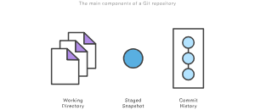

These components are sometimes know as "The three trees" of Git.

Checkout and reset are generally used for making local or private 'undos'. They modify the history of a repository that can cause conflicts when pushing to remote shared repositories. Revert is considered a safe operation for 'public undos' as it creates new history which can be shared remotely and doesn't overwrite history remote team members may be dependent on.

# Git reset

## Reset A Specific Commit

On the commit-level, resetting is a way to move the tip of a branch to a different commit. This can be used to remove commits from the current branch. For example, the following command moves the hotfix branch backwards by two commits.

git checkout hotfix

git reset HEAD~2

The two commits that were on the end of hotfix are now dangling, or orphaned commits. This means they will be deleted the next time Git performs a garbage collection. In other words, you’re saying that you want to throw away these commits. This can be visualized as the following:

# Checkout old commits

The git checkout command is used to update the state of the repository to a specific point in the projects history. When passed with a branch name, it lets you switch between branches.

git checkout hotfix

Internally, all the above command does is move HEAD to a different branch and update the working directory to match. Since this has the potential to overwrite local changes, Git forces you to commit or [stash](https://www.atlassian.com/git/tutorials/saving-changes/git-stash) any changes in the working directory that will be lost during the checkout operation. Unlike git reset, git checkout doesn’t move any branches around.

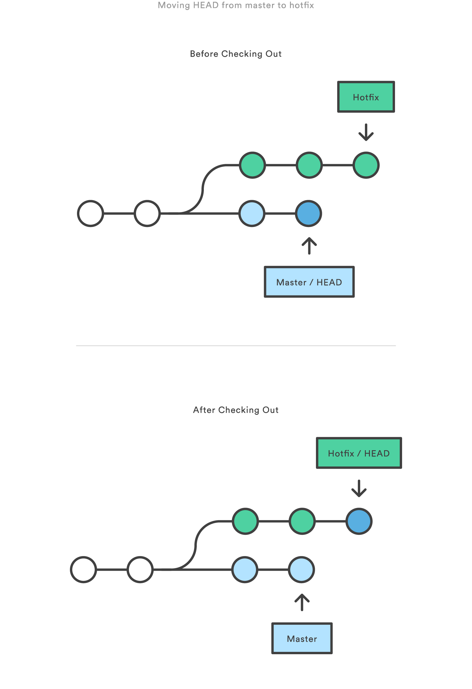

You can also check out arbitrary commits by passing the commit reference instead of a branch. This does the exact same thing as checking out a branch: it moves the HEAD reference to the specified commit. For example, the following command will check out the grandparent of the current commit:

git checkout HEAD~2

# 

# This is useful for quickly inspecting an old version of your project. However, since there is no branch reference to the current HEAD, this puts you in a detached HEAD state. This can be dangerous if you start adding new commits because there will be no way to get back to them after you switch to another branch.

# For this reason, you should always create a new branch before adding commits to a detached HEAD.

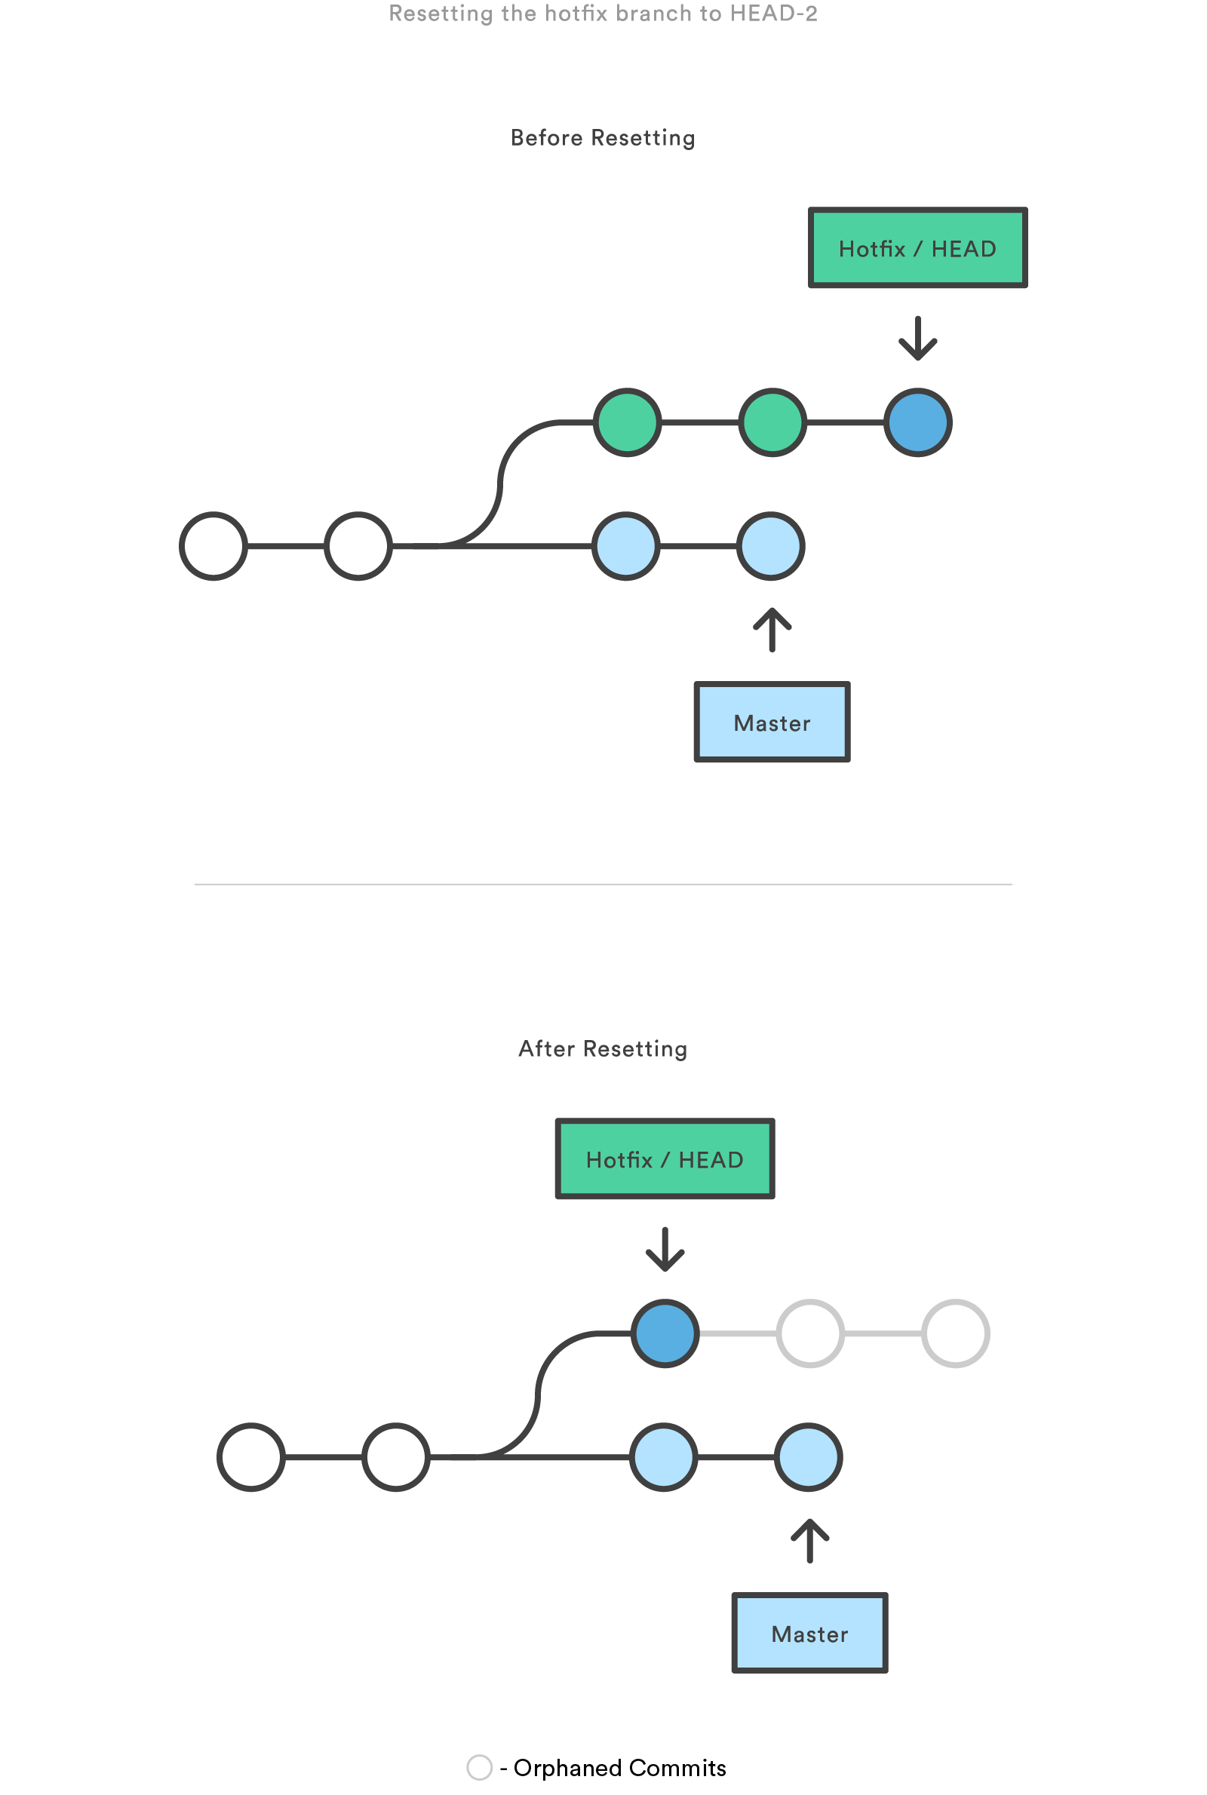

This usage of git reset is a simple way to undo changes that haven’t been shared with anyone else. It’s your go-to command when you’ve started working on a feature and find yourself thinking, “Oh crap, what am I doing? I should just start over.”

In addition to moving the current branch, you can also get git reset to alter the staged snapshot and/or the working directory by passing it one of the following flags:

* --soft – The staged snapshot and working directory are not altered in any way.
* --mixed – The staged snapshot is updated to match the specified commit, but the working directory is not affected. This is the default option.
* --hard – The staged snapshot and the working directory are both updated to match the specified commit.

It’s easier to think of these modes as defining the scope of a git reset operation. For further detailed information visit the [git reset](https://www.atlassian.com/git/tutorials/undoing-changes/git-reset) page.

# Git lost and found

|  |
| --- |
| git fsck --dangling  git fsck --unreachable  git fsck --lost-found |

Whenever you add a file to the index, the content of that file are added to Git's object database as a blob. When you then reset/rm --cached that file, the blobs will still exist (they will be garbage collected the next time you run gc)

However, when those files are part of a commit and you decide later to reset history, then the old commits are still reachable from Git's reflog and will only be garbage collected after a period of time (usually a month, iirc). Those objects should not show up as dangling though, since they are still referenced from the reflog.

# In git, what is the difference between a dangling commit and a dangling blob?

Git creates blob for every file in the repository (unless the same content already exists). Dangling blobs are blobs not associated with any commit and are no much use unless your repository was broken in case of disk failure, etc.

You can see their contents using git show <blob SHA-1>.

Dangling commits, are the commits, which are not reachable from HEAD of any branch. You can still use them, for example by invoking git cherry-pick <SHA-1> or git reset <SHA-1>.

There is more explanation in Scott Chacon's [Git user's manual](http://schacon.github.com/git/user-manual.html#dangling-objects).

# How do I prevent git diff from using a pager?

|  |
| --- |
| Use --no-pager  git --no-pager log |

# Git reset: When I forgot to do some changes and I push changes to remote, then how to incorporate that change and resend the push

|  |
| --- |
| Do  unset LESS  Get the git log:  $ git --no-pager log --oneline --decorate --date=relative --all --graph --abbrev-commit  Or more detailed use --stat  $ git --no-pager log --oneline --pretty="@%h" --stat --graph --abbrev-commit --date=relative --all --decorate  or  $ git --no-pager log --graph --pretty=format:'%Cred%h%Creset -%C(yellow)%d%Creset %s %Cgreen(%cr) %C(bold blue)<%an>%Creset' --abbrev-commit --decorate --date=relative  Or  git --no-pager reflog --date=relative --abbrev-commit  Or  $ git --no-pager log --graph --abbrev-commit --decorate --date=relative --oneline --all  Or  $ git --no-onine log --oneline --all --graph --decorate $(git reflog | awk '{print $1}')  Lets say i have the following situation  nth commit - cedc856  n+1 commit - kaskdkh  I forgot to incorporate some changes before i did n+1 commit and pushed to remote  So i will revert back to nth commit using reset (--soft) read <https://hackernoon.com/reset-101-ba05d9e3f2c7> to know the difference between soft, middle and hard  We will use soft because we want to add some more changes with the previous changes  $ git reset --soft cedc856 or for previous git reset --soft HEAD^1  Do the missing change we forgot  git add .  git commit  git push --force origin master |

|  |
| --- |
| Switching branches changes files in your working directory  It’s important to note that when you switch branches in Git, files in your working directory will change. If you switch to an older branch, your working directory will be reverted to look like it did the last time you committed on that branch. If Git cannot do it cleanly, it will not let you switch at all. |

# 

# 

# Changing the Last Commit

<https://git-scm.com/book/en/v2/Git-Tools-Rewriting-History>

Changing your most recent commit is probably the most common rewriting of history that you’ll do. You’ll often want to do two basic things to your last commit: simply change the commit message, or change the actual content of the commit by adding, removing and modifying files.

## simply change the commit message

If you simply want to modify your last commit message, that’s easy:

$ git commit --amend

The command above loads the previous commit message into an editor session, where you can make changes to the message, save those changes and exit. When you save and close the editor, the editor writes a new commit containing that updated commit message and makes it your new last commit.

## change the actual content of your last commit

If, on the other hand, you want to change the actual *content* of your last commit, the process works basically the same way — first make the changes you think you forgot, stage those changes, and the subsequent git commit --amend *replaces* that last commit with your new, improved commit.

You need to be careful with this technique because amending changes the SHA-1 of the commit. It’s like a very small rebase — don’t amend your last commit if you’ve already pushed it.

|  |  |
| --- | --- |
| Tip | An amended commit may (or may not) need an amended commit message  When you amend a commit, you have the opportunity to change both the commit message and the content of the commit. If you amend the content of the commit substantially, you should almost certainly update the commit message to reflect that amended content.  On the other hand, if your amendments are suitably trivial (fixing a silly typo or adding a file you forgot to stage) such that the earlier commit message is just fine, you can simply make the changes, stage them, and avoid the unnecessary editor session entirely with:  $ git commit --amend --no-edit |

|  |
| --- |
| **$ git push**  Enter passphrase for key '/home/simha/.ssh/id_rsa':  To github.com:sant527/django_basic_documentation.git  ! [rejected] master -> master (non-fast-forward)  error: failed to push some refs to 'git@github.com:sant527/django_basic_documentation.git'  hint: Updates were rejected because the tip of your current branch is behind  hint: its remote counterpart. Integrate the remote changes (e.g.  hint: 'git pull ...') before pushing again.  hint: See the 'Note about fast-forwards' in 'git push --help' for details. |

# How to change the git rebase editor to sublime text:

From: <https://www.kevinkuszyk.com/2016/03/08/git-tips-2-change-editor-for-interactive-git-rebase/>

|  |
| --- |
| #gauranga  $ git config --global core.editor "'/usr/bin/subl' -n -w"  What does this command do?  >> git config is used to set global and repository settings.  >> core.editor is the setting which tells Git which editor to use.  >> -n tells Git to open a new editor window. Omit this flag you want Git to reuse the Sublime window you already have open.  >> -w tells Git to wait until the commit message is saved.  Now after this when we do:  $ git rebase -i --root  >> (During file is open)  hint: Waiting for your editor to close the file...  >> (after file is closed with changes)  Stopped at 773a7bc... Zero Commit: Documentation Django, git, awk, commands, gitignore  You can amend the commit now, with  git commit --amend  Once you are satisfied with your changes, run  git rebase --continue  OR  >> (after file is closed without changes)  Successfully rebased and updated refs/heads/master.  It will open sublime text and in the command prompt it says waiting for editor to close.  Eg:  pick 773a7bc Zero Commit:  pick 4a39a7b First Commit:  Change to  edit 773a7bc Zero Commit:  pick 4a39a7b First Commit:  Then save and close the file |

# Git rebase:: Changing Multiple Commit Messages

## interactive rebase tool

You can run rebase interactively by adding the -i option to git rebase. You must indicate how far back you want to rewrite commits by telling the command which commit to rebase onto.

$ git rebase -i HEAD~3

Remember again that this is a rebasing command — every commit included in the range HEAD~3..HEADwill be rewritten, whether you change the message or not. Don’t include any commit you’ve already pushed to a central server — doing so will confuse other developers by providing an alternate version of the same change.

## Running this command gives you a list of commits in your text editor that looks something like this:

pick f7f3f6d changed my name a bit

pick 310154e updated README formatting and added blame

pick a5f4a0d added cat-file

# Rebase 710f0f8..a5f4a0d onto 710f0f8

#

# Commands:

# p, pick <commit> = use commit

# r, reword <commit> = use commit, but edit the commit message

# e, edit <commit> = use commit, but stop for amending

# s, squash <commit> = use commit, but meld into previous commit

# f, fixup <commit> = like "squash", but discard this commit's log message

# x, exec <command> = run command (the rest of the line) using shell

# b, break = stop here (continue rebase later with 'git rebase --continue')

# d, drop <commit> = remove commit

# l, label <label> = label current HEAD with a name

# t, reset <label> = reset HEAD to a label

# m, merge [-C <commit> | -c <commit>] <label> [# <oneline>]

# . create a merge commit using the original merge commit's

# . message (or the oneline, if no original merge commit was

# . specified). Use -c <commit> to reword the commit message.

#

# These lines can be re-ordered; they are executed from top to bottom.

#

# If you remove a line here THAT COMMIT WILL BE LOST.

#

# However, if you remove everything, the rebase will be aborted.

#

# Note that empty commits are commented out

It’s important to note that these commits are listed in the opposite order than you normally see them using the log command. If you run a log, you see something like this:

$ git log --pretty=format:"%h %s" HEAD~3..HEAD

a5f4a0d added cat-file

310154e updated README formatting and added blame

f7f3f6d changed my name a bit

Notice the reverse order. The interactive rebase gives you a script that it’s going to run. It will start at the commit you specify on the command line (HEAD~3) and replay the changes introduced in each of these commits from top to bottom. It lists the oldest at the top, rather than the newest, because that’s the first one it will replay.

You need to edit the script so that it stops at the commit you want to edit. To do so, change the word ‘pick’ to the word ‘edit’ for each of the commits you want the script to stop after. For example, to modify only the third commit message, you change the file to look like this:

edit f7f3f6d changed my name a bit

pick 310154e updated README formatting and added blame

pick a5f4a0d added cat-file

When you save and exit the editor, Git rewinds you back to the last commit in that list and drops you on the command line with the following message:

$ git rebase -i HEAD~3

Stopped at f7f3f6d... changed my name a bit

You can amend the commit now, with

git commit --amend

Once you're satisfied with your changes, run

git rebase --continue

## These instructions tell you exactly what to do. Type

$ git commit --amend

## Change the commit message, and exit the editor. Then, run

$ git rebase --continue

This command will apply the other two commits automatically, and then you’re done. If you change pick to edit on more lines, you can repeat these steps for each commit you change to edit. Each time, Git will stop, let you amend the commit, and continue when you’re finished.

## Reordering Commits

You can also use interactive rebases to reorder or remove commits entirely. If you want to remove the “added cat-file” commit and change the order in which the other two commits are introduced, you can change the rebase script from this

pick f7f3f6d changed my name a bit

pick 310154e updated README formatting and added blame

pick a5f4a0d added cat-file

to this:

pick 310154e updated README formatting and added blame

pick f7f3f6d changed my name a bit

When you save and exit the editor, Git rewinds your branch to the parent of these commits, applies 310154e and then f7f3f6d, and then stops. You effectively change the order of those commits and remove the “added cat-file” commit completely.

## Squashing Commits

It’s also possible to take a series of commits and squash them down into a single commit with the interactive rebasing tool. The script puts helpful instructions in the rebase message:

#

# Commands:

# p, pick <commit> = use commit

# r, reword <commit> = use commit, but edit the commit message

# e, edit <commit> = use commit, but stop for amending

# s, squash <commit> = use commit, but meld into previous commit

# f, fixup <commit> = like "squash", but discard this commit's log message

# x, exec <command> = run command (the rest of the line) using shell

# b, break = stop here (continue rebase later with 'git rebase --continue')

# d, drop <commit> = remove commit

# l, label <label> = label current HEAD with a name

# t, reset <label> = reset HEAD to a label

# m, merge [-C <commit> | -c <commit>] <label> [# <oneline>]

# . create a merge commit using the original merge commit's

# . message (or the oneline, if no original merge commit was

# . specified). Use -c <commit> to reword the commit message.

#

# These lines can be re-ordered; they are executed from top to bottom.

#

# If you remove a line here THAT COMMIT WILL BE LOST.

#

# However, if you remove everything, the rebase will be aborted.

#

# Note that empty commits are commented out

If, instead of “pick” or “edit”, you specify “squash”, Git applies both that change and the change directly before it and makes you merge the commit messages together. So, if you want to make a single commit from these three commits, you make the script look like this:

pick f7f3f6d changed my name a bit

squash 310154e updated README formatting and added blame

squash a5f4a0d added cat-file

When you save and exit the editor, Git applies all three changes and then puts you back into the editor to merge the three commit messages:

# This is a combination of 3 commits.

# The first commit's message is:

changed my name a bit

# This is the 2nd commit message:

updated README formatting and added blame

# This is the 3rd commit message:

added cat-file

When you save that, you have a single commit that introduces the changes of all three previous commits.

# Git log --all

No, that doesn't mean it shows all the latest commits. It shows all commits in the history of branches, tags and other refs, but it does not show commits that are not reachable from any ref. A typical example of a commit that is not reachable from any ref is when you've just run git commit --amend: the previous commit still exists locally, but it's no longer reachable and won't be shown in git log --all. But git reflog will confirm that it does indeed still exist.

As for why --all isn't the default: you normally won't want that. For instance, if you're on branch master, and you run git log, you typically aren't interested in the history of any feature branches, you typically want to see the history of master.

If you do normally want the --all behaviour, I recommend creating an alias.

# Changing/Amend root commit

$ git rebase -i --root

Then it will open interactive

|  |
| --- |
| pick 61b4d15 First Commit: Fresh virtualenv with pipenv and install django and remove SECRETKEY and add README.md and COMMITDOC.md  pick eaf11a6 Second Commit: django-environ and .env and setttings.py and psycopg2 and sensitive information secure |

Change pick of first commit to edit

|  |
| --- |
| **edit** 61b4d15 First Commit: Fresh virtualenv with pipenv and install django and remove SECRETKEY and add README.md and COMMITDOC.md  pick eaf11a6 Second Commit: django-environ and .env and setttings.py and psycopg2 and sensitive information secure |

:wq! And save and leave

**Now the head is at** 61b4d15

The output will be like this

|  |
| --- |
| Stopped at 61b4d15... First Commit: Fresh virtualenv with pipenv and install django and remove SECRETKEY and add README.md and COMMITDOC.md  You can amend the commit now, with  git commit --amend  Once you are satisfied with your changes, run  git rebase --continue |

See it shows it stopped at 61b4d15

|  |
| --- |
| $ git --no-pager log --graph --pretty=format:'%Cred%h%Creset -%C(yellow)%d%Creset %s %Cgreen(%cr) %C(bold blue)<%an>%Creset' --abbrev-commit  * 61b4d15 - (HEAD) First Commit: Fresh virtualenv with pipenv and install django and remove SECRETKEY and add README.md and COMMITDOC.md (8 minutes ago) <santhosh>% |

|  |
| --- |
| $ git --no-pager reflog  61b4d15 (HEAD) HEAD@{0}: rebase -i: fast-forward  f255330 HEAD@{1}: rebase -i (start): checkout f2553303741c2b1ce86fc740180f0074de90840f  eaf11a6 (master) HEAD@{2}: rebase -i (finish): returning to refs/heads/master |

Now we are in first commit and the working directory is also in first commit. Now add or remove or edit files and then do git add -A

|  |
| --- |
| git add -A |

Then do the commit as below

|  |
| --- |
| git commit --amend |

It will open an editor

## **** How do I exit the editor without committing anything? Exit Vim without committing changes in Git

vim opens up for making changes. If I then change my mind and exit vim without making any changes, a commit is still made which shows up in git reflog.

How do I exit the editor without committing anything?

|  |
| --- |
| the git appication runs the editor application, and if the editor application returnes unsuccessfully (non-zero exitcode) the git application recognizes this and stops further processing.  in vim you can perform this with  :cq!  from the vim manual:    :cq[uit][!] Quit Vim with an error code, so that the compiler  will not compile the same file again.  WARNING: All changes in files are lost! Also when the  [!] is not used. It works like ":qall!" :qall,  except that Vim returns a non-zero exit code.  exitcodes are a very fundamental concept in unix/linux and and easy way to inform the caller application if everyhing was ok (exitcode 0) or something went wrong. |

Do the changes to commit message if you want and then close. Once closed the chages are saved

NOw continue to the next commit by

|  |
| --- |
| **git commit --continue** |

**Since we used pick for second commit it will rebase and complete the task**

**Then push the changes to github**

|  |
| --- |
| **git push -f** |

# AMENDIND MULTIPLE COMMITS USING REBASE FROM ROOT AND USING STASH

|  |
| --- |
| #### First STASH  git rebase will not work if you have not staged the current changes. If we are in the middle of some work then we dont want to loose those changes and not sure to stage them all. So what we do is first stash those changes. Stash saves both current working directory and the staged index.  $ git stash --include-untracked (will also include only untracked files and no longer touches ignored files) (this is what we want)  Now we can see the working directory changes the current commit.  $ git status  On branch master  Your branch is up to date with 'origin/master'.  nothing to commit, working tree clean  Getting list of all stashes  $ git --no-pager stash list  If we want to see the stash files (incase we want to copy some changes to previous commits)  $ git stash show -p stash@{0}  ### THEN REBASE  $ git rebase -i root or git rebase -i 5e684b4 (if we want to move back to a particular commit)  Or  $ git rebase -i --root  -- > opens a vim editor , change all to edit from pick and :wq!  OUTPUT  Stopped at c37a5b9... First Commit: Fresh virtualenv with pipenv and install django and remove SECRETKEY and add README.md and COMMITDOC.md  You can amend the commit now, with  git commit --amend  Once you are satisfied with your changes, run  git rebase --continue  Now the working directory is at root commit.  For checking:  $ git --no-pager log --graph --pretty=format:'%Cred%h%Creset -%C(yellow)%d%Creset %s %Cgreen(%cr) %C(bold blue)<%an>%Creset' --abbrev-commit  $ git status  Modify or add files and then  $ git status  $ git add -A  $ git commit --amend  Vi editor is opened so that you can change the commit message. But if you think you want to quit vim and still do some more changes in files then q! Will not work, it will create a commit. So to avoid that  vim opens up for making changes. If I then change my mind and exit vim without making any changes, a commit is still made which shows up in git reflog.  How do I exit the editor without committing anything?  the git appication runs the editor application, and if the editor application returnes unsuccessfully (non-zero exitcode) the git application recognizes this and stops further processing.  in vim you can perform this with  :cq!  exitcodes are a very fundamental concept in unix/linux and and easy way to inform the caller application if everyhing was ok (exitcode 0) or something went wrong.  Do the changes to commit message if you want and then close. Once closed the chages are saved  NOw continue to the next commit by  $ git commit --continue  Once you are done then  Then push the changes to github  $ git push -f  The git commit --amend command is a convenient way to modify the most recent commit  It lets you combine staged changes with the previous commit instead of creating an entirely new commit.  It can also be used to simply edit the previous commit message without changing its snapshot.  But, amending does not just alter the most recent commit, it replaces it entirely, meaning the amended commit will be a new entity with its own ref. |

# Git reset vs Git checkout

**Git checkout b**

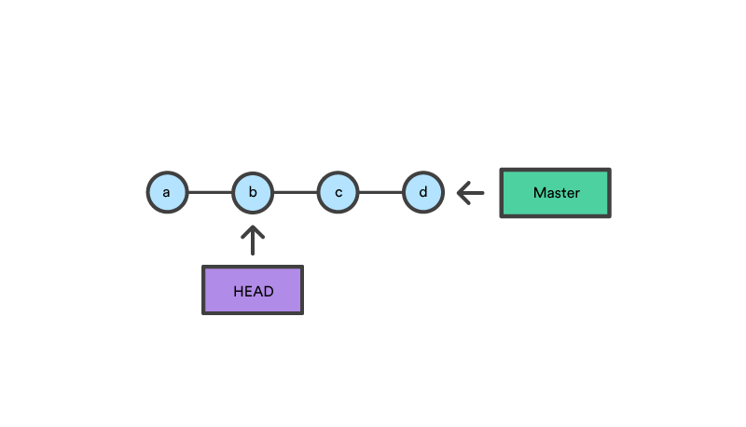

With git checkout, the master ref is still pointing to d. The HEAD ref has been moved, and now points at commit b. The repo is now in a 'detached HEAD' state.

**git reset b**

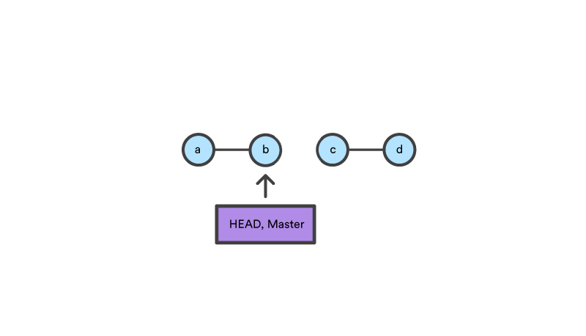

Comparatively, git reset, moves both the HEAD and branch refs to the specified commit.

In addition to updating the commit ref pointers, git reset will modify the state of the three trees. The ref pointer modification always happens and is an update to the third tree, the Commit tree. The command line arguments --soft, --mixed, and --hard direct how to modify the Staging Index, and Working Directory trees.

# git understanding staging index and git reset

|  |
| --- |
| mkdir git_reset_test  cd git_reset_test/  git init .  Initialized empty Git repository in /home/simha/git_reset_test/.git/ |

To accurately view the state of the Staging Index we must utilize a lesser known Git command git ls-files. The git ls-files command is essentially a debug utility for inspecting the state of the Staging Index tree.

|  |
| --- |
| $>  git ls-files -s  No output |

Now we add a file to the directory

|  |
| --- |
| $>  touch reset_lifecycle_file |

Check the staging status. Even though we added a file in the working directory its not staged. Because we didnt add to staging using git add till now

|  |
| --- |
| $>  git ls-files -s  No output |

Now add reset_lifecycle_file to staging

|  |
| --- |
| $>  git add reset_lifecycle_file |

And check the staging tree here not the second column SHA1

|  |
| --- |
| $ git ls-files -s  100644 e69de29bb2d1d6434b8b29ae775ad8c2e48c5391 0 reset_lifecycle_file |

Then commit changes

|  |
| --- |
| $ git commit -m "initial commit"  [master (root-commit) 839fefc] initial commit  1 file changed, 0 insertions(+), 0 deletions(-)  create mode 100644 reset_lifecycle_file |

Now chang the file reset_lifecycle_file

|  |
| --- |
| $ echo 'hello git reset' >> reset_lifecycle_file  $ git status  On branch master  Changes not staged for commit:  (use "git add <file>..." to update what will be committed)  (use "git checkout -- <file>..." to discard changes in working directory)  modified: reset_lifecycle_file  no changes added to commit (use "git add" and/or "git commit -a") |

We check the status

|  |
| --- |
| $ git ls-files -s  100644 e69de29bb2d1d6434b8b29ae775ad8c2e48c5391 0 reset_lifecycle_file |

Once we add to staging then we see that the

|  |
| --- |
| $ git add reset_lifecycle_file  $ git ls-files -s  100644 d7d77c1b04b5edd5acfc85de0b592449e5303770 0 reset_lifecycle_file |

**Let us now execute a git reset --hard and examine the new state of the repository.**

|  |
| --- |
| $ git reset --hard  HEAD is now at 3e94c9a changes added 1  $ git status  On branch master  nothing to commit, working tree clean  $ git ls-files -s  100644 e69de29bb2d1d6434b8b29ae775ad8c2e48c5391 0 reset_lifecycle_file |

Here we have executed a "hard reset" using the --hard option. Git displays output indicating that HEAD is pointing to the latest commit 3e94c9a. Next, we check the state of the repo with git status. Git indicates there are no pending changes. We also examine the state of the Staging Index and see that it has been reset to a point before

Our modifications to reset_lifecycle_file have been destroyed. This data loss cannot be undone, this is critical to take note of.

Here working directory is reset back completely

**Instead of hard we use --mixed reset (mixed is default)**

|  |
| --- |
| $ echo 'append content' >> reset_lifecycle_file  $ git add reset_lifecycle_file  $ git status  On branch master  Changes to be committed:  (use "git reset HEAD <file>..." to unstage)  modified: reset_lifecycle_file  $ git ls-files -s  100644 c6a3de2668346719a6a2ebf1230abc43acbad0b7 0 reset_lifecycle_file  $ git reset --mixed  Unstaged changes after reset:  M reset_lifecycle_file  $ git status  On branch master  Changes not staged for commit:  (use "git add <file>..." to update what will be committed)  (use "git checkout -- <file>..." to discard changes in working directory)  modified: reset_lifecycle_file  no changes added to commit (use "git add" and/or "git commit -a")  $ git ls-files -s  100644 e69de29bb2d1d6434b8b29ae775ad8c2e48c5391 0 reset_lifecycle_file |

Here we see the working directory is same but the staging had been reset.

**By default, git reset is equivalent to git reset HEAD**

# see the files changed in a particular commit

|  |
| --- |
| $ git --no-pager show --stat 386a29a  gitdoc/images/image10.png | Bin 15308 -> 26177 bytes  gitdoc/images/image11.png | Bin 105357 -> 3706 bytes  gitdoc/images/image12.png | Bin 44159 -> 104790 bytes  gitdoc/images/image17.png | Bin 0 -> 56950 bytes  gitdoc/images/image18.png | Bin 0 -> 8337 bytes  gitdoc/images/image19.png | Bin 0 -> 39563 bytes  README.md | 96  gitdoc/GITDOC.md | 166  And another way (better way)  $ git diff-tree -r 386a29a  386a29a7021b42a3f001763c25f65f256198c327  :100644 100644 1ea3daedd80d3e57d7bb871756cdf1c2e1d847c0 db6674684c28327383e142b12e424ab49979be3e M README.md  :000000 100644 0000000000000000000000000000000000000000 d32fb35cac4e02836a67becf43818f0d9adfeae3 A gitdoc/images/image7.jpg  :100644 000000 498bea414f1d08a5baa36c43157bfe6770660f89 0000000000000000000000000000000000000000 D gitdoc/images/image7.png |

# Copying a git commit to a new folder

Whenever we want to have a copy of the current working directory just make a copy of the folder.

# Revert back from github

# How to get the project from git and start fresh

1. Take back up of the django_basic_documentation folder

|  |
| --- |
| # gauranga  cp -R /home/web_dev/django_basic_documentation /home/web_dev/backup_git/django_basic_documentation_backup_$(date +%Y-%m-%d-%H_%M_%S) |

1. Delete everything inside /home/web_dev/django_basic_documentation

|  |
| --- |
| #gauranga  Since we are using zsh so as per the comment below  <https://unix.stackexchange.com/questions/77127/rm-rf-all-files-and-all-hidden-files-without-error#comment1001026_77313>  # rm -rf /home/web_dev/django_basic_documentation/*(D) |

1. Cd into the directory and clone the git contents into the directory (Note: the directory as to be empty when we clone)

|  |
| --- |
| cd /home/web_dev/django_basic_documentation/  git clone git@github.com:sant527/django_basic_documentation.git .  Warning: Permanently added the RSA host key for IP address '140.82.118.4' to the list of known hosts.  Enter passphrase for key '/home/simha/.ssh/id_rsa':  (it will ask for a password since we have set up ssh key) |

1. Check git log

|  |
| --- |
| #gauranga  git --no-pager log --graph --pretty=format:'%Cred%h%Creset -%C(yellow)%d%Creset %s %Cgreen(%cr) %C(bold blue)<%an>%Creset' --abbrev-commit |

1. Install virtual env and activate it

|  |
| --- |
| #gauranga  export PIPENV_VENV_IN_PROJECT=1 (this will install virtual env in a .venv folder)  pipenv install  pipenv shell |

1. Copy .env file to basic_django (on git we dont commit the .env file so without it django will not runserver

|  |
| --- |
| #guranga  cp /home/web_dev/env_django_basic_documentation/.env /home/web_dev/django_basic_documentation/basic_django/basic_django/.env |

1. cd django project folder and runserver

|  |
| --- |
| cd /home/web_dev/django_basic_documentation/basic_django/  python manage.py runserver |

# 

# Remove a file back till first commit

Assuming i have 5 commits. I have a file which is added in the first commit and kept modifying in all the commits.

I want to remove it in all the commits and keep it only in the first commit. Later whenever i want to modify i will always add it using rebase the first commit.

We can use rebase -i --root to delete in all the commits. Instead we have to go backwards each commit. So we have to use rebase 4 times and delete backwards else it will show file conflicts.

# Merge conflicts while rebasing and changing file in previous commit

When we want to change a file in one of previous commit

Eg: we have four commits

Commit1

Commit2

Commit3

Commit4

Commit1 is the first commit.

We want to do some changes in the file of Commit2 which we forgot

So we do

$ git rebase -i Commit1 (note we have to rebase one level down)

Then it will open a vim editor there change “pick” of Commit2 to “edit” and close

Now the working directory will be of Commit2 and the HEAD will be at Commit2

$ git --no-pager log --graph --pretty=format:'%Cred%h%Creset -%C(yellow)%d%Creset %s %Cgreen(%cr) %C(bold blue)<%an>%Creset' --abbrev-commit

Now do the changes in the file we wanted. And stage the file again

$ git add -A

Now change Commit2 using commit --amend

$ git commit --amend (this will amend the Commit2 with staged files)

Vi editor will open, just to wq!: to save and exit

$ git rebase --continue

Removing images/image1.png

Auto-merging basic_django/basic_django/settings.py

CONFLICT (content): Merge conflict in basic_django/basic_django/settings.py

error: could not apply 1e24eaa... FOURTH COMMIT: Added custom model and manager and AUTH_USER_MODEL to settings and migrate

Resolve all conflicts manually, mark them as resolved with

"git add/rm <conflicted_files>", then run "git rebase --continue".

You can instead skip this commit: run "git rebase --skip".

To abort and get back to the state before "git rebase", run "git rebase --abort".

Could not apply 1e24eaa... FOURTH COMMIT: Added custom model and manager and AUTH_USER_MODEL to settings and migrate

Here is says FOURTH COMMIT is not done because of some conflicts. It stopped at THIRD COMMIT

We have to manually interfere with the file settings.py

<<<<<<< HEAD

=======

>>>>>>> new_branch_to_merge_later

Think of these new lines as "conflict dividers". The ======= line is the "center" of the conflict. All the content between the center and the <<<<<<< HEAD line is content that exists in the current branch master which the HEAD ref is pointing to. Alternatively all content between the center and >>>>>>> new_branch_to_merge_later is content that is present in our merging branch.

We edit the file the wy want it to be in the FOURTH COMMIT

Then do

$ git add -A

Then (dont do git commit --amend this is used to do changes to already committed commit)

$ git rebase --continue

Now vi editor will open. Just save it with wq!

And then the rebase will continue ahead.

# How to commit only a message to GIT?

|  |
| --- |
| git commit --allow-empty  The doc for --allow-empty reads:  Usually recording a commit that has the exact same tree as its sole parent commit is a mistake, and the command prevents you from making such a commit. This option bypasses the safety, and is primarily for use by foreign SCM interface scripts.  Doc makes sense but isn't easy to search for. |

# Git branching

https://git-scm.com/book/en/v2/Git-Branching-Basic-Branching-and-Merging

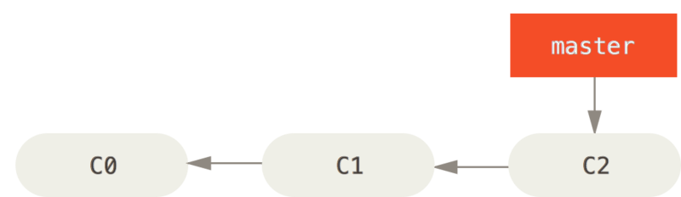

FIG: A simple commit history

Suppose the following is the current master branch and You’ve decided that you’re going to work on issue #53

To create a new branch and switch to it at the same time, you can run the git checkout command with the -b switch:

|  |
| --- |
| $ git checkout -b iss53  Switched to a new branch "iss53" |

This is shorthand for:

|  |
| --- |
| $ git branch iss53  $ git checkout iss53 |

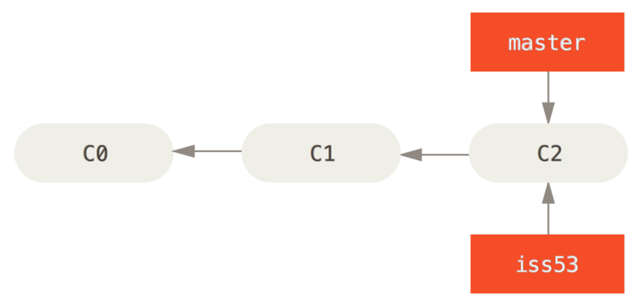

FIG: Creating a new branch pointer (git checkout -b iss53)

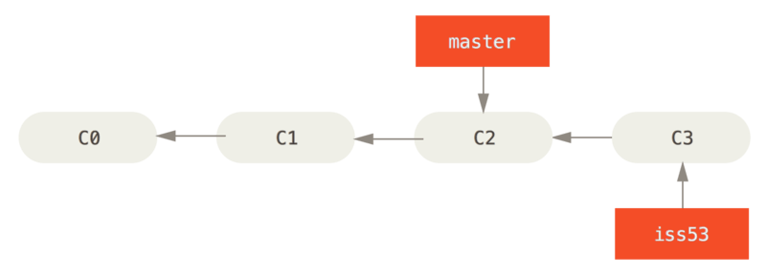

FIG: The iss53 branch has moved forward with your work

|  |
| --- |
| vim index.html  git commit -a -m 'added a new footer [issue 53]' [Here C3] |

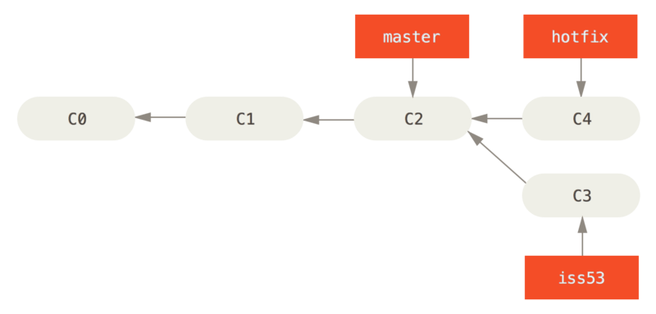

FIG: Hotfix branch based on master

|  |
| --- |
| $ git checkout master [come back to C2]  Switched to branch 'master'  $ git checkout -b hotfix  Switched to a new branch 'hotfix'  $ vim index.html  $ git commit -a -m 'fixed the broken email address' [C4 here] |

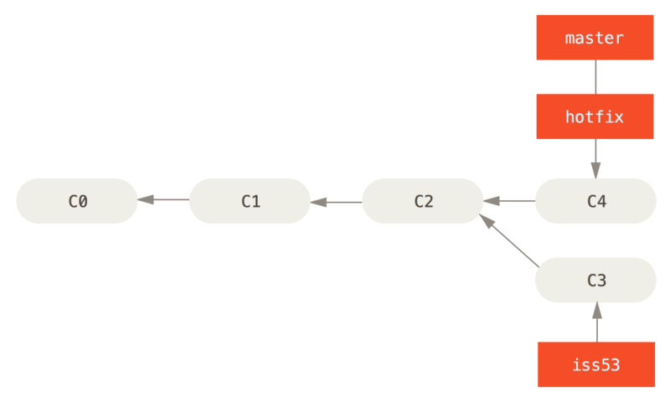

FIG: master is fast-forwarded to hotfix

|  |
| --- |
| $ git checkout master  $ git merge hotfix |

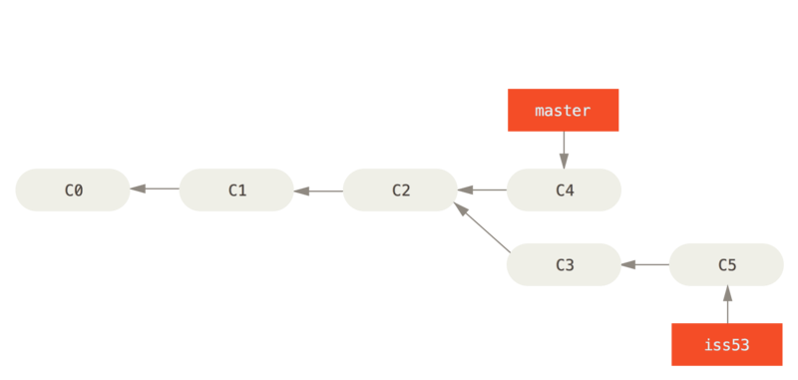

FIG: Work continues on iss53

|  |
| --- |
| Delete hotfix since not needed anymore (or its in the same forward line)  $ git branch -d hotfix  Deleted branch hotfix (3a0874c).  Start working back on iss53  $ git checkout iss53  Switched to branch "iss53"  $ vim index.html  $ git commit -a -m 'finished the new footer [issue 53]'  [iss53 ad82d7a] finished the new footer [issue 53]  1 file changed, 1 insertion(+) |

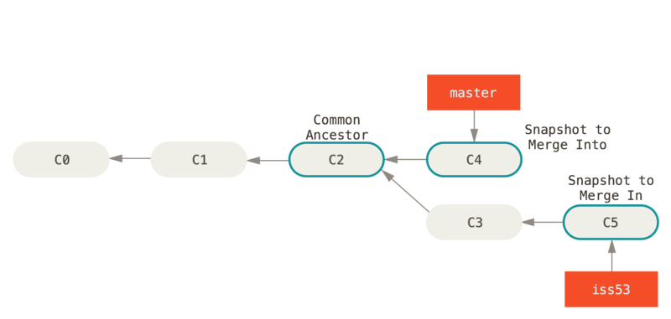

Fig: Three snapshots used in a typical merge

|  |
| --- |
| For Merging a branch into another (Her mering iss53 into master) - check out the branch you wish to merge into and then run the git merge command:  This looks a bit different than the hotfix merge you did earlier. In this case, your development history has diverged from some older point. Because the commit on the branch you’re on isn’t a direct ancestor of the branch you’re merging in, Git has to do some work. **** In this case, Git does a simple three-way merge, using the two snapshots pointed to by the branch tips and the common ancestor of the two.  ****  Instead of just moving the branch pointer forward, Git creates a new snapshot that results from this three-way merge and automatically creates a new commit that points to it. This is referred to as a merge commit, and is special in that it has more than one parent. |

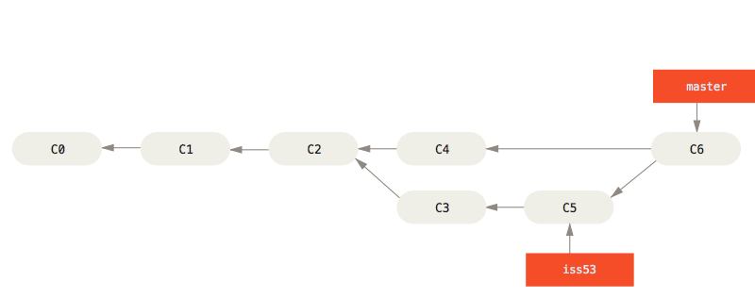

Fig: A merge commit (The final merge commit)

|  |
| --- |
| Now that your work is merged in, you have no further need for the iss53 branch. You can close the ticket in your ticket-tracking system, and delete the branch:  $ git branch -d iss53 |

## Basic Merge Conflicts

Occasionally, this process doesn’t go smoothly. If you changed the same part of the same file differently in the two branches you’re merging, Git won’t be able to merge them cleanly. If your fix for issue #53 modified the same part of a file as the hotfix branch, you’ll get a merge conflict that looks something like this:

|  |
| --- |
| $ git merge iss53  Auto-merging index.html  CONFLICT (content): Merge conflict in index.html  Automatic merge failed; fix conflicts and then commit the result. |

Git hasn’t automatically created a new merge commit. It has paused the process while you resolve the conflict. If you want to see which files are unmerged at any point after a merge conflict, you can run git status:

|  |
| --- |
| $ git status  On branch master  You have unmerged paths.  (fix conflicts and run "git commit")  Unmerged paths:  (use "git add <file>..." to mark resolution)  both modified: index.html  no changes added to commit (use "git add" and/or "git commit -a") |

Anything that has merge conflicts and hasn’t been resolved is listed as unmerged. Git adds standard conflict-resolution markers to the files that have conflicts, so you can open them manually and resolve those conflicts. Your file contains a section that looks something like this:

|  |
| --- |
| <<<<<<< HEAD:index.html  <div id="footer">contact : email.support@github.com</div>  =======  <div id="footer">  please contact us at support@github.com  </div>  >>>>>>> iss53:index.html |

This means the version in HEAD (your master branch, because that was what you had checked out when you ran your merge command) is the top part of that block (everything above the =======), while the version in your iss53 branch looks like everything in the bottom part. In order to resolve the conflict, you have to either choose one side or the other or merge the contents yourself. For instance, you might resolve this conflict by replacing the entire block with this:

|  |
| --- |
| <div id="footer">  please contact us at email.support@github.com  </div> |

This resolution has a little of each section, and the <<<<<<<, =======, and >>>>>>> lines have been completely removed. After you’ve resolved each of these sections in each conflicted file, run git add on each file to mark it as resolved. Staging the file marks it as resolved in Git.

If you want to use a graphical tool to resolve these issues, you can run git mergetool, which fires up an appropriate visual merge tool and walks you through the conflicts:

You can run git status again to verify that all conflicts have been resolved:

|  |
| --- |
| $ git status  On branch master  All conflicts fixed but you are still merging.  (use "git commit" to conclude merge)  Changes to be committed:  modified: index.html |

If you’re happy with that, and you verify that everything that had conflicts has been staged, you can type git commit to finalize the merge commit. The commit message by default looks something like this:

|  |
| --- |
| Merge branch 'iss53'  Conflicts:  index.html  #  # It looks like you may be committing a merge.  # If this is not correct, please remove the file  # .git/MERGE_HEAD  # and try again.  # Please enter the commit message for your changes. Lines starting  # with '#' will be ignored, and an empty message aborts the commit.  # On branch master  # All conflicts fixed but you are still merging.  #  # Changes to be committed:  # modified: index.html  # |

If you think it would be helpful to others looking at this merge in the future, you can modify this commit message with details about how you resolved the merge and explain why you did the changes you made if these are not obvious.

## Branch Management

### Get List of Branches and the current branch

The git branch command does more than just create and delete branches. If you run it with no arguments, you get a simple listing of your current branches:

|  |
| --- |
| $ git branch  iss53  * master  testing |

Notice the * character that prefixes the master branch: it indicates the branch that you currently have checked out (i.e., the branch that HEAD points to). This means that if you commit at this point, the master branch will be moved forward with your new work

### To see the last commit on each branch, you can run git branch -v:

|  |
| --- |
| $ git branch -v  iss53 93b412c fix javascript issue  * master 7a98805 Merge branch 'iss53'  testing 782fd34 add scott to the author list in the readmes |

Show merged and non merged branches

|  |
| --- |
| $ git branch --merged  iss53  * master |

Because you already merged in iss53 earlier, you see it in your list. Branches on this list without the * in front of them are generally fine to delete with git branch -d; you’ve already incorporated their work into another branch, so you’re not going to lose anything.

|  |
| --- |
| $ git branch --no-merged  testing |

This shows your other branch. Because it contains work that isn’t merged in yet, trying to delete it with git branch -d will fail:

|  |
| --- |
| $ git branch -d testing  error: The branch 'testing' is not fully merged. |

If you are sure you want to delete it, run 'git branch -D testing'.

If you really do want to delete the branch and lose that work, you can force it with -D, as the helpful message points out.

## changes in working directory and changes staged in index do not belong to a branch.

## git stash --all

Using only Git stash

git stash push

By default, running git stash will stash:

changes that have been added to your index (staged changes)

changes made to files that are currently tracked by Git (unstaged changes)

But it will not stash:

new files in your working copy that have not yet been staged

files that have been ignored

** git stash --include-untracked (will also include only untracked files and no longer touches ignored files) (this is what we want)

git stash --all (which stashes all files, including untracked and ignored files)

|  |
| --- |
| git stash pop  or  git stash apply (is my preferred command, as it does not remove the stash itself.) |

## [image] Git stash typical usage

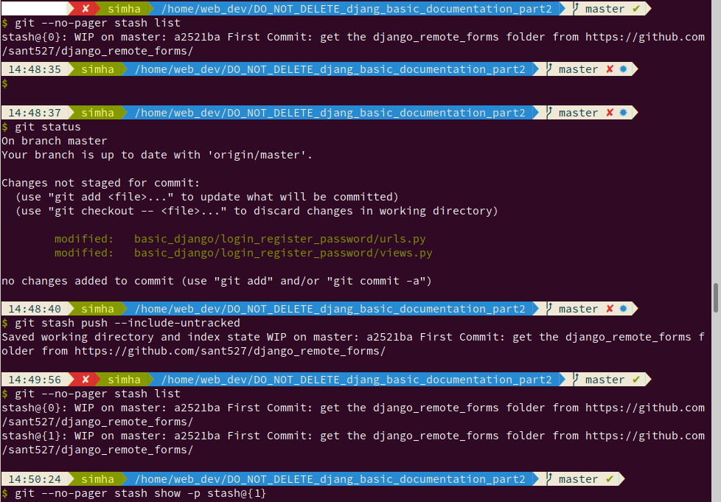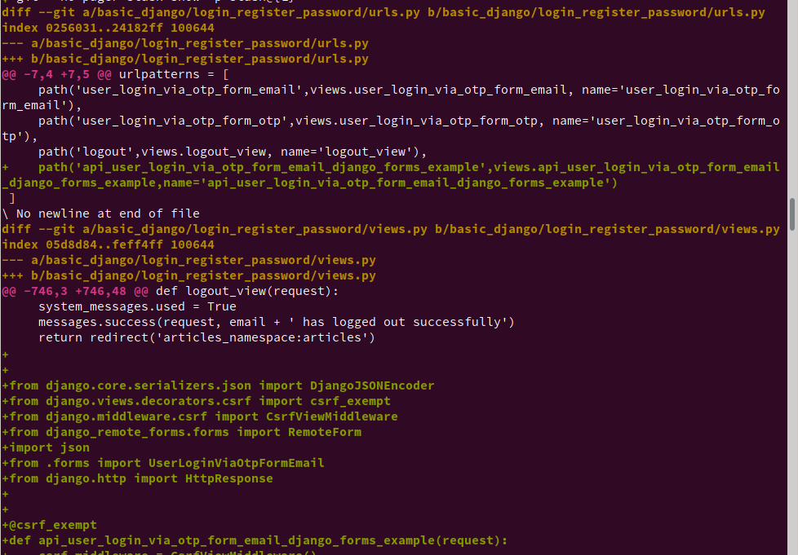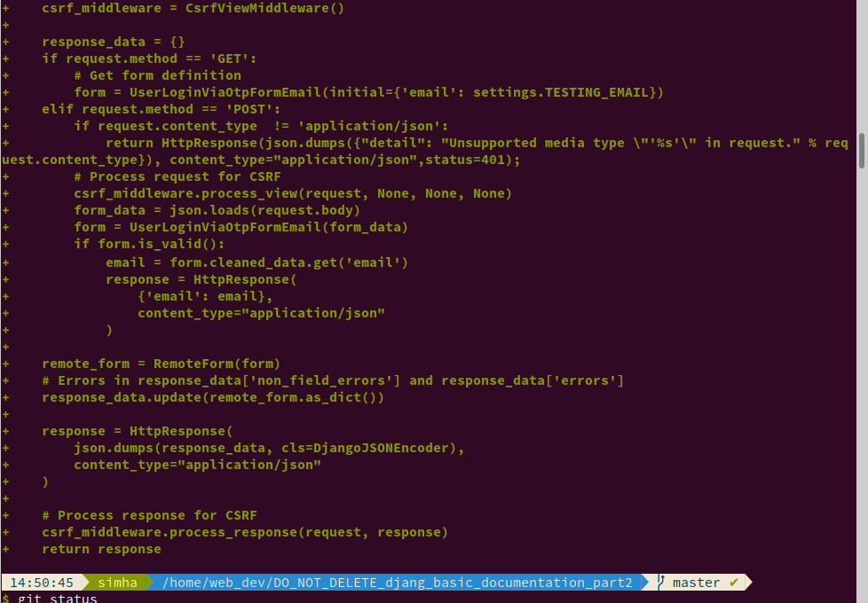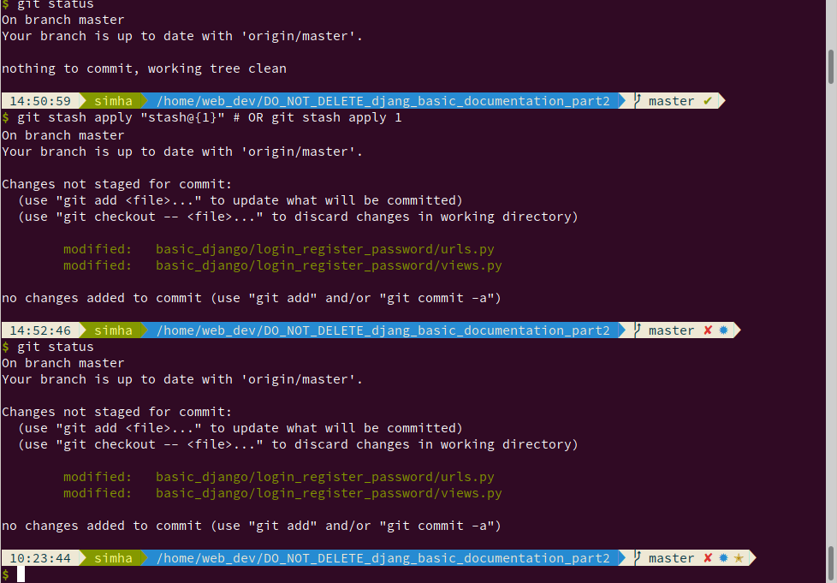

## How to take a back up of the current code in a new branch

Sometimes we work on a logic and later realize we want to use different logic. But we want to save that work because we have done many important things in them. So we want keep a backup to refer in new branch.

|  |
| --- |
| This is what i was looking for  I am currently on the masters branch, I am in between a work with some unstaged files and also with some untracked files. I want to save my current state into a new branch just as a backup/reference for future.  So i did stash push --include-untracked in my current state and then create and checkout to a new branch and stash apply there and stage all files by add -A and then commit changes. Again come back to master branch and again do stash apply there.  there  $ git status  On branch master  Changes not staged for commit:  (use "git add <file>..." to update what will be committed)  (use "git checkout -- <file>..." to discard changes in working directory)  modified: filename1  Untracked files:  (use "git add <file>..." to include in what will be committed)  filename2  no changes added to commit (use "git add" and/or "git commit -a")  $ git stash push --include-untracked  One stash is run  Getting list of all stashes  $ git --no-pager stash list  If we want to see the stash files (incase we want to copy some changes to previous commits)  $ git --no-pager stash show -p stash@{0}  $ git status  On branch master  Your branch is up to date with 'origin/master'.  nothing to commit, working tree clean  $ git checkout -b backup_branch  Switched to a new branch 'backup_branch'  $ git stash apply  On branch backup_branch  Changes not staged for commit:  (use "git add <file>..." to update what will be committed)  (use "git checkout -- <file>..." to discard changes in working directory)  modified: filename1  Untracked files:  (use "git add <file>..." to include in what will be committed)  filename2  $ git status  On branch backup_branch  Changes not staged for commit:  (use "git add <file>..." to update what will be committed)  (use "git checkout -- <file>..." to discard changes in working directory)  modified: filename1  Untracked files:  (use "git add <file>..." to include in what will be committed)  filename2  $ git add -A  $ git commit -m "Saved for backup"  $ git checkout master  Switched to branch 'master'  Your branch is up to date with 'origin/master'.  $ git stash apply  On branch origin/master  Changes not staged for commit:  (use "git add <file>..." to update what will be committed)  (use "git checkout -- <file>..." to discard changes in working directory)  modified: filename1  Untracked files:  (use "git add <file>..." to include in what will be committed)  filename2  $ git status  On branch origin/master  Changes not staged for commit:  (use "git add <file>..." to update what will be committed)  (use "git checkout -- <file>..." to discard changes in working directory)  modified: filename1  Untracked files:  (use "git add <file>..." to include in what will be committed)  filename2 |

Now i am back with the same working dir. With a backup of my current state in a new branch backup_branch

## How to push a branch to github

|  |
| --- |
| Create a new branch:  git checkout -b feature_branch_name  Edit, add and commit your files.  Push your branch to the remote repository:  git push -u origin feature_branch_name |

## How git will handle the working tree (unstaged and untracked) files when doing checkout

https://stackoverflow.com/a/8526445/2897115

|  |
| --- |
| Git will only disallow the branch change if performing the change would require modifying any of the files that have unstaged changes. If all of the modified files will be untouched by the branch checkout, git will not complain at all. This means that regardless of what branch you check out, you can always check out the previous branch and your working tree will be identical to how you left it. |

Switching branches carries uncommitted changes with you.

EG: If the branch name already exists

|  |
| --- |
| $ git checkout -b backup_of_login_with_database  fatal: A branch named 'backup_of_login_with_database' already exists. |

EG: if uncommited changes are creating problem

|  |
| --- |
| $ git checkout backup_of_login_with_database  error: Your local changes to the following files would be overwritten by checkout:  Pipfile  Pipfile.lock  basic_django/basic_django/__init__.py  basic_django/basic_django/settings.py  basic_django/basic_django/urls.py  basic_django/custom_user/models.py  Please commit your changes or stash them before you switch branches.  error: The following untracked working tree files would be overwritten by checkout:  basic_django/basic_django/celery.py  basic_django/custom_user/migrations/0002_auto_20190914_1734.py  basic_django/login_register_password/__init__.py  basic_django/login_register_password/admin.py  basic_django/login_register_password/apps.py  basic_django/login_register_password/custom_backends.py  basic_django/login_register_password/forms.py  basic_django/login_register_password/migrations/__init__.py  basic_django/login_register_password/models.py  basic_django/login_register_password/tasks.py  basic_django/login_register_password/templates/login_register_password/base.html  basic_django/login_register_password/templates/login_register_password/login_via_otp/login_otp_sendemail.html  basic_django/login_register_password/templates/login_register_password/login_via_otp/user_login_via_otp_form_email.html  basic_django/login_register_password/templates/login_register_password/login_via_otp/user_login_via_otp_form_otp.html  basic_django/login_register_password/tests.py  basic_django/login_register_password/urls.py  basic_django/login_register_password/views.py  sublime_text_tips.txt  Please move or remove them before you switch branches.  Aborting |

Solution is to stash them and then checkout and later get them back

|  |
| --- |
| git stash push --include-untracked  git checkout branchname  go some changes and commit  git checkout master/prevbranch  git stash apply |

# How to: Colours in Git

Bored with just black and white in your git status? Add some colour!

Open up your global Git configuration file (it should be found in ~/.gitconfig) and enter this into it:

|  |
| --- |
| [color]  ui = auto  [color "branch"]  current = yellow reverse  local = yellow  remote = green  [color "diff"]  meta = yellow bold  frag = magenta bold  old = red bold  new = green bold  [color "status"]  added = yellow  changed = green  untracked = cyan |

Now when you do a git status you should see some pretty colours.

Of course you can change the colours if you want to. The accepted values are two of

|  |
| --- |
| normal,  black,  red,  green,  yellow,  blue,  magenta,  cyan and  white  and optionally one of  bold,  dim,  ul,  blink and  reverse. |

If two colours are given the first is the foreground and the second is the background.

# Git add custom commands in gitconfig:

|  |
| --- |
| [alias]  lg = !"git lg1"  lg1 = !"git lg1-specific --all"  lg2 = !"git lg2-specific --all"  lg3 = !"git lg3-specific --all"  lg1-specific = log --graph --abbrev-commit --decorate --format=format:'%C(bold blue)%h%C(reset) - %C(bold green)(%ar)%C(reset) %C(cyan)%s%C(reset) %C(dim magenta)- %an%C(reset)%C(auto)%d%C(reset)'  lg2-specific = log --graph --abbrev-commit --decorate --format=format:'%C(bold blue)%h%C(reset) - %C(bold cyan)%aD%C(reset) %C(bold green)(%ar)%C(reset)%C(auto)%d%C(reset)%n'' %C(white)%s%C(reset) %C(dim white)- %an%C(reset)'  lg3-specific = log --graph --abbrev-commit --decorate --format=format:'%C(bold blue)%h%C(reset) - %C(bold cyan)%aD%C(reset) %C(bold green)(%ar)%C(reset) %C(bold cyan)(committed: %cD)%C(reset) %C(auto)%d%C(reset)%n'' %C(white)%s%C(reset)%n'' %C(dim white)- %an <%ae> %C(reset) %C(dim white)(committer: %cn <%ce>)%C(reset)'  lg4 = log --graph --pretty=format:"%C(#cd9a00)%h\\%C(#0080ff)\\ <%an>\\ %C(#17b062)(%cr)\\ %d\\%C(#c0d6de)%s"  l1 = log --pretty=format:"%C(#cd9a00)%h\\%C(#0080ff)\\ <%an>\\ %C(#17b062)(%cr)\\ %d\\%C(#c0d6de)%s"  lgf = log --name-status --graph --pretty=format:"%C(#cd9a00)%h\\%C(#0080ff)\\ <%an>\\ %C(#17b062)(%cr)\\ %d\\%C(#c0d6de)%s"  l1f = log --name-status --pretty=format:"%C(#cd9a00)%h\\%C(#0080ff)\\ <%an>\\ %C(#17b062)(%cr)\\ %d\\%C(#c0d6de)%s" |

For log:

|  |
| --- |
| #gauranga  git --no-pager log --graph --abbrev-commit --decorate --format=format:'%C(bold blue)%h%C(reset) - %C(bold cyan)%aD%C(reset) %C(bold green)(%ar)%C(reset)%C(auto)%d%C(reset)%n'' %C(green)%s%C(reset) %C(dim magenta)- %an%C(reset)' --all |