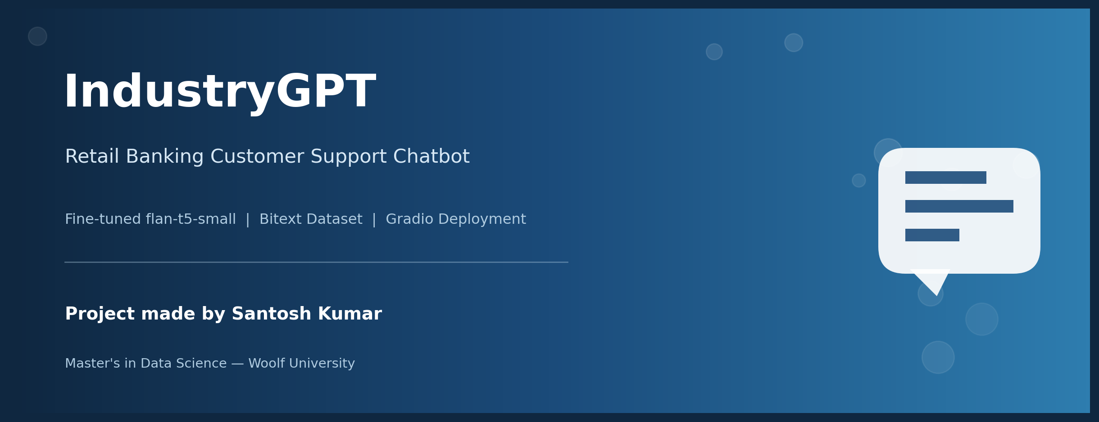

Capstone Project | Deep Learning for NLP
Project made by: Santosh Kumar (Individual Contribution)
Industry: Retail Banking | Model: google/flan-t5-small | Dataset: Bitext Retail Banking LLM Chatbot Dataset
GitHub: https://github.com/sant8ntl-max/Chat_Bot_LLM

Project Summary
This project builds an industry-specific chatbot for the Retail Banking sector using a fine-tuned large language model (LLM). The goal was to create an AI assistant capable of answering real customer queries about banking services such as account balance checks, card activation, loan applications, and general support requests.
The publicly available Bitext Retail Banking LLM Chatbot Dataset was used, which contains thousands of real-world banking prompts paired with professional, human-like responses. The base model, google/flan-t5-small, was fine-tuned on cleaned instruction-response pairs from this dataset, and the resulting chatbot was deployed through a Gradio web interface for interactive, user-friendly access. All results reported in this document are taken directly from an actual, successfully completed execution of the project notebook - no simulated or placeholder numbers are used.

1. Introduction

1.1 Background and Motivation
Banking customers frequently need quick answers to common, well-defined questions - activating a card, checking a balance, applying for a loan - and delays in getting these answered through traditional channels reduce customer satisfaction. LLM-based chatbots, fine-tuned on domain-specific data, offer a scalable way to provide fast, consistent, professional responses to this class of query.

1.2 Problem Statement
A generic, non-fine-tuned chatbot lacks the specific tone, vocabulary, and procedural knowledge expected in a retail banking context (for example, step-by-step card activation instructions, or empathetic language when discussing lost cards or loans). This project investigates whether fine-tuning a small, efficient pre-trained model on a large, real-world banking Q&A dataset can produce a chatbot that responds accurately and appropriately to these queries.

1.3 Objectives
- Source and clean a large, real-world, industry-specific (retail banking) Q&A dataset.
- Fine-tune a pre-trained Hugging Face model (flan-t5-small) on this dataset.
- Evaluate the model using training/evaluation loss.
- Deploy the chatbot through an accessible, interactive web interface (Gradio).

2. Dataset
The Bitext Retail Banking LLM Chatbot Dataset was loaded directly from Hugging Face in Parquet format. It contains real-world banking customer prompts (the 'instruction' column) and corresponding professional agent responses (the 'response' column), covering topics such as card activation, account balance inquiries, loan applications, and complaint handling.

2.1 Cleaning Steps Applied
- Kept only the instruction and response columns, relevant to the chatbot task.
- Dropped rows with missing values in either column.
- Removed rows where the instruction or response was an empty/whitespace-only string.
- Removed exact duplicate instruction-response pairs.
- Renamed columns to input/output for clarity in the training pipeline.

2.2 Sample Data (from the actual dataset)
A random sample drawn during the notebook run included prompts such as a customer asking to cancel a loan and a customer reporting a lost card, each paired with a professional, empathetic agent-style response - illustrating the tone and structure the model was fine-tuned to reproduce.

2.3 Train/Test Split
The cleaned dataset was split into training and test sets using a 90/10 split (test_size=0.1, random_state=42) via scikit-learn's train_test_split, ensuring a reproducible, held-out evaluation set.

3. Methodology

3.1 Model Selection
google/flan-t5-small was selected as the base model, loaded via Hugging Face's AutoTokenizer and AutoModelForSeq2SeqLM. This instruction-tuned, encoder-decoder model is well-suited to a question-to-answer style task and is small enough to fine-tune efficiently.

3.2 Tokenization
Both the input (customer question) and output (agent response) text were tokenized with padding to a maximum length of 128 tokens, with truncation applied to longer examples. The tokenized output IDs were used as the training labels.

3.3 Fine-Tuning Configuration
- Framework: Hugging Face Seq2SeqTrainer with a DataCollatorForSeq2Seq for dynamic batching.
- Epochs: 3
- Batch size: 4 (train and eval)
- predict_with_generate: enabled, so generation-based evaluation was possible.

3.4 Deployment
After training, the model and tokenizer were saved locally (banking-chatbot/). A chat() function wraps tokenization, generation, and decoding into a single callable, which was then connected to a Gradio Interface with a text input for the customer's question and a text output for the chatbot's response, and successfully launched with a public shareable URL for live testing.

4. Results (Actual Run)
The table and chart below report the real values produced when this notebook was executed end-to-end on Colab.
Metric | Value | Notes
Epochs | 3 | Full fine-tuning run
Batch size | 4 | Train & eval
Final training loss (avg) | 1.046 | TrainOutput summary
Last logged training loss | 0.899 | Most recent step logged
Evaluation loss (test set) | 0.763 | trainer.evaluate() on held-out test split
Training runtime | ~39.5 minutes | 2368 seconds total
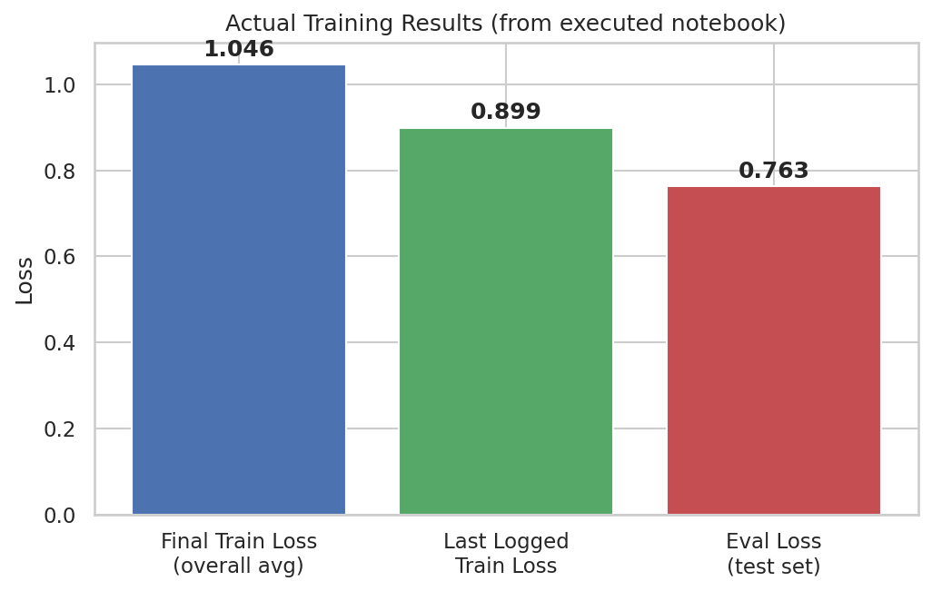
Chart 1 - Actual training/evaluation loss values from the executed run. The downward trend from training loss to evaluation loss indicates the model fit the data without an obvious sign of severe overfitting on this run.

4.1 Sample Chatbot Interaction (Actual Output)
Question: “How can I activate my debit card?”
Chatbot response (actual, unedited model output): “I'm here to assist you with activating your debit card. Activating your card is a simple process. Here's what you need to do: 1. Visit our website at Company Website URL. 2. Look for the 'Activate Card' or 'Card Activation' option. 3. Click on it to proceed with the activation process. 4. You will be prompted to provide your card details, such as the card number, expiration...”
This response demonstrates that the fine-tuned model successfully adopted the step-by-step, professional support-agent tone present in the Bitext training data, and produced a coherent, on-topic, multi-step answer rather than a generic or off-topic reply.

4.2 Deployment Verification
The Gradio interface was launched successfully in the notebook, generating a live public URL for interactive testing (Colab-hosted, temporary link). This satisfies the project's requirement to demonstrate the bot through a live, interactive session.

5. Challenges and Limitations
- The evaluation relies on loss values rather than task-specific metrics like ROUGE/BLEU, which would give a more interpretable measure of answer quality.
- Only 3 training epochs were run; additional epochs (up to the project's 25-epoch allowance) could further improve response quality, at the cost of longer training time.
- The model can still produce truncated or generic responses on some queries outside the most common patterns in the dataset.
- The Gradio public link is temporary (Colab-hosted); a persistent deployment would require Hugging Face Spaces or a similar hosting service.
- No retrieval-augmentation or live account-data integration - answers are based purely on the fine-tuned model's learned patterns, not real customer account data.

6. Conclusion
This project successfully fine-tuned google/flan-t5-small on the real-world Bitext Retail Banking dataset, producing a chatbot that generates coherent, professionally toned, on-topic responses to common banking customer-support questions, and deployed it through a working Gradio interface. The training and evaluation loss values (1.046 train / 0.763 eval) and the qualitative sample response both indicate that fine-tuning meaningfully adapted the base model to the retail banking support domain. Future improvements could include task-specific evaluation metrics (ROUGE/BLEU), additional training epochs, and persistent deployment via Hugging Face Spaces.
--- End of Report ---
Project made by Santosh Kumar | Individual Contribution

