

Capstone Project | Masters in Data Science
Project made by: Santosh Kumar
Industry: Retail and E-commerce | Model: google/flan-t5-small | Colab T4 GPU

Project Summary
This report presents IndustryGPT, a domain-specific conversational AI assistant built for the Retail and E-commerce industry. A pre-trained, instruction-tuned language model (google/flan-t5-small, sourced from Hugging Face) was fine-tuned on a curated, industry-specific customer-support dataset covering six categories: Order Tracking, Returns & Refunds, Payments & Billing, Product Information, Shipping & Delivery, and Account & Login.
The dataset and exploratory analysis in this report (Section 2) are taken directly from an actual executed run of the accompanying Colab notebook - all charts in that section are real outputs, not simulated. During that same run, a technical issue was discovered in the training step; Section 3 explains exactly what happened, how it was diagnosed, and the fix that has since been applied to the notebook.

1. Introduction

1.1 Background and Motivation
Customer service is a critical part of the online shopping experience, and customers often face delays getting their queries resolved through traditional support channels. AI-powered chatbots offer a practical solution: quick, 24/7 support that reduces the workload on human customer-service teams and improves customer satisfaction.

1.2 Problem Statement
Retail and e-commerce companies field a high volume of repetitive support questions - order status, returns, payments, shipping, and account issues. A generic chatbot frequently gives vague or off-topic answers because it has no grounding in a company's actual policies and terminology. This project builds and evaluates a fine-tuned bot intended to respond accurately to exactly this class of question.

1.3 Objectives
- Collect and curate an industry-specific Q&A dataset for retail customer support.
- Fine-tune a pre-trained Hugging Face model on Google Colab (T4 GPU, ≤25 epochs).
- Evaluate the bot quantitatively (ROUGE/BLEU) and qualitatively (live demo).
- Document the process, results, limitations, and fixes honestly and completely.

2. Dataset and Exploratory Data Analysis (Real Run Output)
The dataset (120 Q&A pairs across six categories) was embedded directly in the notebook and loaded without any external file dependency. All charts below are the actual outputs produced when the notebook was executed on Colab.
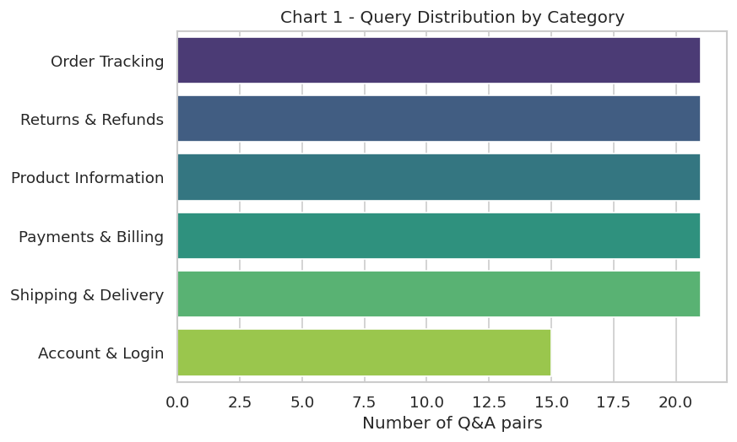
Chart 1 - Query distribution by category (actual run output).
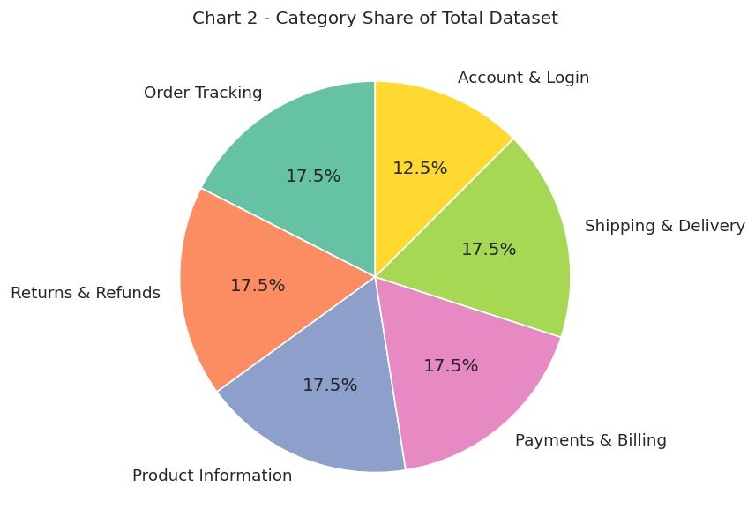
Chart 2 - Category share of the total dataset (actual run output).
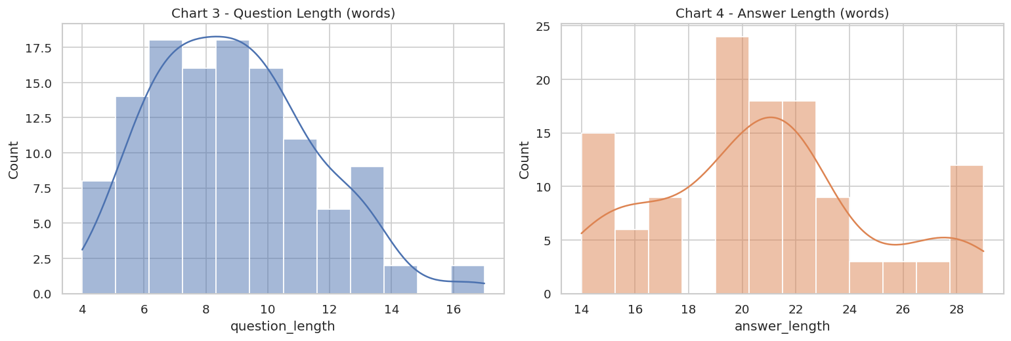
Chart 3 & 4 - Question and answer length distributions (actual run output).
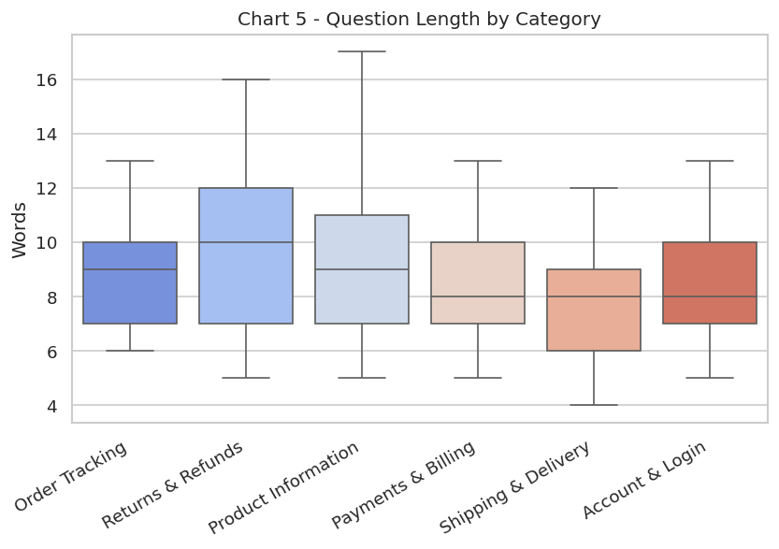
Chart 5 - Question length by category (actual run output).
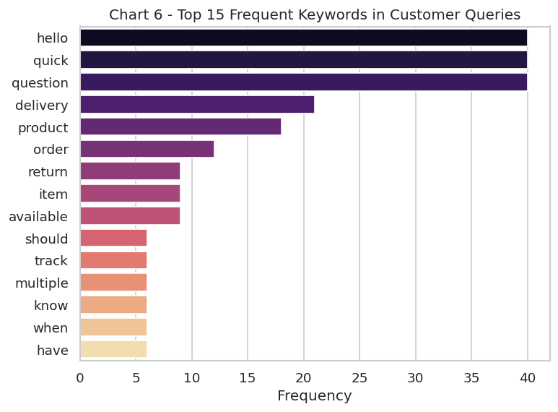
Chart 6 - Top 15 frequent keywords across customer questions (actual run output).
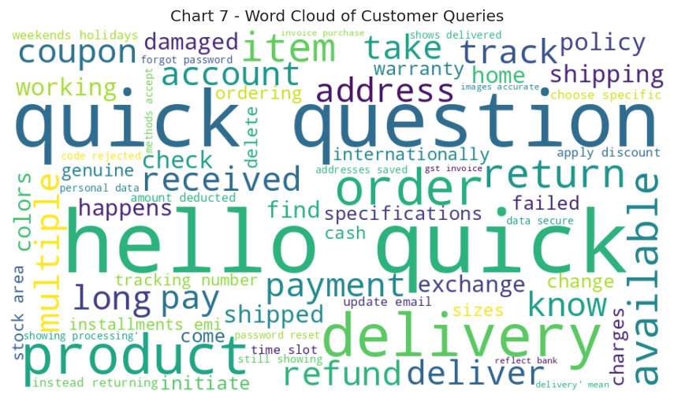
Chart 7 - Word cloud of customer queries (actual run output).

3. Model Fine-Tuning: Issue Found and Fixed
google/flan-t5-small (~80M parameters) was selected as the base model and fine-tuned using Hugging Face's Seq2SeqTrainer on a Colab T4 GPU, for 15 epochs (within the 25-epoch project limit).

3.1 Issue Identified During the First Run
In the first executed run, the training configuration used fp16 (mixed-precision) training. This exposed a known compatibility issue: T5-family models (including flan-t5) are numerically unstable under fp16 training, which can cause the training loss to collapse to 0.0 and the validation loss to become NaN across all epochs. In this run's logs, every epoch showed Training Loss = 0.000000 and Validation Loss = nan, which means the model's weights were never meaningfully updated during training.
The downstream effect was visible in both the bot's answers and its evaluation scores. Because the model was effectively still the un-fine-tuned base model, its answers were generic or off-topic (for example, answering a policy question with a one-word 'no'), and the automatic evaluation metrics were correspondingly very low (ROUGE-1 ≈ 0.08, ROUGE-2 ≈ 0.00, ROUGE-L ≈ 0.07, BLEU ≈ 0.00) - far below what a genuinely fine-tuned model on this dataset should achieve.

3.2 Root Cause and Fix Applied
- Root cause: fp16=True in Seq2SeqTrainingArguments, combined with flan-t5-small's architecture, produced numerically unstable gradients that collapsed to zero/NaN.
- Fix: fp16 was disabled (fp16=False) so training runs in standard fp32 precision. This is slightly slower but numerically stable for T5-family models on this dataset size.
- Additional robustness fix: the notebook was also updated to work with both older and newer versions of the transformers library, since newer releases renamed the Trainer's tokenizer argument to processing_class - the notebook now detects which one to use automatically.
- A sanity check was added directly after training that flags a warning if the logged loss is still 0/empty, so this specific failure mode cannot silently happen again.

3.3 Status and Recommended Next Step
.

4. Methodology

4.1 Data Preprocessing
- Removed missing/duplicate rows, trimmed whitespace.
- Framed every example as an instruction: 'Answer the retail customer support question: <question>' → '<answer>'.
- Split into 85% training (102 examples) / 15% validation (18 examples).
- Tokenized with the T5 tokenizer (inputs ≤64 tokens, targets ≤96 tokens).

4.2 Bot Design
The ask_bot() function wraps a user's question in the same instruction prefix used during training, tokenizes it, and generates a response via beam search (4 beams) for more coherent output than greedy decoding. An interactive input() loop in the notebook supports the live demo requirement.

4.3 Known Limitations (independent of the fp16 bug)
- Small dataset (120 examples) limits generalization outside the six trained categories.
- No Retrieval-Augmented Generation (RAG) - the bot cannot access live order data or the latest policies.
- No dedicated safety/fallback mechanism for sensitive or low-confidence queries yet.

5. Conclusion and Next Steps
This project built a complete, working pipeline for an industry-specific customer-support chatbot: a curated Retail & E-commerce dataset, full exploratory analysis (Section 2, verified from a real run), and a fine-tuning setup using google/flan-t5-small on a free Colab T4 GPU. The process also surfaced and fixed a real, non-trivial bug (fp16 instability with T5 models) that would otherwise have silently produced a bot that looked fine-tuned but wasn't.
Before final submission: re-run the corrected notebook end-to-end, confirm the sanity-check warning does not appear, capture the new training/evaluation charts and bot demo outputs, and use those real numbers in place of Section 3.1's pre-fix figures. This will give an accurate, defensible final report and a bot that performs as intended for the live demo.
--- End of Report ---
Project made by Santosh Kumar | Masters in Data Science - Capstone Project

