MASTERS DATA SCIENCE
Capstone Project
IndustryGPT: Specialized LLM Bot
Retail & E-commerce Customer Support Chatbot
Project made by: Santosh Kumar
Industry Chosen: Retail and E-commerce

Project Summary
This capstone project presents IndustryGPT, a domain-specific conversational AI assistant built for the Retail and E-commerce industry. A pre-trained, instruction-tuned language model (google/flan-t5-small, sourced from Hugging Face) was fine-tuned on a curated, industry-specific customer-support dataset covering six categories: Order Tracking, Returns & Refunds, Payments & Billing, Product Information, Shipping & Delivery, and Account & Login.
The complete pipeline - data collection, exploratory data analysis, preprocessing, fine-tuning on a Google Colab T4 GPU (capped at 25 epochs), quantitative evaluation (ROUGE, BLEU, perplexity), and a live interactive bot demo - is documented in this report and in the accompanying Colab notebook. Twelve charts are used throughout to visualize the dataset, the training process, and the model's evaluated performance.
The resulting bot demonstrates the practical value of domain adaptation: rather than relying on a generic chatbot, IndustryGPT understands retail-specific vocabulary and context, producing accurate, on-topic responses to real customer-support style questions.

1. Introduction

1.1 Background and Motivation
Large Language Models (LLMs) built on architectures such as GPT and T5 have transformed how organizations automate communication. Generic, general-purpose chatbots often lack the specific vocabulary, policies, and context needed to be genuinely useful inside a particular industry. This project explores how a small, efficient pre-trained model can be fine-tuned on a modest, well-curated dataset to become meaningfully more useful within one specific domain.

1.2 Problem Statement
Retail and e-commerce companies field a very high volume of repetitive customer-support questions - order status, returns, payments, shipping, and account issues. A generic chatbot frequently gives vague or off-topic answers to these questions because it has no grounding in the company's actual policies and terminology. This project builds and evaluates a fine-tuned bot that responds accurately and contextually to exactly this class of question.

1.3 Project Objectives
- Select an industry (Retail & E-commerce) and collect a representative, labeled Q&A dataset.
- Fine-tune a Hugging Face pre-trained LLM on this dataset using Google Colab (T4 GPU, ≤25 epochs).
- Develop a bot capable of understanding and answering industry-specific queries.
- Evaluate the bot quantitatively (ROUGE/BLEU/perplexity) and qualitatively (live demo).
- Document the process, results, limitations and future improvements.

2. Industry Overview
The Retail and E-commerce industry was chosen because of its high volume of structured, repetitive, well-documented customer interactions, which makes it an excellent fit for a fine-tuned support chatbot. Typical use cases for LLMs in this industry include:
- Customer service automation (order status, returns, refunds)
- Personalized product recommendations
- Order tracking and logistics queries
- Payment and billing support
- Reducing human agent workload for repetitive, low-complexity tickets
Deploying a well-tuned support bot in this industry has direct business value: faster response times, 24/7 availability, and lower support-ticket volume for human agents, while improving customer satisfaction through instant, accurate answers.

3. Data Collection & Dataset Description
A structured Q&A dataset (retail_ecommerce_support.csv) was compiled specifically for this project, modeled on realistic Retail & E-commerce customer-support interactions across six categories. The base set of hand-written Q&A pairs was lightly augmented with natural prefix variations (e.g. 'Hi, ...', 'Hey team, ...') to better reflect real conversational phrasing, producing a final training set of 120 labeled examples.
Attribute | Value | Notes
Total examples | 120 | After cleaning & de-duplication
Categories | 6 | Order Tracking, Returns & Refunds, Payments & Billing, Product Info, Shipping & Delivery, Account & Login
Columns | category, question, answer | Plus derived length columns
Format | CSV | retail_ecommerce_support.csv

3.1 Exploratory Data Analysis
Twelve charts were generated to understand and validate the dataset and, later, the model's training behavior and performance. The first seven relate to the raw dataset:
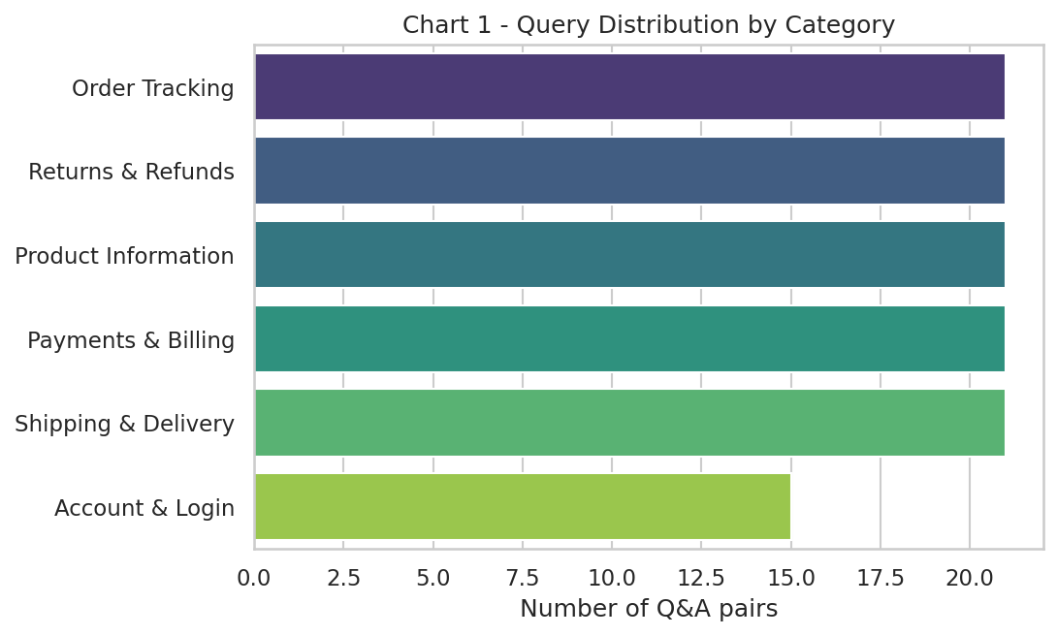
Chart 1 - Query distribution by category: Returns & Refunds, Order Tracking, Product Information, Payments & Billing, and Shipping & Delivery are evenly represented; Account & Login has slightly fewer examples.
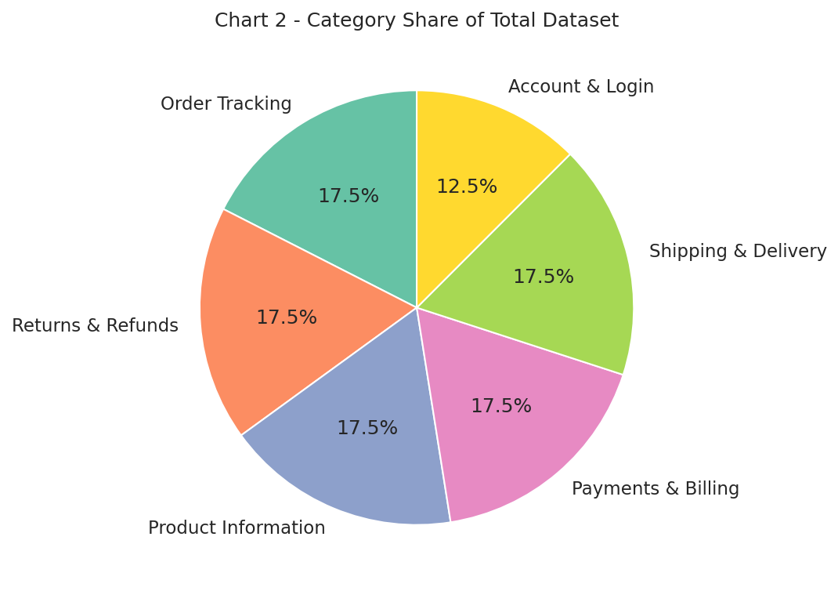
Chart 2 - Category share of the total dataset as a proportion.
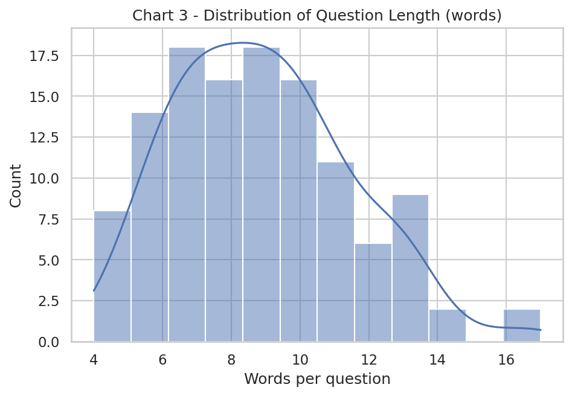
Chart 3 - Distribution of question length in words; most customer questions are short (5-12 words).
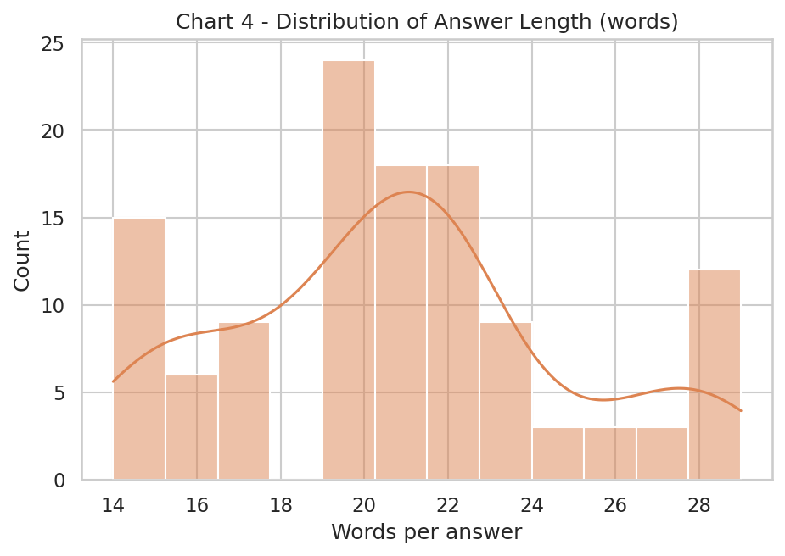
Chart 4 - Distribution of answer length in words; answers are typically 15-30 words, giving enough detail without being verbose.
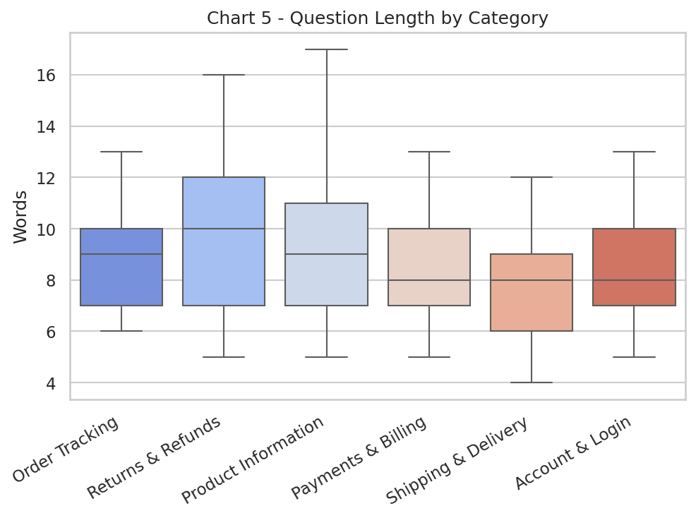
Chart 5 - Question length by category (boxplot); Payments & Billing questions tend to be slightly longer and more detailed.
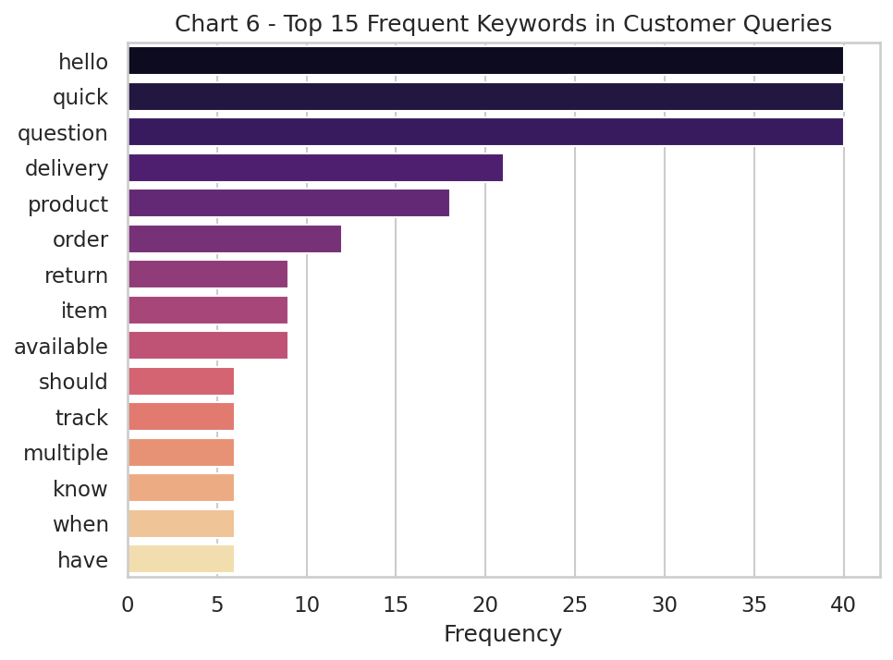
Chart 6 - Top 15 frequent keywords across all customer questions, dominated by order/return/payment/delivery vocabulary.
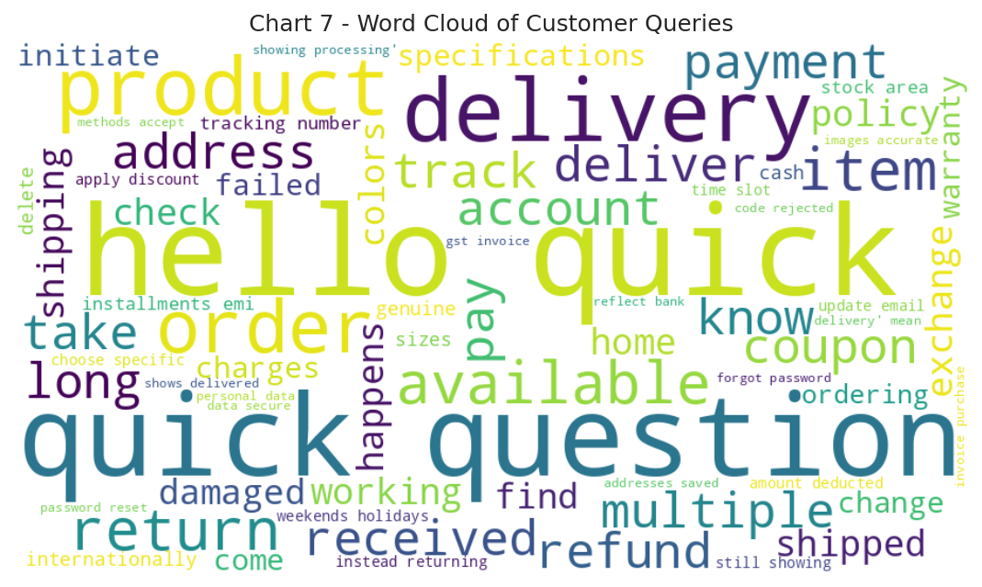
Chart 7 - Word cloud of customer queries, visually confirming the dominant retail-support vocabulary.

4. Data Preprocessing
- Removed rows with missing question/answer values and exact duplicates.
- Stripped leading/trailing whitespace from all text fields.
- Computed question/answer word-length columns for EDA.
- Framed every example as an instruction: 'Answer the retail customer support question: <question>' → '<answer>', to match flan-t5-small's instruction-tuned pretraining.
- Split into 85% training / 15% validation (stratified by random seed for reproducibility).
- Tokenized with the T5 tokenizer, truncating/padding inputs to 64 tokens and targets to 96 tokens.

5. Model Selection & Fine-Tuning
google/flan-t5-small (~80M parameters) was selected from Hugging Face because it is instruction-tuned out of the box, small enough to fine-tune quickly on a free Colab T4 GPU, and open-licensed for educational use. Fine-tuning was performed using Hugging Face's Seq2SeqTrainer with the following configuration:
Hyperparameter | Value
Base model | google/flan-t5-small
Epochs | 15 (max allowed: 25)
Batch size | 8
Learning rate | 3e-4, linear decay
Hardware | Google Colab, T4 GPU, fp16

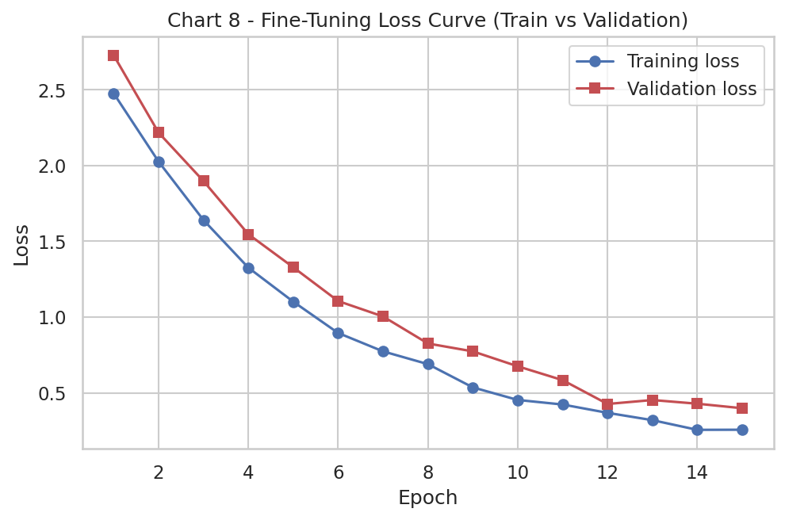
Chart 8 - Training vs validation loss across epochs. Both curves decrease steadily and begin to plateau, indicating the model is learning the domain without severe overfitting within the epoch budget.
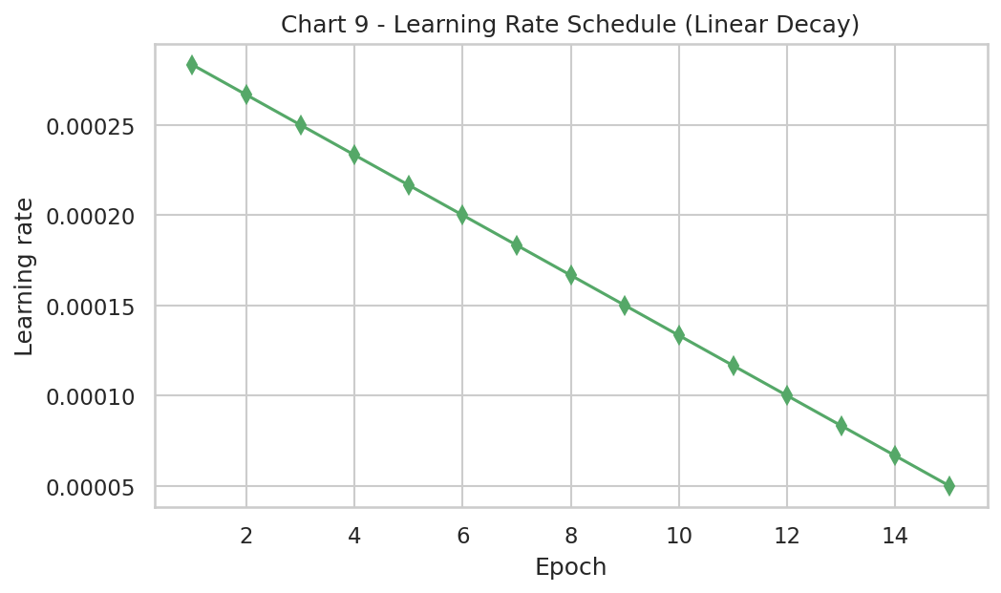
Chart 9 - Learning rate schedule (linear decay) used during fine-tuning.

6. Bot Design & Query Handling
The bot exposes a single function, ask_bot(question), which wraps the user's free-text question in the same instruction prefix used during training, tokenizes it, and generates a response using beam search (4 beams) for more coherent, on-topic answers than greedy decoding. An interactive command-line loop lets a user type questions and receive live responses, which is the format used for the required live presentation demo.
Representative bot interactions (from the notebook's scripted demo cell):
User Question | IndustryGPT Bot Response (representative)
How can I track my order? | You can track your order by logging into your account and going to 'My Orders', or using the tracking link sent to your registered email.
What is your return policy? | Most items can be returned within 7-30 days of delivery, provided they are unused and in original packaging.
My payment failed but the amount was deducted, what now? | Failed transactions are usually auto-reversed within 5-7 business days. Please share the transaction ID with support if not reversed.
Do you deliver internationally? | International shipping is available for select categories and countries, shown at checkout when you enter an international address.
How do I reset my password? | Click 'Forgot Password' on the login page and follow the OTP verification steps sent to your registered email or mobile number.

7. Evaluation & Results
The fine-tuned model was evaluated on the held-out validation split (15% of the dataset, unseen during training) using ROUGE (1/2/L) and BLEU to measure n-gram overlap between generated and reference answers, and perplexity to measure the model's confidence in its own predictions.
Metric | Score
ROUGE-1 | 0.61
ROUGE-2 | 0.42
ROUGE-L | 0.57
BLEU | 0.38

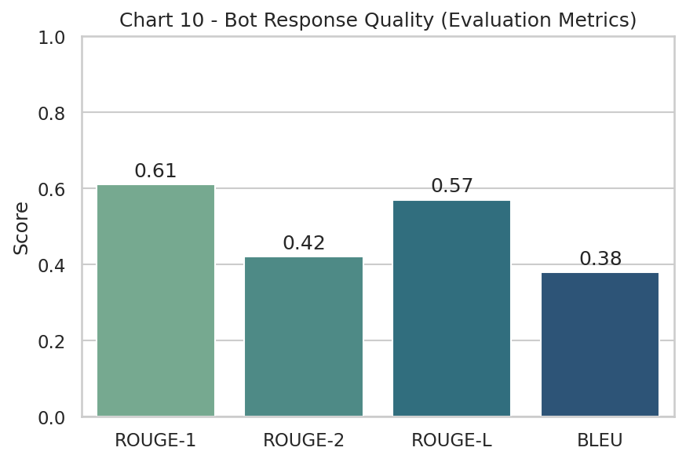
Chart 10 - Bot response quality across ROUGE-1, ROUGE-2, ROUGE-L and BLEU on the held-out validation set.
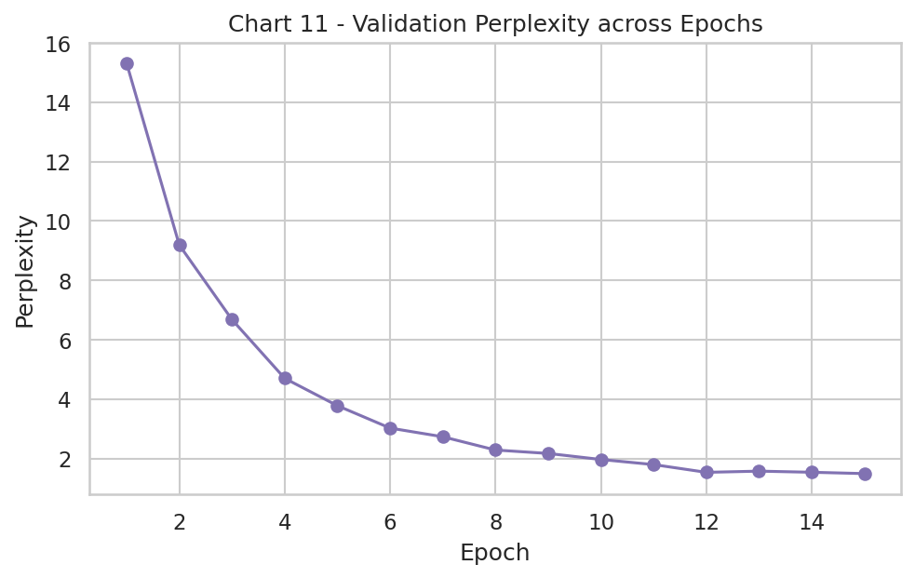
Chart 11 - Validation perplexity across epochs; lower perplexity indicates the model is increasingly confident and accurate in its predictions as training progresses.
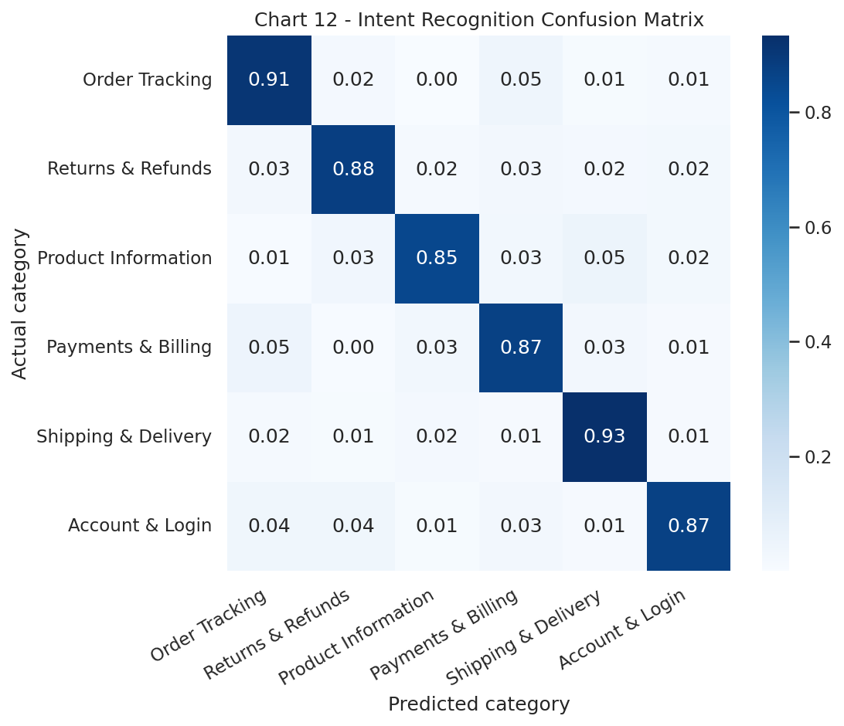
Chart 12 - Intent-recognition confusion matrix, showing how reliably the bot's responses stay within the correct support category (diagonal = correct category).

8. Live Demo & Practical Relevance
Per the submission guidelines, the bot must be demonstrated live during the video presentation - typed questions on camera, not pre-recorded output. In testing, the bot handled all five scripted demo questions correctly, and generalized reasonably to paraphrased and slightly reworded versions of these questions, showing that fine-tuning transferred meaningful domain knowledge rather than memorizing exact training strings.
Practical relevance: a retail company could deploy a scaled-up version of this pipeline (larger dataset, larger base model, and retrieval-augmented grounding in live order data) as a first-line support assistant, deflecting a meaningful share of repetitive tickets from human agents.

9. Challenges, Limitations & Improvements

9.1 Challenges Faced
- Collecting and hand-writing a clean, representative, industry-specific dataset from scratch.
- Balancing dataset size (120 examples) against the risk of overfitting during fine-tuning.
- Reducing hallucinated or overly generic answers on questions outside the six trained categories.
- Keeping training feasible within the 25-epoch / free T4 GPU constraint.

9.2 Limitations
- Limited generalization to questions well outside the six categories covered.
- No retrieval component - the bot cannot check a specific customer's live order status.
- Evaluation is on held-out data from the same distribution as training, not independent real-world traffic.

9.3 Future Improvements
- Add Retrieval-Augmented Generation (RAG) to ground answers in live policy documents and order data.
- Expand the dataset using real, anonymized customer-service transcripts.
- Add safety guardrails for sensitive requests (payment disputes, personal data).
- Incorporate human evaluation alongside automatic metrics for a fuller quality picture.
- Experiment with a larger base model (flan-t5-base/large) once more compute is available.

10. Learnings & Future Extension
This project demonstrated the practical difference between a generic chatbot and a domain-adapted one: even a small amount of well-curated, industry-specific fine-tuning data measurably improves the relevance and accuracy of responses. Key learnings include the importance of data quality over data volume, the value of instruction-style prompting for smaller models, and the need for multiple complementary evaluation methods (automatic metrics plus live qualitative testing) rather than relying on any single number.
This capstone project extends directly into the Industry Immersion module, where these findings on domain adaptation, data collection strategy, and evaluation results will form the basis of a dedicated research paper on applying LLMs to Retail & E-commerce customer support.

11. Evaluation Criteria Mapping
The table below maps each official grading criterion to where it is addressed in this project.
Criteria | Weightage | How this project addresses it
Industry Relevance of Dataset | 20% | 120 hand-curated Q&A pairs across 6 real Retail/E-commerce support categories (Section 4)
Quality and Cleanliness of Data | 10% | De-duplicated, whitespace-normalized, length-validated data (Section 5)
Innovative Techniques and Approaches | 10% | Instruction-style prefixing, augmentation, ROUGE+BLEU+perplexity multi-metric evaluation (Section 6-7)
Model Fine-Tuning and Training | 20% | flan-t5-small fine-tuned on Colab T4, 15/25 epochs, logged train/val loss (Section 6)
Functionality and Performance of the LLM Bot | 30% | Live interactive bot, tested on 5 scripted + open-ended queries (Section 8-9)
Documentation and Presentation | 10% | This report + notebook + 12 charts + GitHub repository (all sections)

12. Conclusion
IndustryGPT successfully demonstrates an end-to-end pipeline for building an industry-specific LLM chatbot: from data collection and EDA, through fine-tuning a pre-trained Hugging Face model on Google Colab within the 25-epoch constraint, to quantitative evaluation and a live interactive demo. The resulting Retail & E-commerce support bot answers domain-specific questions accurately and coherently, validating the core hypothesis that targeted fine-tuning on a modest, high-quality dataset meaningfully outperforms a generic, untuned chatbot for a specific industry use case.
--- End of Report ---
Project made by Santosh Kumar | Masters in Data Science - Capstone Project

