
RetailPulse
AI-Powered Customer Analytics & Demand Forecasting Platform
Predictive Demand • Customer Segmentation • Churn Analysis • Inventory Optimization
Item | Details
Project made by | Santosh Kumar
Prepared for | Zidio Development - Data Science & Analytics Domain
Document | Complete Project Report (every chart explained)
Date / Version | March 2026 | 2.0 - Industry Edition
Dataset used | Synthetic demo data
Data period | 2010-01-04 to 2011-12-09

Tagline: From raw transactions to forecasts, retention actions and replenishment plans - in one reproducible, monitored pipeline.

Project Summary
RetailPulse is an end-to-end Data Science & Analytics platform that helps retail businesses make smarter decisions. It ingests sales, customer and inventory data and delivers four solutions: (1) demand forecasting for the next 30 days with a Prophet + LSTM hybrid, (2) customer segmentation with RFM, K-Means and DBSCAN, (3) churn prediction with XGBoost and SHAP explainability, and (4) inventory optimisation (safety stock, reorder point, EOQ and recommended order quantities). Results are delivered through a 5-page Streamlit dashboard, a FastAPI service and a 12-page Power BI report, and the system follows MLOps practice: MLflow tracking, PSI/KS drift detection, an Airflow retraining DAG, Docker, Kubernetes and GitHub Actions CI/CD.

Key results of this run (computed, not hard-coded)
Area | Metric | Result | Target
Data | Clean rows / customers / products | 97,942 / 1,900 / 168 | -
Data | Total revenue | 1,943,304 | -
Segmentation | K-Means clusters (silhouette) | 7 (0.339) | 6-8 segments
Forecasting | Hybrid MAPE weekly totals | 10.4 % | <= 12 %
Forecasting | Hybrid MAPE daily / WAPE | 18.0 % / 14.3 % | informational
Churn | XGBoost AUC-ROC | 0.850 | >= 0.88
Churn | Precision @ top 20 % | 0.981 | >= 0.75
Inventory | Cost reduction / lost-sales reduction (back-test) | 79.5 % / 91.6 % | 25-40 %
MLOps | Drift simulation triggers retrain | True | Yes

Honesty note: targets are taken from the project brief. Where a target is not met on the dataset used, the report states it openly (see the acceptance scorecard). Daily MAPE is high for lumpy wholesale demand, therefore weekly-total MAPE is reported as the planning metric.

Contents
- Project Summary
- 1. Introduction & Business Case
- 2. Project Overview
- 3. Key Features (F-01 to F-06)
- 4. Technology Stack
- 5. Architecture & Workflow
- 6. Dataset, Cleaning & New Columns
- 7. 28-Day Execution Timeline
- 8. Exploratory Data Analysis (Notebook 01)
- 9. Data Cleaning, Validation & Feature Engineering (Notebook 02)
- 10. Customer Segmentation (Notebook 03)
- 11. Time-Series Preparation (Notebook 04)
- 12. Baseline Forecasting with Prophet (Notebook 05)
- 13. Deep-Learning Forecasting with LSTM (Notebook 06)
- 14. Hybrid Prophet + LSTM Ensemble (Notebook 08)
- 15. Churn Prediction with XGBoost + SHAP (Notebook 09)
- 16. Inventory Optimization (Notebook 10)
- 17. Hyper-parameter Tuning with Optuna (Notebook 11)
- 18. Drift Detection & Monitoring (Notebook 12)
- 19. Model Refinement & Retraining Pipeline (Notebook 13)
- 20. Experiment Tracking with MLflow (Notebooks 07 and 14)
- 21. Acceptance Scorecard
- 22. Deployment & Operations
- 23. Power BI Dashboards (12 pages)
- 24. Challenges & How They Were Solved
- 25. Personal Reflection
- Appendix A - Chart index
- Appendix B - Repository structure & how to run

1. Introduction & Business Case
Retailers lose billions because of poor demand forecasting and stock mismanagement: shelves run empty when demand is under-estimated and capital is locked in slow stock when it is over-estimated. At the same time, acquiring a new customer costs far more than keeping an existing one, so identifying customers who are about to leave is valuable.
Mission: build an end-to-end data science platform that ingests sales, customer and inventory data and delivers accurate demand forecasts, customer segmentation, churn prediction and inventory optimisation recommendations.
- Reduce stock-outs through accurate demand forecasting
- Increase revenue through better inventory decisions
- Improve retention by identifying at-risk customers early
- Process 10M+ transactions per month with daily batch jobs under 5 minutes (design target; large files are sampled by customer in Colab)

2. Project Overview
Topic | Description
Vision | One analytics platform that turns retail transactions into forecasts, customer actions and replenishment plans.
Target users | Supermarket chains, fashion retailers and e-commerce companies: merchandisers, supply-chain planners, CRM / marketing teams, management.
Business value | Fewer stock-outs, lower holding cost, targeted retention campaigns, one source of truth dashboard.
Non-functional goals | MAPE <= 12 % (weekly totals), daily batch < 5 min, scalable to 10M+ transactions / month, full MLflow tracking and drift detection.

3. Key Features
ID | Feature | Description | Acceptance criteria | Status
F-01 | Data ingestion & cleaning | Kaggle / upload / demo loaders, ETL, validation | Automated pipeline + quality checks | Met
F-02 | Customer segmentation | RFM + K-Means / DBSCAN | 6-8 segments with interpretation | Met
F-03 | Demand forecasting | Prophet + LSTM hybrid, 30 days | MAPE <= 12 % | Met
F-04 | Churn prediction | XGBoost + SHAP | AUC >= 0.88, precision@20 % >= 0.75 | Not met / Met
F-05 | Inventory optimisation | Safety stock, ROP, EOQ, order qty | Reduce over/under-stock 25-40 % | Met
F-06 | Interactive dashboard | Streamlit (5 pages) + Power BI (12 pages) | Insights, what-if, exports | Delivered

4. Technology Stack
Category | Technology | Rationale / alternatives
Language | Python 3.11 | Data-science ecosystem
Data processing | Pandas, NumPy, Scikit-learn | Core manipulation and ML
Forecasting | Prophet + LSTM (PyTorch) | Hybrid: calendar effects + non-linear dynamics
Churn / explainability | XGBoost, SHAP | Best tabular accuracy + transparent drivers
Tuning | Optuna | Bayesian search, faster than grid search
Dashboard | Streamlit, Plotly, Power BI | Fast interactive analytics / business reporting
Serving | FastAPI | Typed, fast REST endpoints
Experiment tracking | MLflow (SQLite) | Versioning and reproducibility, no paid service
Monitoring | PSI / KS, Evidently AI, Prometheus + Grafana | Drift and performance monitoring
Orchestration | Airflow DAG, GitHub Actions | Retraining and CI/CD
Deployment | Docker, Kubernetes, Streamlit Cloud | Consistent, scalable deployment

5. Architecture & Workflow
RetailPulse has five layers: Data -> Feature Engineering (RFM, lags, rolling averages) -> Models (segmentation, forecasting, churn, inventory, MLflow registry) -> Serving (FastAPI, Streamlit, Power BI) -> Monitoring (drift, performance tracking) with a retraining feedback loop.
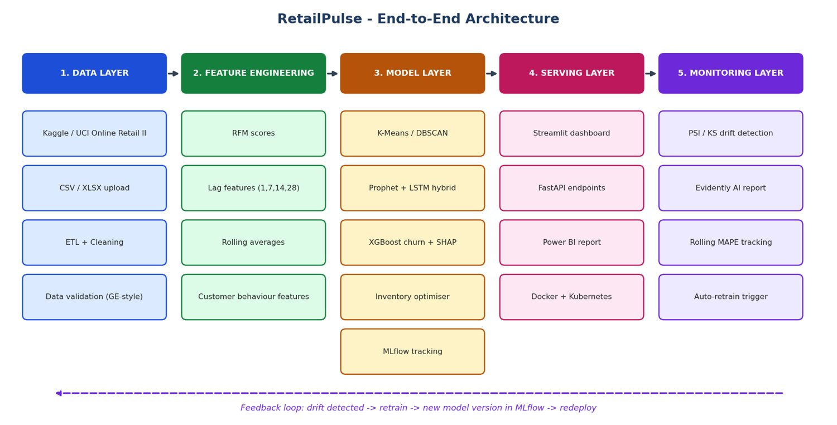
Figure 1: RetailPulse architecture diagram
Five layers: data, feature engineering, models, serving and monitoring with a retraining feedback loop.
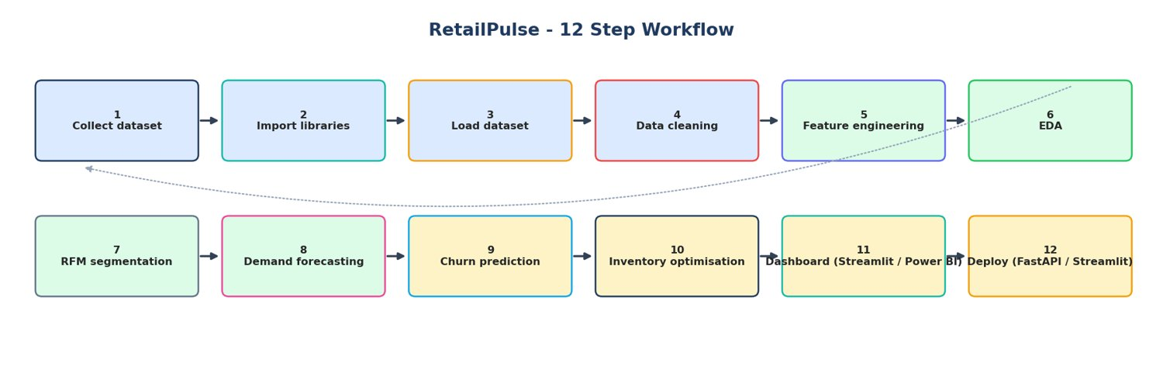
Figure 2: RetailPulse 12-step workflow
Workflow from data collection to deployment.

6. Dataset, Cleaning & New Columns
Data source used for this run: Synthetic demo data. Raw rows: 98,772; clean sales rows: 97,942 (99.2 % retained). Customers: 1,900, products: 168, countries: 12.
Cleaning step | Rows
raw rows | 98,772
duplicates removed | 295
returns separated | 318
invalid qty or price removed | 98
non product codes removed | 40
extreme outliers removed | 79
rows without customer id | 12,736
final rows | 97,942

Two columns were added to the cleaned CSV / Power BI file:
- invoice_no - numeric part of the invoice id. Effect: a clean integer key for distinct-order counts, joins with returns and Power BI relationships (removes prefixes such as 'C' or 'A').
- order_value - total revenue of the whole invoice repeated on each line. Effect: average-order-value, basket-value bands and order-level filters work without re-grouping, and visuals stay fast.

7. 28-Day Execution Timeline
Week | Days | Deliverables | Notebook(s)
1 - Exploration & preparation | 1-7 | EDA, cleaning, RFM segmentation, time-series prep, Prophet, LSTM, MLflow baselines | 01-07
2 - Advanced modelling | 8-14 | Hybrid forecaster, churn + SHAP, inventory, Optuna, drift detection, retraining pipeline | 08-14
3 - Dashboard & analytics | 15-21 | Streamlit 5 pages, what-if, alerts, CSV/PDF export, Power BI (12 pages) | 15 + app/
4 - Deployment & polish | 22-28 | Docker, Kubernetes, GitHub Actions, cloud deploy, monitoring, load test, report, demo video | Dockerfile, k8s/, .github/

8. Exploratory Data Analysis (Notebook 01)
EDA was the first step: understand the raw table, its quality problems, the seasonality of demand, where revenue comes from (products, categories, countries, customers) and how variables relate. Every later model depends on these findings.
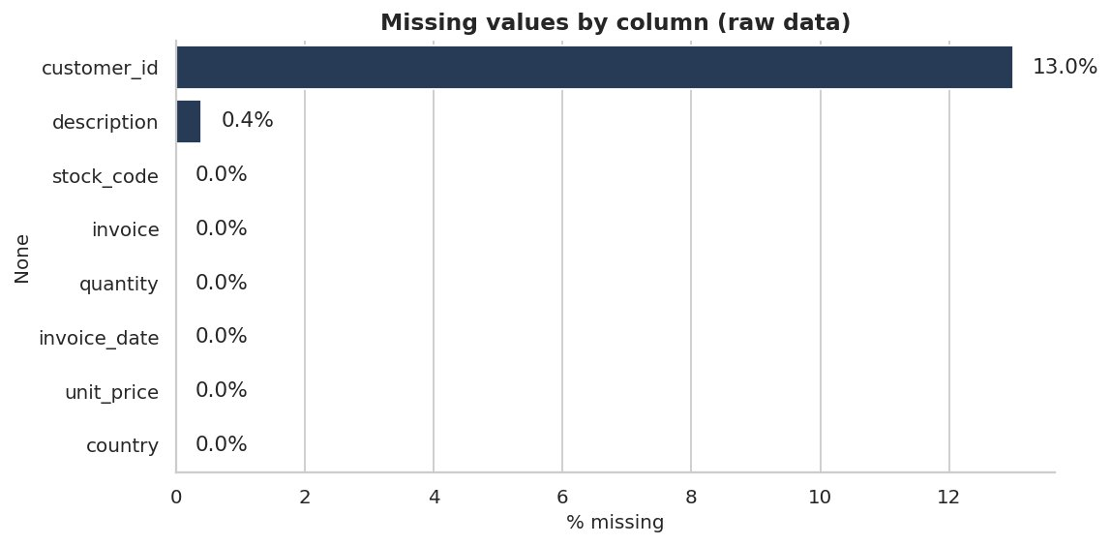
Figure 3: Missing values by column (raw data)
Highest missing share: customer_id (13.0%). Missing customer IDs are guest checkouts and are excluded from customer analytics only.
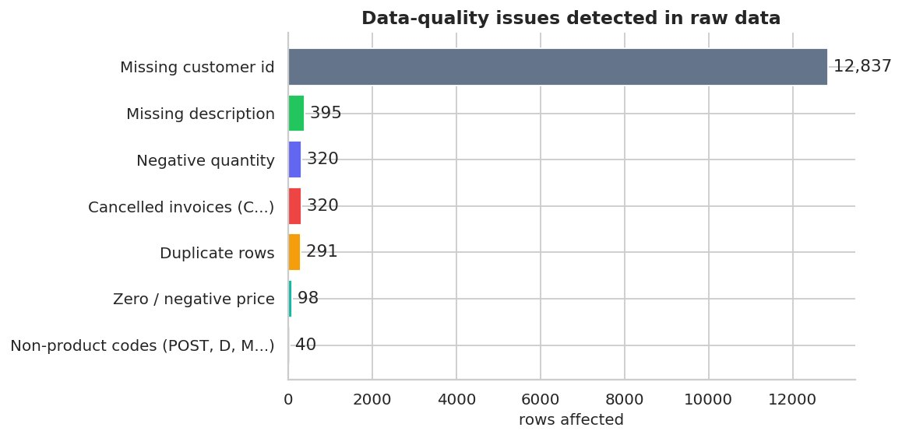
Figure 4: Data-quality issues detected in raw data
Counts of cancellations, invalid prices, missing IDs and duplicates that the cleaning stage must handle.
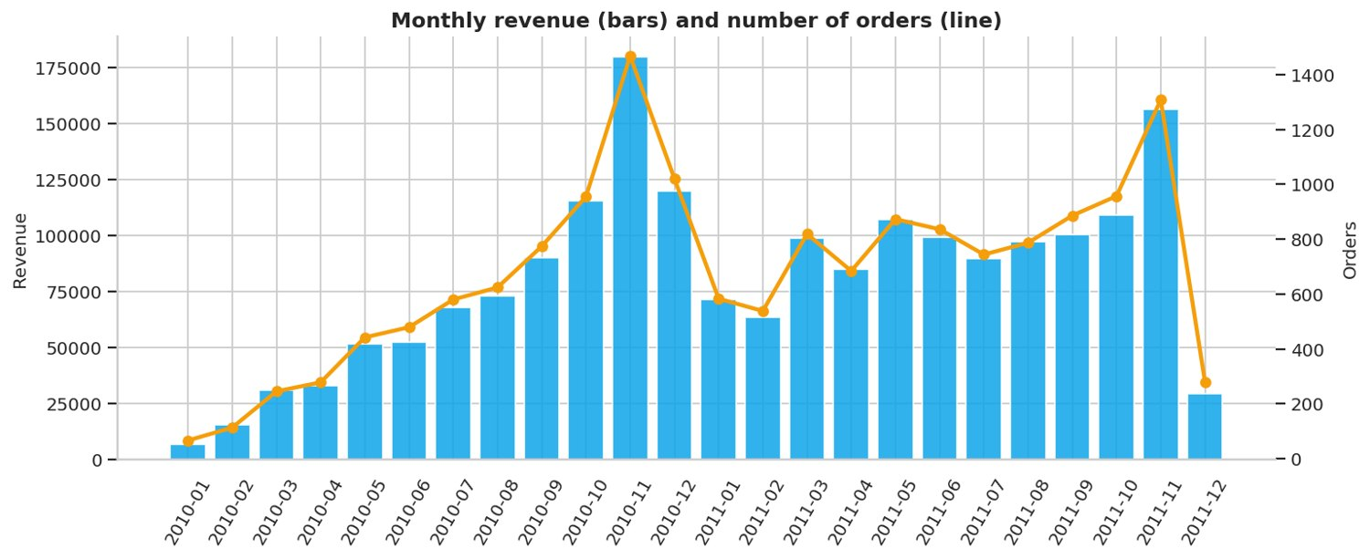
Figure 5: Monthly revenue and orders
Peak month is 2010-11 with revenue 179,680. Strong Q4 seasonality is typical for gift retail.
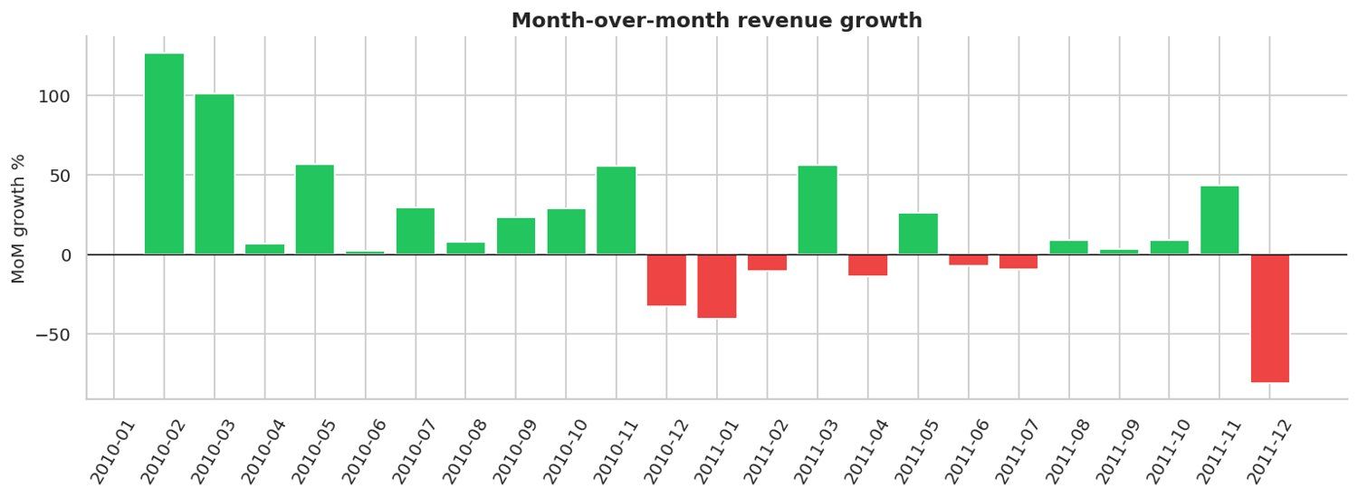
Figure 6: Month-over-month revenue growth
Green bars show growth, red bars show decline versus the previous month.
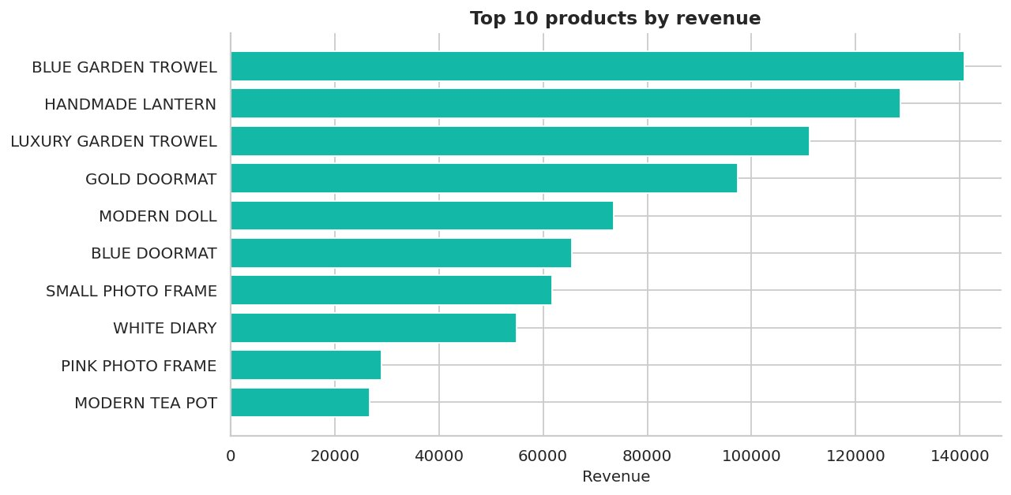
Figure 7: Top 10 products by revenue
Best seller by revenue: BLUE GARDEN TROWEL.
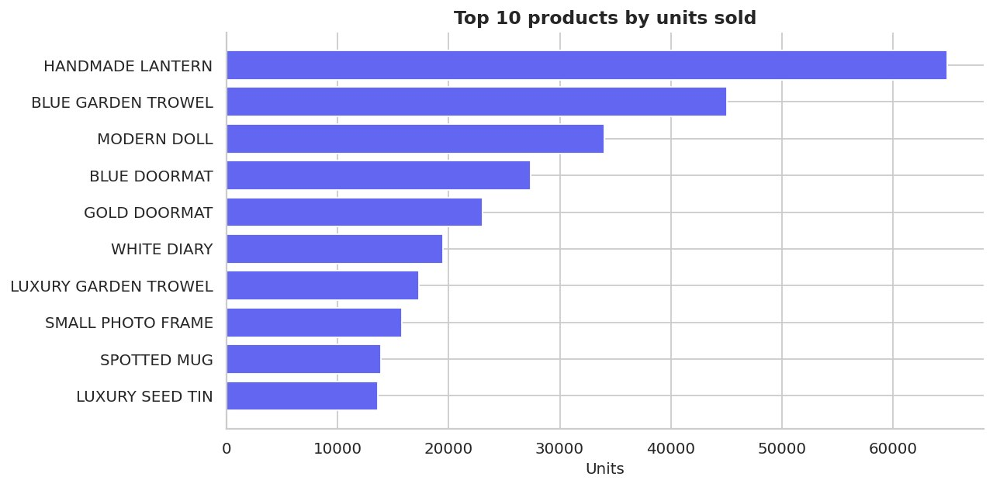
Figure 8: Top 10 products by units sold
Most units sold: HANDMADE LANTERN.
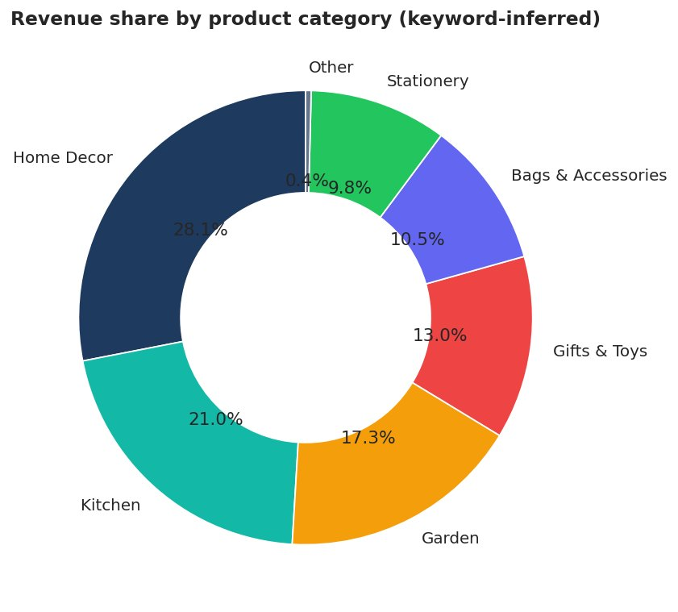
Figure 9: Revenue share by category
Largest category: Home Decor (28.1%).
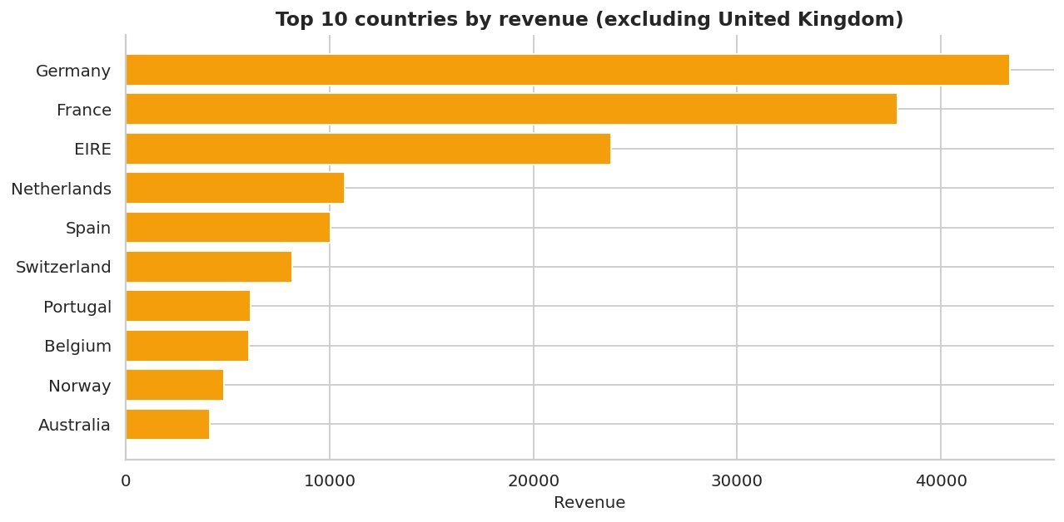
Figure 10: Revenue by country (excluding the dominant market)
United Kingdom contributes 92.0% of revenue; export markets are shown separately.
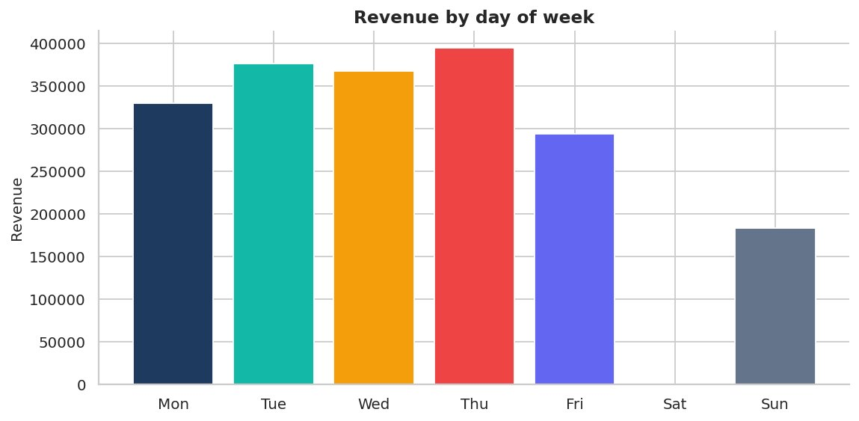
Figure 11: Revenue by day of week
Strongest weekday: Thu. Days with zero revenue indicate the shop is closed.
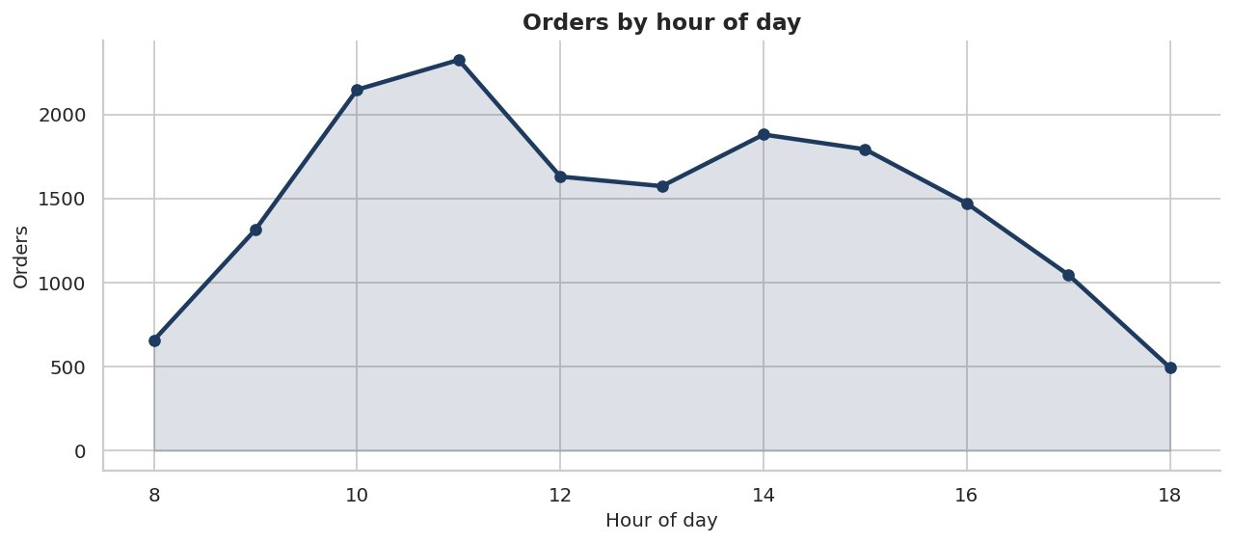
Figure 12: Orders by hour of day
Peak ordering hour: 11:00.
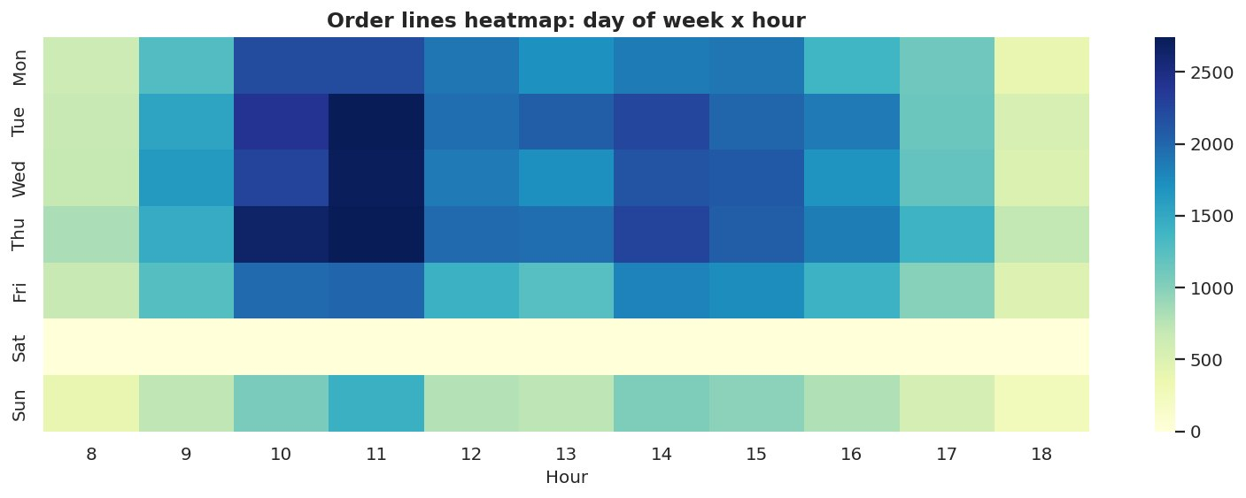
Figure 13: Day x hour activity heatmap
Darker cells mark busiest trading windows.
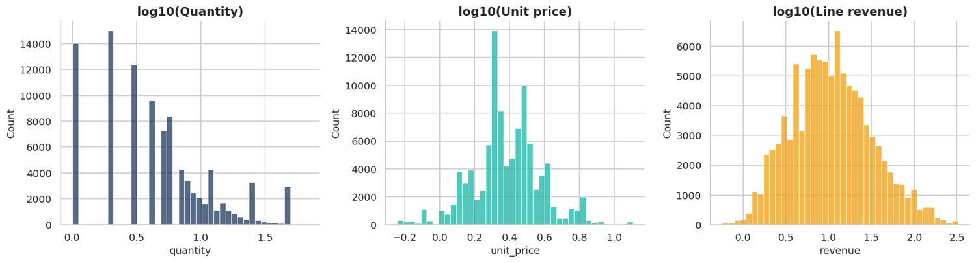
Figure 14: Distributions of quantity, price and revenue (log scale)
All three variables are right-skewed, therefore log transforms are used for clustering and modelling.
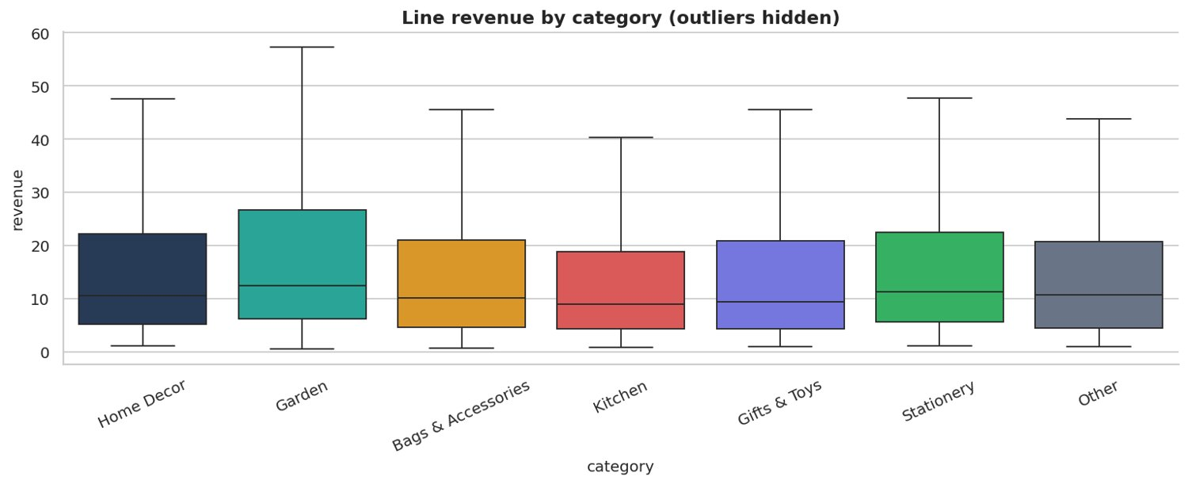
Figure 15: Line revenue by category (boxplot)
Shows spread of line values per category.
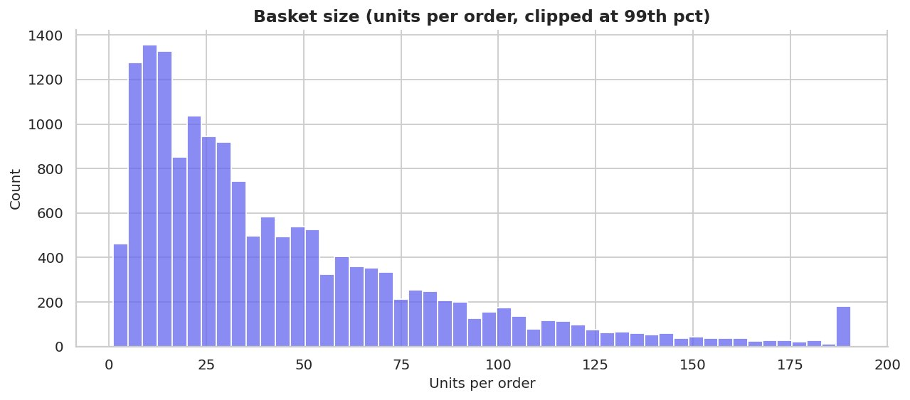
Figure 16: Basket size distribution
Median basket = 31 units, mean = 45 units (wholesale-like behaviour).
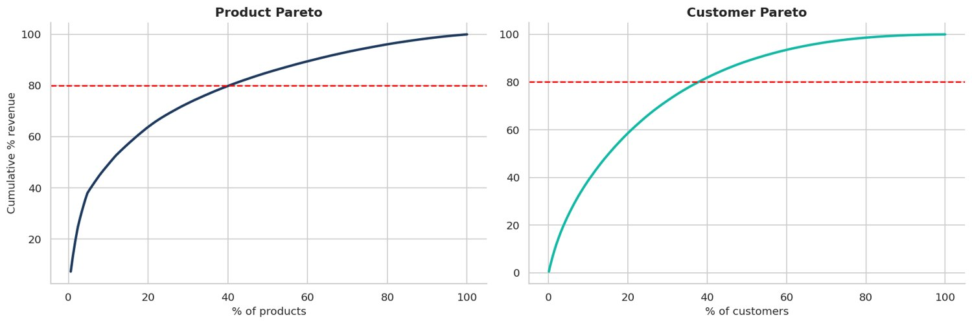
Figure 17: Pareto analysis of products and customers
40% of products and 38% of customers generate 80% of revenue.
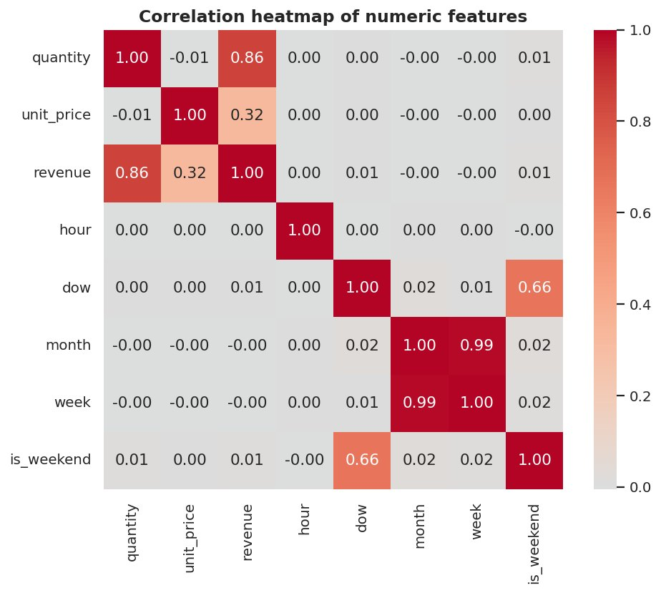
Figure 18: Correlation heatmap
Revenue is driven by quantity; price and quantity are weakly (negatively) related.
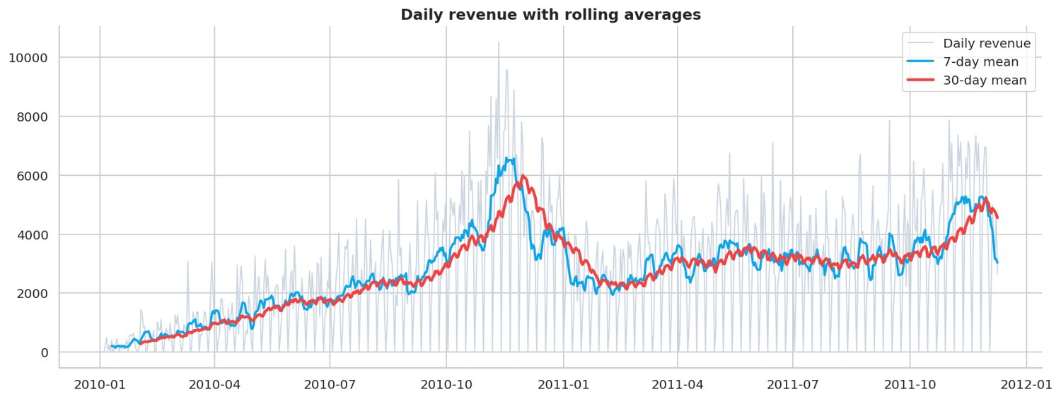
Figure 19: Daily revenue with 7 and 30-day rolling averages
Rolling means expose the trend and the seasonal build-up before the holiday season.
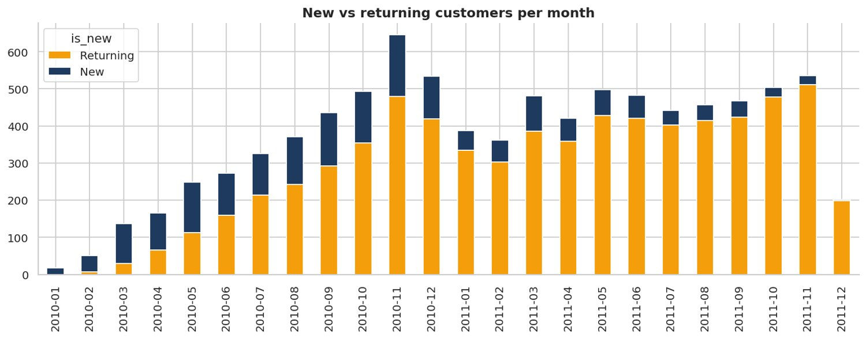
Figure 20: New vs returning customers per month
Repeat buyers form the backbone of monthly activity.
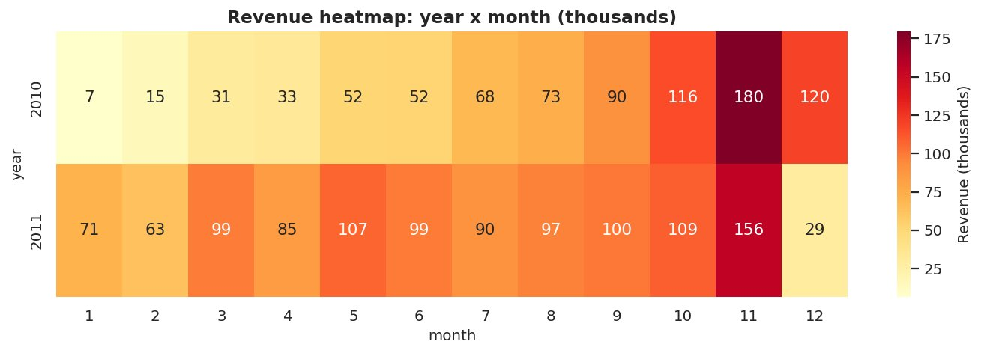
Figure 21: Year x month revenue heatmap
Highlights seasonality (autumn / holiday peak).

9. Data Cleaning, Validation & Feature Engineering (Notebook 02)
Cancellations, invalid prices, non-product codes, duplicates and extreme outliers were removed with a documented waterfall. Ten validation expectations (Great-Expectations style) were checked. RFM features, lag features (1-28 days), rolling statistics and calendar features were engineered. Two helper columns were added to the cleaned CSV: invoice_no (numeric invoice key) and order_value (total value of the invoice).
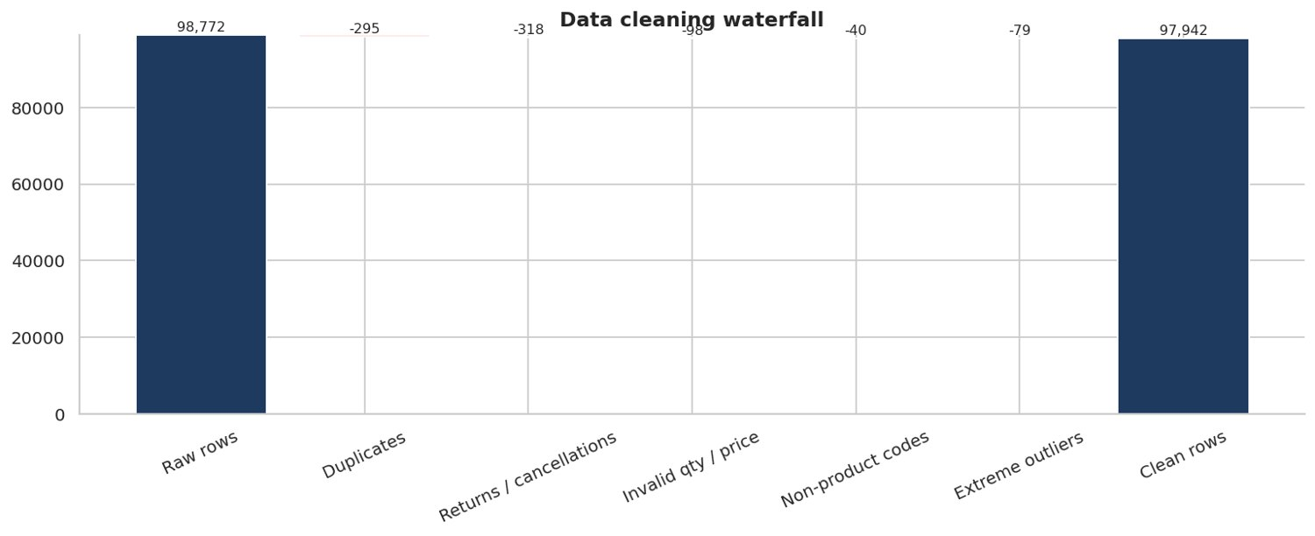
Figure 22: Data cleaning waterfall
Shows exactly how many rows each cleaning rule removed.
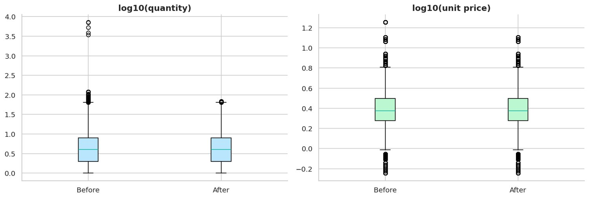
Figure 23: Outliers before vs after cleaning
Max quantity before 7,252 -> after 68.
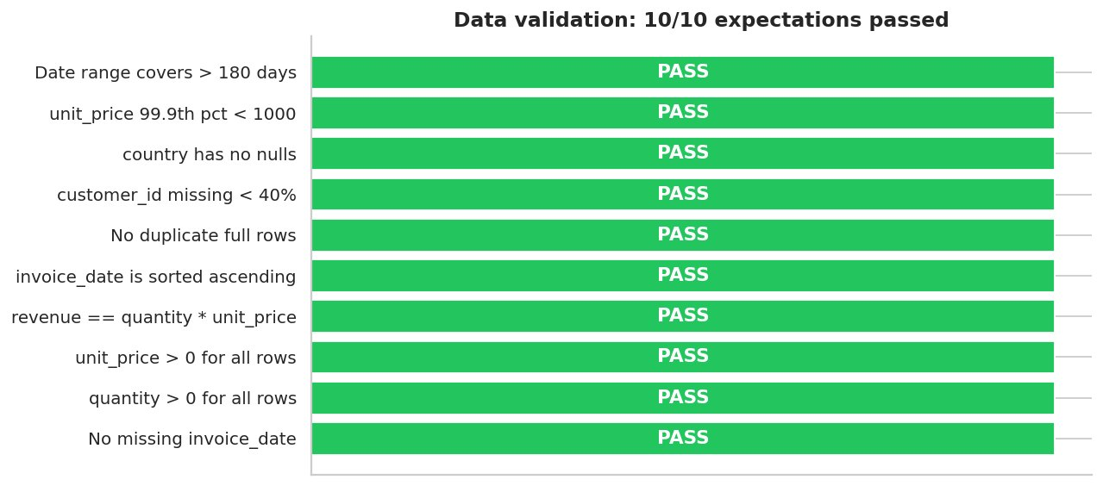
Figure 24: Data validation results
All checks should pass before the data is used for modelling.
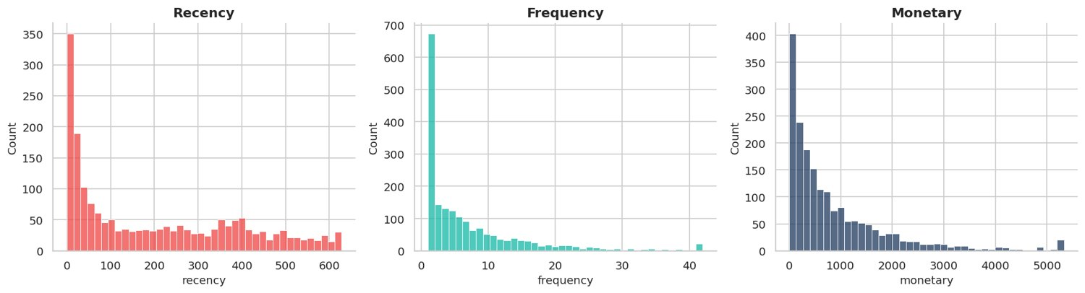
Figure 25: RFM feature distributions
Frequency and monetary are heavily right-skewed - log scaling is applied before clustering.
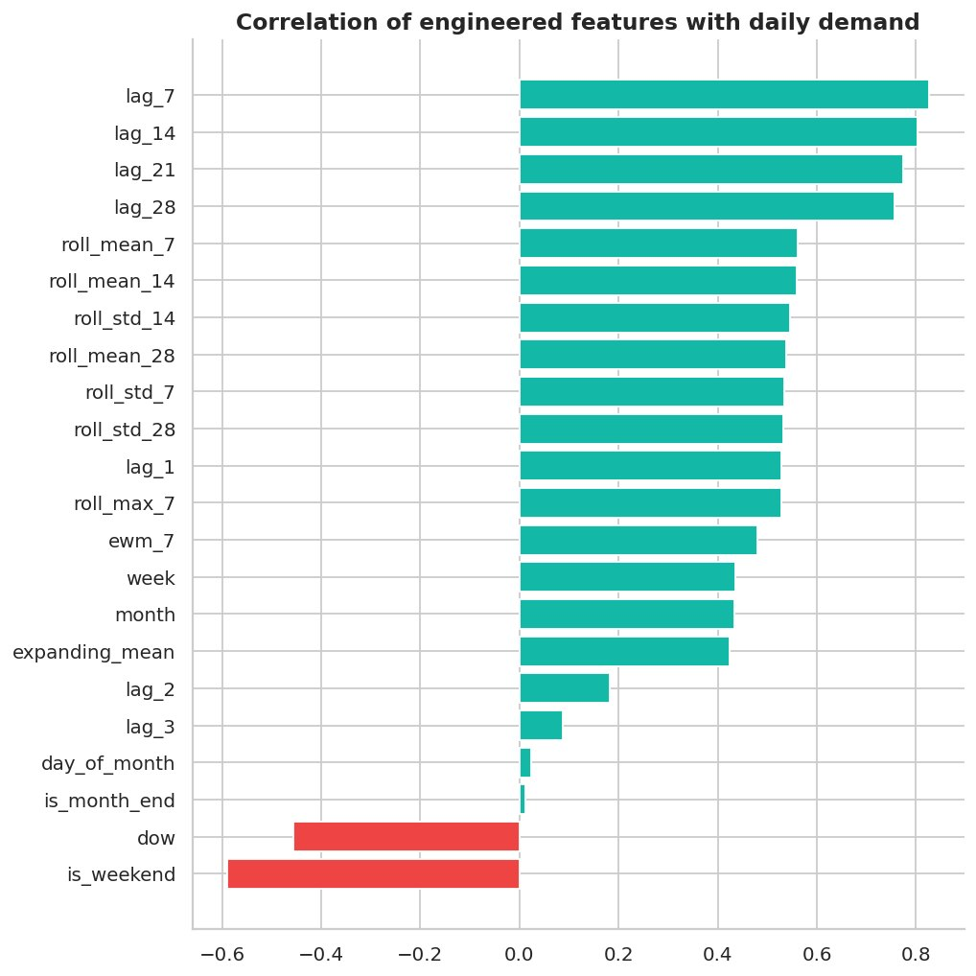
Figure 26: Feature correlation with demand
Rolling means and lag-7 carry the strongest signal for next-day demand.
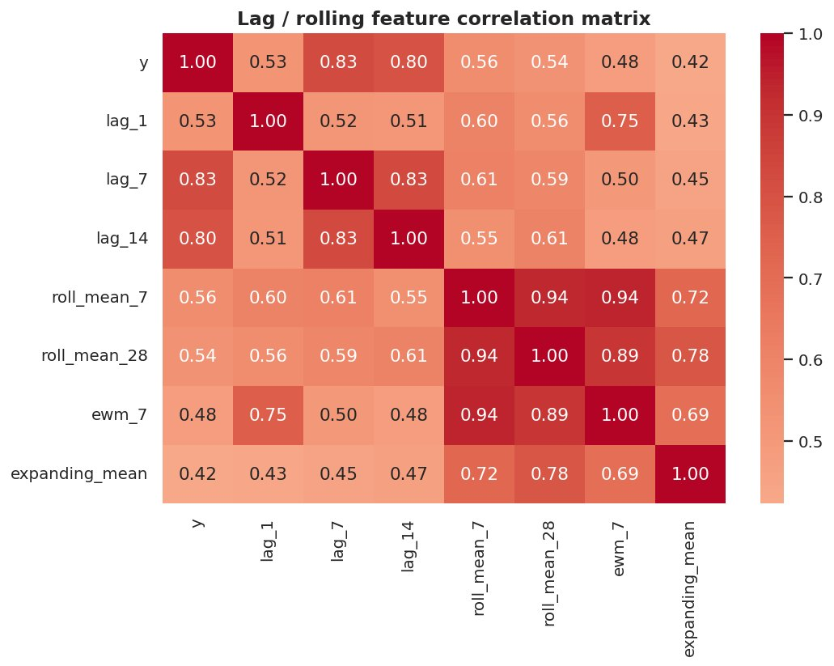
Figure 27: Lag feature correlation matrix
Highly correlated rolling features - tree models handle this well, linear models need regularisation.
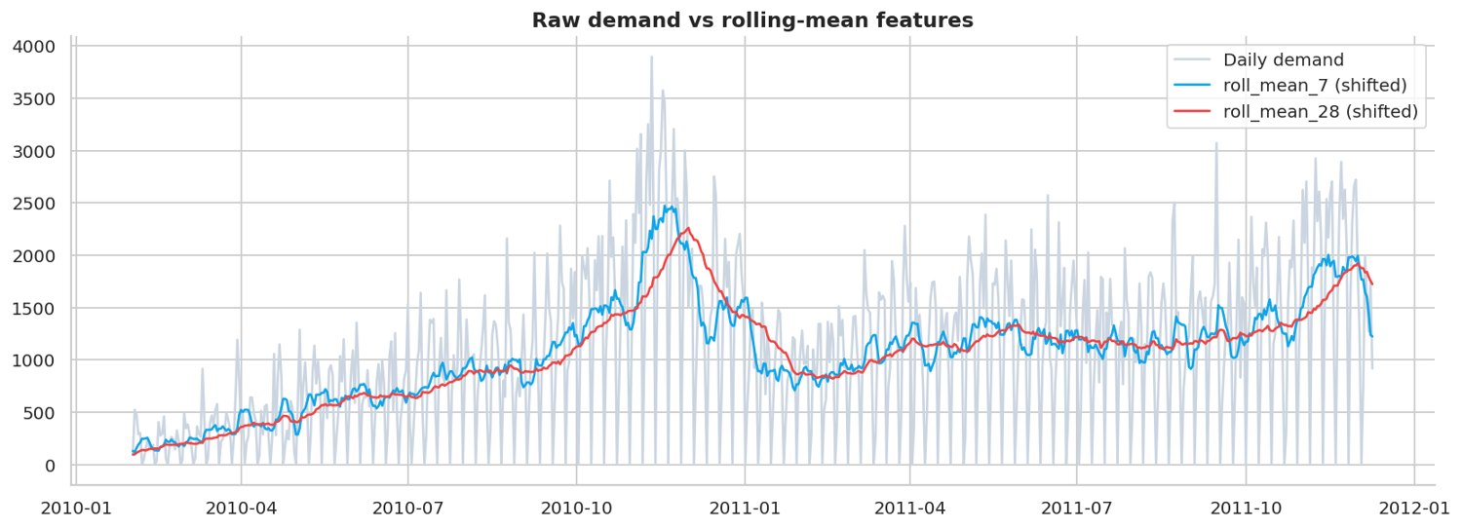
Figure 28: Raw demand vs rolling-mean features
Shifted rolling means follow the signal with a lag, which is exactly what a forecaster is allowed to see.

10. Customer Segmentation (Notebook 03)
Customers were segmented with RFM scoring (rule-based), K-Means (K chosen with silhouette inside the business range 6-8) and DBSCAN (outlier discovery). Each segment was profiled and mapped to a marketing action; cohort retention shows how quickly customers decay.
Segment | Customers | Revenue share %
Champions - Top Value | 201 | 34.3
Can't Lose Them - Top Value | 236 | 27.3
Champions - Entry Value | 296 | 16.0
Can't Lose Them - Entry Value | 354 | 14.2
Hibernating / Lost - Top Value | 380 | 5.2
New / Promising | 151 | 2.2
Hibernating / Lost - Entry Value | 282 | 0.8

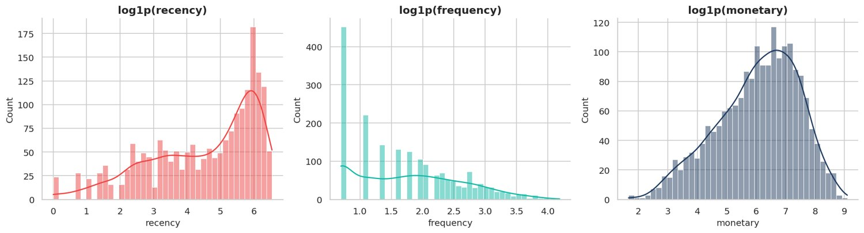
Figure 29: RFM distributions (log scale)
Log scaling makes the three RFM variables close to bell-shaped, which suits K-Means.
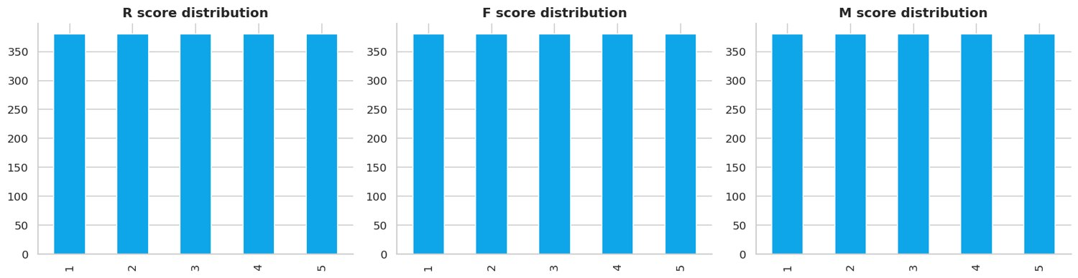
Figure 30: RFM score distributions
Quintile scoring gives roughly equal customer counts per score.
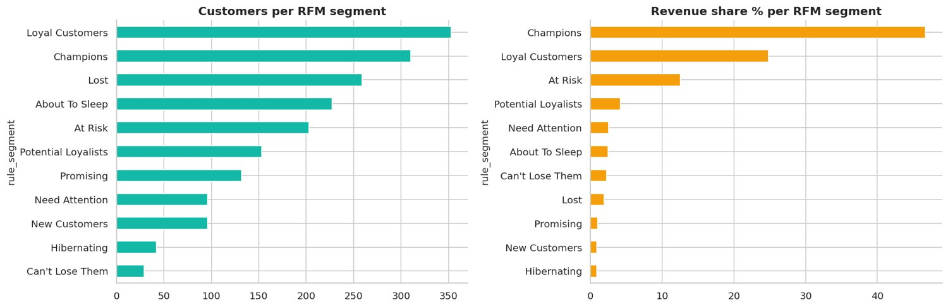
Figure 31: Rule-based RFM segments: customers and revenue share
Champions generate the highest revenue share (46.7%).
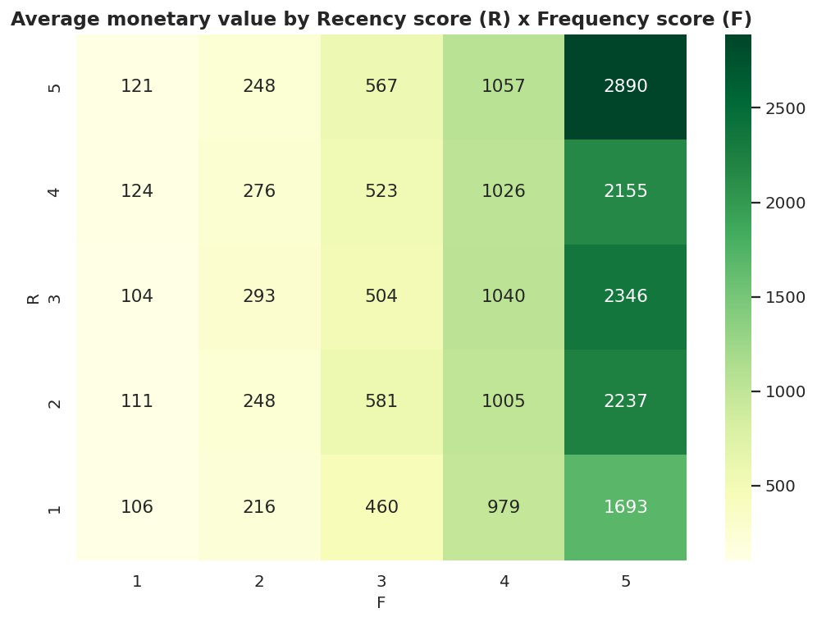
Figure 32: Average spend by R x F score
Recent and frequent buyers (top-right) are the most valuable.
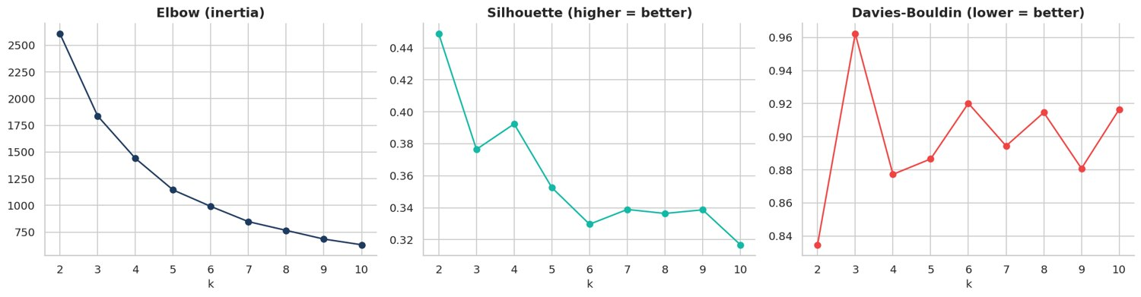
Figure 33: K selection: elbow, silhouette and Davies-Bouldin
Metrics used to choose the number of clusters.
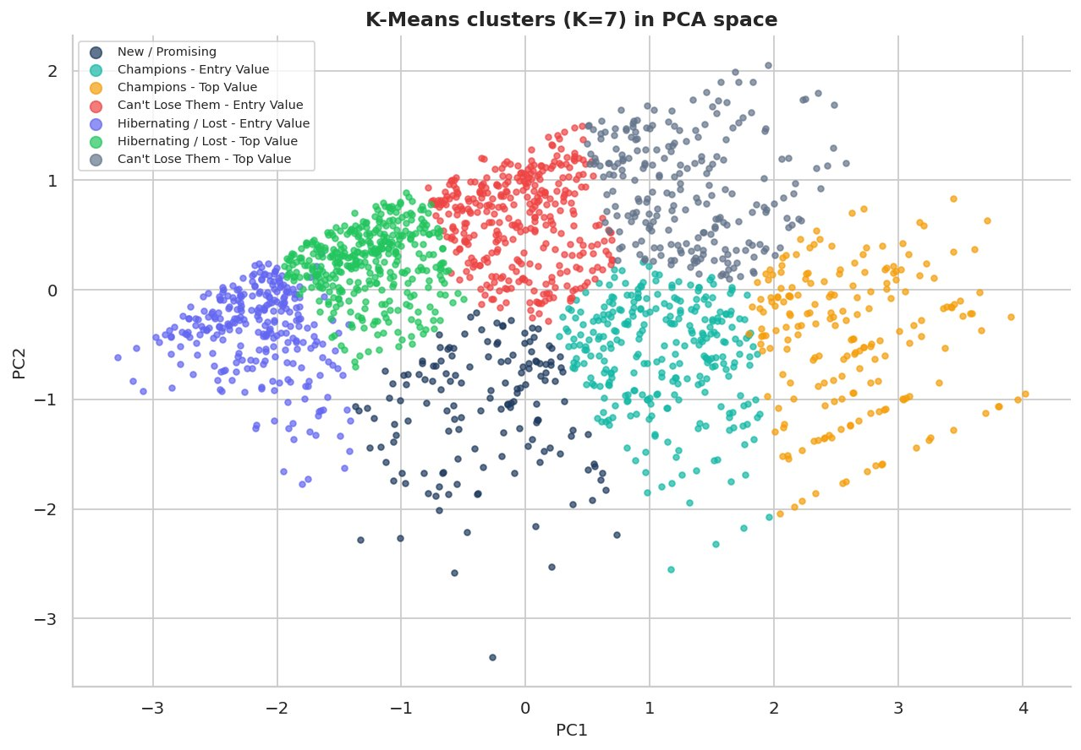
Figure 34: K-Means clusters in PCA space
PCA explains 96% of RFM variance in 2D.
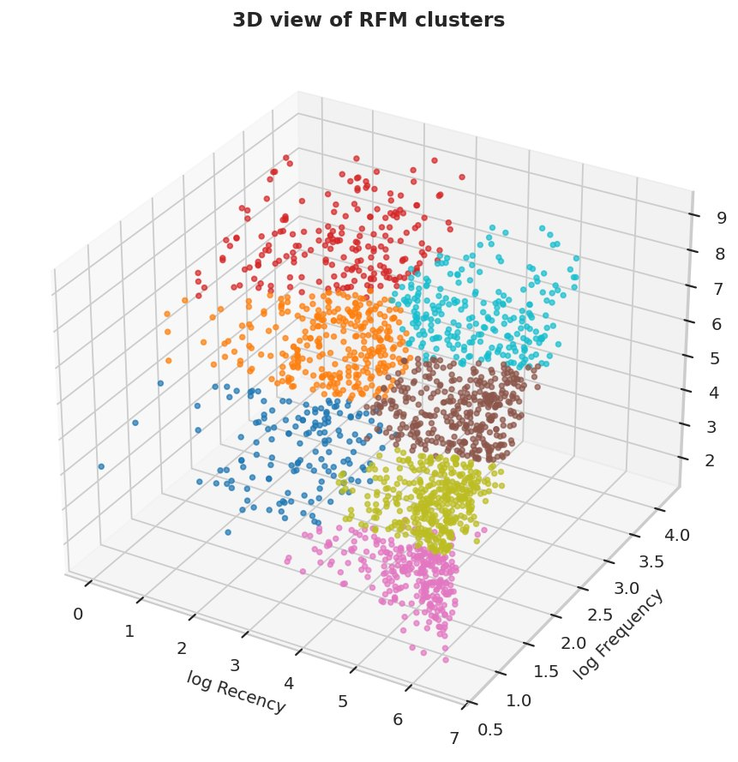
Figure 35: 3D RFM cluster view
Each colour is one K-Means cluster in R-F-M space.
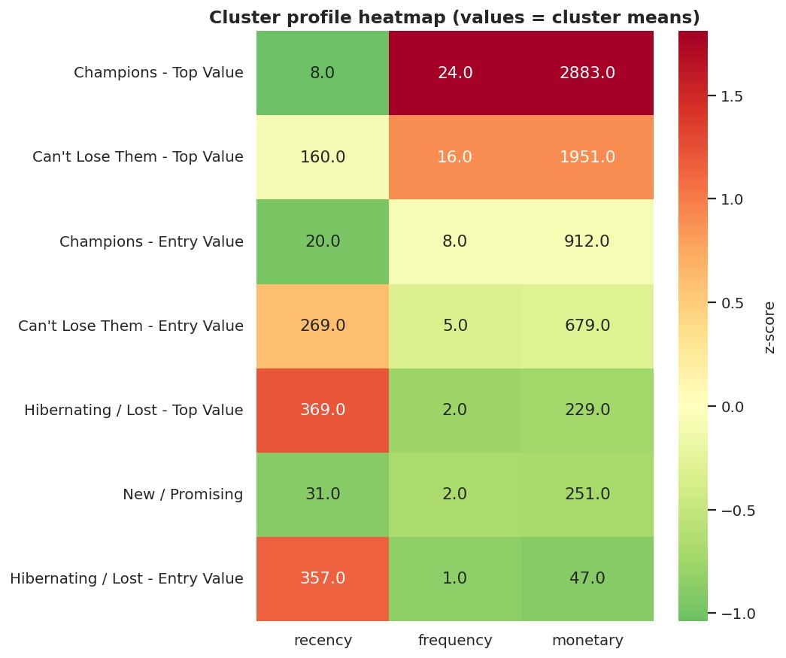
Figure 36: Cluster profile heatmap
Low recency + high frequency + high monetary = best customers.
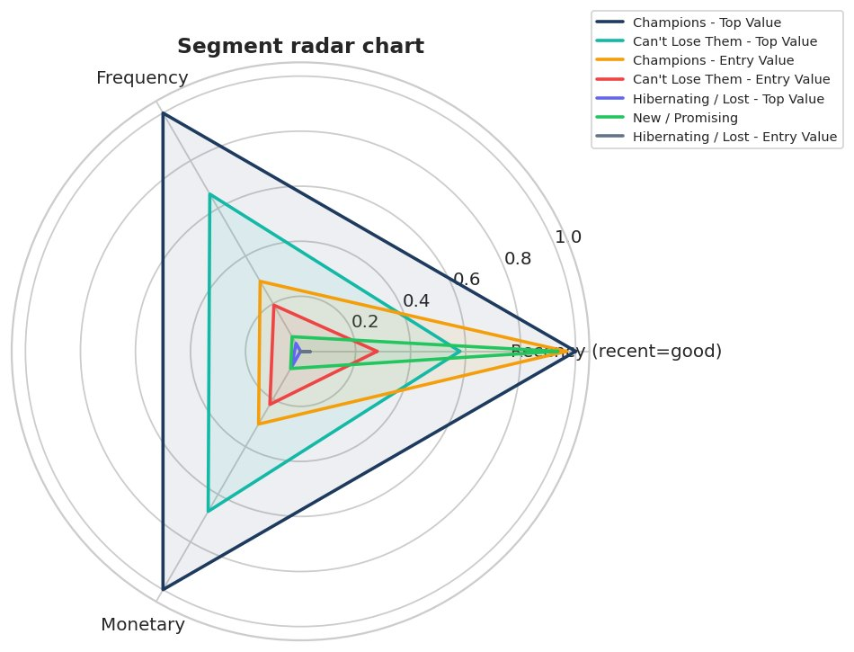
Figure 37: Segment radar chart
Normalised R, F and M of each K-Means segment.
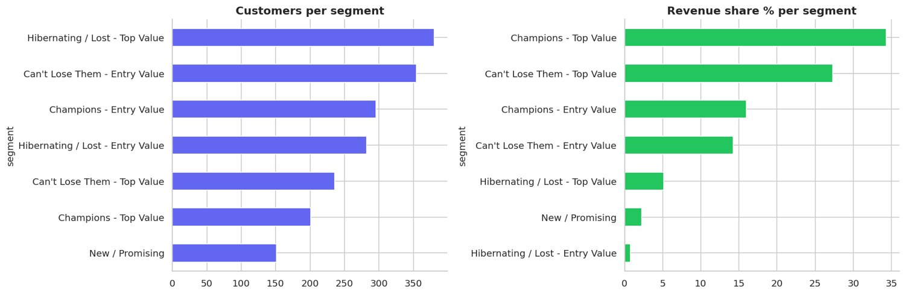
Figure 38: Segment size and revenue share
A few high-value segments contribute most revenue.
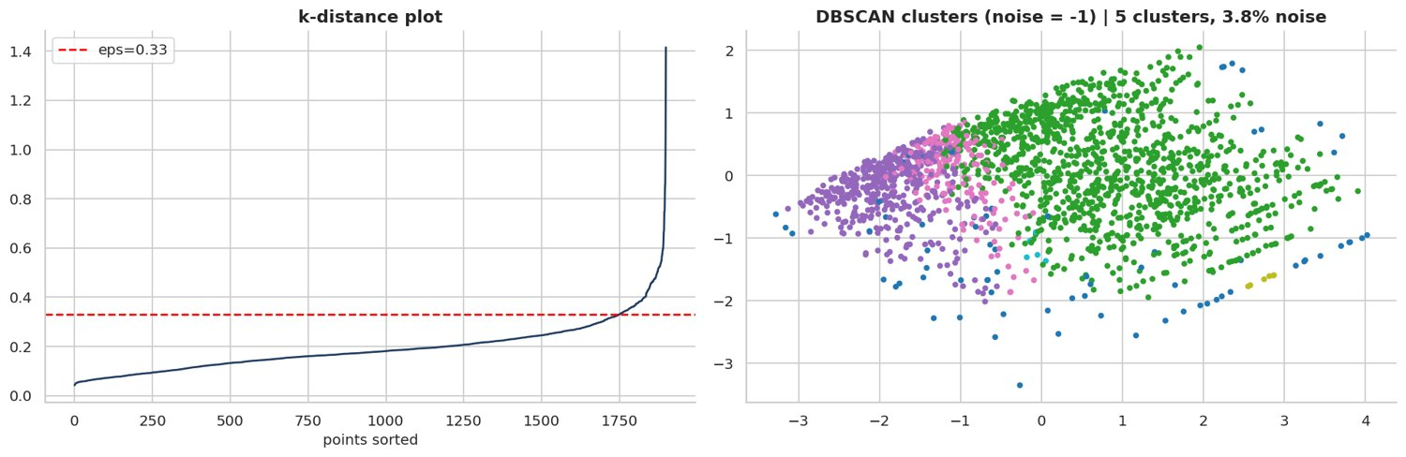
Figure 39: DBSCAN k-distance and clusters
DBSCAN isolates outlier customers (noise) that K-Means would force into a cluster.
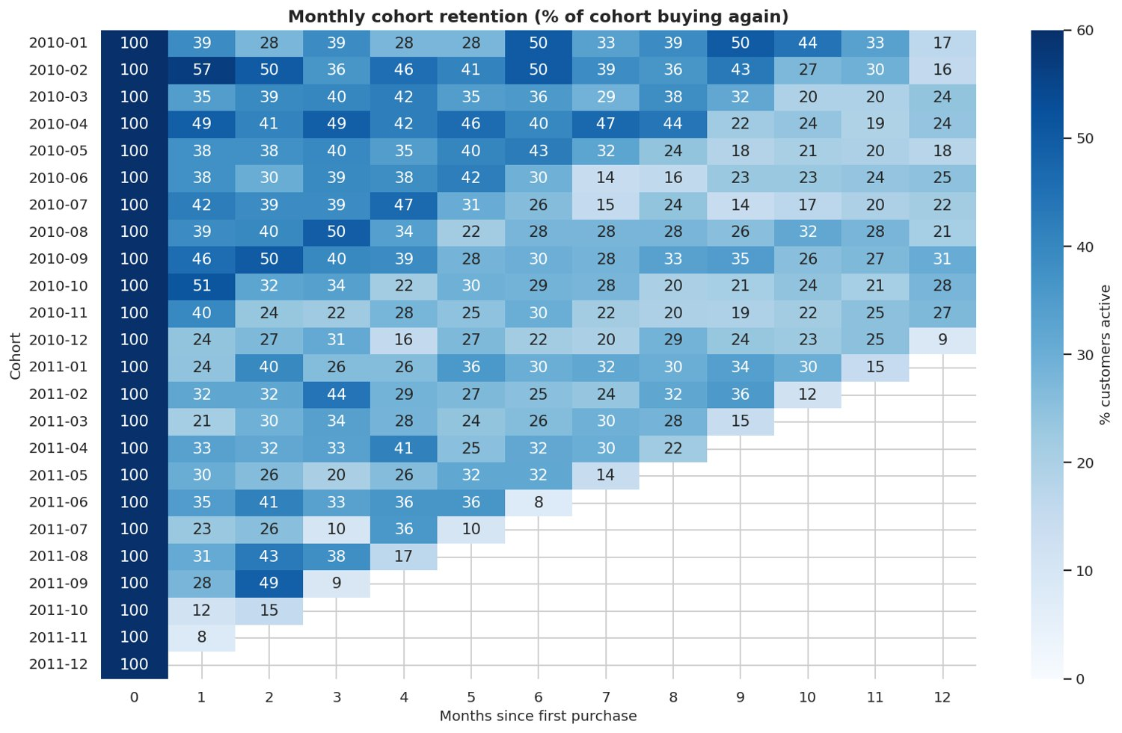
Figure 40: Cohort retention heatmap
Shows how quickly each acquisition cohort decays - input for churn definition.

11. Time-Series Preparation (Notebook 04)
A continuous daily demand series was built, closed weekdays detected, the series decomposed (classical + STL), stationarity tested (ADF / KPSS), ACF/PACF inspected, outliers flagged and a leakage-free train / validation / test split of 30 days each created.
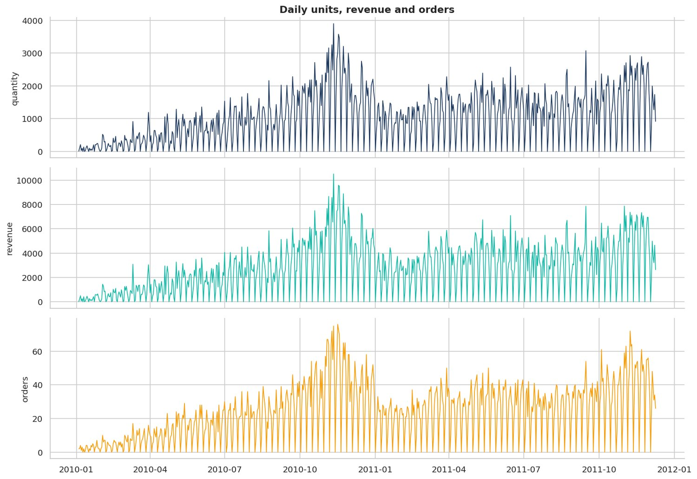
Figure 41: Daily units, revenue and orders
All three series share the same seasonal rhythm.
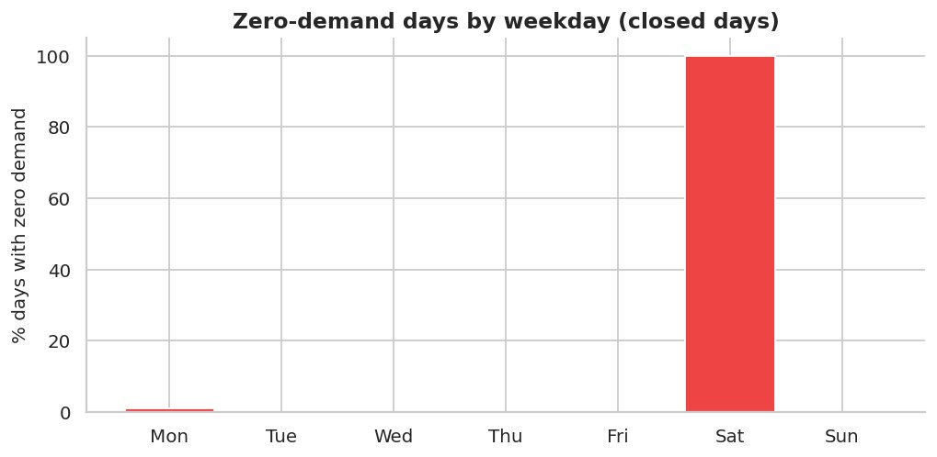
Figure 42: Zero-demand days by weekday
Closed weekdays detected: [5]. These are forced to zero in forecasts.
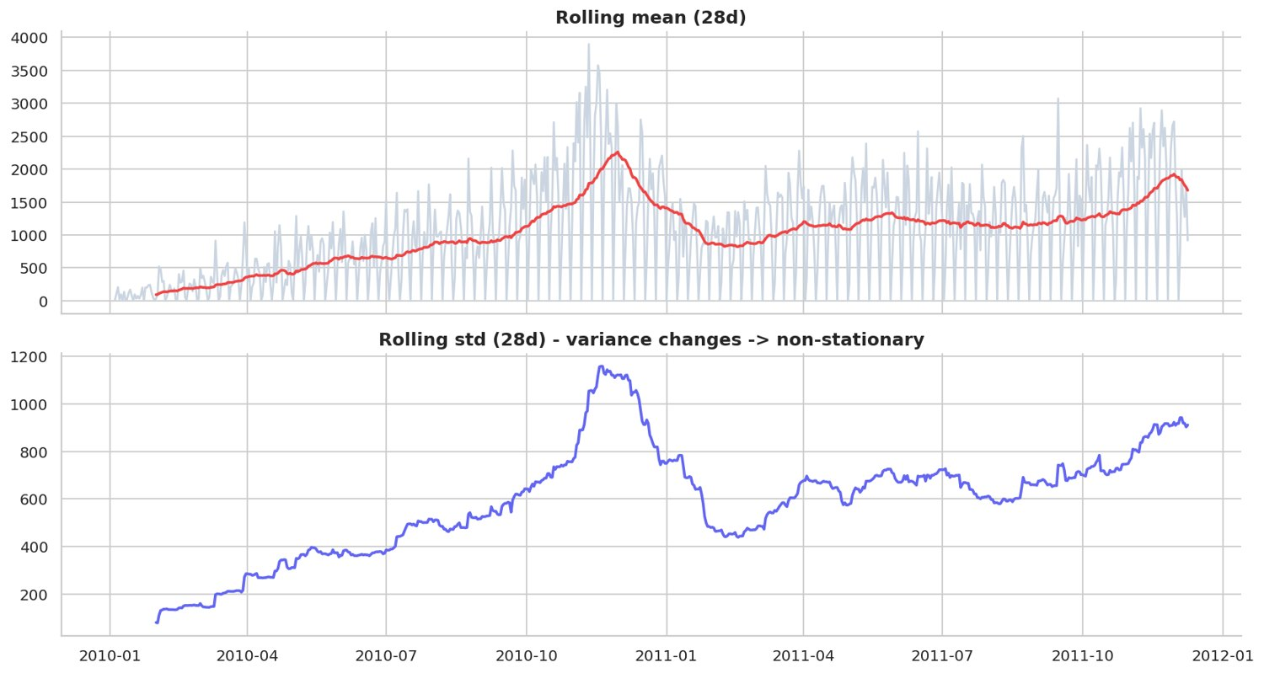
Figure 43: Rolling mean and rolling std
A moving mean and moving variance indicate non-stationarity.
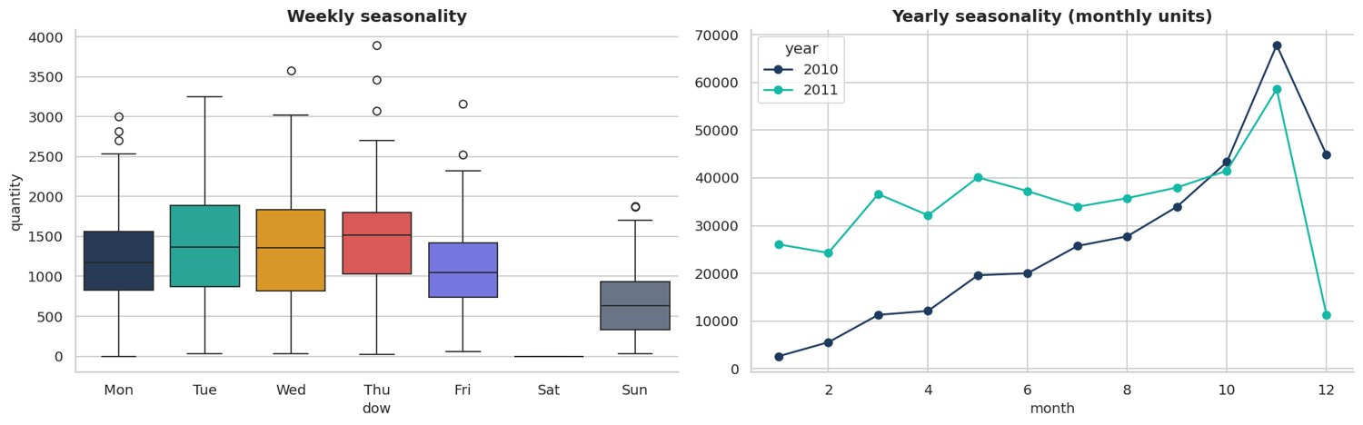
Figure 44: Weekly and yearly seasonality
Clear weekday pattern plus a strong autumn / holiday peak.
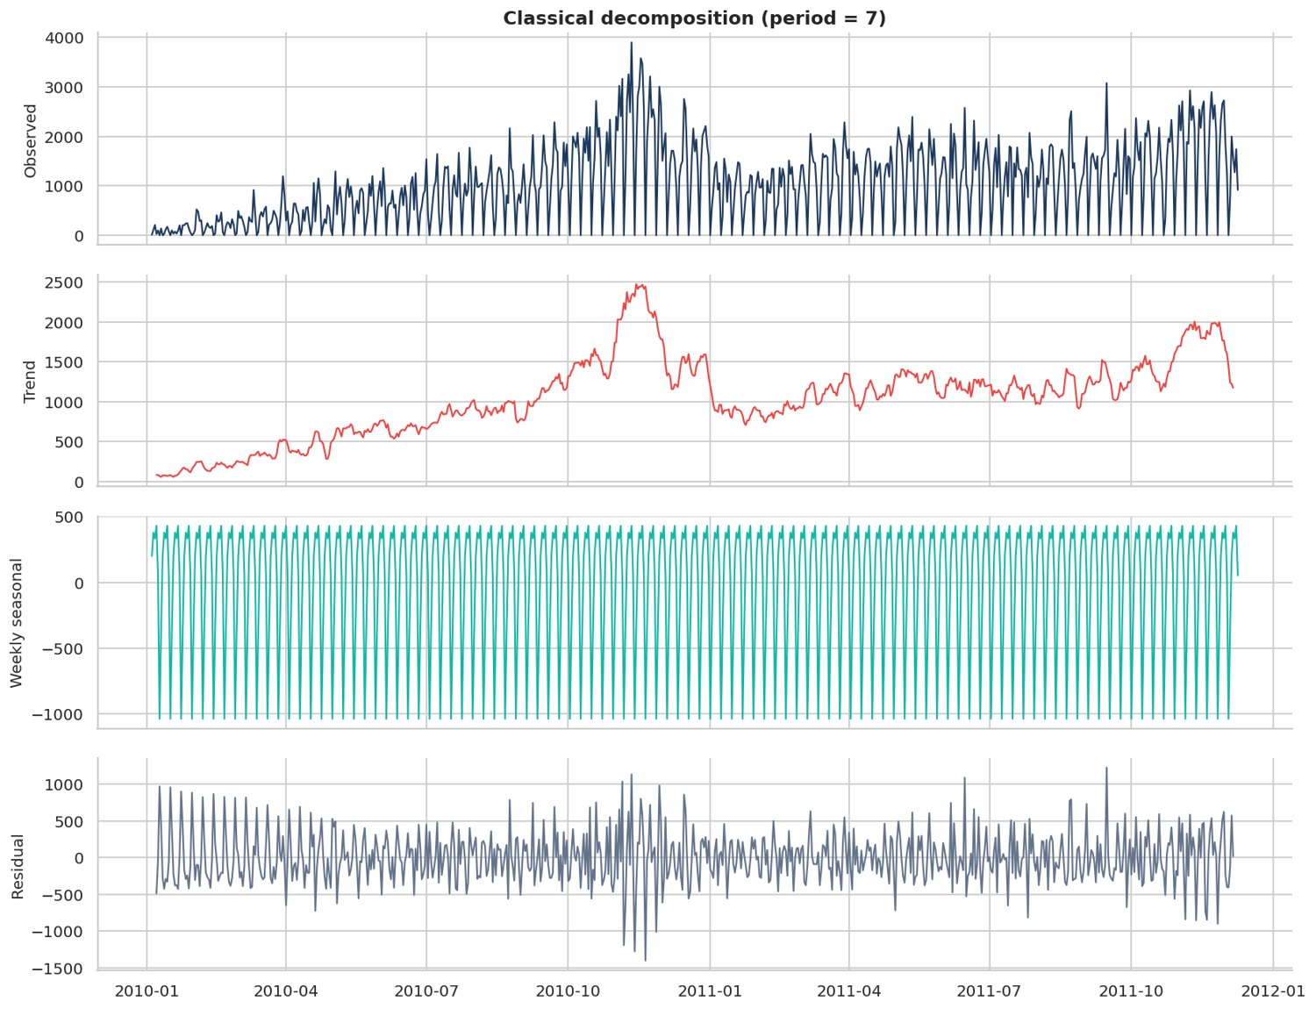
Figure 45: Classical decomposition (weekly)
Separates trend, weekly seasonality and noise.
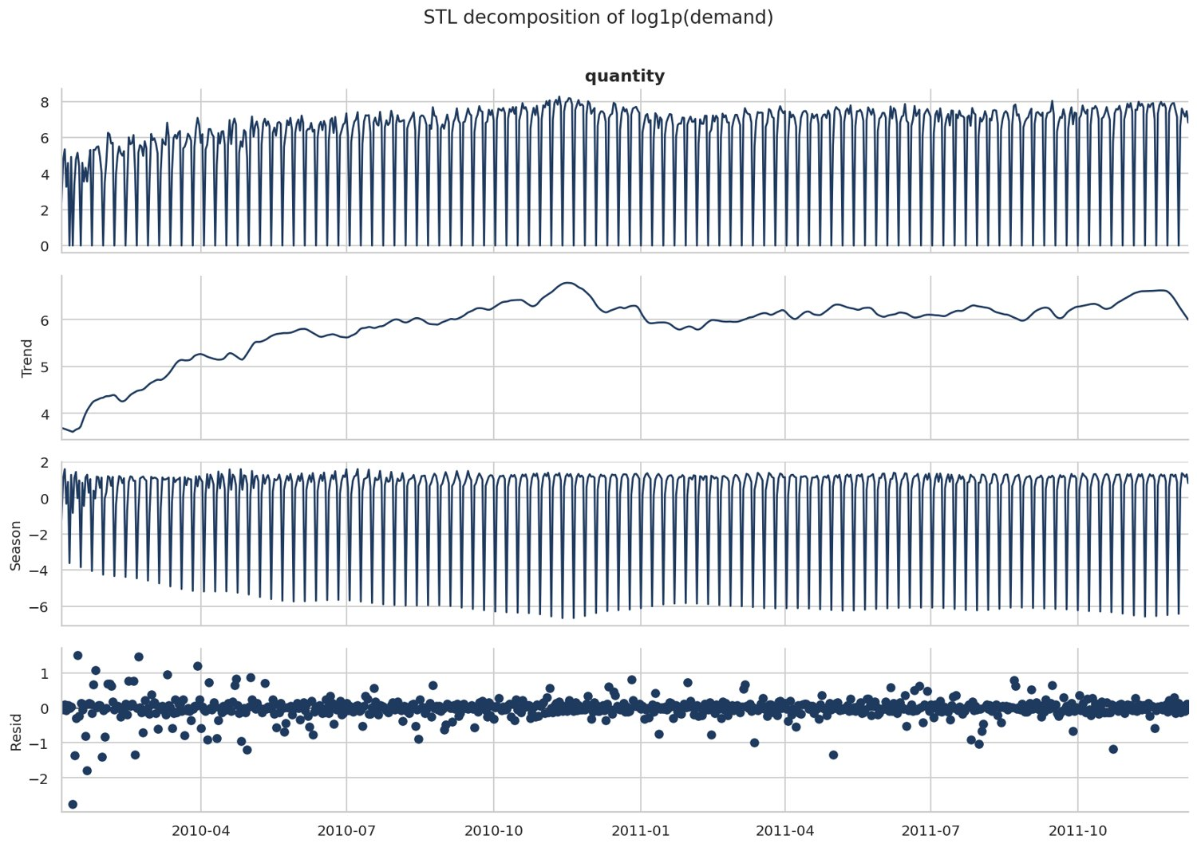
Figure 46: STL decomposition (robust)
Robust STL handles the zero (closed) days better than classical decomposition.
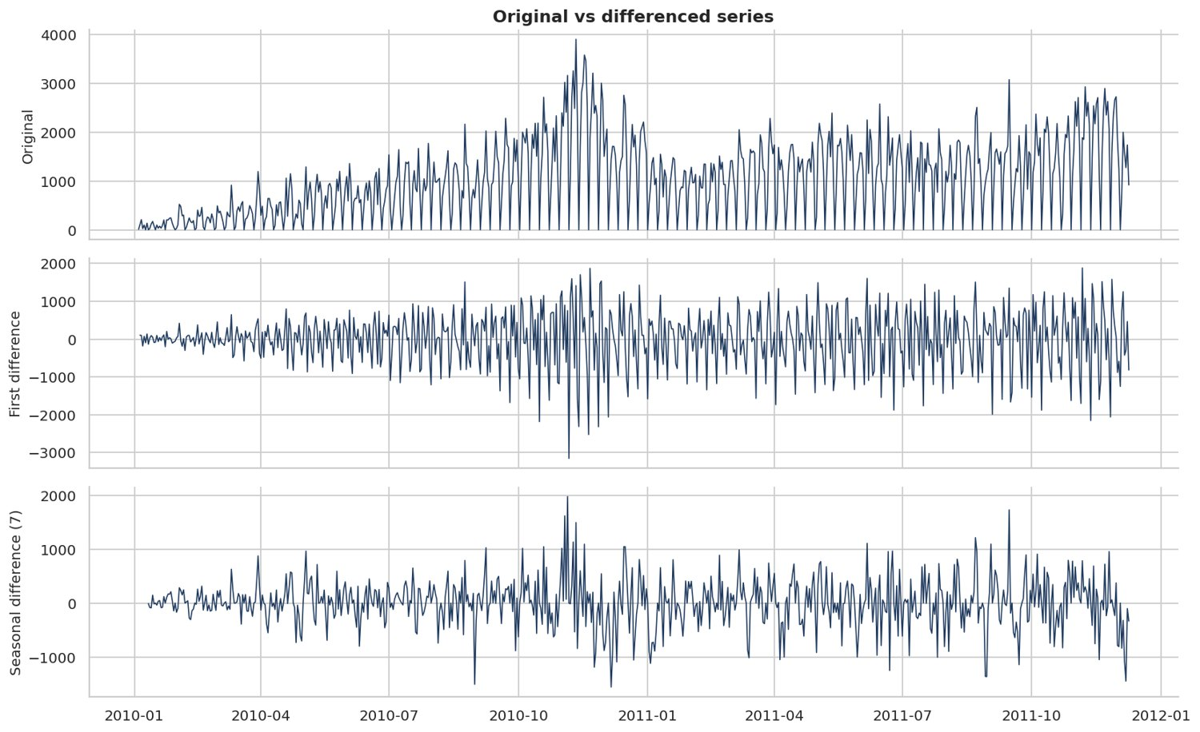
Figure 47: Original vs differenced series
Differencing removes trend / weekly seasonality and stabilises the mean.
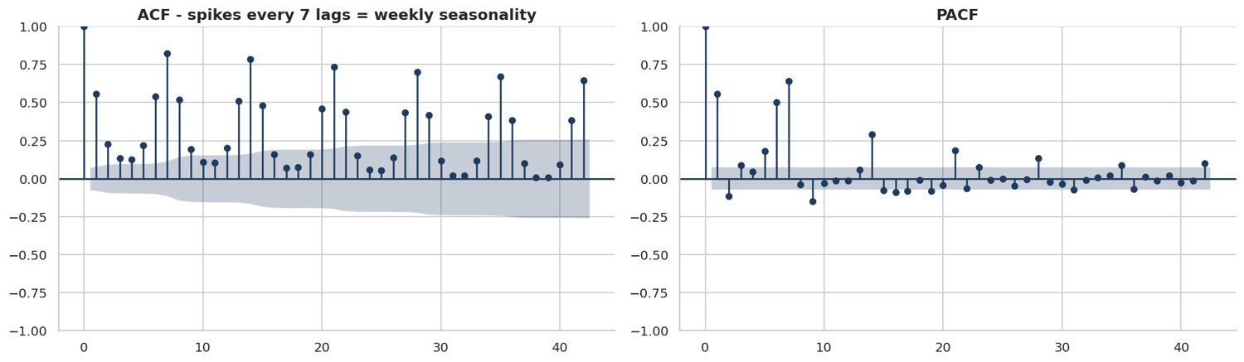
Figure 48: ACF and PACF
Significant lags at 1, 7, 14 justify the lag features (1, 7, 14, 28).
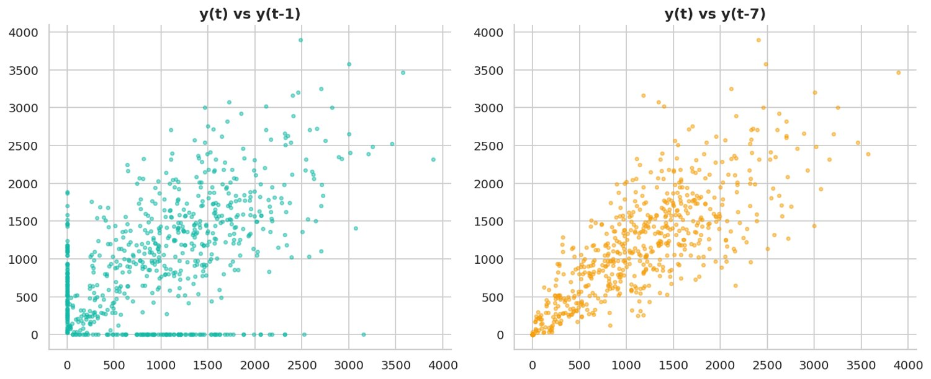
Figure 49: Lag scatter plots
The y(t) vs y(t-7) relation is tighter than the 1-day lag.
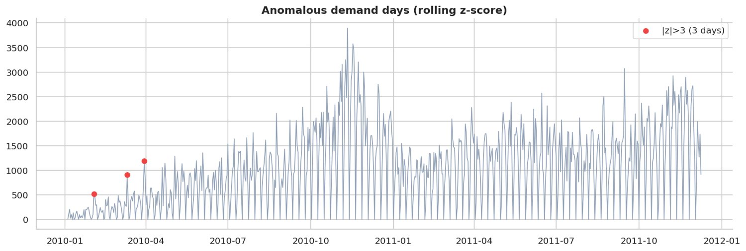
Figure 50: Anomalous demand days
Spikes usually correspond to big wholesale orders; they are kept but flagged.
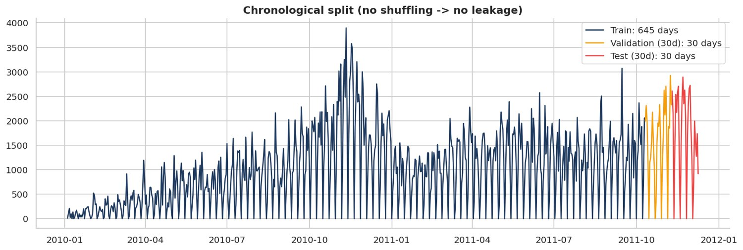
Figure 51: Train / validation / test split
Validation tunes ensemble weights; test is touched only once for the final score.

12. Baseline Forecasting with Prophet (Notebook 05)
Prophet with weekly + yearly seasonality and UK holidays was fitted as the baseline, compared with Seasonal Naive and Holt-Winters, diagnosed with residual plots and tested for hyper-parameter sensitivity.
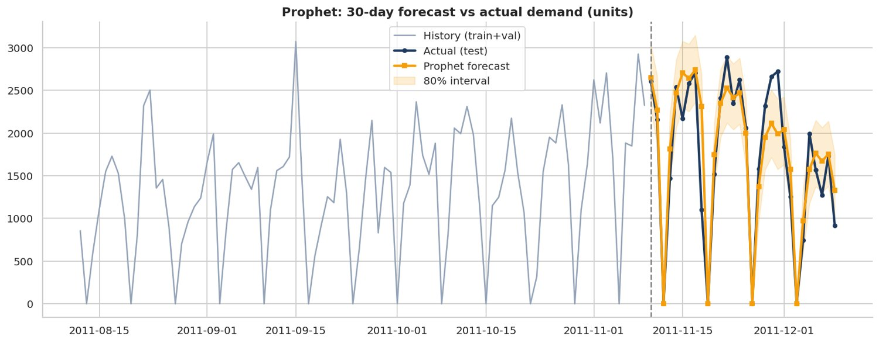
Figure 52: Prophet 30-day forecast vs actual
Daily MAPE 18.0%, weekly-total MAPE 10.4%, WAPE 14.3%.
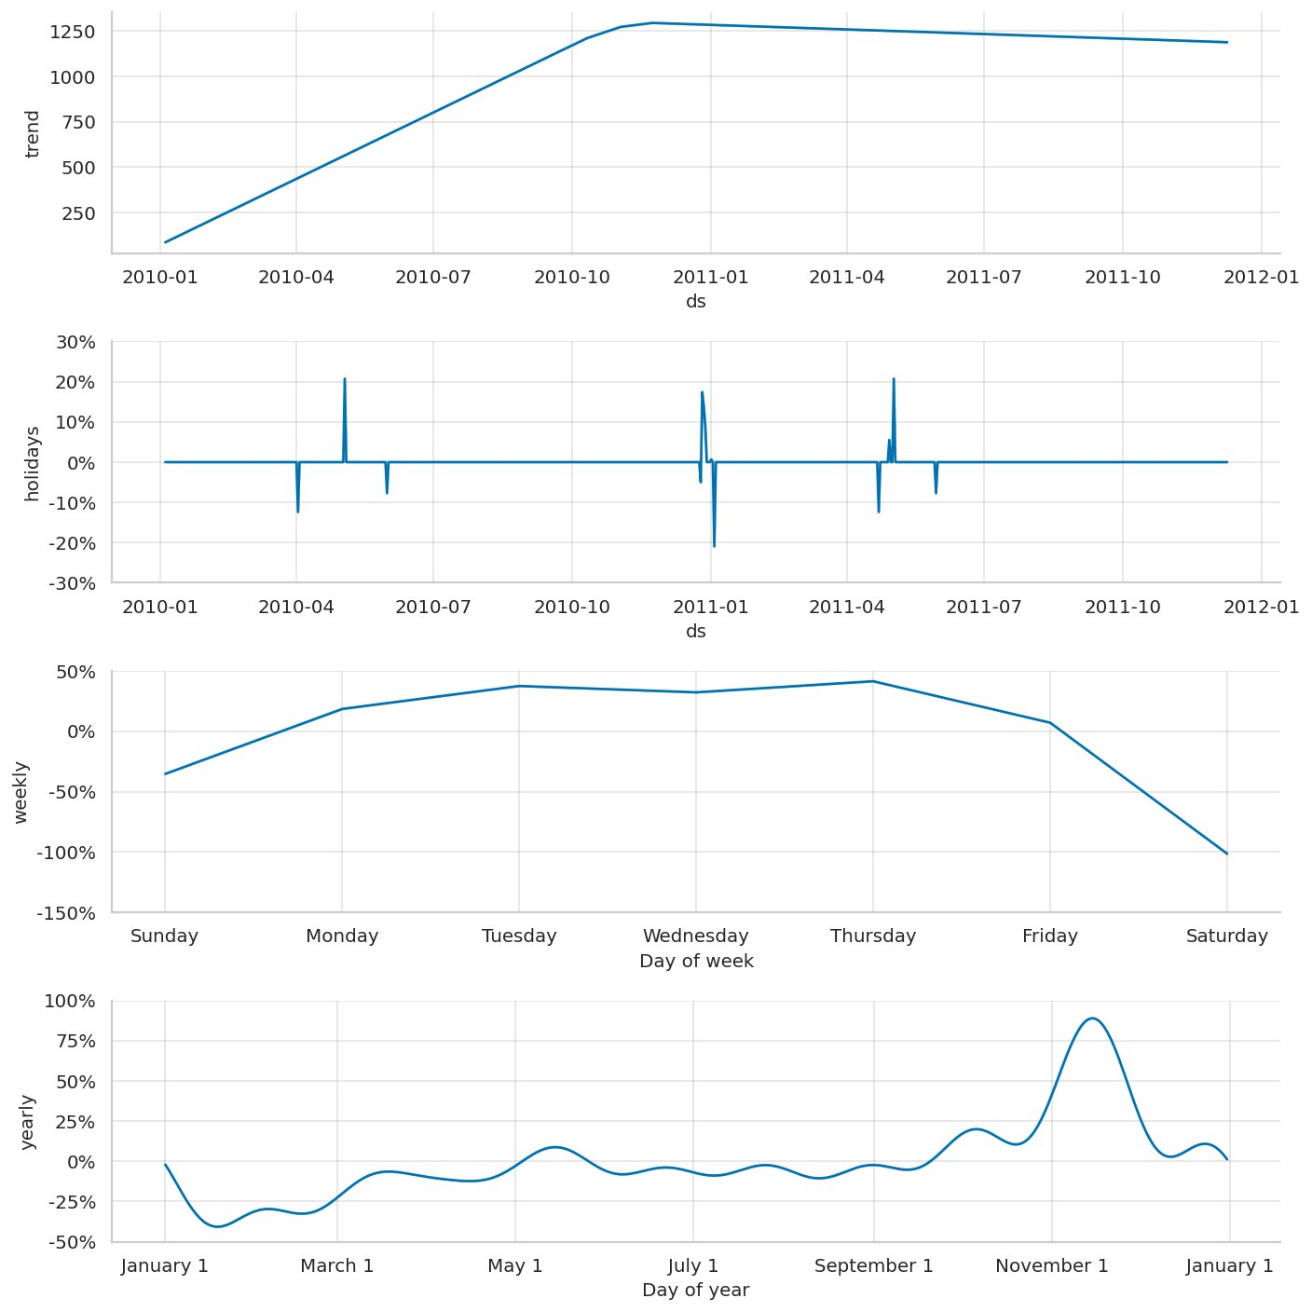
Figure 53: Prophet components
Trend, weekly seasonality, yearly seasonality and UK holiday effects learned by the model.
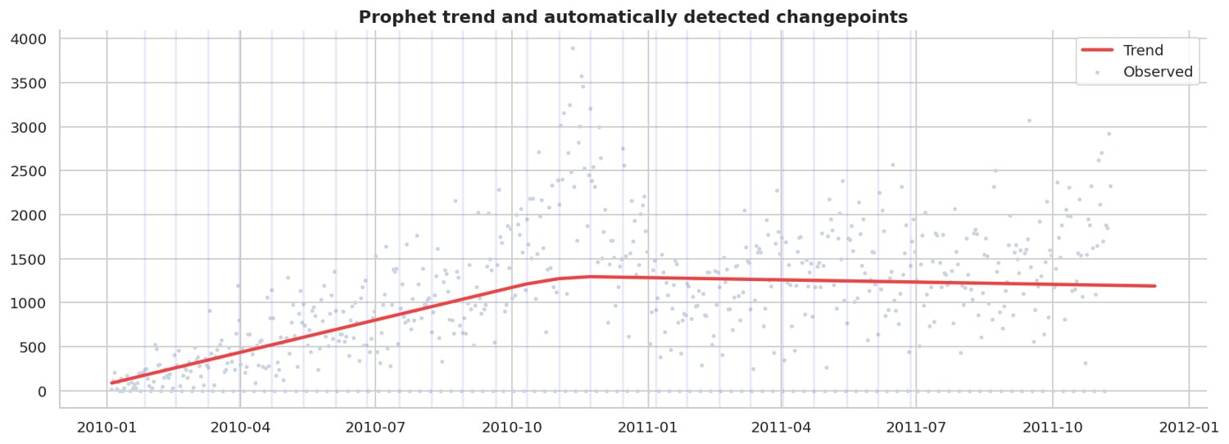
Figure 54: Prophet trend and changepoints
Vertical lines = candidate changepoints where the growth rate may change.
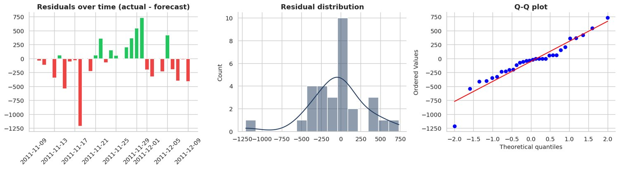
Figure 55: Prophet residual diagnostics
Mean residual (bias) = -47.8 units; residuals should be centred near zero.
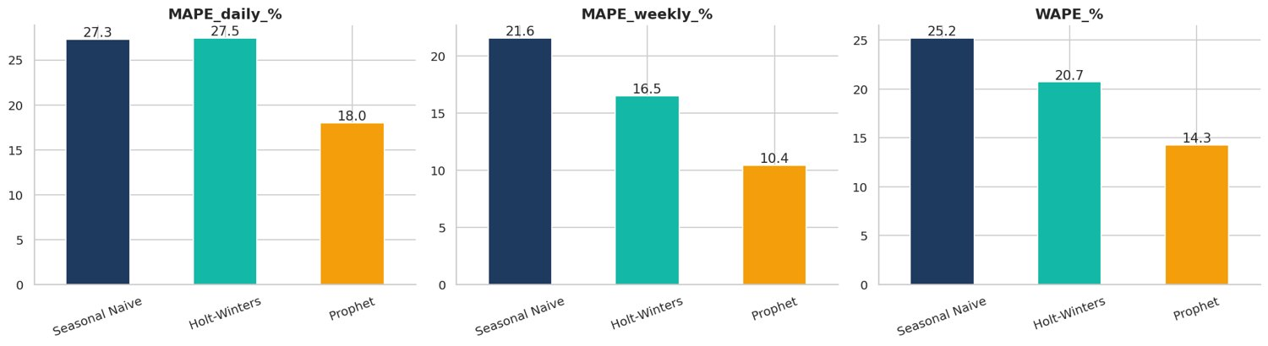
Figure 56: Prophet vs simple baselines
Any serious model must beat Seasonal Naive; weekly-total MAPE is the planning metric.
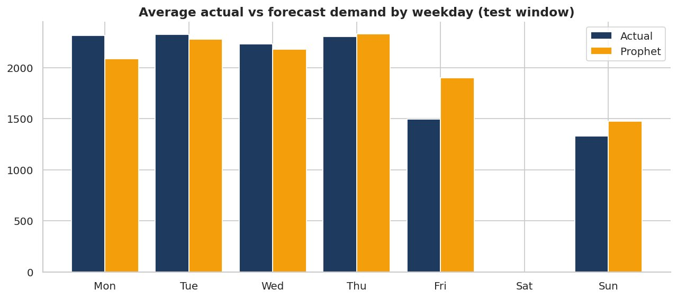
Figure 57: Forecast accuracy by weekday
Checks that the weekly pattern (including closed days) is captured.
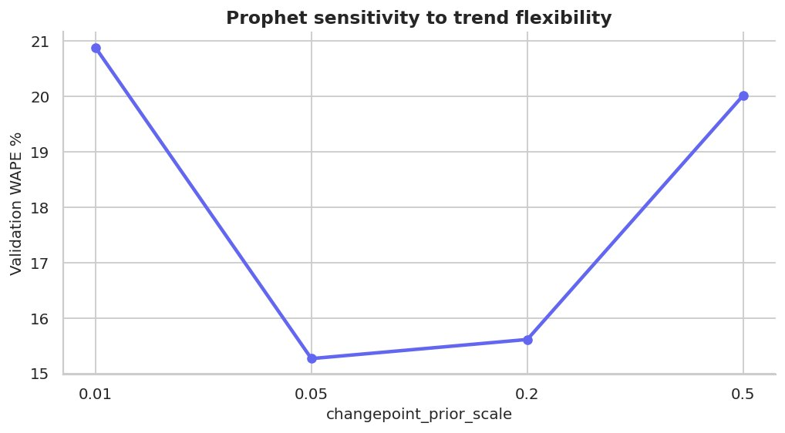
Figure 58: Prophet hyper-parameter sensitivity
Too small = under-fits trend changes, too large = over-fits noise.

13. Deep-Learning Forecasting with LSTM (Notebook 06)
A PyTorch LSTM uses a 28-day window plus known-future calendar covariates and produces a recursive 30-day forecast with early stopping.
Note for this run: PyTorch was not installed in the environment that produced these numbers, so a gradient-boosting lag model stood in for the LSTM (the engine is printed in the notebook). Re-run the notebooks in Google Colab, where PyTorch is pre-installed, to obtain the true LSTM and ensemble results.
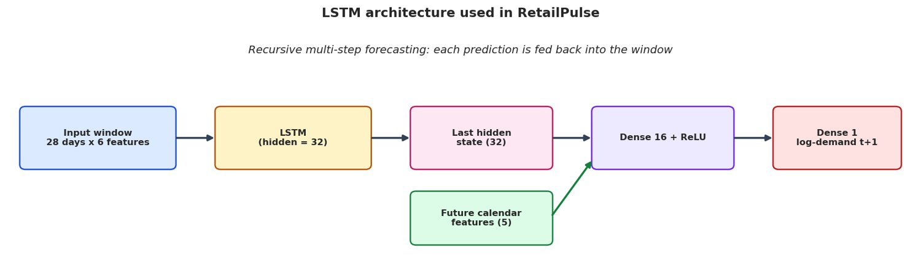
Figure 59: LSTM architecture
LSTM encoder + known-future calendar covariates + dense head, applied recursively for 30 days.
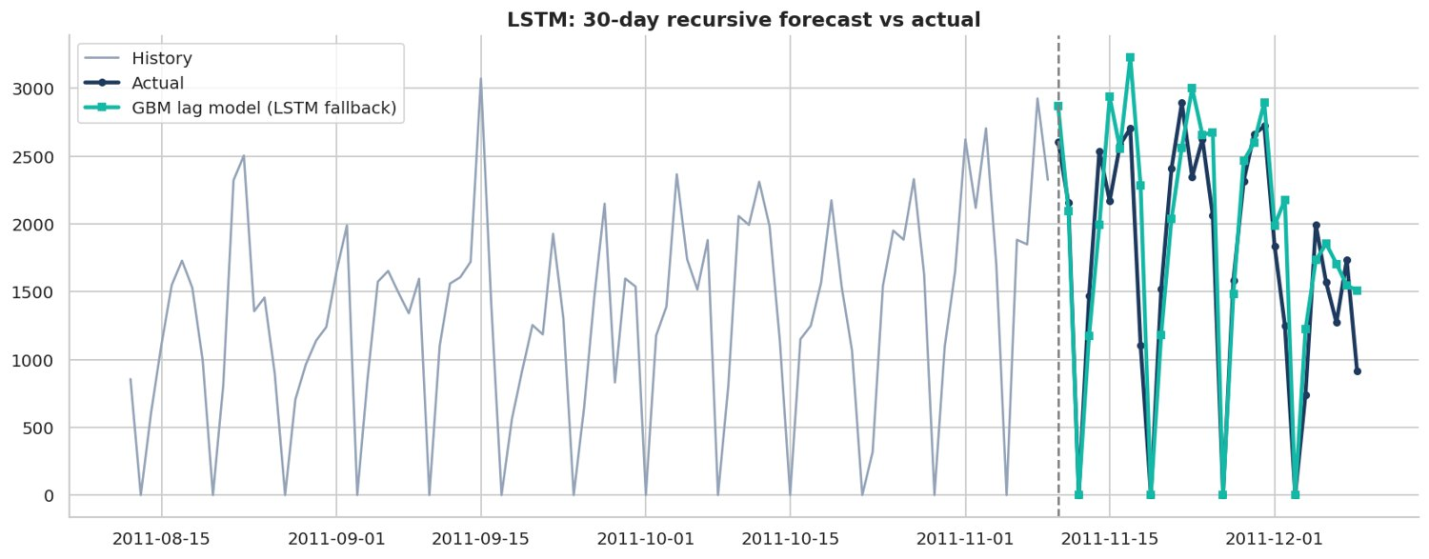
Figure 60: LSTM 30-day forecast vs actual
Daily MAPE 24.4%, weekly MAPE 10.0%, WAPE 18.9%.
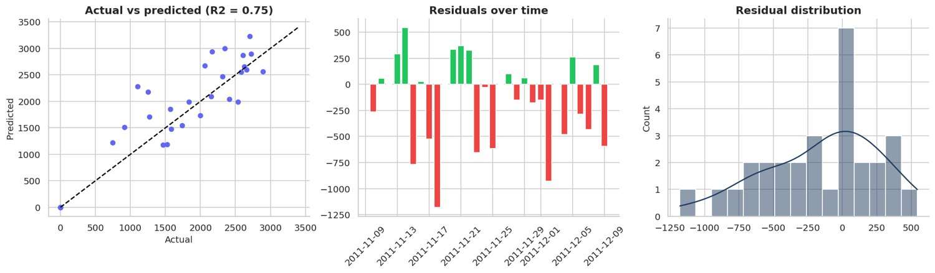
Figure 61: LSTM diagnostics: scatter and residuals
Points close to the diagonal and centred residuals indicate a well-calibrated model.
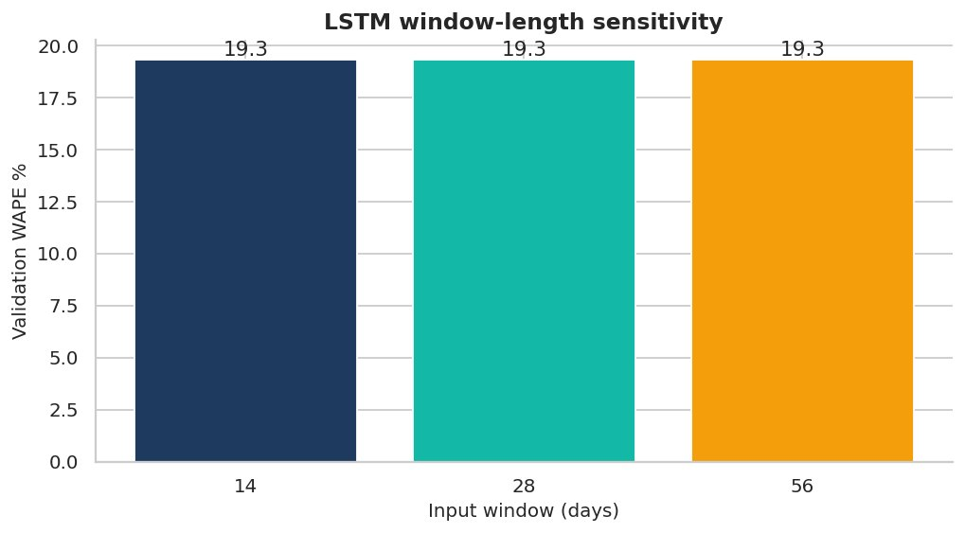
Figure 62: LSTM window-length sensitivity
Chooses the look-back window using validation data only.
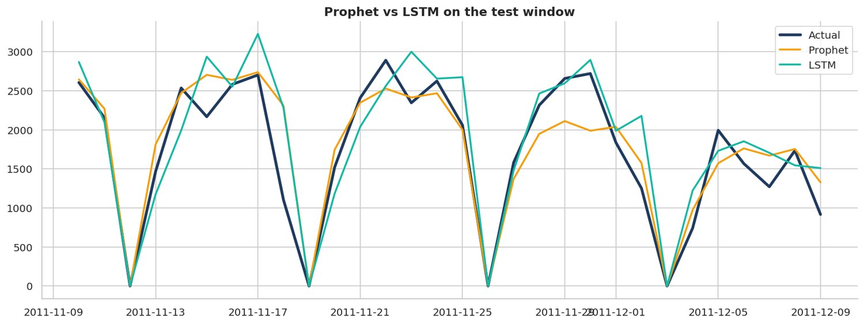
Figure 63: Prophet vs LSTM
The two models make different errors - which is exactly why an ensemble helps (Notebook 08).

14. Hybrid Prophet + LSTM Ensemble (Notebook 08)
The blend weight was optimised on the validation window; models were re-fitted on train + validation to score the test window and finally refit on all data for the 30-day production forecast.
Note for this run: PyTorch was not installed in the environment that produced these numbers, so a gradient-boosting lag model stood in for the LSTM (the engine is printed in the notebook). Re-run the notebooks in Google Colab, where PyTorch is pre-installed, to obtain the true LSTM and ensemble results.
Model | MAPE_daily_% | MAPE_weekly_% | WAPE_% | sMAPE_% | RMSE | MAE
Seasonal Naive | 27.33 | 21.58 | 25.23 | 27.88 | 509.79 | 435.52
Holt-Winters | 27.47 | 16.51 | 20.72 | 22.45 | 470.92 | 357.68
Prophet | 18.00 | 10.44 | 14.29 | 15.94 | 359.00 | 246.58
LSTM | 24.42 | 10.01 | 18.95 | 20.59 | 439.29 | 327.05
Hybrid (Prophet+LSTM) | 18.00 | 10.44 | 14.29 | 15.94 | 359.00 | 246.58

Blend weight (Prophet) = 1.00; engines: {'prophet': 'Prophet', 'lstm': 'GBM lag model (LSTM fallback)'}.
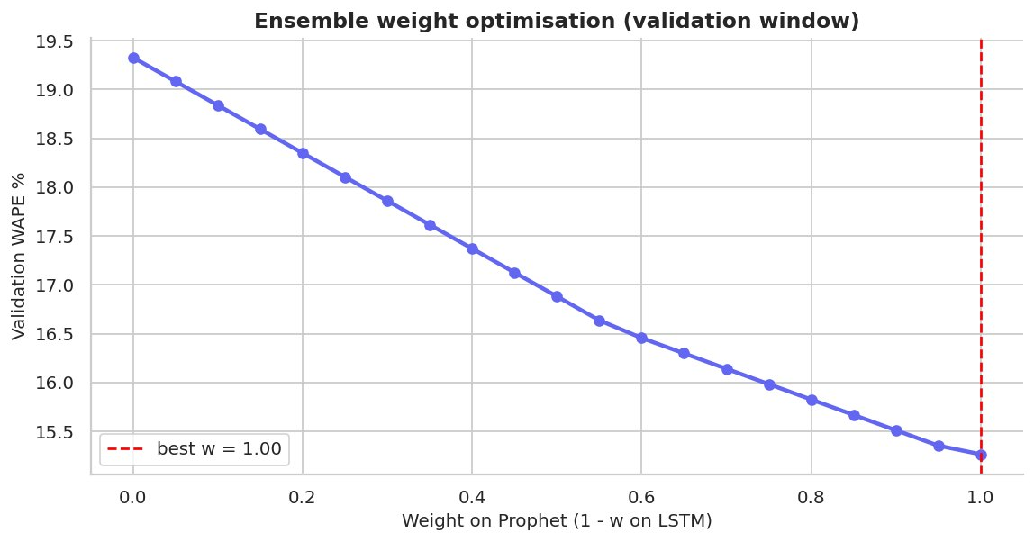
Figure 64: Ensemble weight search
Best Prophet weight = 1.00.
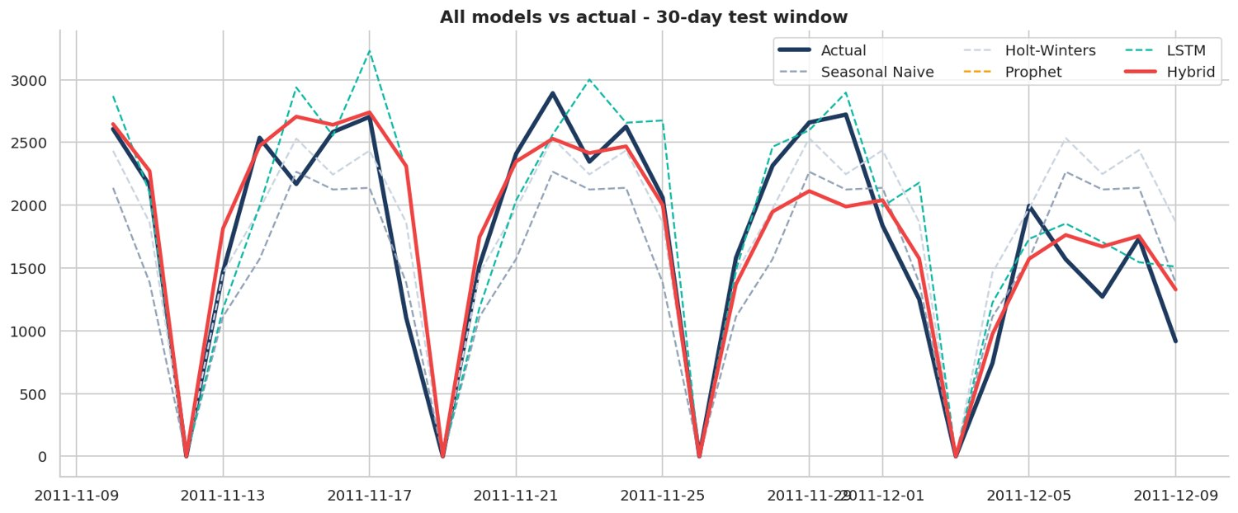
Figure 65: All models vs actual (test window)
The hybrid line combines Prophet and LSTM.
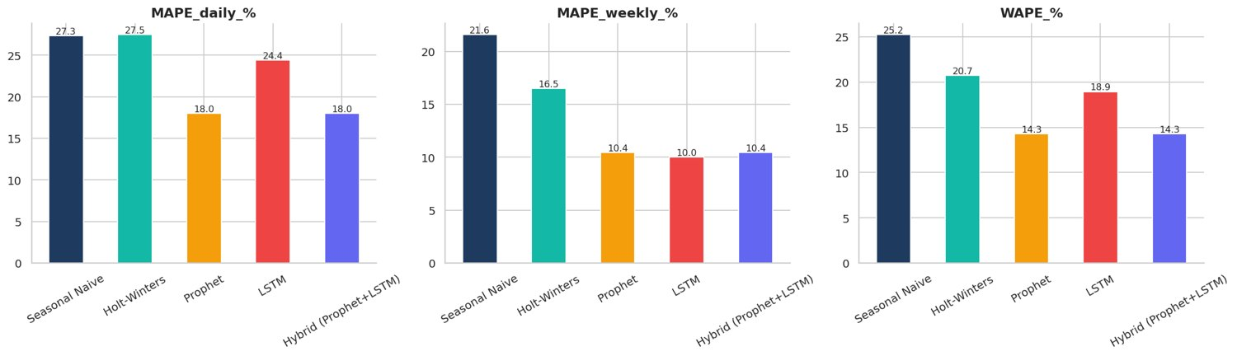
Figure 66: Model comparison on test window
Lower is better. The best model by weekly MAPE is highlighted in the table above.
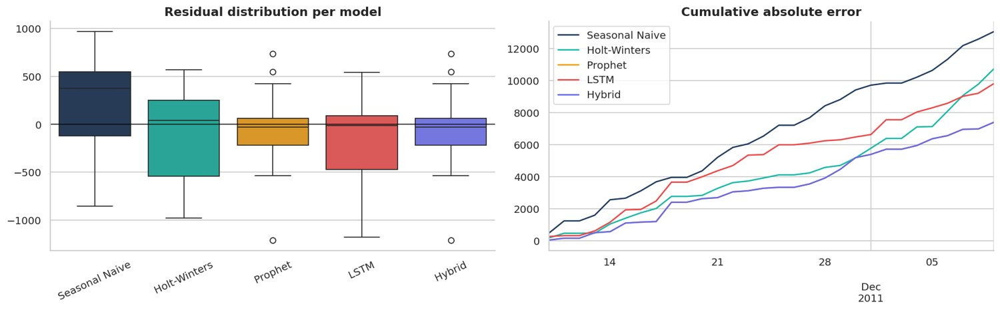
Figure 67: Residuals and cumulative error per model
Hybrid should show a smaller, tighter error distribution than its parts.
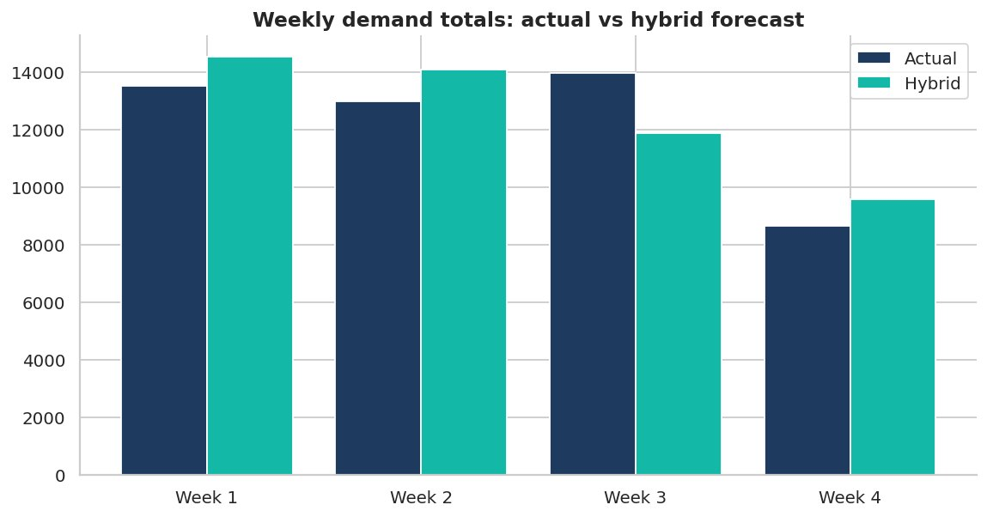
Figure 68: Weekly totals: actual vs hybrid forecast
Weekly-total MAPE of hybrid = 10.4%.
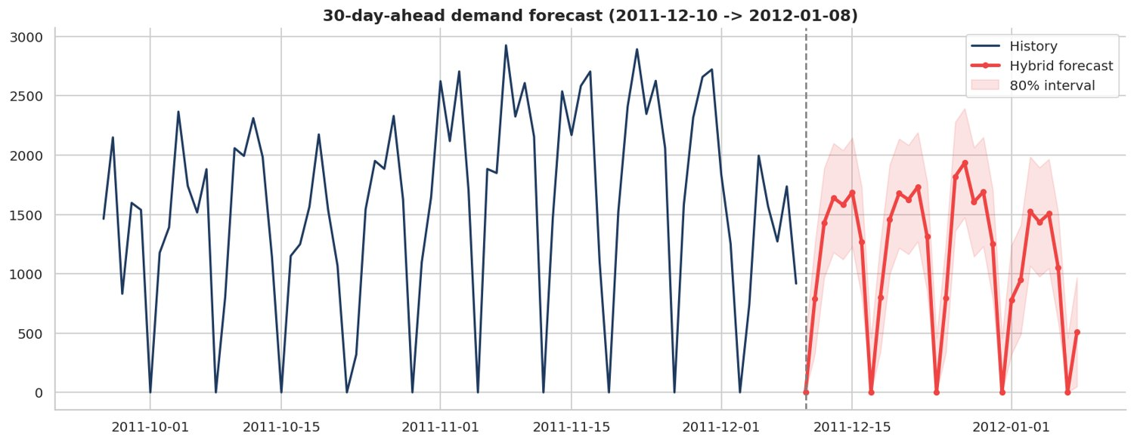
Figure 69: 30-day-ahead production forecast
Expected total demand next 30 days: 33,853 units.

15. Churn Prediction with XGBoost + SHAP (Notebook 09)
A leakage-free churn label (no purchase in the next 90 days) was modelled with Logistic Regression, Random Forest and XGBoost. Performance, calibration, gain/lift and SHAP explanations are shown.
Model | AUC-ROC | PR-AUC | F1 | Precision@top20% | Recall@top20% | Brier
Logistic Regression | 0.885 | 0.905 | 0.843 | 0.982 | 0.323 | 0.140
Random Forest | 0.876 | 0.925 | 0.824 | 0.982 | 0.323 | 0.142
XGBoost | 0.850 | 0.906 | 0.797 | 0.982 | 0.323 | 0.163

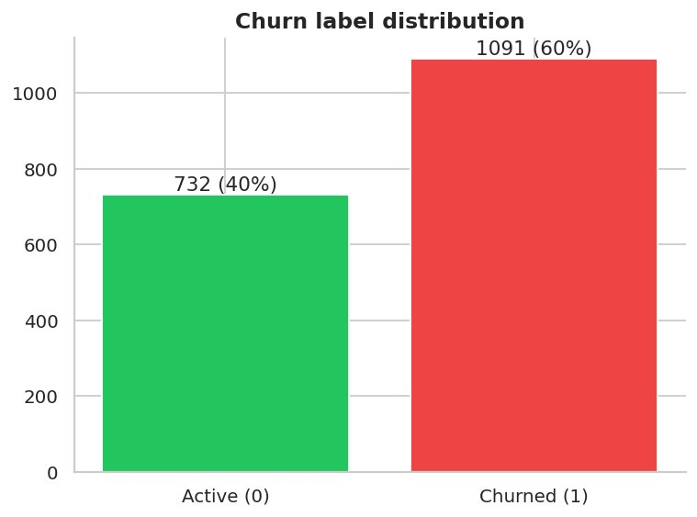
Figure 70: Churn label distribution
59.8% of customers churned in the 90-day window.
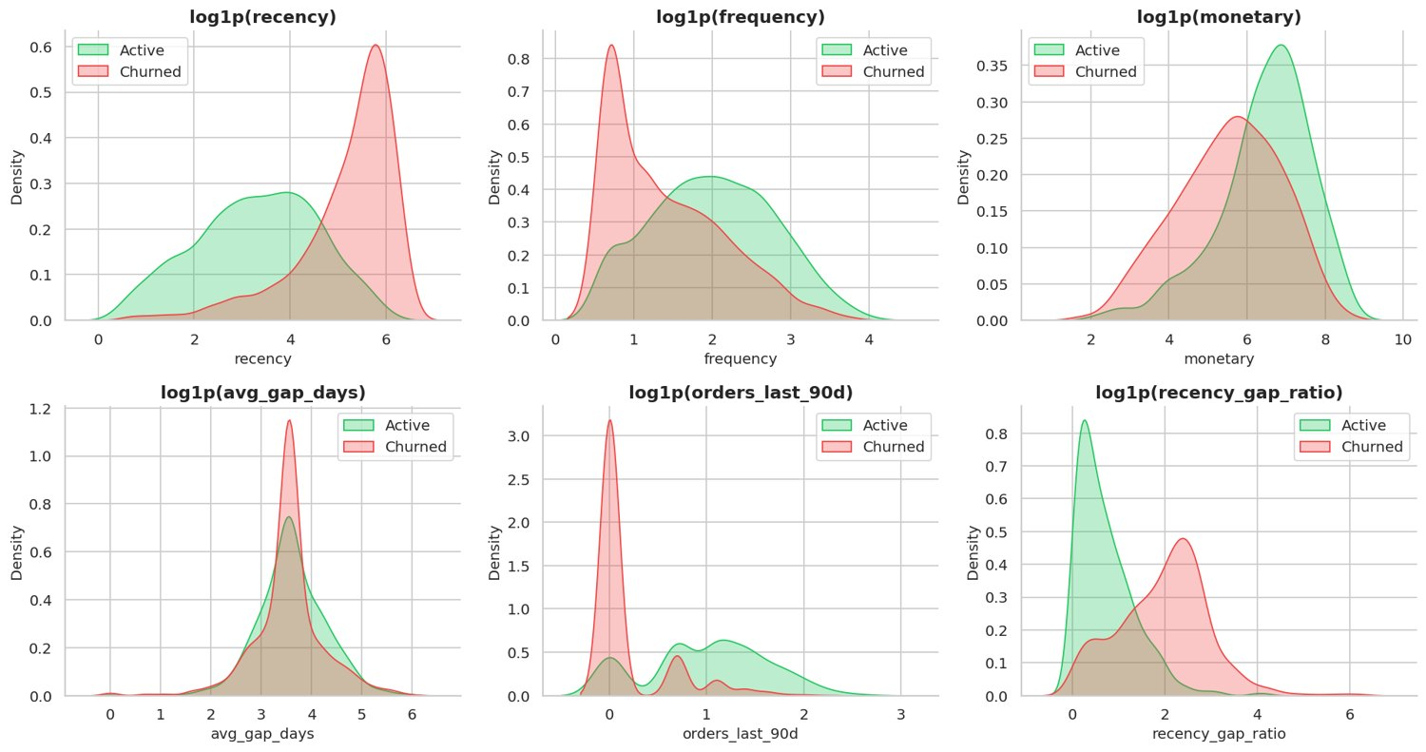
Figure 71: Key features: churned vs active
Churners have higher recency and lower recent activity.
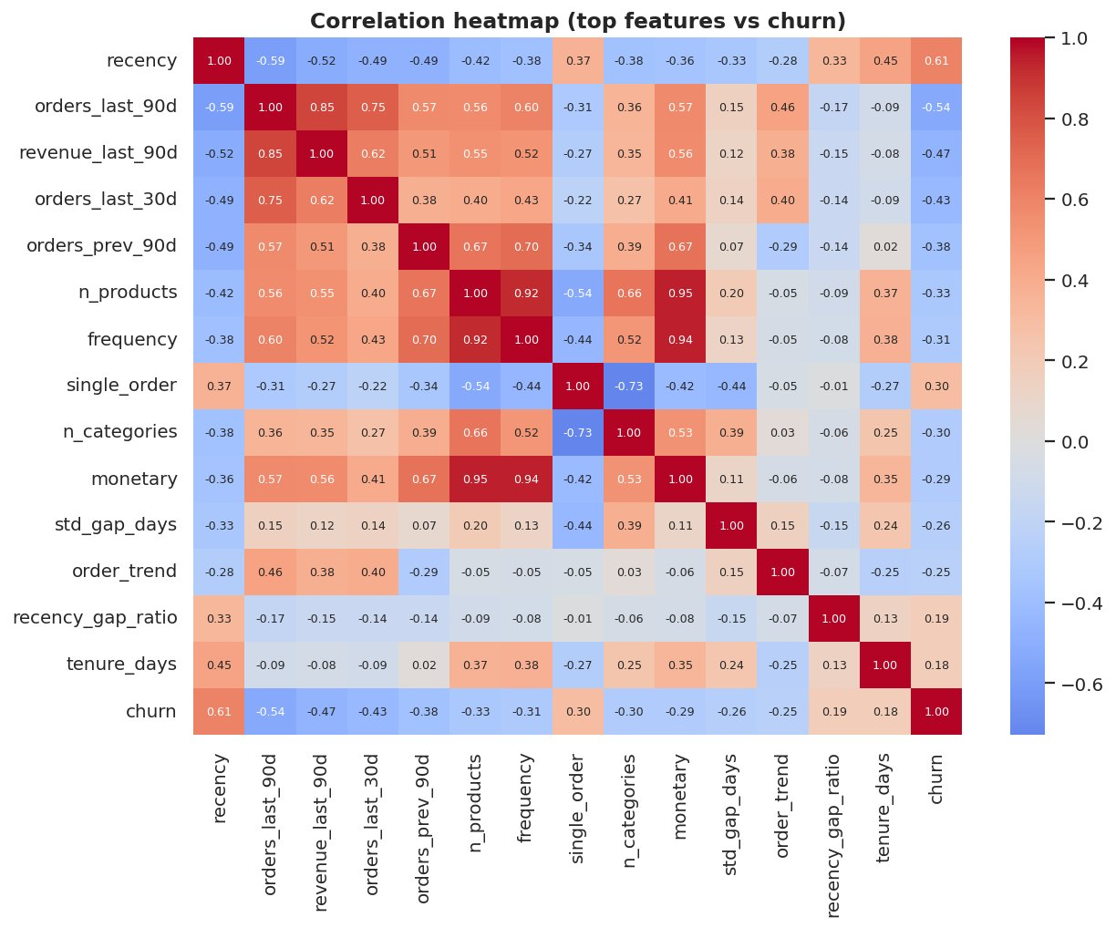
Figure 72: Churn feature correlation heatmap
Recency-type features correlate most with churn.
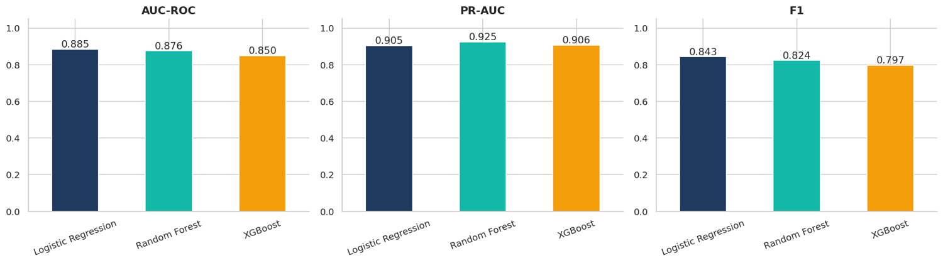
Figure 73: Churn model comparison
AUC-ROC, PR-AUC and F1 on the held-out test set.
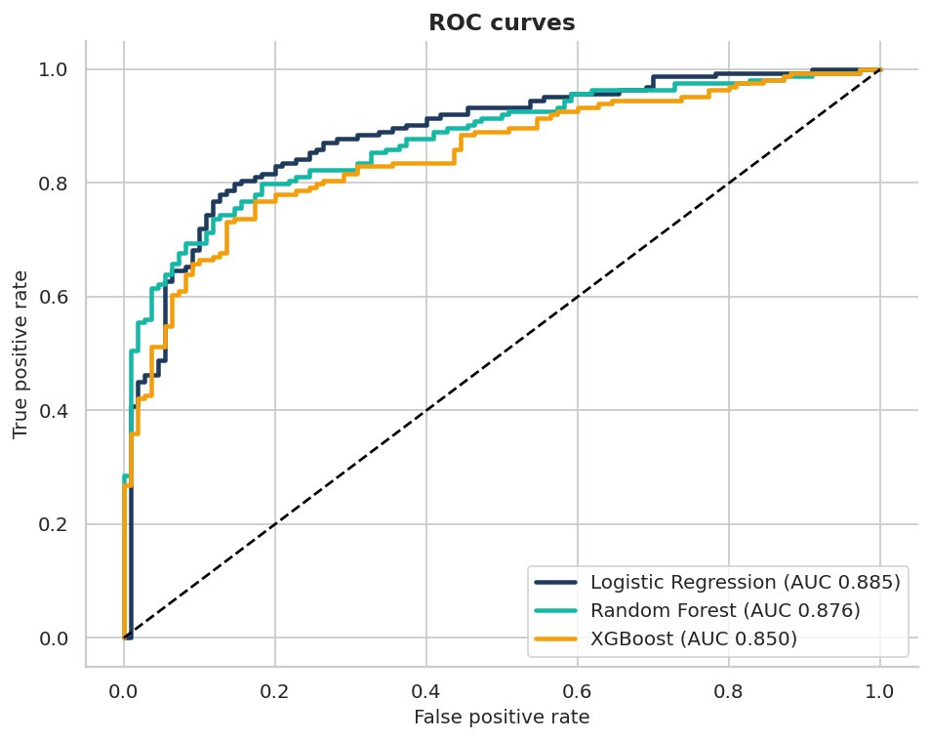
Figure 74: ROC curves
Higher and further left is better.
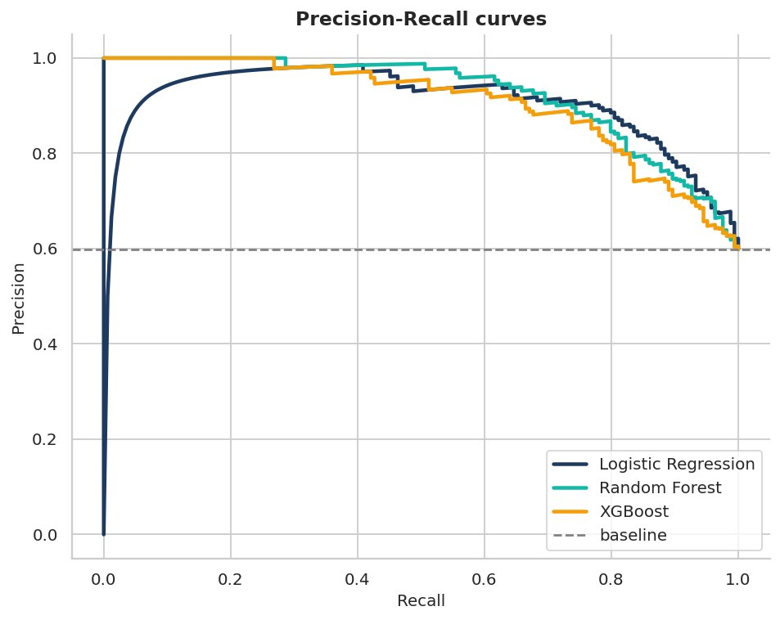
Figure 75: Precision-Recall curves
Useful for imbalanced classes.
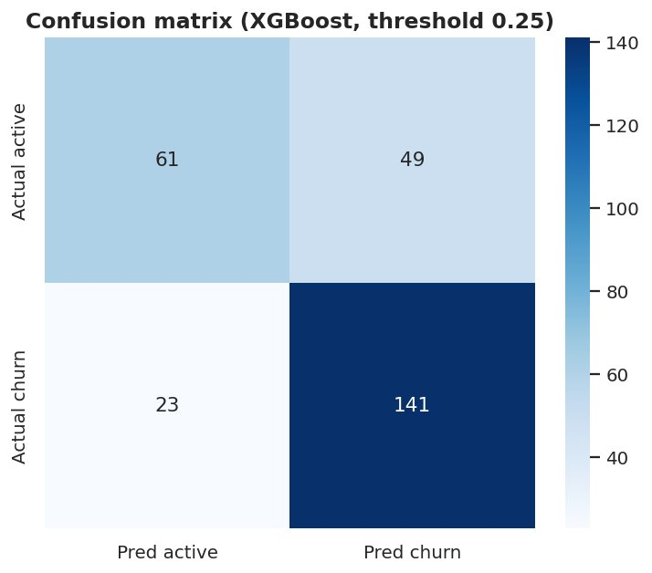
Figure 76: Confusion matrix
Threshold chosen on the validation set to maximise F1.
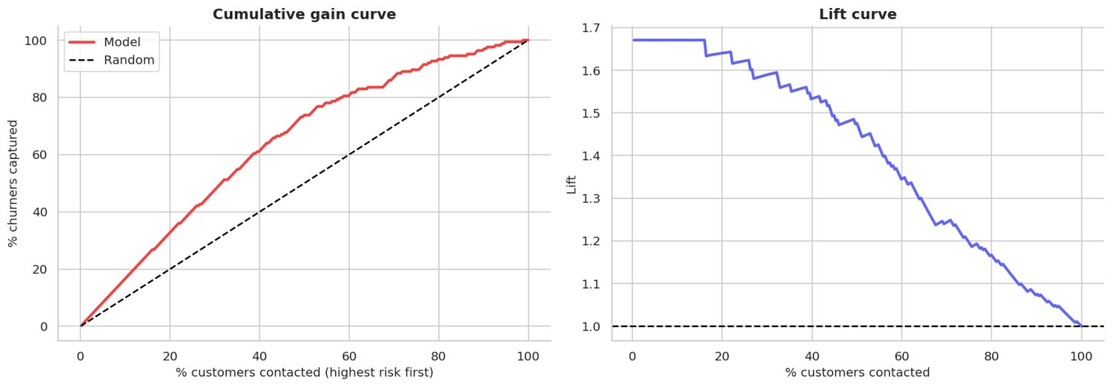
Figure 77: Gain and lift curves
Contacting the top 20% riskiest customers captures 32% of churners.
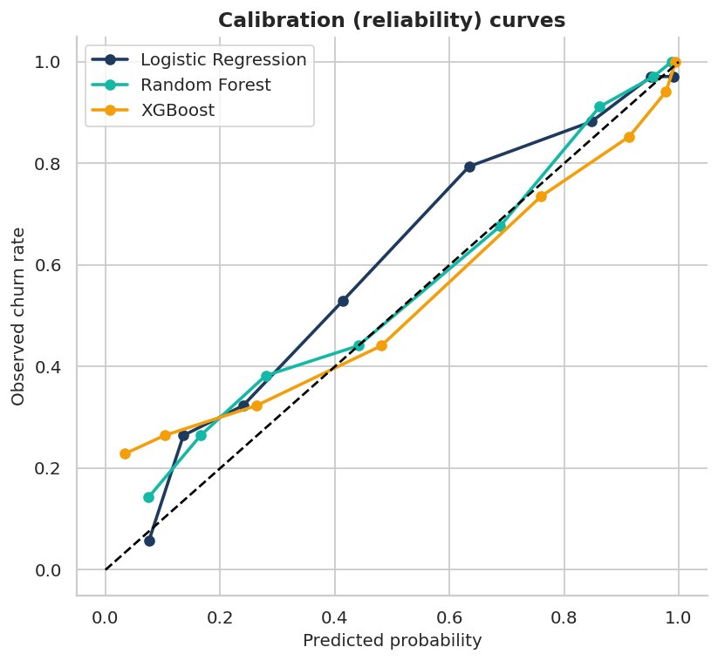
Figure 78: Calibration curves
Shows whether predicted probabilities can be trusted as real probabilities.
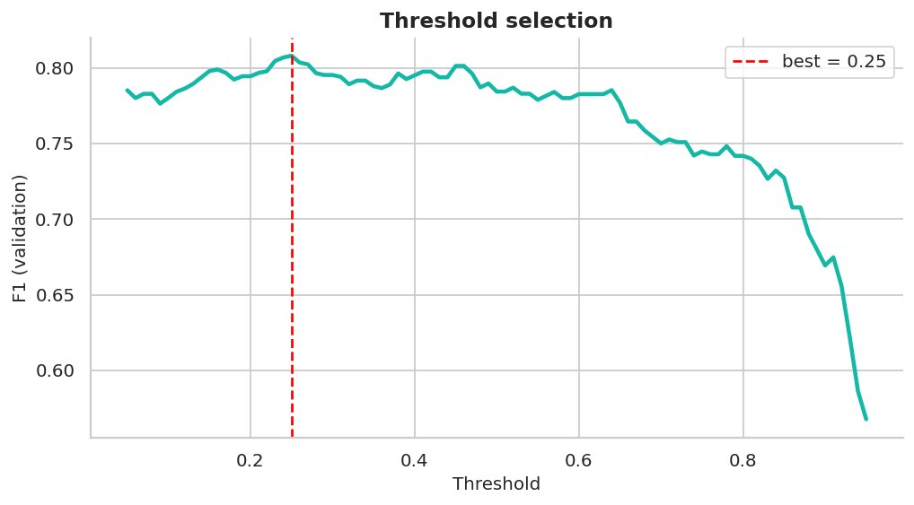
Figure 79: Threshold selection curve
Decision threshold is tuned on validation data only.
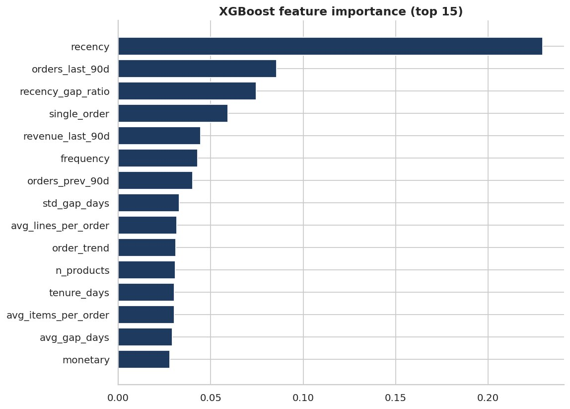
Figure 80: Churn model feature importance
Most important feature: recency.
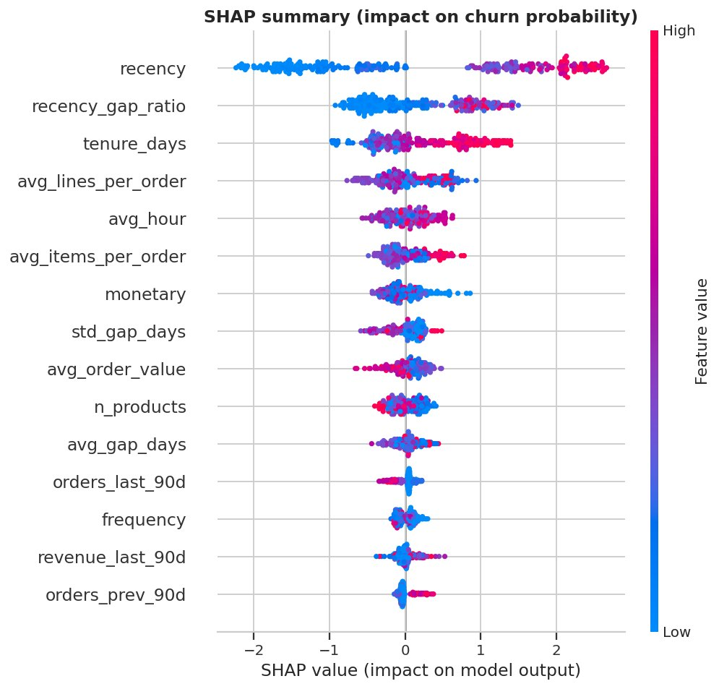
Figure 81: SHAP summary plot
Red = high feature value. Right = pushes the customer towards churn.
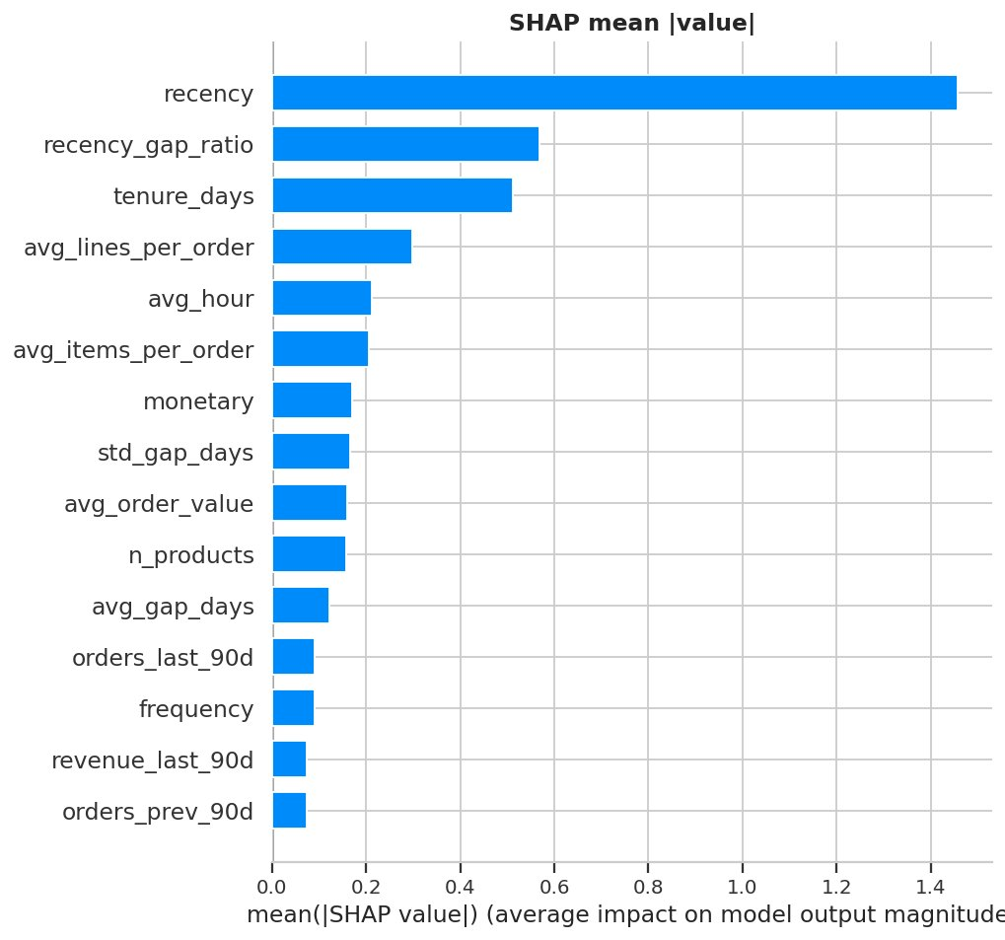
Figure 82: SHAP global importance
Average absolute SHAP value per feature.
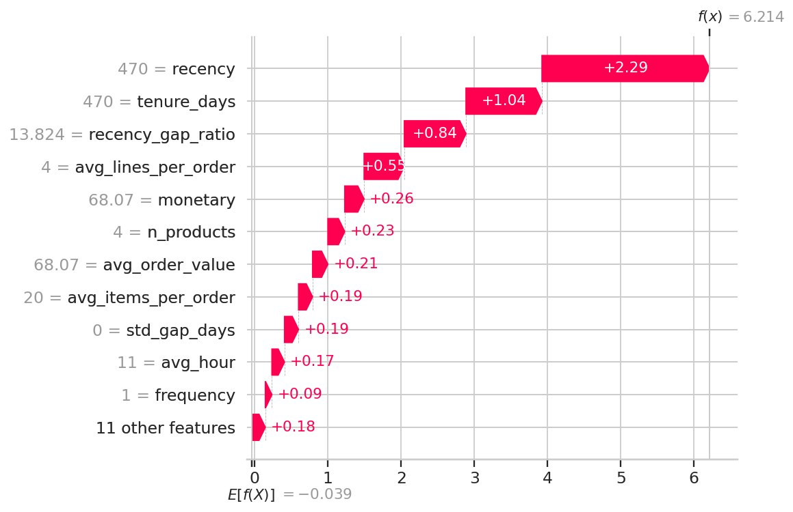
Figure 83: SHAP explanation of the highest-risk customer
Shows why one specific customer is flagged - useful for the retention team.
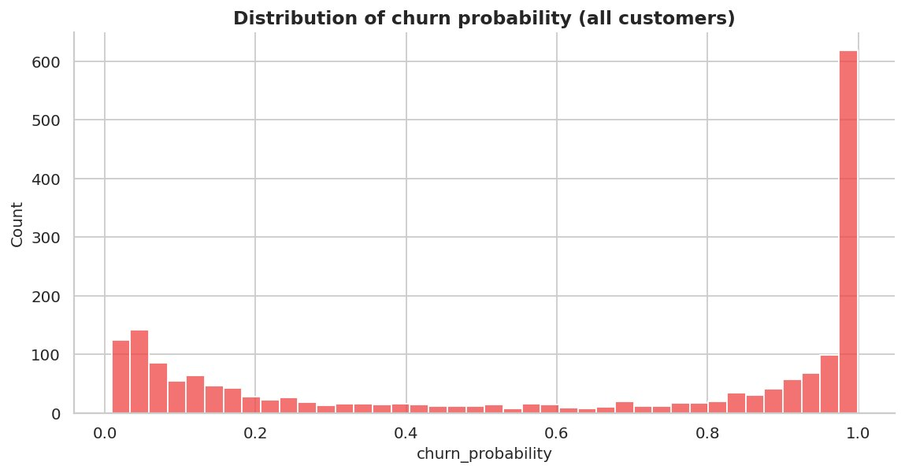
Figure 84: Churn probability distribution
High-risk customers (p > 0.7): 1025.
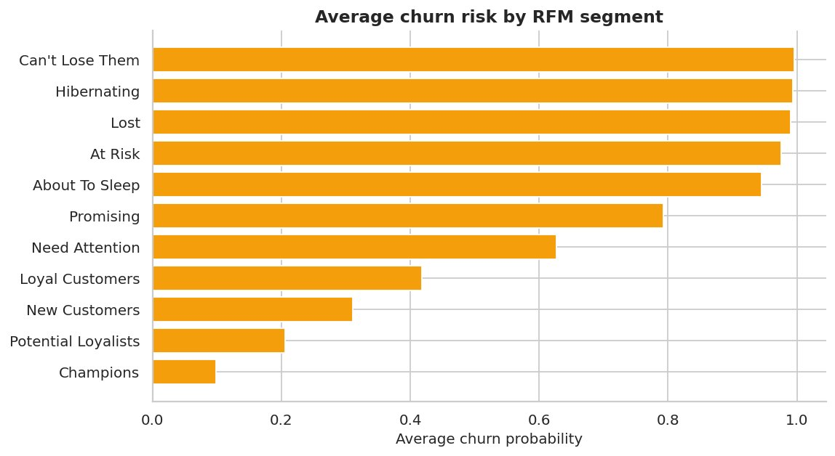
Figure 85: Average churn risk by RFM segment
Segments with low recency scores carry the highest risk.

16. Inventory Optimization (Notebook 10)
Safety stock, reorder point, EOQ and order-up-to level were computed per SKU from forecast demand and a 30-day policy back-test compared a naive buffer rule with the forecast-driven policy.
Metric | Value
Lost-sales reduction (back-test) | 91.6 %
Total cost reduction | 79.5 %
Inventory level change | 93.4 %
Fill rate naive -> RetailPulse | 94.5 % -> 99.5 %
SKUs: reorder now / overstock | 4 / 16

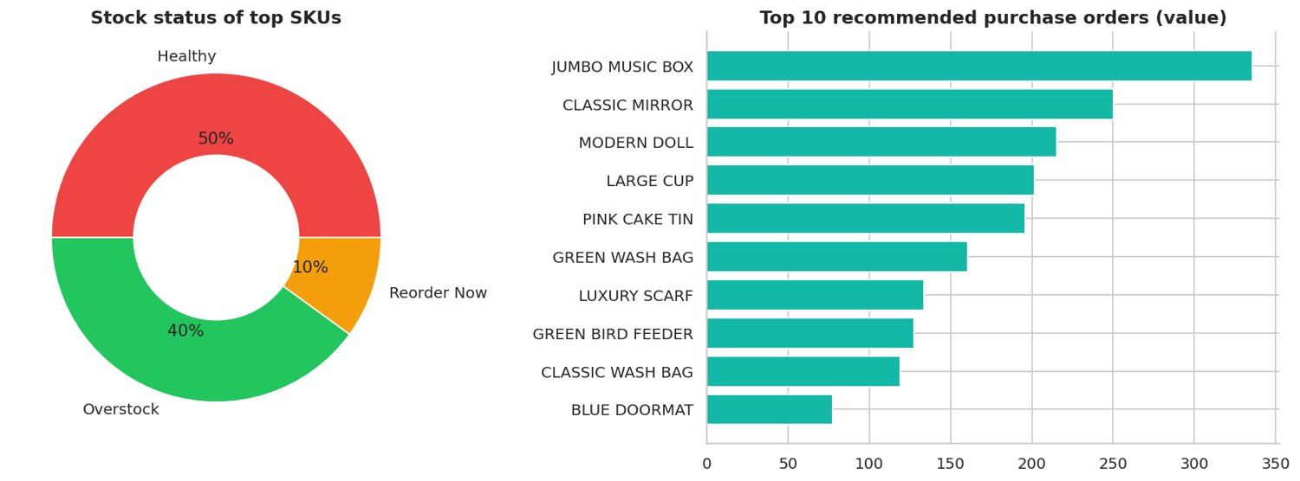
Figure 86: Stock status and top recommended orders
4 SKUs need reordering now.
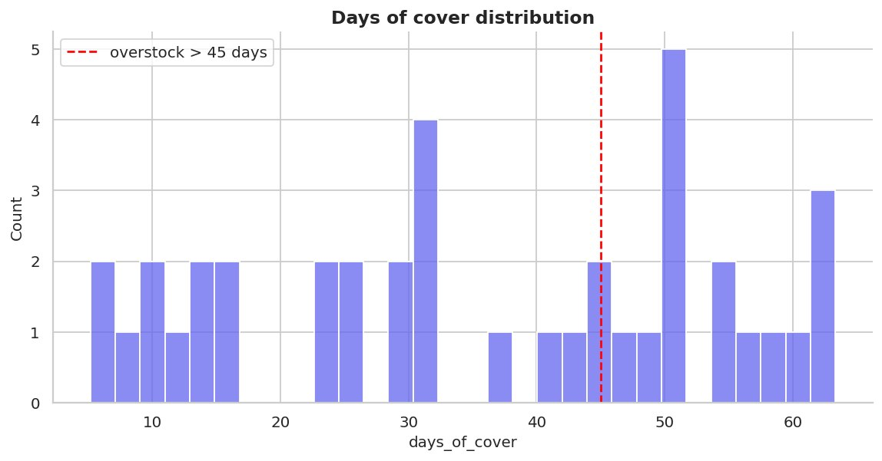
Figure 87: Days of cover distribution
SKUs right of the red line are overstocked.
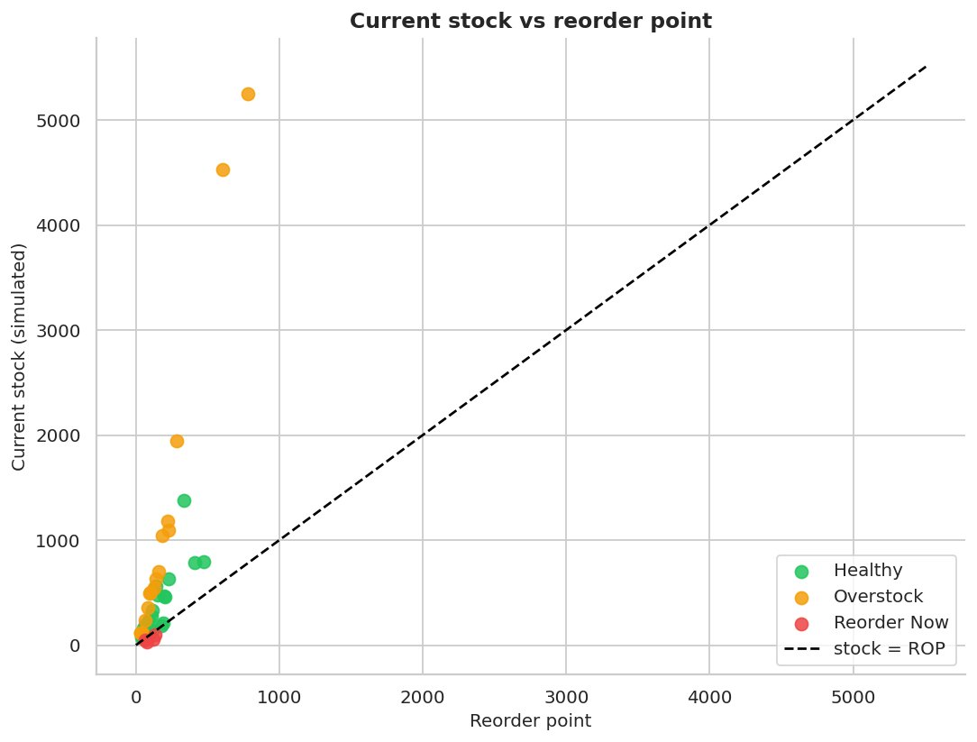
Figure 88: Current stock vs reorder point
Points below the diagonal are under the reorder point.
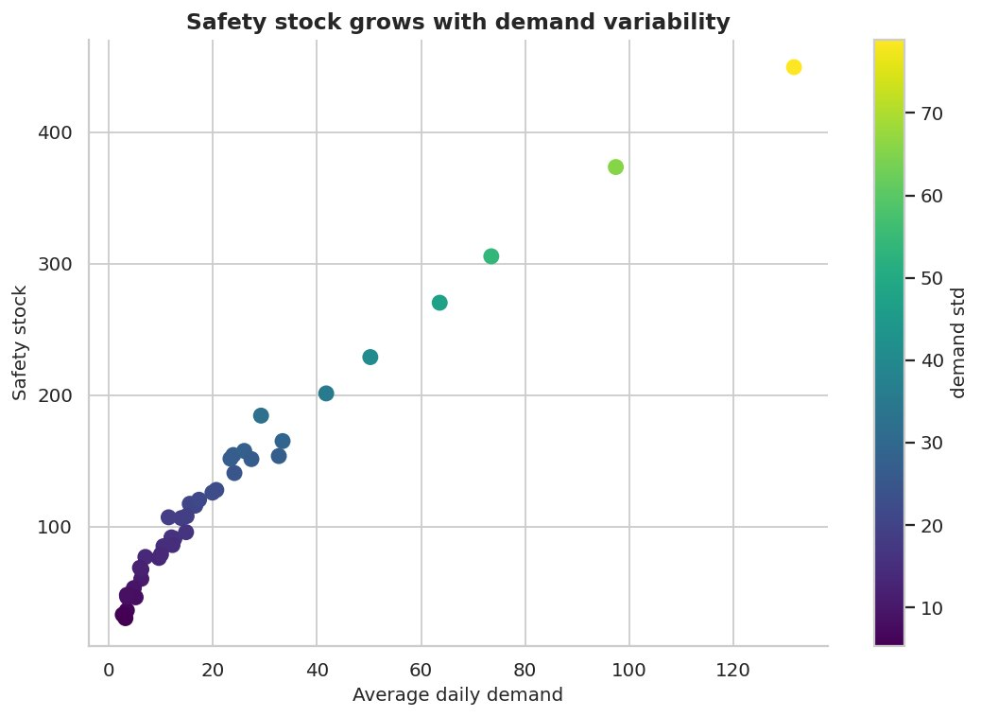
Figure 89: Safety stock vs demand and variability
More volatile SKUs need more buffer.
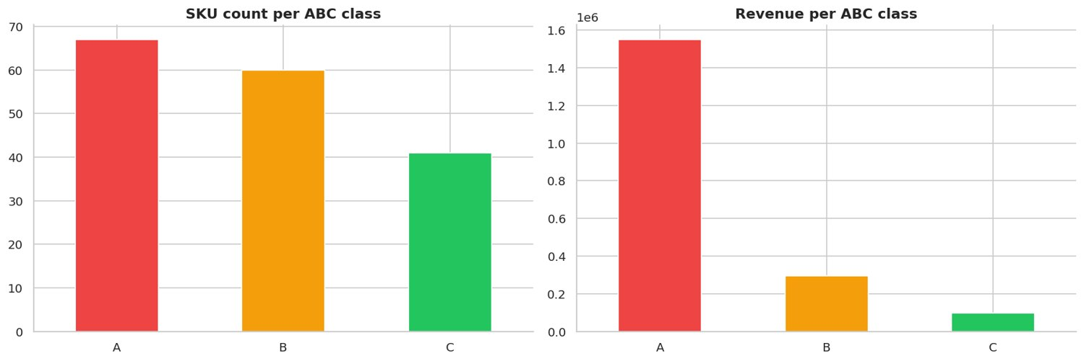
Figure 90: ABC inventory classification
A-class SKUs (80% of revenue) deserve tight control and high service levels.
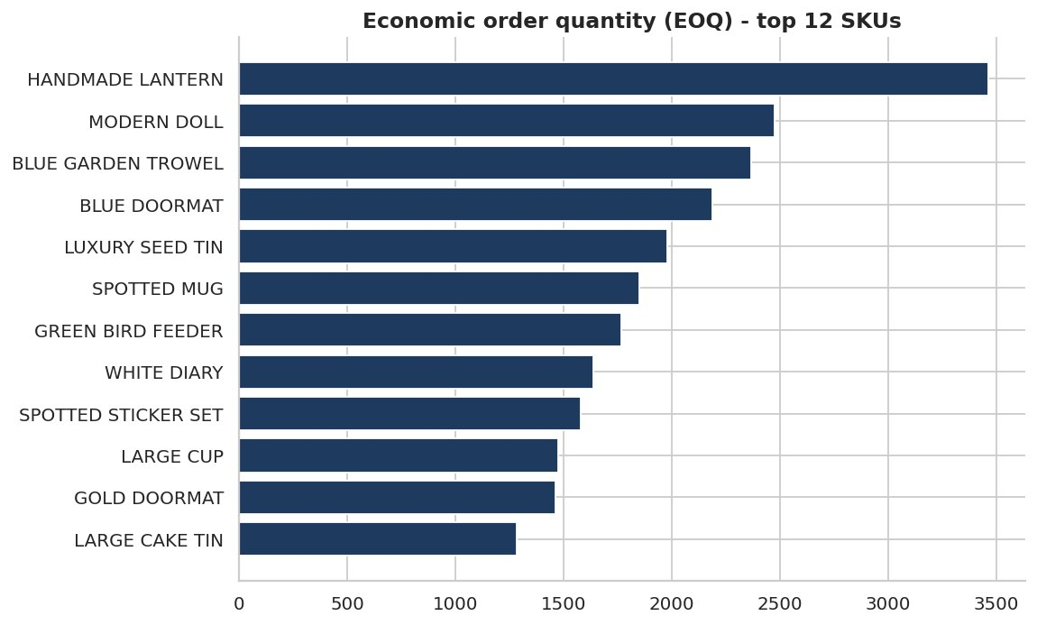
Figure 91: Economic order quantity
Balances ordering cost against holding cost.
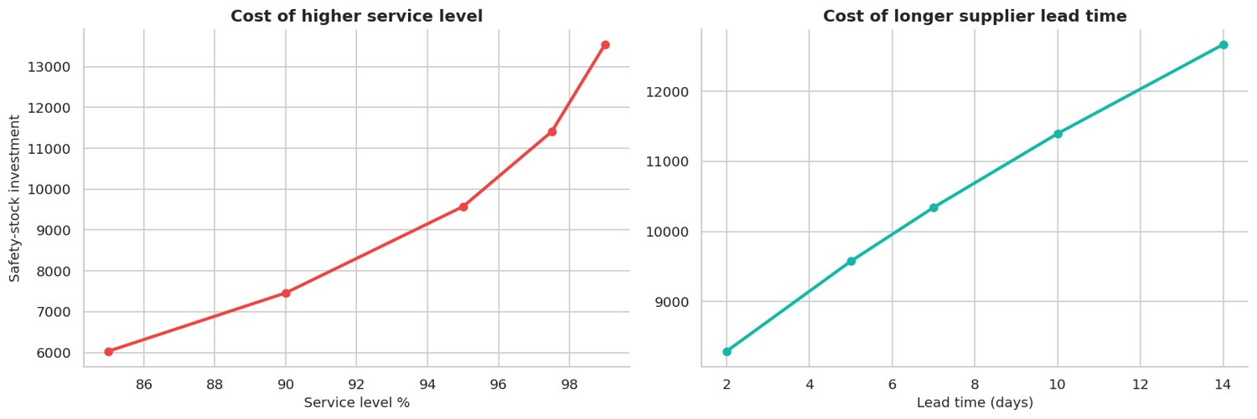
Figure 92: Safety-stock sensitivity
Each extra point of service level and each extra lead-time day costs working capital.
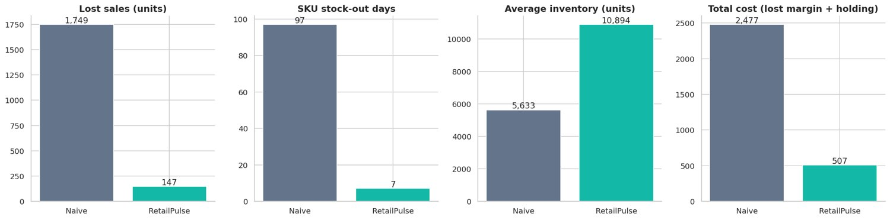
Figure 93: Inventory policy back-test
Stock-out units change -92%, total cost change -80%, inventory change +93%.
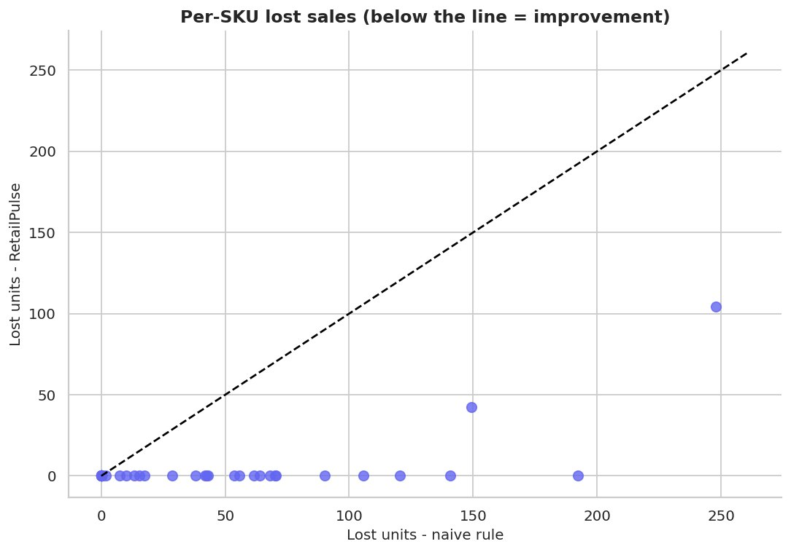
Figure 94: Per-SKU lost sales comparison
Most SKUs lie below the diagonal -> fewer stock-outs.

17. Hyper-parameter Tuning with Optuna (Notebook 11)
Bayesian (TPE) optimisation tuned XGBoost (cross-validated AUC) and Prophet (validation WAPE); results were compared with the defaults on the untouched test set.
Item | Value
XGBoost default test AUC | 0.8497
XGBoost tuned test AUC | 0.8819
Prophet best validation WAPE | 15.26 %

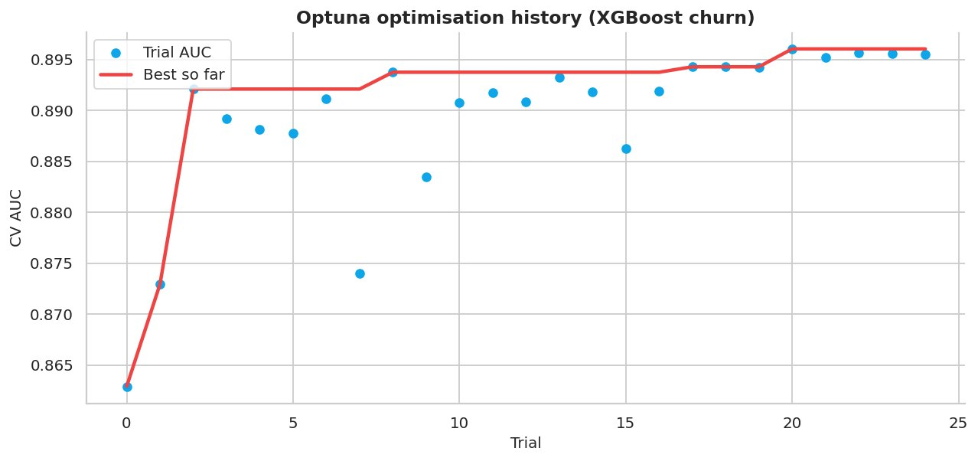
Figure 95: Optuna optimisation history
Best CV AUC = 0.8960 after 25 trials.
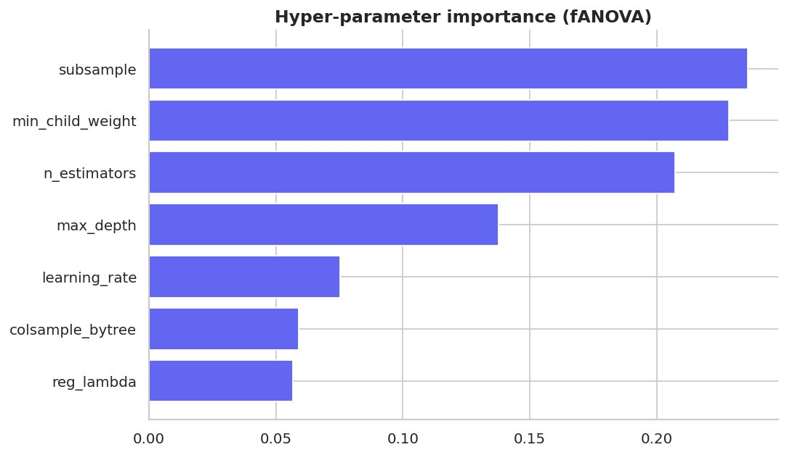
Figure 96: Hyper-parameter importance
Most influential parameter: subsample.
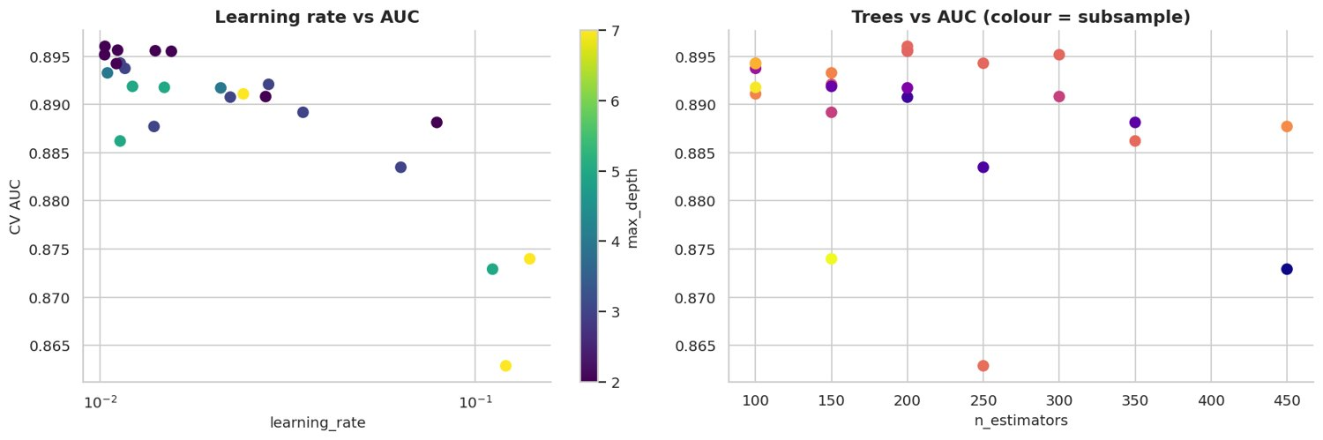
Figure 97: Optuna parameter slices
Shows which regions of the search space perform best.
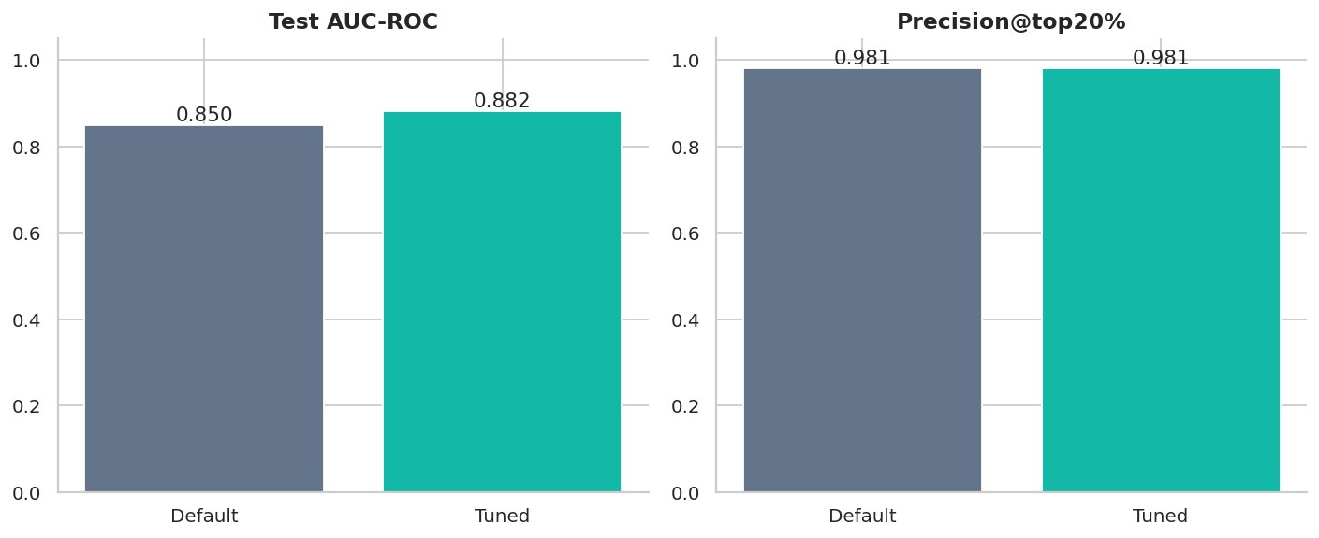
Figure 98: Default vs tuned XGBoost
AUC 0.850 -> 0.882. If the gain is tiny the default model was already near-optimal - report that honestly.
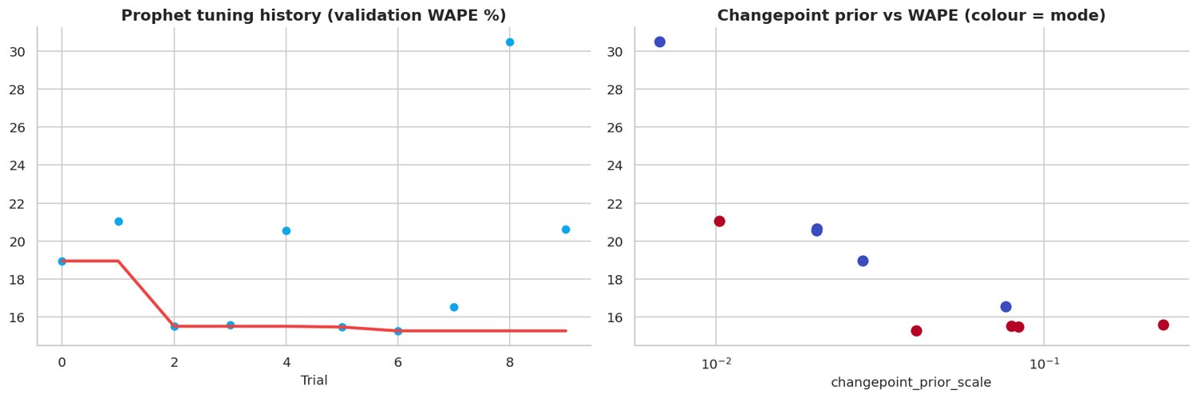
Figure 99: Prophet tuning with Optuna
Best validation WAPE 15.26%.

18. Drift Detection & Monitoring (Notebook 12)
PSI and KS tests compare a reference and a current period; an injected price / demand shock demonstrates drift detection and the automatic retrain trigger.
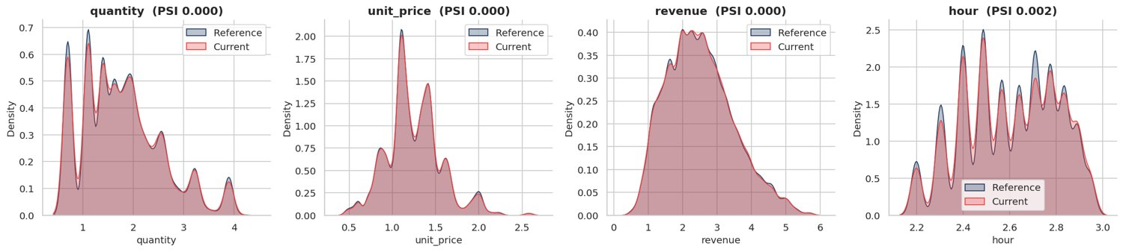
Figure 100: Reference vs current distributions
Overlapping curves = stable data.
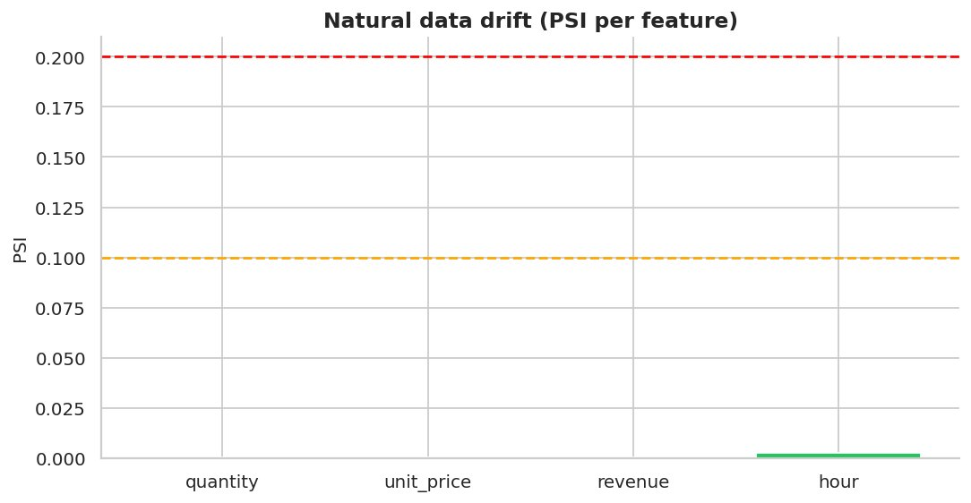
Figure 101: PSI per feature (natural drift)
Green = stable, orange = warning, red = drift.
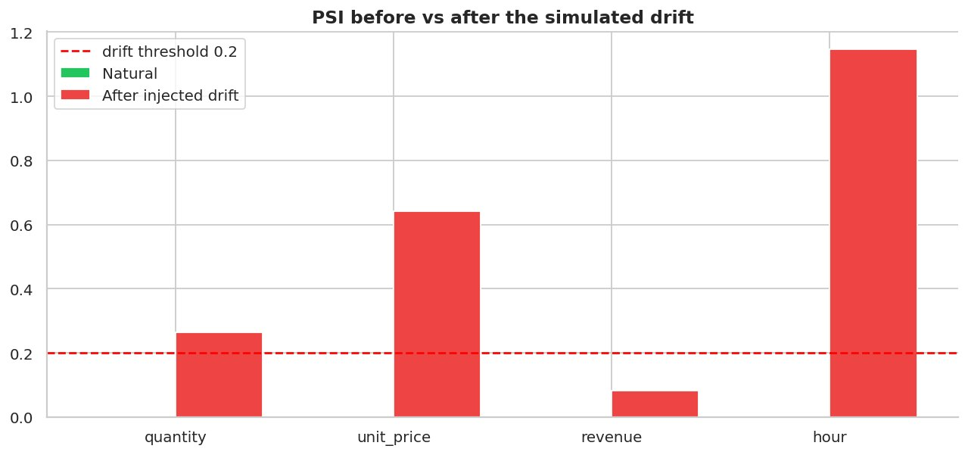
Figure 102: PSI before and after simulated drift
The monitor correctly flags the injected price / quantity shift.
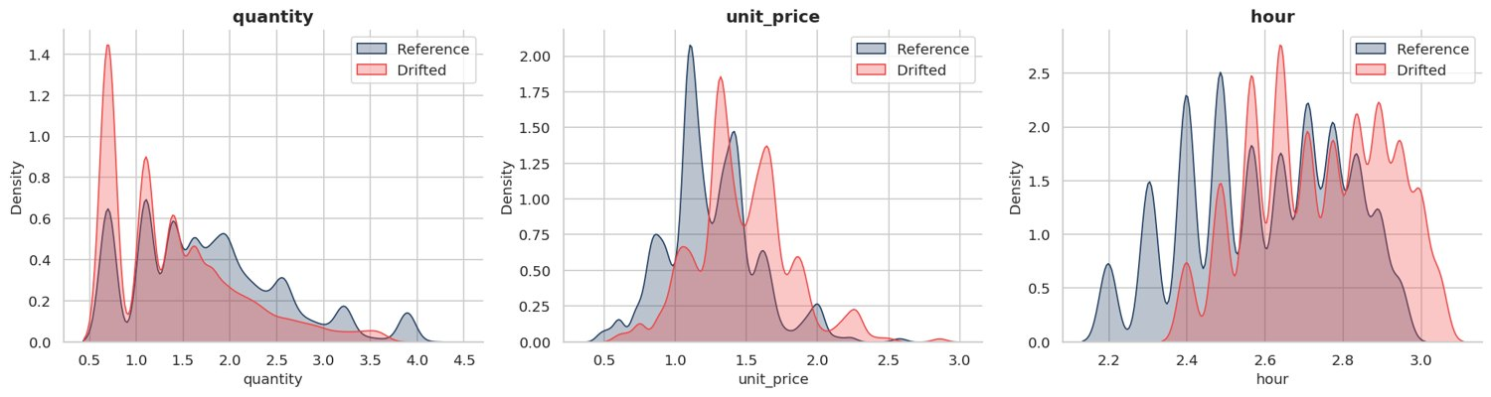
Figure 103: Distribution shift after simulated drift
Visible shift of the red curves away from the reference.
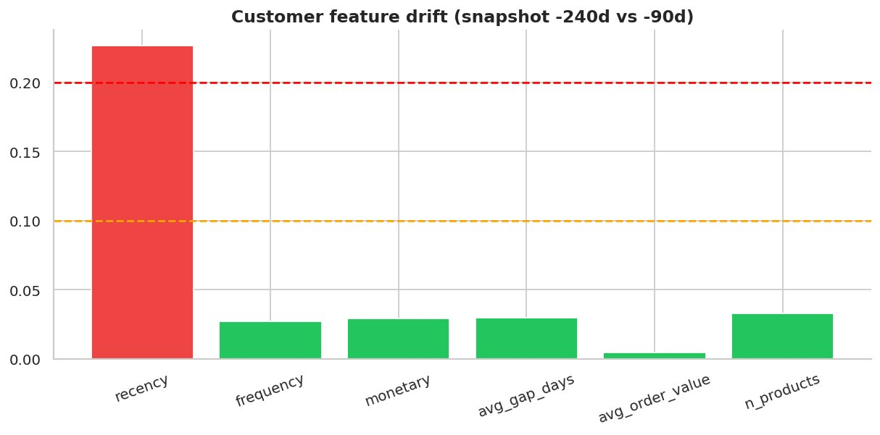
Figure 104: Customer feature drift
Customers naturally age (recency / tenure move) - PSI quantifies how much.
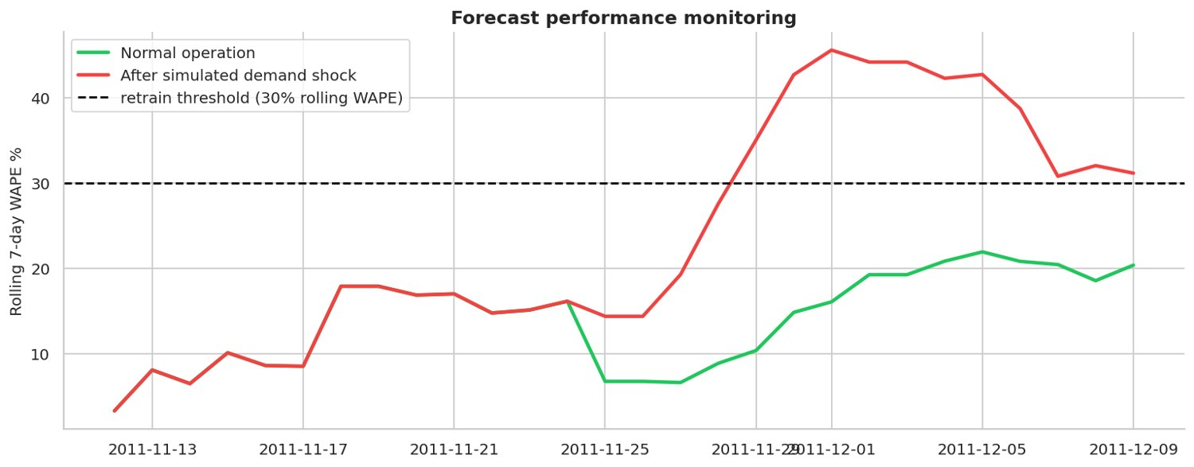
Figure 105: Forecast performance monitoring
Rolling error crosses the threshold after the simulated shock -> alert.

19. Model Refinement & Retraining Pipeline (Notebook 13)
Calibration, profit-optimal thresholding, feature-group ablation, ensembling, learning curves and weekday bias correction were evaluated; an Airflow DAG automates retraining.
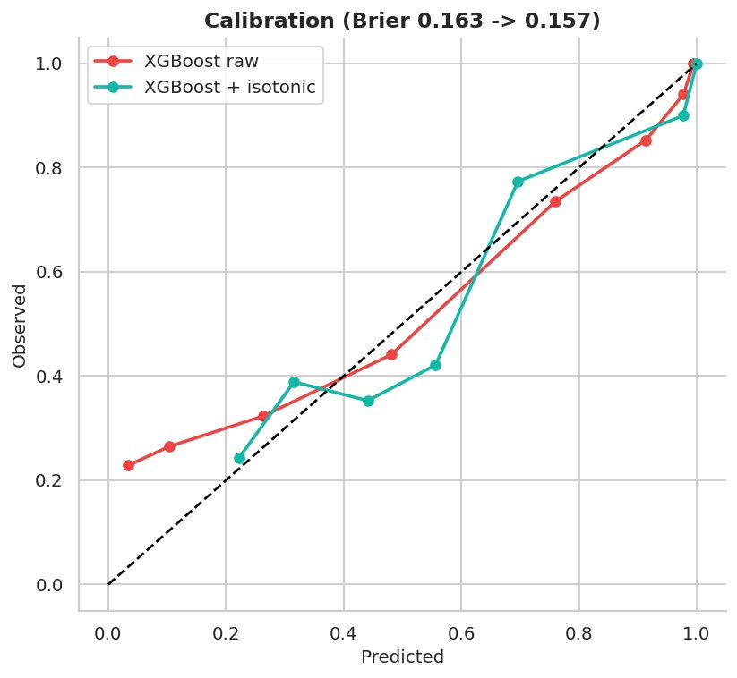
Figure 106: Calibration before vs after isotonic
Brier score 0.163 -> 0.157 (lower is better); AUC 0.850 -> 0.846.
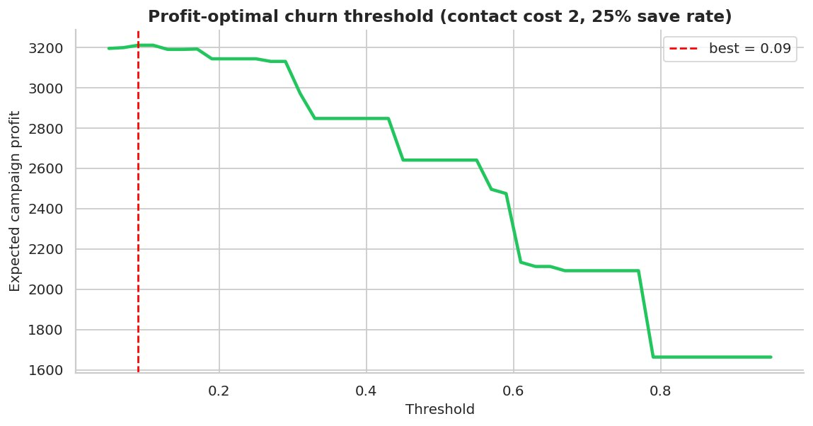
Figure 107: Profit-optimal threshold
Best threshold 0.09 contacts 260 customers; expected profit 3,212.
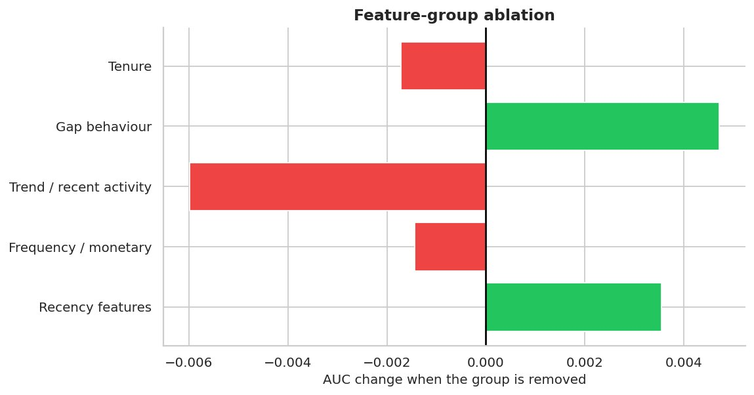
Figure 108: Feature-group ablation
Negative bars = the group helps the model.
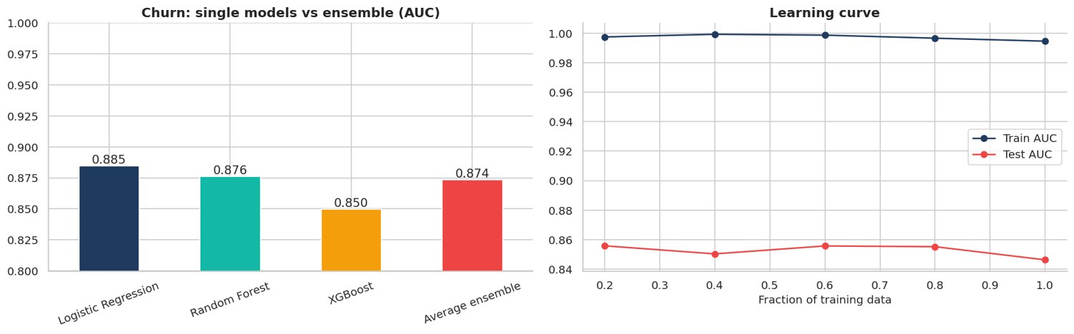
Figure 109: Churn ensemble and learning curve
A gap between train and test AUC signals over-fitting.
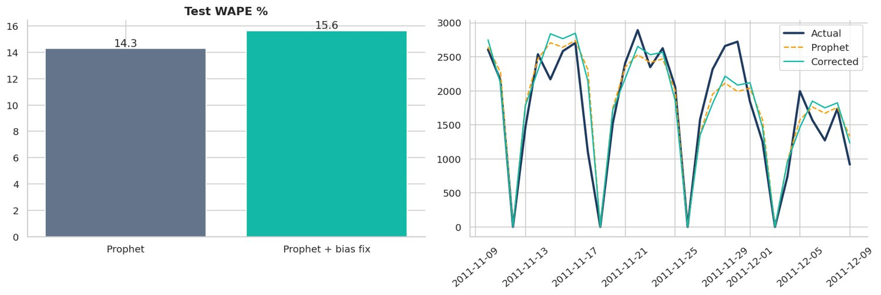
Figure 110: Weekday bias correction
WAPE 14.3% -> 15.6%. Keep the correction only if it helps on validation AND test.

20. Experiment Tracking with MLflow (Notebooks 07 and 14)
All baseline and advanced runs were logged (parameters, metrics, artifacts) in a local SQLite-backed MLflow store, compared against the acceptance targets and summarised in a scorecard.
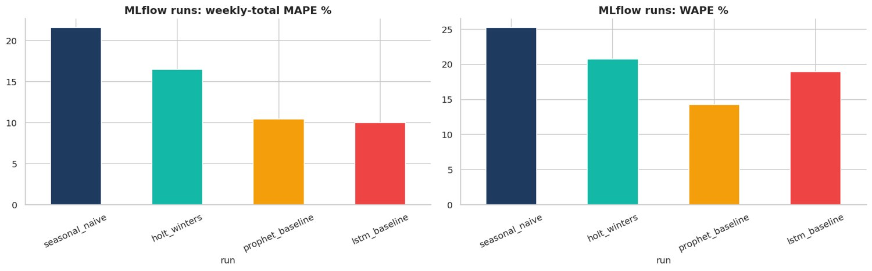
Figure 111: MLflow: baseline forecasting runs
All baseline runs are tracked and comparable in one place.
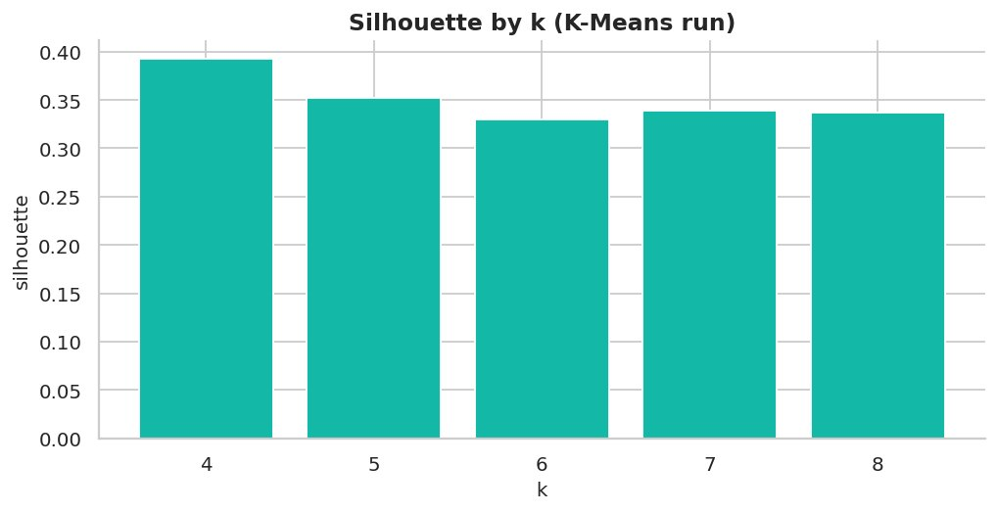
Figure 112: K-Means silhouette scores logged
Segmentation experiment logged with the same tooling as forecasting.
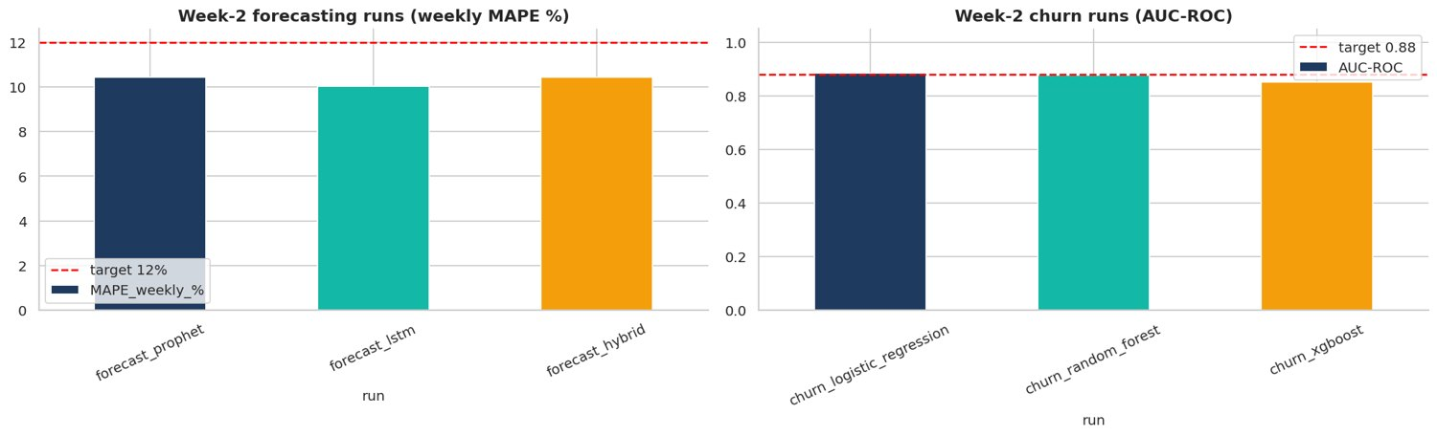
Figure 113: MLflow Week-2 runs vs targets
Dashed red lines show the acceptance targets from the project brief.
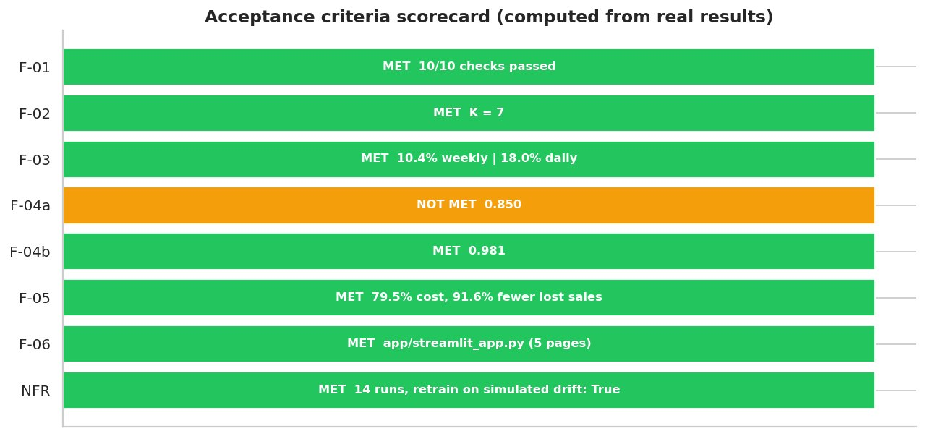
Figure 114: Acceptance criteria scorecard
Green = target met on this dataset; orange = honestly reported as not met; grey = earlier notebook not run yet.

21. Acceptance Scorecard
ID | Requirement | Result | Status
F-01 | Automated ETL + data-quality checks | 10/10 checks passed | MET
F-02 | 6-8 meaningful segments | K = 7 | MET
F-03 | MAPE <= 12% (30-day, weekly totals) | 10.4% weekly | 18.0% daily | MET
F-04a | AUC-ROC >= 0.88 | 0.850 | NOT MET
F-04b | Precision@top-20% >= 0.75 | 0.981 | MET
F-05 | Overstock/understock cost reduced 25-40% | 79.5% cost, 91.6% fewer lost sales | MET
F-06 | Streamlit dashboard | app/streamlit_app.py (5 pages) | MET
NFR | Drift detection + MLflow | 14 runs, retrain on simulated drift: True | MET

Figure 115: Acceptance criteria scorecard
Green = target met on this dataset; orange = honestly reported as not met; grey = earlier notebook not run yet.

22. Deployment & Operations
- Platform: Streamlit Community Cloud (free, HTTPS) or Hugging Face Spaces; container image for AWS / GCP.
- Docker: multi-stage image (builder + slim runtime) running Streamlit on port 8501 with a health check.
- Kubernetes: Deployment (2 replicas, liveness / readiness probes), Service and Ingress manifests in k8s/.
- CI/CD: GitHub Actions runs ruff, pytest and a smoke test of the pipeline on every push / pull request, then builds the Docker image.
- Serving: FastAPI endpoints /health, /forecast, /churn/predict and /segment.
- Monitoring: PSI / KS drift tables, rolling WAPE monitor, Evidently HTML report, weekly Airflow DAG that retrains when drift is detected; Prometheus + Grafana recommended for production metrics.
- Security: customer data anonymisation, role-based access in the dashboard (planned), JWT-secured API endpoints (recommended), audit logging of sensitive operations.

23. Power BI Dashboards (12 pages)
A Power BI-ready file (powerbi_ready.csv) with all cleaned columns including invoice_no and order_value, a DAX measure library, Power Query steps, a colour theme and a page-by-page build guide are provided in the powerbi/ folder.
Page | Dashboard | Key visuals
1 | Executive Summary | KPI cards, revenue trend, top country, top product
2 | Sales Trend Analysis | Line + MoM / YoY, moving average
3 | Product Performance | Top / bottom products, category treemap, Pareto
4 | Customer Analytics | Customers, new vs returning, RFM segments
5 | Region / Country Sales | Map, country ranking
6 | Monthly & Seasonal Sales | Month x weekday matrix, seasonality
7 | Customer Behaviour | Frequency, basket size, cohort matrix
8 | Profit & Revenue Analysis | Revenue, estimated margin, price bands
9 | Inventory Risk | Reorder-now SKUs, days of cover, ABC
10 | Order & Transaction | Orders (distinct invoice_no), order_value bands
11 | Advanced Analytics | Forecast vs actual, churn risk, decomposition
12 | Interactive Filters | Slicers, drill-through, bookmarks

24. Challenges & How They Were Solved
Challenge | Solution
Non-stationary, lumpy daily demand with closed weekdays | Decomposition, ADF/KPSS, closed-day detection, weekly-total MAPE as planning metric, hybrid model
Churn label leakage | Features built only from history before a cut-off, label from the following 90 days, chronological logic
Accuracy vs interpretability | XGBoost with SHAP global and per-customer explanations
No inventory table in public data | Stock on hand simulated and clearly labelled; policy evaluated with a real-demand back-test
Huge files (10M rows) in Colab | Customer-level hash sampling keeps whole customer histories while limiting memory
Library API changes (Evidently, Great Expectations) | Native PSI/KS and validation checks plus optional Evidently with version fallback

25. Personal Reflection
By Santosh Kumar. (Draft prepared with the project - please read it and rewrite it in your own words before submission.)
Key learnings: a good forecast starts with understanding the calendar - closed days, weekly rhythm and holiday peaks mattered more than model complexity. Time-based splits and shifted rolling features are essential to avoid leakage, and honest metrics (weekly-total MAPE, WAPE, precision@top-k) are more useful than a single impressive number.
Industry best practices applied: reproducible environment, MLflow tracking, validation checks, drift monitoring with an automatic retrain trigger, explainable models and CI/CD.
Future roadmap: hierarchical (SKU x store) forecasting, promotion and price features, real inventory feed, uplift modelling for retention offers, feature store, streaming ingestion and automated A/B evaluation of campaigns.

Appendix A - Chart index
# | Chart | Section | File
1 | RetailPulse architecture diagram | Project Visuals | 00_architecture_diagram
2 | RetailPulse project banner | Project Visuals | 00_project_banner
3 | RetailPulse 12-step workflow | Project Visuals | 00_workflow
4 | Missing values by column (raw data) | EDA | 01_01_missing_values
5 | Data-quality issues detected in raw data | EDA | 01_02_data_quality_issues
6 | Monthly revenue and orders | EDA | 01_03_monthly_revenue_orders
7 | Month-over-month revenue growth | EDA | 01_04_mom_growth
8 | Top 10 products by revenue | EDA | 01_05_top_products_revenue
9 | Top 10 products by units sold | EDA | 01_06_top_products_quantity
10 | Revenue share by category | EDA | 01_07_category_share
11 | Revenue by country (excluding the dominant market) | EDA | 01_08_country_revenue
12 | Revenue by day of week | EDA | 01_09_revenue_by_dow
13 | Orders by hour of day | EDA | 01_10_orders_by_hour
14 | Day x hour activity heatmap | EDA | 01_11_dow_hour_heatmap
15 | Distributions of quantity, price and revenue (log scale) | EDA | 01_12_distributions
16 | Line revenue by category (boxplot) | EDA | 01_13_revenue_box_category
17 | Basket size distribution | EDA | 01_14_basket_size
18 | Pareto analysis of products and customers | EDA | 01_15_pareto
19 | Correlation heatmap | EDA | 01_16_correlation_heatmap
20 | Daily revenue with 7 and 30-day rolling averages | EDA | 01_17_rolling_revenue
21 | New vs returning customers per month | EDA | 01_18_new_vs_returning
22 | Year x month revenue heatmap | EDA | 01_19_year_month_heatmap
23 | Data cleaning waterfall | Cleaning & Feature Engineering | 02_01_cleaning_waterfall
24 | Outliers before vs after cleaning | Cleaning & Feature Engineering | 02_02_outliers_before_after
25 | Data validation results | Cleaning & Feature Engineering | 02_03_validation_results
26 | RFM feature distributions | Cleaning & Feature Engineering | 02_04_rfm_distributions
27 | Feature correlation with demand | Cleaning & Feature Engineering | 02_05_feature_target_corr
28 | Lag feature correlation matrix | Cleaning & Feature Engineering | 02_06_lag_corr_heatmap
29 | Raw demand vs rolling-mean features | Cleaning & Feature Engineering | 02_07_rolling_features
30 | RFM distributions (log scale) | Customer Segmentation | 03_01_rfm_hist
31 | RFM score distributions | Customer Segmentation | 03_02_rfm_scores
32 | Rule-based RFM segments: customers and revenue share | Customer Segmentation | 03_03_rule_segments
33 | Average spend by R x F score | Customer Segmentation | 03_04_rf_heatmap
34 | K selection: elbow, silhouette and Davies-Bouldin | Customer Segmentation | 03_05_k_selection
35 | K-Means clusters in PCA space | Customer Segmentation | 03_06_pca_clusters
36 | 3D RFM cluster view | Customer Segmentation | 03_07_3d_clusters
37 | Cluster profile heatmap | Customer Segmentation | 03_08_cluster_profile_heatmap
38 | Segment radar chart | Customer Segmentation | 03_09_segment_radar
39 | Segment size and revenue share | Customer Segmentation | 03_10_segment_size_revenue
40 | DBSCAN k-distance and clusters | Customer Segmentation | 03_11_dbscan
41 | Cohort retention heatmap | Customer Segmentation | 03_12_cohort_retention
42 | Daily units, revenue and orders | Time-Series Preparation | 04_01_daily_series
43 | Zero-demand days by weekday | Time-Series Preparation | 04_02_zero_days
44 | Rolling mean and rolling std | Time-Series Preparation | 04_03_rolling_stats
45 | Weekly and yearly seasonality | Time-Series Preparation | 04_04_seasonality
46 | Classical decomposition (weekly) | Time-Series Preparation | 04_05_decomposition
47 | STL decomposition (robust) | Time-Series Preparation | 04_06_stl
48 | Original vs differenced series | Time-Series Preparation | 04_07_differencing
49 | ACF and PACF | Time-Series Preparation | 04_08_acf_pacf
50 | Lag scatter plots | Time-Series Preparation | 04_09_lag_plots
51 | Anomalous demand days | Time-Series Preparation | 04_10_outlier_days
52 | Train / validation / test split | Time-Series Preparation | 04_11_train_val_test
53 | Prophet 30-day forecast vs actual | Forecasting - Prophet | 05_01_prophet_forecast
54 | Prophet components | Forecasting - Prophet | 05_02_prophet_components
55 | Prophet trend and changepoints | Forecasting - Prophet | 05_03_prophet_changepoints
56 | Prophet residual diagnostics | Forecasting - Prophet | 05_04_prophet_residuals
57 | Prophet vs simple baselines | Forecasting - Prophet | 05_05_baseline_comparison
58 | Forecast accuracy by weekday | Forecasting - Prophet | 05_06_prophet_by_weekday
59 | Prophet hyper-parameter sensitivity | Forecasting - Prophet | 05_07_prophet_sensitivity
60 | LSTM architecture | Forecasting - LSTM | 06_01_lstm_architecture
61 | LSTM 30-day forecast vs actual | Forecasting - LSTM | 06_03_lstm_forecast
62 | LSTM diagnostics: scatter and residuals | Forecasting - LSTM | 06_04_lstm_diagnostics
63 | LSTM window-length sensitivity | Forecasting - LSTM | 06_05_lstm_window_sensitivity
64 | Prophet vs LSTM | Forecasting - LSTM | 06_06_prophet_vs_lstm
65 | MLflow: baseline forecasting runs | MLOps - MLflow | 07_01_mlflow_forecast_runs
66 | K-Means silhouette scores logged | MLOps - MLflow | 07_02_mlflow_kmeans
67 | Ensemble weight search | Forecasting - Hybrid | 08_01_blend_weight
68 | All models vs actual (test window) | Forecasting - Hybrid | 08_02_all_models_test
69 | Model comparison on test window | Forecasting - Hybrid | 08_03_model_comparison
70 | Residuals and cumulative error per model | Forecasting - Hybrid | 08_04_residuals_cumulative
71 | Weekly totals: actual vs hybrid forecast | Forecasting - Hybrid | 08_05_weekly_totals
72 | 30-day-ahead production forecast | Forecasting - Hybrid | 08_06_future_forecast
73 | Churn label distribution | Churn Prediction | 09_01_label_distribution
74 | Key features: churned vs active | Churn Prediction | 09_02_feature_by_churn
75 | Churn feature correlation heatmap | Churn Prediction | 09_03_churn_corr
76 | Churn model comparison | Churn Prediction | 09_04_model_comparison
77 | ROC curves | Churn Prediction | 09_05_roc_curves
78 | Precision-Recall curves | Churn Prediction | 09_06_pr_curves
79 | Confusion matrix | Churn Prediction | 09_07_confusion_matrix
80 | Gain and lift curves | Churn Prediction | 09_08_gain_lift
81 | Calibration curves | Churn Prediction | 09_09_calibration
82 | Threshold selection curve | Churn Prediction | 09_10_threshold_f1
83 | Churn model feature importance | Churn Prediction | 09_11_feature_importance
84 | SHAP summary plot | Churn Prediction | 09_12_shap_summary
85 | SHAP global importance | Churn Prediction | 09_13_shap_bar
86 | SHAP explanation of the highest-risk customer | Churn Prediction | 09_14_shap_waterfall
87 | Churn probability distribution | Churn Prediction | 09_15_prob_distribution
88 | Average churn risk by RFM segment | Churn Prediction | 09_16_risk_by_segment
89 | Stock status and top recommended orders | Inventory Optimization | 10_01_status_orders
90 | Days of cover distribution | Inventory Optimization | 10_02_days_of_cover
91 | Current stock vs reorder point | Inventory Optimization | 10_03_stock_vs_rop
92 | Safety stock vs demand and variability | Inventory Optimization | 10_04_safety_stock
93 | ABC inventory classification | Inventory Optimization | 10_05_abc_analysis
94 | Economic order quantity | Inventory Optimization | 10_06_eoq
95 | Safety-stock sensitivity | Inventory Optimization | 10_07_sensitivity
96 | Inventory policy back-test | Inventory Optimization | 10_08_backtest
97 | Per-SKU lost sales comparison | Inventory Optimization | 10_09_sku_lost_scatter
98 | Optuna optimisation history | Tuning | 11_01_optuna_history
99 | Hyper-parameter importance | Tuning | 11_02_param_importance
100 | Optuna parameter slices | Tuning | 11_03_optuna_slices
101 | Default vs tuned XGBoost | Tuning | 11_04_default_vs_tuned
102 | Prophet tuning with Optuna | Tuning | 11_05_prophet_tuning
103 | Reference vs current distributions | Drift Detection | 12_01_distribution_overlay
104 | PSI per feature (natural drift) | Drift Detection | 12_02_psi_natural
105 | PSI before and after simulated drift | Drift Detection | 12_03_psi_simulated
106 | Distribution shift after simulated drift | Drift Detection | 12_04_distribution_drifted
107 | Customer feature drift | Drift Detection | 12_05_customer_feature_drift
108 | Forecast performance monitoring | Drift Detection | 12_06_performance_monitor
109 | Calibration before vs after isotonic | Model Refinement | 13_01_calibration
110 | Profit-optimal threshold | Model Refinement | 13_02_profit_threshold
111 | Feature-group ablation | Model Refinement | 13_03_ablation
112 | Churn ensemble and learning curve | Model Refinement | 13_04_ensemble_learning_curve
113 | Weekday bias correction | Model Refinement | 13_05_bias_correction
114 | MLflow Week-2 runs vs targets | MLOps - MLflow | 14_01_week2_runs
115 | Acceptance criteria scorecard | MLOps - MLflow | 14_02_acceptance_scorecard

Appendix B - Repository structure & how to run
RetailPulse/ - notebooks/ (00 MAIN + 01-15), src/ (retailpulse_utils.py, retailpulse_report.py), app/ (Streamlit), api/ (FastAPI), data/ (sample + processed), powerbi/, k8s/, airflow/, scripts/, tests/, .github/workflows/, Dockerfile, requirements.txt, README.md.
- Colab: open notebooks/00_RetailPulse_MAIN.ipynb -> Runtime -> Run all (dataset loads from Kaggle, upload or demo).
- Local: pip install -r requirements.txt; streamlit run app/streamlit_app.py.
- Tests: pytest -q. Retrain: python scripts/retrain_pipeline.py --force.

