
RetailPulse
AI-Powered Customer Analytics & Demand Forecasting Platform
Predictive Demand • Customer Segmentation • Churn Analysis • Inventory Optimization
Item | Details
Project made by | Santosh Kumar
Prepared for | Zidio Development - Data Science & Analytics Domain
Document | Project Report (compact Zidio submission edition)
Date / Version | March 2026 | 2.0 - Industry Edition
Dataset used | Synthetic demo data
Data period | 2010-01-04 to 2011-12-09

Tagline: From raw transactions to forecasts, retention actions and replenishment plans - in one reproducible, monitored pipeline.

Project Summary
RetailPulse is an end-to-end Data Science & Analytics platform that helps retail businesses make smarter decisions. It ingests sales, customer and inventory data and delivers four solutions: (1) demand forecasting for the next 30 days with a Prophet + LSTM hybrid, (2) customer segmentation with RFM, K-Means and DBSCAN, (3) churn prediction with XGBoost and SHAP explainability, and (4) inventory optimisation (safety stock, reorder point, EOQ and recommended order quantities). Results are delivered through a 5-page Streamlit dashboard, a FastAPI service and a 12-page Power BI report, and the system follows MLOps practice: MLflow tracking, PSI/KS drift detection, an Airflow retraining DAG, Docker, Kubernetes and GitHub Actions CI/CD.

Key results of this run (computed, not hard-coded)
Area | Metric | Result | Target
Data | Clean rows / customers / products | 97,942 / 1,900 / 168 | -
Data | Total revenue | 1,943,304 | -
Segmentation | K-Means clusters (silhouette) | 7 (0.339) | 6-8 segments
Forecasting | Hybrid MAPE weekly totals | 10.4 % | <= 12 %
Forecasting | Hybrid MAPE daily / WAPE | 18.0 % / 14.3 % | informational
Churn | XGBoost AUC-ROC | 0.850 | >= 0.88
Churn | Precision @ top 20 % | 0.981 | >= 0.75
Inventory | Cost reduction / lost-sales reduction (back-test) | 79.5 % / 91.6 % | 25-40 %
MLOps | Drift simulation triggers retrain | True | Yes

Honesty note: targets are taken from the project brief. Where a target is not met on the dataset used, the report states it openly (see the acceptance scorecard). Daily MAPE is high for lumpy wholesale demand, therefore weekly-total MAPE is reported as the planning metric.

Contents
- Project Summary
- 1. Introduction & Business Case
- 2. Project Overview
- 3. Key Features (F-01 to F-06)
- 4. Technology Stack
- 5. Architecture & Workflow
- 6. Dataset, Cleaning & New Columns
- 7. 28-Day Execution Timeline
- 8. Exploratory Data Analysis (Notebook 01)
- 9. Data Cleaning, Validation & Feature Engineering (Notebook 02)
- 10. Customer Segmentation (Notebook 03)
- 11. Time-Series Preparation (Notebook 04)
- 12. Baseline Forecasting with Prophet (Notebook 05)
- 13. Deep-Learning Forecasting with LSTM (Notebook 06)
- 14. Hybrid Prophet + LSTM Ensemble (Notebook 08)
- 15. Churn Prediction with XGBoost + SHAP (Notebook 09)
- 16. Inventory Optimization (Notebook 10)
- 17. Hyper-parameter Tuning with Optuna (Notebook 11)
- 18. Drift Detection & Monitoring (Notebook 12)
- 19. Model Refinement & Retraining Pipeline (Notebook 13)
- 20. Experiment Tracking with MLflow (Notebooks 07 and 14)
- 21. Acceptance Scorecard
- 22. Deployment & Operations
- 23. Power BI Dashboards (12 pages)
- 24. Challenges & How They Were Solved
- 25. Personal Reflection
- Appendix A - Chart index
- Appendix B - Repository structure & how to run

1. Introduction & Business Case
Retailers lose billions because of poor demand forecasting and stock mismanagement: shelves run empty when demand is under-estimated and capital is locked in slow stock when it is over-estimated. At the same time, acquiring a new customer costs far more than keeping an existing one, so identifying customers who are about to leave is valuable.
Mission: build an end-to-end data science platform that ingests sales, customer and inventory data and delivers accurate demand forecasts, customer segmentation, churn prediction and inventory optimisation recommendations.
- Reduce stock-outs through accurate demand forecasting
- Increase revenue through better inventory decisions
- Improve retention by identifying at-risk customers early
- Process 10M+ transactions per month with daily batch jobs under 5 minutes (design target; large files are sampled by customer in Colab)

2. Project Overview
Topic | Description
Vision | One analytics platform that turns retail transactions into forecasts, customer actions and replenishment plans.
Target users | Supermarket chains, fashion retailers and e-commerce companies: merchandisers, supply-chain planners, CRM / marketing teams, management.
Business value | Fewer stock-outs, lower holding cost, targeted retention campaigns, one source of truth dashboard.
Non-functional goals | MAPE <= 12 % (weekly totals), daily batch < 5 min, scalable to 10M+ transactions / month, full MLflow tracking and drift detection.

3. Key Features
ID | Feature | Description | Acceptance criteria | Status
F-01 | Data ingestion & cleaning | Kaggle / upload / demo loaders, ETL, validation | Automated pipeline + quality checks | Met
F-02 | Customer segmentation | RFM + K-Means / DBSCAN | 6-8 segments with interpretation | Met
F-03 | Demand forecasting | Prophet + LSTM hybrid, 30 days | MAPE <= 12 % | Met
F-04 | Churn prediction | XGBoost + SHAP | AUC >= 0.88, precision@20 % >= 0.75 | Not met / Met
F-05 | Inventory optimisation | Safety stock, ROP, EOQ, order qty | Reduce over/under-stock 25-40 % | Met
F-06 | Interactive dashboard | Streamlit (5 pages) + Power BI (12 pages) | Insights, what-if, exports | Delivered

4. Technology Stack
Category | Technology | Rationale / alternatives
Language | Python 3.11 | Data-science ecosystem
Data processing | Pandas, NumPy, Scikit-learn | Core manipulation and ML
Forecasting | Prophet + LSTM (PyTorch) | Hybrid: calendar effects + non-linear dynamics
Churn / explainability | XGBoost, SHAP | Best tabular accuracy + transparent drivers
Tuning | Optuna | Bayesian search, faster than grid search
Dashboard | Streamlit, Plotly, Power BI | Fast interactive analytics / business reporting
Serving | FastAPI | Typed, fast REST endpoints
Experiment tracking | MLflow (SQLite) | Versioning and reproducibility, no paid service
Monitoring | PSI / KS, Evidently AI, Prometheus + Grafana | Drift and performance monitoring
Orchestration | Airflow DAG, GitHub Actions | Retraining and CI/CD
Deployment | Docker, Kubernetes, Streamlit Cloud | Consistent, scalable deployment

5. Architecture & Workflow
RetailPulse has five layers: Data -> Feature Engineering (RFM, lags, rolling averages) -> Models (segmentation, forecasting, churn, inventory, MLflow registry) -> Serving (FastAPI, Streamlit, Power BI) -> Monitoring (drift, performance tracking) with a retraining feedback loop.
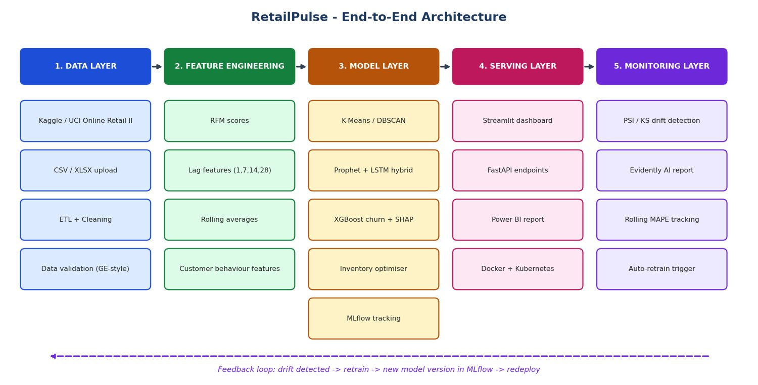
Figure 1: RetailPulse architecture diagram
Five layers: data, feature engineering, models, serving and monitoring with a retraining feedback loop.
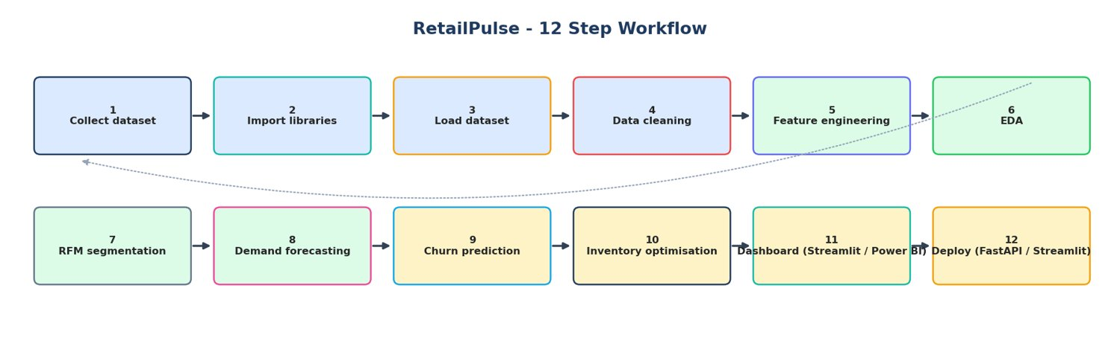
Figure 2: RetailPulse 12-step workflow
Workflow from data collection to deployment.

6. Dataset, Cleaning & New Columns
Data source used for this run: Synthetic demo data. Raw rows: 98,772; clean sales rows: 97,942 (99.2 % retained). Customers: 1,900, products: 168, countries: 12.
Cleaning step | Rows
raw rows | 98,772
duplicates removed | 295
returns separated | 318
invalid qty or price removed | 98
non product codes removed | 40
extreme outliers removed | 79
rows without customer id | 12,736
final rows | 97,942

Two columns were added to the cleaned CSV / Power BI file:
- invoice_no - numeric part of the invoice id. Effect: a clean integer key for distinct-order counts, joins with returns and Power BI relationships (removes prefixes such as 'C' or 'A').
- order_value - total revenue of the whole invoice repeated on each line. Effect: average-order-value, basket-value bands and order-level filters work without re-grouping, and visuals stay fast.

7. 28-Day Execution Timeline
Week | Days | Deliverables | Notebook(s)
1 - Exploration & preparation | 1-7 | EDA, cleaning, RFM segmentation, time-series prep, Prophet, LSTM, MLflow baselines | 01-07
2 - Advanced modelling | 8-14 | Hybrid forecaster, churn + SHAP, inventory, Optuna, drift detection, retraining pipeline | 08-14
3 - Dashboard & analytics | 15-21 | Streamlit 5 pages, what-if, alerts, CSV/PDF export, Power BI (12 pages) | 15 + app/
4 - Deployment & polish | 22-28 | Docker, Kubernetes, GitHub Actions, cloud deploy, monitoring, load test, report, demo video | Dockerfile, k8s/, .github/

8. Exploratory Data Analysis (Notebook 01)
EDA was the first step: understand the raw table, its quality problems, the seasonality of demand, where revenue comes from (products, categories, countries, customers) and how variables relate. Every later model depends on these findings.
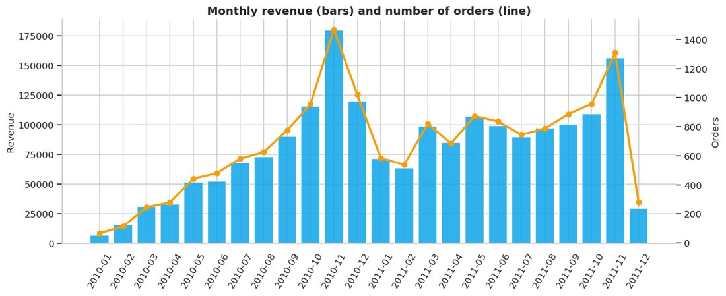 | 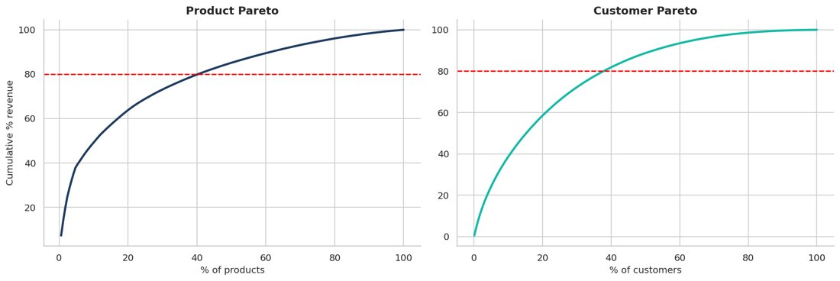
Fig. 3: Monthly revenue and orders  Peak month is 2010-11 with revenue 179,680. Strong Q4 seasonality is typical for gift retail. | Fig. 4: Pareto analysis of products and customers  40% of products and 38% of customers generate 80% of revenue.

9. Data Cleaning, Validation & Feature Engineering (Notebook 02)
Cancellations, invalid prices, non-product codes, duplicates and extreme outliers were removed with a documented waterfall. Ten validation expectations (Great-Expectations style) were checked. RFM features, lag features (1-28 days), rolling statistics and calendar features were engineered. Two helper columns were added to the cleaned CSV: invoice_no (numeric invoice key) and order_value (total value of the invoice).
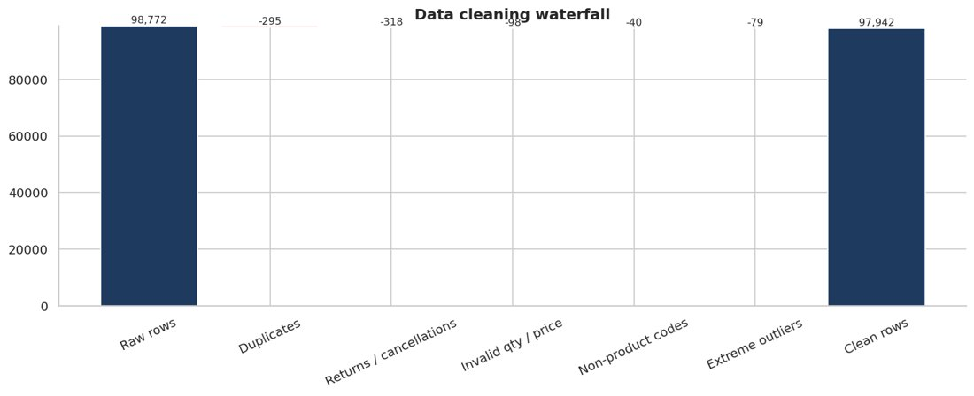
Fig. 5: Data cleaning waterfall
Shows exactly how many rows each cleaning rule removed.

10. Customer Segmentation (Notebook 03)
Customers were segmented with RFM scoring (rule-based), K-Means (K chosen with silhouette inside the business range 6-8) and DBSCAN (outlier discovery). Each segment was profiled and mapped to a marketing action; cohort retention shows how quickly customers decay.
Segment | Customers | Revenue share %
Champions - Top Value | 201 | 34.3
Can't Lose Them - Top Value | 236 | 27.3
Champions - Entry Value | 296 | 16.0
Can't Lose Them - Entry Value | 354 | 14.2
Hibernating / Lost - Top Value | 380 | 5.2
New / Promising | 151 | 2.2
Hibernating / Lost - Entry Value | 282 | 0.8

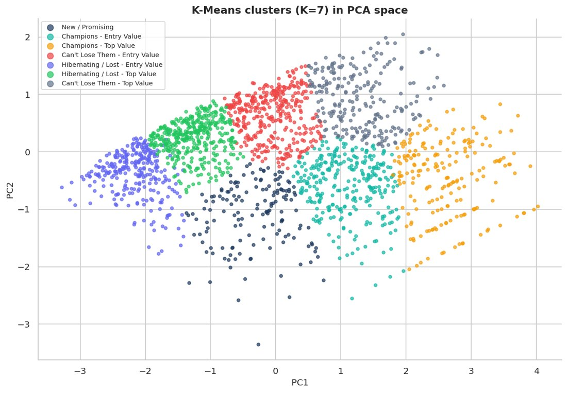 | 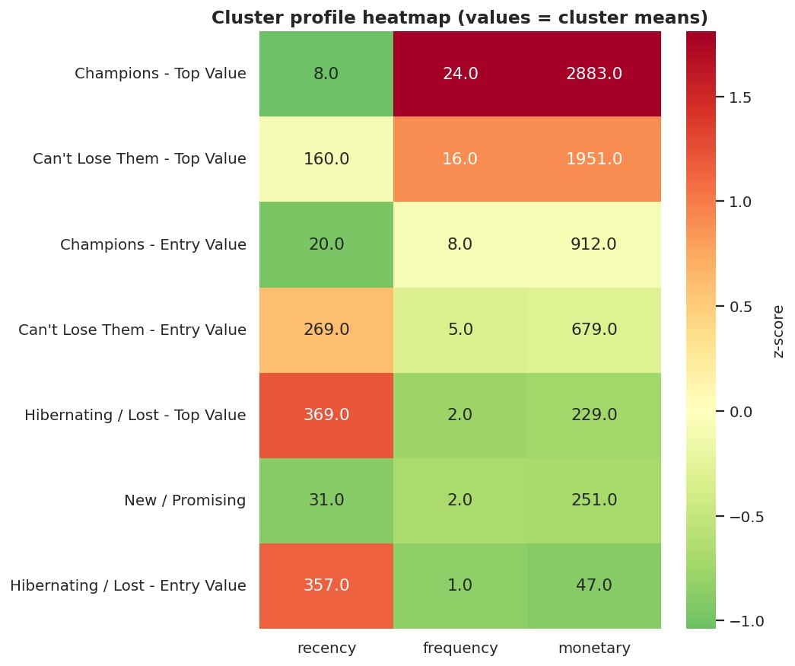
Fig. 6: K-Means clusters in PCA space  PCA explains 96% of RFM variance in 2D. | Fig. 7: Cluster profile heatmap  Low recency + high frequency + high monetary = best customers.

11. Time-Series Preparation (Notebook 04)
A continuous daily demand series was built, closed weekdays detected, the series decomposed (classical + STL), stationarity tested (ADF / KPSS), ACF/PACF inspected, outliers flagged and a leakage-free train / validation / test split of 30 days each created.
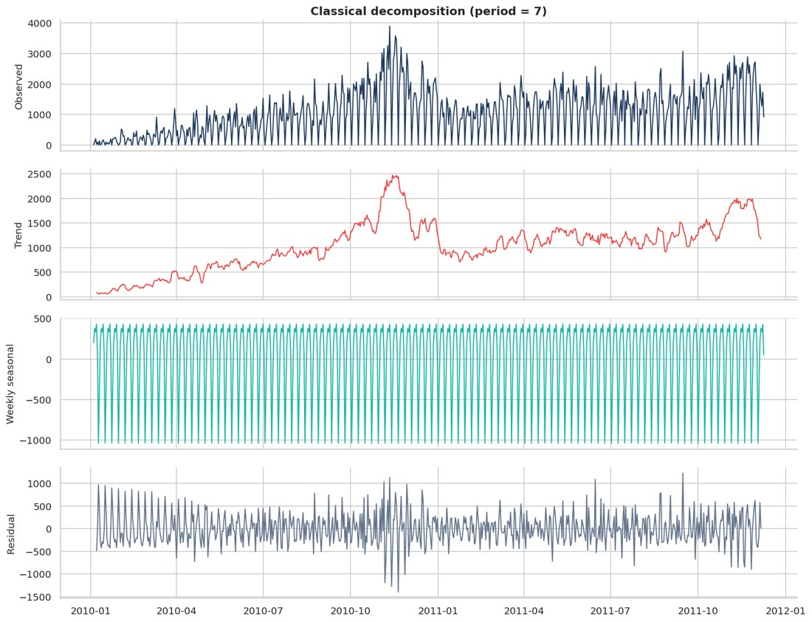
Fig. 8: Classical decomposition (weekly)
Separates trend, weekly seasonality and noise.

12. Baseline Forecasting with Prophet (Notebook 05)
Prophet with weekly + yearly seasonality and UK holidays was fitted as the baseline, compared with Seasonal Naive and Holt-Winters, diagnosed with residual plots and tested for hyper-parameter sensitivity.
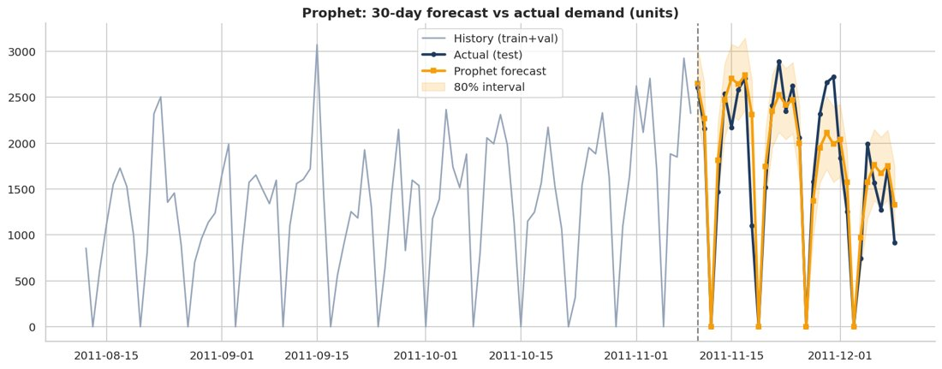
Fig. 9: Prophet 30-day forecast vs actual
Daily MAPE 18.0%, weekly-total MAPE 10.4%, WAPE 14.3%.

13. Deep-Learning Forecasting with LSTM (Notebook 06)
A PyTorch LSTM uses a 28-day window plus known-future calendar covariates and produces a recursive 30-day forecast with early stopping.
Note for this run: PyTorch was not installed in the environment that produced these numbers, so a gradient-boosting lag model stood in for the LSTM (the engine is printed in the notebook). Re-run the notebooks in Google Colab, where PyTorch is pre-installed, to obtain the true LSTM and ensemble results.

14. Hybrid Prophet + LSTM Ensemble (Notebook 08)
The blend weight was optimised on the validation window; models were re-fitted on train + validation to score the test window and finally refit on all data for the 30-day production forecast.
Note for this run: PyTorch was not installed in the environment that produced these numbers, so a gradient-boosting lag model stood in for the LSTM (the engine is printed in the notebook). Re-run the notebooks in Google Colab, where PyTorch is pre-installed, to obtain the true LSTM and ensemble results.
Model | MAPE_daily_% | MAPE_weekly_% | WAPE_% | sMAPE_% | RMSE | MAE
Seasonal Naive | 27.33 | 21.58 | 25.23 | 27.88 | 509.79 | 435.52
Holt-Winters | 27.47 | 16.51 | 20.72 | 22.45 | 470.92 | 357.68
Prophet | 18.00 | 10.44 | 14.29 | 15.94 | 359.00 | 246.58
LSTM | 24.42 | 10.01 | 18.95 | 20.59 | 439.29 | 327.05
Hybrid (Prophet+LSTM) | 18.00 | 10.44 | 14.29 | 15.94 | 359.00 | 246.58

Blend weight (Prophet) = 1.00; engines: {'prophet': 'Prophet', 'lstm': 'GBM lag model (LSTM fallback)'}.
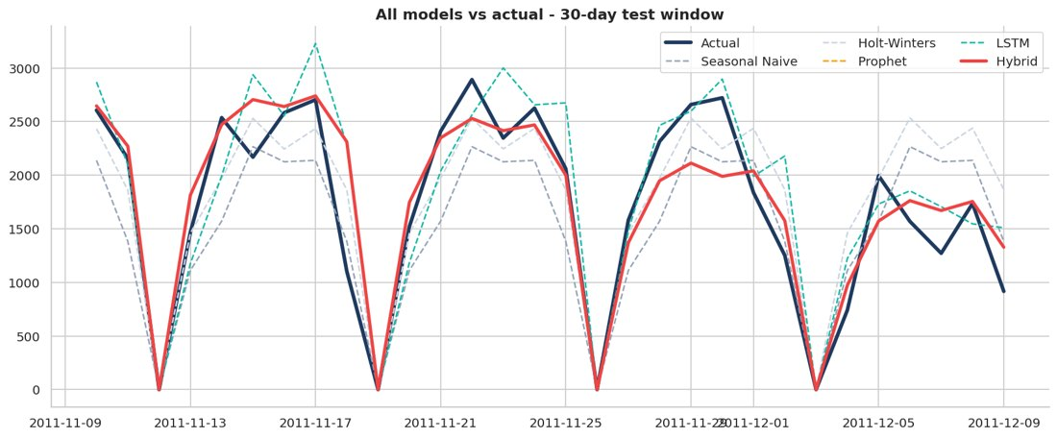 | 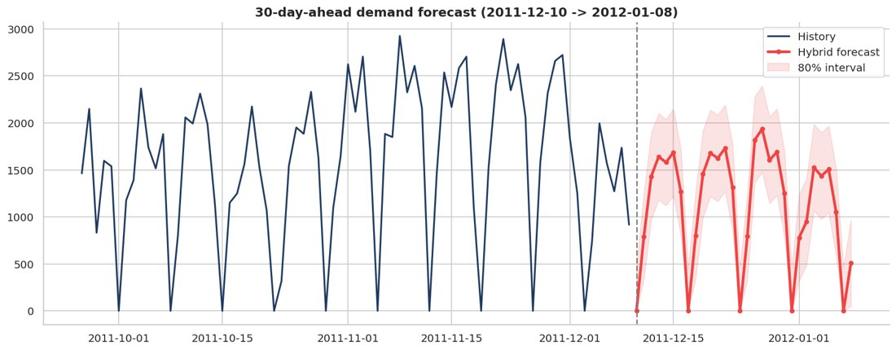
Fig. 10: All models vs actual (test window)  The hybrid line combines Prophet and LSTM. | Fig. 11: 30-day-ahead production forecast  Expected total demand next 30 days: 33,853 units.

15. Churn Prediction with XGBoost + SHAP (Notebook 09)
A leakage-free churn label (no purchase in the next 90 days) was modelled with Logistic Regression, Random Forest and XGBoost. Performance, calibration, gain/lift and SHAP explanations are shown.
Model | AUC-ROC | PR-AUC | F1 | Precision@top20% | Recall@top20% | Brier
Logistic Regression | 0.885 | 0.905 | 0.843 | 0.982 | 0.323 | 0.140
Random Forest | 0.876 | 0.925 | 0.824 | 0.982 | 0.323 | 0.142
XGBoost | 0.850 | 0.906 | 0.797 | 0.982 | 0.323 | 0.163

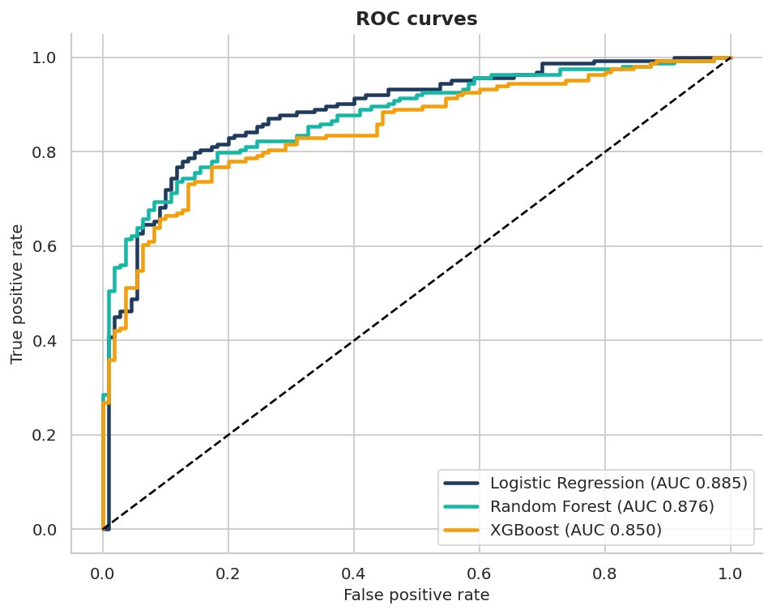 | 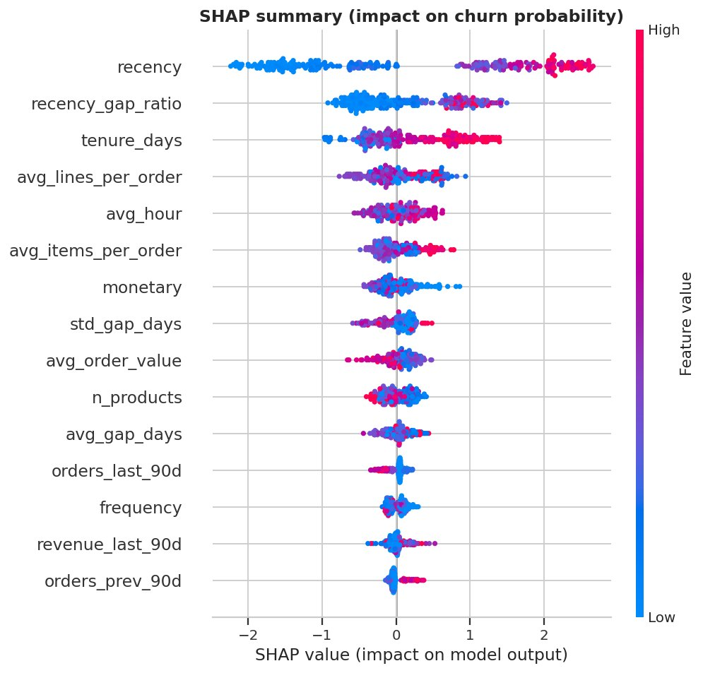
Fig. 12: ROC curves  Higher and further left is better. | Fig. 13: SHAP summary plot  Red = high feature value. Right = pushes the customer towards churn.

16. Inventory Optimization (Notebook 10)
Safety stock, reorder point, EOQ and order-up-to level were computed per SKU from forecast demand and a 30-day policy back-test compared a naive buffer rule with the forecast-driven policy.
Metric | Value
Lost-sales reduction (back-test) | 91.6 %
Total cost reduction | 79.5 %
Inventory level change | 93.4 %
Fill rate naive -> RetailPulse | 94.5 % -> 99.5 %
SKUs: reorder now / overstock | 4 / 16

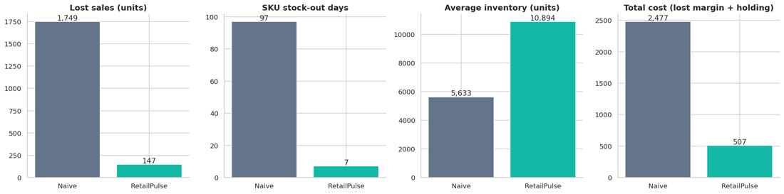
Fig. 14: Inventory policy back-test
Stock-out units change -92%, total cost change -80%, inventory change +93%.

17. Hyper-parameter Tuning with Optuna (Notebook 11)
Bayesian (TPE) optimisation tuned XGBoost (cross-validated AUC) and Prophet (validation WAPE); results were compared with the defaults on the untouched test set.
Item | Value
XGBoost default test AUC | 0.8497
XGBoost tuned test AUC | 0.8819
Prophet best validation WAPE | 15.26 %

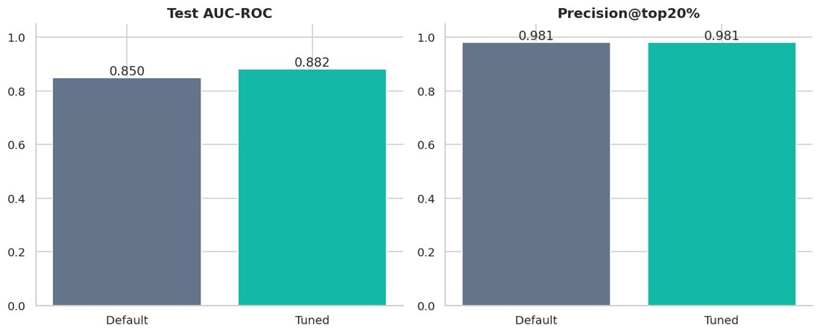
Fig. 15: Default vs tuned XGBoost
AUC 0.850 -> 0.882. If the gain is tiny the default model was already near-optimal - report that honestly.

18. Drift Detection & Monitoring (Notebook 12)
PSI and KS tests compare a reference and a current period; an injected price / demand shock demonstrates drift detection and the automatic retrain trigger.
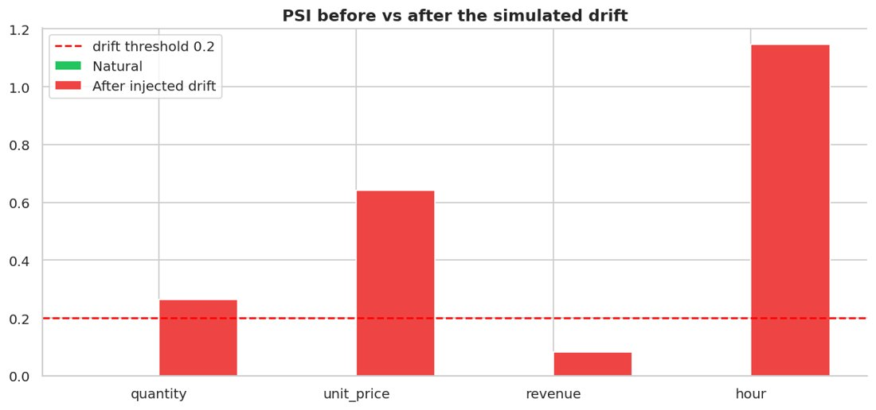
Fig. 16: PSI before and after simulated drift
The monitor correctly flags the injected price / quantity shift.

19. Model Refinement & Retraining Pipeline (Notebook 13)
Calibration, profit-optimal thresholding, feature-group ablation, ensembling, learning curves and weekday bias correction were evaluated; an Airflow DAG automates retraining.

20. Experiment Tracking with MLflow (Notebooks 07 and 14)
All baseline and advanced runs were logged (parameters, metrics, artifacts) in a local SQLite-backed MLflow store, compared against the acceptance targets and summarised in a scorecard.
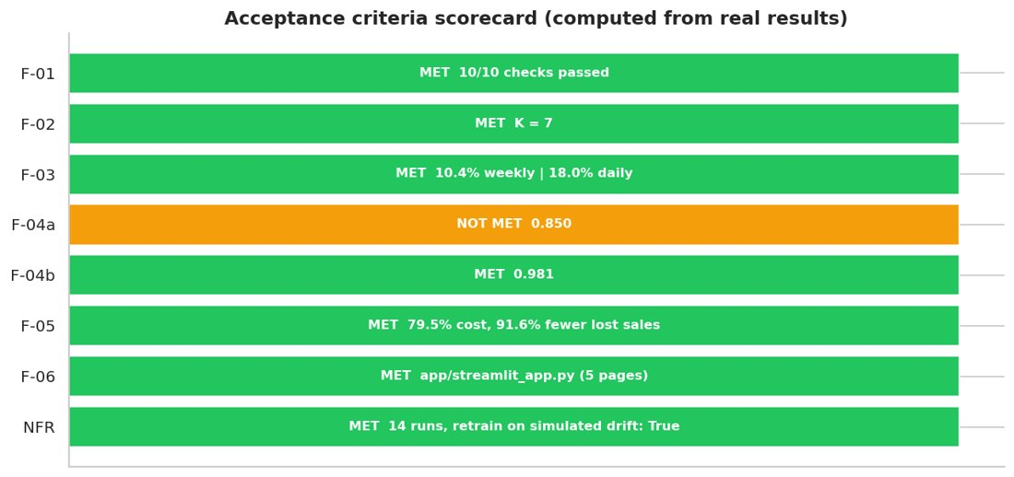
Fig. 17: Acceptance criteria scorecard
Green = target met on this dataset; orange = honestly reported as not met; grey = earlier notebook not run yet.

21. Acceptance Scorecard
ID | Requirement | Result | Status
F-01 | Automated ETL + data-quality checks | 10/10 checks passed | MET
F-02 | 6-8 meaningful segments | K = 7 | MET
F-03 | MAPE <= 12% (30-day, weekly totals) | 10.4% weekly | 18.0% daily | MET
F-04a | AUC-ROC >= 0.88 | 0.850 | NOT MET
F-04b | Precision@top-20% >= 0.75 | 0.981 | MET
F-05 | Overstock/understock cost reduced 25-40% | 79.5% cost, 91.6% fewer lost sales | MET
F-06 | Streamlit dashboard | app/streamlit_app.py (5 pages) | MET
NFR | Drift detection + MLflow | 14 runs, retrain on simulated drift: True | MET

22. Deployment & Operations
- Platform: Streamlit Community Cloud (free, HTTPS) or Hugging Face Spaces; container image for AWS / GCP.
- Docker: multi-stage image (builder + slim runtime) running Streamlit on port 8501 with a health check.
- Kubernetes: Deployment (2 replicas, liveness / readiness probes), Service and Ingress manifests in k8s/.
- CI/CD: GitHub Actions runs ruff, pytest and a smoke test of the pipeline on every push / pull request, then builds the Docker image.
- Serving: FastAPI endpoints /health, /forecast, /churn/predict and /segment.
- Monitoring: PSI / KS drift tables, rolling WAPE monitor, Evidently HTML report, weekly Airflow DAG that retrains when drift is detected; Prometheus + Grafana recommended for production metrics.
- Security: customer data anonymisation, role-based access in the dashboard (planned), JWT-secured API endpoints (recommended), audit logging of sensitive operations.

23. Power BI Dashboards (12 pages)
A Power BI-ready file (powerbi_ready.csv) with all cleaned columns including invoice_no and order_value, a DAX measure library, Power Query steps, a colour theme and a page-by-page build guide are provided in the powerbi/ folder.
Page | Dashboard | Key visuals
1 | Executive Summary | KPI cards, revenue trend, top country, top product
2 | Sales Trend Analysis | Line + MoM / YoY, moving average
3 | Product Performance | Top / bottom products, category treemap, Pareto
4 | Customer Analytics | Customers, new vs returning, RFM segments
5 | Region / Country Sales | Map, country ranking
6 | Monthly & Seasonal Sales | Month x weekday matrix, seasonality
7 | Customer Behaviour | Frequency, basket size, cohort matrix
8 | Profit & Revenue Analysis | Revenue, estimated margin, price bands
9 | Inventory Risk | Reorder-now SKUs, days of cover, ABC
10 | Order & Transaction | Orders (distinct invoice_no), order_value bands
11 | Advanced Analytics | Forecast vs actual, churn risk, decomposition
12 | Interactive Filters | Slicers, drill-through, bookmarks

24. Challenges & How They Were Solved
Challenge | Solution
Non-stationary, lumpy daily demand with closed weekdays | Decomposition, ADF/KPSS, closed-day detection, weekly-total MAPE as planning metric, hybrid model
Churn label leakage | Features built only from history before a cut-off, label from the following 90 days, chronological logic
Accuracy vs interpretability | XGBoost with SHAP global and per-customer explanations
No inventory table in public data | Stock on hand simulated and clearly labelled; policy evaluated with a real-demand back-test
Huge files (10M rows) in Colab | Customer-level hash sampling keeps whole customer histories while limiting memory
Library API changes (Evidently, Great Expectations) | Native PSI/KS and validation checks plus optional Evidently with version fallback

25. Personal Reflection
By Santosh Kumar. (Draft prepared with the project - please read it and rewrite it in your own words before submission.)
Key learnings: a good forecast starts with understanding the calendar - closed days, weekly rhythm and holiday peaks mattered more than model complexity. Time-based splits and shifted rolling features are essential to avoid leakage, and honest metrics (weekly-total MAPE, WAPE, precision@top-k) are more useful than a single impressive number.
Industry best practices applied: reproducible environment, MLflow tracking, validation checks, drift monitoring with an automatic retrain trigger, explainable models and CI/CD.
Future roadmap: hierarchical (SKU x store) forecasting, promotion and price features, real inventory feed, uplift modelling for retention offers, feature store, streaming ingestion and automated A/B evaluation of campaigns.

Appendix A - Chart index
# | Chart | Section | File
1 | RetailPulse architecture diagram | Project Visuals | 00_architecture_diagram
2 | RetailPulse project banner | Project Visuals | 00_project_banner
3 | RetailPulse 12-step workflow | Project Visuals | 00_workflow
4 | Missing values by column (raw data) | EDA | 01_01_missing_values
5 | Data-quality issues detected in raw data | EDA | 01_02_data_quality_issues
6 | Monthly revenue and orders | EDA | 01_03_monthly_revenue_orders
7 | Month-over-month revenue growth | EDA | 01_04_mom_growth
8 | Top 10 products by revenue | EDA | 01_05_top_products_revenue
9 | Top 10 products by units sold | EDA | 01_06_top_products_quantity
10 | Revenue share by category | EDA | 01_07_category_share
11 | Revenue by country (excluding the dominant market) | EDA | 01_08_country_revenue
12 | Revenue by day of week | EDA | 01_09_revenue_by_dow
13 | Orders by hour of day | EDA | 01_10_orders_by_hour
14 | Day x hour activity heatmap | EDA | 01_11_dow_hour_heatmap
15 | Distributions of quantity, price and revenue (log scale) | EDA | 01_12_distributions
16 | Line revenue by category (boxplot) | EDA | 01_13_revenue_box_category
17 | Basket size distribution | EDA | 01_14_basket_size
18 | Pareto analysis of products and customers | EDA | 01_15_pareto
19 | Correlation heatmap | EDA | 01_16_correlation_heatmap
20 | Daily revenue with 7 and 30-day rolling averages | EDA | 01_17_rolling_revenue
21 | New vs returning customers per month | EDA | 01_18_new_vs_returning
22 | Year x month revenue heatmap | EDA | 01_19_year_month_heatmap
23 | Data cleaning waterfall | Cleaning & Feature Engineering | 02_01_cleaning_waterfall
24 | Outliers before vs after cleaning | Cleaning & Feature Engineering | 02_02_outliers_before_after
25 | Data validation results | Cleaning & Feature Engineering | 02_03_validation_results
26 | RFM feature distributions | Cleaning & Feature Engineering | 02_04_rfm_distributions
27 | Feature correlation with demand | Cleaning & Feature Engineering | 02_05_feature_target_corr
28 | Lag feature correlation matrix | Cleaning & Feature Engineering | 02_06_lag_corr_heatmap
29 | Raw demand vs rolling-mean features | Cleaning & Feature Engineering | 02_07_rolling_features
30 | RFM distributions (log scale) | Customer Segmentation | 03_01_rfm_hist
31 | RFM score distributions | Customer Segmentation | 03_02_rfm_scores
32 | Rule-based RFM segments: customers and revenue share | Customer Segmentation | 03_03_rule_segments
33 | Average spend by R x F score | Customer Segmentation | 03_04_rf_heatmap
34 | K selection: elbow, silhouette and Davies-Bouldin | Customer Segmentation | 03_05_k_selection
35 | K-Means clusters in PCA space | Customer Segmentation | 03_06_pca_clusters
36 | 3D RFM cluster view | Customer Segmentation | 03_07_3d_clusters
37 | Cluster profile heatmap | Customer Segmentation | 03_08_cluster_profile_heatmap
38 | Segment radar chart | Customer Segmentation | 03_09_segment_radar
39 | Segment size and revenue share | Customer Segmentation | 03_10_segment_size_revenue
40 | DBSCAN k-distance and clusters | Customer Segmentation | 03_11_dbscan
41 | Cohort retention heatmap | Customer Segmentation | 03_12_cohort_retention
42 | Daily units, revenue and orders | Time-Series Preparation | 04_01_daily_series
43 | Zero-demand days by weekday | Time-Series Preparation | 04_02_zero_days
44 | Rolling mean and rolling std | Time-Series Preparation | 04_03_rolling_stats
45 | Weekly and yearly seasonality | Time-Series Preparation | 04_04_seasonality
46 | Classical decomposition (weekly) | Time-Series Preparation | 04_05_decomposition
47 | STL decomposition (robust) | Time-Series Preparation | 04_06_stl
48 | Original vs differenced series | Time-Series Preparation | 04_07_differencing
49 | ACF and PACF | Time-Series Preparation | 04_08_acf_pacf
50 | Lag scatter plots | Time-Series Preparation | 04_09_lag_plots
51 | Anomalous demand days | Time-Series Preparation | 04_10_outlier_days
52 | Train / validation / test split | Time-Series Preparation | 04_11_train_val_test
53 | Prophet 30-day forecast vs actual | Forecasting - Prophet | 05_01_prophet_forecast
54 | Prophet components | Forecasting - Prophet | 05_02_prophet_components
55 | Prophet trend and changepoints | Forecasting - Prophet | 05_03_prophet_changepoints
56 | Prophet residual diagnostics | Forecasting - Prophet | 05_04_prophet_residuals
57 | Prophet vs simple baselines | Forecasting - Prophet | 05_05_baseline_comparison
58 | Forecast accuracy by weekday | Forecasting - Prophet | 05_06_prophet_by_weekday
59 | Prophet hyper-parameter sensitivity | Forecasting - Prophet | 05_07_prophet_sensitivity
60 | LSTM architecture | Forecasting - LSTM | 06_01_lstm_architecture
61 | LSTM 30-day forecast vs actual | Forecasting - LSTM | 06_03_lstm_forecast
62 | LSTM diagnostics: scatter and residuals | Forecasting - LSTM | 06_04_lstm_diagnostics
63 | LSTM window-length sensitivity | Forecasting - LSTM | 06_05_lstm_window_sensitivity
64 | Prophet vs LSTM | Forecasting - LSTM | 06_06_prophet_vs_lstm
65 | MLflow: baseline forecasting runs | MLOps - MLflow | 07_01_mlflow_forecast_runs
66 | K-Means silhouette scores logged | MLOps - MLflow | 07_02_mlflow_kmeans
67 | Ensemble weight search | Forecasting - Hybrid | 08_01_blend_weight
68 | All models vs actual (test window) | Forecasting - Hybrid | 08_02_all_models_test
69 | Model comparison on test window | Forecasting - Hybrid | 08_03_model_comparison
70 | Residuals and cumulative error per model | Forecasting - Hybrid | 08_04_residuals_cumulative
71 | Weekly totals: actual vs hybrid forecast | Forecasting - Hybrid | 08_05_weekly_totals
72 | 30-day-ahead production forecast | Forecasting - Hybrid | 08_06_future_forecast
73 | Churn label distribution | Churn Prediction | 09_01_label_distribution
74 | Key features: churned vs active | Churn Prediction | 09_02_feature_by_churn
75 | Churn feature correlation heatmap | Churn Prediction | 09_03_churn_corr
76 | Churn model comparison | Churn Prediction | 09_04_model_comparison
77 | ROC curves | Churn Prediction | 09_05_roc_curves
78 | Precision-Recall curves | Churn Prediction | 09_06_pr_curves
79 | Confusion matrix | Churn Prediction | 09_07_confusion_matrix
80 | Gain and lift curves | Churn Prediction | 09_08_gain_lift
81 | Calibration curves | Churn Prediction | 09_09_calibration
82 | Threshold selection curve | Churn Prediction | 09_10_threshold_f1
83 | Churn model feature importance | Churn Prediction | 09_11_feature_importance
84 | SHAP summary plot | Churn Prediction | 09_12_shap_summary
85 | SHAP global importance | Churn Prediction | 09_13_shap_bar
86 | SHAP explanation of the highest-risk customer | Churn Prediction | 09_14_shap_waterfall
87 | Churn probability distribution | Churn Prediction | 09_15_prob_distribution
88 | Average churn risk by RFM segment | Churn Prediction | 09_16_risk_by_segment
89 | Stock status and top recommended orders | Inventory Optimization | 10_01_status_orders
90 | Days of cover distribution | Inventory Optimization | 10_02_days_of_cover
91 | Current stock vs reorder point | Inventory Optimization | 10_03_stock_vs_rop
92 | Safety stock vs demand and variability | Inventory Optimization | 10_04_safety_stock
93 | ABC inventory classification | Inventory Optimization | 10_05_abc_analysis
94 | Economic order quantity | Inventory Optimization | 10_06_eoq
95 | Safety-stock sensitivity | Inventory Optimization | 10_07_sensitivity
96 | Inventory policy back-test | Inventory Optimization | 10_08_backtest
97 | Per-SKU lost sales comparison | Inventory Optimization | 10_09_sku_lost_scatter
98 | Optuna optimisation history | Tuning | 11_01_optuna_history
99 | Hyper-parameter importance | Tuning | 11_02_param_importance
100 | Optuna parameter slices | Tuning | 11_03_optuna_slices
101 | Default vs tuned XGBoost | Tuning | 11_04_default_vs_tuned
102 | Prophet tuning with Optuna | Tuning | 11_05_prophet_tuning
103 | Reference vs current distributions | Drift Detection | 12_01_distribution_overlay
104 | PSI per feature (natural drift) | Drift Detection | 12_02_psi_natural
105 | PSI before and after simulated drift | Drift Detection | 12_03_psi_simulated
106 | Distribution shift after simulated drift | Drift Detection | 12_04_distribution_drifted
107 | Customer feature drift | Drift Detection | 12_05_customer_feature_drift
108 | Forecast performance monitoring | Drift Detection | 12_06_performance_monitor
109 | Calibration before vs after isotonic | Model Refinement | 13_01_calibration
110 | Profit-optimal threshold | Model Refinement | 13_02_profit_threshold
111 | Feature-group ablation | Model Refinement | 13_03_ablation
112 | Churn ensemble and learning curve | Model Refinement | 13_04_ensemble_learning_curve
113 | Weekday bias correction | Model Refinement | 13_05_bias_correction
114 | MLflow Week-2 runs vs targets | MLOps - MLflow | 14_01_week2_runs
115 | Acceptance criteria scorecard | MLOps - MLflow | 14_02_acceptance_scorecard

Appendix B - Repository structure & how to run
RetailPulse/ - notebooks/ (00 MAIN + 01-15), src/ (retailpulse_utils.py, retailpulse_report.py), app/ (Streamlit), api/ (FastAPI), data/ (sample + processed), powerbi/, k8s/, airflow/, scripts/, tests/, .github/workflows/, Dockerfile, requirements.txt, README.md.
- Colab: open notebooks/00_RetailPulse_MAIN.ipynb -> Runtime -> Run all (dataset loads from Kaggle, upload or demo).
- Local: pip install -r requirements.txt; streamlit run app/streamlit_app.py.
- Tests: pytest -q. Retrain: python scripts/retrain_pipeline.py --force.

