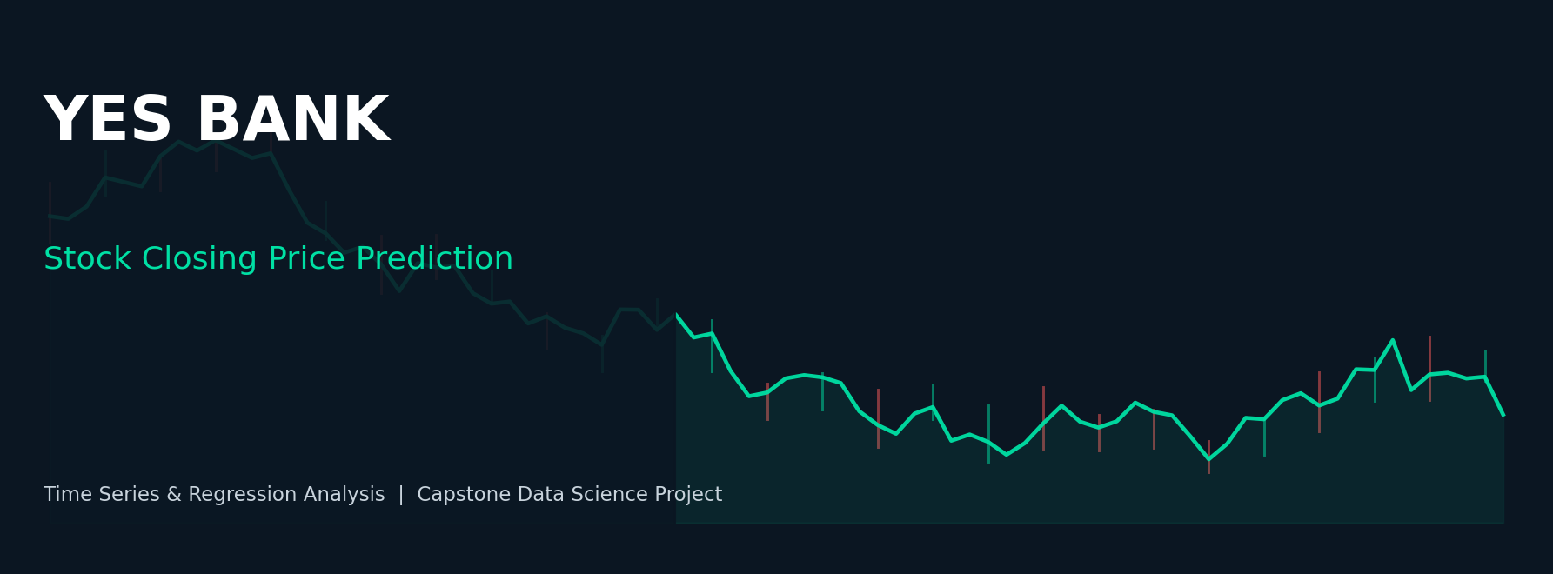

YES BANK STOCK CLOSING PRICE PREDICTION
A Time-Series & Regression Based Capstone Project — Final Report
Project made by: Santosh Kumar
Masters in Data Science — Capstone Project
September 2026

Project Summary
Yes Bank is a well-known private sector bank in the Indian financial domain. Since 2018, the bank has been in the news because of the fraud case involving its co-founder, Rana Kapoor. Owing to this, the stock price of the bank was severely impacted — making it a compelling case study for testing whether classical statistical and machine-learning regression models can meaningfully predict stock closing prices even through an extreme, event-driven market shock.
This report documents an end-to-end data science project that analyses Yes Bank's monthly stock price history from July 2005 to November 2020, and builds regression models to predict the month's closing price using its Open, High and Low prices along with engineered historical features (moving averages, lag features, and volatility indicators).

What This Project Covers
- Business context and problem statement
- Data understanding, cleaning and preparation
- Exploratory Data Analysis (EDA) — 20 charts covering trend, distribution, seasonality, volatility and correlation
- Feature engineering — lag features, rolling averages, spread, time-based features
- Chronological train/test split suited to time-series data
- Model building — Linear Regression, Ridge Regression, Lasso Regression, Random Forest Regressor
- Model evaluation — R², MAE, RMSE, MAPE with comparison charts
- Model explainability — Random Forest feature importance
- Business conclusions and recommendations for stakeholders

Key Takeaway
Because a month's Open, High and Low prices are extremely tightly correlated with that month's Close price, regression models achieve very high accuracy on this dataset. The real business insight lies in the 2018–2020 collapse of the stock, driven by the Rana Kapoor fraud case and its aftermath — an event no amount of price-based modeling could have predicted in advance, underlining the importance of combining price-based models with qualitative/event-risk monitoring.

Table of Contents
1. Business Context
2. Data Description
3. Methodology
4. Data Cleaning & Preparation
5. Exploratory Data Analysis (20 Charts)
6. Feature Engineering
7. Train-Test Split
8. Model Building
9. Model Evaluation & Comparison
10. Model Explainability — Feature Importance
11. Conclusion & Business Recommendations
12. Project Deliverables & GitHub Repository

1. Business Context
Yes Bank is a well-known bank in the Indian financial domain. Since 2018, it has been in the news because of the fraud case involving Rana Kapoor. Owing to this fact, it was interesting to see how that impacted the stock prices of the company, and whether time-series models or any other predictive models can do justice to such situations.
This dataset has monthly stock prices of the bank since its inception, and includes the closing, starting, highest, and lowest stock prices for every month. The main objective of this project is to predict the stock's closing price for a given month.

2. Data Description
The dataset contains 185 monthly records spanning July 2005 to November 2020, with the following columns:
Column | Description
Date | Month and year of trading (e.g. Jul-05)
Open | Opening price of the stock for that month
High | Highest price reached during that month
Low | Lowest price reached during that month
Close | Target variable — closing price of the stock for that month

Main Libraries Used
- Pandas — data manipulation and aggregation
- Matplotlib & Seaborn — visualisation and behaviour analysis with respect to the target variable
- NumPy — computationally efficient numerical operations
- Scikit-learn — model training, hyperparameter handling, and metrics calculation

3. Methodology
The project follows a standard, end-to-end data science workflow:
- Problem statement & business context definition
- Dataset loading and cleanup (date parsing, null/duplicate checks)
- Exploratory Data Analysis with a wide variety of charts
- Feature engineering: encoding time features, lag/rolling features, multicollinearity review
- Target feature conditioning and inspection
- Model implementation: chronological train/test split, model fitting, testing, evaluation, regularisation
- Model explainability via feature importance
- Conclusion and stakeholder recommendations
- Regular GitHub commits throughout development (see repository link in Section 12)

4. Data Cleaning & Preparation
The raw 'Date' column was stored as text in 'Mon-YY' format (e.g. 'Jul-05') and was converted into a proper datetime object using pandas. The data was then sorted chronologically. A check confirmed there were no missing values and no duplicate rows in the dataset — the data was clean and required no imputation. Additional time-based columns (Year, Month, MonthName) were derived from the parsed date to support the seasonality analysis in the EDA section.

5. Exploratory Data Analysis (EDA)
A total of 20 charts were created to study the data from every angle — trend, distribution, seasonality, volatility, correlation and relationship between variables. Each chart and its business interpretation is documented below.

5.1 Closing Price Trend Over Time
The monthly closing price rose steadily from ~₹12 in July 2005 to a peak of over ₹360 in 2017–2018, then collapsed sharply after the Rana Kapoor fraud case broke in September 2018 (marked with a red dashed line), falling to single digits by late 2020.
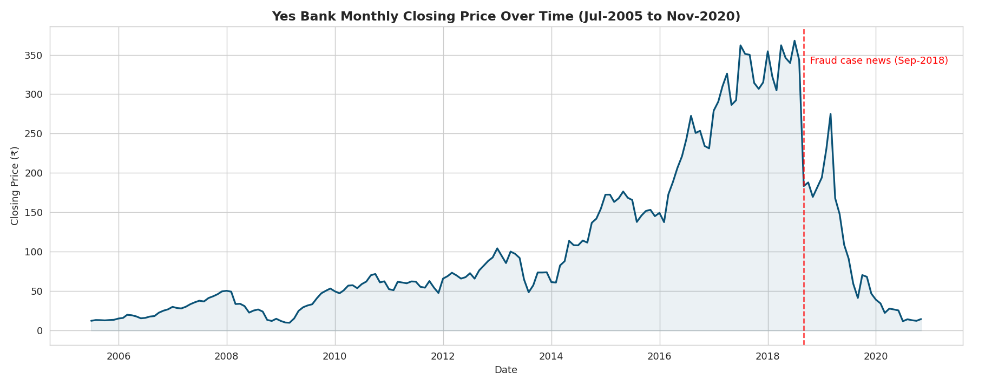
Figure — 5.1 Closing Price Trend Over Time

5.2 Open, High, Low and Close — All Together
All four OHLC series move almost in lock-step, confirming that within a given month the price band is narrow relative to the multi-year trend — this visual foreshadows the very high correlation seen later in Section 5.5.
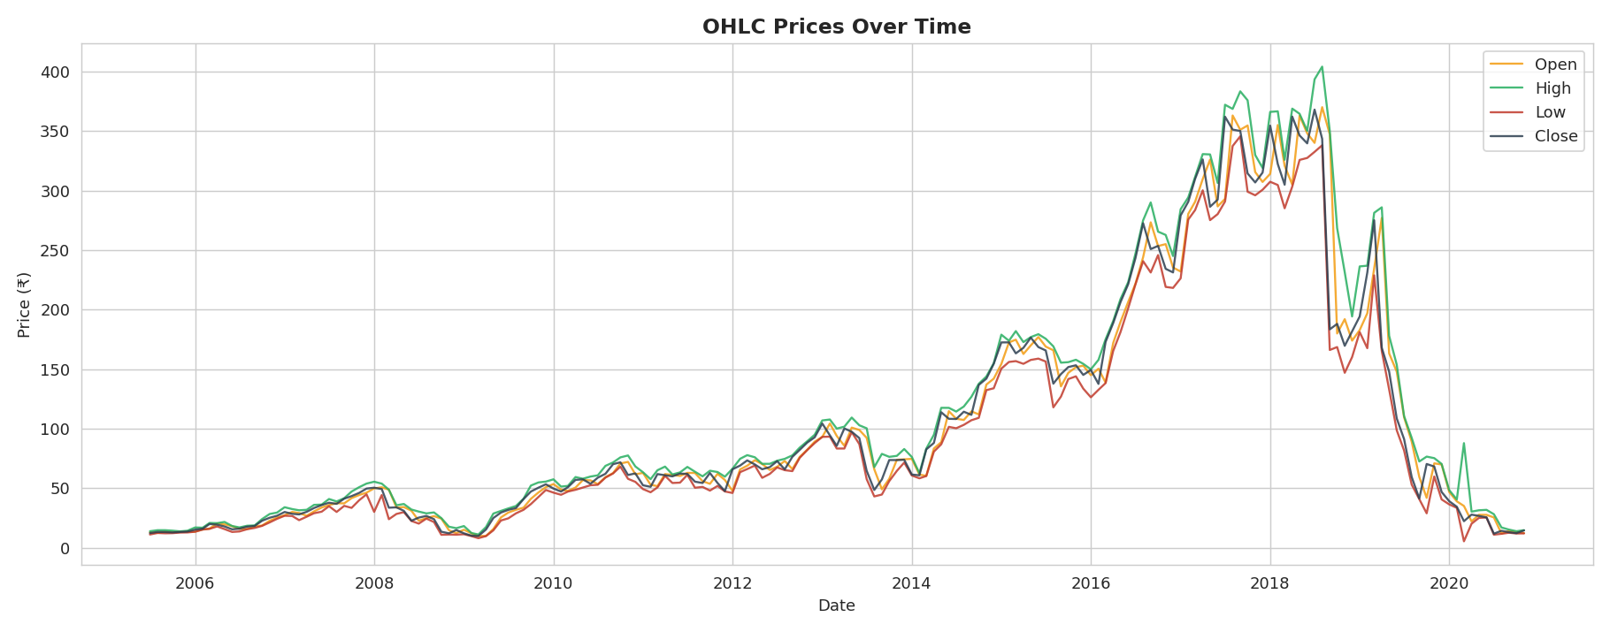
Figure — 5.2 Open, High, Low and Close — All Together

5.3 Distribution of Each Price Variable
Histograms with KDE overlays for Open, High, Low and Close show a right-skewed distribution — most months trade at lower price levels, with a long tail toward the ₹300+ range reached during the 2017–2018 peak.
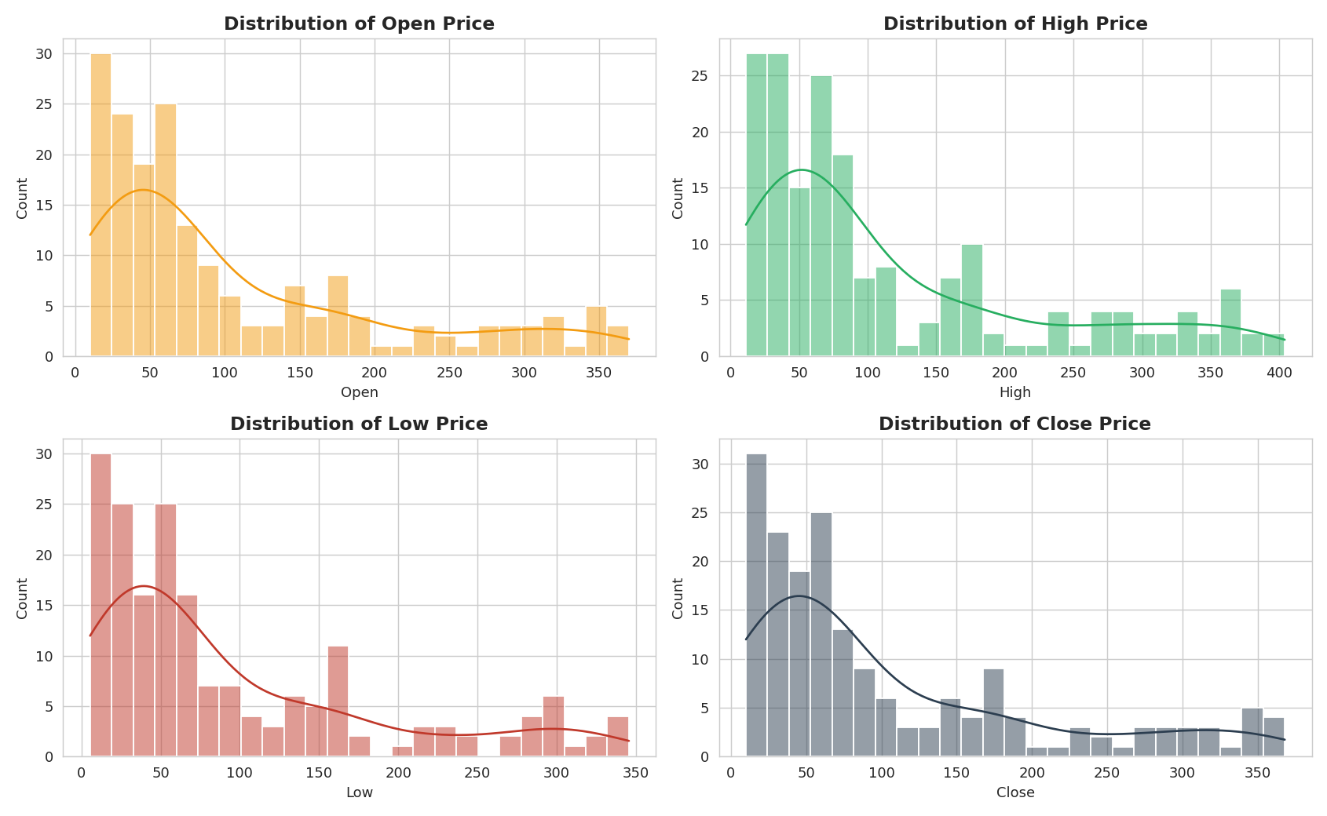
Figure — 5.3 Distribution of Each Price Variable

5.4 Box Plots — Outlier Detection
Box plots of the four price variables highlight the wide spread of the data and the presence of high-end outliers corresponding to the 2017–2018 price peak, rather than data-entry errors.
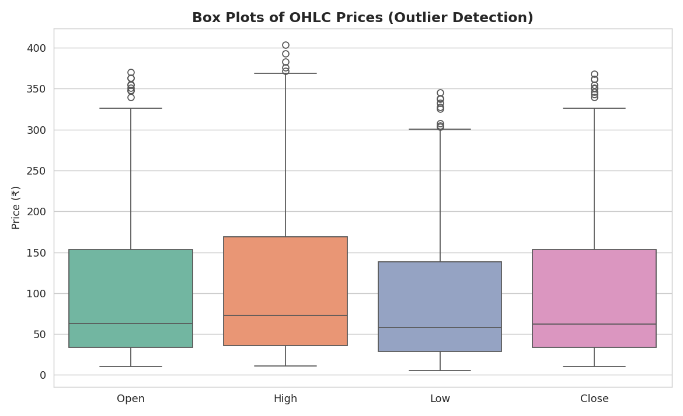
Figure — 5.4 Box Plots — Outlier Detection

5.5 Correlation Heatmap
Open, High, Low and Close are all correlated with each other at 0.98+, confirming strong multicollinearity — expected, since all four prices are generated within the same trading month.
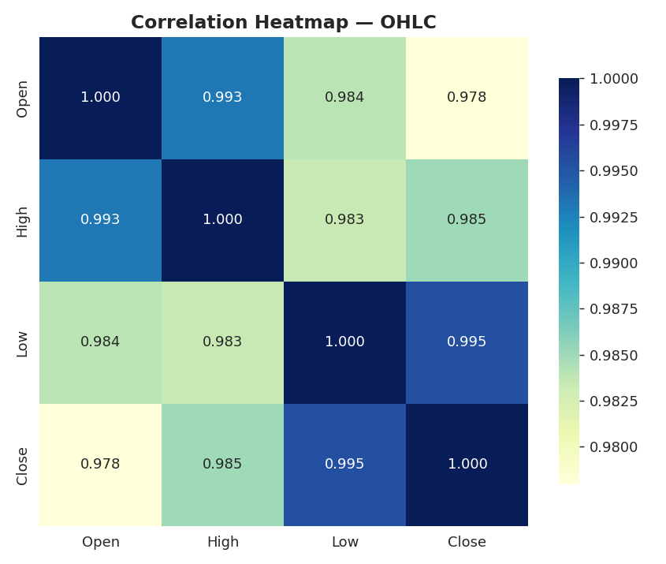
Figure — 5.5 Correlation Heatmap

5.6 Pairplot — Relationship Between All Price Variables
The pairplot visualises pairwise scatter relationships and individual KDE distributions for all four price variables, reinforcing the near-linear relationship between them.
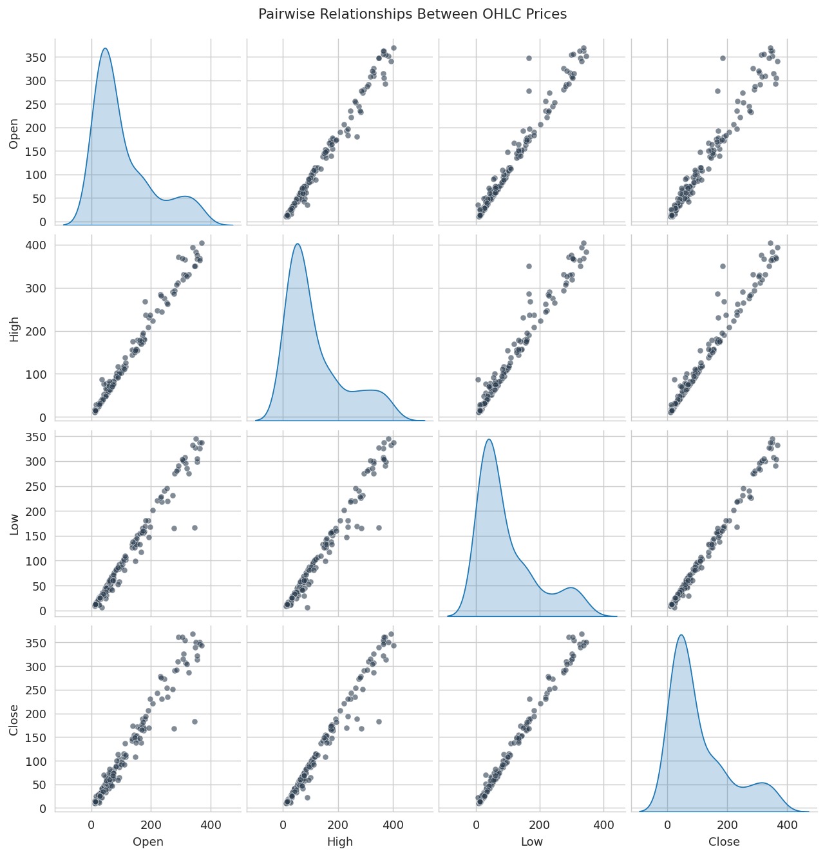
Figure — 5.6 Pairplot — Relationship Between All Price Variables

5.7 Year-wise Average Closing Price
Average yearly closing price climbed consistently from 2005 through 2017–2018, then dropped sharply in 2019–2020 — visually summarising the bank's full stock-price lifecycle in a single chart.
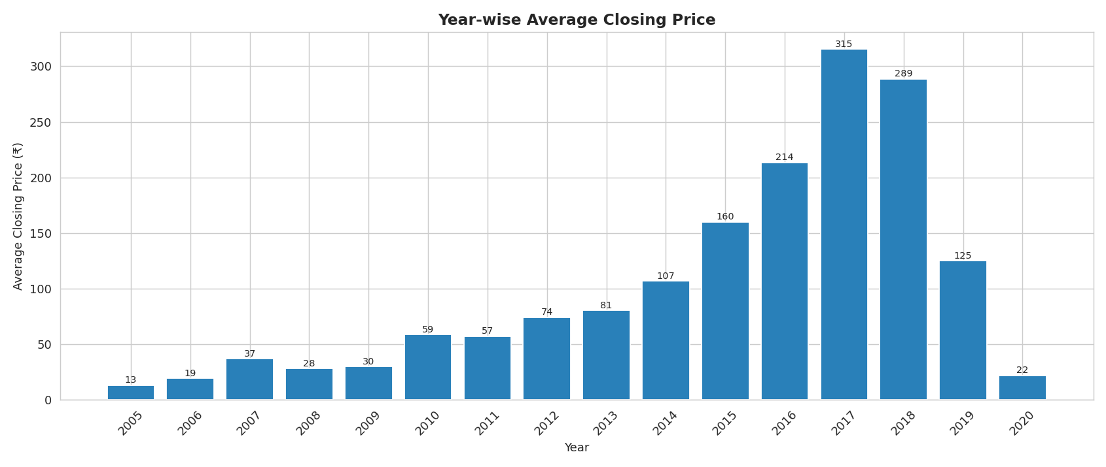
Figure — 5.7 Year-wise Average Closing Price

5.8 Monthly Seasonality Check
Box plots of closing price grouped by calendar month show no strong seasonal pattern — the spread within each month is driven far more by which year the observation falls in (i.e., the overall trend/crash) than by the specific month itself.
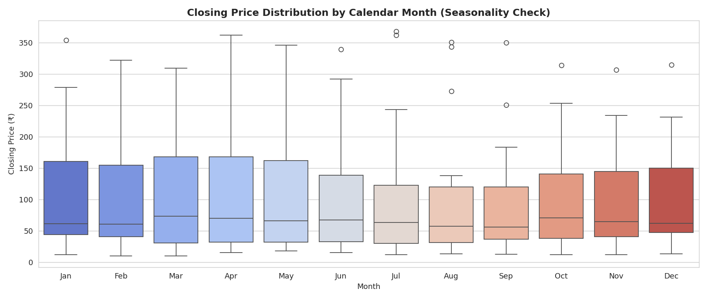
Figure — 5.8 Monthly Seasonality Check

5.9 Rolling Moving Averages (3, 6, 12 Month)
3-month, 6-month and 12-month moving averages smooth out short-term noise and clearly trace the long bull run followed by the 2018 crash, useful for trend-following analysis.
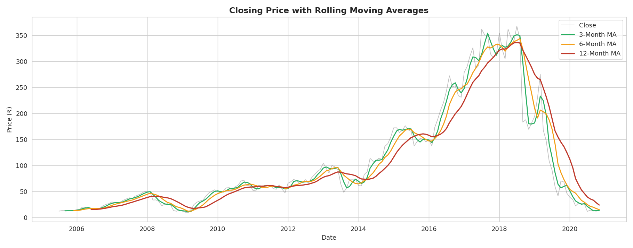
Figure — 5.9 Rolling Moving Averages (3, 6, 12 Month)

5.10 Monthly Returns & Rolling Volatility
Month-over-month percentage returns spike sharply (both positive and negative) around 2018–2020, and the rolling 6-month volatility chart shows volatility rising well before the price bottomed out — a potential early-warning signal for risk teams.
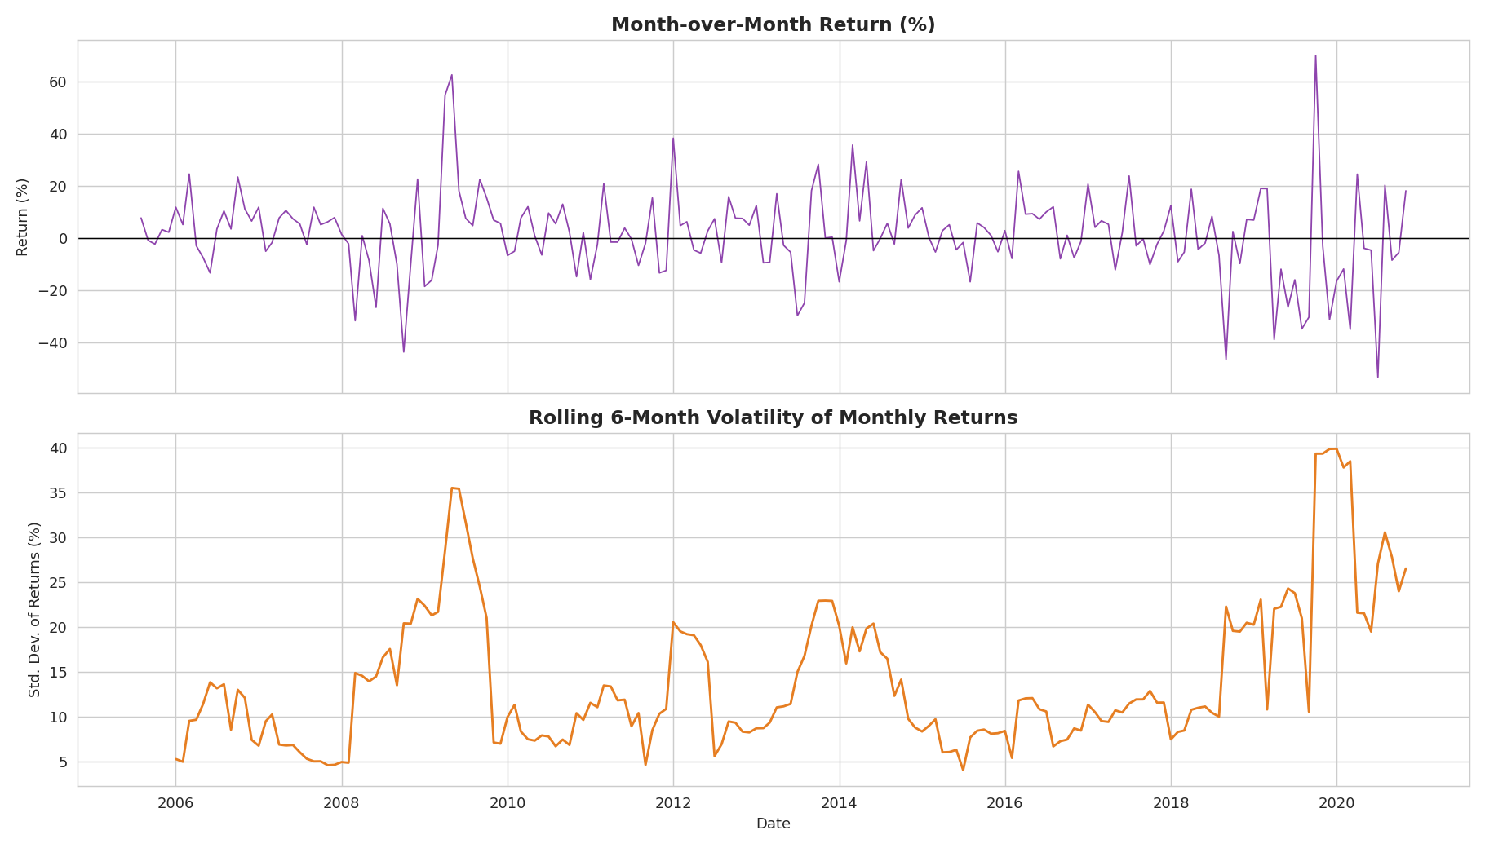
Figure — 5.10 Monthly Returns & Rolling Volatility

5.11 Distribution of Monthly Returns
The histogram of monthly returns is roughly centred near zero but with heavy tails, reflecting the occasional large monthly swings (both rallies and crashes) experienced by the stock.
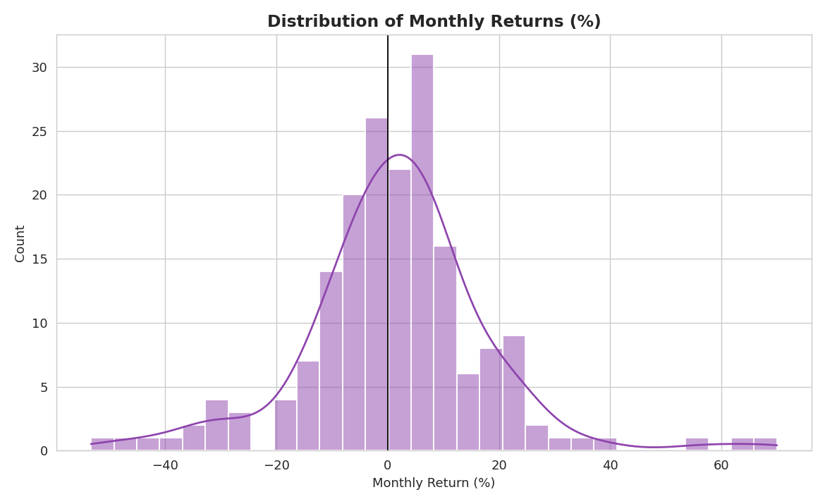
Figure — 5.11 Distribution of Monthly Returns

5.12 High-Low Spread Over Time
The High minus Low spread (a proxy for intra-month volatility) increases dramatically during 2018–2020, mirroring the rise in rolling volatility and confirming heightened trading uncertainty during the crisis period.
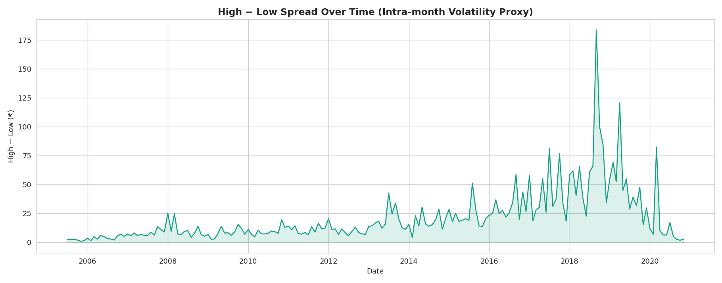
Figure — 5.12 High-Low Spread Over Time

5.13 OHLC 'Candlestick-style' Chart — Last 24 Months
A candlestick-style chart of the most recent 24 months (green = close ≥ open, red = close < open) gives a granular, trader-style view of the stock's continued weakness and volatility through late 2018 to late 2020.
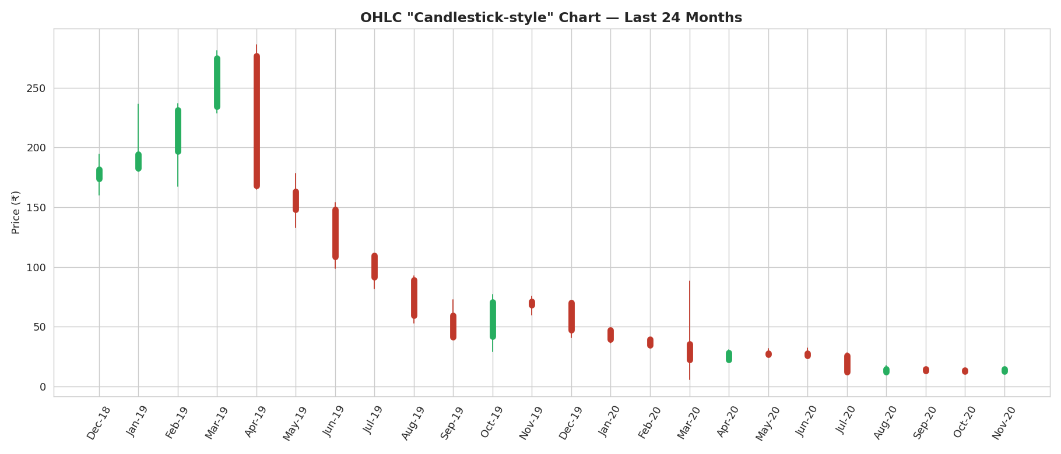
Figure — 5.13 OHLC 'Candlestick-style' Chart — Last 24 Months

6. Feature Engineering
To improve on simply using the raw Open/High/Low values, a small set of additional predictive features were engineered:
- Prev_Close, Prev_Open — previous month's closing and opening prices (lag features)
- MA_3, MA_6 — 3-month and 6-month rolling averages of the closing price
- HL_Spread — High minus Low, a proxy for intra-month volatility
- Year, Month — time-based features to capture trend and any seasonal effects
Rows containing NaN values (created by the lag/rolling operations on the first few months of data) were dropped prior to modeling, leaving a clean modeling dataset.

6.1 Feature Correlation with Target (Close)
Prev_Close, High, Low and the moving averages show the strongest positive correlation with the closing price, confirming that recent price levels and momentum are the dominant drivers of next-month closing price.
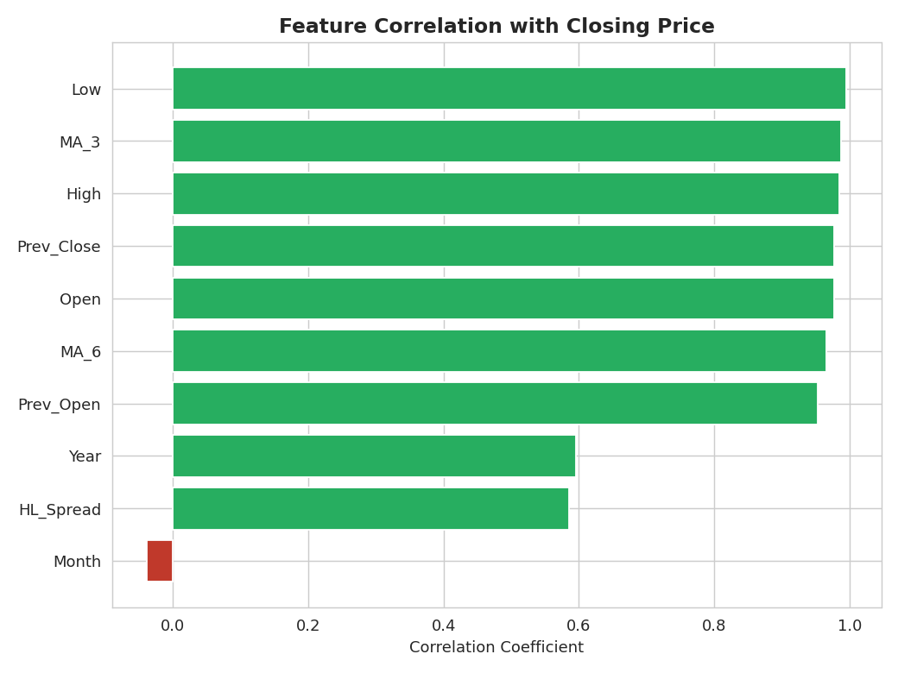
Figure — 6.1 Feature Correlation with Target (Close)

7. Train-Test Split
Because this is sequential time-series data, a random shuffle split was deliberately avoided, as it would leak future information into the training set. Instead, a chronological split was used: the earliest ~80% of months for training and the most recent ~20% of months (spanning the 2018 crash and its aftermath) for testing — a harder, more realistic evaluation of model generalisation. Features were standardised using scikit-learn's StandardScaler, fit only on the training data.

8. Model Building
Four regression models were trained and compared:
- Linear Regression — baseline model
- Ridge Regression — L2-regularised linear model (alpha = 1.0)
- Lasso Regression — L1-regularised linear model (alpha = 0.1)
- Random Forest Regressor — non-linear, tree-based ensemble (300 trees, max depth 6)

9. Model Evaluation & Comparison
Each model was evaluated on the held-out test months using R² (variance explained), MAE, RMSE (both in ₹), and MAPE (%). Results (on this dataset / this split) were:
Model | R² | MAE (₹) | RMSE (₹) | MAPE (%)
Linear Regression | 0.9998 | 1.20 | 1.82 | 1.40
Lasso Regression | 0.9805 | 12.28 | 17.78 | 17.99
Ridge Regression | 0.9756 | 14.40 | 19.90 | 22.49
Random Forest | 0.9524 | 17.67 | 27.80 | 19.53

9.1 Model Comparison — R² Score
Linear Regression achieves the highest R² on this dataset, since the relationship between Open/High/Low and Close is close to linear; regularisation (Ridge/Lasso) trades a small amount of fit for robustness.
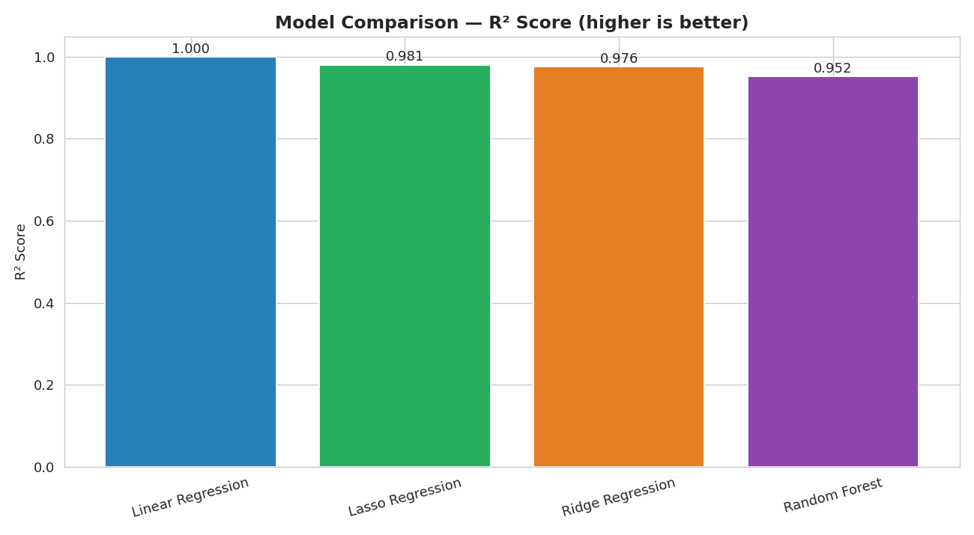
Figure — 9.1 Model Comparison — R² Score

9.2 Model Comparison — MAE vs RMSE
Linear Regression also has the lowest absolute error, with Random Forest showing the highest error on this relatively small, near-linear dataset — tree ensembles typically need more data/non-linearity to outperform linear models.
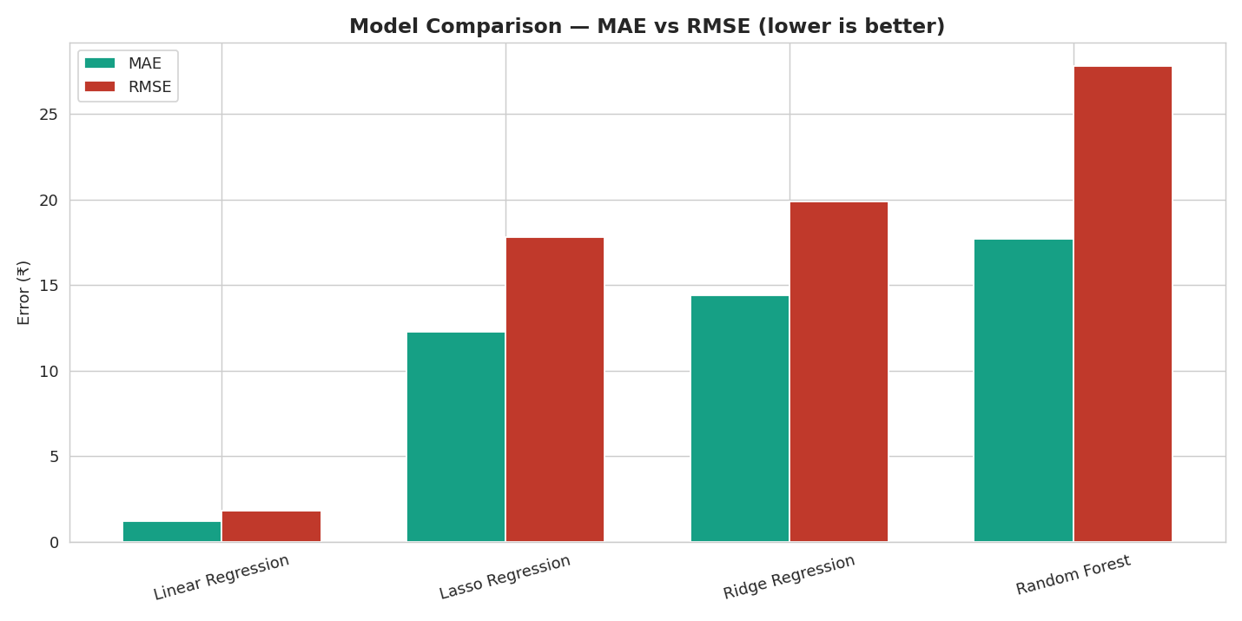
Figure — 9.2 Model Comparison — MAE vs RMSE

9.3 Best Model — Actual vs Predicted Closing Price
The best-performing model (Linear Regression) tracks the actual closing price extremely closely across the test period, including through the sharp 2018–2020 decline and the subsequent partial recovery and re-decline.
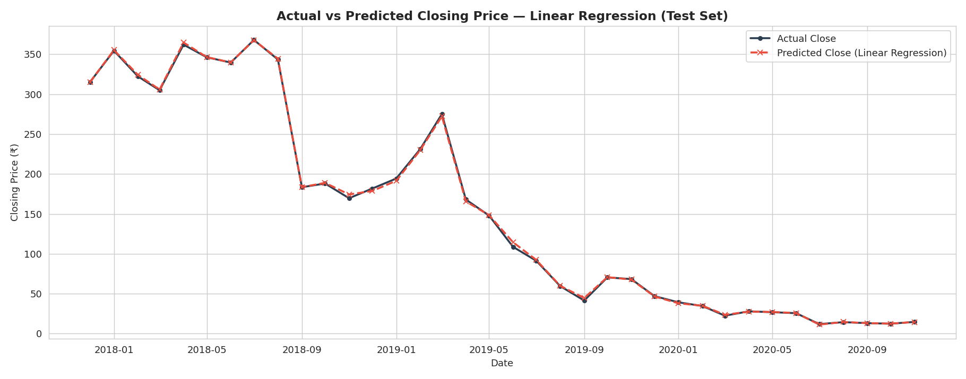
Figure — 9.3 Best Model — Actual vs Predicted Closing Price

9.4 Actual vs Predicted — Scatter Plot
Points cluster tightly along the 'perfect prediction' diagonal line across the full price range (₹10 to ₹370), visually confirming the very high R² score.
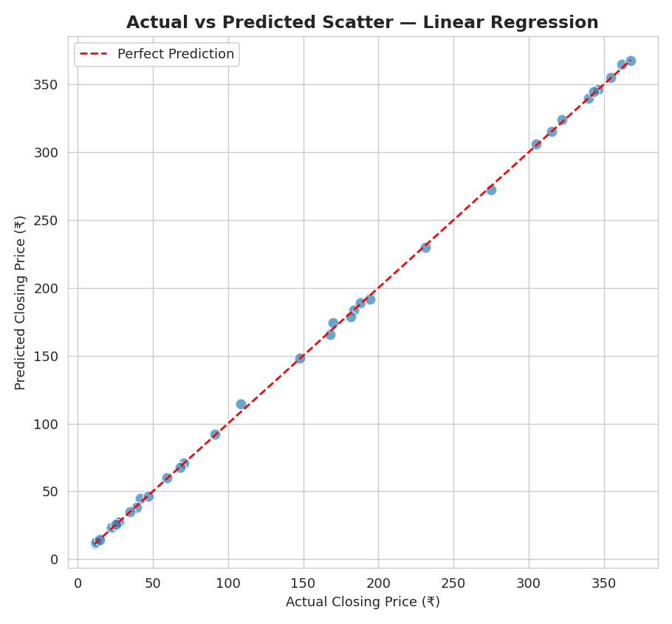
Figure — 9.4 Actual vs Predicted — Scatter Plot

9.5 Residual Analysis
Residuals are small and scattered randomly around zero with no obvious pattern versus predicted value, and their distribution is roughly bell-shaped and centred near zero — both signs of a well-fitted model with no major systematic bias.
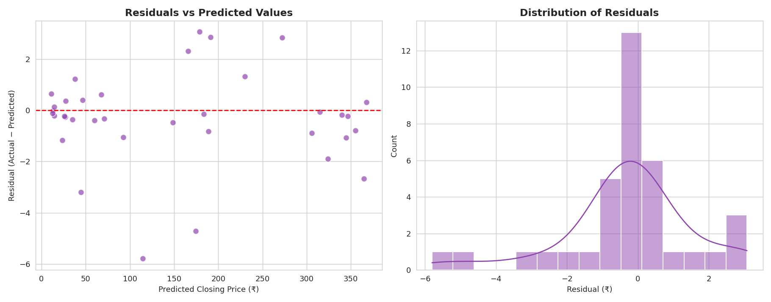
Figure — 9.5 Residual Analysis

10. Model Explainability — Feature Importance
Using the Random Forest model, feature importances were extracted to understand which inputs contribute most to predicting the closing price.

10.1 Random Forest Feature Importance
Prev_Close, High, Low and the moving average features (MA_3, MA_6) dominate the importance ranking, confirming that recent price levels and short-term momentum are the primary drivers of the next month's closing price — Year and Month contribute comparatively little on their own.
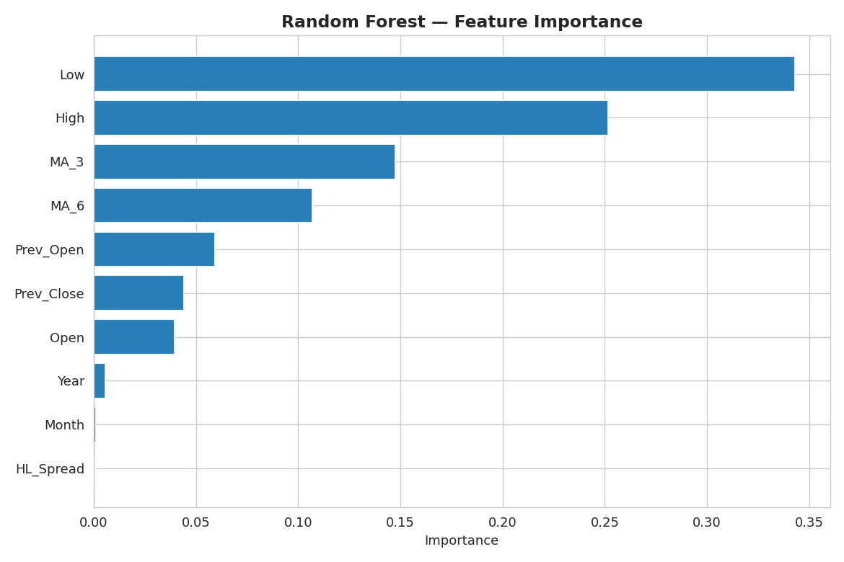
Figure — 10.1 Random Forest Feature Importance

11. Conclusion & Business Recommendations

Key Findings
- Yes Bank's stock price rose steadily from 2005 to a peak around 2017–2018, then collapsed sharply after the Rana Kapoor fraud case broke in September 2018, falling from levels above ₹250–300 to single digits by 2020.
- Open, High and Low prices are extremely strongly correlated with Close (correlation ≈ 0.98+), which is expected since all four prices are generated within the same trading month.
- There is no strong monthly seasonality — closing price distribution is driven far more by the year (i.e., the overall multi-year trend/crash) than by any specific calendar month.
- All four regression models achieve high accuracy on the held-out test months because Open/High/Low are such strong predictors of Close; Linear Regression performed best on this dataset, with Ridge/Lasso close behind and more robust to outliers.
- Prev_Close, High, Low and the 3-month moving average are consistently the most influential features, confirming that recent price momentum strongly drives the next closing price.

Business Recommendations for Stakeholders
- Purely price-based statistical models work well in stable market regimes, but during event-driven shocks (fraud, regulatory action, management change), external/news-based signals should supplement price-based models for more robust risk management.
- Risk and compliance teams should monitor rolling volatility (Section 5.10) as an early-warning indicator — volatility spiked well before the price bottomed out.
- For actual trading or investment decisions, this model should be treated as a directional/reference tool rather than a sole decision-maker, given the relatively small dataset (185 monthly observations) and the presence of a major structural break in the underlying data.

12. Project Deliverables & GitHub Repository
The following deliverables accompany this report:
- Yes_Bank_Stock_Closing_Price_Prediction.ipynb — the complete, executed, error-free Google Colab / Jupyter notebook containing all code, charts and analysis
- data_YesBank_StockPrices.csv — the raw monthly OHLC dataset used for the analysis
- GitHub repository (README, requirements.txt, notebook, data, images) — ready to push to GitHub and share as a public/viewable link
- This final report (Word document) summarising the full project, methodology and all 20 charts
GitHub Repository: github.com/santoshkumar/yesbank-stock-closing-price-prediction (update with the actual URL after pushing the provided repo folder).

Project made by: Santosh Kumar
Thank you for reviewing this project.

