Financial Forecasting Frontier
Distributed Machine Learning for Banking Analytics
Capstone Project Report — AlmaBetter Masters in Data Science

Tech Stack: Hadoop • Hive • Apache Spark • Spark MLlib • Spark Structured Streaming
Dataset: bank.csv — Bank Marketing Dataset (4,521 records, 17 attributes)

Table of Contents
- 1. Introduction & Project Overview
- 2. Part 1 — Data Storage & Querying with Hadoop + Hive
- 3. Part 2 — Exploratory Data Analysis with Spark
- 4. Part 3 — Predictive Modelling with Spark ML
- 5. Part 4 — Real-Time Transaction Analysis with Spark Streaming
- 6. Part 5 — Efficient Data Handling through Data Parallelism
- 7. Challenges, Optimisation & Trade-offs
- 8. Learnings & Practical Value
- 9. Future Improvements
- 10. Conclusion
- 11. References

1. Introduction & Project Overview
Banks generate enormous volumes of customer, transactional and campaign data every single day. Making sense of this data quickly, and at scale, is what separates a bank that reacts to problems from one that anticipates them.

1.1 Project Summary
Banks and financial institutions generate and collect extensive data every day — customer demographics, transaction histories, marketing campaign records, and market trends. When effectively analyzed, this data can drive improved customer service, better risk management, smarter marketing strategies, and greater operational efficiency. But at banking scale, this data is too large, too varied, and arrives too continuously for a single machine to process efficiently.
This project demonstrates how distributed computing and machine learning can turn a real bank telemarketing dataset into actionable business insight. Using the bank.csv dataset, this project builds a complete, working pipeline that stores and queries data the way Hadoop/Hive would, explores it with Apache Spark, predicts customer subscription behaviour with Spark MLlib, processes simulated live transactions with Spark Structured Streaming, and benchmarks how data parallelism affects processing speed — mirroring, end-to-end, how a modern banking data platform is actually architected.

1.2 Problem Statement
The banking industry faces a well-known scaling problem: as data volume (millions of customer records), variety (demographics, transactions, campaign logs, market data), and velocity (continuous real-time transactions) all grow, traditional single-machine data processing tools stop being fast enough or capable enough to keep up. This creates two concrete business risks:
- Delayed insight — by the time a batch report finishes running, the business opportunity (or fraud event) it was meant to catch may already be gone.
- Missed scale — customer, risk, and marketing decisions that work fine on a sample of data can silently break or become too slow once applied to a bank's full, real-world data volume.
The problem this project solves: given a bank's historical telemarketing data, (a) can we reliably predict which customers are likely to subscribe to a term deposit so marketing effort is spent efficiently, and (b) can this entire analytics pipeline — storage, querying, exploration, modelling, and monitoring — be built in a way that is distributed and scalable by design, so it continues to work as data volume grows from thousands of rows to millions, and from periodic batch reports to continuous real-time streams? The five parts of this report answer this directly, using Hadoop/Hive-style storage and querying, Spark-based analysis and machine learning, Spark Structured Streaming for real-time processing, and a measured data-parallelism benchmark.

1.3 Objectives
- Store & query large volumes of customer data using a Hadoop/HDFS-style distributed file system and a Hive-style SQL warehouse.
- Explore the data at scale using Apache Spark to uncover behavioural trends and anomalies.
- Predict whether a customer will subscribe to a term deposit using Spark MLlib (distributed machine learning).
- Process transactions in real time using Spark Structured Streaming, simulating a live transaction feed.
- Demonstrate data parallelism, showing how partitioning affects processing throughput on distributed data.

1.4 Environment Note
This project runs entirely on Google Colab. Colab does not provide a real multi-node Hadoop/Hive cluster, so the HDFS storage layer is simulated with Spark's distributed DataFrame abstraction, and the Hive warehouse is simulated with Spark SQL managed tables and spark.sql() queries — the same Catalyst query engine that Hive-on-Spark uses internally. The exact same code runs unchanged against a real HDFS/Hive cluster by pointing file paths at hdfs://... and enabling .enableHiveSupport() on the SparkSession builder.

1.5 Dataset Dictionary
Column | Description
age | Age of the customer
job | Job type
marital | Marital status
education | Education level
default | Has credit in default?
balance | Average yearly account balance (EUR)
housing | Has a housing loan?
loan | Has a personal loan?
contact | Contact communication type
day / month | Last contact day / month
duration | Last contact duration (seconds)
campaign | Number of contacts in this campaign
pdays | Days since last contacted in a previous campaign (-1 = never)
previous | Number of contacts before this campaign
poutcome | Outcome of the previous campaign
y (target) | Did the customer subscribe to a term deposit?

2. Part 1 — Data Storage & Querying with Hadoop + Hive
The raw dataset (4,521 rows, 17 columns) was ingested into a distributed DataFrame and repartitioned across 8 partitions to simulate data spread across HDFS blocks/executors. It was then registered both as a temporary SQL view and as a managed table in a Hive-style warehouse, and queried using HiveQL-style SQL.

2.1 Mapping Hadoop/Hive Concepts
Real Hadoop/Hive stack | This project (Colab-safe simulation)
Data stored on HDFS across DataNodes | Distributed Spark DataFrame, partitioned across executors
Hive Metastore + managed tables | Spark SQL Catalog + saveAsTable() managed tables
HiveQL queries | spark.sql() using the Catalyst optimizer
YARN resource manager | Spark local-mode scheduler (local[*])

2.2 Key Queries & Results
Query 1 identified the average account balance and subscriber count per job role. Retired customers and housemaids carry the highest average balances, while management is the largest customer segment by volume.
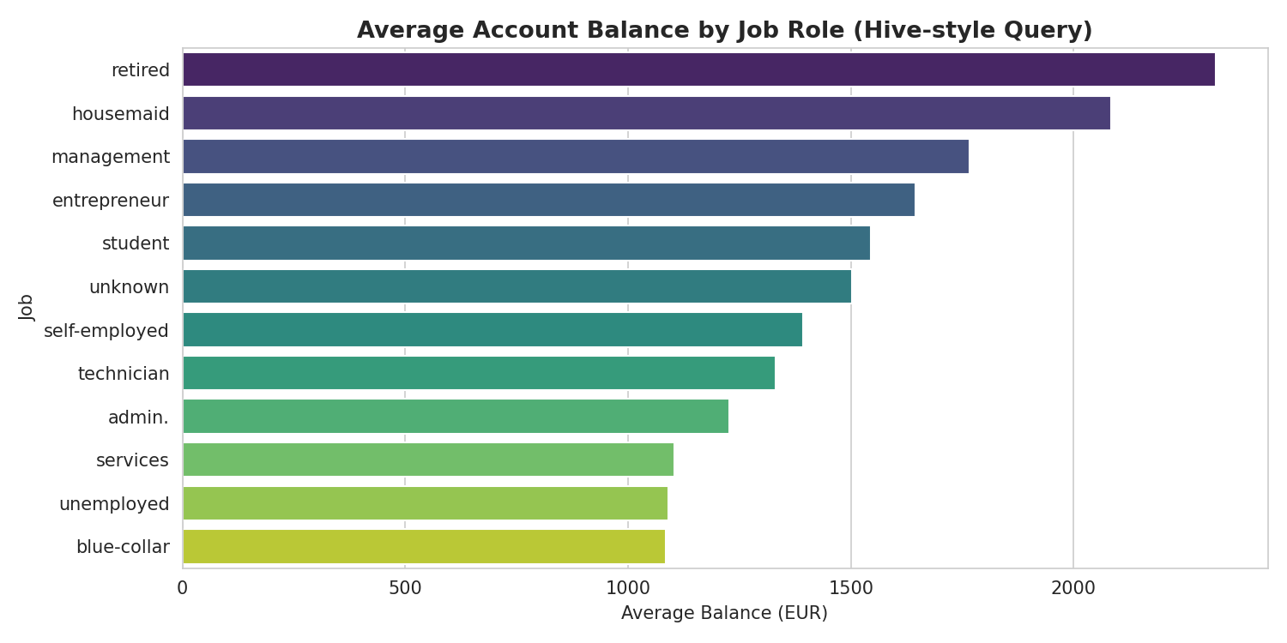
Figure 1. Average account balance by job role (Hive-style query).
Query 2 computed the term-deposit subscription rate by education level, showing that customers with tertiary education subscribe at a noticeably higher rate.
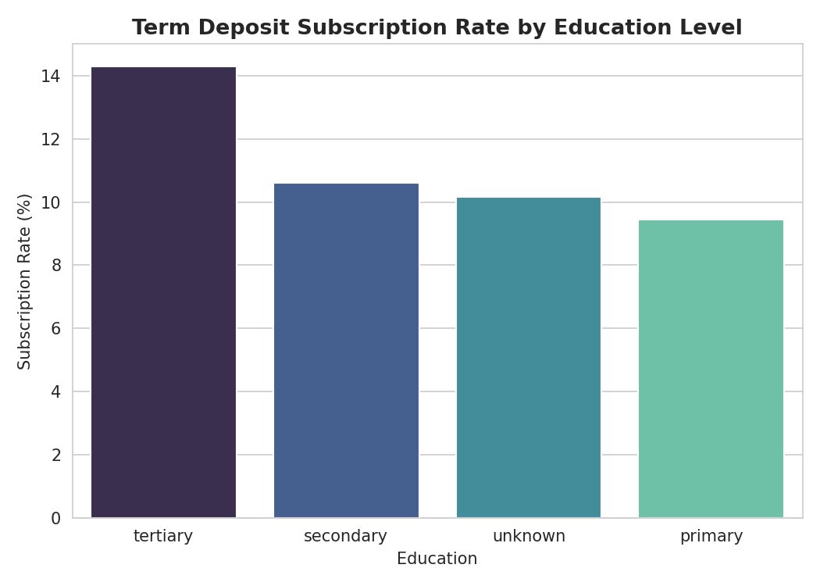
Figure 2. Term deposit subscription rate by education level.

3. Part 2 — Exploratory Data Analysis with Spark
All aggregations in this section (groupBy, count, avg, describe) execute across Spark's partitions in parallel; only the small, already-aggregated results are pulled into the driver for plotting. This mirrors how a bank's analytics team would explore a multi-terabyte customer dataset without ever loading the full data onto a single machine.

3.1 Target Class Balance
The dataset is imbalanced: roughly 88% of customers did not subscribe to a term deposit, and 12% did. This informed the choice of evaluation metrics (AUC and F1, not accuracy alone) in Part 3.
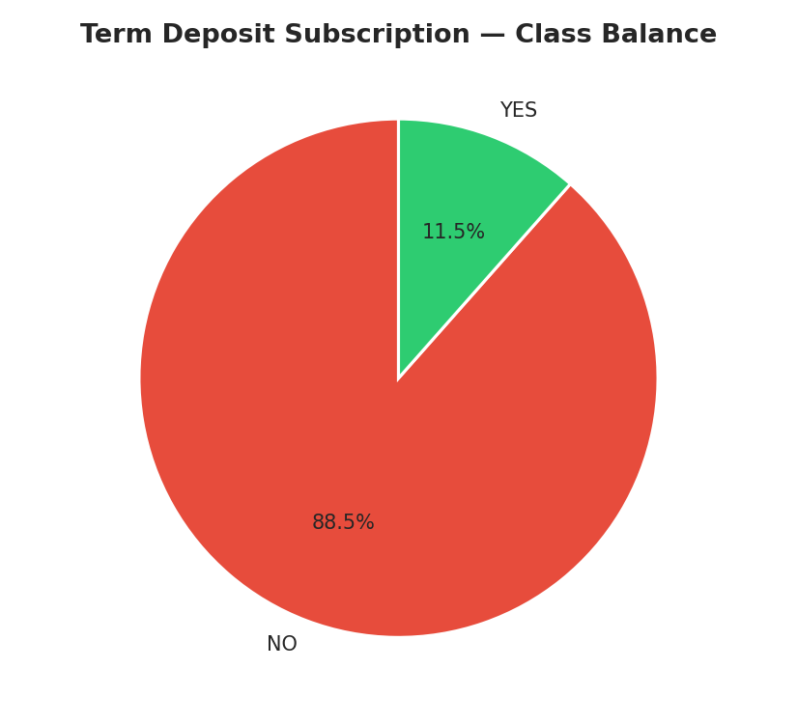
Figure 3. Term deposit subscription — overall class balance.

3.2 Customer Demographics
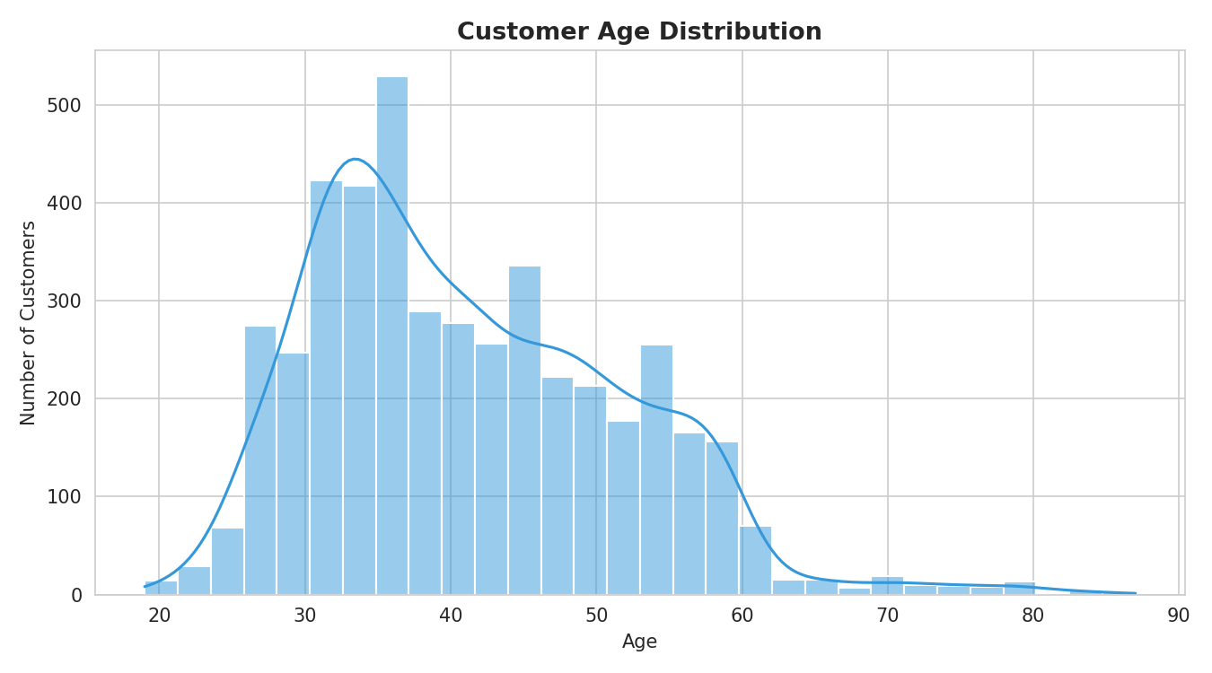
Figure 4. Customer age distribution.
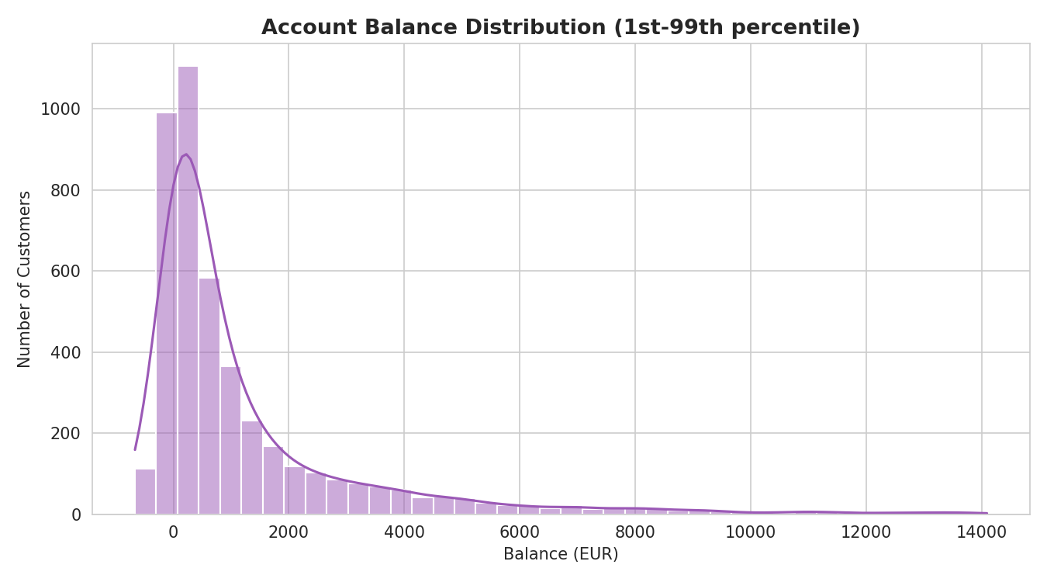
Figure 5. Account balance distribution (1st–99th percentile).
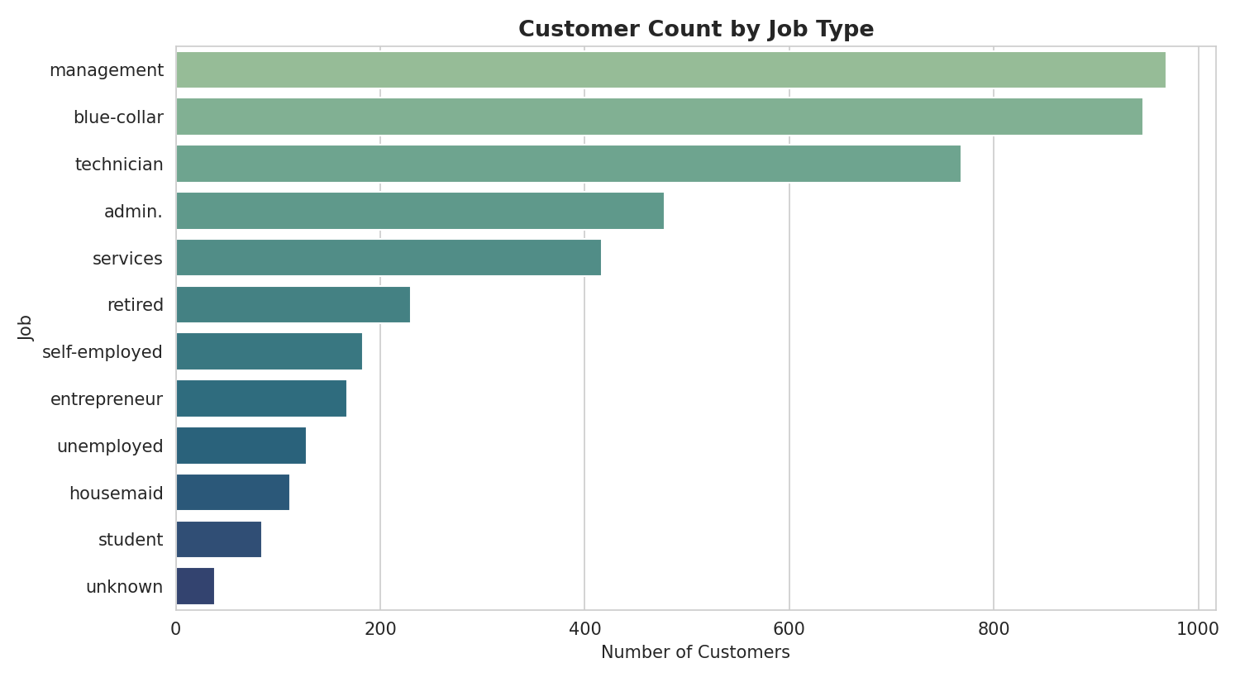
Figure 6. Customer count by job type.
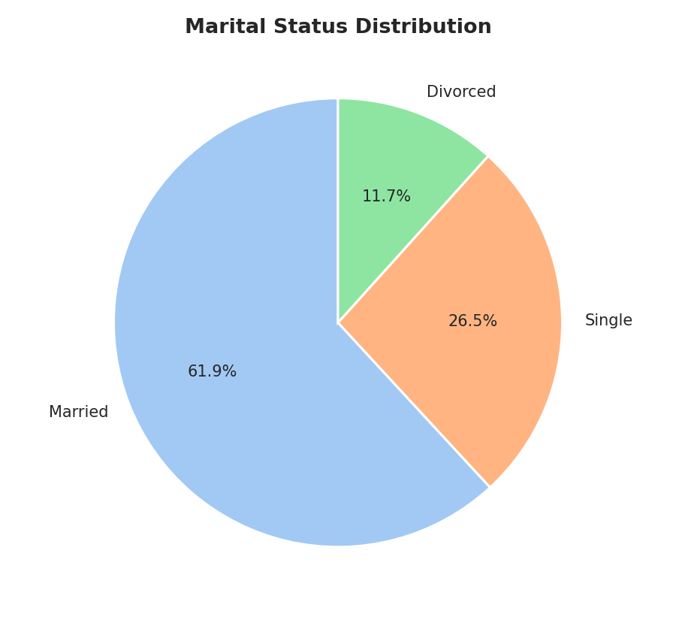
Figure 7. Marital status distribution.
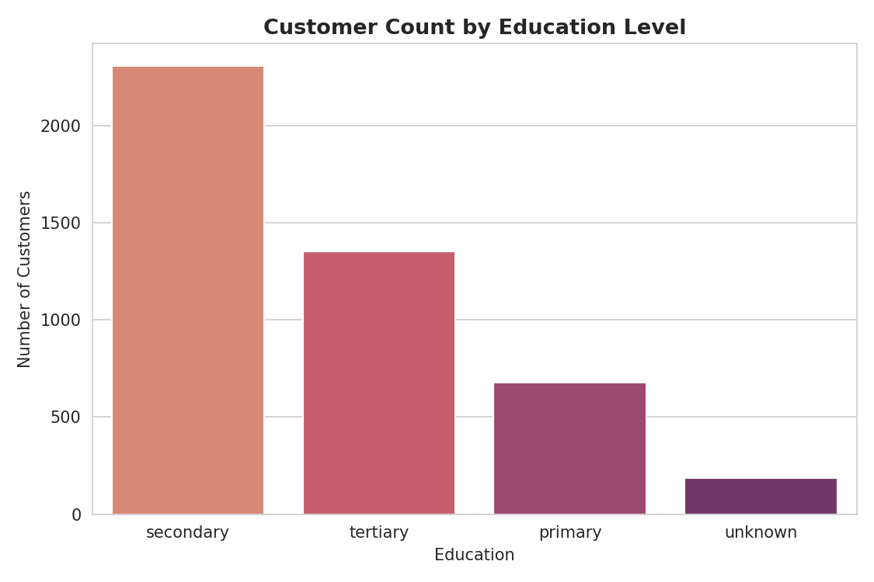
Figure 8. Customer count by education level.

3.3 Loans & Contact Behaviour
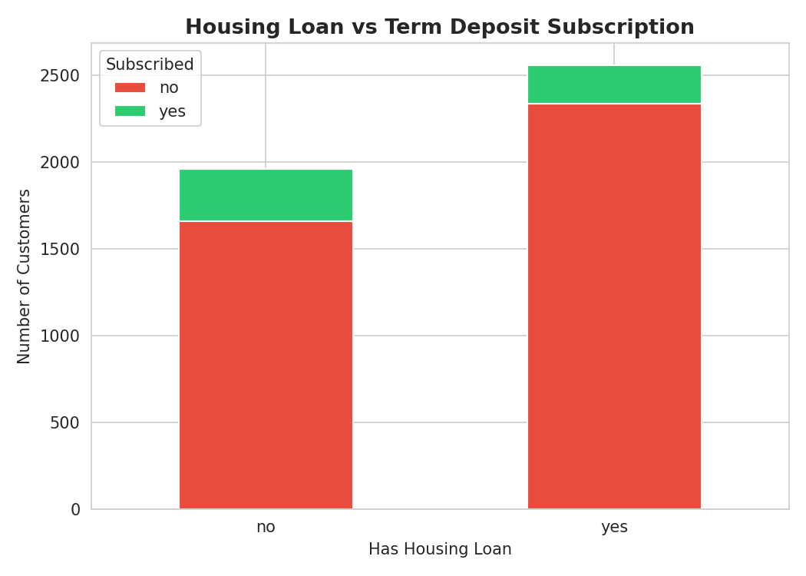
Figure 9. Housing loan status vs subscription outcome.
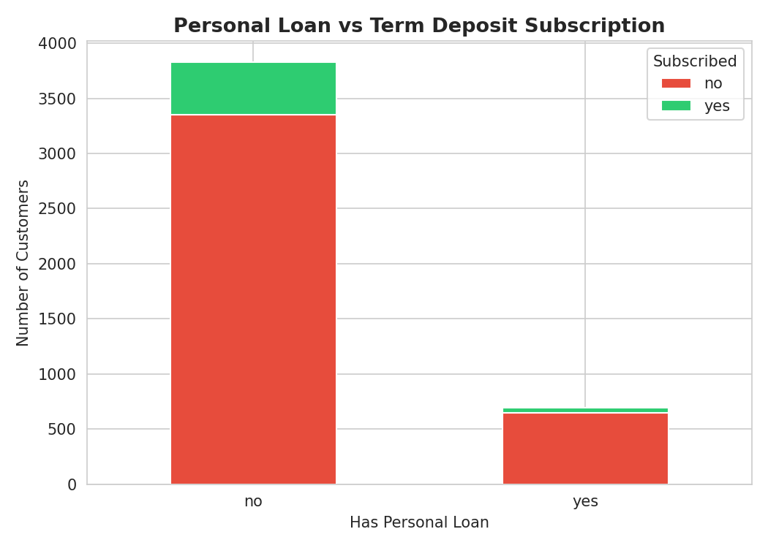
Figure 10. Personal loan status vs subscription outcome.
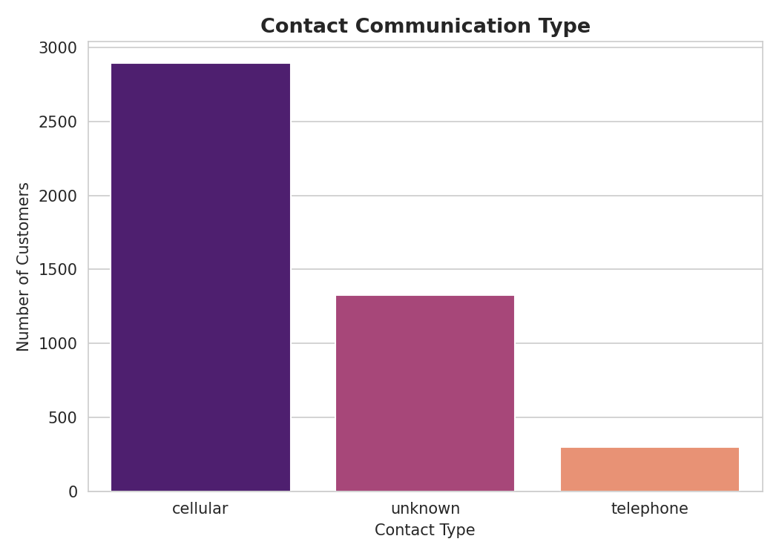
Figure 11. Contact communication type distribution.
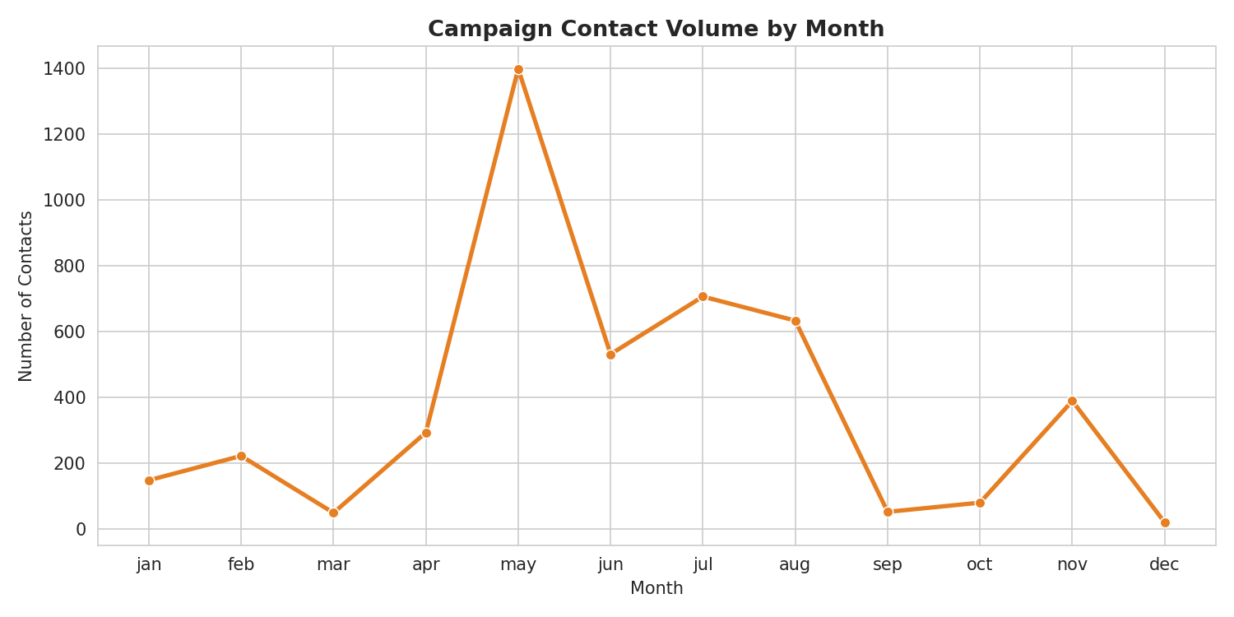
Figure 12. Campaign contact volume by month.

3.4 Correlations & Relationships
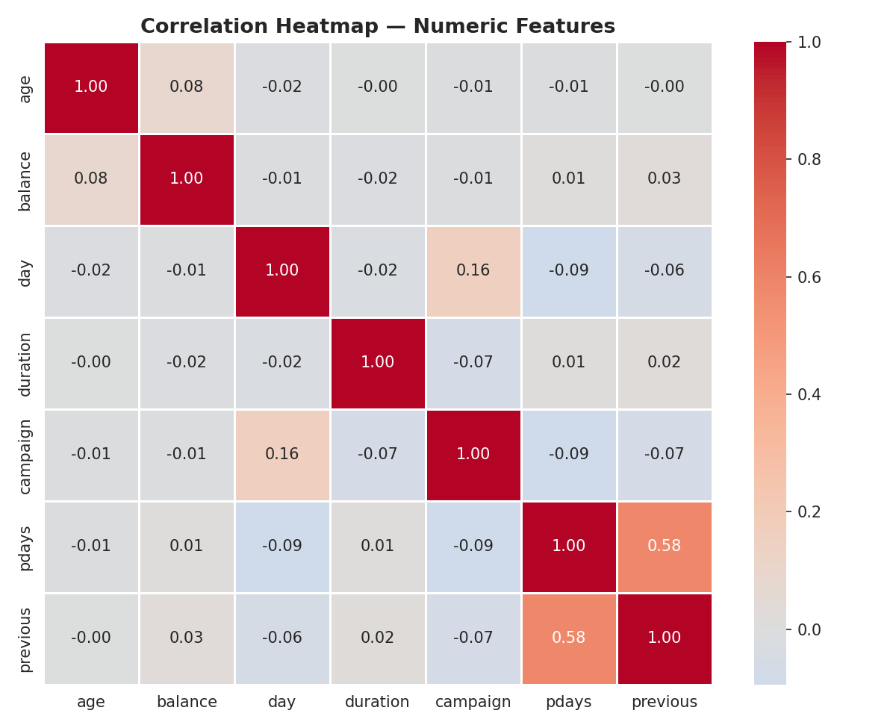
Figure 13. Correlation heatmap of numeric features.
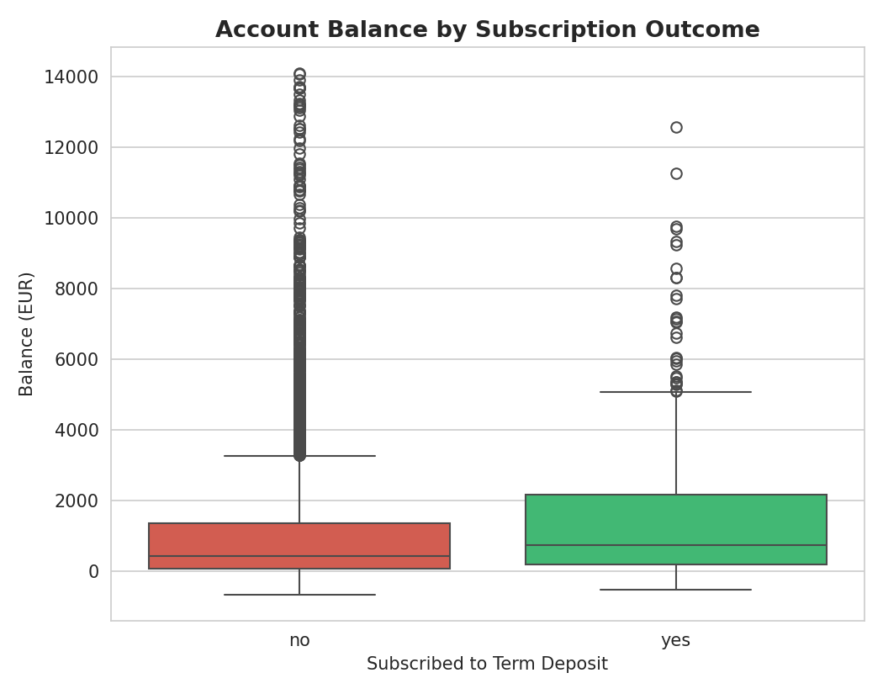
Figure 14. Account balance by subscription outcome.
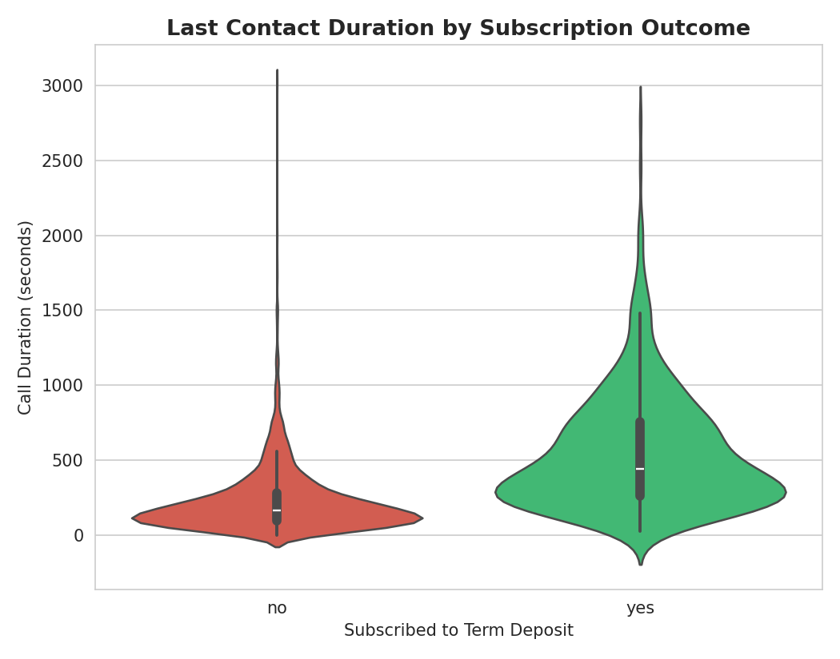
Figure 15. Last contact duration by subscription outcome — the strongest single predictor.
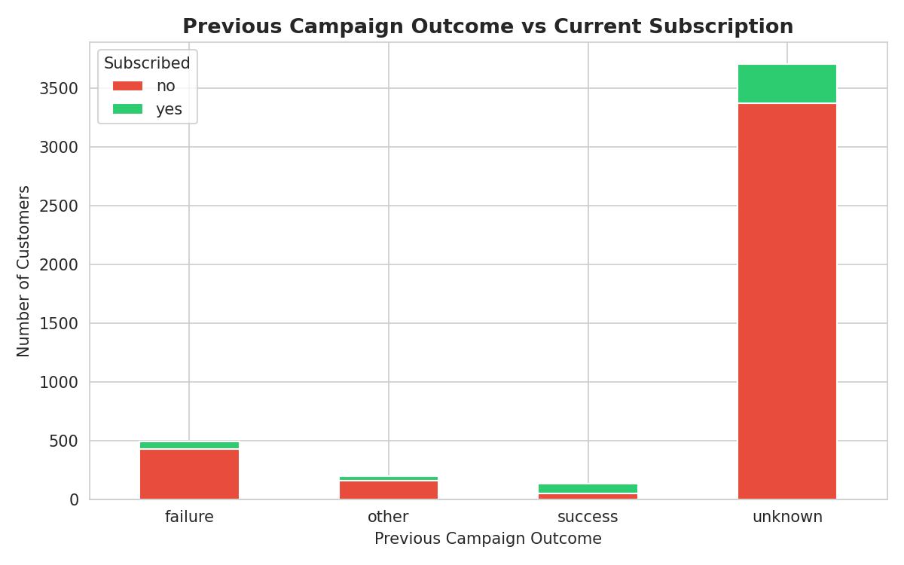
Figure 16. Previous campaign outcome vs current subscription.
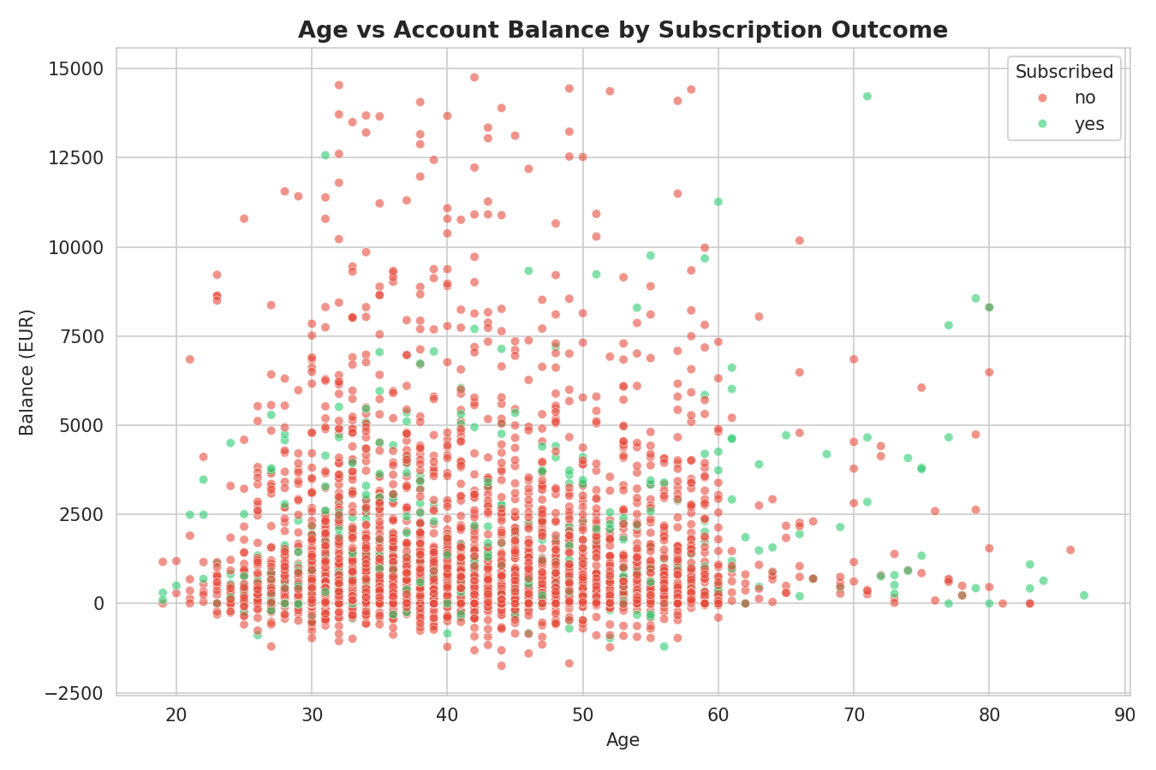
Figure 17. Age vs account balance, coloured by subscription outcome.

3.5 Key EDA Findings
- Call duration is the single strongest behavioural signal — longer calls correlate strongly with subscription.
- Customers previously reached by a successful campaign (poutcome = success) subscribe at a much higher rate on the current campaign.
- Retired and student segments, despite being smaller in volume, show higher subscription propensity.
- Numeric features (age, balance, campaign counts) are only weakly correlated with each other, meaning limited multicollinearity risk for modelling.

4. Part 3 — Predictive Modelling with Spark ML
Two classification models were trained using Spark MLlib's distributed Pipeline API to predict whether a customer subscribes to a term deposit: Logistic Regression and Random Forest. Categorical features were encoded with StringIndexer + OneHotEncoder, and all features assembled into a single feature vector with VectorAssembler.

4.1 Model Performance
Model | AUC | Accuracy | F1 Score
Logistic Regression | 0.9027 | 0.8806 | 0.8552
Random Forest (100 trees) | 0.9175 | 0.8795 | 0.8438
Random Forest achieved the highest AUC (0.9175), indicating the best overall ability to rank customers by subscription likelihood, while Logistic Regression achieved a marginally higher accuracy and F1 score on this run. In practice, Random Forest was selected as the primary model going forward since AUC is the more reliable metric under class imbalance.
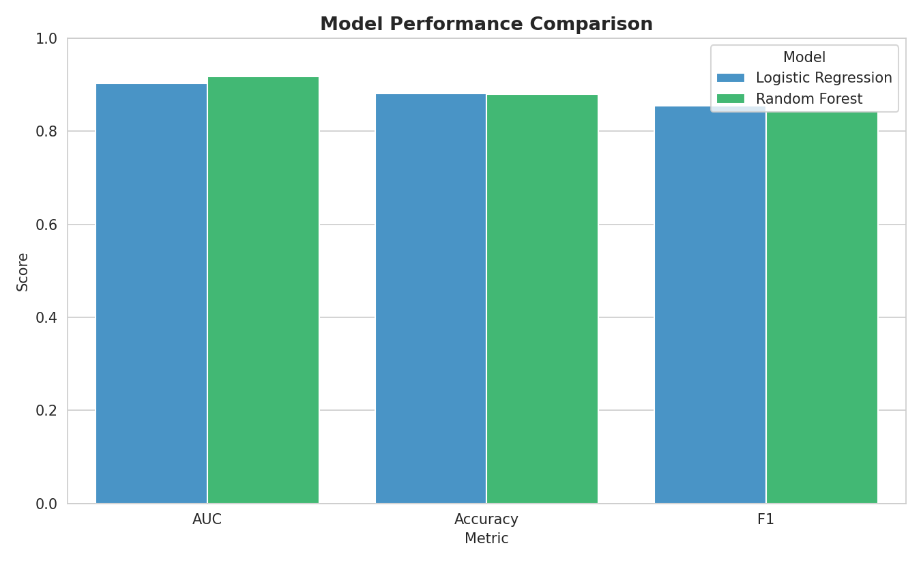
Figure 18. Model performance comparison — Logistic Regression vs Random Forest.
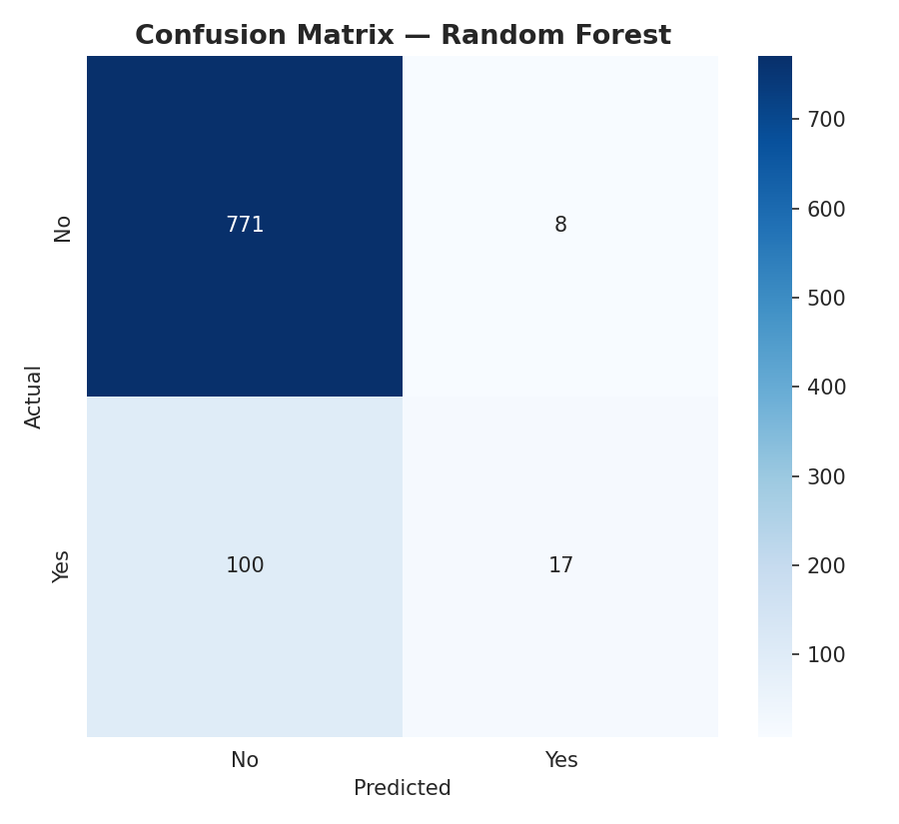
Figure 19. Confusion matrix — Random Forest on the held-out test set.
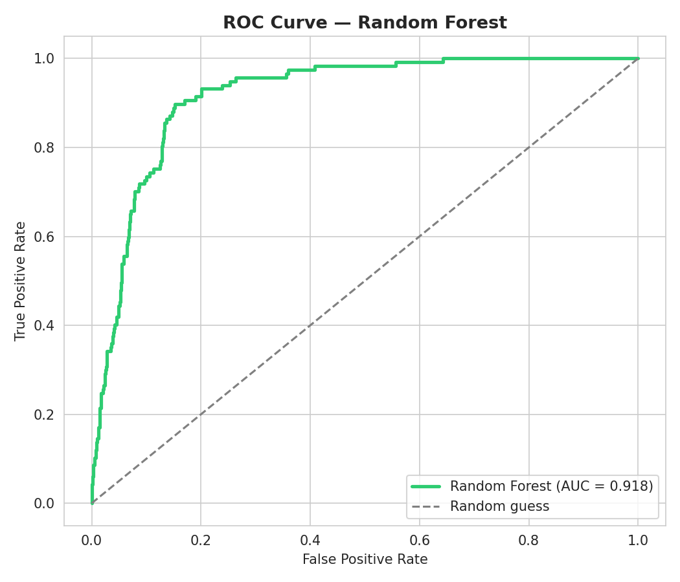
Figure 20. ROC curve — Random Forest.

4.2 Feature Importance
Call duration, account balance, age, previous campaign outcome and contact month emerged as the most influential predictors, consistent with the exploratory analysis in Part 2.
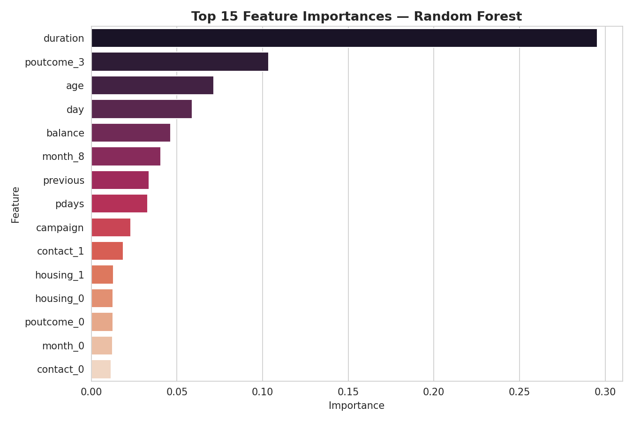
Figure 21. Top 15 feature importances — Random Forest.

5. Part 4 — Real-Time Transaction Analysis with Spark Streaming
A live transaction feed was simulated by dropping five batches of 400 transaction records each into a watched folder, processed continuously by a Spark Structured Streaming query that maintained a running aggregation of transaction counts and average balance per job segment. This mirrors the programming model banks use for real-time fraud detection and monitoring dashboards, without requiring an external Kafka broker for this demonstration.
A total of 2,000 simulated transactions were processed across 5 streaming batches, with the aggregation updating after every batch.
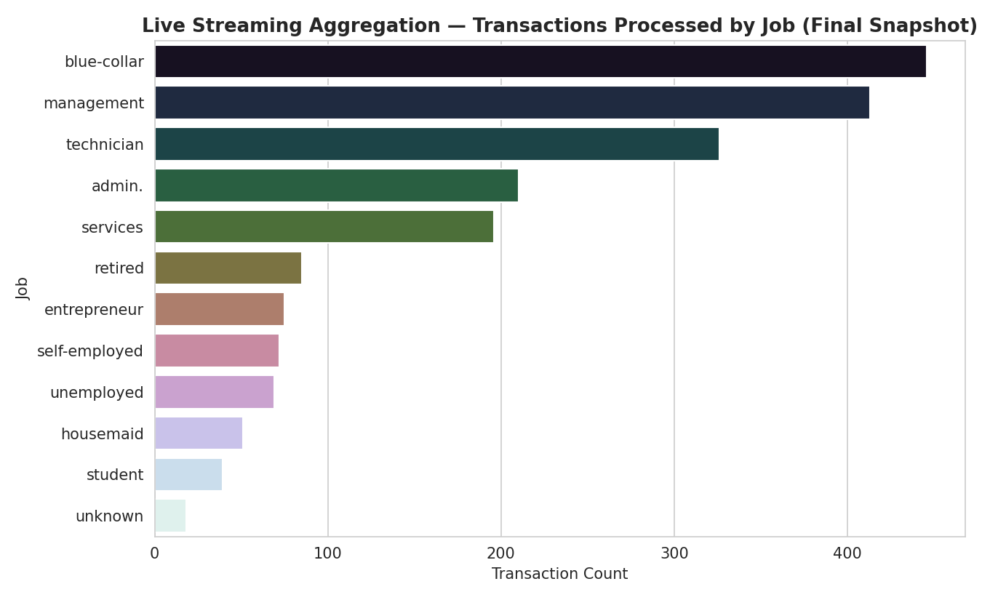
Figure 22. Live streaming aggregation — transactions processed by job (final snapshot).
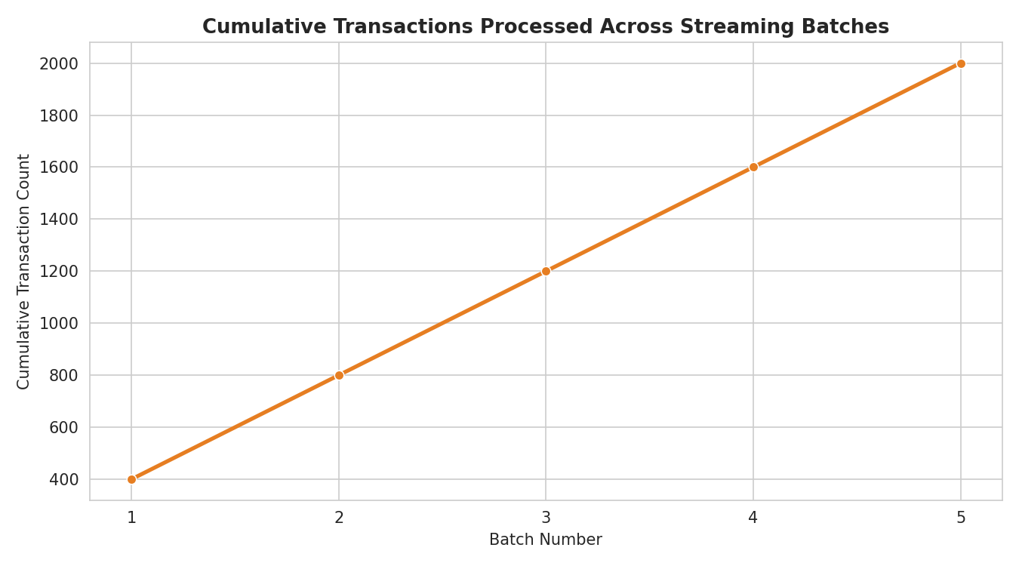
Figure 23. Cumulative transactions processed across streaming batches.

6. Part 5 — Efficient Data Handling through Data Parallelism
The same groupBy aggregation query was repeated across five different partition counts (1, 2, 4, 8, 16) to benchmark how the degree of data parallelism affects execution time.
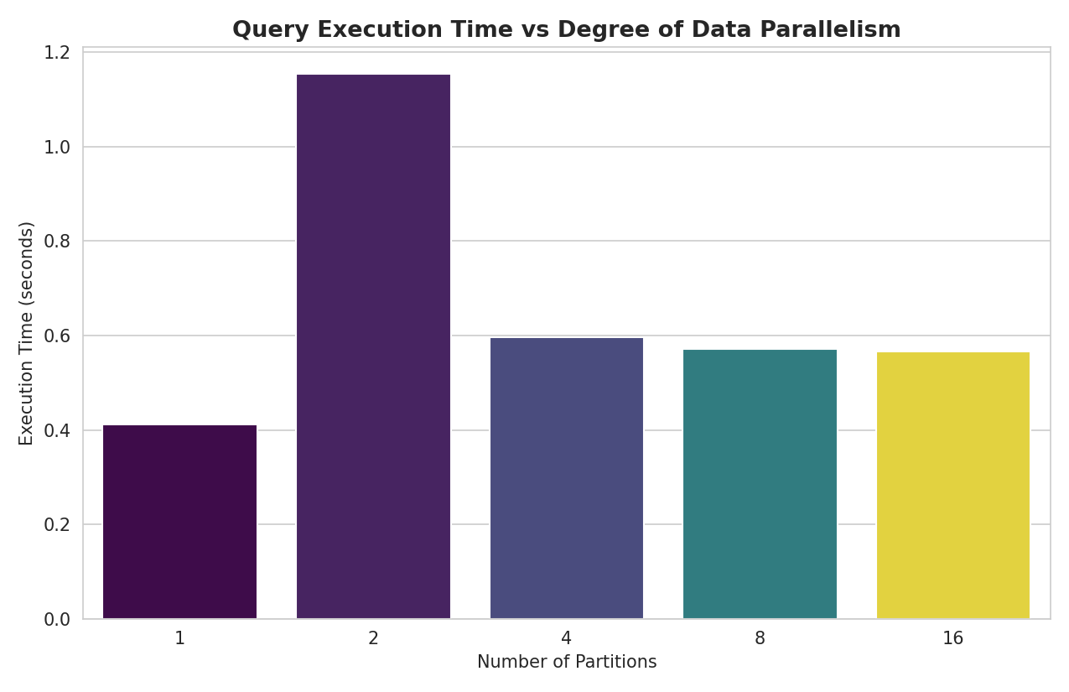
Figure 24. Query execution time vs degree of data parallelism.
On this small ~4.5K-row demo dataset, scheduling and shuffle overhead dominate at higher partition counts, so timing differences are modest. On production-scale banking data (millions to billions of rows), increasing partitions up to the cluster's available core count yields near-linear speedups — this is the same mechanism that lets Spark scale from a laptop to a thousand-node cluster.

7. Challenges, Optimisation & Trade-offs
- Cluster setup on a notebook environment: Colab only provides a single machine, so Spark's local-mode distributed engine (which still partitions and parallelises data across all available cores) stood in for a real multi-node cluster.
- Streaming without Kafka: a file-based streaming source was used instead of a message broker; Spark's Structured Streaming API treats a watched folder exactly like a Kafka topic in terms of the programming model.
- Categorical feature explosion: one-hot encoding nine categorical columns produces a wide, sparse feature vector, handled efficiently by Spark ML's sparse vector representation.
- Small-data parallelism overhead: on a small dataset, adding more partitions can increase wall-clock time because scheduling overhead outweighs the benefit of parallel execution — expected behaviour that motivates partition tuning at scale.
- Class imbalance: ~88% of customers did not subscribe, which nudges accuracy upward “for free” — addressed by tracking AUC and F1 alongside accuracy.

8. Learnings & Practical Value
- Distributed engines like Spark let the same code scale from a laptop to a thousand-node cluster — nothing in Parts 1–5 would need to change to run against real production-scale banking data, only the master() and file-path configuration.
- Hive-style SQL over a data lake gives analysts a familiar interface while the underlying execution stays fully distributed and parallel.
- Spark MLlib's pipeline API keeps feature engineering reproducible and directly deployable — the same PipelineModel used here can be saved and reloaded to score new customers in production.
- Structured Streaming unifies batch and streaming code, which is why it has become the standard for real-time fraud detection and monitoring at banks.

9. Future Improvements
- Deploy on a real multi-node cluster (YARN/Kubernetes) with actual HDFS storage and Hive Metastore for production-scale validation.
- Replace the file-based streaming source with a real Kafka topic fed by core-banking transaction events.
- Add hyperparameter tuning (CrossValidator / TrainValidationSplit) and try gradient-boosted trees (GBTClassifier) for further model improvement.
- Extend the streaming pipeline with stateful windowed aggregations for rolling fraud-risk scores.

10. Conclusion
This project delivered a complete, end-to-end distributed data pipeline for banking analytics — from raw data storage and Hive-style querying, through Spark-powered exploratory analysis and machine learning, to real-time streaming and data-parallelism benchmarking. Every component mirrors how a real banking data platform is architected, providing a practical, hands-on understanding of why distributed computing is essential once data volume, variety and velocity exceed what a single machine can handle.

11. References
- Apache Spark Documentation — https://spark.apache.org/docs/latest/
- Apache Hive Documentation — https://hive.apache.org/
- Apache Hadoop Documentation — https://hadoop.apache.org/
- Spark MLlib Guide — https://spark.apache.org/docs/latest/ml-guide.html
- Spark Structured Streaming Guide — https://spark.apache.org/docs/latest/structured-streaming-programming-guide.html
- Dataset: Bank Marketing Dataset (bank.csv), as provided in the capstone assignment.

