STUDENT LEARNING PATTERN ANALYSIS USING CLUSTERING
A PROJECT REPORT
Submitted by
[RITHIK VISHNU M – 610524091059]
[SABARIVEL D – 610524091060]
[SRIKISHORE C – 610524091079]

in partial fulfillment of the requirements for the award of the degree of
BACHELOR OF ENGINEERING


DEPARTMENT OF Artificial Intelligence
and
Data Science
HINDUSTHAN COLLEGE OF TECHNOLOGY,
SALEM-636309
SEPTEMBER 2026

BONAFIDE CERTIFICATE
This is to certify that the project report entitled “STUDENT LEARNING PATTERN ANALYSIS USING CLUSTERING” is the Bonafide work of RITHIK VISHNU M (610524091059), SABARIVEL D (610524091060), SRIKISHORE C (610524091079) who carried out the project work under my supervision and guidance in partial fulfillment of the requirements for the award of the degree of Bachelor of Engineering.
The project work presented in this report is original and has been carried out satisfactorily by the above students under the guidance and supervision of, Dr. R. Divya. The work reported herein has not been submitted in full or in part to any other university or institution for the award of any degree, diploma or other academic qualification.

Dr. R. Divya
Project Guide
Department of Electrical and Electronics Engineering

V. Gnanasekar
Head of the Department
Department of Artificial Intelligence and Data Science

DECLARATION
We hereby declare that the project report entitled “STUDENT LEARNING PATTERN ANALYSIS USING CLUSTERING” submitted in partial fulfilment of the requirements for the award of the degree of Bachelor of Engineering in ARTIFICIAL INTELLIGENCE AND DATA SCIENCE is the original work carried out by us under the guidance of Dr. R. DIVYA.
We further declare that this project work has not been submitted, either wholly or partly, to any other university or institution for the award of any degree, diploma or other academic qualification.

Place: [SALEM]
Date: [DATE]
[RITHIK VISHNU M – 610524091059]
[SABARIVEL D – 610524091060]
[SRIKISHORE C – 610524091079]

ACKNOWLEDGEMENT
We express our sincere gratitude to Smt. ARCHANA MANOJKUMAR, Secretary, HINDUSTHAN COLLEGE OF TECHNOLOGY, SALEM, for providing the institutional support and encouragement necessary for the successful completion of our project.
We extend our sincere thanks to Dr. A. SELVARAJ, Principal, HINDUSTHAN COLLEGE OF TECHNOLOGY, SALEM, for providing the necessary facilities, resources and support to carry out this project successfully.
We sincerely thank Mr. V. GNANASEKAR, Head of the Department of ARTIFICIAL INTELLIGENCE AND DATA SCIENCE for the valuable guidance, encouragement and support provided throughout the course of this project.
We express our deepest gratitude to our project guide, Dr. R. DIVYA, ASSISTANT PROFESSOR, for the continuous guidance, technical expertise, constructive suggestions and valuable feedback provided at every stage of the project. Their guidance and encouragement played an important role in the successful completion of this work.
We also thank all the faculty members and technical staff of the Department of ARTIFICIAL INTELLIGENCE AND DATA SCIENCE for their cooperation, assistance and support throughout the project.
Finally, we express our heartfelt gratitude to our parents, friends and everyone who contributed to the successful completion of this project.
Thank You.

ABSTRACT
Student performance can vary based on attendance, academic scores and other measurable learning indicators. Identifying common patterns can help teachers understand groups of students and provide suitable academic support. This project presents a simple Student Learning Pattern Analysis system using K-Means clustering to group students according to similarity in selected academic and learning-related attributes.
The system accepts structured student data, validates the records and preprocesses the numerical features before clustering. Standardization is applied so that features measured on different scales can be used together. K-Means then assigns students to clusters based on their distance from cluster centroids. The resulting groups are displayed through an interactive dashboard containing performance summaries and graphical analysis.
The application is implemented using Python, Streamlit, SQLite, Pandas, Scikit-learn and Plotly. SQLite provides persistent storage, while the Streamlit interface supports role-based access for students, teachers and administrators. The project also provides individual student analysis, intervention records and Excel report generation.
The system is intended as a decision-support tool for academic monitoring. It does not replace teacher judgement or automatically determine a student's ability. The final application demonstrates how a basic machine-learning technique can be combined with data visualization and database management to make student learning patterns easier to understand and support timely academic intervention.
Keywords: Student Performance, K-Means Clustering, Machine Learning, Learning Patterns, Data Visualization

TABLE OF CONTENTS
CHAPTER / SECTION | TITLE | PAGE NO.
CHAPTER 1 | INTRODUCTION | [1]
1.1 | Background | [1]
1.2 | Problem Statement | [1]
1.3 | Motivation | [1]
1.4 | Objectives | [1]
1.5 | Scope of the Project | [2]
1.6 | Applications | [2]
1.7 | Project Contributions | [2]
1.8 | Organization of the Report | [2]
CHAPTER 2 | LITERATURE SURVEY | [3]
2.1 | Introduction | [3]
2.2 | Review of Existing Research | [3]
2.3 | Comparative Analysis | [3]
2.4 | Research / Technical Gap | [3]
2.5 | Chapter Summary | [3]
CHAPTER 3 | EXISTING SYSTEM | [5]
3.1 | Overview | [5]
3.2 | Existing System Architecture | [5]
3.3 | Working of Existing System | [6]
3.4 | Advantages | [6]
3.5 | Limitations | [6]
3.6 | Need for the Proposed System | [6]
CHAPTER 4 | PROPOSED SYSTEM | [7]
4.1 | Overview | [7]
4.2 | Proposed System Architecture | [7]
4.3 | Proposed Modules | [8]
4.4 | Working Principle | [8]
4.5 | Flowchart | [8]
4.6 | Algorithm | [9]
4.7 | Mathematical Formulation | [9]
4.8 | Advantages of Proposed System | [9]
CHAPTER 5 | SYSTEM REQUIREMENTS | [10]
5.1 | Hardware Requirements | [10]
5.2 | Software Requirements | [10]
5.3 | Programming Language | [10]
5.4 | Development Platform | [10]
CHAPTER 6 | METHODOLOGY AND IMPLEMENTATION | [11]
6.1 | Methodology | [11]
6.2 | Input / Data Collection | [12]
6.3 | Data Preprocessing | [12]
6.4 | Feature Extraction / Parameter Selection | [12]
6.5 | Module Implementation | [12]
6.6 | Hardware Implementation | [13]
6.7 | Software Implementation | [13]
6.8 | Implementation Screenshots | [13]
6.9 | Testing | [16]
CHAPTER 7 | RESULTS AND DISCUSSION | [17]
7.1 | Experimental Setup | [17]
7.2 | Experimental Results | [17]
7.3 | Performance Evaluation | [17]
7.4 | Graphical Analysis | [18]
7.5 | Comparison with Existing System | [19]
7.6 | Discussion | [19]
7.7 | Achievement of Objectives | [20]
CHAPTER 8 | CONCLUSION AND FUTURE SCOPE | [21]
8.1 | Conclusion | [21]
8.2 | Limitations | [21]
8.3 | Future Scope | [21-22]
 | Appendices | [23-57]
 | References | [61-62]

LIST OF TABLES
TABLE NO. | TITLE | PAGE NO.
2.1 | Comparative Analysis of Reviewed Literature | [4]
5.1 | Hardware Requirements | [10]
5.2 | Software Requirements | [10]
6.1 | Testing of the Proposed System | [16]
7.1 | Comparison with Existing System | [19]
7.2 | Achievement of Objectives | [20]
B.1 | Project technology Stack | [56]

LIST OF FIGURES
Figure No. | Title | Page No.
3.1 | General Workflow of Existing Student Monitoring System | [5]
4.1 | Proposed System Architecture | [7]
4.2 | Flowchart of Proposed System | [8]
6.1 | Overall Methodology of the Proposed System | [12]
6.2 | Login Screen | [13]
6.3 | Student Dashboard | [14]
6.4 | Teacher / Administrator Dashboard | 14]
6.5 | K-Means Cluster Visualization | [14]
6.6 | Individual Student Analysis | [15]
6.7 | Excel Report Generation | [15]
7.1 | Student Cluster Distribution | [17]
7.2 | Performance Comparison Graph | [18]
7.3 | Cluster Visualization | [18]
7.4 | Correlation Analysis | [19]
Symbol | Description
xᵢ | Feature vector of the i-th student
μⱼ | Centroid of cluster j
d(xᵢ, μⱼ) | Euclidean distance between a student and a cluster centroid
K | Number of clusters
J | K-Means objective function
Σ | Summation operator

CHAPTER 1
INTRODUCTION
1.1 Background
Educational institutions collect different types of student information such as attendance, academic marks, grade point average and other learning indicators. Analyzing these records manually can make it difficult to identify common learning patterns, especially when the number of students increases.
Machine learning techniques can be used to discover useful patterns from student data. Clustering is an unsupervised learning technique that groups similar data records together. In this project, K-Means clustering is used to identify groups of students with similar academic and learning characteristics.
1.2 Problem Statement
Traditional student monitoring commonly depends on spreadsheets, individual records and manual interpretation. Although these methods can work for small datasets, they require repeated checking and may not clearly show groups of students with similar performance patterns.
Therefore, a simple system is required to preprocess student data, apply clustering and display the resulting learning patterns through an understandable dashboard.
1.3 Motivation
The main motivation of this project is to provide teachers and academic staff with a quick and understandable method for analysing student learning patterns. Grouping students based on similar characteristics can support mentoring, academic follow-up and remedial activities.
1.4 Objectives
• To collect and store structured student academic information.
• To validate and preprocess the input student data.
• To apply K-Means clustering to identify similar student groups.
• To visualize clustering and performance information through an interactive dashboard.
• To provide individual student performance analysis.
• To maintain intervention and teacher feedback records.
• To generate student analysis reports in Excel format.
1.5 Scope of the Project
The project focuses on analysing structured student performance data using clustering. It includes data validation, preprocessing, feature selection, standardization, K-Means clustering, graphical visualization and student-level analysis. The application also provides role-based access for students, teachers and administrators.
1.6 Applications
• Student performance grouping.
• Academic mentoring and follow-up.
• Attendance-based monitoring.
• Identification of students requiring additional support.
• Performance trend analysis.
• Generation of student reports.
1.7 Project Contributions
The project integrates machine learning, data visualization, database management and reporting into a single academic monitoring application. K-Means clustering is combined with Streamlit for the user interface, SQLite for persistent data storage, Plotly for visualization and Excel generation for reports.
1.8 Organization of the Report
Chapter 1 introduces the project. Chapter 2 presents the literature survey. Chapter 3 explains the existing system. Chapter 4 describes the proposed system and algorithm. Chapter 5 presents system requirements. Chapter 6 explains methodology and implementation. Chapter 7 presents results and discussion. Chapter 8 concludes the project and discusses future scope.

CHAPTER 2
LITERATURE SURVEY
2.1 Introduction
The literature survey provides background for clustering, data preprocessing and educational data analysis. Previous work on clustering has established methods for grouping numerical observations based on similarity. These concepts form the foundation of the proposed student learning pattern analysis system.
2.2 Review of Existing Research
K-Means is one of the commonly used clustering techniques for numerical datasets. It partitions observations into a predefined number of clusters by repeatedly assigning observations to the nearest centroid and updating the centroid positions.
Educational data mining and learning analytics also demonstrate the usefulness of analysing student records to understand academic patterns. Data preprocessing and appropriate feature selection are important because clustering results depend strongly on the quality and scale of input data.
2.3 Comparative Analysis
The reviewed technical sources indicate that clustering can be used for numerical pattern discovery, while visualization helps users interpret analytical results. The proposed project combines these concepts with persistent student records and an interactive dashboard.
2.4 Research / Technical Gap
A simple academic application can be improved by combining similarity-based student grouping with persistent storage, interactive visualization, individual student analysis and report generation. The proposed system addresses this implementation-level gap by integrating these components into one application.
2.5 Chapter Summary
The literature survey establishes the use of K-Means clustering for grouping numerical data and highlights the importance of preprocessing and visualization. These concepts are applied in the proposed student learning pattern analysis system.
Table 2.1 presents selected technical and research references relevant to clustering and visualization.
S.No | Source | Topic | Relevance
1 | MacQueen (1967) | K-Means clustering | Introduced the K-Means approach for grouping observations.
2 | Lloyd (1982) | Least-squares quantization | Provides the iterative basis related to K-Means clustering.
3 | Jain (2010) | Data clustering | Discusses clustering concepts and limitations.
4 | Scikit-learn documentation | K-Means and StandardScaler | Provides implementation support for clustering and feature scaling.
5 | Plotly documentation | Interactive visualization | Supports graphical analysis of analytical results.

CHAPTER 3
EXISTING SYSTEM
3.1 Overview
In a conventional academic monitoring process, student records are commonly maintained using spreadsheets, documents or separate institutional systems. Teachers inspect marks, attendance and other indicators manually and identify students who may need attention.
3.2 Existing System Architecture
The general workflow of the existing system is: student records are collected, stored in spreadsheets or databases, manually filtered and analysed, and finally used by teachers to make academic decisions.
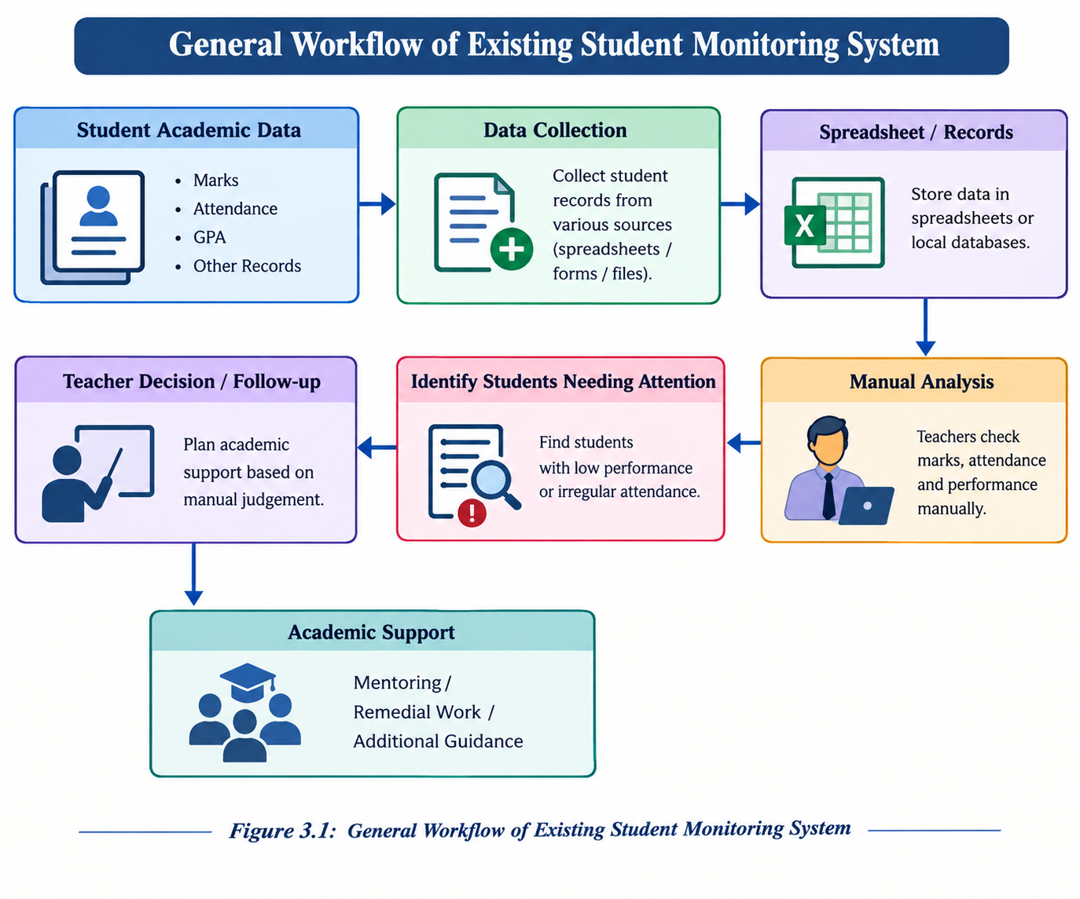
Figure 3.1: General Workflow of Existing Student Monitoring System

3.3 Working of Existing System
1. Student information is collected from academic records.
2. Attendance and marks are maintained.
3. Teachers inspect individual records.
4. Students requiring attention are identified manually.
5. Academic actions are planned based on teacher judgement.
3.4 Advantages
• Easy to understand.
• Requires minimal technical infrastructure.
• Suitable for small datasets.
• Teachers can directly interpret student records.
3.5 Limitations
• Manual analysis can be time consuming.
• Similar student groups may not be immediately visible.
• Repeated spreadsheet inspection is required.
• There is no automatic clustering.
• Visual analysis may be limited.
• Report preparation can require additional manual work.
3.6 Need for Proposed System
A more organized system can reduce repeated manual analysis by automatically grouping students according to selected numerical features. Interactive graphs can also make the resulting patterns easier to understand.

CHAPTER 4
PROPOSED SYSTEM
4.1 Overview
The proposed system is a Student Learning Pattern Analysis application based on K-Means clustering. It accepts student performance data, validates and preprocesses the data, applies clustering and presents the results through an interactive Streamlit dashboard.
4.2 Proposed System Architecture
The proposed architecture consists of authentication, data access, validation, preprocessing, feature selection, standardization, K-Means clustering, result interpretation, visualization and reporting modules.
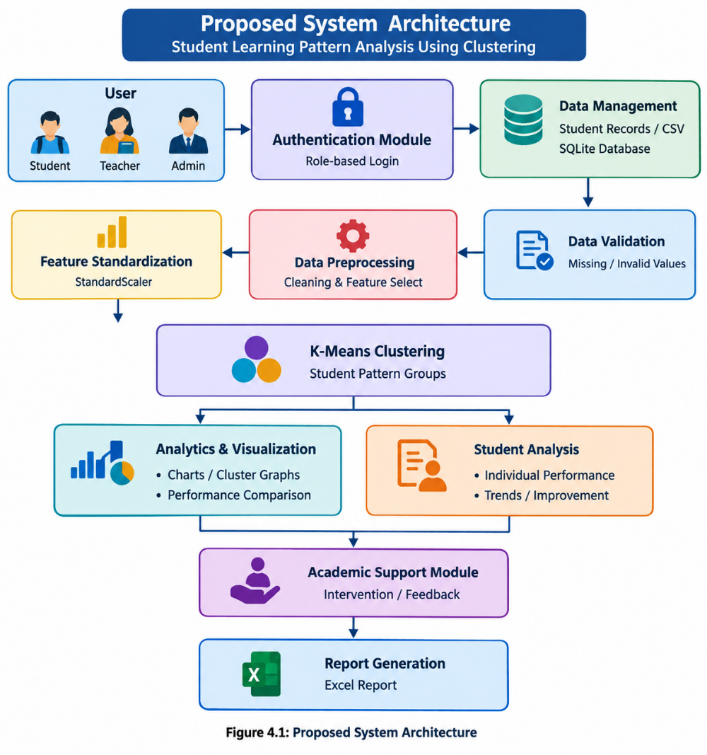
Figure 4.1: Proposed System Architecture

4.3 Proposed Modules
• Authentication Module
• Student Dashboard
• Teacher/Admin Command Center
• Data Management Module
• Data Preprocessing Module
• K-Means Clustering Module
• Analytics and Visualization Module
• Intervention Management Module
• Excel Reporting Module
4.4 Working Principle
1.The user logs into the system according to the assigned role.
2. The application loads the student dataset.
3. Input records are validated.
4. Required numerical features are selected.
5. The selected features are standardized.
6. K-Means clustering is applied.
7. Cluster assignments are analysed.
8. Results are displayed through interactive graphs.
9. Teachers can record interventions and feedback.
10. Student analysis can be exported as an Excel report.
4.5 Flowchart
Start → Login → Select Role → Load Data → Validate Data → Preprocess Data → Standardize Features → Apply K-Means → Analyse Clusters → Display Dashboard → Intervention / Report → End

4.6 Algorithm
Step 1: Select the numerical features required for clustering.
Step 2: Load the student dataset.
Step 3: Check the input records for missing or invalid values.
Step 4: Convert required fields into numerical form.
Step 5: Standardize the selected features.
Step 6: Select the number of clusters K.
Step 7: Initialize K cluster centroids.
Step 8: Assign each student to the nearest centroid.
Step 9: Recalculate the centroid of each cluster.
Step 10: Repeat assignment and centroid calculation until convergence.
Step 11: Display and interpret the resulting student groups.
4.7 Mathematical Formulation
For a student vector xᵢ and cluster centroid μⱼ, the Euclidean distance is calculated as:
d(xᵢ, μⱼ) = √ Σₖ (xᵢₖ − μⱼₖ)²
The K-Means objective is to minimize the within-cluster sum of squared distances:
J = Σᵢ minⱼ ||xᵢ − μⱼ||²
Feature standardization is used because different student attributes may be measured on different scales. Standardization helps prevent a feature with a larger numerical range from dominating the distance calculation.
4.8 Advantages of Proposed System
• Automatically groups similar students.
• Provides interactive visualization.
• Stores data using SQLite.
• Provides role-based access.
• Supports individual student analysis.
• Allows intervention records and provides Excel report generation.
CHAPTER 5
SYSTEM REQUIREMENTS
5.1 Hardware Requirements
Component | Requirement
Processor | Modern dual-core or above processor
RAM | Minimum 4 GB
Storage | At least 5 GB free space
Display | Standard monitor
Input | Keyboard and mouse
GPU | Not required
5.2 Software Requirements
Software | Requirement
Operating System | Windows / Linux
Python | Python 3.x
Framework | Streamlit
Database | SQLite
Data Processing | Pandas, NumPy
Machine Learning | Scikit-learn
Visualization | Plotly
Excel Reporting | openpyxl
5.3 Programming Language
Python is used as the primary programming language because it provides libraries for data processing, machine learning, visualization, database integration and web application development.
5.4 Development Platform
The application is developed as a local Streamlit application. SQLite is used for persistent storage and Scikit-learn provides the K-Means clustering implementation.
CHAPTER 6
METHODOLOGY AND IMPLEMENTATION
6.1 Methodology
The methodology consists of data collection, validation, preprocessing, feature selection, standardization, clustering, visualization and interpretation. Additional modules provide authentication, database storage, intervention management and report generation.
Data Collection
↓
Data Validation
↓
Data Preprocessing
↓
Feature Selection
↓
Feature Standardization
↓
K-Means Clustering
↓
Cluster Analysis
↓
Data Visualization
↓
Student Performance Analysis
↓
Academic Intervention / Feedback
↓
Report Generation
Overall Methodology of the Proposed System
6.2 Input / Data Collection
The application uses structured student records containing academic and learning-related numerical attributes. Data can be maintained within the project database and can also be supplied through CSV-based data management.
6.3 Data Preprocessing
• Validate required columns.
• Check missing and invalid records.
• Convert numerical fields into suitable data types.
• Select relevant numerical features.
• Apply feature standardization.
6.4 Feature Extraction / Parameter Selection
Features such as attendance, academic marks, GPA and other available numerical learning indicators can be selected for clustering. Feature selection is important because irrelevant attributes may reduce the usefulness of the resulting groups.
6.5 Module Implementation
• Authentication and role management.
• Student dashboard.
• Teacher and administrator command center.
• CSV data validation and management.
• Data preprocessing.
• K-Means clustering.
• Interactive analytics.
• Intervention tracking.
• Excel report generation.
6.6 Hardware Implementation
No special hardware is required. The system can run on a standard personal computer or laptop with Python installed.
6.7 Software Implementation
The user interface is developed using Streamlit. Pandas and NumPy are used for data processing. Scikit-learn provides StandardScaler and K-Means clustering. Plotly is used for interactive visualization. SQLite provides persistent storage and openpyxl is used for Excel report generation.
6.8 Implementation Screenshots
Replace the following placeholders with screenshots captured from the final working application.
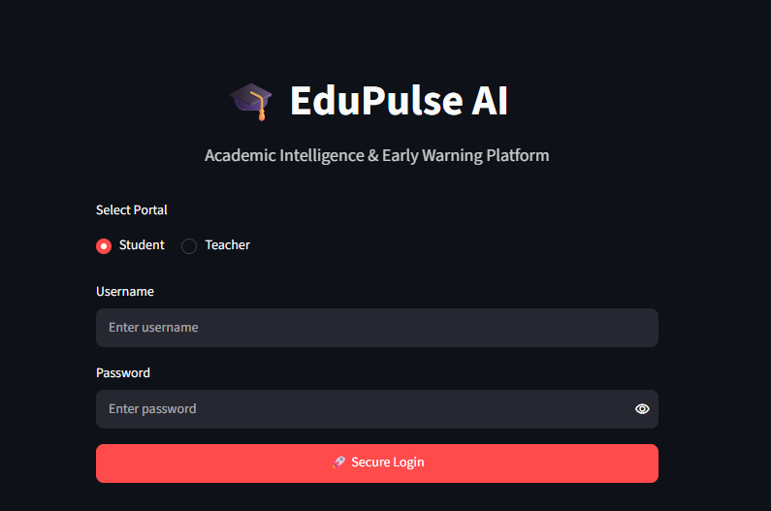
Figure 6.2: Login Screen
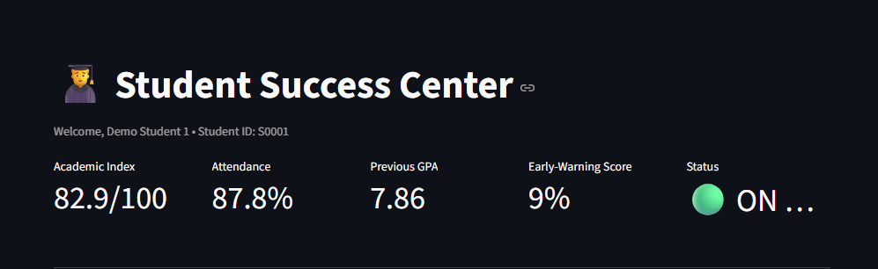
Figure 6.3: Student Dashboard
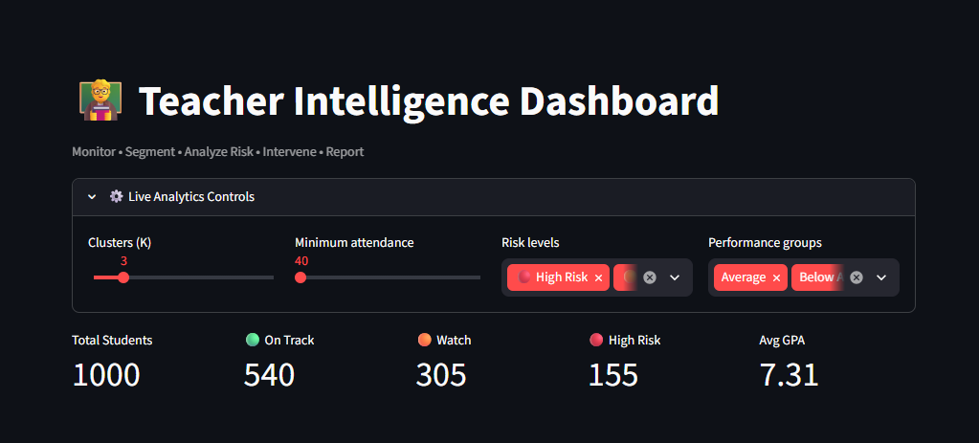
Figure 6.4: Teacher / Administrator Dashboard
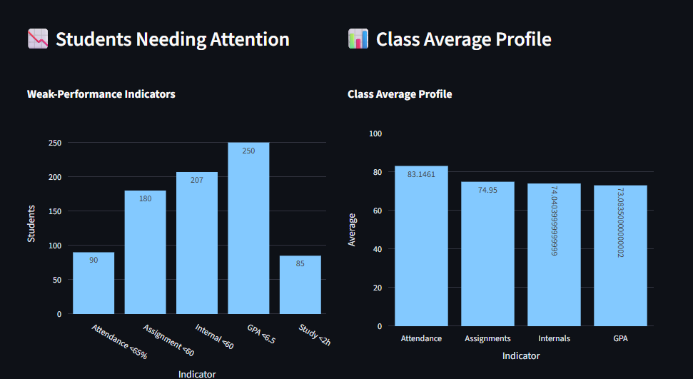
Figure 6.5: K-Means Cluster Visualization
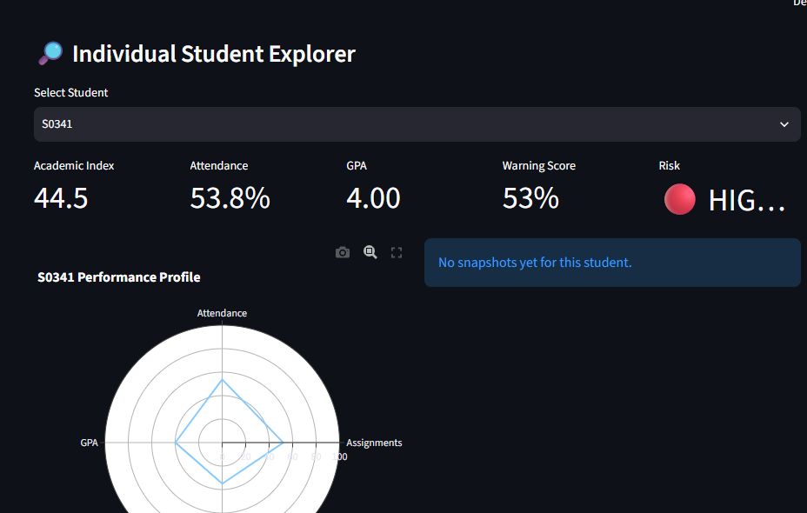
Figure 6.6: Individual Student Analysis
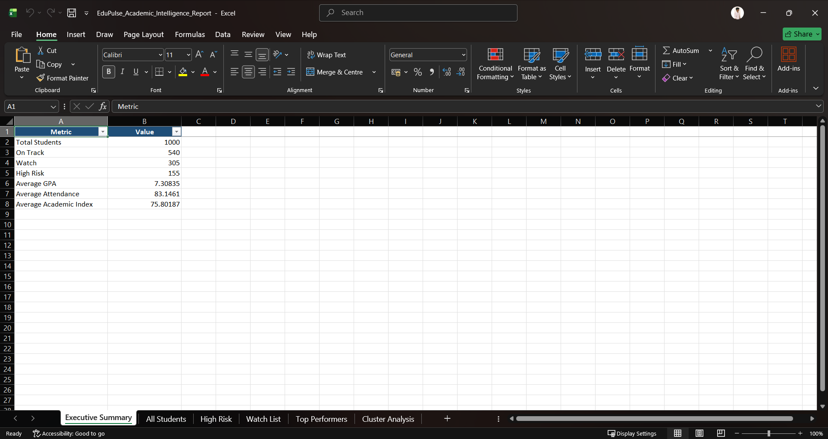
Figure 6.7: Excel Report Generation

6.9 Testing
Test ID | Module | Input | Expected Result | Status
TC01 | Login | Valid credentials | Dashboard opens | Pass
TC02 | Login | Invalid credentials | Error displayed | Pass
TC03 | Data Loading | Valid student dataset | Dataset loads | Pass
TC04 | Validation | Invalid/missing data | Validation message | Pass
TC05 | Clustering | Valid numerical features | Clusters generated | Pass
TC06 | Dashboard | Clustered dataset | Graphs displayed | Pass
TC07 | Student Search | Valid student | Student analysis displayed | Pass
TC08 | Intervention | Feedback entry | Record saved | Pass
TC09 | Excel | Student report request | Excel file generated | Pass

CHAPTER 7
RESULTS AND DISCUSSION
7.1 Experimental Setup
The application was tested in a local Python environment using the Streamlit framework. Student data was loaded into the application and processed using the preprocessing and clustering pipeline. Standardized numerical features were supplied to the K-Means algorithm.
7.2 Experimental Results
The system produces cluster assignments for student records. Students with similar values in the selected features are placed into the same cluster. The final cluster counts and numerical performance values should be recorded from the actual dataset used during the final project demonstration.
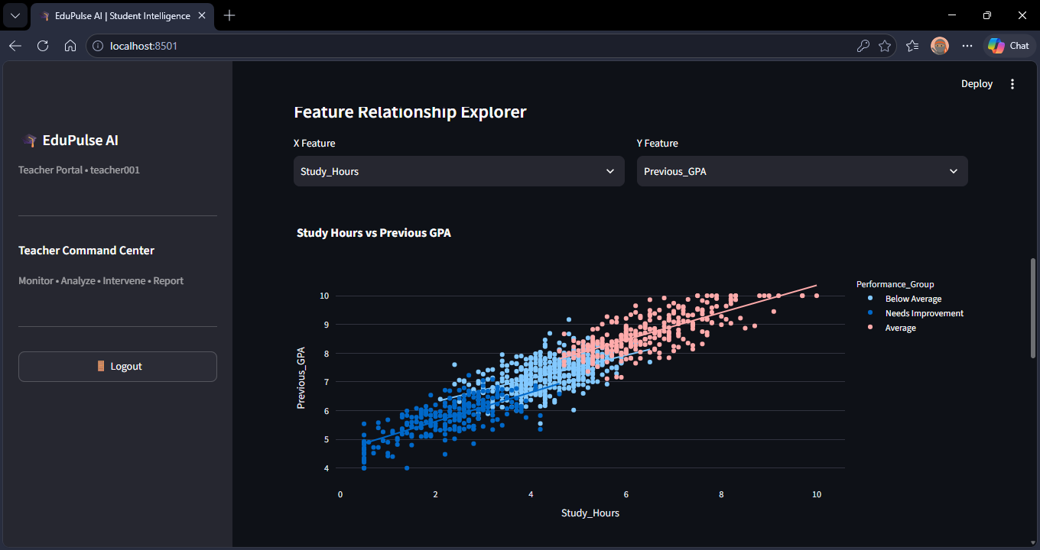
Figure 7.1: Student Cluster Distribution
7.3 Performance Evaluation
The system can evaluate clustering quality using measures such as the silhouette score. The actual score should be taken from the final experiment and inserted here. The score should be interpreted together with the dataset size, selected features and chosen number of clusters.
Final Experimental Silhouette Score: _________0.3694963___________

7.4 Graphical Analysis
The dashboard provides graphical analysis of student performance and cluster patterns. Graphs can be used to compare academic indicators, inspect cluster distribution and observe relationships between selected features.
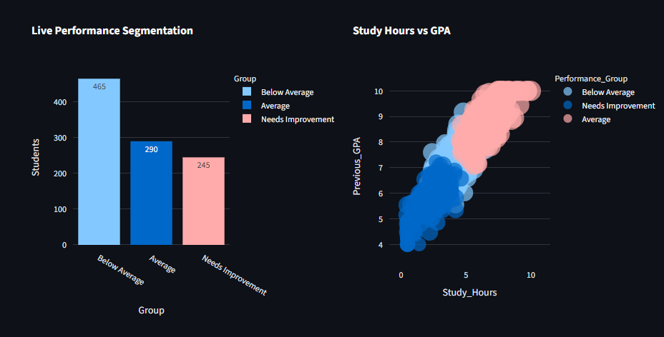
Figure 7.2: Performance Comparison Graph
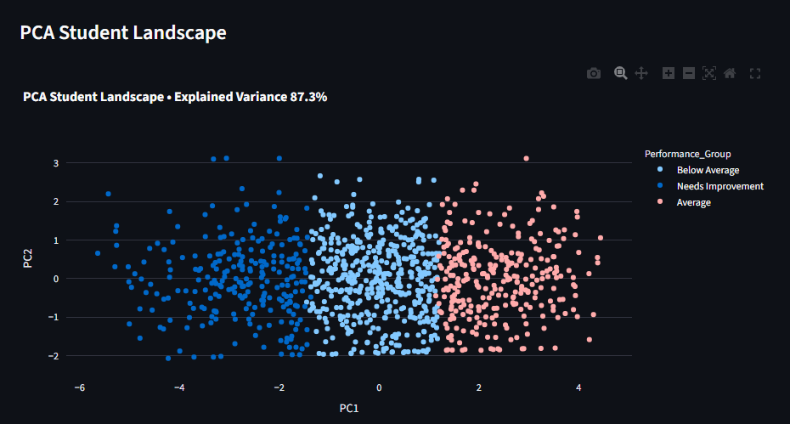
Figure 7.3: Cluster Visualization
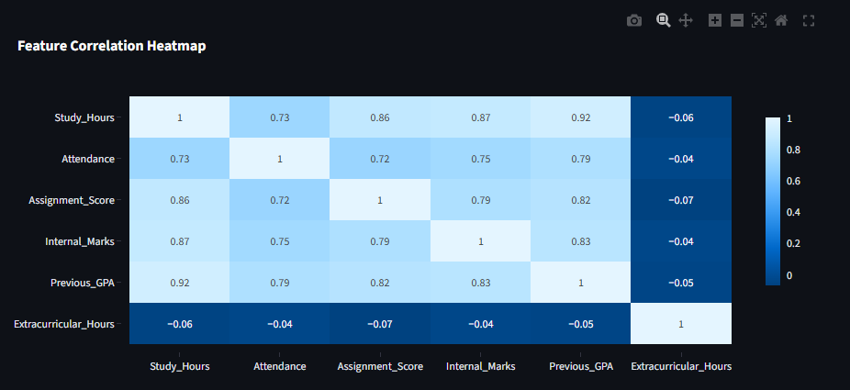
Figure 7.4: Correlation Analysis
7.5 Comparison with Existing System
Feature | Existing System | Proposed System
Data Analysis | Mostly manual | Automated preprocessing
Student Grouping | Manual interpretation | K-Means clustering
Visualization | Limited | Interactive graphs
Storage | Spreadsheet/manual | SQLite database
Intervention Records | Separate/manual | Integrated
Report Generation | Manual | Excel export
7.6 Discussion
The results demonstrate that K-Means can be used to organize students into groups based on similarity in selected numerical attributes. The resulting clusters should be treated as data patterns rather than permanent labels of student ability.
The system can support academic monitoring by providing a common analytical view of the dataset. However, teacher judgement remains important when deciding academic interventions.

7.7 Achievement of Objectives
Objective | Status
Objective | Status
Student data collection and storage | Achieved
Data validation and preprocessing | Achieved
K-Means clustering | Achieved
Interactive visualization | Achieved
Individual student analysis | Achieved
Intervention records | Achieved
Excel report generation | Achieved

CHAPTER 8
CONCLUSION AND FUTURE SCOPE
8.1 Conclusion
The Student Learning Pattern Analysis Using Clustering project demonstrates a practical application of machine learning for academic data analysis. The system uses K-Means clustering to group students based on selected learning and academic indicators.
The combination of Python, Streamlit, SQLite, Scikit-learn, Pandas and Plotly provides an integrated environment for data processing, clustering, visualization and academic monitoring. The application also supports role-based access, intervention records and Excel report generation.
The system is designed as a decision-support application. Cluster results describe patterns in the available data and should be considered along with teacher judgement and other academic information.
8.2 Limitations
• The quality of results depends on the quality of the input dataset.
• Feature selection can influence the clustering result.
• The number of clusters K must be selected appropriately.
• Outliers can affect cluster centroids.
• Different initialization conditions can influence K-Means results.
• Clusters should not be interpreted as permanent measures of student ability.
• The early-warning score used by the application is a heuristic indicator and is not a trained probability model.
8.3 Future Scope
• Use larger and more diverse student datasets.
• Include additional behavioural and learning features.
• Automatically determine an appropriate number of clusters.
• Compare K-Means with other clustering algorithms.
• Develop a supervised early-warning prediction model.
• Add time-series analysis of student performance.
• Support institutional deployment with stronger privacy and access controls.
• Provide more advanced academic recommendation features.

APPENDIX A
SOURCE CODE / PROGRAM
import os
import sys
import shutil
from datetime import date, datetime

# =========================================================
# PROJECT PATH
# =========================================================

PROJECT_ROOT = os.path.abspath(os.path.join(os.path.dirname(__file__), ".."))
if PROJECT_ROOT not in sys.path:
sys.path.insert(0, PROJECT_ROOT)

# =========================================================
# THIRD-PARTY IMPORTS
# =========================================================

import numpy as np
import pandas as pd
import plotly.express as px
import plotly.graph_objects as go
import streamlit as st

from sklearn.cluster import KMeans
from sklearn.preprocessing import StandardScaler
from sklearn.metrics import silhouette_score
from sklearn.decomposition import PCA

# =========================================================
# LOCAL IMPORTS
# =========================================================

from src.data_preprocessing import FEATURES
from src.auth_db import (
init_db,
authenticate,
create_user,
list_users,
get_user_by_username,
save_snapshot,
get_student_history,
add_intervention,
list_interventions,
)
from src.excel_reports import dataframe_to_xlsx

# =========================================================
# PAGE CONFIG
# =========================================================

st.set_page_config(
page_title="EduPulse AI | Student Intelligence",
page_icon="🎓",
layout="wide",
initial_sidebar_state="expanded",
)

# =========================================================
# PATHS
# =========================================================

BASE_DIR = PROJECT_ROOT
DATA_PATH = os.path.join(BASE_DIR, "data", "raw", "student_performance.csv")

# =========================================================
# DATA LOADING
# =========================================================

@st.cache_data(show_spinner=False)
def load_dataset():
if not os.path.exists(DATA_PATH):
st.error(f"Academic dataset was not found.\n\nExpected file:\n{DATA_PATH}")
st.stop()

df = pd.read_csv(DATA_PATH)

if "Student_ID" not in df.columns:
st.error("Dataset must contain a 'Student_ID' column.")
st.stop()

missing_features = [feature for feature in FEATURES if feature not in df.columns]
if missing_features:
st.error("Dataset is missing required columns:\n" + ", ".join(missing_features))
st.stop()

df["Student_ID"] = df["Student_ID"].astype(str).str.strip()
df[FEATURES] = df[FEATURES].apply(pd.to_numeric, errors="coerce")
df[FEATURES] = df[FEATURES].fillna(df[FEATURES].median(numeric_only=True))
return df

def refresh_dataset():
st.cache_data.clear()
st.rerun()

# =========================================================
# LOAD DATA + INITIALIZE DATABASE
# =========================================================

df = load_dataset()
student_ids = df["Student_ID"].dropna().astype(str).tolist()
init_db(student_ids)

# =========================================================
# SESSION STATE
# =========================================================

SESSION_DEFAULTS = {
"logged_in": False,
"role": None,
"username": None,
"user": None,
}

for key, default in SESSION_DEFAULTS.items():
if key not in st.session_state:
st.session_state[key] = default

# =========================================================
# DATABASE COMPATIBILITY HELPERS
# =========================================================

def authenticate_account(username, password, role):
"""Authenticate against the existing SQLite auth_db API."""
try:
return authenticate(username, password, role)
except TypeError:
try:
account = authenticate(username, password)
if account and account.get("role") == role:
return account
return None
except Exception:
return None
except Exception:
return None

def create_student_account_compat(
username,
password,
student_id,
full_name,
email="",
created_by=None,
):
"""Create a Student account using the existing create_user() function."""
username = str(username).strip()
password = str(password)
student_id = str(student_id).strip()
full_name = str(full_name).strip()
email = str(email or "").strip()

if not username:
return False, "Username is required."
if len(password) < 6:
return False, "Password must contain at least 6 characters."
if not student_id:
return False, "Student ID is required."
if not full_name:
return False, "Full name is required."

try:
result = create_user(
username=username,
password=password,
role="Student",
student_id=student_id,
full_name=full_name,
email=email,
created_by=created_by,
)
if isinstance(result, tuple):
return result
if isinstance(result, bool):
return (result, "Student account created successfully." if result else "Could not create student account.")
if isinstance(result, dict):
return (True, "Student account created successfully.")
return True, "Student account created successfully."

except TypeError:
try:
result = create_user(username, password, "Student", student_id, full_name, email, created_by)
if isinstance(result, tuple):
return result
if isinstance(result, bool):
return (result, "Student account created successfully." if result else "Could not create student account.")
return True, "Student account created successfully."
except TypeError:
pass

try:
result = create_user(username, password, "Student", student_id, full_name, email)
if isinstance(result, tuple):
return result
if isinstance(result, bool):
return (result, "Student account created successfully." if result else "Could not create student account.")
return True, "Student account created successfully."
except Exception as exc:
return False, f"Could not create account: {exc}"
except Exception as exc:
return False, f"Could not create account: {exc}"

# =========================================================
# LOGIN SCREEN
# =========================================================

def login_screen():
st.markdown(
"""
<div style="text-align:center; padding:35px 0 15px;">
<h1>🎓 EduPulse AI</h1>
<p style="font-size:18px; opacity:0.8;">
Academic Intelligence & Early Warning Platform
</p>
</div>
""",
unsafe_allow_html=True,
)

_, center, _ = st.columns([1, 2, 1])

with center:
role = st.radio("Select Portal", ["Student", "Teacher"], horizontal=True)
username = st.text_input("Username", placeholder="Enter username")
password = st.text_input("Password", type="password", placeholder="Enter password")

if st.button("🚀 Secure Login", use_container_width=True, type="primary"):
selected_role = "Student" if role == "Student" else "Teacher"
account = authenticate_account(username.strip(), password, selected_role)

if account is None and role == "Teacher":
account = authenticate_account(username.strip(), password, "Admin")

if account:
st.session_state.logged_in = True
st.session_state.role = account.get("role")
st.session_state.username = account.get("username")
st.session_state.user = account
st.rerun()
else:
st.error("❌ Invalid username or password for the selected portal.")

st.divider()
st.markdown("#### 🧪 Demo Accounts")
st.info(
"👨‍🎓 **Student:** `student001` / `student123`\n\n"
"👨‍🏫 **Teacher:** `teacher001` / `teacher123`\n\n"
"🛡️ **Admin:** `admin` / `admin123`"
)

with st.expander("📝 Student Self-Registration"):
name = st.text_input("Full name", key="reg_name")
sid = st.text_input("Student ID", key="reg_sid")
new_username = st.text_input("New username", key="reg_user")
new_password = st.text_input("New password", type="password", key="reg_pw")
email = st.text_input("Email (optional)", key="reg_email")

if st.button("Create Student Account", use_container_width=True):
valid_ids = set(df["Student_ID"].astype(str))
sid_clean = sid.strip()

if sid_clean not in valid_ids:
st.error("Student ID was not found in the academic dataset.")
elif len(new_password) < 6:
st.error("Password must contain at least 6 characters.")
elif not name.strip():
st.error("Full name is required.")
elif not new_username.strip():
st.error("Username is required.")
else:
ok, message = create_student_account_compat(
new_username,
new_password,
sid_clean,
name.strip(),
email.strip(),
"self-registration",
)
if ok:
st.success(message)
else:
st.error(message)

# =========================================================
# SHOW LOGIN OR STOP
# =========================================================

if not st.session_state.logged_in:
login_screen()
st.stop()

# =========================================================
# ML / SCORING FUNCTIONS
# =========================================================

@st.cache_data(show_spinner=False)
def cluster_data(k):
scaler = StandardScaler()
X = scaler.fit_transform(df[FEATURES])
model = KMeans(n_clusters=k, n_init=20, random_state=42)
labels = model.fit_predict(X)

clustered_df = df.copy()
clustered_df["Cluster"] = labels
means = clustered_df.groupby("Cluster")[FEATURES].mean()

performance_score = (
means["Attendance"] * 0.20
+ means["Assignment_Score"] * 0.25
+ means["Internal_Marks"] * 0.25
+ means["Previous_GPA"] * 10 * 0.30
)

ordered_clusters = list(performance_score.sort_values().index)
names = [
"Needs Improvement",
"Below Average",
"Average",
"Good Performer",
"High Performer",
"Excellent",
"Outstanding",
"Elite",
]

mapping = {
cluster: names[min(index, len(names) - 1)]
for index, cluster in enumerate(ordered_clusters)
}

clustered_df["Performance_Group"] = clustered_df["Cluster"].map(mapping)
return clustered_df, mapping

def academic_score(row):
score = (
row["Attendance"] * 0.20
+ row["Assignment_Score"] * 0.25
+ row["Internal_Marks"] * 0.25
+ row["Previous_GPA"] * 10 * 0.30
)
return float(np.clip(score, 0, 100))

def risk_label(row):
score = academic_score(row)
if score < 60 or row["Attendance"] < 65:
return "🔴 High Risk"
if score < 75 or row["Attendance"] < 75:
return "🟠 Watch"
return "🟢 On Track"

def warning_probability(row):
"""Explainable early-warning score heuristic."""
deficits = [
max(0, 65 - row["Attendance"]) / 65,
max(0, 60 - row["Assignment_Score"]) / 60,
max(0, 60 - row["Internal_Marks"]) / 60,
max(0, 6.5 - row["Previous_GPA"]) / 6.5,
max(0, 2 - row["Study_Hours"]) / 2,
]
base = 100 - academic_score(row)
probability = np.clip(base * 0.55 + sum(deficits) * 12, 0, 100)
return float(probability)

def risk_reasons(row):
reasons = []
if row["Attendance"] < 65:
reasons.append(f"Attendance is {row['Attendance']:.1f}%")
if row["Assignment_Score"] < 60:
reasons.append(f"Assignment score is {row['Assignment_Score']:.1f}")
if row["Internal_Marks"] < 60:
reasons.append(f"Internal marks are {row['Internal_Marks']:.1f}")
if row["Previous_GPA"] < 6.5:
reasons.append(f"GPA is {row['Previous_GPA']:.2f}")
if row["Study_Hours"] < 2:
reasons.append(f"Study time is {row['Study_Hours']:.1f} hrs")
return reasons or ["No major warning indicators detected"]

def action_for(row):
risk = row.get("Risk", risk_label(row))
if risk.startswith("🔴"):
return "Schedule intervention + attendance monitoring + weekly follow-up"
if risk.startswith("🟠"):
return "Targeted feedback + monitor next evaluation"
return "Continue regular mentoring"

def styled_status(status):
if "High Risk" in status:
return "🔴 HIGH RISK"
if "Watch" in status:
return "🟠 WATCH"
return "🟢 ON TRACK"

# =========================================================
# SIDEBAR
# =========================================================

with st.sidebar:
st.markdown("## 🎓 EduPulse AI")
st.caption(f"{st.session_state.role} Portal • {st.session_state.username}")
st.divider()

if st.session_state.role in ("Teacher", "Admin"):
st.markdown("**Teacher Command Center**")
st.caption("Monitor • Analyze • Intervene • Report")
else:
st.markdown("**Student Success Center**")
st.caption("Track • Improve • Grow")

st.divider()
if st.button("🚪 Logout", use_container_width=True):
st.session_state.logged_in = False
st.session_state.role = None
st.session_state.username = None
st.session_state.user = None
st.rerun()

# =========================================================
# STUDENT PORTAL
# =========================================================

if st.session_state.role == "Student":
account = st.session_state.user or get_user_by_username(st.session_state.username)
sid = ""
if account:
sid = str(account.get("student_id") or "").strip()

valid_student_ids = set(df["Student_ID"].astype(str))
if not sid or sid not in valid_student_ids:
st.error("Your account is not linked to a valid Student ID. Please contact a teacher/admin.")
st.stop()

student_rows = df[df["Student_ID"] == sid]
if student_rows.empty:
st.error("Student academic record could not be found.")
st.stop()

student = student_rows.iloc[0]
clustered, _ = cluster_data(3)
cluster_rows = clustered[clustered["Student_ID"] == sid]

if cluster_rows.empty:
st.error("Student clustering record could not be generated.")
st.stop()

cluster_student = cluster_rows.iloc[0]
score = academic_score(student)
risk = risk_label(student)
warning_score = warning_probability(student)

history = pd.DataFrame(get_student_history(sid))
interventions = pd.DataFrame(list_interventions(sid))

st.title("👨‍🎓 Student Success Center")
st.caption(f"Welcome, {account.get('full_name') or st.session_state.username} • Student ID: {sid}")

a, b, c, d, e = st.columns(5)
a.metric("Academic Index", f"{score:.1f}/100")
b.metric("Attendance", f"{student['Attendance']:.1f}%")
c.metric("Previous GPA", f"{student['Previous_GPA']:.2f}")
d.metric("Early-Warning Score", f"{warning_score:.0f}%")
e.metric("Status", styled_status(risk))

st.divider()

tabs = st.tabs([
"📊 My Dashboard",
"📈 My Trends",
"🤖 Improvement Plan",
"📝 Teacher Feedback",
"📥 My Report",
])

with tabs[0]:
left, right = st.columns(2)
with left:
st.subheader("📈 Performance Radar")
values = [
student["Study_Hours"] * 10,
student["Attendance"],
student["Assignment_Score"],
student["Internal_Marks"],
student["Previous_GPA"] * 10,
]
categories = ["Study", "Attendance", "Assignments", "Internal", "GPA"]
radar_fig = go.Figure(
go.Scatterpolar(
r=values + [values[0]],
theta=categories + [categories[0]],
fill="toself",
name="My Profile",
)
)
radar_fig.update_layout(
polar=dict(radialaxis=dict(range=[0, 100])),
height=420,
showlegend=False,
)
st.plotly_chart(radar_fig, use_container_width=True)

with right:
st.subheader("🎯 Indicator Breakdown")
indicators = pd.DataFrame({
"Indicator": ["Study Hours", "Attendance", "Assignment", "Internal Marks", "GPA"],
"Score": [
student["Study_Hours"] * 10,
student["Attendance"],
student["Assignment_Score"],
student["Internal_Marks"],
student["Previous_GPA"] * 10,
],
})
fig = px.bar(indicators, x="Indicator", y="Score", text="Score", title="Current Academic Indicators")
fig.update_yaxes(range=[0, 100])
st.plotly_chart(fig, use_container_width=True)

st.info(f"**Your K-Means segment:** {cluster_student['Performance_Group']} • Cluster {cluster_student['Cluster']}")

with tabs[1]:
st.subheader("📈 Historical Performance")
if not history.empty:
if "captured_at" in history.columns:
history["captured_at"] = pd.to_datetime(history["captured_at"], errors="coerce")

trend_options = ["academic_index", "attendance", "assignment_score", "internal_marks", "previous_gpa"]
available_metrics = [m for m in trend_options if m in history.columns]

if available_metrics:
metric = st.selectbox("Trend metric", available_metrics)
fig = px.line(history, x="captured_at", y=metric, markers=True, title=metric.replace("_", " ").title() + " Trend")
st.plotly_chart(fig, use_container_width=True)
st.caption("Trend history is created when a teacher captures an academic snapshot after an update.")
else:
st.warning("Historical data exists, but no supported trend metrics were found.")
else:
st.info("No historical snapshots yet. Your teacher can capture a snapshot after each evaluation/update.")

with tabs[2]:
st.subheader("🤖 Personalized Improvement Plan")
reasons = risk_reasons(student)
has_warning = False

if student["Attendance"] < 75:
has_warning = True
st.warning("📅 **Attendance:** Target at least 75% and avoid consecutive absences.")
if student["Study_Hours"] < 2:
has_warning = True
st.warning("📚 **Study:** Build a consistent daily study block of 2+ hours.")
if student["Assignment_Score"] < 70:
has_warning = True
st.warning("📝 **Assignments:** Complete every assignment and target 70+.")
if student["Internal_Marks"] < 70:
has_warning = True
st.warning("✍️ **Internals:** Focus on revision, previous questions and weekly practice.")
if student["Previous_GPA"] < 7:
has_warning = True
st.warning("🎯 **GPA:** Prioritize weak subjects and meet your mentor regularly.")
if not has_warning:
st.success("🌟 Excellent consistency. Maintain your current routine and help peers where possible.")

st.write("**Current warning indicators:**")
for reason in reasons:
st.write(f"• {reason}")

with tabs[3]:
st.subheader("📝 Teacher Feedback & Interventions")
if interventions.empty:
st.info("No teacher interventions recorded yet.")
else:
columns = ["reason", "action", "notes", "follow_up_date", "status", "created_at"]
available = [c for c in columns if c in interventions.columns]
st.dataframe(interventions[available], use_container_width=True, hide_index=True)

with tabs[4]:
st.subheader("📥 Personal Excel Report")
report_df = pd.DataFrame([student]).copy()
report_df["Academic_Index"] = score
report_df["Risk"] = risk
report_df["Early_Warning_Score"] = warning_score
report_df["Performance_Group"] = cluster_student["Performance_Group"]

intervention_report = (
interventions if not interventions.empty
else pd.DataFrame(columns=["student_id", "reason", "action", "notes", "follow_up_date", "status"])
)

workbook = dataframe_to_xlsx({
"My Performance": report_df,
"Interventions": intervention_report,
})

st.download_button(
"⬇️ Download My .xlsx Report",
workbook,
f"{sid}_EduPulse_Report.xlsx",
"application/vnd.openxmlformats-officedocument.spreadsheetml.sheet",
)

# =========================================================
# TEACHER / ADMIN PORTAL
# =========================================================

else:
clustered, mapping = cluster_data(3)
clustered["Academic_Index"] = clustered.apply(academic_score, axis=1)
clustered["Risk"] = clustered.apply(risk_label, axis=1)
clustered["Early_Warning_Score"] = clustered.apply(warning_probability, axis=1)
clustered["Teacher_Action"] = clustered.apply(action_for, axis=1)

st.title("🧑‍🏫 Teacher Intelligence Dashboard")
st.caption("Monitor • Segment • Analyze Risk • Intervene • Report")

with st.expander("⚙️ Live Analytics Controls", expanded=True):
c1, c2, c3, c4 = st.columns(4)
with c1:
k = st.slider("Clusters (K)", 2, 8, 3)
with c2:
min_attendance = st.slider("Minimum attendance", 40, 100, 40)
with c3:
risk_filter = st.multiselect(
"Risk levels",
["🔴 High Risk", "🟠 Watch", "🟢 On Track"],
default=["🔴 High Risk", "🟠 Watch", "🟢 On Track"],
)
with c4:
initial_groups = sorted(clustered["Performance_Group"].dropna().unique().tolist())
group_filter = st.multiselect(
"Performance groups",
initial_groups,
default=initial_groups,
)

clustered, mapping = cluster_data(k)
clustered["Academic_Index"] = clustered.apply(academic_score, axis=1)
clustered["Risk"] = clustered.apply(risk_label, axis=1)
clustered["Early_Warning_Score"] = clustered.apply(warning_probability, axis=1)
clustered["Teacher_Action"] = clustered.apply(action_for, axis=1)

view = clustered[
(clustered["Attendance"] >= min_attendance)
& clustered["Risk"].isin(risk_filter)
& clustered["Performance_Group"].isin(group_filter)
].copy()

high_risk = clustered[clustered["Risk"].str.startswith("🔴")].copy()
watch = clustered[clustered["Risk"].str.startswith("🟠")].copy()
on_track = clustered[clustered["Risk"].str.startswith("🟢")].copy()

a, b, c, d, e = st.columns(5)
a.metric("Total Students", len(clustered))
b.metric("🟢 On Track", len(on_track))
c.metric("🟠 Watch", len(watch))
d.metric("🔴 High Risk", len(high_risk))
e.metric("Avg GPA", f"{clustered['Previous_GPA'].mean():.2f}")

st.divider()

tabs = st.tabs([
"🏠 Command Center",
"📊 Live Overview",
"🚨 Early Warning",
"🔎 Student Explorer",
"🧠 Analytics Lab",
"📝 Interventions",
"👥 Accounts",
"📥 Reports",
"🗂️ Data Management",
])

with tabs[0]:
left, right = st.columns([1.3, 1])
with left:
st.subheader("🚨 Priority Students")
priority = high_risk.sort_values("Early_Warning_Score", ascending=False).head(10)
if priority.empty:
st.success("No high-risk students detected.")
else:
priority_display = priority[[
"Student_ID", "Attendance", "Previous_GPA", "Academic_Index", "Early_Warning_Score"
]].copy()
priority_display["Early_Warning_Score"] = (
priority_display["Early_Warning_Score"].round(0).astype(int).astype(str) + "%"
)
st.dataframe(priority_display, use_container_width=True, hide_index=True)

with right:
st.subheader("📌 Risk Distribution")
risk_counts = clustered["Risk"].value_counts().rename_axis("Risk").reset_index(name="Students")
fig = px.pie(risk_counts, names="Risk", values="Students", hole=0.45)
st.plotly_chart(fig, use_container_width=True)

left, right = st.columns(2)
with left:
st.subheader("📉 Students Needing Attention")
weak = pd.DataFrame({
"Indicator": ["Attendance <65%", "Assignment <60", "Internal <60", "GPA <6.5", "Study <2h"],
"Students": [
(clustered["Attendance"] < 65).sum(),
(clustered["Assignment_Score"] < 60).sum(),
(clustered["Internal_Marks"] < 60).sum(),
(clustered["Previous_GPA"] < 6.5).sum(),
(clustered["Study_Hours"] < 2).sum(),
],
})
fig = px.bar(weak, x="Indicator", y="Students", text="Students", title="Weak-Performance Indicators")
st.plotly_chart(fig, use_container_width=True)

with right:
st.subheader("📊 Class Average Profile")
average_profile = pd.DataFrame({
"Indicator": ["Attendance", "Assignments", "Internals", "GPA"],
"Average": [
clustered["Attendance"].mean(),
clustered["Assignment_Score"].mean(),
clustered["Internal_Marks"].mean(),
clustered["Previous_GPA"].mean() * 10,
],
})
fig = px.bar(average_profile, x="Indicator", y="Average", text="Average", title="Class Average Profile")
fig.update_yaxes(range=[0, 100])
st.plotly_chart(fig, use_container_width=True)

with tabs[1]:
left, right = st.columns(2)
with left:
counts = view["Performance_Group"].value_counts().rename_axis("Group").reset_index(name="Students")
fig = px.bar(counts, x="Group", y="Students", color="Group", text="Students", title="Live Performance Segmentation")
st.plotly_chart(fig, use_container_width=True)

with right:
fig = px.scatter(
view,
x="Study_Hours",
y="Previous_GPA",
color="Performance_Group",
size="Attendance",
hover_name="Student_ID",
hover_data=["Assignment_Score", "Internal_Marks", "Risk"],
title="Study Hours vs GPA",
trendline="ols",
)
st.plotly_chart(fig, use_container_width=True)

left, right = st.columns(2)
with left:
fig = px.histogram(view, x="Attendance", color="Risk", nbins=20, title="Attendance Distribution")
st.plotly_chart(fig, use_container_width=True)

with right:
fig = px.box(view, x="Performance_Group", y="Academic_Index", color="Performance_Group", title="Academic Index by Group")
st.plotly_chart(fig, use_container_width=True)

with tabs[2]:
st.subheader("🚨 Early Warning System")
st.caption("The Early-Warning Score is an explainable heuristic derived from academic deficits. It is not presented as a trained probability model.")
risk_view = clustered.sort_values("Early_Warning_Score", ascending=False)
warning_columns = [
"Student_ID", "Study_Hours", "Attendance", "Assignment_Score", "Internal_Marks",
"Previous_GPA", "Academic_Index", "Early_Warning_Score", "Performance_Group", "Risk", "Teacher_Action"
]
st.dataframe(risk_view[warning_columns], use_container_width=True, height=520)

warning_sid = st.selectbox("Inspect warning reasons", clustered["Student_ID"].tolist(), key="warning_sid")
warning_row = clustered[clustered["Student_ID"] == warning_sid].iloc[0]
st.write(f"### {warning_sid} • {warning_row['Risk']} • {warning_row['Early_Warning_Score']:.0f}% warning score")
for reason in risk_reasons(warning_row):
st.write("• " + reason)

with tabs[3]:
st.subheader("🔎 Individual Student Explorer")
explorer_sid = st.selectbox("Select Student", clustered["Student_ID"].tolist(), key="explorer_sid")
explorer_row = clustered[clustered["Student_ID"] == explorer_sid].iloc[0]

a, b, c, d, e = st.columns(5)
a.metric("Academic Index", f"{explorer_row['Academic_Index']:.1f}")
b.metric("Attendance", f"{explorer_row['Attendance']:.1f}%")
c.metric("GPA", f"{explorer_row['Previous_GPA']:.2f}")
d.metric("Warning Score", f"{explorer_row['Early_Warning_Score']:.0f}%")
e.metric("Risk", styled_status(explorer_row["Risk"]))

left, right = st.columns(2)
with left:
radar = pd.DataFrame({
"Indicator": ["Attendance", "Assignments", "Internal", "GPA"],
"Score": [
explorer_row["Attendance"],
explorer_row["Assignment_Score"],
explorer_row["Internal_Marks"],
explorer_row["Previous_GPA"] * 10,
],
})
fig = px.line_polar(radar, r="Score", theta="Indicator", line_close=True, title=f"{explorer_sid} Performance Profile")
fig.update_layout(polar=dict(radialaxis=dict(range=[0, 100])))
st.plotly_chart(fig, use_container_width=True)

with right:
student_history = pd.DataFrame(get_student_history(explorer_sid))
if not student_history.empty:
if "captured_at" in student_history.columns:
student_history["captured_at"] = pd.to_datetime(student_history["captured_at"], errors="coerce")
if "academic_index" in student_history.columns:
fig = px.line(student_history, x="captured_at", y="academic_index", markers=True, title="Historical Academic Index")
st.plotly_chart(fig, use_container_width=True)
else:
st.info("Historical snapshots exist, but Academic Index is unavailable.")
else:
st.info("No snapshots yet for this student.")

st.info("**Teacher action:** " + action_for(explorer_row))

with tabs[4]:
st.subheader("🧠 Analytics Lab")
st.markdown("#### Cluster Quality")
quality_rows = []
X = StandardScaler().fit_transform(df[FEATURES])
max_k = min(8, len(df) - 1)

if max_k >= 2:
for kk in range(2, max_k + 1):
labels = KMeans(n_clusters=kk, n_init=20, random_state=42).fit_predict(X)
quality_rows.append({
"K": kk,
"Silhouette Score": silhouette_score(X, labels),
})

quality_df = pd.DataFrame(quality_rows)
if not quality_df.empty:
left, right = st.columns(2)
with left:
fig = px.line(quality_df, x="K", y="Silhouette Score", markers=True, title="Silhouette Score by K")
st.plotly_chart(fig, use_container_width=True)

with right:
fig = px.line(quality_df, x="K", y="Silhouette Score", markers=True, title="Optimal K Explorer")
st.plotly_chart(fig, use_container_width=True)
best_k_row = quality_df.loc[quality_df["Silhouette Score"].idxmax()]
st.success(f"Best evaluated K: **{int(best_k_row['K'])}** with Silhouette Score **{best_k_row['Silhouette Score']:.3f}**")

st.markdown("#### Feature Relationship Explorer")
f1, f2 = st.columns(2)
with f1:
x_feature = st.selectbox("X Feature", FEATURES, index=0, key="analytics_x_feature")
with f2:
y_feature = st.selectbox("Y Feature", FEATURES, index=min(4, len(FEATURES) - 1), key="analytics_y_feature")

if not view.empty:
fig = px.scatter(
view,
x=x_feature,
y=y_feature,
color="Performance_Group",
hover_name="Student_ID",
hover_data=["Attendance", "Previous_GPA", "Academic_Index"],
trendline="ols",
title=f"{x_feature.replace('_', ' ')} vs {y_feature.replace('_', ' ')}",
)
st.plotly_chart(fig, use_container_width=True)

correlation = view[FEATURES].corr().round(2)
if not correlation.empty:
st.plotly_chart(
px.imshow(correlation, text_auto=True, title="Feature Correlation Heatmap", aspect="auto"),
use_container_width=True,
)

if len(view) >= 2:
st.markdown("#### PCA Student Landscape")
pca_scaler = StandardScaler()
z = pca_scaler.fit_transform(view[FEATURES])
pca = PCA(n_components=2)
components = pca.fit_transform(z)

pca_df = view[["Student_ID", "Performance_Group", "Risk"]].copy()
pca_df["PC1"] = components[:, 0]
pca_df["PC2"] = components[:, 1]
explained_variance = pca.explained_variance_ratio_.sum()

fig = px.scatter(
pca_df,
x="PC1",
y="PC2",
color="Performance_Group",
hover_name="Student_ID",
hover_data=["Risk"],
title=f"PCA Student Landscape • Explained Variance {explained_variance:.1%}",
)
st.plotly_chart(fig, use_container_width=True)
else:
st.info("At least two students are required for PCA visualization.")

with tabs[5]:
st.subheader("📝 Intervention Management")
selected_sid = st.selectbox("Student", clustered["Student_ID"].tolist(), key="intervention_sid")
selected_row = clustered[clustered["Student_ID"] == selected_sid].iloc[0]

st.info(f"Current status: **{selected_row['Risk']}** • {selected_row['Academic_Index']:.1f}/100")

with st.form("intervention_form"):
default_reasons = []
if selected_row["Attendance"] < 65:
default_reasons.append("Low Attendance")
if selected_row["Assignment_Score"] < 60:
default_reasons.append("Low Assignment Scores")
if selected_row["Internal_Marks"] < 60:
default_reasons.append("Low Internal Marks")
if selected_row["Previous_GPA"] < 6.5:
default_reasons.append("Low GPA")
if selected_row["Study_Hours"] < 2:
default_reasons.append("Low Study Hours")

reasons = st.multiselect(
"Reason",
[
"Low Attendance",
"Low Assignment Scores",
"Low Internal Marks",
"Low GPA",
"Low Study Hours",
"Performance Decline",
],
default=default_reasons,
)
action = st.selectbox(
"Action",
[
"Counseling",
"Parent Contact",
"Extra Classes",
"Study Plan",
"Attendance Monitoring",
"Mentoring",
"Targeted Feedback",
],
)
notes = st.text_area("Teacher notes")
follow_up = st.date_input("Follow-up date", value=date.today())
intervention_status = st.selectbox("Status", ["Follow-up Required", "In Progress", "Resolved"])
submitted = st.form_submit_button("💾 Save Intervention", type="primary", use_container_width=True)

if submitted:
if not reasons:
st.error("Select at least one reason.")
else:
try:
add_intervention(
selected_sid,
", ".join(reasons),
action,
notes,
follow_up.isoformat(),
intervention_status,
st.session_state.username,
)
st.success("Intervention saved successfully.")
st.rerun()
except Exception as exc:
st.error(f"Could not save intervention: {exc}")

all_interventions = pd.DataFrame(list_interventions(selected_sid))
if not all_interventions.empty:
intervention_columns = ["reason", "action", "notes", "follow_up_date", "status", "teacher_username", "created_at"]
available_columns = [c for c in intervention_columns if c in all_interventions.columns]
st.dataframe(all_interventions[available_columns], use_container_width=True, hide_index=True)

with tabs[6]:
st.subheader("👥 Account Management")
st.caption("Teachers can create student login accounts linked to academic records.")

with st.form("teacher_create_student"):
account_sid = st.selectbox("Student ID", clustered["Student_ID"].tolist())
full_name = st.text_input("Student full name")
account_username = st.text_input("Username")
account_password = st.text_input("Temporary password", type="password")
account_email = st.text_input("Email (optional)")
create_account = st.form_submit_button("➕ Create Student Account", type="primary")

if create_account:
if len(account_password) < 6:
st.error("Password must contain at least 6 characters.")
elif not full_name.strip():
st.error("Student full name is required.")
else:
ok, message = create_student_account_compat(
account_username,
account_password,
account_sid,
full_name,
account_email,
st.session_state.username,
)
if ok:
st.success(message)
else:
st.error(message)

users = pd.DataFrame(list_users("Student"))
if not users.empty:
display_columns = ["username", "full_name", "student_id", "email", "active", "created_by", "created_at"]
available_columns = [c for c in display_columns if c in users.columns]
display = users[available_columns].copy()
if "active" in display.columns:
display["active"] = display["active"].map({1: "Active", 0: "Disabled", True: "Active", False: "Disabled"})
st.dataframe(display, use_container_width=True, hide_index=True)
else:
st.info("No student accounts found.")

with tabs[7]:
st.subheader("📥 Professional Excel Reports")
summary = pd.DataFrame({
"Metric": [
"Total Students", "On Track", "Watch", "High Risk",
"Average GPA", "Average Attendance", "Average Academic Index"
],
"Value": [
len(clustered),
len(on_track),
len(watch),
len(high_risk),
clustered["Previous_GPA"].mean(),
clustered["Attendance"].mean(),
clustered["Academic_Index"].mean(),
],
})

all_interventions = pd.DataFrame(list_interventions())
report_sheets = {
"Executive Summary": summary,
"All Students": clustered,
"High Risk": high_risk,
"Watch List": watch,
"Top Performers": clustered.sort_values("Academic_Index", ascending=False).head(20),
"Cluster Analysis": (
clustered.groupby(["Cluster", "Performance_Group"], as_index=False)[
["Academic_Index", "Attendance", "Previous_GPA"]
].mean()
),
}

if not all_interventions.empty:
report_sheets["Interventions"] = all_interventions

workbook = dataframe_to_xlsx(report_sheets)
st.download_button(
"📊 Download Complete EduPulse Excel Workbook",
workbook,
"EduPulse_Academic_Intelligence_Report.xlsx",
"application/vnd.openxmlformats-officedocument.spreadsheetml.sheet",
use_container_width=True,
)

st.markdown(
"""
**Workbook includes:**
Executive Summary • All Students • High Risk • Watch List • Top Performers • Cluster Analysis • Intervention History
"""
)

with tabs[8]:
st.subheader("🗂️ Academic Data Management")
st.warning("Upload a CSV only when you have an updated academic dataset. Required columns must match the project schema.")
uploaded = st.file_uploader("Upload updated student_performance.csv", type=["csv"])

if uploaded:
try:
new_df = pd.read_csv(uploaded)
required_columns = ["Student_ID"] + FEATURES
missing_columns = [col for col in required_columns if col not in new_df.columns]

if missing_columns:
st.error("Missing required columns: " + ", ".join(missing_columns))
else:
new_df["Student_ID"] = new_df["Student_ID"].astype(str).str.strip()
new_df[FEATURES] = new_df[FEATURES].apply(pd.to_numeric, errors="coerce")
invalid_total = int(new_df[FEATURES].isna().sum().sum())

if invalid_total > 0:
st.warning(f"The uploaded dataset contains {invalid_total} missing/invalid numeric values. They will be handled during dataset loading.")

st.success(f"Validated dataset: {len(new_df)} students, {len(new_df.columns)} columns.")
st.dataframe(new_df.head(10), use_container_width=True, hide_index=True)

if st.button("💾 Replace Academic Dataset", type="primary"):
backup_path = DATA_PATH + ".backup"
if os.path.exists(DATA_PATH):
shutil.copy2(DATA_PATH, backup_path)

new_df.to_csv(DATA_PATH, index=False)
st.success("Dataset updated successfully. Dashboard will reload with the new records.")
refresh_dataset()
except Exception as exc:
st.error(f"Could not read the uploaded CSV: {exc}")
st.divider()
st.write("**Current dataset:**", len(df), "students")
if os.path.exists(DATA_PATH):
modified_time = datetime.fromtimestamp(os.path.getmtime(DATA_PATH))
st.write("**Last local file modification:**", modified_time.strftime("%d %b %Y, %I:%M %p"))
if st.button("📸 Capture Current Academic Snapshot", use_container_width=True):
try:
snapshot = clustered.copy()
captured = save_snapshot(snapshot, st.session_state.username)
st.success(f"Snapshot captured at {captured}. Students can now see trend history.")
except Exception as exc:
st.error(f"Could not capture snapshot: {exc}")

APPENDIX B
PROJECT TECHNOLOGY STACK
Technology | Usage
Programming Language | Python
Frontend / UI | Streamlit
Database | SQLite
Data Processing | Pandas / NumPy
Machine Learning | Scikit-learn
Visualization | Plotly
Excel Reporting | openpyxl
Clustering Algorithm | K-Means

APPENDIX C
PROJECT PHOTOGRAPHS

REFERENCES
J. MacQueen, “Some Methods for Classification and Analysis of Multivariate Observations,” Proceedings of the Fifth Berkeley Symposium on Mathematical Statistics and Probability, 1967.
S. P. Lloyd, “Least Squares Quantization in PCM,” IEEE Transactions on Information Theory, 1982.
A. K. Jain, “Data Clustering: 50 Years Beyond K-Means,” Pattern Recognition Letters, vol. 31, no. 8, pp. 651–666, 2010.
Scikit-learn Documentation, K-Means Clustering and StandardScaler documentation.
Plotly Documentation, Python Graphing and Interactive Visualization documentation.

