Before delete vote pod

VOTE page

Result page

After deleting vote pod, due to replicaSet=1 and deployment, immediately another replica of vote pod comes up while existing is in terminating state, the VOTE UI application agnostic to this delete only change is in container ID

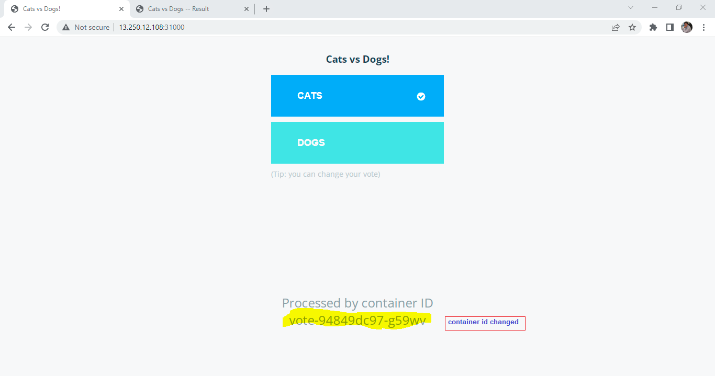

Result: No affect on results UI , user able to see results agnostic to delete of vote pod

**Conclusion:** Any deletion of vote pod, application continues to work agnostic to delete pod action.

Before deleting worker pod :

After deleting worker pod

No change in vote / result

After deleting DB POD, vote app is working while results are not reflecting when users vote or change their vote

See above, post DB pod deletion, I changed my vote to cat and it should be 100% but result is still showing old vote % which was for Dog

After result pager is refreshed, the vote is showing blank though user try to vote on vote UI:

See above, the vote count is blank/reset if result UI page refreshed

**Summary:**

path

[root@ip-172-31-22-169 ~]# pwd

/root

**Get voting app yaml from githb**

[root@ip-172-31-22-169 ~]# **git clone https://github.com/ashishrpandey/example-voting-app**

Cloning into 'example-voting-app'...

remote: Enumerating objects: 494, done.

remote: Total 494 (delta 0), reused 0 (delta 0), pack-reused 494

Receiving objects: 100% (494/494), 236.17 KiB | 13.12 MiB/s, done.

Resolving deltas: 100% (179/179), done.

**Run app yaml**

[root@ip-172-31-22-169 ~]# **cd example-voting-app/k8s-specifications/**

[root@ip-172-31-22-169 k8s-specifications]#

[root@ip-172-31-23-162 k8s-specifications]# **kubectl apply -f .**

deployment.apps/db created

service/db created

deployment.apps/redis created

service/redis created

deployment.apps/result created

service/result created

deployment.apps/vote created

service/vote created

deployment.apps/worker created

[root@ip-172-31-23-162 k8s-specifications]#

**POD & node details: All pods on worker node:**

[root@ip-172-31-23-162 k8s-specifications]# **kubectl get nodes**

NAME STATUS ROLES AGE VERSION

ip-172-31-22-169.ap-southeast-1.compute.internal Ready <none> 6d18h v1.18.5

ip-172-31-23-162.ap-southeast-1.compute.internal Ready master 6d18h v1.18.5

[root@ip-172-31-23-162 k8s-specifications]#

[root@ip-172-31-23-162 k8s-specifications]# **kubectl get po -o wide**

NAME READY STATUS RESTARTS AGE IP NODE NOMINATED NODE READINESS GATES

db-b54cd94f4-dldb9 1/1 Running 0 114s 192.168.163.223 ip-172-31-22-169.ap-southeast-1.compute.internal <none> <none>

redis-868d64d78-r244b 1/1 Running 0 114s 192.168.163.225 ip-172-31-22-169.ap-southeast-1.compute.internal <none> <none>

result-5d57b59f4b-hs2pl 1/1 Running 0 113s 192.168.163.224 ip-172-31-22-169.ap-southeast-1.compute.internal <none> <none>

vote-94849dc97-5jskk 1/1 Running 0 113s 192.168.163.226 ip-172-31-22-169.ap-southeast-1.compute.internal <none> <none>

worker-dd46d7584-d5lzz 1/1 Running 0 113s 192.168.163.227 ip-172-31-22-169.ap-southeast-1.compute.internal <none> <none>

[root@ip-172-31-23-162 k8s-specifications]#

**Verify vote & result pod is NodePort:**

[root@ip-172-31-23-162 ~]# **kubectl get all**

NAME READY STATUS RESTARTS AGE

pod/db-b54cd94f4-42c8p 1/1 Running 0 50m

pod/redis-868d64d78-r244b 1/1 Running 0 136m

pod/result-5d57b59f4b-hs2pl 1/1 Running 0 136m

pod/vote-94849dc97-g59wv 1/1 Running 0 58m

pod/worker-dd46d7584-2wb4q 1/1 Running 1 52m

NAME TYPE CLUSTER-IP EXTERNAL-IP PORT(S) AGE

service/db ClusterIP 10.96.147.23 <none> 5432/TCP 136m

service/kubernetes ClusterIP 10.96.0.1 <none> 443/TCP 6d20h

service/kubia2 ClusterIP 10.99.10.99 <none> 80/TCP 17h

service/redis ClusterIP 10.103.91.208 <none> 6379/TCP 136m

**service/result** **NodePort** 10.101.6.99 <none> 5001:31001/TCP 136m

**service/vote** **NodePort** 10.101.203.100 <none> 5000:31000/TCP 136m

**Delete vote 🡪Worker 🡪DB pods in sequence**

[root@ip-172-31-23-162 k8s-specifications]# **kubectl delete po vote-94849dc97-5jskk**

pod "vote-94849dc97-5jskk" deleted

^C

[root@ip-172-31-23-162 k8s-specifications]# **kubectl get po**

NAME READY STATUS RESTARTS AGE

db-b54cd94f4-dldb9 1/1 Running 0 78m

redis-868d64d78-r244b 1/1 Running 0 78m

result-5d57b59f4b-hs2pl 1/1 Running 0 78m

**vote-94849dc97-5jskk 0/1 Terminating 0 78m**

**vote-94849dc97-g59wv 1/1 Running 0 3s**

worker-dd46d7584-d5lzz 1/1 Running 0 78m

[root@ip-172-31-23-162 k8s-specifications]# **kubectl get po**

NAME READY STATUS RESTARTS AGE

db-b54cd94f4-dldb9 1/1 Running 0 82m

redis-868d64d78-r244b 1/1 Running 0 82m

result-5d57b59f4b-hs2pl 1/1 Running 0 82m

**vote-94849dc97-g59wv 1/1 Running 0 4m40s**

worker-dd46d7584-d5lzz 1/1 Running 0 82m

[root@ip-172-31-23-162 k8s-specifications]# **kubectl delete po worker-dd46d7584-d5lzz**

pod "worker-dd46d7584-d5lzz" deleted

^C

[root@ip-172-31-23-162 k8s-specifications]# **kubectl get po**

NAME READY STATUS RESTARTS AGE

db-b54cd94f4-dldb9 1/1 Running 0 84m

redis-868d64d78-r244b 1/1 Running 0 84m

result-5d57b59f4b-hs2pl 1/1 Running 0 84m

vote-94849dc97-g59wv 1/1 Running 0 6m6s

**worker-dd46d7584-2wb4q 0/1 ContainerCreating 0 3s**

**worker-dd46d7584-d5lzz 1/1 Terminating 0 84m**

[root@ip-172-31-23-162 k8s-specifications]# **kubectl get po**

NAME READY STATUS RESTARTS AGE

db-b54cd94f4-dldb9 1/1 Running 0 85m

redis-868d64d78-r244b 1/1 Running 0 85m

result-5d57b59f4b-hs2pl 1/1 Running 0 85m

vote-94849dc97-g59wv 1/1 Running 0 7m3s

**worker-dd46d7584-2wb4q 1/1 Running 0 60s**

[root@ip-172-31-23-162 k8s-specifications]# **kubectl delete po db-b54cd94f4-dldb9**

pod "db-b54cd94f4-dldb9" deleted

^C

[root@ip-172-31-23-162 k8s-specifications]# **kubectl get po**

NAME READY STATUS RESTARTS AGE

**db-b54cd94f4-42c8p 1/1 Running 0 3s**

**db-b54cd94f4-dldb9 1/1 Terminating 0 86m**

redis-868d64d78-r244b 1/1 Running 0 86m

result-5d57b59f4b-hs2pl 1/1 Running 0 86m

vote-94849dc97-g59wv 1/1 Running 0 7m50s

worker-dd46d7584-2wb4q 1/1 Running 0 107s

[root@ip-172-31-22-169 k8s-specifications]# **kubectl get po**

NAME READY STATUS RESTARTS AGE

**db-b54cd94f4-42c8p 1/1 Running** 0 2m44s

redis-868d64d78-r244b 1/1 Running 0 88m

result-5d57b59f4b-hs2pl 1/1 Running 0 88m

vote-94849dc97-g59wv 1/1 Running 0 10m

worker-dd46d7584-2wb4q 1/1 Running 1 4m28s

[root@ip-172-31-23-162 k8s-specifications]#

**JARGONS**:

**Container**

**Docker**

**Image**

**Object**

**Microservices**

**Kubernetes API Server**

**etcd**

**Pod**

**Node**

**Cluster**

**Controller**

**Kube-scheduler**

**Kubectl**

**Kubelet**

**Master Node**

**Worker Node**

**Label**

**Namespace**

**ReplicaController**

**ReplicaSet**

**Selector**

**Daemon Set**

**Service**

**Deployment**

**kubeadm**

**Job**

**CronJob**

**Kube-proxy**

**RBAC (Role-Based Access Control)**

**Toleratio**

**Volume**

**Persistent Volumes**

**StatefulSet**

**Taint**

**Container Network Interface (CNI)**

**Prometheus**